USER STORY

Courier organizations need a dependable way to coordinate customers, parcels, delivery personnel, branches, billing, and operational reporting. When these activities are maintained through separate registers or spreadsheets, staff may spend significant time checking records, contacting agents, and updating customers manually. This can make it difficult to identify the latest shipment status and to maintain consistent information across branches.
The proposed Courier Management System (CMS) uses Salesforce as a centralized cloud platform. It brings shipment registration, parcel tracking, agent allocation, delivery updates, invoice management, notifications, and management reporting into one connected solution. The objective is to reduce repetitive work, improve visibility, and give branch teams a common source of operational information.

1. INTRODUCTION

1.1 Project Overview
Courier and logistics operations involve a sequence of activities beginning with customer registration and shipment booking and continuing through allocation, transit, delivery confirmation, and billing. A system that connects these activities can reduce duplicate data entry and make shipment information easier to access.
CMS is implemented on Salesforce and uses custom objects, relationships, validation rules, flows, profiles, roles, reports, and dashboards. The application is intended to support day-to-day branch operations while also providing managers with summarized information for monitoring service performance.

1.2 Purpose
The purpose of CMS is to provide a single digital workspace for managing courier transactions and delivery operations. The solution is intended to simplify shipment creation, maintain accurate parcel information, support agent assignment, record delivery events, generate invoices, and present operational metrics.
- Reduce dependency on paper registers and disconnected spreadsheets.
- Maintain a consistent shipment record from booking to completion.
- Automate repetitive status and assignment activities using Salesforce Flows.
- Provide controlled access for administrators, branch managers, delivery agents, and support staff.
- Give managers reports and dashboards for operational review.

2. IDEATION PHASE

2.1 Problem Statement
PS | User | Goal | Current Difficulty | Root Cause | Effect
PS-01 | Branch Manager | Coordinate branch shipments | Status information is scattered | Separate records | Repeated follow-ups
PS-02 | Customer | Know parcel progress | Updates are not immediate | Manual communication | Low visibility
PS-03 | Dispatcher | Allocate delivery work | Assignments are maintained manually | No central workload view | Scheduling issues
PS-04 | Accounts Staff | Prepare invoices | Billing details require repeated checking | Disconnected shipment data | Processing delays

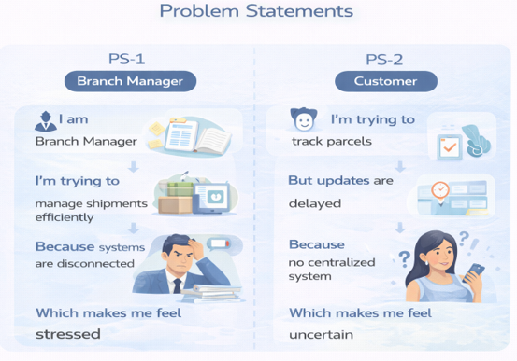

2.2 Empathy Map Canvas
User Persona: Branch Manager
- Think & Feel: Wants accurate information before making operational decisions.
- Hear: Questions from customers and staff about shipment status.
- See: Multiple records, spreadsheets, and branch-level updates.
- Say & Do: Checks shipment records and contacts agents for confirmation.
- Pain: Delayed information, workload conflicts, and repeated manual verification.
- Gain: A centralized dashboard, current shipment status, and automated workflow support.

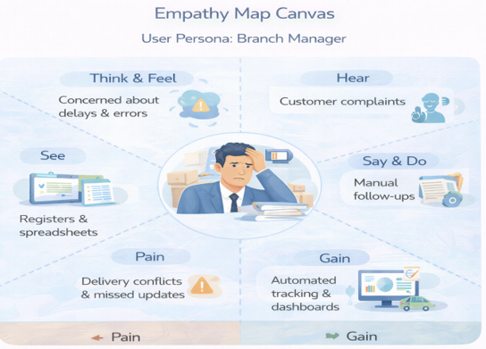

2.3 Brainstorming & Idea Prioritization
Idea | Main Benefit | Main Limitation
Paper / Manual Register | Very simple to start | Difficult to search, update, and share
Spreadsheet Tracking | Easy digital record keeping | Limited automation and multi-user control
Custom Standalone Portal | Dedicated courier interface | Requires separate development and maintenance
Salesforce CRM | Integrated objects, automation, security, and analytics | Requires platform configuration and administration
Final Selection: Salesforce CRM
Salesforce was selected for the proposed CMS because it provides configurable data objects, workflow automation, role-based access, cloud availability, and built-in reporting capabilities. These features allow the courier workflow to be represented within a single platform.

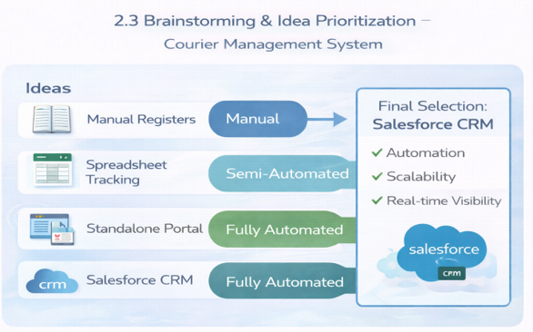

3. REQUIREMENT ANALYSIS PHASE

3.1 Customer Journey Map
Customer journey: Booking → Shipment Registration → Allocation → Transit → Delivery Confirmation → Billing → Review
Stage | System Activity | Expected Outcome
Booking | Capture customer and parcel information | Shipment request is registered
Shipment Registration | Create tracking record | Unique shipment reference is available
Allocation | Assign an available delivery agent | Responsibility is clearly defined
Transit | Record movement/status changes | Current progress is visible
Delivery Confirmation | Capture final delivery status and remarks | Shipment completion is recorded
Billing | Prepare invoice information | Charges are documented
Review | Generate reports and dashboards | Managers can assess performance

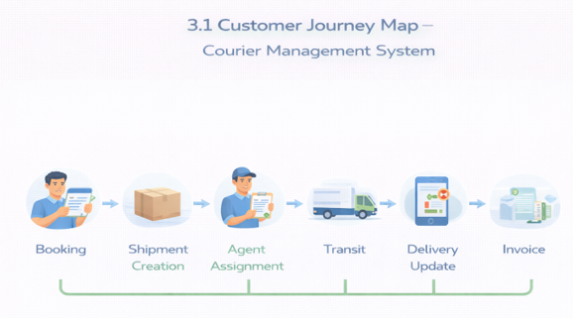

3.2 Solution Requirements

Functional Requirements
FR No. | Requirement
FR-01 | Maintain customer profiles and contact details
FR-02 | Register and manage shipment bookings
FR-03 | Allocate shipments to delivery agents
FR-04 | Record and display delivery status changes
FR-05 | Maintain invoice and payment information
FR-06 | Provide operational reports
FR-07 | Display key metrics through dashboards
FR-08 | Support branch-wise operational management

Non-Functional Requirements
NFR | Description
Usability | Provide a clear Lightning-based interface for daily users.
Security | Restrict access using profiles, roles, and object permissions.
Reliability | Use validation and automation to reduce incorrect records.
Performance | Allow users to retrieve shipment information quickly.
Availability | Use Salesforce cloud infrastructure for regular access.
Scalability | Allow additional branches, users, and shipment records to be introduced.

3.3 Data Flow Diagram
Customer / Staff Input → Customer Validation → Shipment Registration → Agent Allocation → Delivery Updates → Invoice Processing → Reports & Dashboards
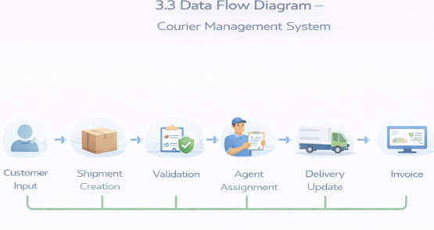

3.4 Technology Stack
Layer | Technology / Salesforce Feature
User Interface | Salesforce Lightning Experience
Application Logic | Salesforce Flow
Data Layer | Custom Salesforce Objects
Data Quality | Validation Rules
Security | Profiles, Roles, Object Permissions
Analytics | Reports and Dashboards
Cloud Platform | Salesforce Developer / Cloud Environment

4. PROJECT DESIGN PHASE
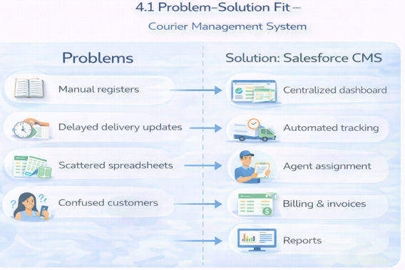

4.1 Problem–Solution Fit
CMS addresses the operational gap by connecting shipment information, agent allocation, delivery events, billing, and reporting in one Salesforce environment. Instead of maintaining separate operational records, branch staff can work with related records that share the same shipment context.

4.2 Proposed Solution
Parameter | Proposed Approach
Operational Problem | Fragmented courier records and manual coordination
Digital Solution | Salesforce-based Courier Management System
Automation | Flows for status synchronization and operational actions
Visibility | Tracking records, reports, and management dashboards
Security | Role and profile based access
Business Impact | Faster processing and better information availability

4.3 Solution Architecture
The solution is organized around connected Salesforce objects and automation services.
- Customer Object
- Shipment Object
- Delivery Agent Object
- Branch Object
- Delivery Update Object
- Invoice Object
- Salesforce Flows
- Reports
- Dashboards
Relationship flow: Customer → Shipment → Delivery Agent → Branch. Delivery Updates are linked to Shipments, while Invoices reference the associated Shipment.
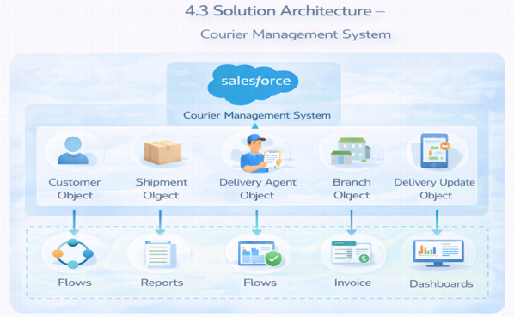

5. PROJECT PLANNING & SCHEDULING

5.1 Project Planning
- Agile development approach
- Epic-based requirement grouping
- User stories with story-point estimation
- Sprint-based implementation
- Velocity used to review completed work and plan upcoming work

5.2 Product Backlog and Sprint Schedule
Sprint | Epic | USN | User Story / Task | Points | Priority | Owner
Sprint 1 | Environment Setup | USN-01 | As an administrator, I want to prepare the Salesforce environment so that the CMS can be configured. | 3 | High | Member 1
Sprint 2 | Data Architecture | USN-02 | As an administrator, I want to create the core courier objects and relationships so that operational data is connected. | 5 | High | Member 2
Sprint 2 | User Interface | USN-03 | As a staff user, I want a Lightning app with courier modules so that I can access daily functions from one place. | 5 | High | Member 3
Sprint 3 | Data Quality | USN-04 | As a system, I want validation rules for important shipment and customer fields so that invalid records are reduced. | 3 | High | Member 4
Sprint 3 | Automation | USN-05 | As a dispatcher, I want workflow automation for delivery allocation and status synchronization so that manual work is reduced. | 5 | High | Member 4
Sprint 4 | Security | USN-06 | As an administrator, I want role and profile controls so that each user receives appropriate access. | 5 | High | Member 2
Sprint 5 | Reporting | USN-07 | As a branch manager, I want shipment and delivery reports so that I can review branch operations. | 4 | Medium | Member 3
Sprint 6 | Analytics | USN-08 | As a branch manager, I want a dashboard of shipment, delivery, and revenue indicators so that I can review performance quickly. | 4 | Medium | Member 4

5.3 Project Tracker and Velocity
Sprint | Planned Points | Duration | Planned Focus | Completion Review
Sprint 1 | 3 | 1 week | Salesforce environment | Review setup completion
Sprint 2 | 10 | 1 week | Objects, relationships, app navigation | Review data model and UI
Sprint 3 | 8 | 1 week | Validation and automation | Test business rules and flows
Sprint 4 | 5 | 1 week | Profiles and roles | Verify access restrictions
Sprint 5 | 4 | 1 week | Reports | Validate report filters and summaries
Sprint 6 | 4 | 1 week | Dashboard | Validate charts and KPIs
Velocity can be calculated from the number of story points accepted as complete during each sprint. The measured velocity can then be used to estimate the amount of work that can reasonably be planned for a subsequent sprint.

6. PROJECT DEVELOPMENT PHASE
The development phase converts the requirements into Salesforce configuration components. The major learning and implementation areas include custom object design, field configuration, relationships, validation rules, page layouts, automation, security, and analytics.

Milestone 1: Salesforce Environment
Create a Salesforce Developer environment and prepare the organization for CMS configuration. The setup includes account activation, access to Setup, and confirmation that the required platform features are available.

Activity 1: Creating Developer Account
Creating a developer org in salesforce.
- Go to https://developer.salesforce.com/signup
- On the sign up form, enter the following details :
3. First name & Last name
4. Email

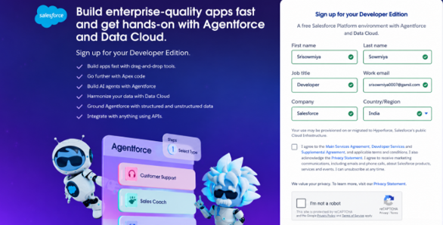
1) First name & Last name
2) Email
3) Job Title: Developer
4) Company: College Name
5) Country: India

Click on sign me up after filling these.

Activity 2: Account Activation
1. Go to the inbox of the email that you used while signing up. Click on the verify account to activate your account. The email may take 10-30 mins and sometimes 2 hours.
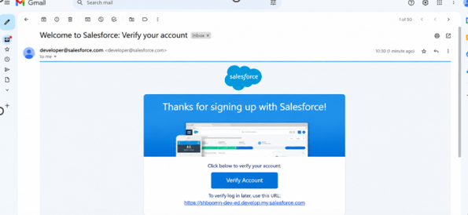

2. Click on Verify Account
3.Give a password and answer a security question and click on change password.
4.Then you will redirect to your salesforce setup page.
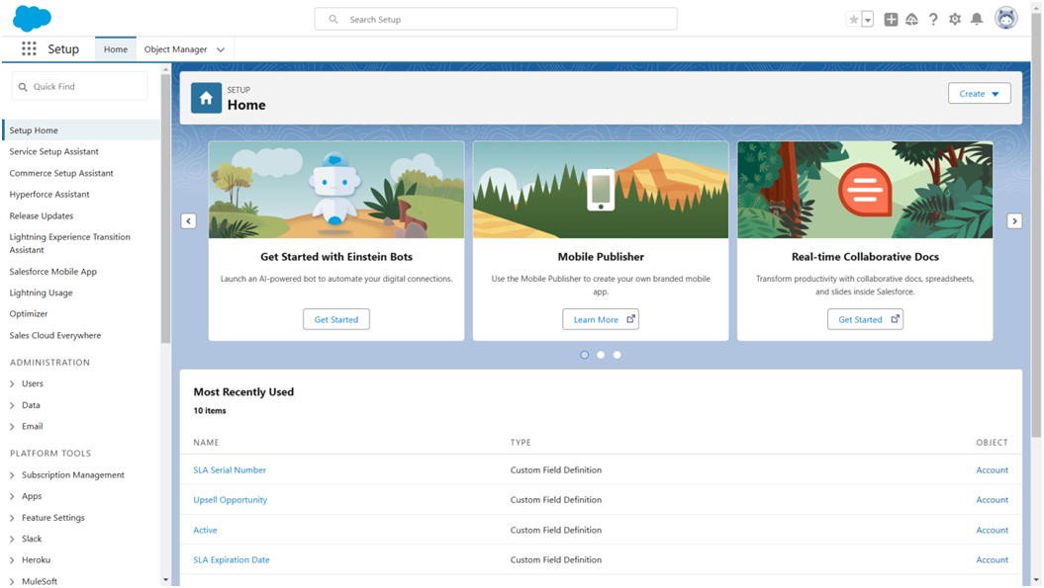

Milestone 2: Custom Objects
The CMS uses custom objects to represent the main business entities.
Steps to Implement :

Activity 1: Create Customer Object
- Click Setup → Object Manager → Create → Custom Object
- Enter the following details:
- Label: Customer
- Plural Label: Customers
- Record Name: Customer Name (Text)
- Under Optional Features:
- Enable Allow Reports
- Enable Track Field History
- In Search Status check the box Allow Search
- In Object Creation Options check the box Add Notes and Attachments related list to default page layout
- Click Save.
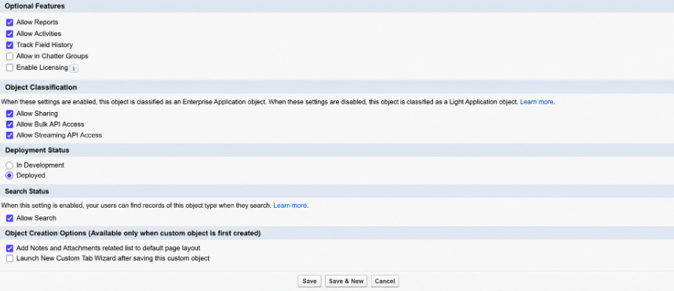

Activity 2: Create Shipment Object
- Go to Setup → Object Manager → Create → Custom Object
- Enter:
- Label: Shipment
- Plural Label: Shipments
- Record Name: Tracking Number (Auto Number)
- Example Format: SHP-{00000}
Starting Number: 0
- Enable:
- Allow Reports
- Track Field History
- Click Save

Activity 3: Create Delivery_Agent Object
- Setup → Object Manager → Create → Custom Object
- Enter:
- Label: Delivery Agent
- Plural Label: Delivery Agents
- Record Name: Agent Name (Text)
- Enable:
- Allow Reports
- Track Field History
- Click Save

Activity 4: Create Branch Object
- Setup → Object Manager → Create → Custom Object
- Enter:
- Label: Branch
- Plural Label: Branches
- Record Name: Branch Name (Text)
- Enable:
- Allow Reports
- Click Save.

Activity 5: Create Delivery_Update Object
- Setup → Object Manager → Create → Custom Object
- Enter:
- Label: Delivery Update
- Plural Label: Delivery Updates
- Record Name: Update Number (Auto Number)
- Example Format: UPD-{0000}
Enter Starting number : 0
- Enable:
- Allow Reports
- Track Field History
- Click Save.

Activity 6: Create Invoice Object
- Setup → Object Manager → Create → Custom Object
- Enter:
- Label: Invoice
- Plural Label: Invoices
- Record Name: Invoice Number (Auto Number)
- Example Format: INV-{0000}
Enter Starting number: 0
- Enable:
- Allow Reports
- Track Field History
- Click Save

Object | Purpose
Customer__c | Stores customer identity, contact, and address information.
Shipment__c | Stores parcel, route, charge, status, and tracking information.
Delivery_Agent__c | Stores agent identity, contact, branch, and availability information.
Branch__c | Stores branch details and location information.
Delivery_Update__c | Stores shipment status events, timestamps, and remarks.
Invoice__c | Stores shipment billing and payment details.

Milestone 3: Tabs and Lightning App
Create custom tabs for the courier objects and combine them in a Lightning App named Courier Management System. The app provides a common navigation point for authorized staff.
- Customer
- Shipment
- Delivery Agent
- Branch
- Delivery Update
- Invoice
- Reports
- Dashboards

Activity 1: Creating a Tab for Customer Object
- Click Home, type Tabs in Quick Find, and select Tabs.
- Under Custom Object Tabs, click New.
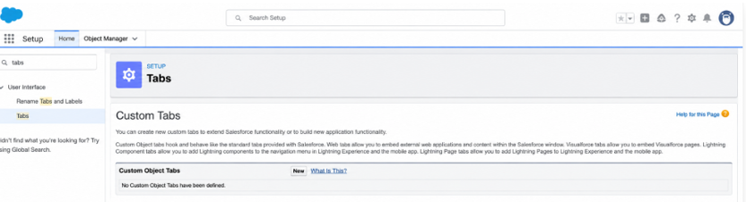
- For Object, select Customer.
- For Tab Style, choose any icon.
- Leave all default settings as they are.
- Click Next, Next, and Save.

Activity 2: Creating a Tab for Shipment Object
- Click Home, type Tabs in Quick Find, and select Tabs.
- Under Custom Object Tabs, click New.
- For Object, select Shipment.
- Choose any Tab Style.
- Keep defaults unchanged.
- Click Next, Next, and Save.

Activity 3: Creating a Tab for Delivery Agent Object
- Click Home, type Tabs in Quick Find, and select Tabs.
- Under Custom Object Tabs, click New.
- For Object, select Delivery Agent.
- Pick any Tab Style.
- Leave default settings.
- Click Next, Next, and Save.

Activity 4: Creating a Tab for Branch Object
- Click Home, type Tabs in Quick Find, and select Tabs.
- Under Custom Object Tabs, click New.
- For Object, select Branch.
- Choose any Tab Style.
- Keep all defaults.
- Click Next, Next, and Save.

Activity 5: Creating a Tab for Delivery Update Object
- Click Home, type Tabs in Quick Find, and select Tabs.
- Under Custom Object Tabs, click New.
- For Object, select Delivery Update.
- Select any Tab Style.
- Keep default configurations.
- Click Next, Next, and Save.

Activity 6: Creating a Tab for Invoice Object
- Click Home, type Tabs in Quick Find, and select Tabs.
- Under Custom Object Tabs, click New.
- For Object, select Invoice.
- Select any Tab Style.
- Leave defaults unchanged.
- Click Next, Next, and Save.

Milestone 4: Fields and Relationships
Fields define the data captured in each record. The following representative field design can be used for CMS.
COURIER MANAGEMENT SYSTEM
1. Introduction
Courier companies often face problems such as manual shipment handling, delayed updates, and difficulty in tracking deliveries. These issues reduce operational efficiency and customer satisfaction.
The Courier Management System (CMS) is a Salesforce-based cloud solution that manages shipments, delivery agents, branches, billing, notifications, and reports in one platform.
2. Purpose
The purpose of CMS is to:
- Automate courier operations.
- Track shipments efficiently.
- Assign delivery agents.
- Manage billing and invoices.
- Provide real-time reports and dashboards.
- Improve customer communication.
3. User Persona – Branch Manager
- Think & Feel: Concerned about delays and errors.
- Hear: Customer complaints.
- See: Registers and spreadsheets.
- Say & Do: Performs manual follow-ups.
- Pain: Delivery conflicts and missed updates.
- Gain: Automated tracking and dashboards.
4. Ideas Considered
- Manual Registers
- Spreadsheet Tracking
- Standalone Portal
- Salesforce CRM
Final Selection
Salesforce CRM was selected because of:
- Automation
- Scalability
- Real-time visibility
- Security
- Reporting
5. Customer Journey
Booking → Shipment Creation → Agent Assignment → Transit → Delivery Update → Invoice → Reporting
6. System Components
- Customer Object
- Shipment Object
- Delivery Agent Object
- Branch Object
- Delivery Update Object
- Invoice Object
- Flows
- Reports
- Dashboards
7. Development Methodology
The project follows the Agile methodology.
- Epics
- User Stories
- Story Points
- Sprint-based development
- Velocity calculation
8. Sprint Plan
Sprint | Module | Story Points
Sprint 1 | Salesforce Setup | 3
Sprint 2 | Data Modeling | 10
Sprint 3 | Automation | 8
Sprint 4 | Security | 5
Sprint 5 | Reports | 4
Sprint 6 | Dashboards | 4
9. Key Features
- Shipment booking and tracking.
- Delivery agent assignment.
- Automated status updates.
- Invoice management.
- Branch management.
- Reports and dashboards.
- Role-based access.
10. Testing
The system is tested for:
- Customer creation.
- Shipment creation.
- Data validation.
- Agent assignment.
- Status updates.
- Invoice generation.
- User access.
- Reports and dashboards.

Object | Important Fields
Customer | Name, Email, Phone, Address, City, State, Pincode, Customer Type
Shipment | Tracking Number, Customer, Source, Destination, Weight, Price, Status, Expected Date, Assigned Agent, Shipment Type
Delivery Agent | Agent Name, Email, Phone, Branch, Status, Joining Date
Branch | Branch Name, Branch Code, City, State, Manager
Delivery Update | Update Number, Shipment, Status, Update Date, Remarks
Invoice | Invoice Number, Shipment, Amount, Invoice Date, Payment Status
Key relationships include Customer-to-Shipments, Shipment-to-Delivery-Agent, Delivery-Agent-to-Branch, Delivery-Update-to-Shipment, and Invoice-to-Shipment.

Milestone 5: Validation Rules
Validation rules are used to prevent incomplete or unreasonable data from being saved.

Activity 1: Create Validation Rules on Customer__c
1. Validation Rule: Email Must Not Be Blank
Steps:
- Click the Gear icon → Setup
- Go to Object Manager
- Search and select Customer__c
- From the left menu, click Validation Rules
- Click New
- Rule Name: Email_Required
- Check Active
In Error Condition Formula, paste:
ISBLANK(Email__c)

- Click Check Syntax
- Error Message: Email is required.
- Error Location: Field → Email
- Click Save.
2. Validation Rule: Phone Must Be 10 Digits
Steps:
- Setup → Object Manager → Customer__c
- Validation Rules → New
- Rule Name: Validate_Phone_Number
- Check Active
Formula:
LEN(Phone__c) <> 10

- Check Syntax
- Error Message: Phone number must be 10 digits.
- Error Location: Field → Phone
- Save
3. Validation Rule: Pincode Must Be 6 Digits
Steps:
- Setup → Object Manager → Customer__c
- Validation Rules → New
- Rule Name: Validate_Pincode
- Active → Yes
Formula:
LEN(Pincode__c) <> 6

- Error Message: Pincode must be 6 digits.
- Location: Field → Pincode
- Save

Activity 2: Create Validation Rules on Shipment__c
1. Validation Rule: Weight Must Be Greater Than Zero
Steps:
- Setup → Object Manager → Shipment__c
- Click Validation Rules → New
- Rule Name: Validate_Weight
- Active → Checked
Formula:
Weight__c <= 0

- Check Syntax
- Error Message: Weight must be greater than zero.
- Location: Field → Weight
- Save
2. Validation Rule: Price Must Be Greater Than Zero
Steps:
- Setup → Object Manager → Shipment__c
- Validation Rules → New
- Rule Name: Validate_Price
- Active → Yes
Formula:
Price__c <= 0

- Error Message: Price must be greater than zero.
- Location: Field → Price
- Save
3. Validation Rule: Expected Date Cannot Be in the Past
Steps:
- Setup → Object Manager → Shipment__c
- Validation Rules → New
- Rule Name: Validate_Expected_Date
Formula:
Expected_Date__c < TODAY()

- Check Syntax
- Error: Expected delivery date cannot be in the past.
- Location: Field → Expected Date
- Save

Activity 3: Create Validation Rules on Delivery_Agent__c
1. Validation Rule: Email Must Be Valid
Steps:
- Setup → Object Manager → Delivery_Agent__c
- Validation Rules → New
- Rule Name: Validate_Agent_Email
- Active → Yes
Formula:
NOT(CONTAINS(Email__c, "@"))

- Error Message: Enter a valid email address.
- Location: Field → Email
- Save

Activity 4: Create Validation Rules on Branch__c
1. Validation Rule: Branch Code Must Not Be Blank
Steps:
- Setup → Object Manager → Branch__c
- Validation Rules → New
- Rule Name: Branch_Code_Required
Formula:
ISBLANK(Branch_Code__c)

- Error Message: Branch Code is mandatory.
- Location: Field → Branch Code
- Save

Activity 5: Create Validation Rules on Delivery_Update__c
1. Validation Rule: Remarks Required If Status is Delayed
Steps:
- Setup → Object Manager → Delivery_Update__c
- Validation Rules → New
- Rule Name: Remarks_Required_For_Delay
Formula:
AND(
ISPICKVAL(Status__c, "Delayed"),
ISBLANK(Remarks__c)
)

- Error Message: Remarks are required when status is Delayed.
- Location: Field → Remarks
- Save

Object | Validation Example | Expected Result
Customer | Email cannot be blank | Record cannot be saved without email
Customer | Phone length must be valid | Invalid contact number is rejected
Customer | Pincode length must be valid | Incorrect postal code is rejected
Shipment | Weight must be greater than zero | Invalid parcel weight is prevented
Shipment | Price must be greater than zero | Invalid charge is prevented
Shipment | Expected date cannot be earlier than today | Past delivery date is rejected
Delivery Update | Remarks required for delayed status | Delay reason must be recorded

Milestone 6: Page Layouts
Page layouts are arranged to place related information into logical sections.

Activity 1: Edit Page Layout for Customer__c
Steps:
- Setup → Object Manager → Customer__c
- Click Page Layouts
- Click the default layout (usually Customer Layout)
Sections to Add & Arrange:
- Open the default layout
- In the top palette, click “Section”
- Drag the Section and drop it anywhere on the layout
A pop-up appears → Fill details:
- Section Name: “Customer Information”
- Layout:
  - 1-Column or
  - 2-Column (recommended)
- Tab-Key Order: Top-Down
- Click OK
The new section will appear on the layout.
- Drop fields inside the section (it will highlight).
- Repeat the same for each field.
Section 1: Customer Information
- Customer Name
- Customer Type
- Email
- Phone
- Is Active
Section 2: Address Details
- Address
- City
- State
- Pincode
- Edit the layout as needed
- Click Save.

Activity 2: Edit Page Layout for Shipment__c
Steps:
- Setup → Object Manager → Shipment__c
- Click Page Layouts
- Open the default Shipment Layout
Sections to Add:
Section 1: Shipment Details
- Tracking Number
- Customer
- Shipment Type
- Weight
- Price
- Status
Section 2: Address Information
- Source Address
- Destination Address
Section 3: Delivery Information
- Expected Date
- Assigned Agent
- Arrange fields properly
- Click Save

Activity 3: Edit Page Layout for Delivery_Agent__c
Steps:
- Setup → Object Manager → Delivery_Agent__c
- Page Layouts
- Open default Delivery Agent Layout
Arrange Fields:
Agent Details
- Agent Name
- Email
- Phone
- Branch
- Status
- Joining Date
Additional Information
- Related Shipments
- Related Delivery Updates
- Edit → Save

Activity 4: Edit Page Layout for Branch__c
Steps:
- Setup → Object Manager → Branch__c
- Page Layouts
- Open default Branch Layout
Sections:
Branch Information
- Branch Name
- Branch Code
- City
- State
- Manager Name
- Arrange fields
- Click Save

Activity 5: Edit Page Layout for Delivery_Update__c
Steps:
- Setup → Object Manager → Delivery_Update__c
- Page Layouts
- Open default Delivery Update Layout
Sections:
Update Information
- Update Number
- Shipment
- Status
- Update Date
- Remarks
- Arrange properly
- Click Save

Activity 6: Edit Page Layout for Invoice__c
Steps:
- Setup → Object Manager → Invoice__c
- Page Layouts
- Open default Invoice Layout
Sections:
Invoice Details
- Invoice Number
- Shipment
- Amount
- Invoice Date
- Payment Status
- Arrange fields as needed
- Click Save

Object | Suggested Sections
Customer | Customer Information; Address Details
Shipment | Shipment Details; Address Information; Delivery Information
Delivery Agent | Agent Details; Assignment Information
Branch | Branch Information
Delivery Update | Update Information
Invoice | Invoice Details; Payment Information

Milestone 7: Salesforce Flows
A record-triggered Flow can be used to synchronize a shipment's status whenever a new delivery update is created.
Flow sequence: Delivery Update Created → Find Related Shipment → Copy Latest Status → Update Shipment Record.
- Create a Record-Triggered Flow on Delivery_Update__c.
- Run the flow when a delivery update record is created.
- Find the related Shipment__c using the Shipment lookup.
- Set Shipment.Status__c to the new Delivery Update status.
- Save, test, and activate the flow.

Activity 1: Auto-Update Shipment Status When Delivery Update is Created
Scenario:
Whenever a Delivery_Update__c record is created, automatically update the related Shipment__c Status with the latest status from Delivery Update.
Part 1: Create the Record-Triggered Flow
Step 1: Open Flow Builder
- Click the Gear Icon → Click Setup
- In the Quick Find box (left side), type Flows
- Click Flows
- Click the New Flow button
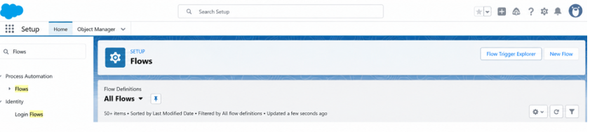
- Select Record-Triggered Flow
- Click Create
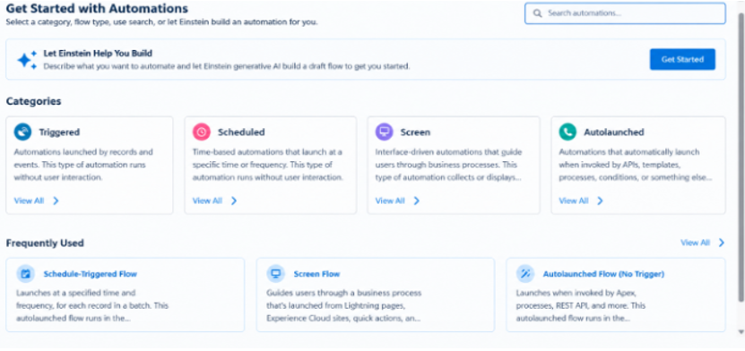

Step 2: Configure the Start (Trigger)
On the Start panel on the right:
- Object: select Delivery_Update__c
- Trigger the Flow When:
  - Select A record is created
- Condition Requirements:
  - Choose: None (Always Run the Flow)
- Optimize the Flow For:
  - Select Actions and Related Records
- Click Done

Part 2: Update Related Shipment Record
Step 3: Add “Update Records” Element
- Click the + icon under the Start element
- Select Update Records
Configure the Update Records Element:
- Label: Update_Shipment_Status
- How to Find Records to Update:
  - Select Specify conditions to identify records
Set Filter Conditions:
- Object: Shipment__c
- Field: Id
- Operator: Equals
- Value: {!$Record.Shipment__c}
(This means update the Shipment linked to the Delivery Update)

Set Field Values to Update
Add field mapping:
Shipment Field | Value Source
Status__c | {!$Record.Status__c}

(This copies status from Delivery Update to Shipment)
- Click Done
Part 3: Save and Activate
Step 4: Save Flow
- Click Save (top-right)
- Flow Label: Auto_Update_Shipment_Status
- API Name will auto-fill
- Click Save
Step 5: Activate Flow
- Click Activate
- Flow status should show Active
Final Flow Layout:
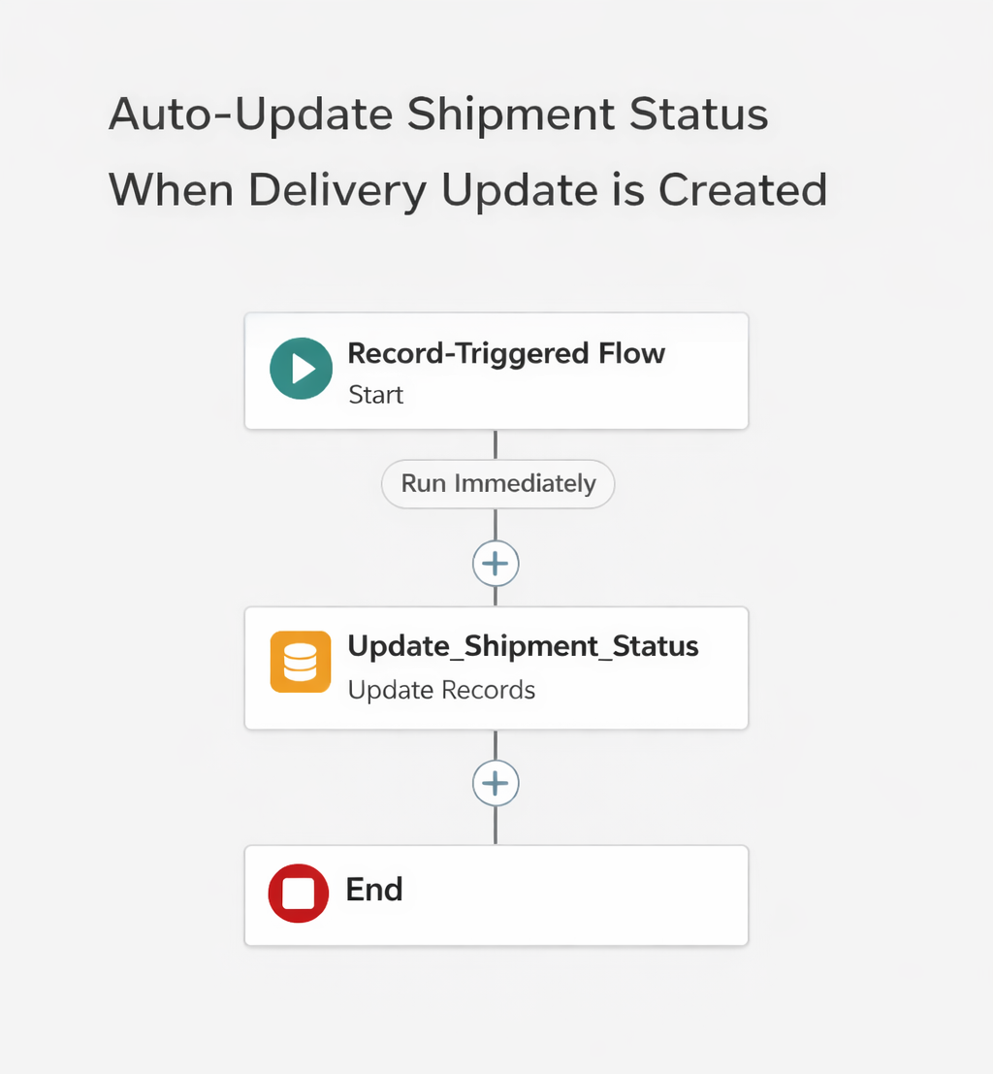

Milestone 8: Lightning App
Configure the Courier Management System Lightning App and add the required object tabs, reports, and dashboards. The app acts as the operational workspace for authorized users.

Activity 1: Create a Lightning App
Create the Courier Management System App
- From Setup, enter App Manager in the Quick Find and select App Manager.
- Click New Lightning App.
  - Enter the Courier Management System as the App Name.
- Upload an image or icon for the app, then click Next.
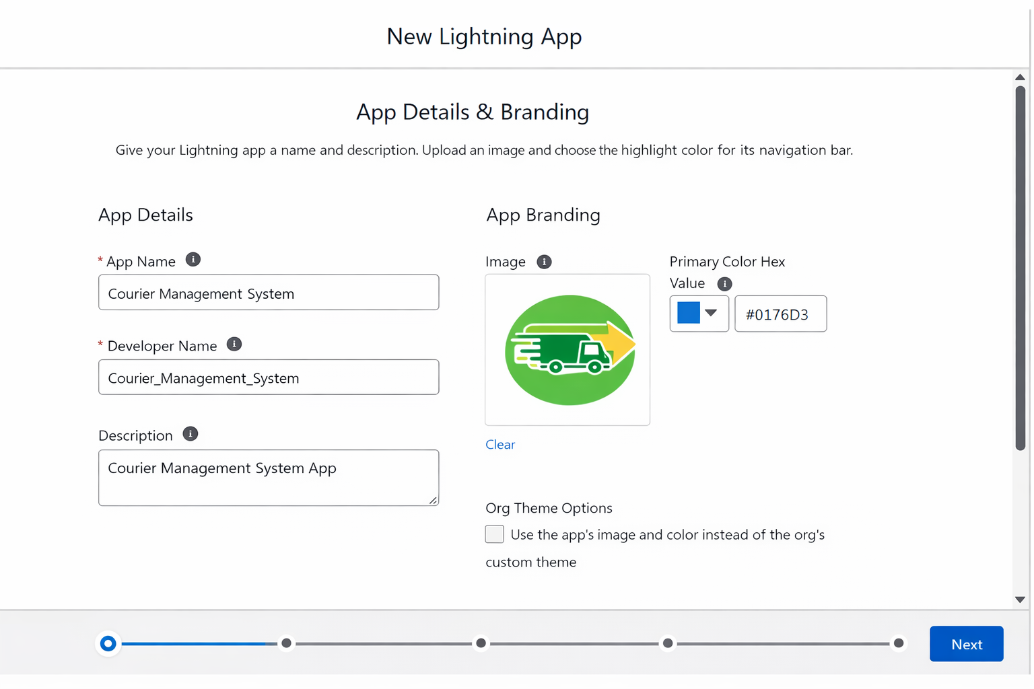
- Under App Options, leave the default selections and click Next.
- Under Utility Items, leave as it is and click Next.
- From Available Items, select the following and move them to Selected Items:
  - Customer
  - Shipment
  - Delivery Agent
  - Branch
  - Delivery Update
  - Invoice
  - Reports
  - Dashboards
- Click Next.
- From Available Profiles, select System Administrator and move it to Selected Profiles.
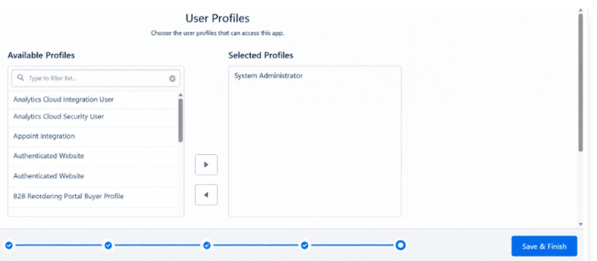
- Click Save & Finish.

Milestone 9: Profiles
Profile | Primary Responsibility
Courier Admin | System configuration and overall control
Branch Manager | Branch operations, shipments, agents, and analytics
Delivery Agent | Assigned shipment handling and delivery updates
Customer Support | Customer information and shipment tracking support

Activity 1: Create a Custom Profile – Courier Admin
Create a Custom Profile:
- From Setup, enter Profiles in the Quick Find box.
- Click Profiles.
- Click New Profile.
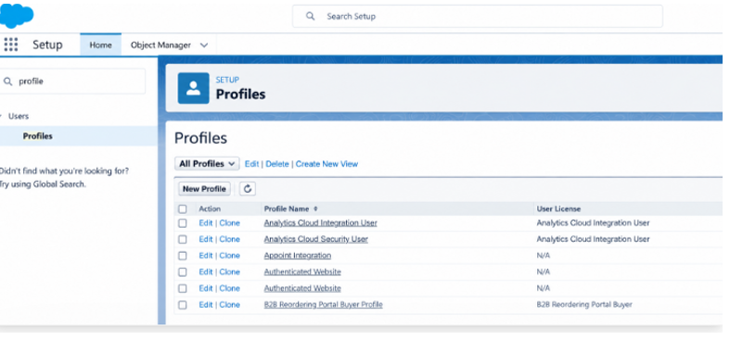
- Select Existing Profile as: System Administrator.
- Enter Profile Name: Courier Admin.
- Click Save.
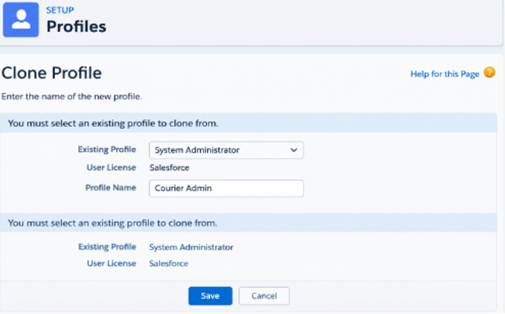
Why use System Administrator as Base?
It already has:
- Modify All Data
- Customize Application
- Full CRUD access on all objects
By cloning it, the Courier Admin profile automatically inherits full access.
You can later restrict permissions if required.

Activity 2: Create a Custom Profile – Branch Manager
Steps:
- From Setup, enter Profiles in the Quick Find box.
- Click Profiles.
- Click New Profile.
- Select Existing Profile as: Standard Platform User.
- Enter Profile Name: Branch Manager.
- Click Save.
- Click Edit on the Branch Manager profile.
Set App & Tab Settings
Under Assigned Apps / Custom App Settings, set the default app to:
Courier Management System App
Ensure Visible Tabs Include:
Set these tabs as Default On or Visible:
- Customers
- Shipments
- Delivery Agents
- Branches
- Delivery Updates
- Invoices
- Reports
- Dashboards
Custom Object Permissions
Scroll to Custom Object Permissions and set access as follows:
Object | Permissions to Grant
Customer__c | Create, Read, Edit
Shipment__c | Create, Read, Edit
Delivery_Agent__c | Read, Edit
Branch__c | Read, Edit
Delivery_Update__c | Create, Read, Edit
Invoice__c | Read
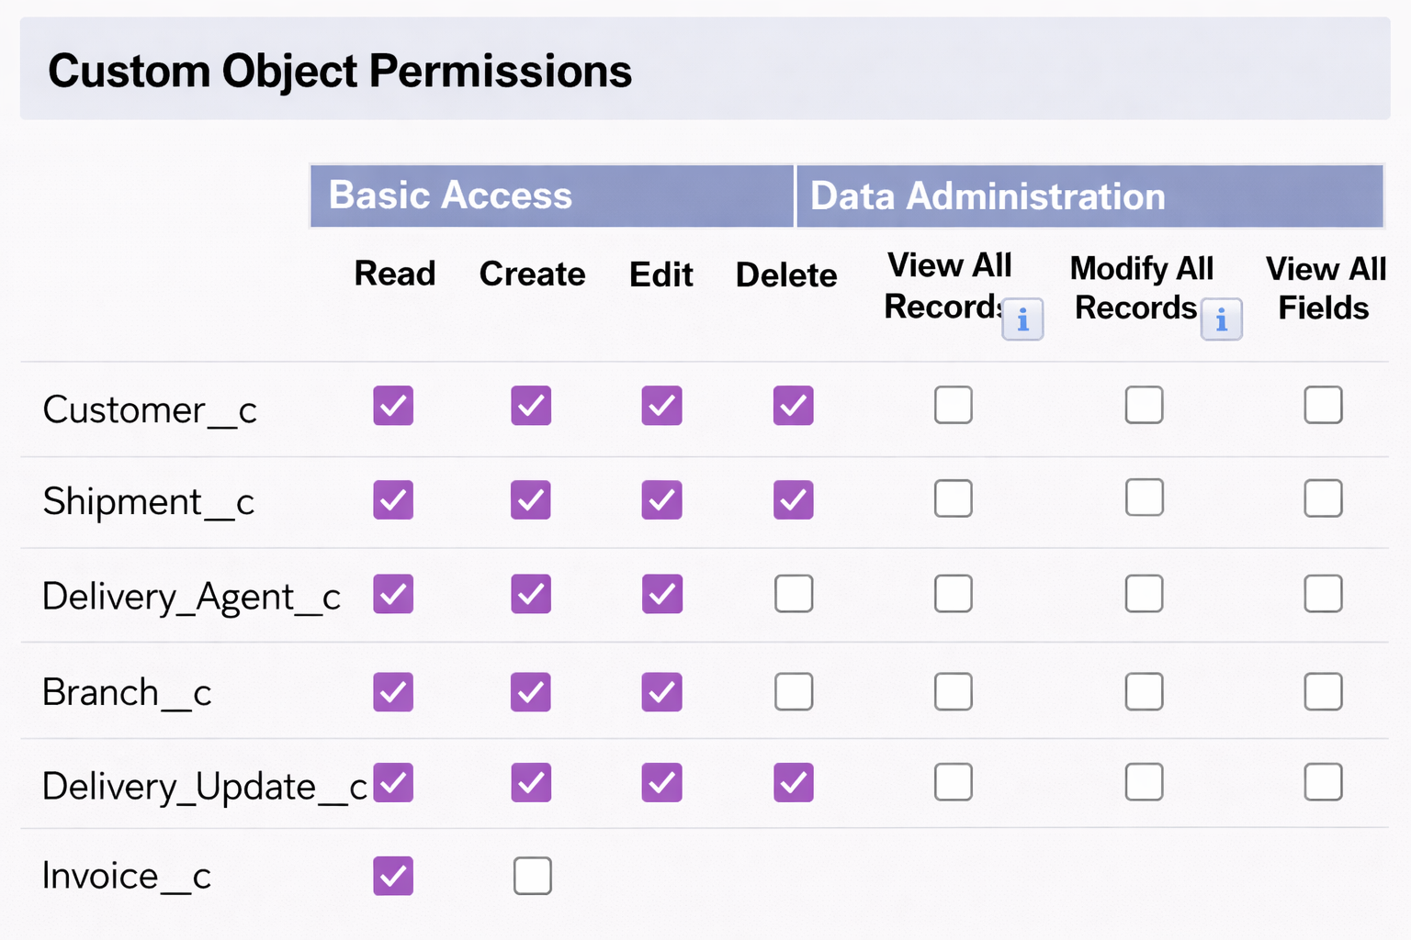

Session & Password Settings
Under Session Settings:
- Session Timeout: 2 Hours of Inactivity
Under Password Policies:
- User passwords expire in: Never Expires
- Minimum Password Length: 8
Click Save.

Activity 3: Create a Custom Profile – Delivery Agent
Steps:
- Setup → Quick Find → Profiles
- Click New Profile
- Existing Profile: Standard Platform User
- Profile Name: Delivery Agent
- Click Save
App & Tab Access
Default App: Courier Management System
Visible Tabs:
- Shipments
- Delivery Updates
Object Permissions :
Object | Permissions
Shipment__c | Read, Edit
Delivery_Update__c | Create, Read, Edit
Customer__c | Read
Invoice__c | Read
Restrictions
- No access to Branch editing
- No delete permissions
- Limited reporting access
Click Save.

Activity 4: Create a Custom Profile – Customer Support
Steps:
- Setup → Profiles → New Profile
- Base Profile: Standard User
- Profile Name: Customer Support
Access Configuration
Tabs Visible:
- Customers
- Shipments
- Delivery Updates

Object Permissions :
Object | Access
Customer__c | Read, Edit
Shipment__c | Read, Edit
Delivery_Update__c | Read
Invoice__c | Read
Session Settings
- Session Timeout: 2 Hours
- Password Length: 8
Click Save
Final Profiles Created in Project :
Profile Name | Purpose
Courier Admin | Full system control
Branch Manager | Manage shipments and agents
Delivery Agent | Update delivery status
Customer Support | Handle customers and tracking

Milestone 10: Roles
A simple role hierarchy can be configured to represent the reporting structure:
- Courier Admin
- Branch Manager
- Delivery Agent
- Customer Support
The hierarchy supports organizational visibility while profiles and object permissions define what each user is allowed to perform.

Activity 1: Creation of Courier Admin Role
Creation of Role:
- From the Quick Find box, search for Roles and click on the Roles option.
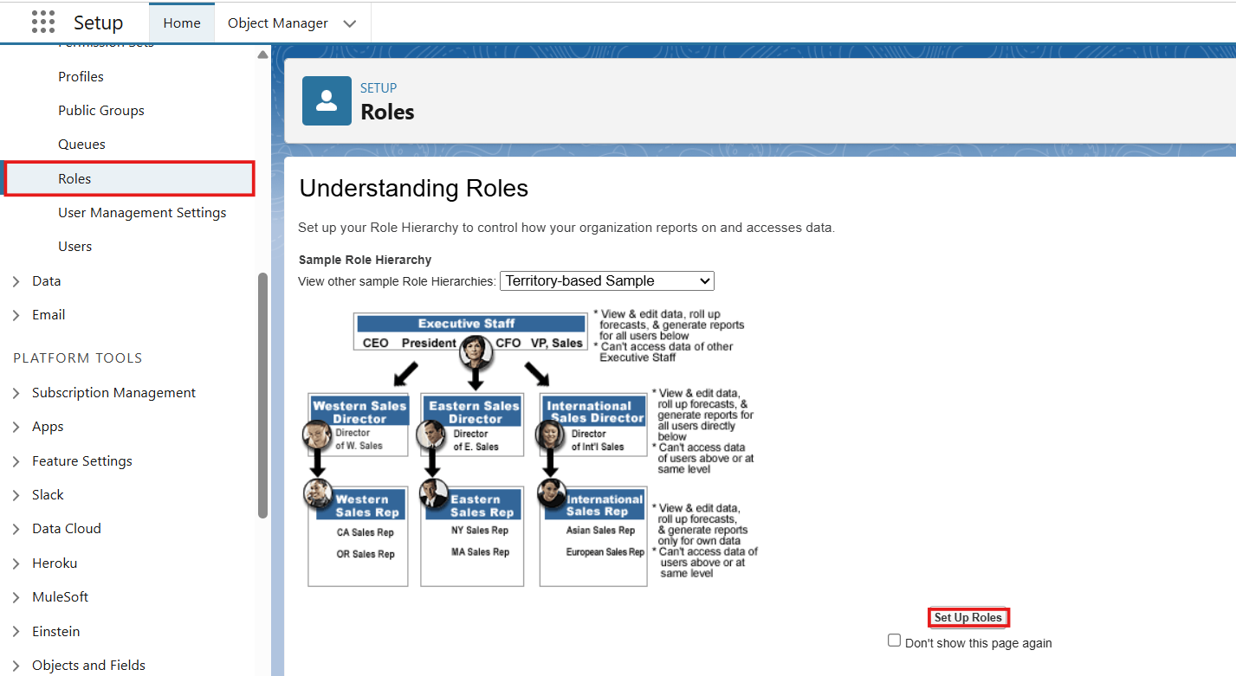
- Select Set Up Roles.
- Click on Expand All and click Add Role under CEO.
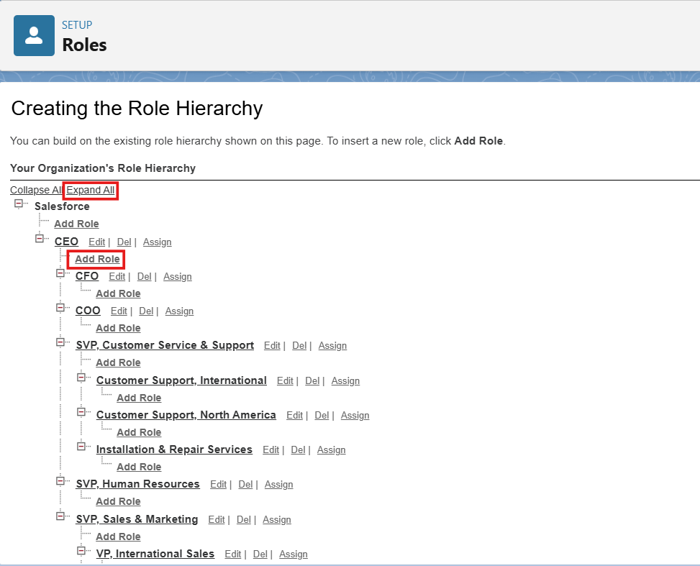
- Give Label as “Courier Admin”.
  - The Role Name will auto-populate.
- Click Save.

Activity 2: Creating Branch Manager Role Under Courier Admin Role
Create another role:
- Create a role with the name “Branch Manager”.
- Below the Courier Admin, click on Add Role.
- Enter the label name as “Branch Manager” and the Role Name will automatically populate.
- Click Save.

Activity 3: Creating Delivery Agent Role Under Branch Manager Role
Steps:
- Below the Branch Manager role, click on Add Role.
- Enter Label as “Delivery Agent”.
  - Role Name will auto-populate.
- Click Save.

Activity 4: Creating Customer Support Role Under Branch Manager
Steps:
- Under the Branch Manager role, click on Add Role.
- Enter Label as “Customer Support”.
- Role Name will automatically populate.
- Click Save.
Purpose of This Hierarchy :
- Courier Admin – Highest level access to all data
- Branch Manager – Manages branch-level operations
- Delivery Agent – Access only to assigned shipments
- Customer Support – Limited access to customer and shipment tracking
This hierarchy ensures proper data sharing and security in the Courier Management System.

Milestone 11: Users
Create users according to their operational responsibilities and assign the appropriate profile and role. Each user should have a unique username and the required access configuration.
User Type | Role | Profile
Administrator | Courier Admin | Courier Admin
Branch Manager | Branch Manager | Branch Manager
Delivery Agent | Delivery Agent | Delivery Agent
Customer Support | Customer Support | Customer Support

Milestone 12: Reports and Dashboards
Reports provide detailed operational views while dashboards summarize important information visually.
Report | Purpose
Shipment Status Report | Review shipment counts by current status.
Agent Workload Report | Compare assigned shipments across delivery agents.
Branch Revenue Report | Review shipment charges by branch and period.
Customer Summary Report | Review customer and shipment activity.
Suggested dashboard components include Shipment Status, Agent Workload, Branch Revenue, and Delivery Completion indicators.
Final loyout:
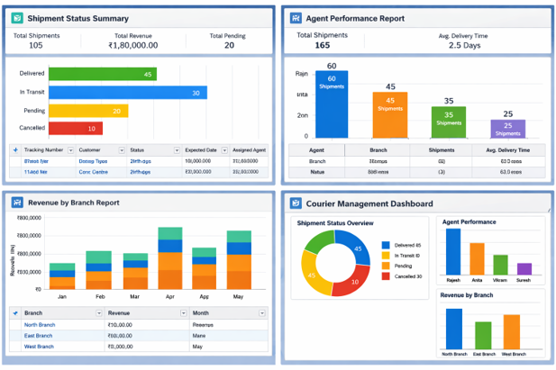

7. FUNCTIONAL & PERFORMANCE TESTING
Testing is performed to confirm that configured Salesforce components behave according to the requirements. Test scenarios should cover record creation, required fields, validation errors, relationship behavior, flow execution, user permissions, reports, and dashboard values.
Test Area | Expected Result
Customer Creation | Valid customer record is saved with required information.
Shipment Creation | Shipment receives a unique tracking reference.
Validation | Invalid values display an error and are not saved.
Agent Assignment | Shipment can reference an appropriate delivery agent.
Delivery Update Flow | Shipment status reflects the latest delivery update.
Invoice | Invoice stores the linked shipment and charge details.
Security | Users can access only the functions allowed by their role/profile.
Reports | Reports display current records using the configured filters.
Dashboard | Charts reflect the underlying report data.

8. ADVANTAGES & DISADVANTAGES

Advantages
- Centralized courier information
- Reduced repetitive manual updates
- Connected shipment and delivery records
- Automated workflow support
- Role-based access control
- Real-time operational reporting
- Scalable multi-branch structure

Disadvantages
- Requires Salesforce platform knowledge
- Initial configuration and data-model design require effort
- Ongoing administration is needed as business rules change
- Some advanced requirements may require additional Salesforce features or integrations

9. CONCLUSION
The proposed Courier Management System provides a structured Salesforce-based approach for managing courier operations. By connecting customers, shipments, agents, branches, delivery updates, invoices, and analytics, the system creates a consistent operational workflow. Automation and validation reduce unnecessary manual activity, while reports and dashboards provide management with a clearer view of day-to-day performance.

10. FUTURE SCOPE
- Customer-facing shipment tracking portal
- Mobile application for delivery agents
- GPS and route-location integration
- SMS / WhatsApp / email notification integration
- Digital proof-of-delivery capture
- Automated payment gateway integration
- AI-assisted route and workload recommendations
- Advanced branch-level performance analytics

11. APPENDIX
Item | Description
Platform | Salesforce Cloud Platform
Primary Data | Salesforce Custom Objects
Automation | Salesforce Flows and Validation Rules
Security | Profiles, Roles, and Object Permissions
Analytics | Salesforce Reports and Dashboards
Demo Environment | Salesforce Developer Organization

THANK YOU

