SmartTicket
Distributed Ticket Booking and Reservation System
Final Project Report
Distributed Systems and Applications
Student Name: ______________________________
Roll Number: _________________________________
Course / Department: __________________________
Institution: ___________________________________
Project Guide: _________________________________
Academic Year: 2026–2027
Prepared from the SmartTicket project source, deployment files, and project test reports

Abstract
SmartTicket is a web-based ticket reservation system designed to illustrate how distributed application components can coordinate under concurrent demand. Users browse events, inspect seat availability, submit bookings, and review booking history. Administrators have event and simulation views. The system is implemented as a React frontend behind an Nginx gateway, two horizontally replicated Spring Boot Booking Service instances, a Seat Service, a MySQL database, Redis, RabbitMQ, and a notification consumer. Booking and seat reservation use synchronous REST calls; booking notifications are published asynchronously. Redis provides cache-aside reads and a short-lived atomic seat lock, while the Seat entity uses JPA versioning to detect conflicting updates. The repository also includes simulation, API test, and load-test materials. Project-authored reports describe an 11-case API test run and load scenarios reporting up to 42.6 requests per second for the two-node booking setup and 4.8 ms average latency for cached seat reads. Those results are presented here as recorded project results and were not rerun for this report. Source review also identifies several deployment and security gaps that should be addressed before production use, including public seat reservation, registration role escalation, and an invalid-looking Nginx preflight return value. The report documents the architecture, implementation, working flow, reported tests, contributions, and limitations.

Contents
• 1. Introduction
• 2. Objectives
• 3. Project Problem statement
• 4. System Architecture
• 5. Distributed systems concepts used
• 6. Technology
• 7. Implementation
• 8. Working/Demo
• 9. Testing Results
• 10. Individual student contribution
• 11. Conclusion
• 12. Annexures

1. Introduction
Online ticketing systems must coordinate many users who may select the same limited resource at nearly the same time. The critical resource in SmartTicket is an individual event seat. The system therefore serves as a practical study of request routing, service boundaries, concurrency control, cache consistency, persistence, and asynchronous messaging. The implementation combines a browser user interface with independently packaged Java services and shared infrastructure orchestrated with Docker Compose [1, 2].

1.1 Project overview
The frontend presents seeded events and their seat grids. The Booking Service authenticates accounts and coordinates a booking. It asks the Seat Service to reserve a seat, stores a confirmed booking and transaction log, and publishes a booking event. The Seat Service owns event and seat operations, reads seat lists through Redis cache-aside, and persists reservations through Spring Data JPA to MySQL. The Notification Service receives RabbitMQ messages and logs the event details. Nginx is the common API entry point and balances requests among two Booking Service replicas [1, 3].

1.2 Scope
The application demonstrates reservation workflow and distributed-systems techniques in an academic, local Docker environment. Its current source does not integrate a payment processor or deliver email/SMS notifications; “payment” and “notification” represent workflow labels and message-consumer logging. MySQL is a single shared database in this deployment, so the application demonstrates service separation and horizontal replication without database sharding or independent databases per service.

2. Objectives
• Provide a browser-based interface to browse events, inspect seats, request a booking, and review booking history.
• Separate booking coordination, seat/event management, and notification consumption into deployable Spring Boot services.
• Route API traffic through Nginx and run two Booking Service replicas to demonstrate horizontal scaling.
• Prevent conflicting updates to one seat through a Redis atomic reservation key and a JPA @Version field.
• Reduce repeated seat reads through cache-aside Redis entries and invalidate the event seat cache after reservation.
• Decouple booking confirmation handling from the HTTP booking response using RabbitMQ.
• Record transaction and performance metrics and provide a concurrent booking simulator for demonstration.
• Document measurable behavior, operational setup, security constraints, and areas requiring further engineering.

3. Project Problem statement
A naive “read available, then mark booked” workflow is vulnerable to a time-of-check/time-of-use race. Two requests can both read AVAILABLE before either writes BOOKED. If both proceed without an atomic guard or conflict check, the same physical seat can be sold twice. High request volumes can also overload one application process, make repeated read queries expensive, and cause slow side effects such as notification handling to delay the user response.

3.1 Problem scenario
1. Request A reads Seat A12 as AVAILABLE.
2. Request B reads Seat A12 as AVAILABLE before A commits.
3. Both attempts try to change the seat and create a booking.
4. Without concurrency control, both might report success for one seat.

3.2 Proposed response
SmartTicket serializes same-seat attempts first with Redis SET-if-absent and then uses database version checking as a durable conflict detector. It adds load-balanced booking replicas, cache-aside seat reads, and RabbitMQ-based asynchronous notification processing. Redis is an acceleration and coordination layer; MySQL remains the durable data store. The design addresses same-seat conflicts, but it does not eliminate every possible integrity or operational risk; the limitations in Sections 7 and 9 identify the remaining gaps.

4. System Architecture
The deployment is described in docker-compose.yml. The React/Vite frontend is published on host port 3000. Nginx listens on port 80 and routes booking, authentication, dashboard, simulation, log, and performance APIs to the Booking Service upstream. Event and seat API routes go directly to the Seat Service. Two booking containers use the same service build with different instance identifiers. Both services connect to the same MySQL database and Redis instance; the Booking Service also connects to RabbitMQ and calls Seat Service over the Docker network [1, 3].
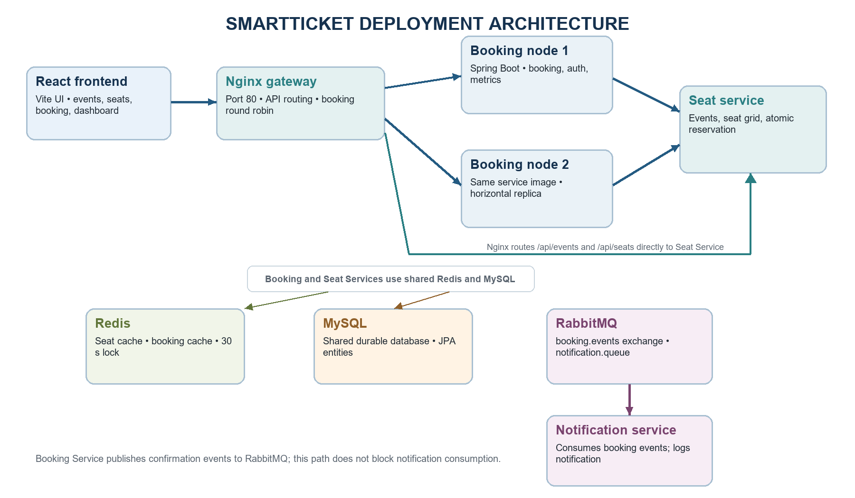
Figure 1. Deployment architecture derived from docker-compose.yml and nginx/nginx.conf.

4.1 Components and responsibilities
Component | Responsibility | Communication
React frontend | Event discovery, seat selection, login/register, history, dashboard, simulation pages. | JSON REST via Axios to Nginx.
Nginx gateway | Common HTTP entry point; route selection and round-robin booking upstream. | HTTP reverse proxy.
Booking Service × 2 | Booking orchestration, user/auth operations, booking history, metrics, event publication. | REST from gateway; REST to Seat Service; AMQP to RabbitMQ; JDBC/JPA to MySQL; Redis.
Seat Service | Events, seat grid reads, reservation, cache management. | REST from gateway and Booking Service; JDBC/JPA to MySQL; Redis.
MySQL | Durable user, event, seat, booking, transaction-log, and metric records. | Shared database connection.
Redis | Seat-list and booking cache, atomic temporary reservation keys. | Redis protocol.
RabbitMQ + Notification Service | Queue booking confirmation events and consume/log them asynchronously. | AMQP exchange, queue, and binding.

4.2 Request flow
A browser booking request reaches Nginx at /api/book. Nginx selects a Booking Service instance. The Booking Service validates the authenticated request, builds a reservation request, and synchronously calls the Seat Service. Seat Service finds the requested seat, attempts to acquire a short-lived Redis key, verifies that the seat is not already booked, persists the seat and event changes, invalidates the seat list cache, and releases its acquired lock. After the seat service responds successfully, Booking Service persists the booking and transaction log and publishes a BookingConfirmed event. The HTTP response returns without waiting for notification consumption.
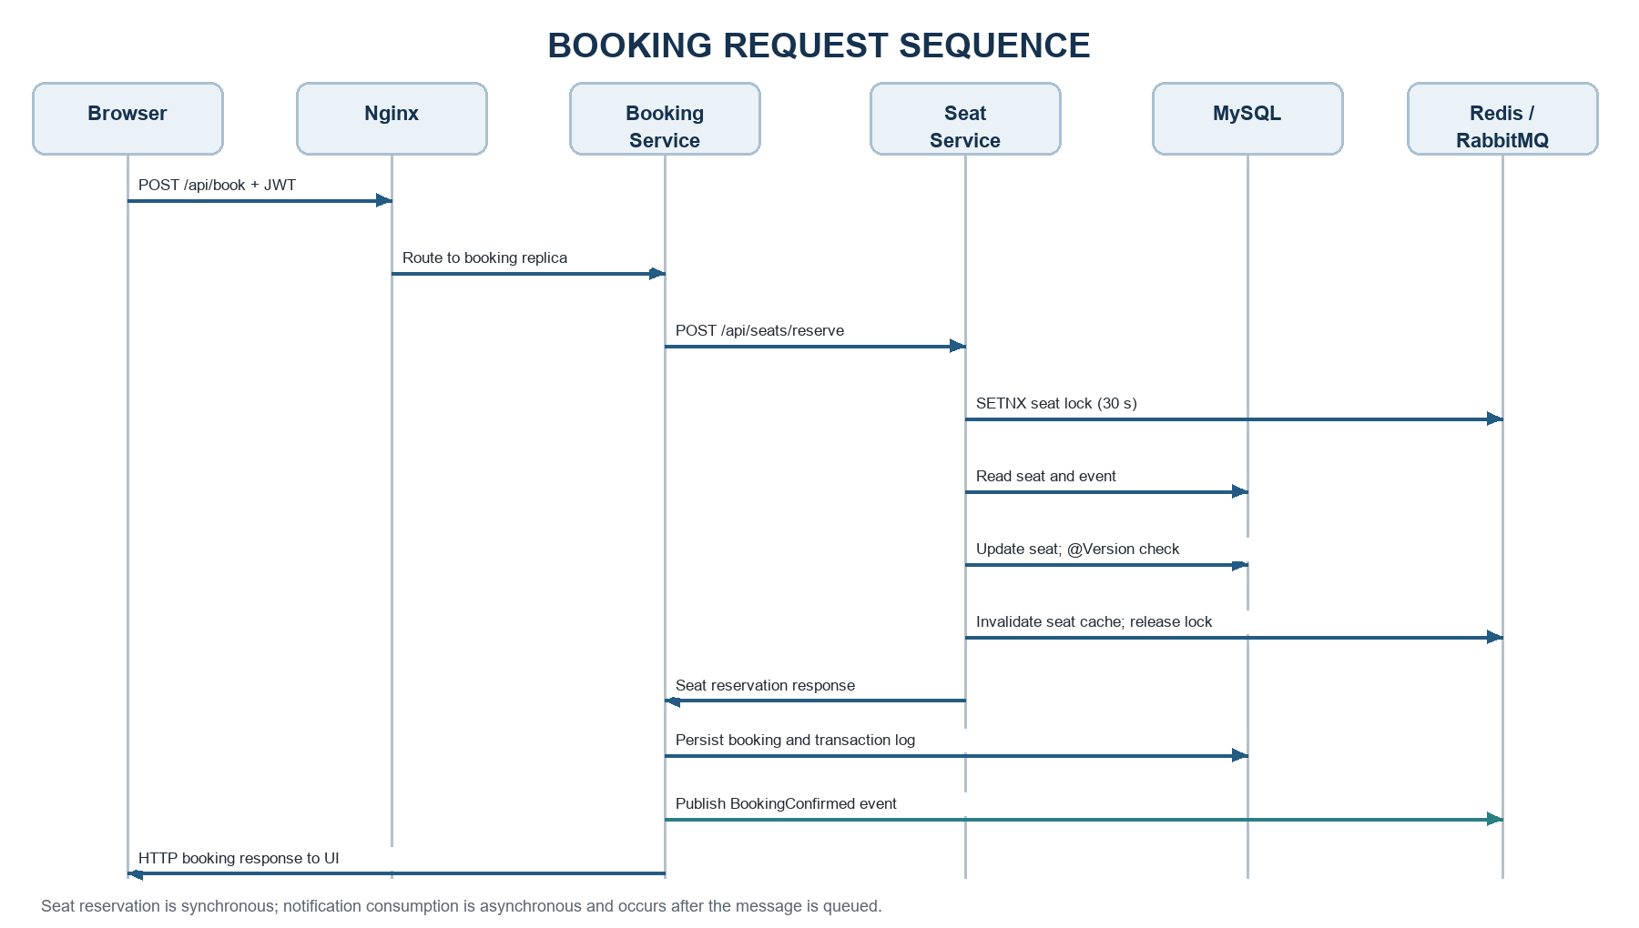
Figure 2. Sequence of a successful booking; asynchronous notification consumption follows publication.

5. Distributed systems concepts used

5.1 Service decomposition and synchronous communication
The deployment separates booking coordination, seat/event management, and notification consumption. This is a service-oriented decomposition with clear HTTP and AMQP interfaces. Booking-to-seat REST communication is synchronous: a booking cannot finish until seat reservation returns. This keeps the workflow straightforward but couples booking availability and response time to Seat Service availability.

5.2 Horizontal replication and load balancing
Two Booking Service containers are registered in Nginx upstream booking_backend. Nginx distributes applicable requests across them. This can increase available application capacity and preserve service when a single booking container is stopped, provided the gateway and shared dependencies remain healthy. The deployment still has single instances of Nginx, Seat Service, MySQL, Redis, and RabbitMQ, so it is not end-to-end highly available.

5.3 Concurrency control: Redis lock and optimistic versioning
SeatDataRepository uses StringRedisTemplate.setIfAbsent on lock:seat:{eventId}:{seatNumber} with a 30-second expiry. Only the caller that obtains the key proceeds through the fast reservation gate. The Seat entity also declares a numeric @Version field. JPA uses the version in update checks so that conflicting writes can be detected at persistence time; the Booking Service has retry/backoff handling for optimistic-lock exceptions [4]. The Redis key is explicitly deleted after a successful save or from the failure handler if this process acquired it. If Redis is unavailable, the code proceeds to database checks and relies on database state and version handling. These mechanisms protect same-seat requests better than an unlocked read/update flow, though correctness depends on transaction boundaries, database constraints, and consistent exception handling.
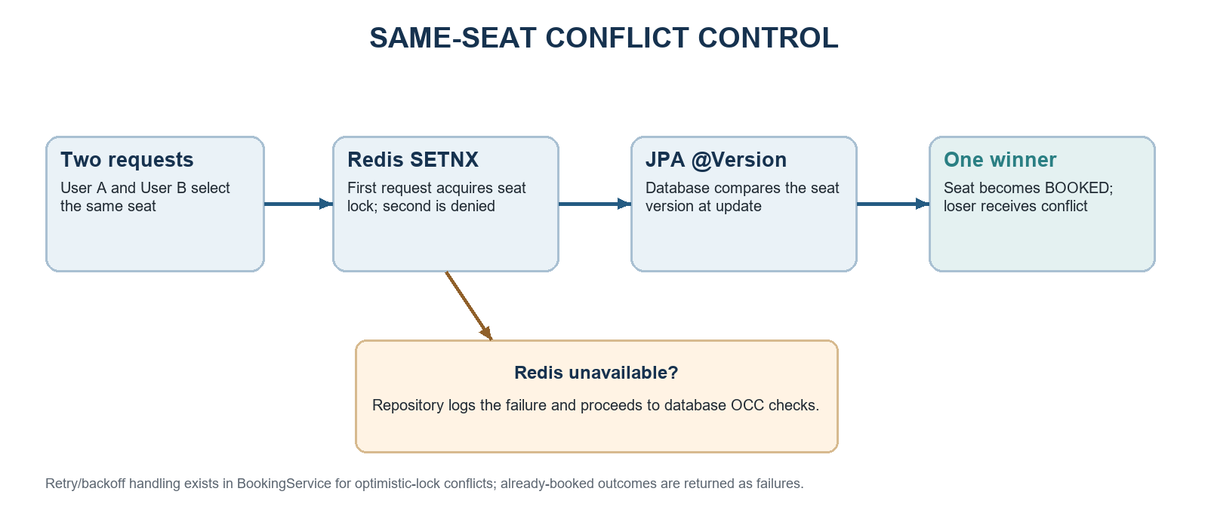
Figure 3. Same-seat conflict path and database fallback when Redis is unavailable.

5.4 Cache-aside and invalidation
Seat reads use the key seats:event:{id}. A cache hit returns serialized seat DTOs from Redis; a miss queries MySQL and stores the result for ten minutes. Booking details use booking:{id} with a fifteen-minute TTL. A successful reservation deletes the event’s seat-list key to prevent subsequent reads from returning the previous availability snapshot. Cache counters are held in service memory, so they are per-process and reset when the instance restarts.

5.5 Asynchronous messaging
Booking Service publishes a BookingEvent to the booking.events topic exchange using routing key booking.confirmed. RabbitMQ binds notification.queue to that routing key, and Notification Service consumes the queue with @RabbitListener. This moves the notification-side task off the request path and allows queued work to wait while the consumer is unavailable. In the present code the consumer logs a simulated notification; it does not send an email or SMS. The publisher catches and logs publication exceptions, so the booking can succeed even if a message is not published; there is no transactional outbox in the implementation.

5.6 Stateless authentication and authorization
The latest source adds a OncePerRequestFilter that reads Bearer JWTs, validates their signature and expiry through JwtConfig, and places the token subject and role in Spring Security’s context. Booking Service requires authentication for booking routes and requires ROLE_ADMIN for simulation and some event mutations. These are the intended security concepts. Current source inspection also shows authorization gaps discussed in Section 7.7; therefore, the report does not characterize the deployment as fully secure.

6. Technology
Layer | Technologies | Use in SmartTicket
Web client | React, Vite, Material UI, Axios, React Router, Chart.js | User interface, route navigation, REST calls, dashboard charts.
Application services | Java 21, Spring Boot 3.2, Spring MVC | REST controllers and domain services.
Persistence | Spring Data JPA, Hibernate, MySQL 8.0, HikariCP | Entity persistence, relational constraints, and connection pooling.
Concurrency and caching | JPA @Version, Spring Data Redis, Redis 7 | Optimistic seat version checks, cache-aside reads, atomic temporary keys.
Messaging | Spring AMQP, RabbitMQ 3.12 | Booking confirmation exchange and notification queue.
Gateway and packaging | Nginx, Docker, Docker Compose | Routing, load balancing, container packaging, and local service network.
Testing artifacts | Postman collection, project API/load reports, k6 script | Endpoint examples and recorded functional/performance scenarios.

The project uses Spring Boot 3.2.4 in Maven descriptors and Java 21 as the target version. The frontend package manifest uses React 19 and Vite 8. Exact resolved dependency versions are recorded in package-lock.json and Maven dependency resolution, while this report lists the technologies and declared versions supported by the project files [1, 5].

7. Implementation

7.1 Frontend
The frontend is a Vite React application with routes for Events, seat selection, login, registration, booking history, dashboard, simulation, and admin pages. AuthContext stores returned authentication data in localStorage. An Axios request interceptor reads the saved token and attaches it as a Bearer token. Events and seat availability are fetched through API wrappers; the booking page posts the selected event and seat to /api/book. Dashboard visualizations use Chart.js through react-chartjs-2 [1].

7.2 Booking Service
BookingController exposes POST /api/book, GET /api/bookings, and GET /api/bookings/{id}. BookingService assigns a transaction context, performs retries for optimistic-lock failures, calls Seat Service, stores the booking and transaction log through BookingDataRepository, and publishes the confirmation event. The request payload includes event, seat, and user identifiers. The present source defaults a missing userId to 1 and uses the provided userId when persisting; it does not derive the owner from the JWT subject. That behavior requires correction before relying on per-user authorization.

7.3 Seat Service and persistence model
SeatController exposes GET /api/seats/{eventId} and POST /api/seats/reserve. EventController supports event listing, retrieval, creation, update, and deletion. SeatDataRepository maps entities to lightweight SeatDto objects for cached reads and processes seat reservation inside a transactional method. The principal entities are User, Event, Seat, Booking, TransactionLog, and PerformanceMetric. Booking references one user, event, and seat; Seat references its event. Seat.version is marked with @Version. Transaction and performance entities support demonstration and analysis rather than the ticket inventory itself.
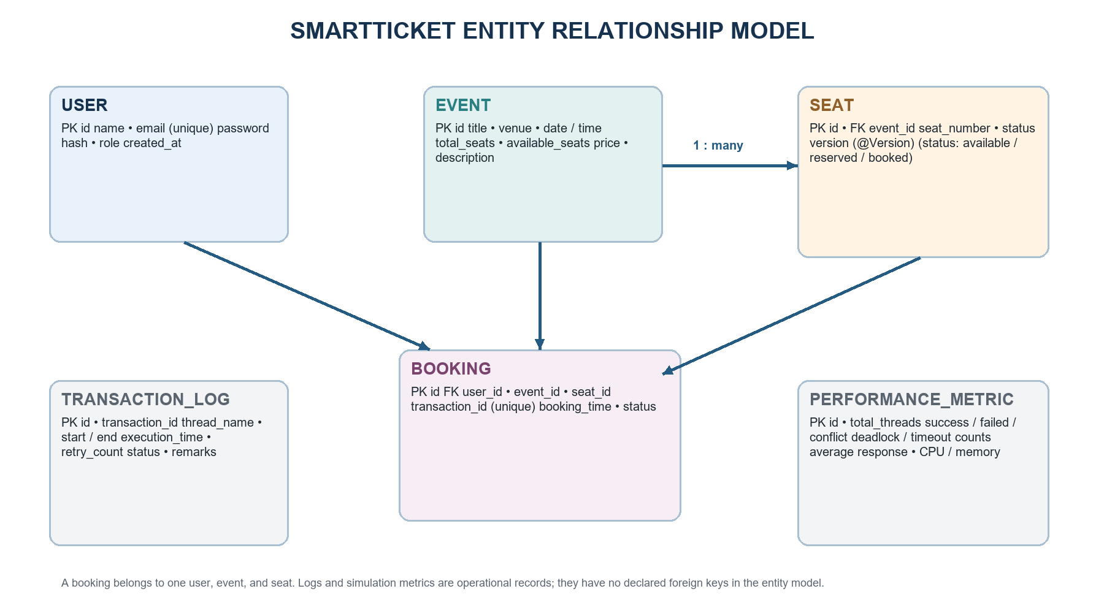
Figure 4. Relational entity relationships derived from JPA entity mappings; metrics/logs do not declare entity foreign keys.

7.4 Reservation transaction
1. Resolve the seat by seatId or by eventId and seatNumber; reject missing or invalid identifiers.
2. Attempt Redis SET-if-absent for the seat lock key with a 30-second TTL. If Redis is unreachable, record the failure and continue to database protections.
3. Reject if the seat is already BOOKED or the event has no seats available.
4. Mark the seat BOOKED, save it with version checking, decrement availableSeats, and save the event.
5. Invalidate seats:event:{eventId}; on success release the lock if this request acquired it. On exception also release it.
6. Return a reservation DTO to Booking Service, which saves the Booking and log and publishes the RabbitMQ event.

7.5 Seed data and configuration
InitialDataSeeder creates a demo administrator and user if the user table is empty, then creates three sample events and seat rows. The current sample credentials are stored in source and are appropriate only for a local demonstration. Docker Compose supplies service hosts and credentials via environment variables and persistent named volumes for MySQL and Redis. The checked-in .env.example contains development-oriented default credentials; deployments should supply unique secrets and restrict network exposure.

7.6 API outline
Method and route | Service | Purpose
POST /api/auth/register | Booking Service | Create a user and return a signed JWT.
POST /api/auth/login | Booking Service | Verify credentials and return JWT/user data.
GET /api/events, GET /api/events/{id} | Seat Service | Browse events.
POST /api/events, PUT /api/events/{id}, DELETE /api/events/{id} | Seat Service | Admin event management intent.
GET /api/seats/{eventId} | Seat Service | Read seat state for an event.
POST /api/seats/reserve | Seat Service | Reserve a seat for Booking Service workflow.
POST /api/book | Booking Service | Coordinate reservation, booking record, and event publication.
GET /api/bookings, GET /api/bookings/{id} | Booking Service | Read booking history/details.
POST /api/simulation/run | Booking Service | Run the concurrent booking simulator.
GET /api/dashboard, /api/logs, /api/performance | Booking Service | Read summary, transaction logs, and metrics.

7.7 Implementation observations and constraints
• Registration accepts a role value of ADMIN and AuthService converts it to ROLE_ADMIN. Public registration can therefore create an administrator account; the role must be assigned only by a trusted administrative process.
• Seat Service SecurityConfig ends with anyRequest().permitAll(), and POST /api/seats/reserve is explicitly permitted. Direct reservation requests can bypass Booking Service authentication. The Nginx gateway sends /api/events to Seat Service, so event mutation rules declared only in Booking Service do not govern those routed requests.
• Booking identity is taken from the request userId rather than the validated JWT subject. Booking history also accepts a caller-supplied userId. Enforce ownership using the authenticated principal and restrict admin actions within the service that actually handles them.
• The entity has no declared unique constraint for (event_id, seat_number), and only Seat has @Version; concurrent updates to Event.availableSeats are not version-protected. Database constraints and a transaction design for event capacity should be added.
• The Redis lock uses a constant value and deletion by key. If a lock expires and another caller acquires it before the original process reaches cleanup, the first process could delete the second caller’s lock. A unique ownership token and compare-and-delete operation would be safer.
• The current Nginx configuration uses return 24 for OPTIONS requests. The Nginx return directive accepts defined HTTP status codes (including 204); 24 is not a valid HTTP response status. Validate and change this to return 204 before relying on the gateway configuration [6].
• There is no payment gateway, transactional outbox, email/SMS provider, database replication, or replicated gateway/Seat Service in the Compose file. These are out of scope for an academic demo but matter for production reliability.

8. Working/Demo

8.1 Start the system
From the project root, run:
docker compose up --build
When services report healthy/started, open the frontend at http://localhost:3000. The gateway is at http://localhost, the RabbitMQ management UI at http://localhost:15672, Redis at localhost:6379, and MySQL at localhost:3306. The environment values in Compose are demo defaults and should not be exposed on a public network [3].

8.2 Demonstration flow
1. Open Events and choose a seeded event; navigate to its seat grid.
2. Log in with a local demo account, select an available seat, and submit a booking. The UI receives the API response with booking/transaction information.
3. Observe the seat state refresh. A first seat-list request is expected to populate Redis; a repeated request can be served from cache until a successful booking invalidates the event cache.
4. Inspect Booking Service and Seat Service logs to trace the synchronous reservation and MySQL write. Inspect RabbitMQ and Notification Service logs to show asynchronous message delivery.
5. Open the dashboard and simulation pages. Use a shared target seat to demonstrate one successful reservation and competing conflicts, then reset the database volume if a fresh demo dataset is required.
The source seeds admin@smartticket.com / admin123 and user@smartticket.com / user123 on an empty database. Use these only in an isolated local demonstration; replace or remove them before any shared deployment. Because role assignment and seat-reservation authorization have gaps in the current code, do not expose administrative or direct reservation APIs outside a controlled demo environment.

9. Testing Results
The repository includes API_TESTING_REPORT.md, PERFORMANCE_LOAD_TEST_REPORT.md, a Postman collection, and a k6 script. The figures below are transcribed as project-reported results; this report did not execute the services, Postman collection, or load generator. They are evidence of documented test outcomes, not an independent reproduction [7, 8].

9.1 API test results recorded in the project
Category | Cases reported | Recorded outcome
Health and event listing | TC-01, TC-02 | 200 OK; 8 ms and 14 ms.
Seat reads and cache | TC-03, TC-04 | 200 OK; cache miss 28 ms; cache hit 5 ms.
Booking and history | TC-05, TC-06, TC-07 | Success/history retrieval; 42 ms booking, 6 ms booking detail, 18 ms history.
Conflict and invalid input | TC-08 to TC-11 | 409 for booked seat; 400 for invalid or malformed inputs; report marks all passed.
Summary | 11 cases | 11 passed, 0 failed, 100% as recorded in API_TESTING_REPORT.md.

9.2 Load and concurrency results recorded in the project
Scenario | Load | Reported measurements
Single booking instance | 25 VUs, 30 s, 450 requests | 48.2 ms average; 95.1 ms P95; 15.0 req/s; 0% errors.
Two-node booking service | 50 VUs, 30 s, 1,280 requests | 26.4 ms average; 56.2 ms P95; 42.6 req/s; 0% errors.
Cached seat reads | 100 VUs, 30 s, 8,500 requests | 4.8 ms average; 283.3 req/s; 0% errors; 98.24% cache hit ratio (8,350 hits / 150 misses).
One hot seat | 100 VUs, 15 s, 100 requests | 18.5 ms average; one success and 99 conflicts; 99% conflict response rate is expected for the one-seat setup.

The reported throughput rose from 15.0 to 42.6 requests/second between the single-instance and two-instance scenarios, approximately 2.84 times. The reported test claims zero duplicate bookings in the hot-seat scenario. These measurements depend on the original test environment and should be rerun on the final code and hardware before being used as guarantees.

9.3 Verification caveats
• The report files do not include raw k6 output, full hardware identifiers, run timestamps for each scenario, or a reproducible result bundle. Hardware is described generically as an Intel / AMD multi-core CPU.
• The Postman collection’s booking requests do not include Authorization headers. The latest Booking Service security configuration requires authentication for booking endpoints, so the recorded unauthenticated request examples may not pass against the current Compose services.
• The Postman collection also includes a direct POST /api/seats/reserve request; this route is currently public in Seat Service. Test and security expectations should be updated together.
• The README describes Redis fallback behavior and service failover scenarios, but the checked-in test reports do not show executed fault-injection evidence for all of those claims.
• Before final submission, rerun the endpoint suite with valid user/admin tokens, test forbidden access and user ownership, validate Nginx configuration, and save raw k6/Postman outputs with the environment and code revision.

10. Individual student contribution
The project source and supporting documents show work across the following areas. The supplied report brief does not identify student names or divide work among team members, so the table records project work areas without assigning unverifiable personal credit. Enter the student’s name and actual role allocation before submission.
Student / role | Contribution area evidenced in project | Details to personalize
[Student name] | Frontend and user workflows | Identify pages/components personally designed or implemented.
[Student name] | Backend services and persistence | Identify controllers, services, repositories, and entities personally developed.
[Student name] | Concurrency and distributed design | Identify work on OCC, Redis, RabbitMQ, service routing, and failure scenarios.
[Student name] | Testing and documentation | Identify test execution, results collection, diagrams, and report preparation.

If this is an individual project, combine the rows under one name and describe the work actually performed. If it is a team project, replace repeated placeholders with each contributor and the work they completed; do not submit the placeholders as final attribution.

11. Conclusion
SmartTicket provides a coherent academic example of a ticket reservation workflow implemented with a React client, Java microservices, an Nginx gateway, MySQL, Redis, and RabbitMQ. It illustrates service routing, booking-to-seat REST coordination, cache-aside reads, temporary atomic locks, JPA version checks, and asynchronous event consumption. Project-authored results report improved throughput with two Booking Service instances, faster cache-hit reads, and exactly one winner in a hot-seat concurrency scenario. Those figures should be treated as recorded project measurements until reproduced against the current code.
The source also exposes practical lessons about distributed-system boundaries: a load balancer does not make every dependency highly available, an in-memory lock is not a durable source of truth, and access rules must be enforced by the service that owns each endpoint. Before production use, the project needs secure role assignment, principal-derived booking ownership, authorization at Seat Service, stronger lock ownership, database integrity constraints, validated gateway configuration, and reproducible tests. Within those boundaries, it is a useful demonstration platform for studying correctness and trade-offs in a small distributed application.

12. Annexures

Annexure A. Deployment and local access
Service | Compose service | Host access
Frontend | frontend | http://localhost:3000
API gateway | nginx | http://localhost:80
MySQL | mysqldb | localhost:3306
Redis | redis | localhost:6379
RabbitMQ AMQP | rabbitmq | localhost:5672
RabbitMQ management | rabbitmq | http://localhost:15672
Booking Service replicas | booking-service-1 / booking-service-2 | Internal Docker network on port 8080
Seat Service | seat-service | Internal Docker network on port 8080

Annexure B. Repository map
Path | Purpose
frontend/src/pages and components | React screens and reusable visual components.
services/booking-service/src/main/java/com/smartticket | Booking API, coordination service, repositories, models, auth, messaging, simulation.
services/seat-service/src/main/java/com/smartticket | Event and seat API, reservation service, Redis cache/lock repository, entities.
services/notification-service/src/main/java/com/smartticket/notification | RabbitMQ consumer and event DTO.
docker-compose.yml and nginx/nginx.conf | Container topology, dependencies, exposed ports, and API routing.
API_TESTING_REPORT.md, PERFORMANCE_LOAD_TEST_REPORT.md | Project-authored test result summaries.
backend/ | Earlier monolithic implementation; not built by the current distributed Compose file.

Annexure C. Main project references
[1] SmartTicket source repository, srisubhash011/dbms, https://github.com/srisubhash011/dbms (accessed 03 October 2026).
[2] Project README.md and complete_system_documentation.md, local SmartTicket repository; architecture and intended demonstration narrative.
[3] docker-compose.yml and nginx/nginx.conf, local SmartTicket repository; deployed service topology and routes.
[4] Spring Data JPA reference, “Locking”, https://docs.spring.io/spring-data/jpa/reference/jpa/locking.html (accessed 03 October 2026).
[5] Declared technology configuration: Maven POM files, frontend/package.json, and package-lock.json in the SmartTicket repository.
[6] Nginx documentation, “Module ngx_http_rewrite_module”, return directive, https://nginx.org/en/docs/http/ngx_http_rewrite_module.html (accessed 03 October 2026).
[7] API_TESTING_REPORT.md and SmartTicket_API_Postman_Collection.json, local project materials; test claims are project-reported and not independently rerun here.
[8] PERFORMANCE_LOAD_TEST_REPORT.md and load_test_script.js, local project materials; benchmark results are project-reported and not independently rerun here.
[9] Spring Security reference, “Authorize HttpServletRequests”, https://docs.spring.io/spring-security/reference/servlet/authorization/authorize-http-requests.html (accessed 03 October 2026).
[10] User-supplied analysis links: https://gitdiagram.com/srisubhash011/dbms and https://gitingest.com/srisubhash011/dbms. Diagrams in this report were redrawn from the checked-in source and configuration.

