SRISUN WEBSITE IMPLEMENTATION HANDOFF
Completed website work and remaining launch tasks
Prepared for the Srisun website project
Status: implementation complete in the workspace; production deployment and business-system connections remain pending.

Description
This handoff records the delivered multi-page Srisun website, the build result and the concrete inputs still needed to publish it. The design follows the Zoho.com reference while using Srisun’s IBM Plex type, 1,240-pixel desktop container and four logo colors.
The code and generated static site are in the project workspace. No production hosting, form backend, analytics property or search-console access was supplied, so those integrations are listed as launch tasks.

Table of Contents:
• Introduction
• Background:
• Problem Statement:
• Existing Architecture:
• Proposed Architecture
• Deployment Steps:
• Conclusion

Introduction
The site now contains linked page families for services, solutions, industries, products, clients, partners, resources, careers and contact. Shared navigation and the Zoho-inspired footer use real internal routes. Direct page entry is supported by static route prerendering in the production build.
The final build command, npm run build, completed successfully and generated 78 route documents in dist. The build includes the homepage, route landing and detail pages, the six career roles, the career application routes and search. The site has not been deployed to a public host.

Background:
The project remains a React 18 and Vite application. The supplied starting point had a home page, careers and contact pages, with many menu links still using placeholder destinations. This implementation adds reusable route content, real menu and footer destinations, route-specific metadata and static prerendering without introducing a CMS or database.
Work is recorded in src/main.jsx, src/styles.css, index.html, package.json, scripts/prerender-routes.mjs, public/robots.txt and public/sitemap.xml. The production output is generated in dist and should be rebuilt after source changes.

Problem Statement:
The main route gaps are addressed in the code: menu and footer destinations now resolve to pages, search can filter site content, and route HTML includes titles, descriptions, canonical URLs, social metadata and structured data. Visible question-and-answer sections are paired with FAQ schema on eligible content pages.
Several pages still contain introductory or generic copy because approved product specifications, service details, formal client stories and legal text were not supplied. Contact and career forms also need an actual destination before they can receive or retain submissions.

Existing Architecture:
The implemented architecture keeps React and Vite for the interactive site and adds a prerender step that writes each route’s HTML before deployment. React hydrates the rendered page in the browser. The same production build copies the sitemap and crawler rules into dist.
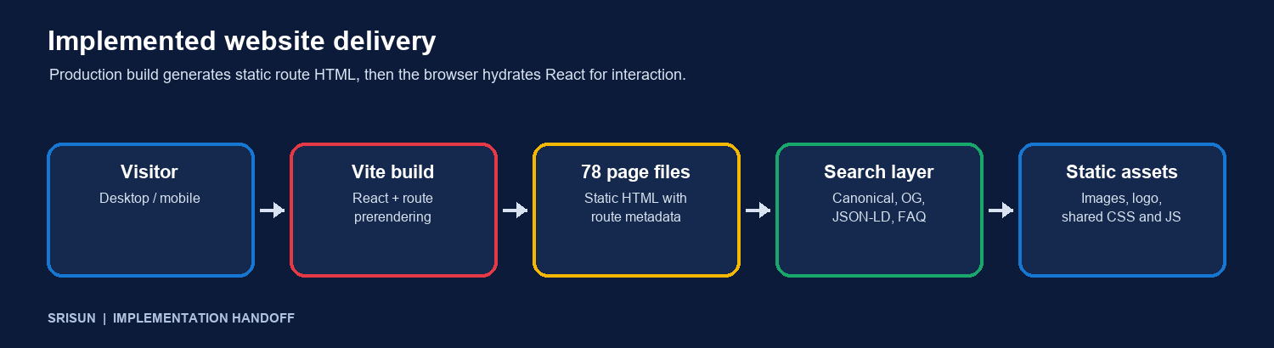
Implemented workspace structure after the production build.
Pages | Service, solution, industry, product, company, resource, client, career and contact routes.
Navigation | Desktop mega menu, mobile menu, footer, breadcrumbs and contextual page links.
Search | Site search route with client-side filtering; search pages are marked noindex.
Search metadata | Unique route title and description, canonical and Open Graph tags, Organization, WebSite and WebPage schema.
AEO content | Visible FAQs and matching FAQPage schema on appropriate non-policy content routes.
Index files | public/robots.txt and public/sitemap.xml; application and legal template routes are excluded from indexing.
The contact form opens an email draft. The career application form currently displays a preview status and does not send or store candidate data. The application process is not production-ready until it connects to an approved form service or backend.

Proposed Architecture
The code structure is ready for a production data and hosting layer selected by Srisun. Keep the current static route pages and connect verified content, secure form handling, analytics and domain hosting without publishing placeholder policy text.
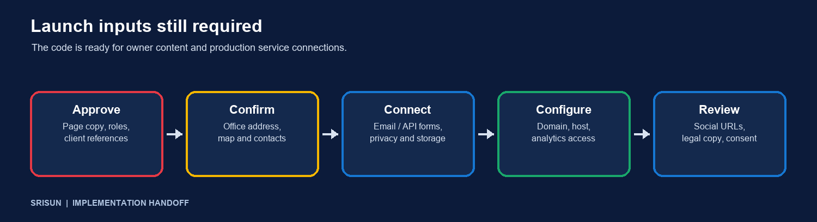
Owner inputs and integrations required before launch.
SEO, GEO and AEO implementation
• Search: route-specific titles and descriptions, canonical URLs, social metadata, robots rules, sitemap and prerendered page text are present. Verify indexed URLs and redirects after the selected host is configured.
• Generative search: company contact details and service descriptions are exposed as page content and Organization structured data. Confirm the office address and keep company facts consistent before adding location schema.
• Answer engines: visible page FAQs are paired with matching FAQPage data. Keep answers accurate when owners revise page copy; structured data cannot promise rich results or rankings.
• Legal route text is intentionally marked as awaiting approved copy and those pages are noindex. Supply formal wording before removing that status or adding them to the sitemap.
What the owner needs to provide
• Approved descriptions, features and availability for all services and products; confirm whether the six listed roles are genuinely open and provide actual qualifications and locations.
• Confirm the office address: the contact card says 606754 while the supplied embedded map refers to 606601. Verify the correct postal address and map pin.
• Approved customer stories, quotes and permission to publish client names, logos and images. Current client cards identify organizations but do not claim measurable outcomes.
• Official social profile URLs, legal policy text, business hours and the preferred sales and recruiting contact destinations.
• Production domain and hosting access, analytics and Search Console IDs, cookie or consent requirements, and the preferred form service or API.

Deployment Steps:
Use the following launch sequence. The generated dist directory is the static deployment artifact; the selected host must serve nested index.html files for each route and use HTTPS on the final domain.
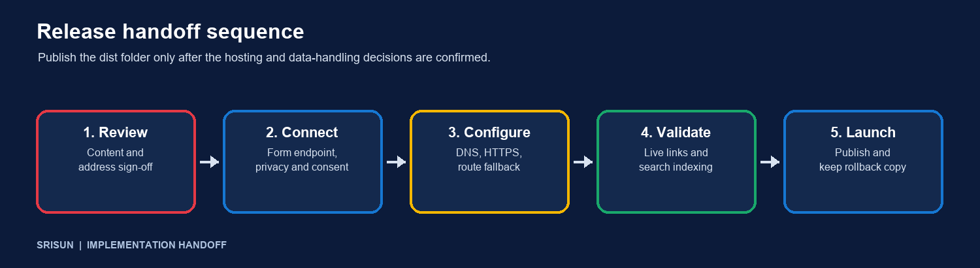
Release sequence after business approvals and access are available.
1. Approve content Review service, solution, industry and product copy; verify careers roles and locations; approve client references and the Srisun company description.
2. Resolve contact facts Confirm one office address and map pin, phone number, email address and hours. Update the contact page and structured data from the approved source.
3. Connect forms Choose a secure contact and recruiting destination. Implement server-side submission, spam protection, consent wording, file handling, retention and success or error feedback. Test without submitting real applicant data.
4. Supply policy and social details Provide approved legal policy copy and real social profile links. Keep policy pages noindex until their contents are reviewed.
5. Configure hosting Select the host, connect the domain and HTTPS, deploy dist, confirm nested route handling, and create redirects for any legacy URLs that must be preserved.
6. Configure measurement Add approved analytics and Search Console properties, consent behavior and ownership verification. Then submit the sitemap and check crawl/index reports.
7. Review and launch Review staging on desktop and mobile, follow every menu and footer link, submit test forms, inspect metadata and structured data, publish, then keep a rollback copy and check key routes.

Conclusion
The complete page and route foundation is implemented and the production build succeeds with 78 prerendered route documents. Srisun can move to staging after the owner confirms content, office details, form handling, hosting and measurement access.
Remaining work is limited to those approvals and integrations, plus review of the live deployment. SEO, GEO and AEO foundations are in place; search visibility depends on accurate ongoing content, indexing and the competitive environment.

