**Exercise 1: Implementing the Singleton Pattern**

**Logger.java**

public class Logger {

private static Logger instance;

private Logger() {

System.out.println("Logger instance created.");

}

public static Logger getInstance() {

if (instance == null) {

instance = new Logger();

}

return instance;

}

public void log(String message) {

System.out.println("[LOG]: " + message);

}

}

**LoggerTest.java**

public class LoggerTest {

public static void main(String[] args) {

Logger logger1 = Logger.getInstance();

logger1.log("This is the first log.");

Logger logger2 = Logger.getInstance();

logger2.log("This is the second log.");

System.out.println(logger1 == logger2 ? "Same instance" : "Different instances");

}

}

**Output:**

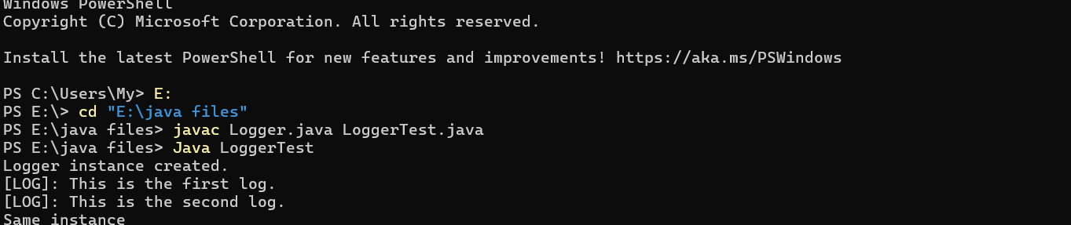

**Exercise 2: Implementing the Factory Method Pattern**

**Document.java**

public interface Document {

void open();

}

**DocumentFactory.java**

public abstract class DocumentFactory {

public abstract Document createDocument();

}

**ExcelDocument.java**

public class ExcelDocument implements Document {

public void open() {

System.out.println("Opening Excel document...");

}

}

**ExcelDocumentFactory.java**

public class ExcelDocumentFactory extends DocumentFactory {

public Document createDocument() {

return new ExcelDocument();

}

}

**FactoryMethodTest.java**

public class FactoryTest {

public static void main(String[] args) {

DocumentFactory wordFactory = new WordDocumentFactory();

Document word = wordFactory.createDocument();

word.open();

DocumentFactory pdfFactory = new PdfDocumentFactory();

Document pdf = pdfFactory.createDocument();

pdf.open();

DocumentFactory excelFactory = new ExcelDocumentFactory();

Document excel = excelFactory.createDocument();

excel.open();

}

}

**PdfDocument.java**

public class PdfDocument implements Document {

public void open() {

System.out.println("Opening PDF document...");

}

}

**PdfDocumentFactory.java**

public class PdfDocumentFactory extends DocumentFactory {

public Document createDocument() {

return new PdfDocument();

}

}

**WordDocument.java**

public class WordDocument implements Document {

public void open() {

System.out.println("Opening Word document...");

}

}

**WordDocumentFactory.java**

public class WordDocumentFactory extends DocumentFactory {

public Document createDocument() {

return new WordDocument();

}

}

**Output:**

