ME614 Computational Fluid Dynamics

Homework 1

-Srinath Tankasala

Problem 1

We evaluate the numerical approximation by analysing truncation error as dx->0. Seeing the trend followed by the truncation will give us the order of our numerical approximation. We compare different schemes, Centered, staggered and with biased, central in each. It comes to a total of 12 combinations. We note that the extremely biased schemes give anomalous spikes at certain points. Also, all the graphs flatten at machine precision ~ 10-16. It varies from machine to machine.

Centered scheme:- comparing staggered vs collocated

l=r=1, 2nd order accuracy

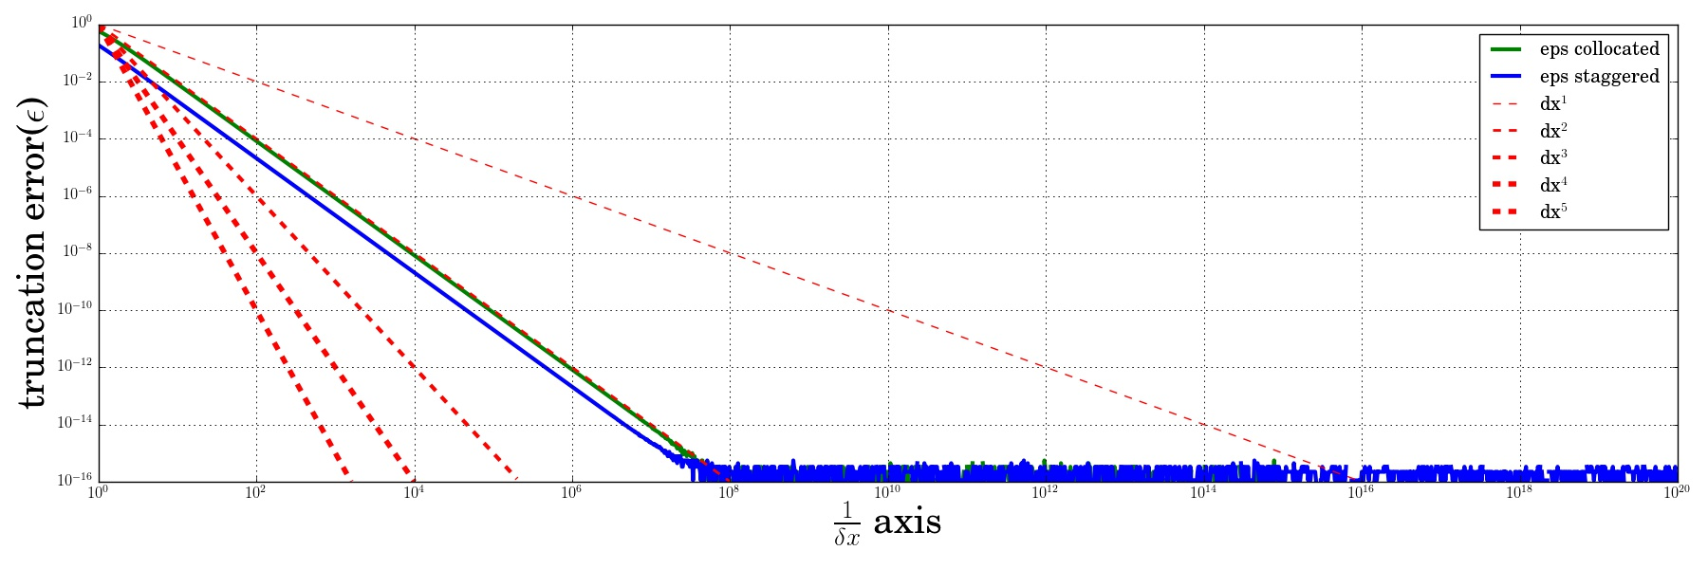

l=r=2, 4th order accuracy

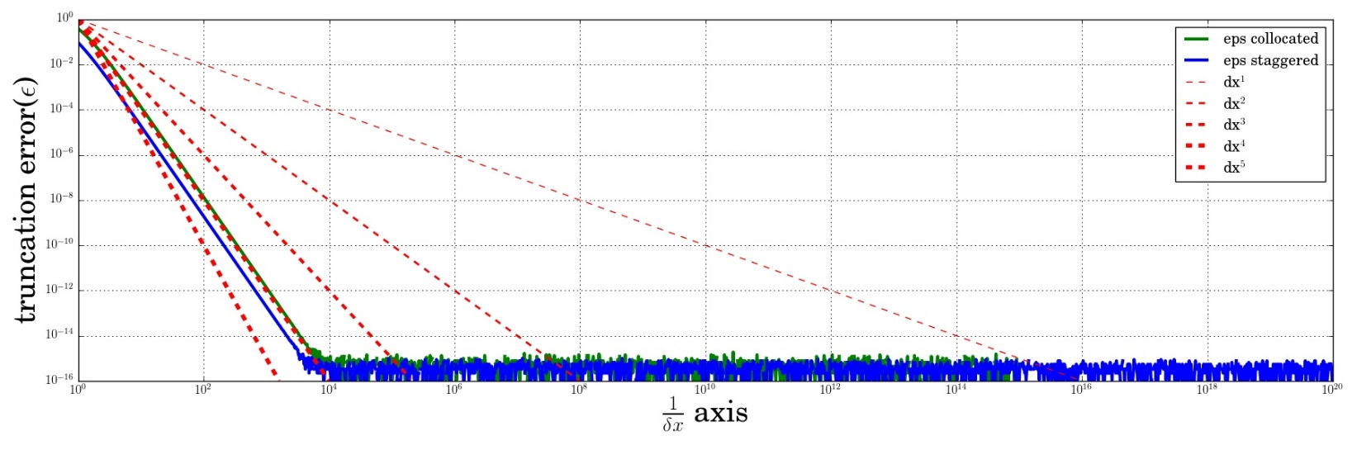

l=r=3, 5th order accuracy

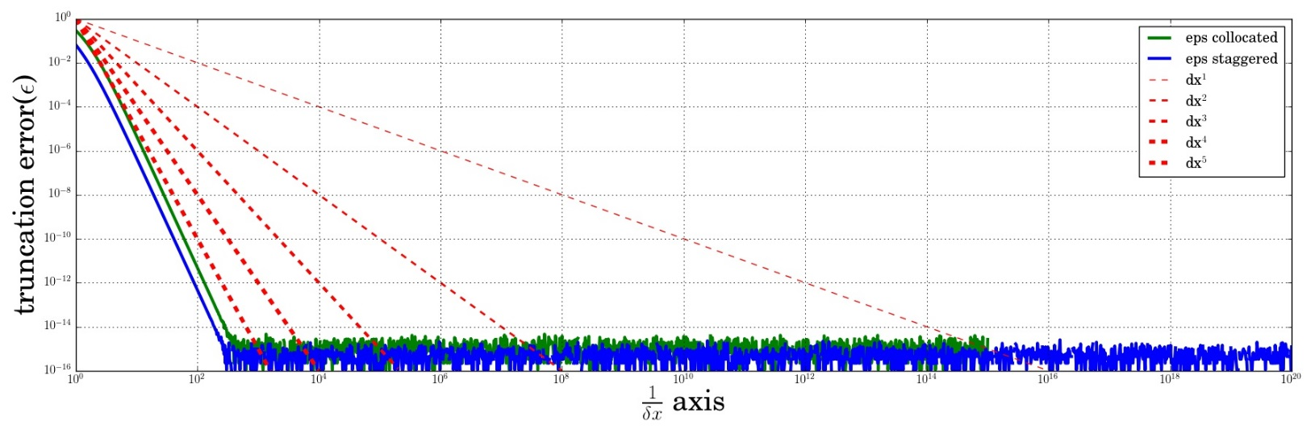

BIASED SCHEME, Collocated vs Staggered

Staggered->l=r=1,

Collocated->l=0,r=1,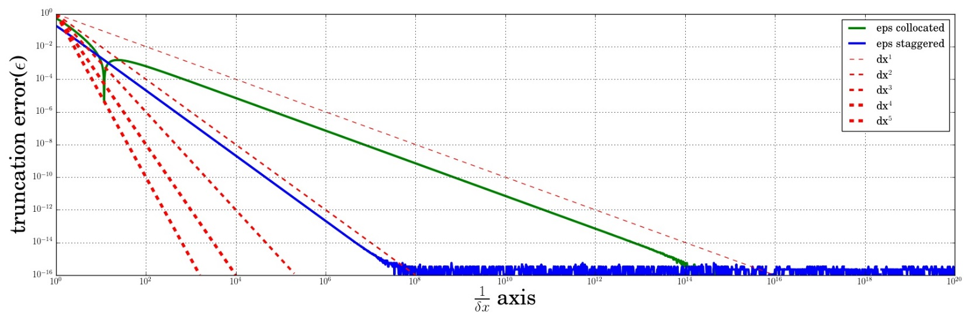

Staggered->l=1,r=2

Collocated->l=0,r=2,

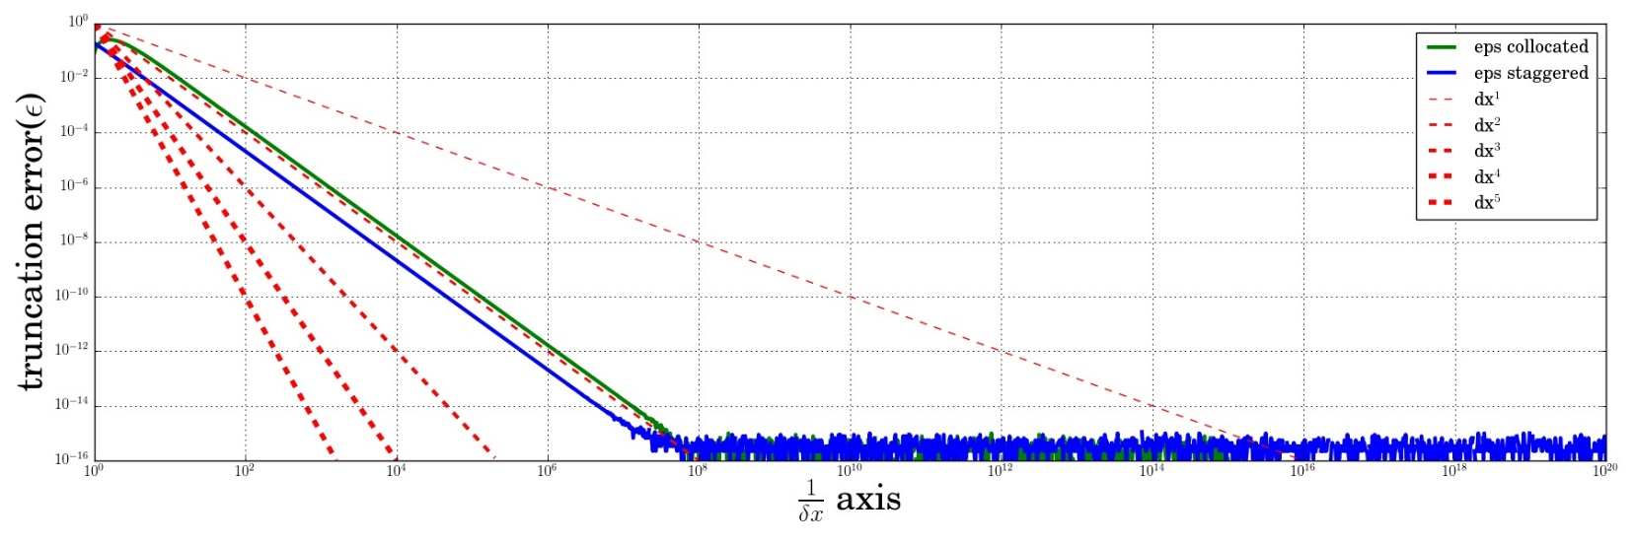

Staggered->l=1,r=3

Collocated->l=0,r=3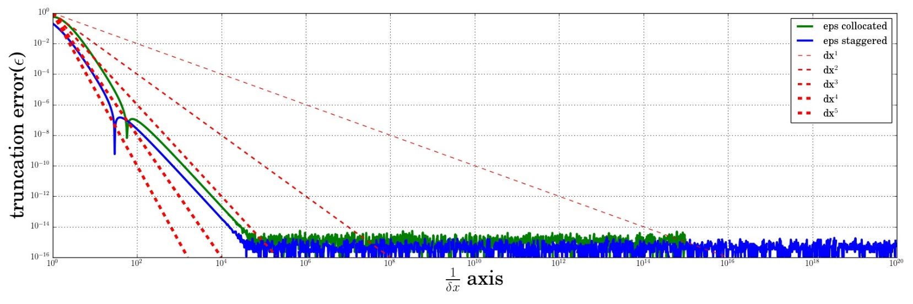

STAGGERED,

Centered vs biased

L=1;r=1 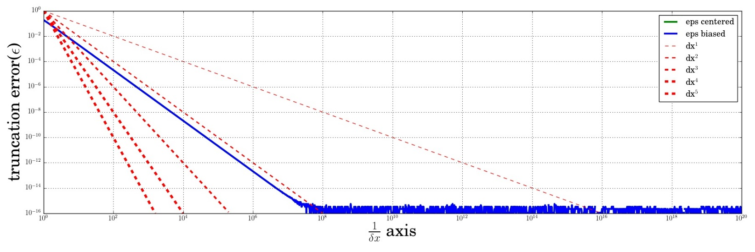

L=r=2 vs l=1,r=2

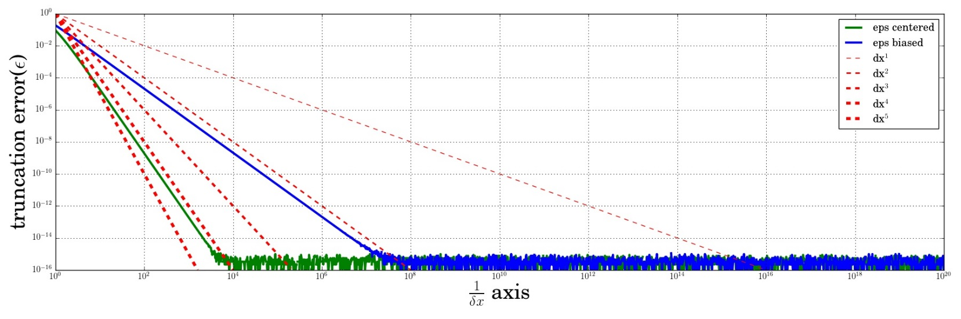

l=r=3 vs l=1,r=3

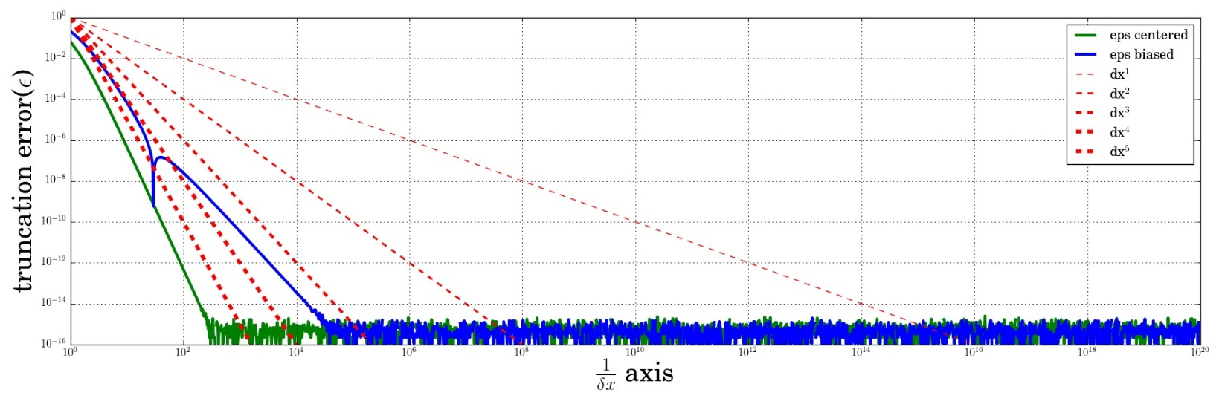

COLLOCATED:- Centered vs Biased

L=r=1 vs l=0,r=1

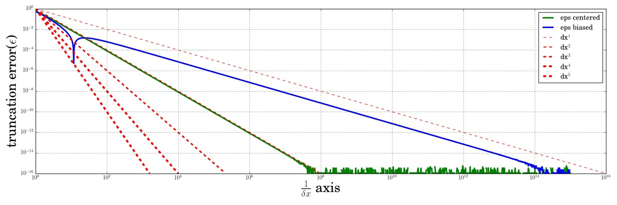

L=r=2 vs l=0, r=2

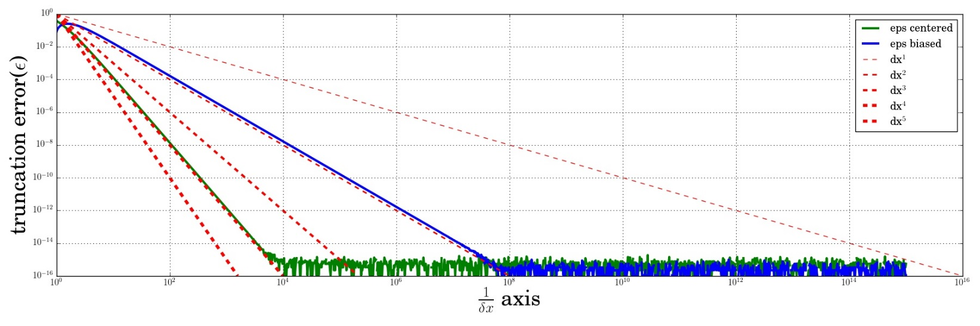

L=r=3 vs l=0,r=3

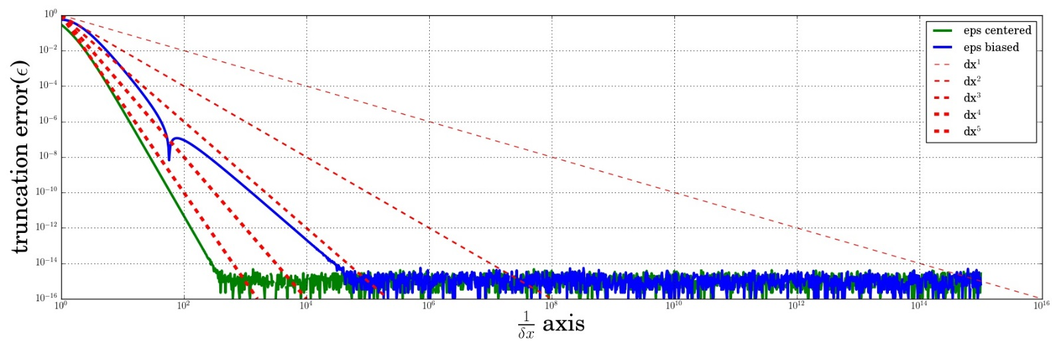

Q1b. Clearly from the above graphs we see that the order of the polynomial interpolant is NOT equal to the order of accuracy. This can be seen in the case of collocated grid, l=r=3. The polynomial is 6th order but the accuracy is 5th. We can see this more clearly when we use the Taylor expansion. When we get the corresponding weights from the polynomial function and plug it into the Taylor series we can see the order of accuracy will be lower than the order of the polynomial.

PROBLEM 2

Q2a

The spy plots of the respective derivatives are present below. I have used a 3rd and 5th order polynomial interpolant. Since I use a staggered stencil I need l=r=2 for 3rd order interpolant and l=r=3 for 5th order interpolant. There are N-1=9 rows and 10 columns. We bias the derivative at the boundaries. The same 4 or 6 points are chosen for the polynomial interpolation. However the derivative is evaluated at different x_eval and the difference arises there. For the 3rd order polynomial the 3rd derivative is constant at point 1,2 and at N-2,N-1. Note the symmetric structure of the matrix is due to the choice of a staggered stencil.

Spy plot for 3rd order 1st derivative:



Spy plot for 3rd order 3rd derivative:



Spy plot for 5th order 1st derivative:



Spy plot for 5th order 3rd derivative:



Q2b.

f(x) = sin(x); x0=0; x1=π;

We plot the RMS of the truncation error over all points. Number of points

We use a staggered grid with 3rd order polynomial interpolation. We obtain the structure as seen above. Note that for operator D3, row1 and row 2 are identical. Also row N-2 and row N-3 are identical => rank(D3) = N-1-2 = N-3.

To make it full rank add the 3 boundary conditions. Therefore 1st row as D3(1,1)=1 and RHS is x0 correspondingly. The 2nd row is the same as the first row of D1(1st derivative, 3rd order). The last row of D3 and D1 are identical. We frame the rhs matrix in the same way i.e. b=[x0;f’(x0+dx/2);f’’’(x);f’(x1-dx/2)]

3rd order polynomial interpolation solution(Staggered):

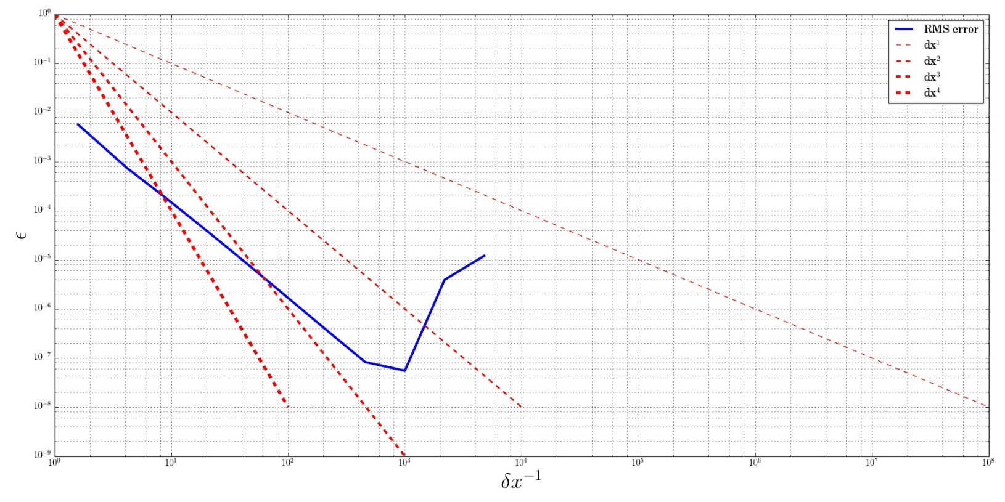

5th order polynomial interpolation solution(Staggered):

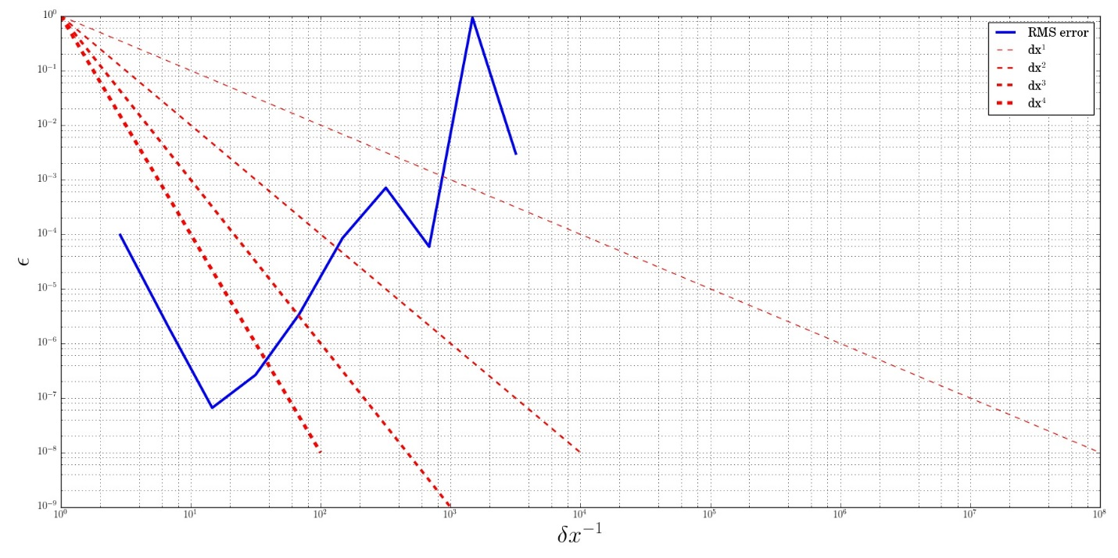

PROBLEM 3

Analytical derivation of 5th order Pade scheme from Taylor series:

Manipulating above eqs. gives:

This gives us L and R. The LHS of above equation is known as f’’’(x) = -cos(x). We also know that f’(x)=cos(x). We use the 3 boundary conditions at the boundaries. We also bias the Pade scheme at end points.

We obtain a 1st order accurate scheme instead of a 5th order. This can be attributed to the biasing we do at the ends.

