Cloned the bootcamp10 project and connected to docker hub

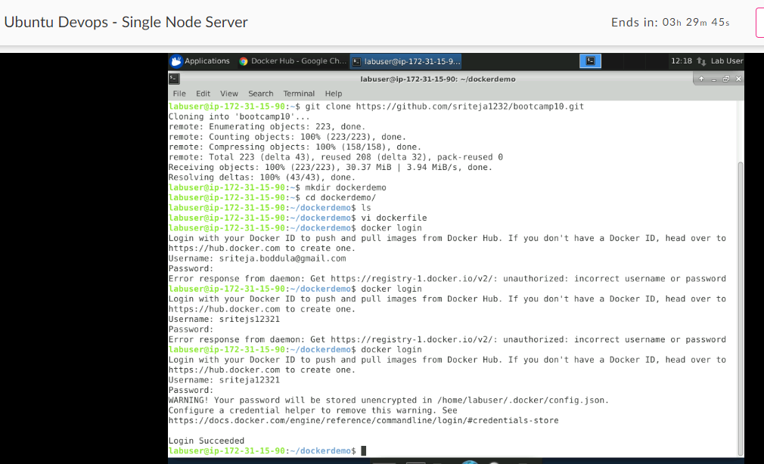

1. Write a docker file to create a docker image for the application using nginx as the base image.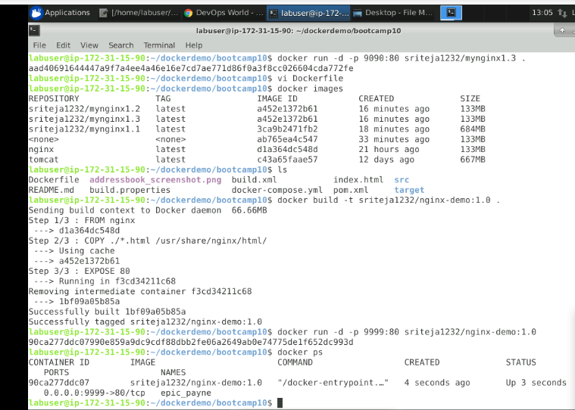

Docker file content:

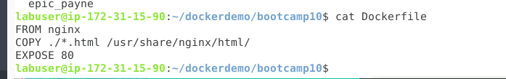

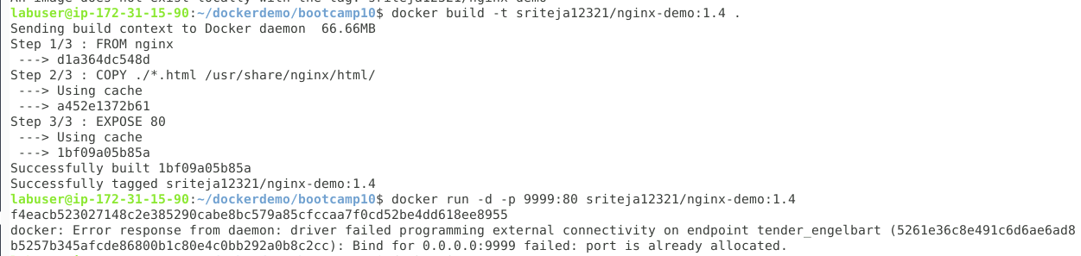

2) Push the docker image to the docker hub.

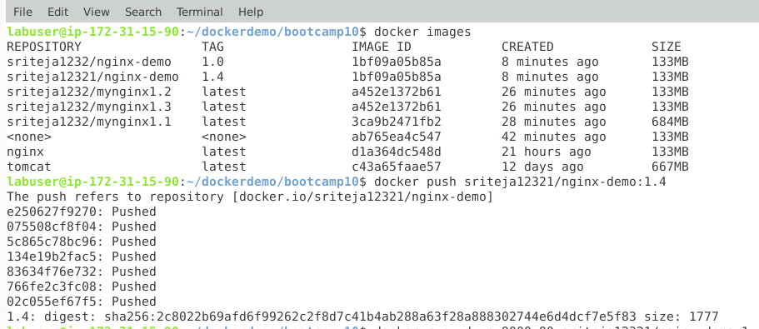  
Docker hub :

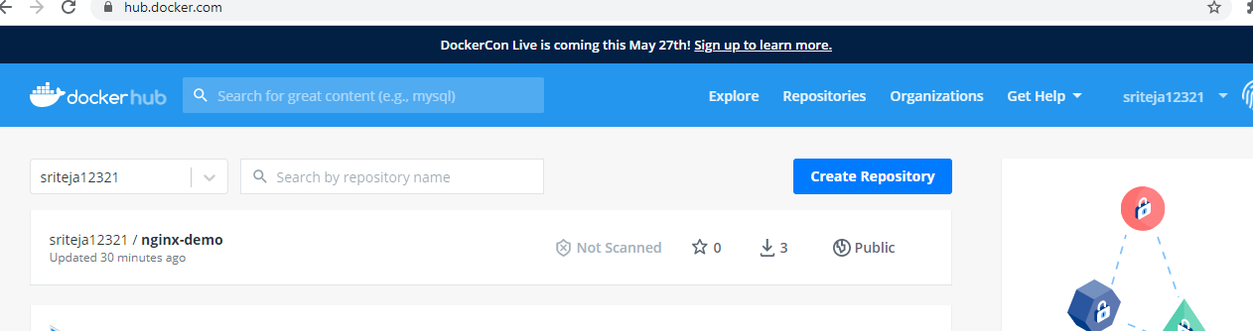

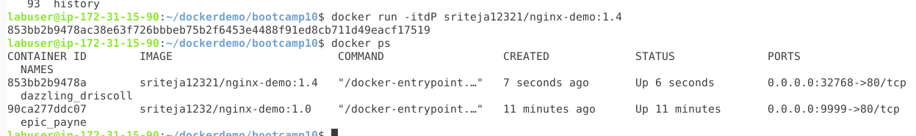

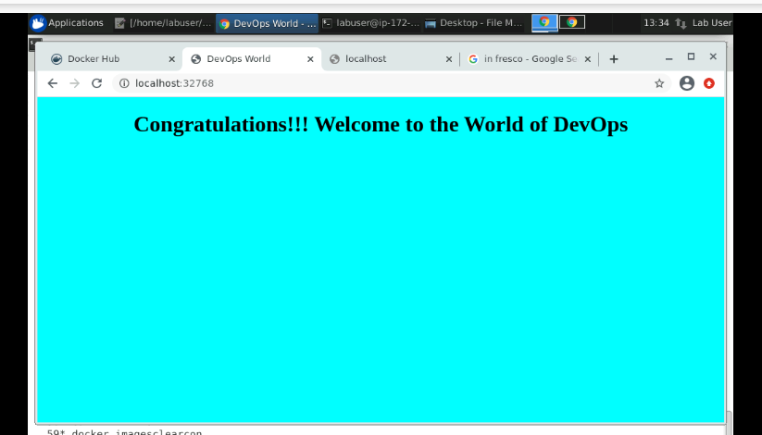

3) Pull and Run the docker containers on any remote instance.

Pulled into another instance on GCP and ran it.

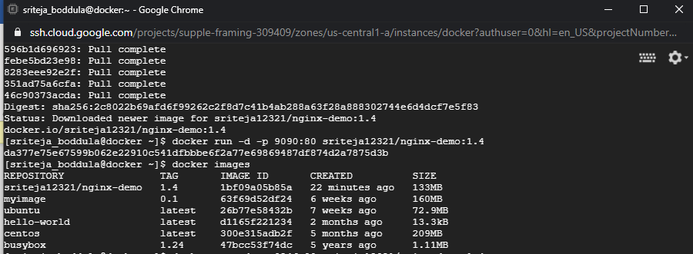

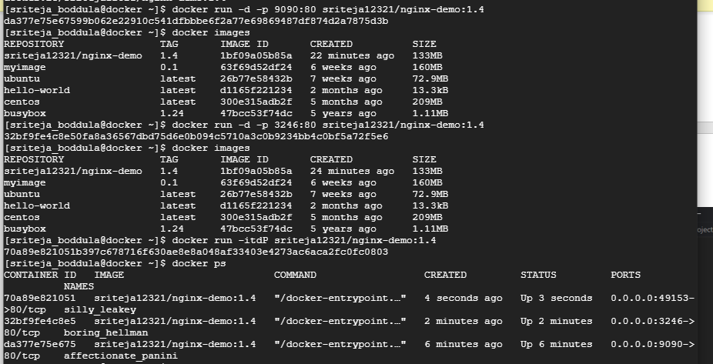

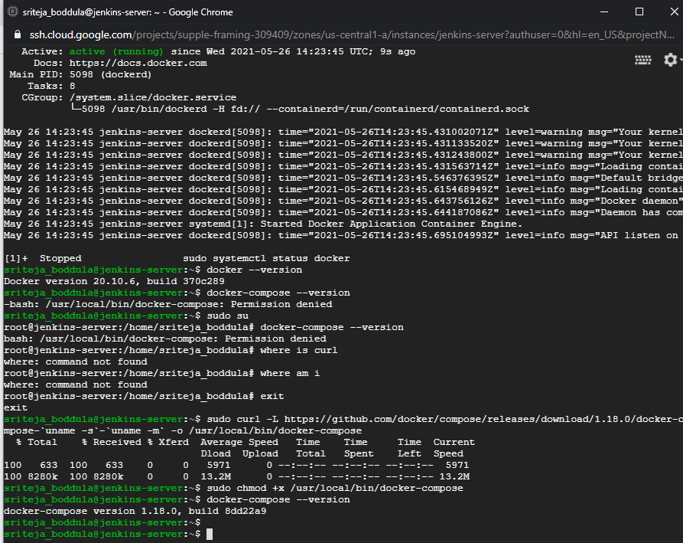

4)Access the application from the browser using appropriate url and port.

Login to 2nd instance IP and port 9090

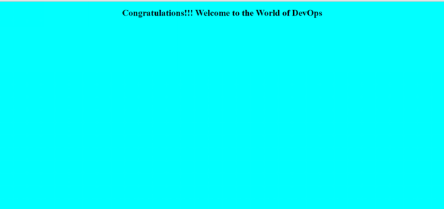

**Docker - compose**

1) Write yml file to run the above application container along with a mysql database container together.

Installed docker-compose in the gcp vm instance.

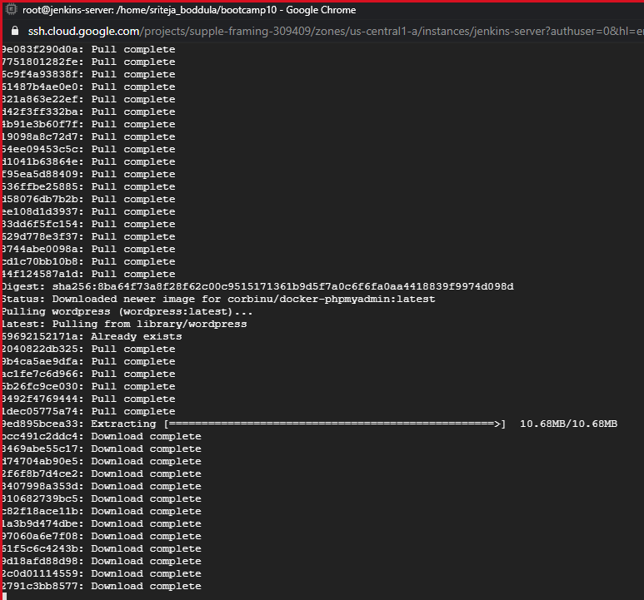

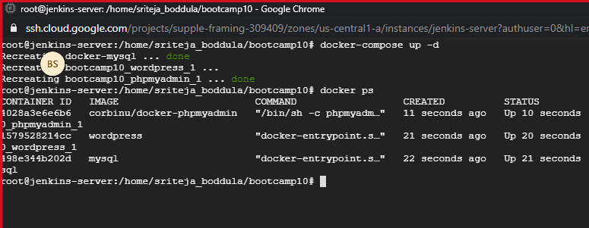

Docker-compose.yaml file:

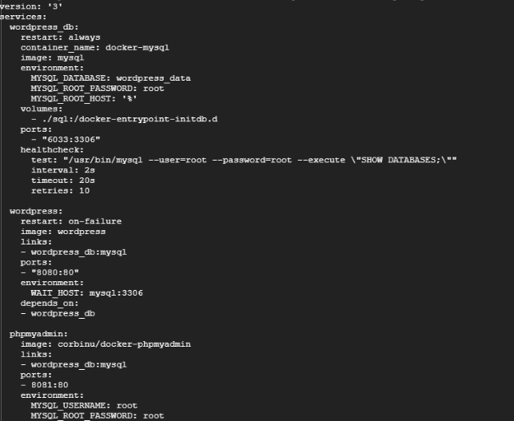

Php admin homepage:

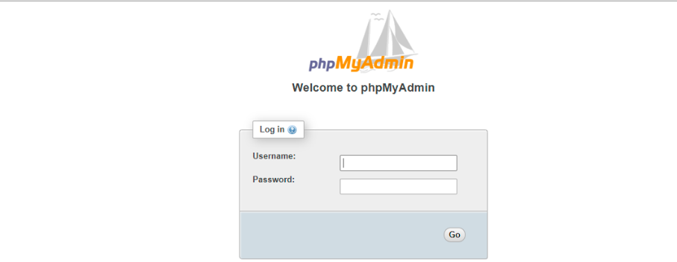

Wordpress homepage:

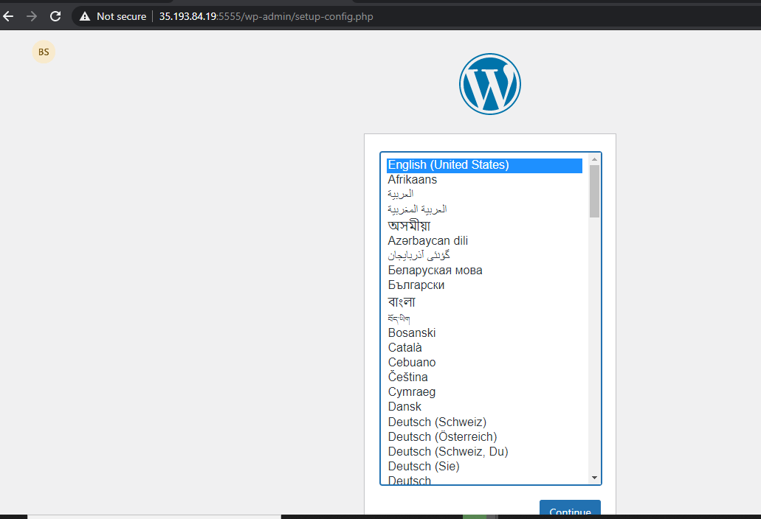

2) Connect to mysql database container in the -it mode and create a table named test having id, name and age as attributes.

