Created two nodes Master-node and Slave-node in AWS EC2:

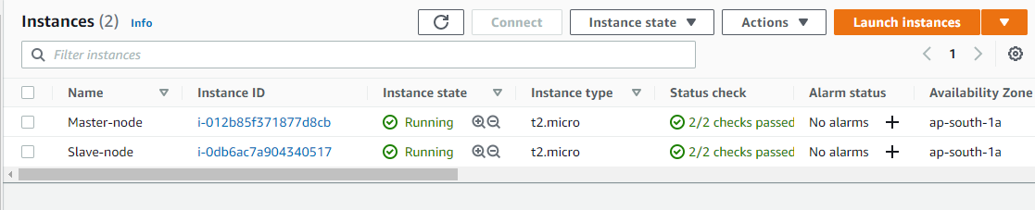

Configuring Master node for password-less authentication with slave node

* SSH into Master Node

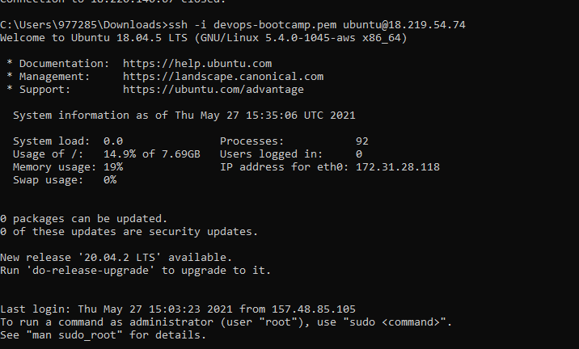

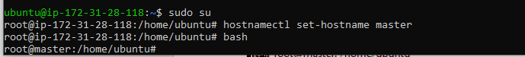

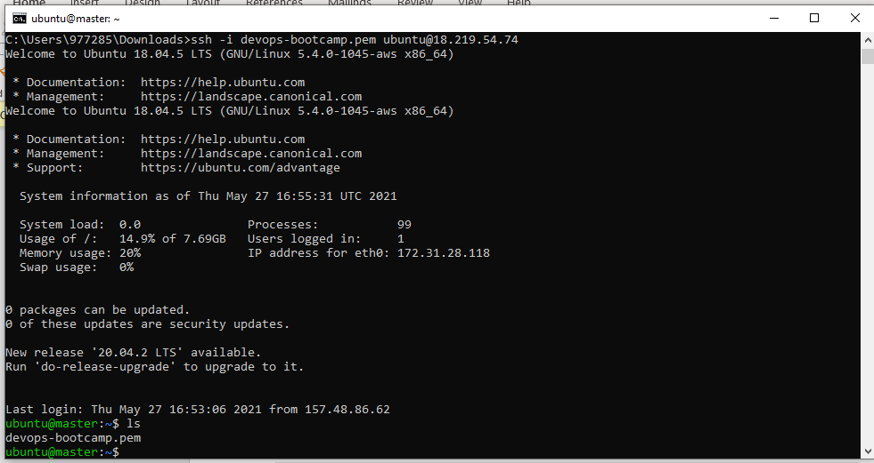

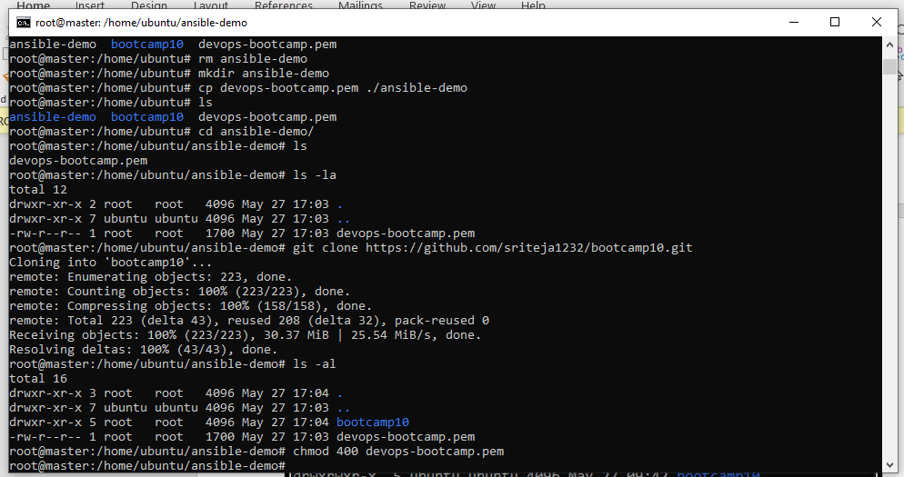

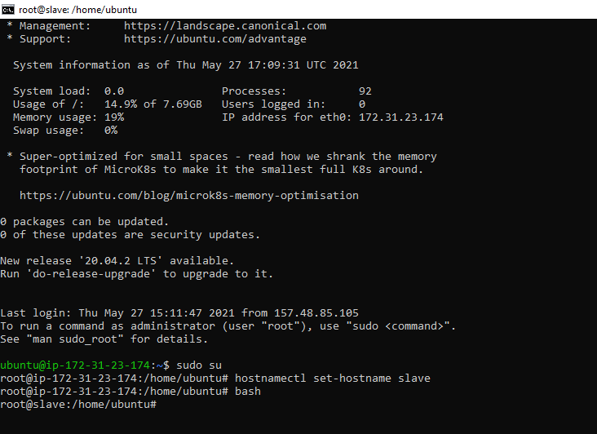

Step 3: Install Ansible on Master Node

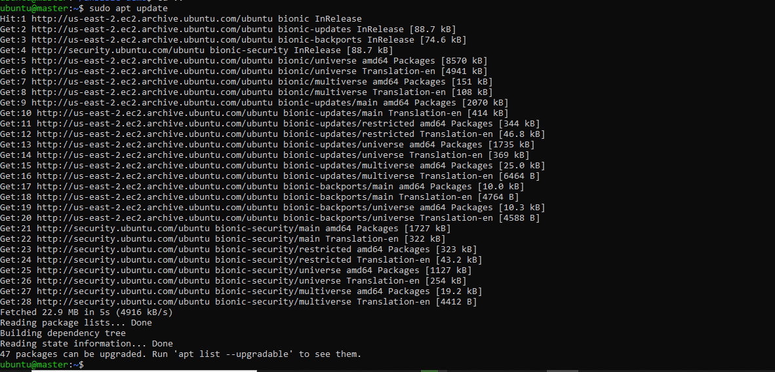

Ansible version:

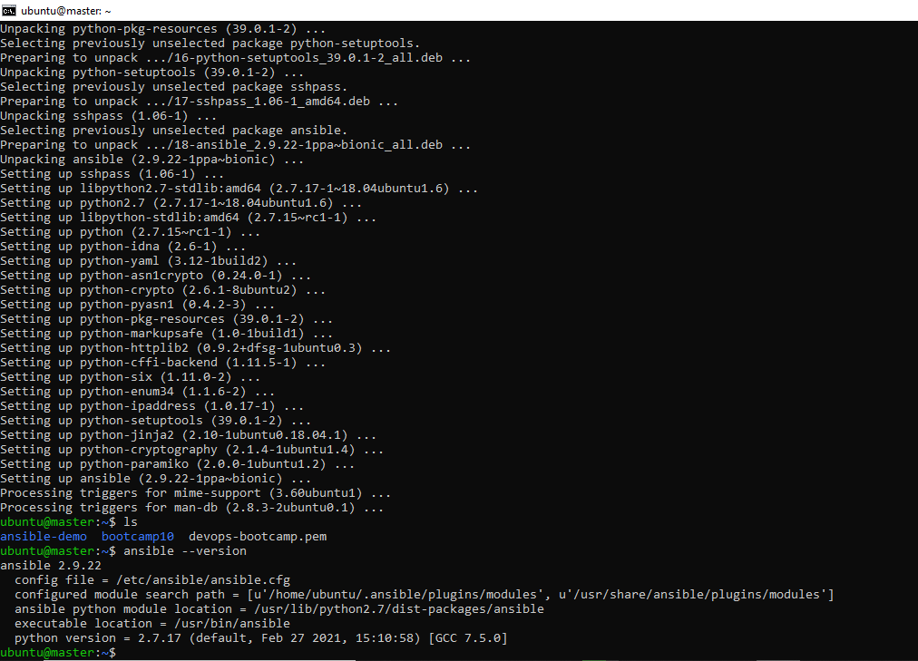

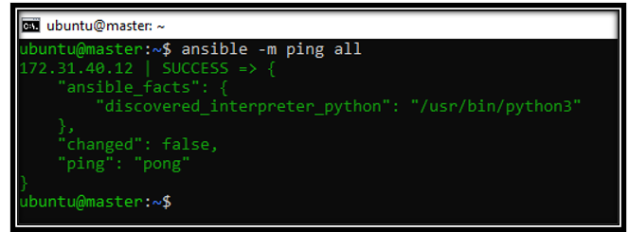

Step 4: Install software on slave

* Assignment-playbook.yml to install **java, maven, nginx and docker** on slave node
* Starting docker service

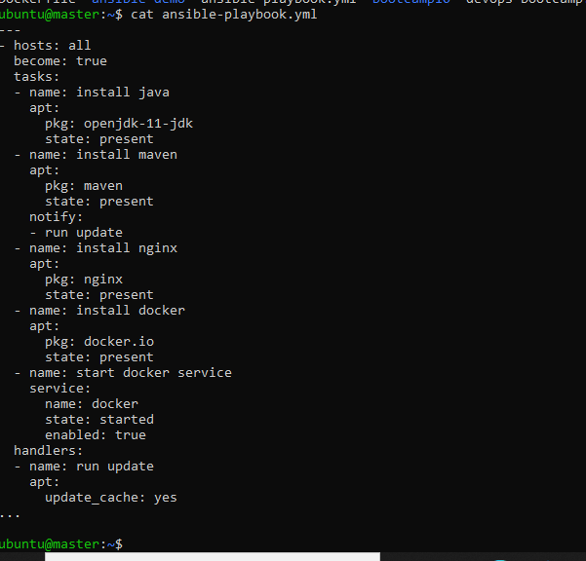

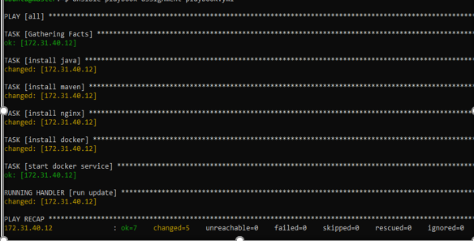

* Checking versions of Java, Maven, nginx and docker software in slave node

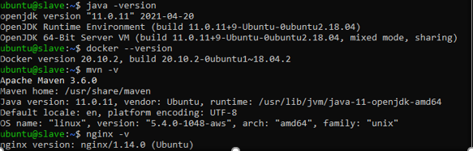

Step 5

* Cloning war-test repo into master node

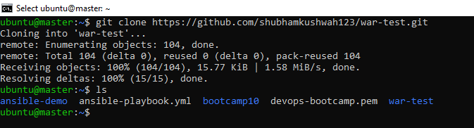

* Creating a war file by running **$mvn clean package**

Build success

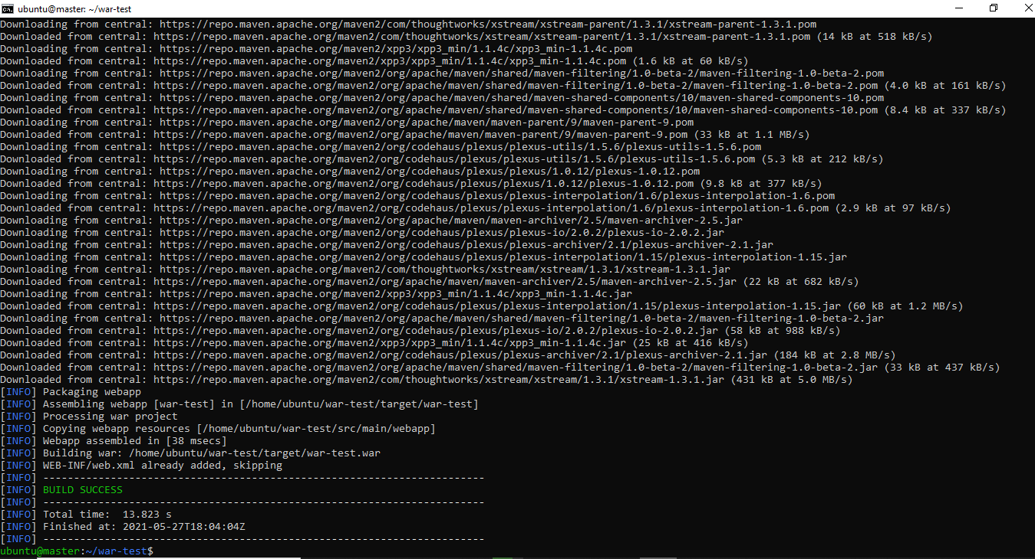

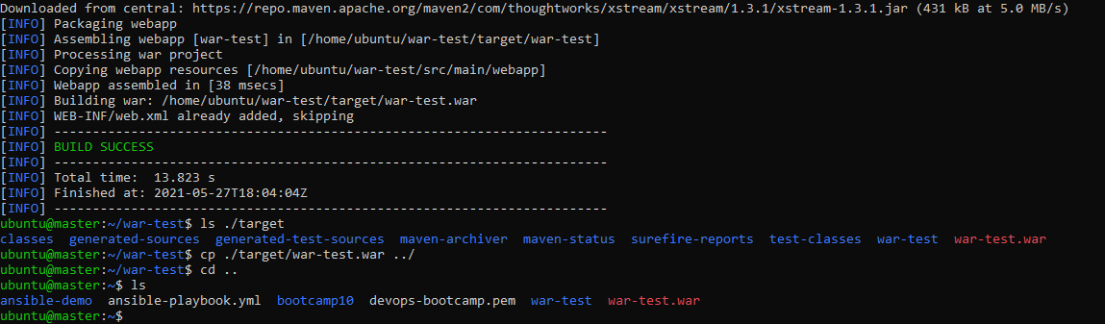

* Building up Dockerfile to create Docker Image

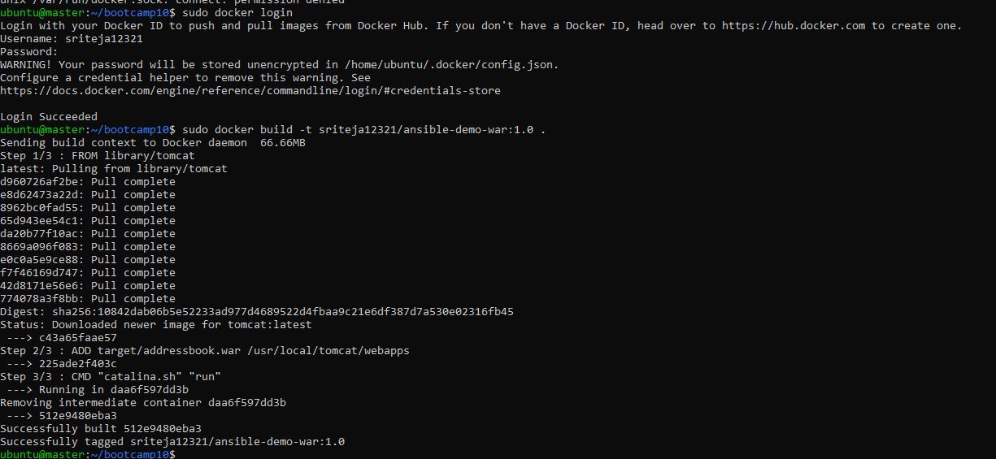

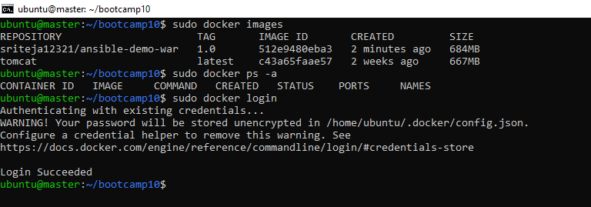

Pushed to Dockerhub:

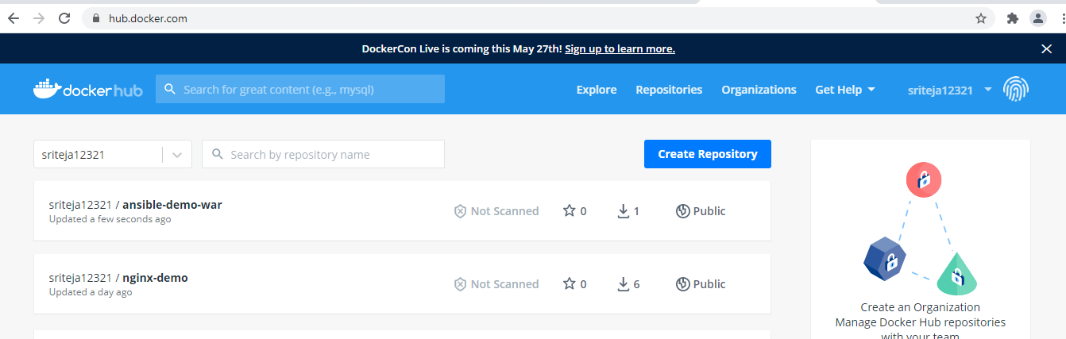

* Modified ansible-playbook.yml for deploying war application in docker container running on Slave node

