STUDENT CRUD USING ANGULAR AND SPRING BOOT

**INSERT OPERATION**

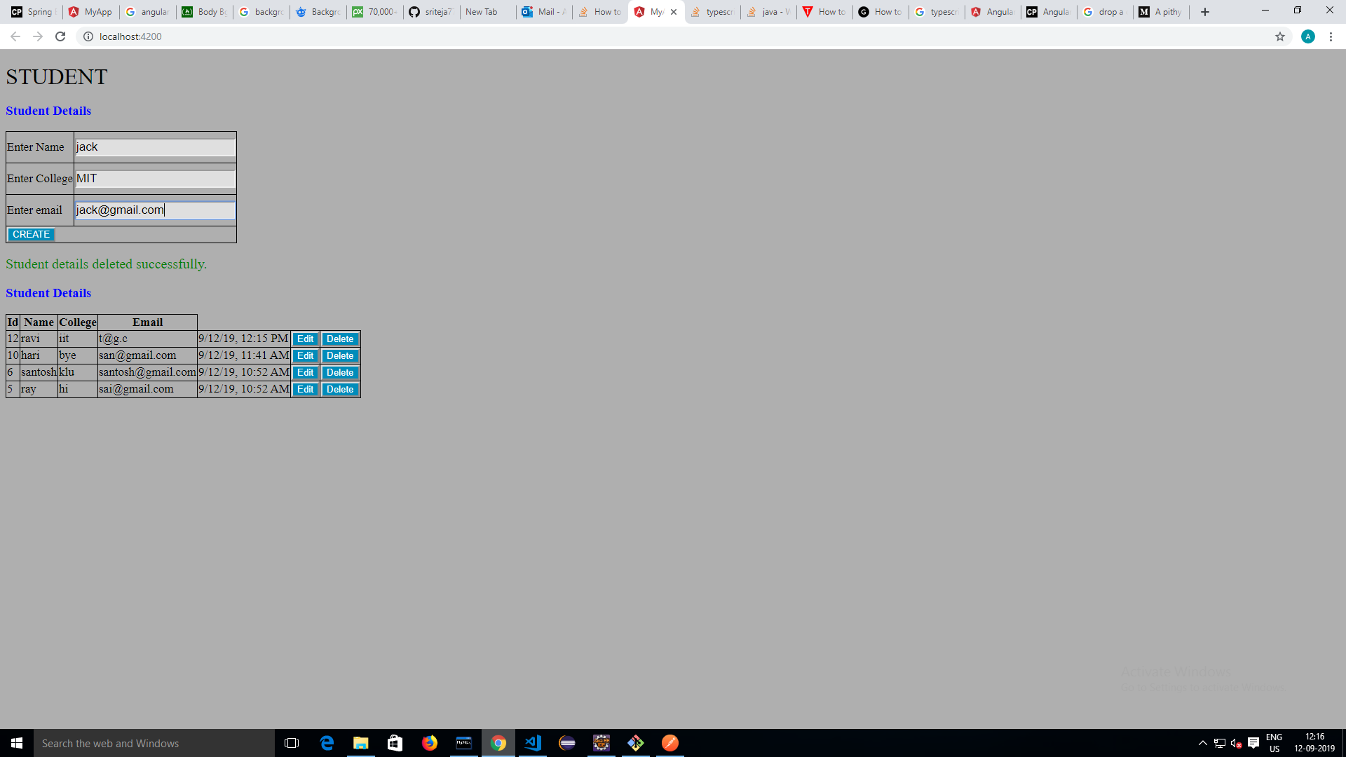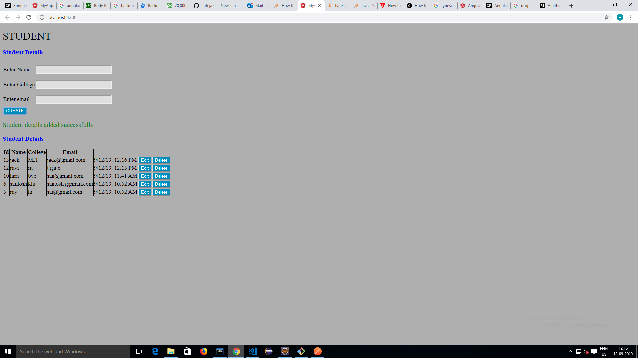

**UPDATE OPERATION:**

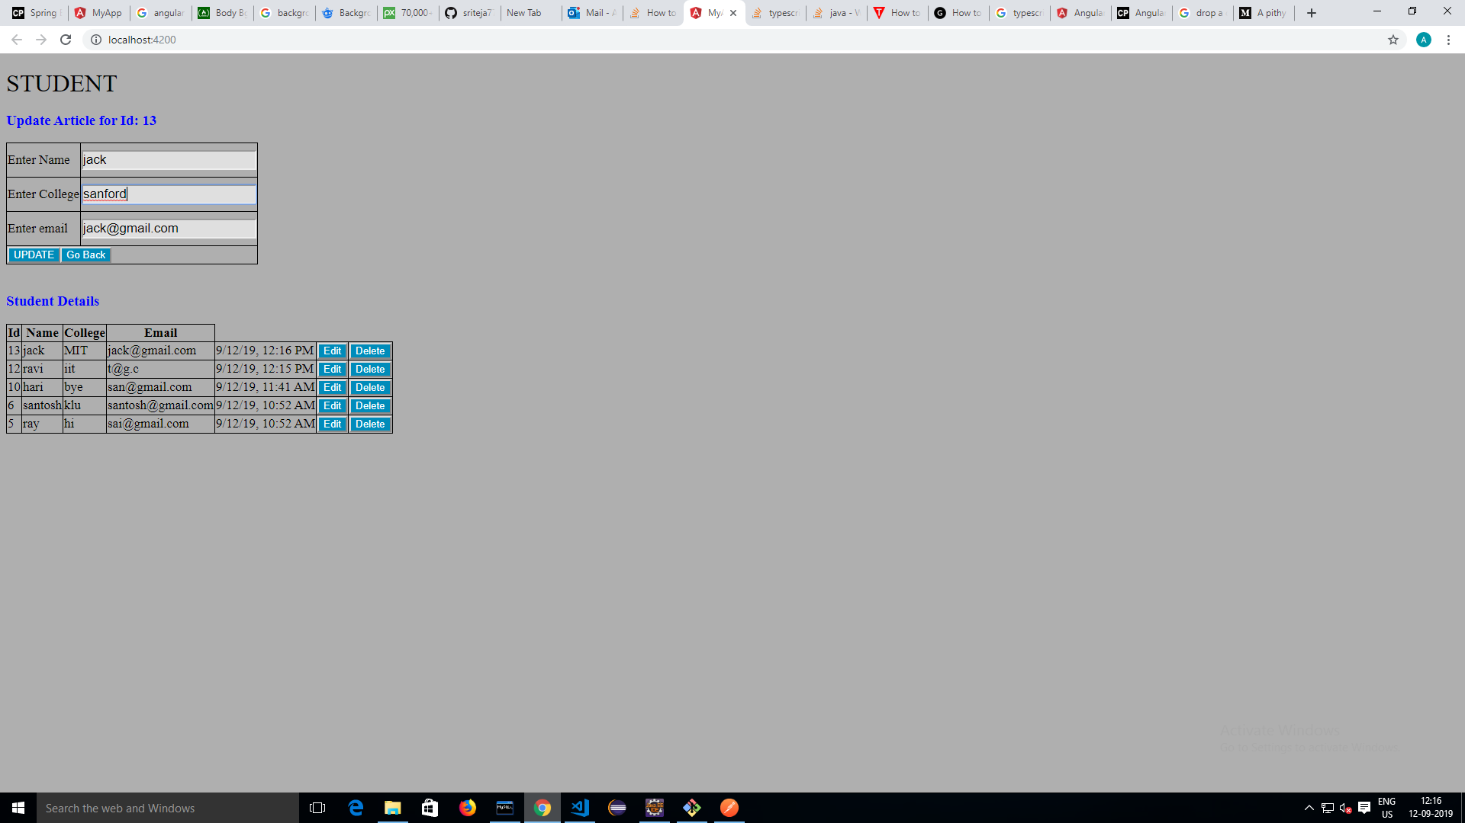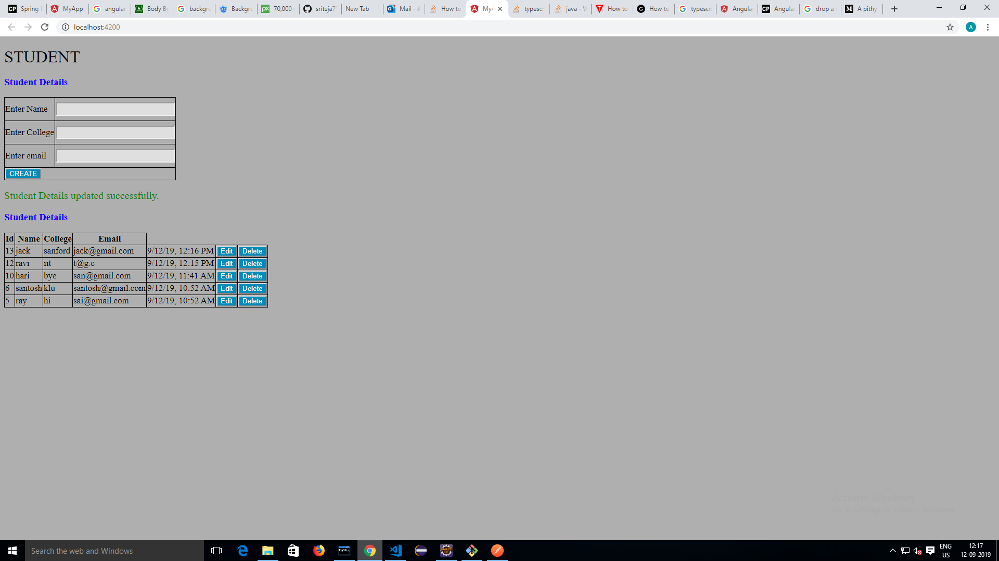

**DELETE OPERATION:**

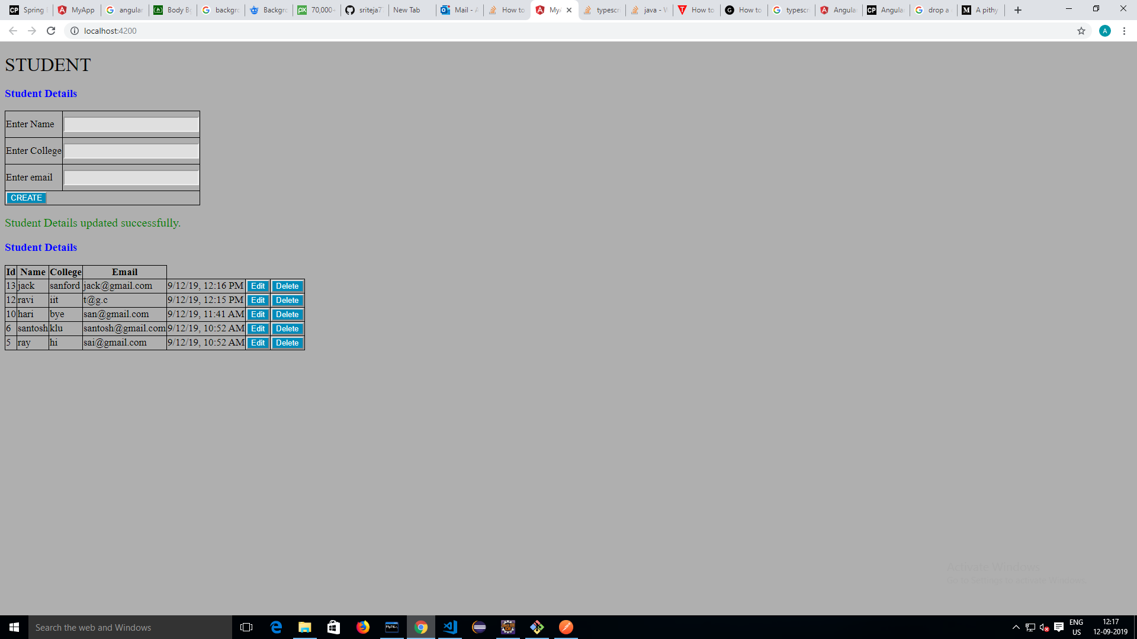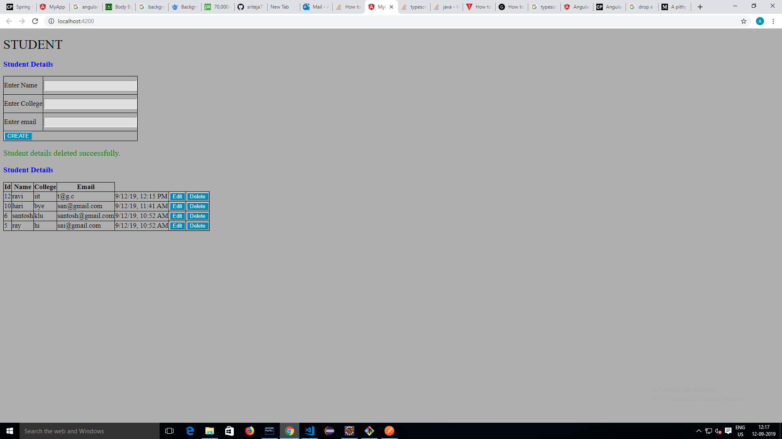

**STUDENT BEAN CLASS:**

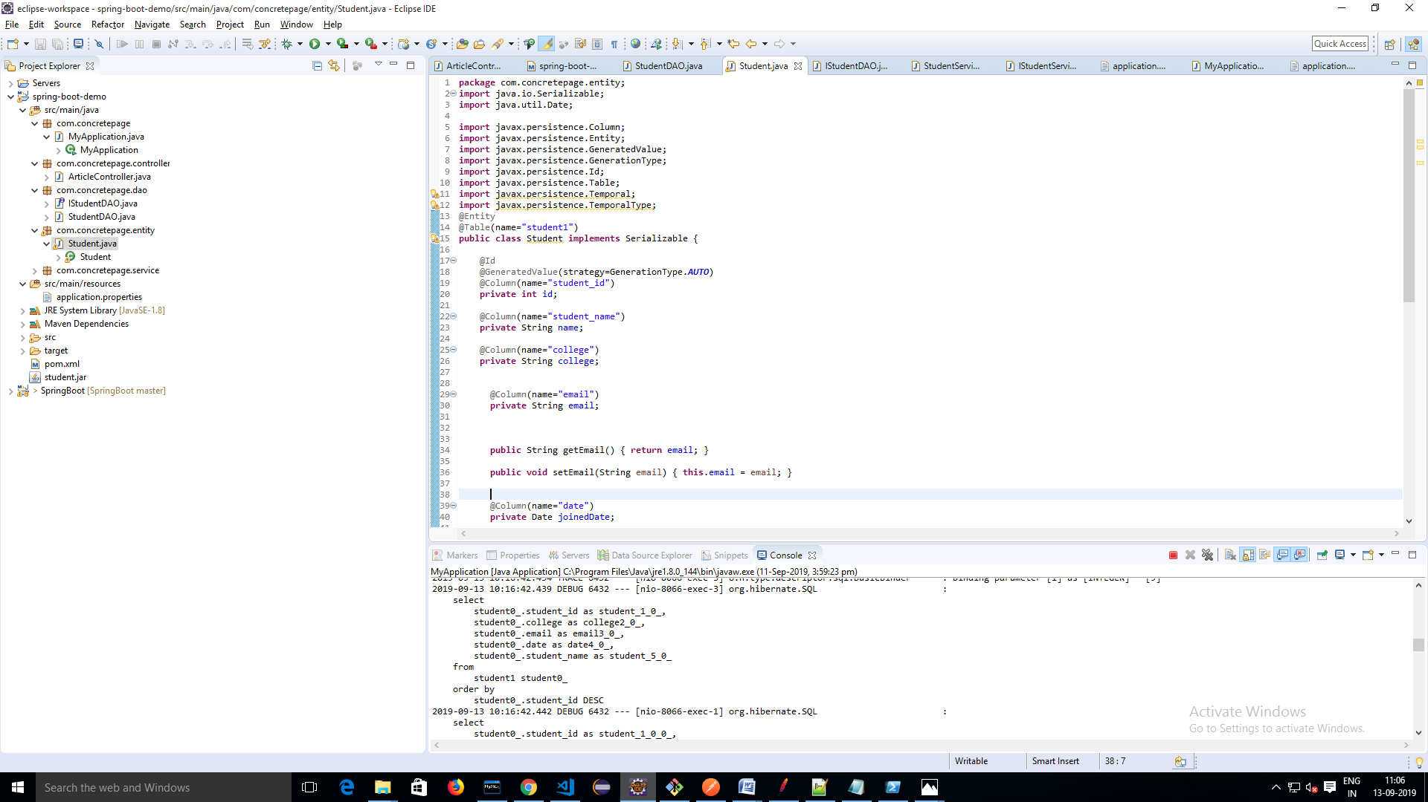

**STUDENT TABLE**

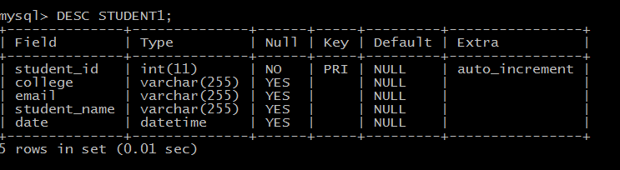

**POSTMAN IMPLEMENTATION:**

GET OPERATION :TO RETRIEVE ALL STUDENT RECORDS

http://localhost:8066/user/all-article

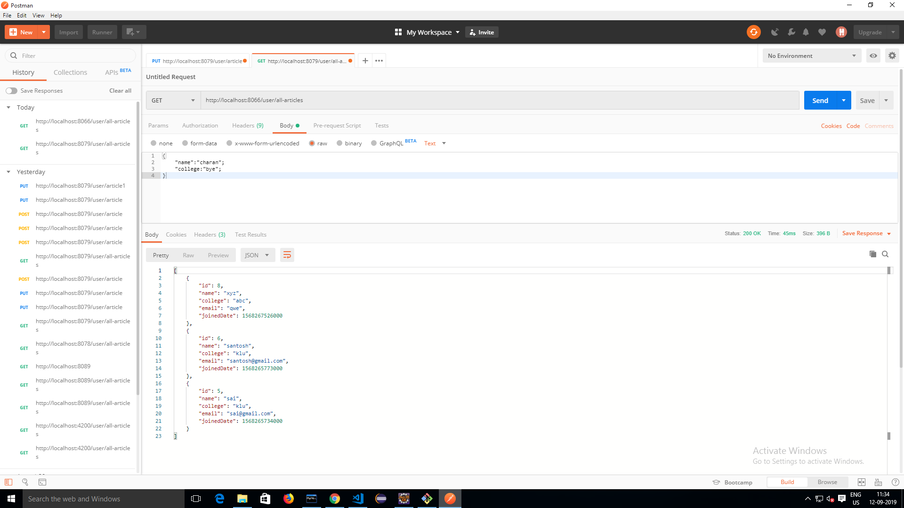

POST OPERATION :TO INSERT DATA

http://localhost:8066/user/article

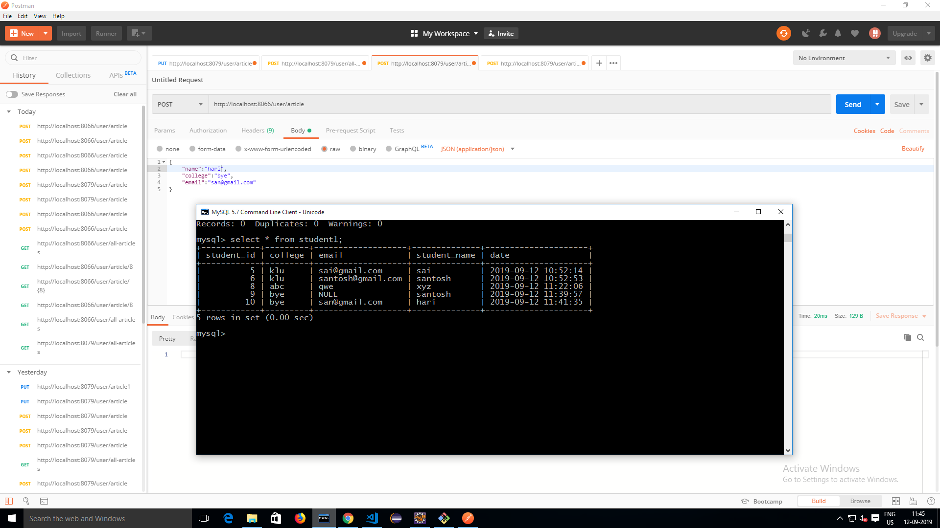

GET OPERATION:TO RETREIVE BY ID

http://localhost:8066/user/article?id=9

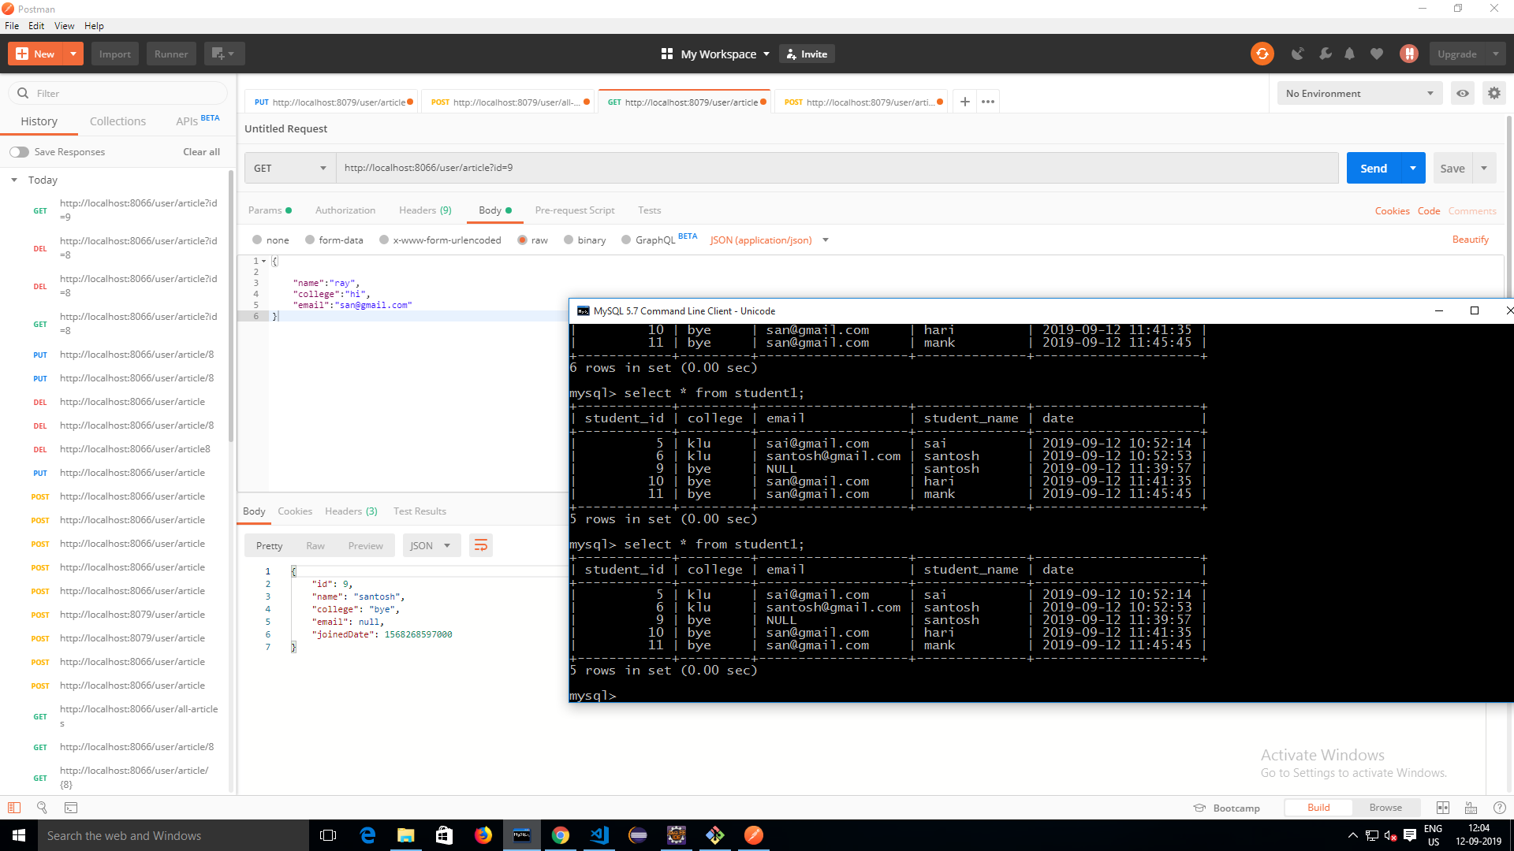

PUT OPERATION: TO EDIT STUDENT RECORD

http://localhost:8066/user/article

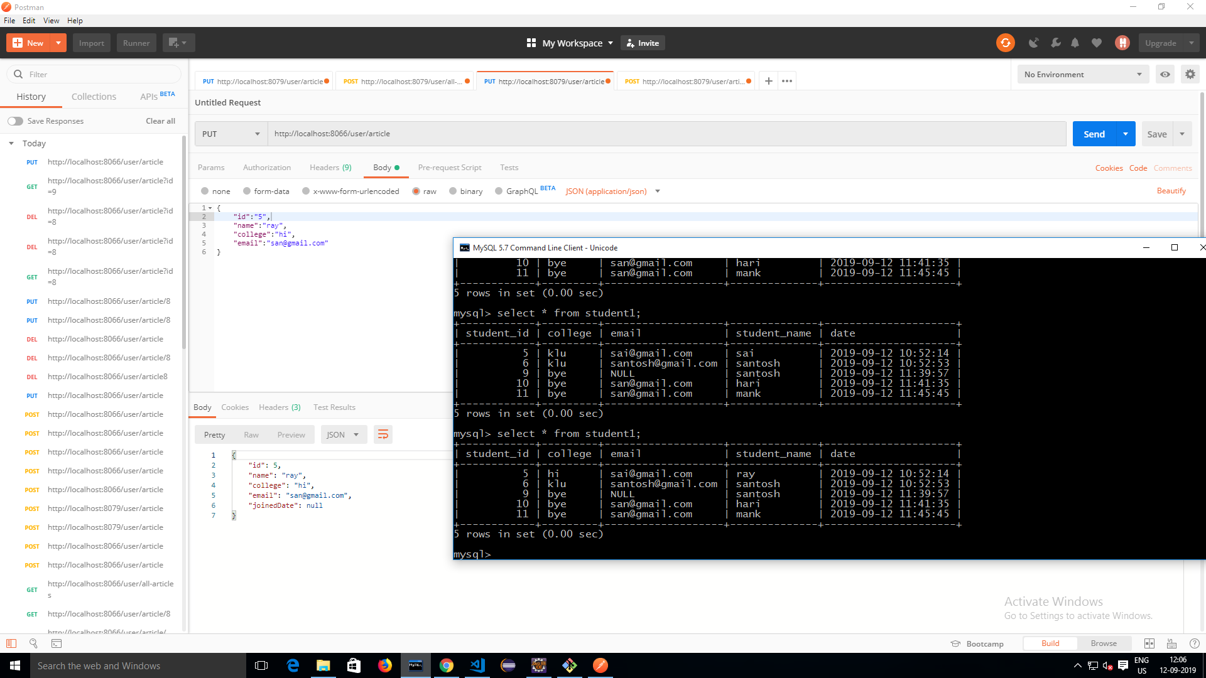

DELETE OPERATION TO DELETE STUDENT RECORD:

http://localhost:8066/user/article?id=8

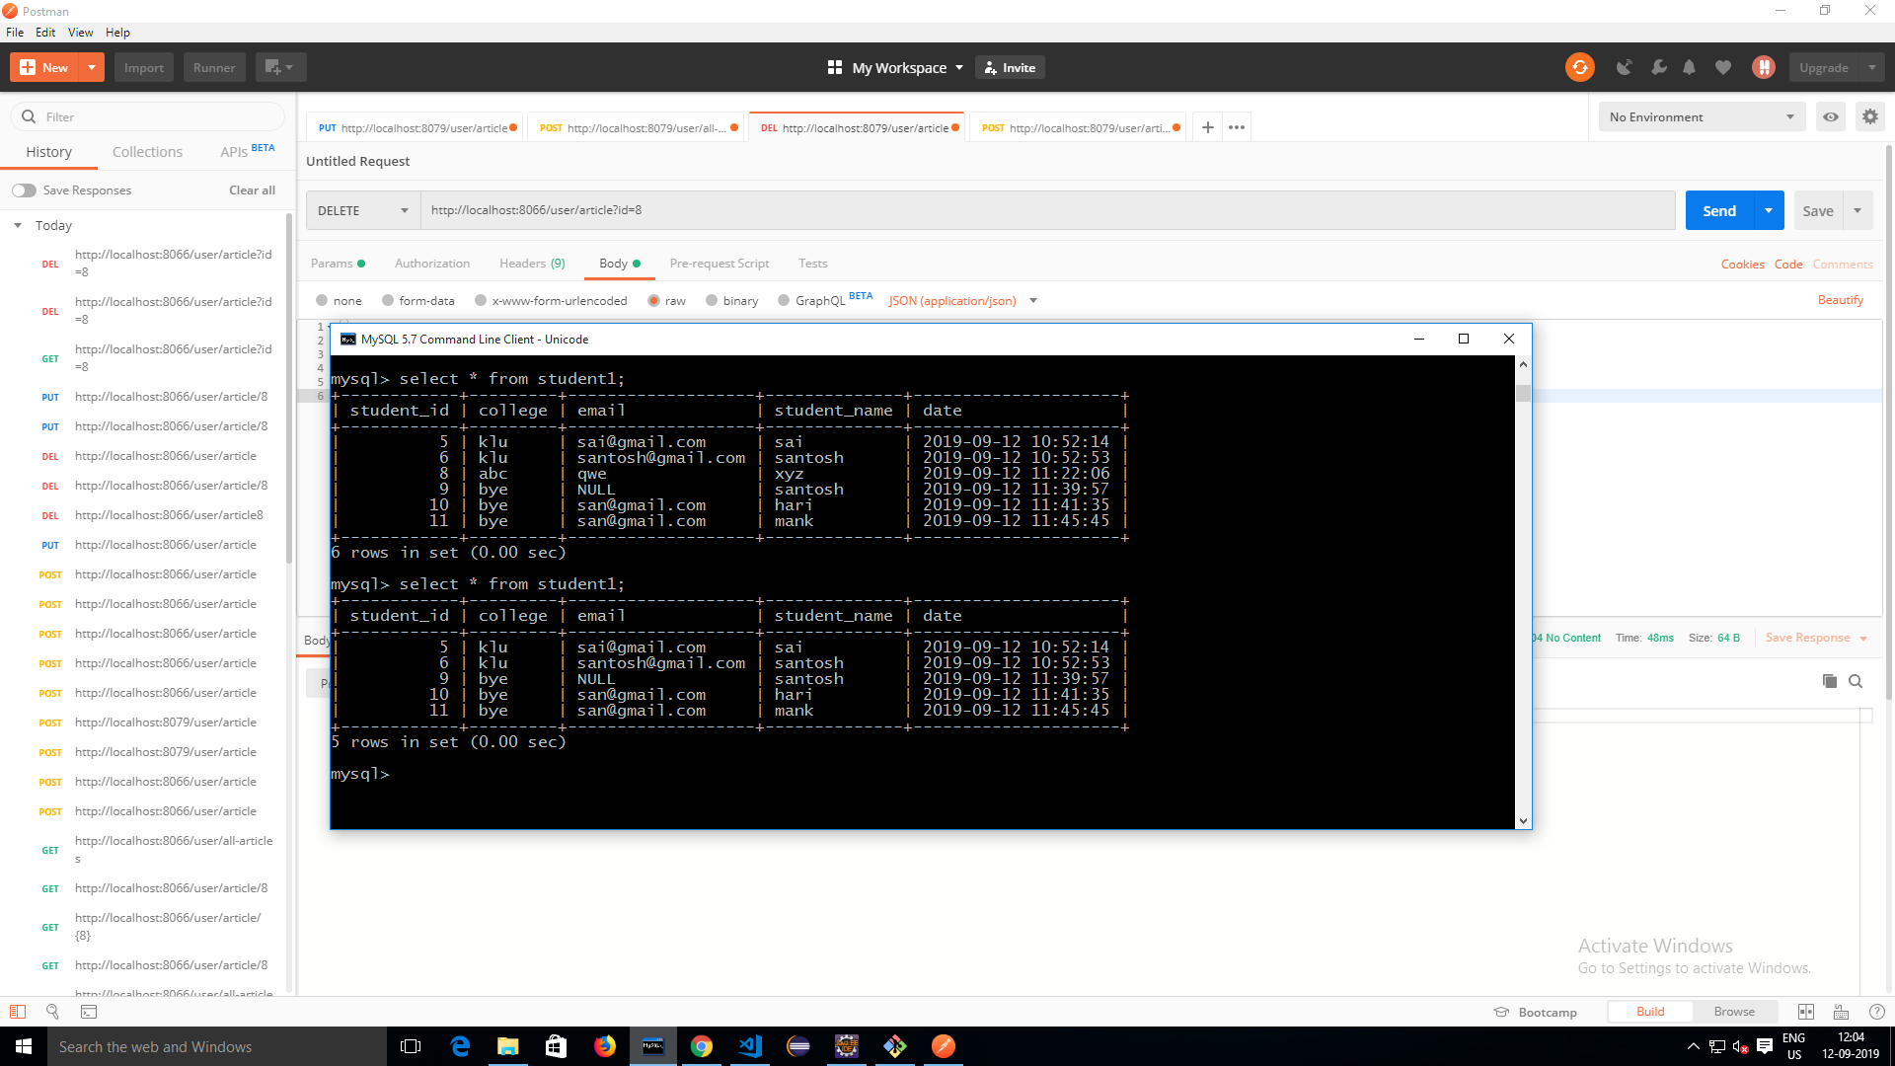

DOCKER IMPLEMENTATION: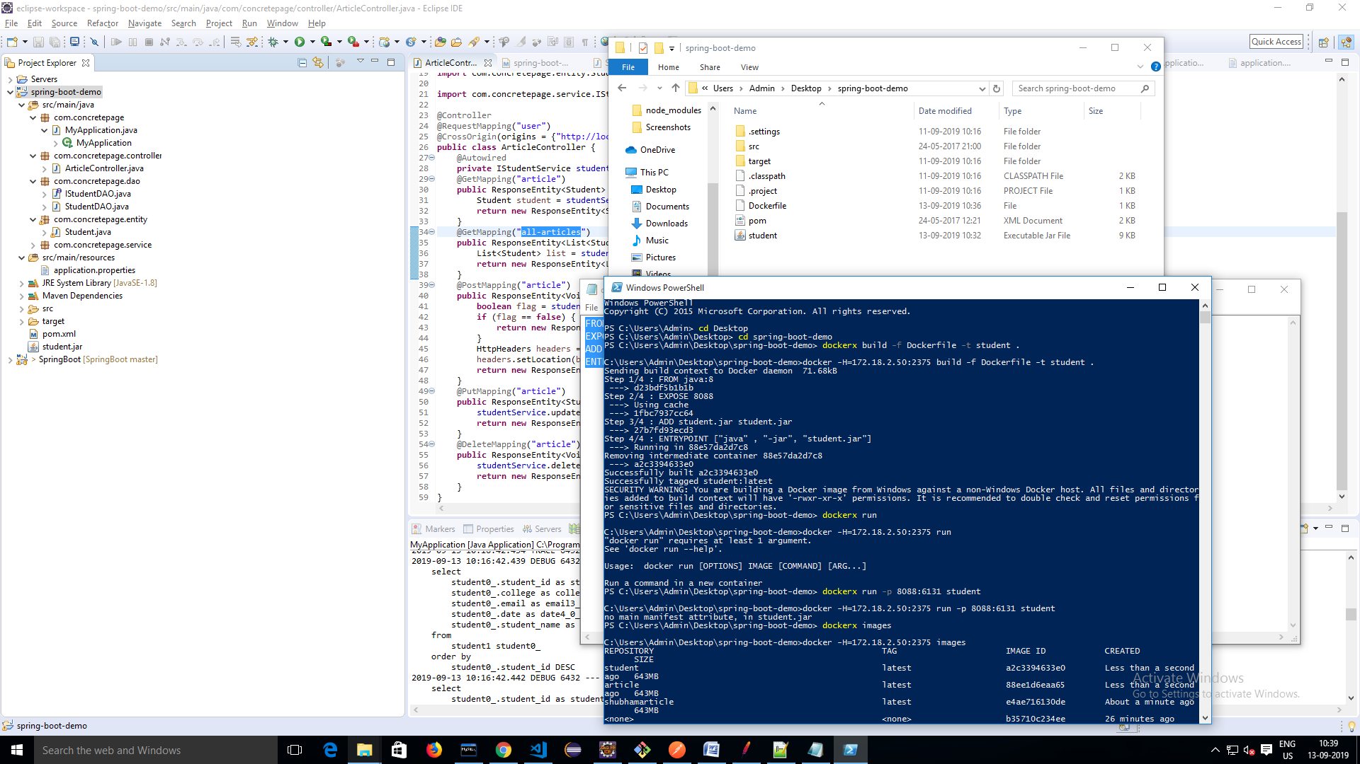

**DOCKER COMMANDS USED**

dockerx build -f Dockerfile -t student .

dockerx run -p 8088:6131 student

dockerx images

JENKINS IMPLEMENTATION SCREEN SHOTS:

