Ex.no:8 | MINI PROJECT – TOURISM & ECONOMIC ANALYTICS DATA ANALYTICS

Aim:
To clean, transform, store, and analyze global tourism and economic data using Python, MySQL, Power BI and Tableau to derive meaningful insights into tourism arrivals, tourism receipts, tourism expenditure, economic indicators, and country-wise tourism performance.

Algorithm:
- Load the global tourism and economic dataset from the CSV file using Pandas.
- Inspect the dataset for missing values and duplicate records.
- Handle missing categorical values and numerical values using suitable imputation methods.
- Remove duplicate records and standardize the column names.
- Create derived attributes such as tourism_balance, arrivals_per_gdp, and period.
- Store the cleaned and transformed dataset in a MySQL database named tourism_analytics.
- Connect the MySQL database to Power BI for analysis and reporting.
- Create DAX measures for total countries, tourist arrivals, tourism receipts, tourism expenditure, average GDP, average inflation, and tourism balance.
- Develop interactive Power BI and Tableau visualizations to analyze tourism and economic trends.
- Generate meaningful insights from the dashboards.
- End the process.

Architecture:

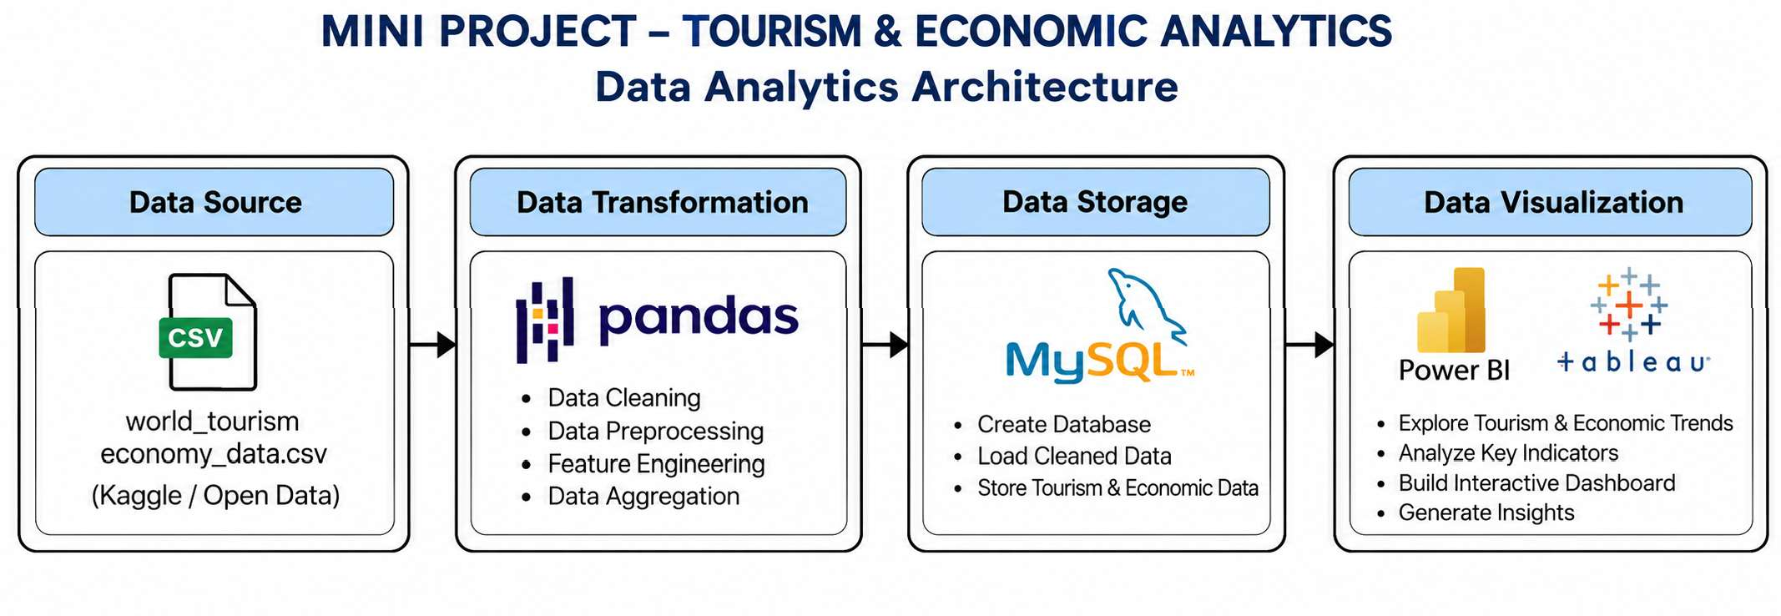

Program:

Python – Data Cleaning & Transformation
import pandas as pd
from sqlalchemy import create_engine, text # Load dataset
df = pd.read_csv("fifa_world_cup_2026_player_performance.csv") # Create a copy for processing
fifa = df.copy()
# Handle missing values
fifa["player_name"] = fifa["player_name"].fillna("Unknown") fifa["nationality"] = fifa["nationality"].fillna("Unknown") fifa["team"] = fifa["team"].fillna("Unknown") fifa["position"] = fifa["position"].fillna("Unknown")
# Remove duplicate records fifa.drop_duplicates(inplace=True) # Convert match date
fifa["match_date"] = pd.to_datetime(fifa["match_date"]) # Create derived columns
fifa["goal_contribution"] = ( fifa["goals"] + fifa["assists"]
)
fifa["pass_efficiency"] = ( fifa["successful_passes"] / fifa["total_passes"]
)
# Standardize column names fifa.columns = (
fifa.columns
.str.lower()
.str.strip()
.str.replace(" ", "_")
)
print("Original Shape:", df.shape) print("Cleaned Shape:", fifa.shape) fifa.head()

Python – Output:
Original dataset shape: 6650 rows × 11 columns. Cleaned dataset shape: 6650 rows × 14 columns.
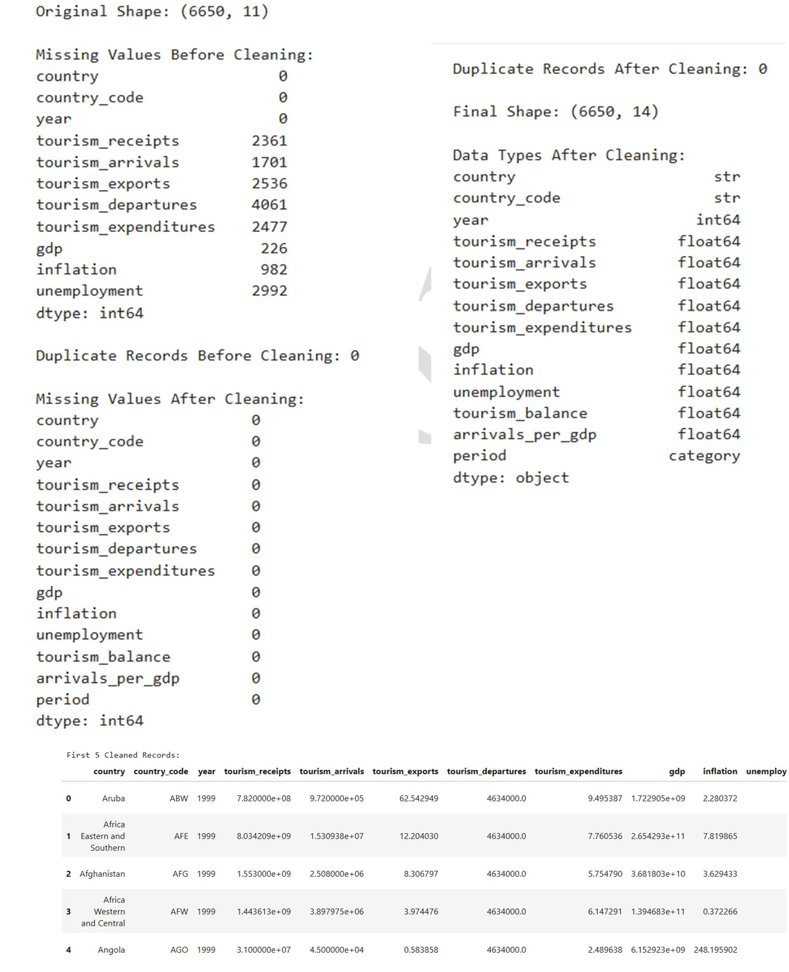

The cleaned dataset contains the original attributes together with tourism_balance, arrivals_per_gdp and period

MySQL – Database and Data Loading MySQL:
CREATE DATABASE IF NOT EXISTS tourism_analytics; USE tourism_analytics;

Python/Jupyter:
from sqlalchemy import create_engine

username = "root" password = "Harini*2006" host = "localhost"
port = 3306

# Connect to MySQL database db_engine = create_engine(
f"mysql+pymysql://{username}:{password}" f"@{host}:{port}/tourism_analytics"
)

# Load cleaned data into MySQL tourism.to_sql(
"tourism_data", con=db_engine, if_exists="replace", index=False
)

print("Data loaded successfully into MySQL.")

Verify:
SELECT COUNT(*) AS total_rows FROM tourism_data;

MySQL – Analysis Queries

Total records
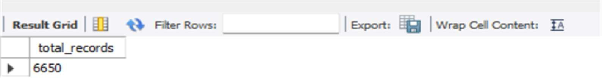
SELECT COUNT(*) AS total_records FROM tourism_data;

Tourism performance by year
SELECT
year,
SUM(tourism_arrivals) AS total_arrivals,

SUM(tourism_receipts) AS total_receipts, SUM(tourism_expenditures) AS total_expenditures
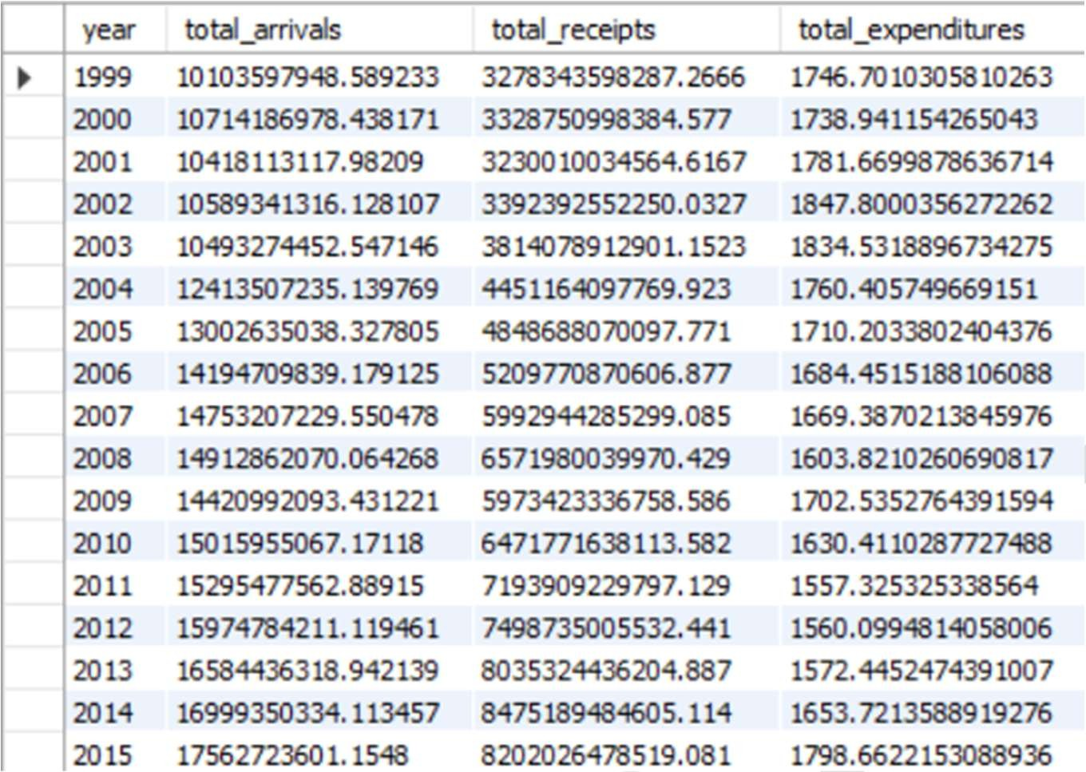
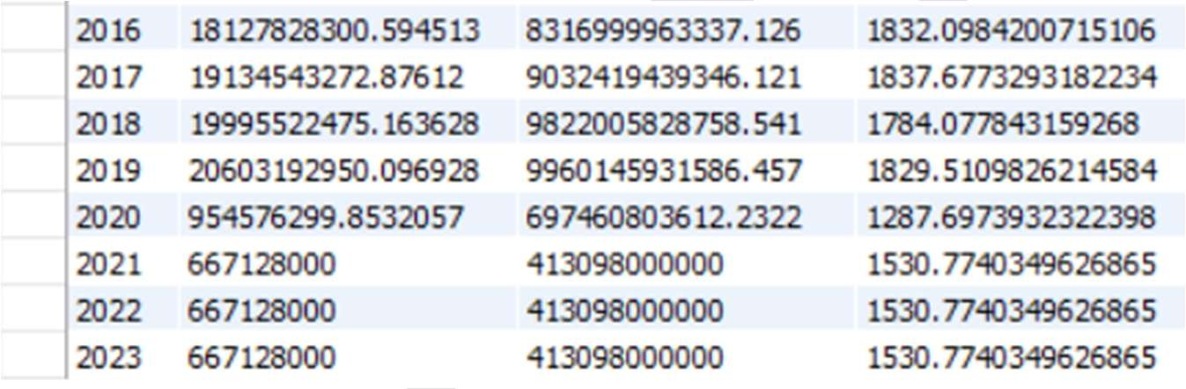
FROM tourism_data GROUP BY year ORDER BY year;

Top countries by tourism receipts
SELECT
country,
SUM(tourism_receipts) AS total_receipts, SUM(tourism_arrivals) AS total_arrivals
FROM tourism_data GROUP BY country
ORDER BY total_receipts DESC LIMIT 10;

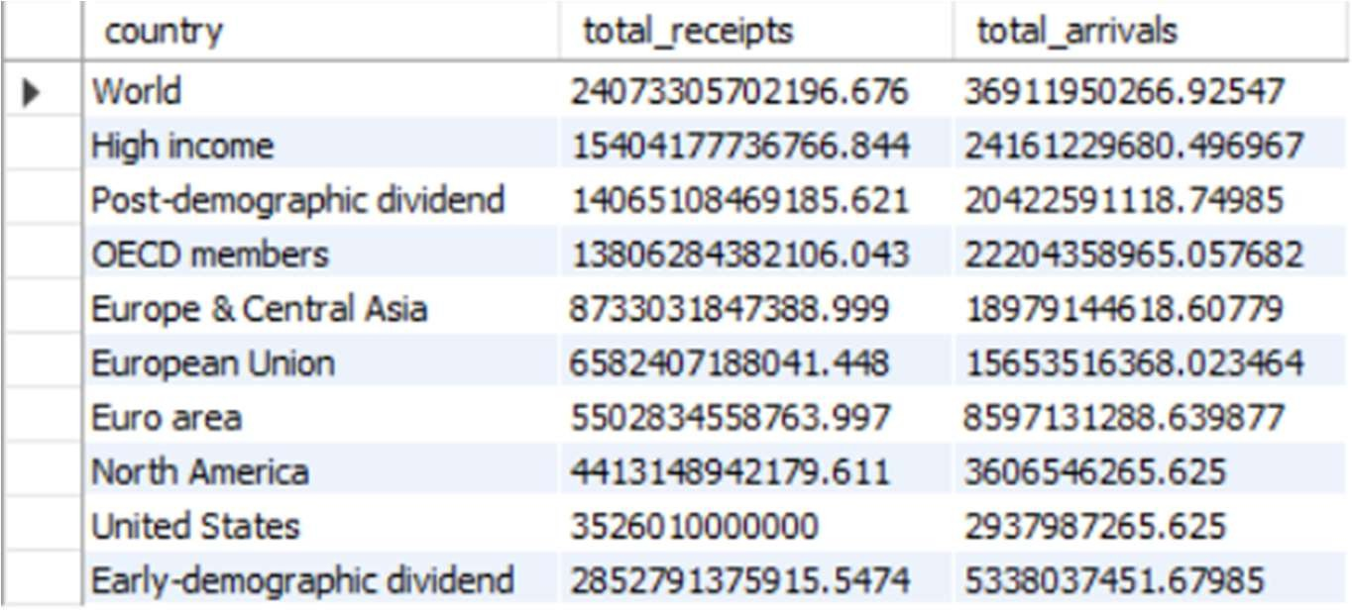

Tourism receipts vs expenditures
SELECT
year,
ROUND(SUM(tourism_receipts), 2) AS total_receipts, ROUND(SUM(tourism_expenditures), 2) AS total_expenditures, ROUND(
SUM(tourism_receipts) - SUM(tourism_expenditures), 2
) AS tourism_balance FROM tourism_data GROUP BY year ORDER BY year;
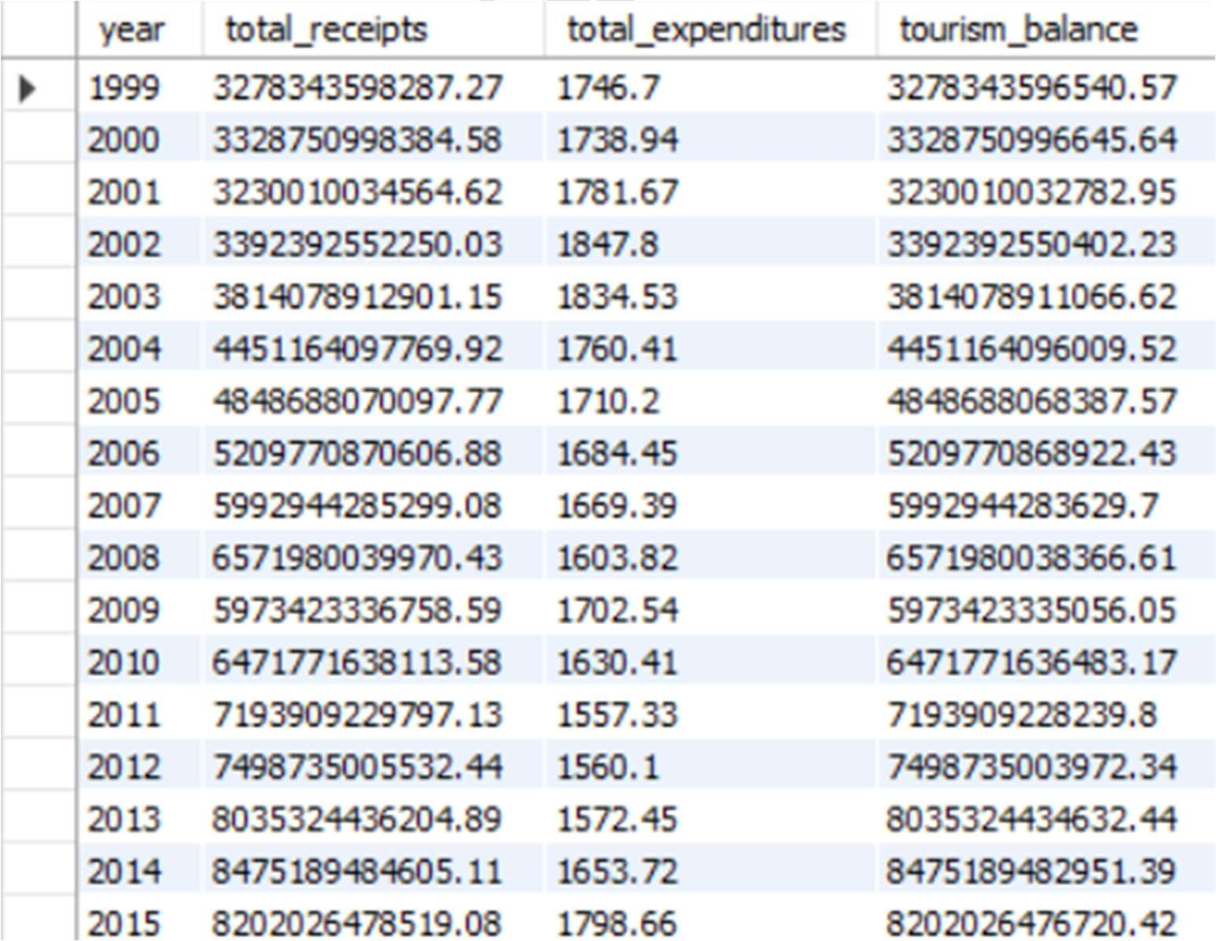

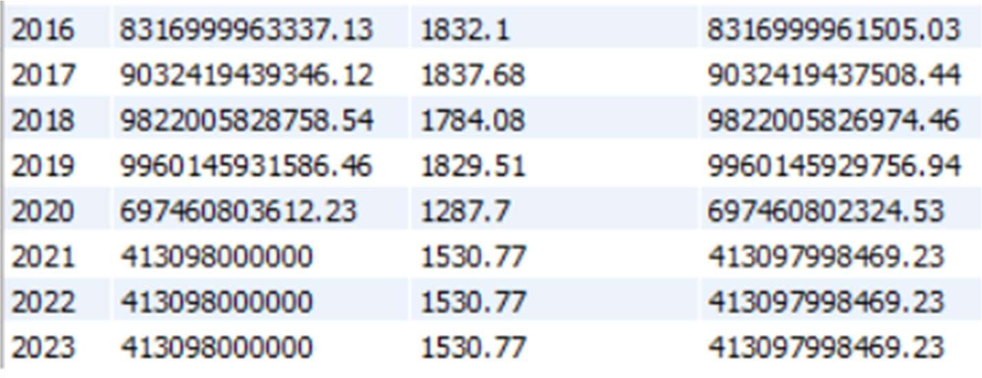

Average economic indicators
SELECT
year,
ROUND(AVG(gdp), 2) AS average_gdp, ROUND(AVG(inflation), 2) AS average_inflation, ROUND(AVG(unemployment), 2) AS average_unemployment
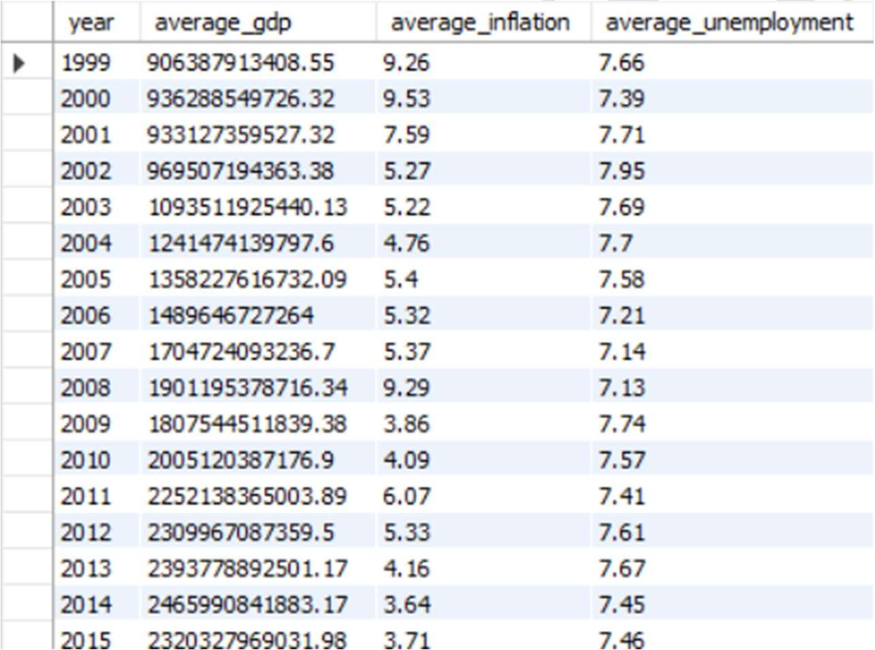
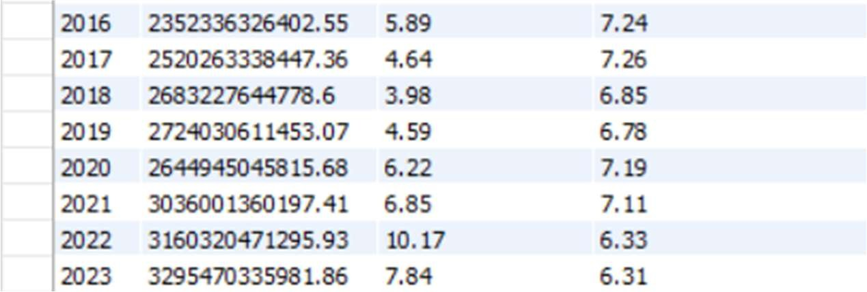
FROM tourism_data GROUP BY year ORDER BY year;

Power BI – DAX Measures Total Countries
Total Countries = DISTINCTCOUNT(tourism_data[country])

Total Tourist Arrivals
Total Tourist Arrivals =SUM(tourism_data[tourism_arrivals])

Total Tourism Receipts
Total Tourism Receipts = SUM(tourism_data[tourism_receipts])

Total Tourism Expenditure
Total Tourism Expenditure = SUM(tourism_data[tourism_expenditures])

Average GDP
Average GDP = AVERAGE(tourism_data[gdp])

Average Inflation
Average Inflation = AVERAGE(tourism_data[inflation])

Tourism Balance
Tourism Balance = [Total Tourism Receipts] - [Total Tourism Expenditure]

Power BI visuals created include KPI cards, tourist arrivals trend, tourism receipts versus expenditure, GDP-related analysis, and inflation versus unemployment.

Tableau Dashboard
The cleaned CSV file was connected to Tableau Public and separate worksheets were created for tourism analysis. A world map was also created using Country with Tourism Receipts to show global tourism distribution.
Tableau worksheets used:
- Tourist Arrivals Trend
- Tourism Receipts vs Expenditure
- Inflation vs Unemployment
- Tourism Balance by Period
- Global Tourism Receipts – World Map

Output:

TABLEAU DASHBOARD
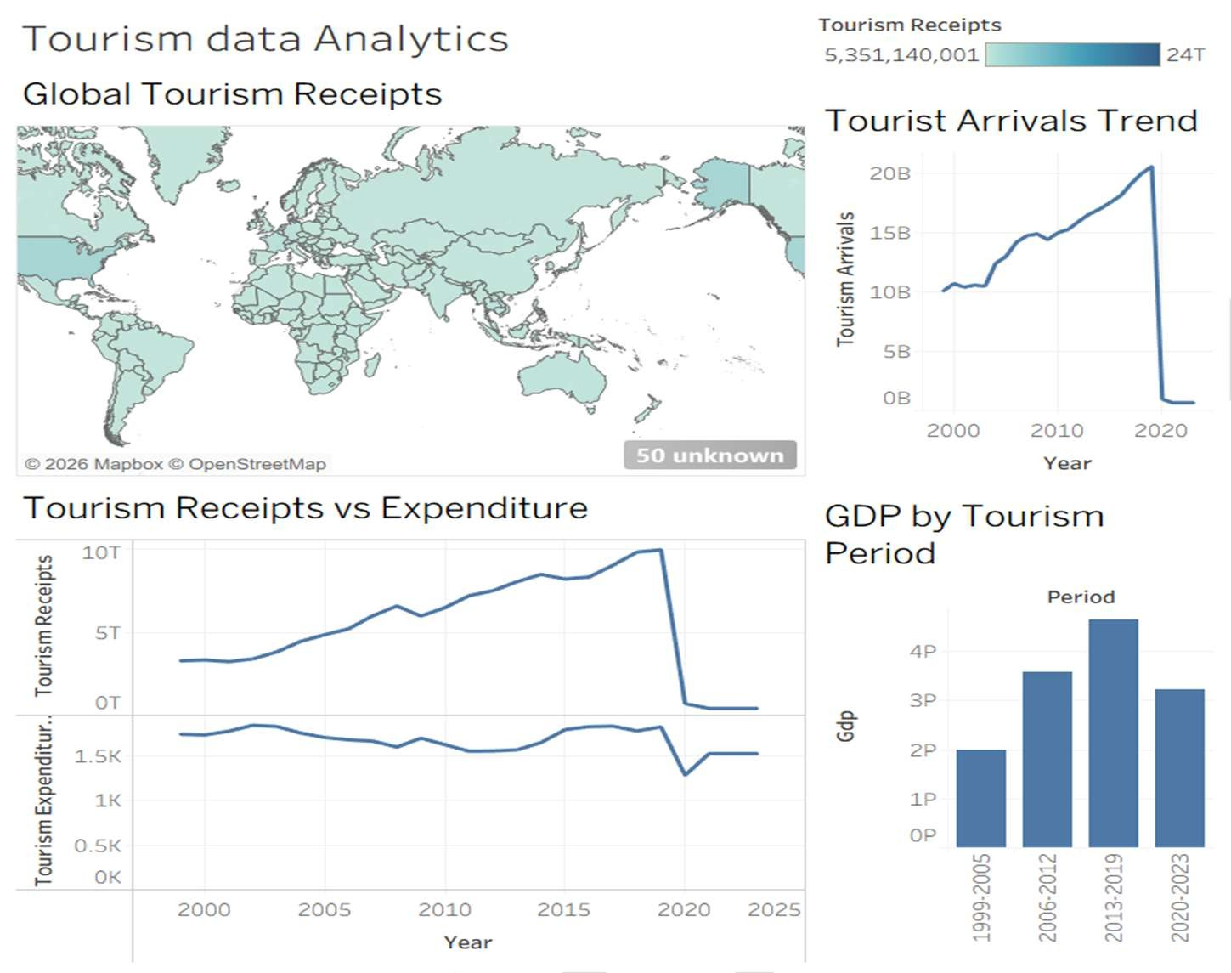

POWER BI DASHBOARD
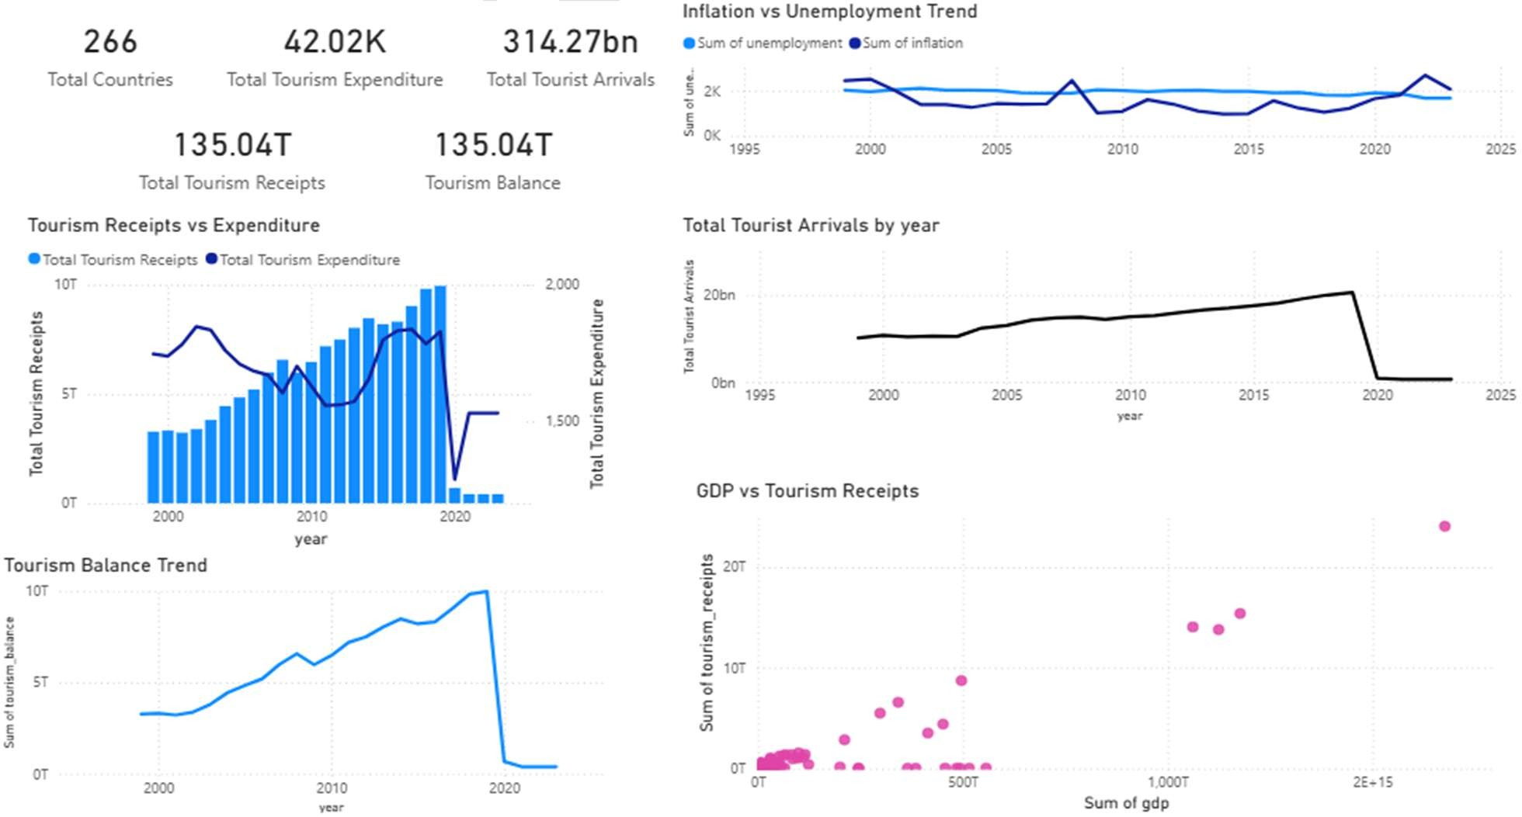

Result:

