EX. NO: 5a
DATA VISUALIZATION USING MATPLOTLIB
AIM:
To visualise the sales dataset using the basic plots provided by the Matplotlib library — line plot, bar chart, horizontal bar chart, pie chart, scatter plot and histogram — and to customise them using titles, axis labels, legends, colours and grid lines.
ALGORITHM:
- Import the Matplotlib library along with Pandas and NumPy and load the sales dataset.
- Enable inline plotting in the Jupyter Notebook using the %matplotlib inline magic command.
- Prepare the data required for plotting by grouping the sales by Product and by Region.
- Draw a line plot to show the trend of sales across the records.
- Draw a bar chart to compare the total sales of each product.
- Draw a horizontal bar chart to compare the total sales of each region.
- Draw a pie chart to show the percentage contribution of each product.
- Draw a scatter plot to show the distribution of the individual sale values.
- Draw a histogram to show the frequency distribution of the Sales column.
- Add titles, axis labels, legends, colours, value labels and grid lines to the plots.
- Display and observe the output of each plot.
PROGRAM:
Step 1: Importing the libraries and preparing the data for plotting
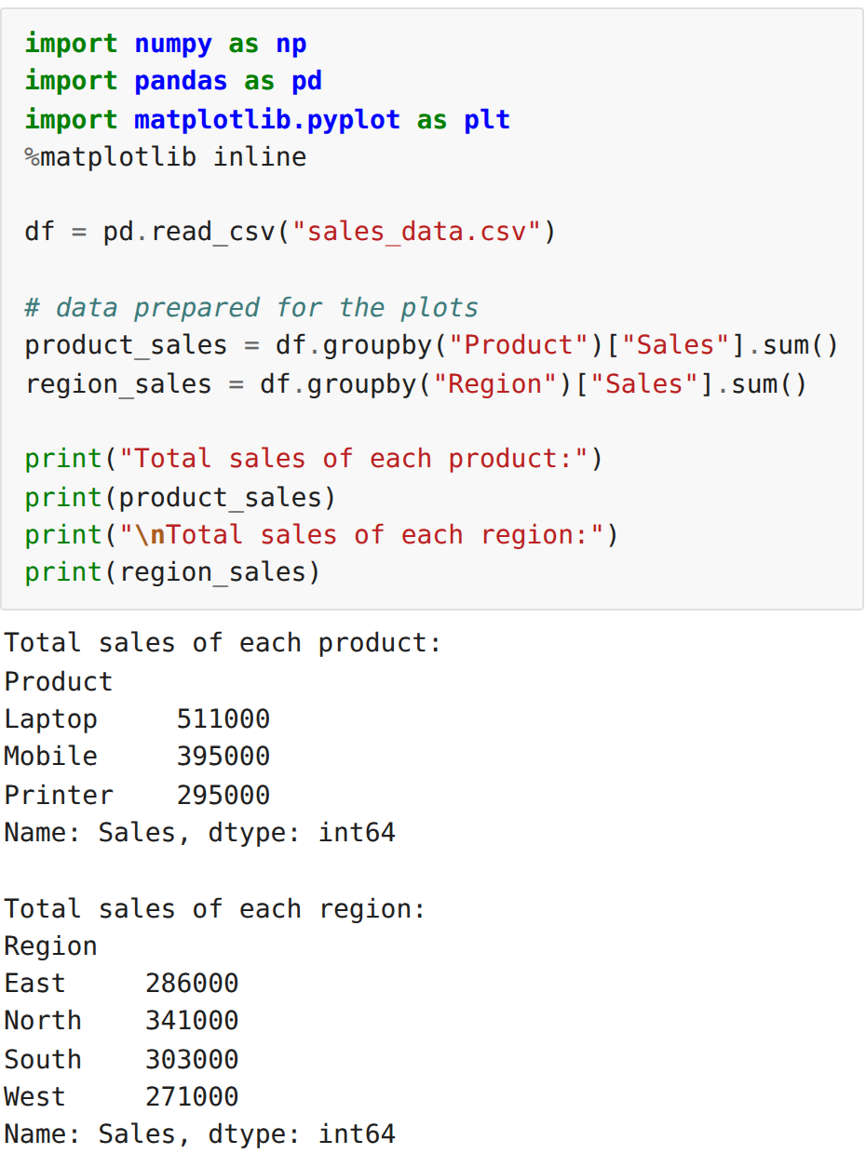
Step 2: Line plot – trend of sales across the records
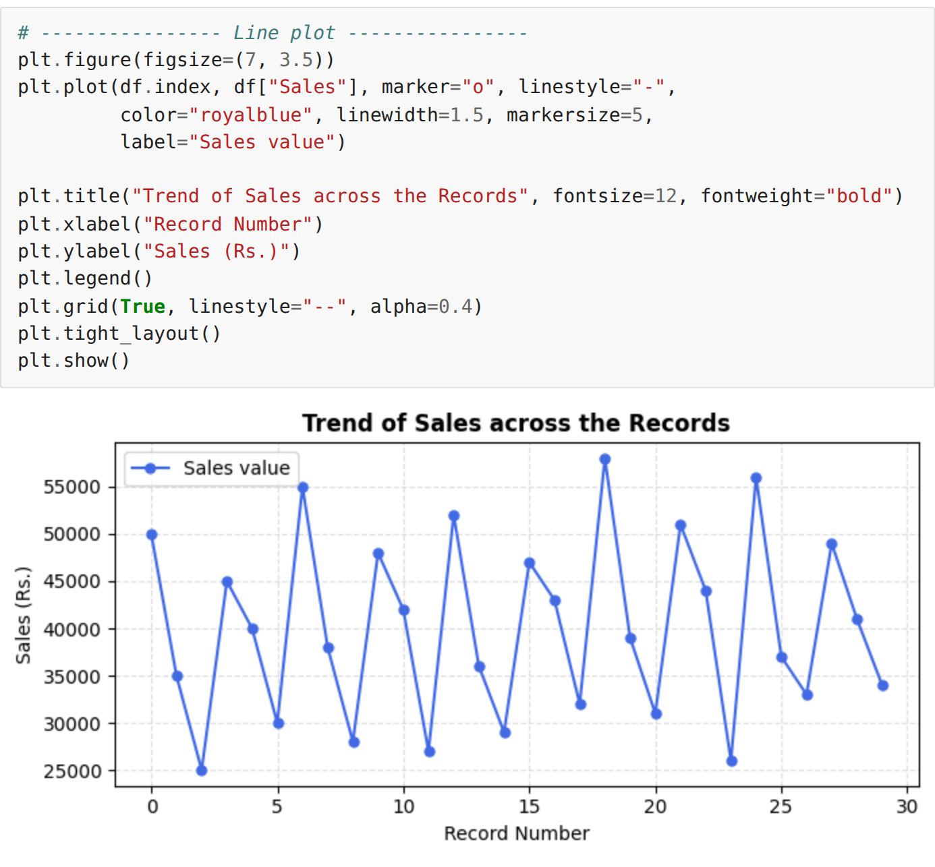
Step 3: Bar chart – total sales of each product
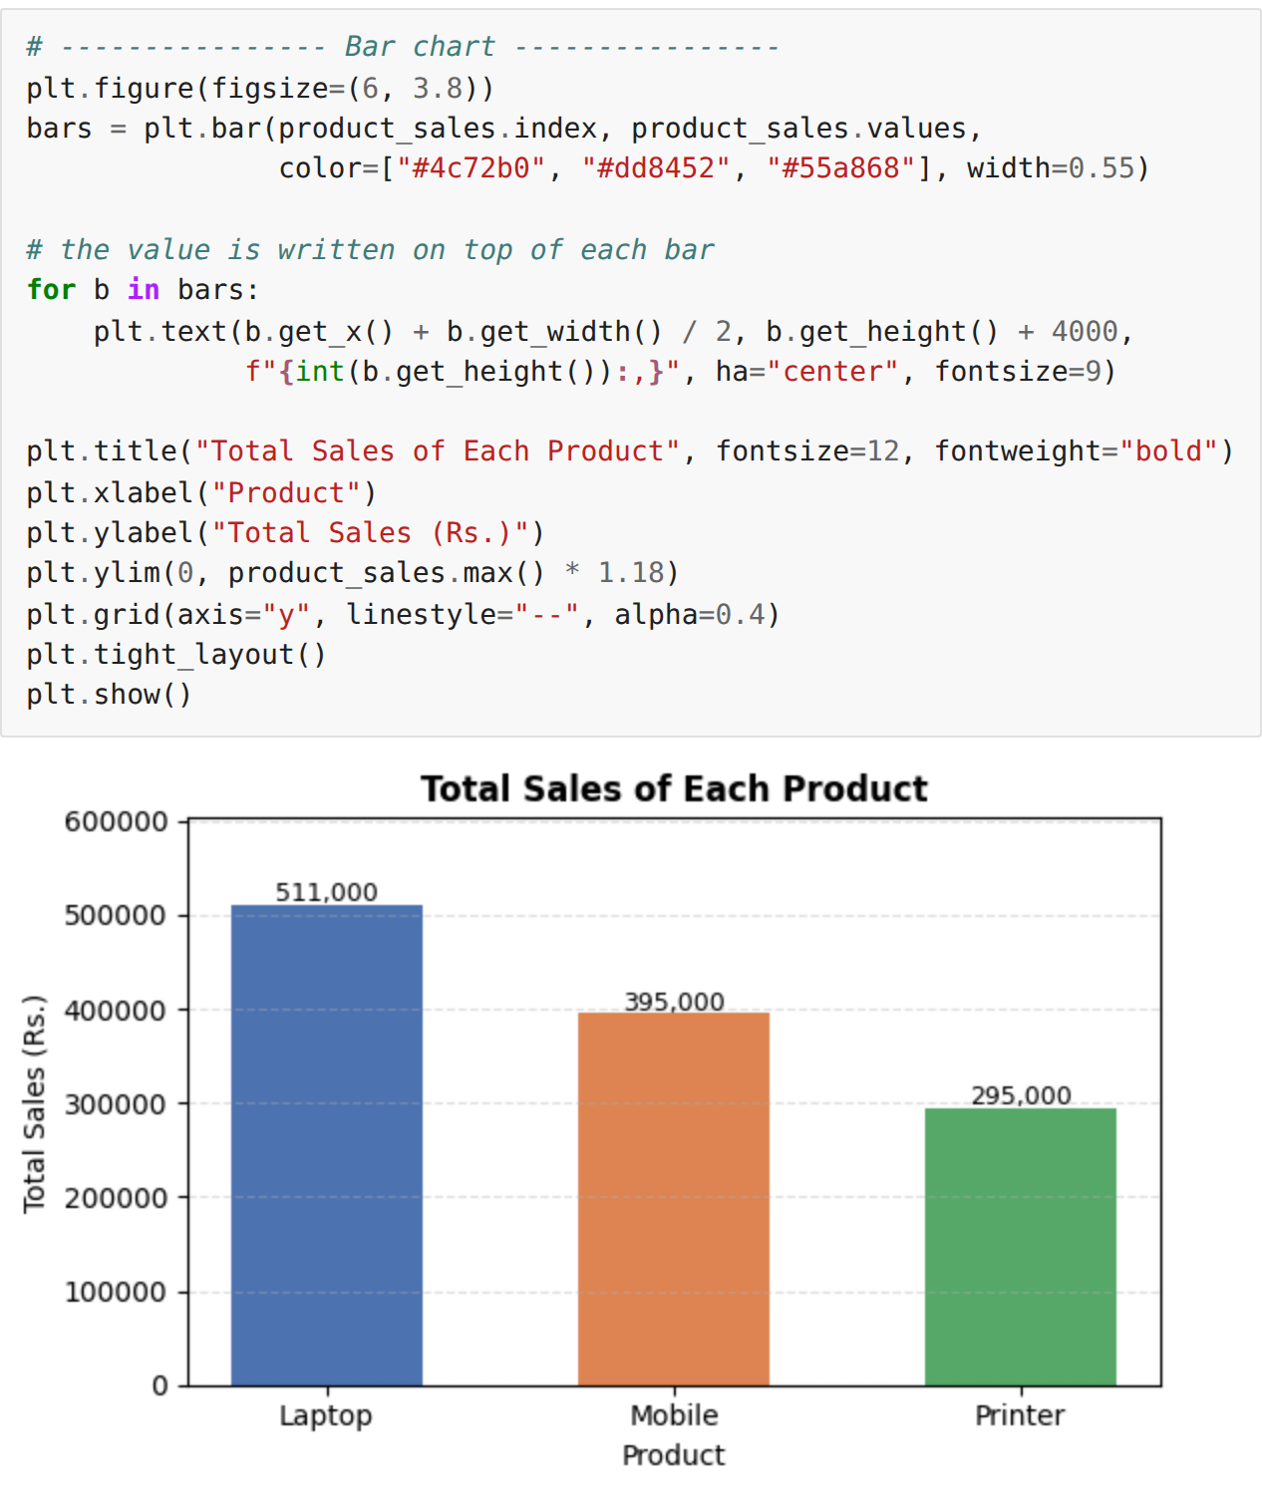
Step 4: Horizontal bar chart – total sales of each region
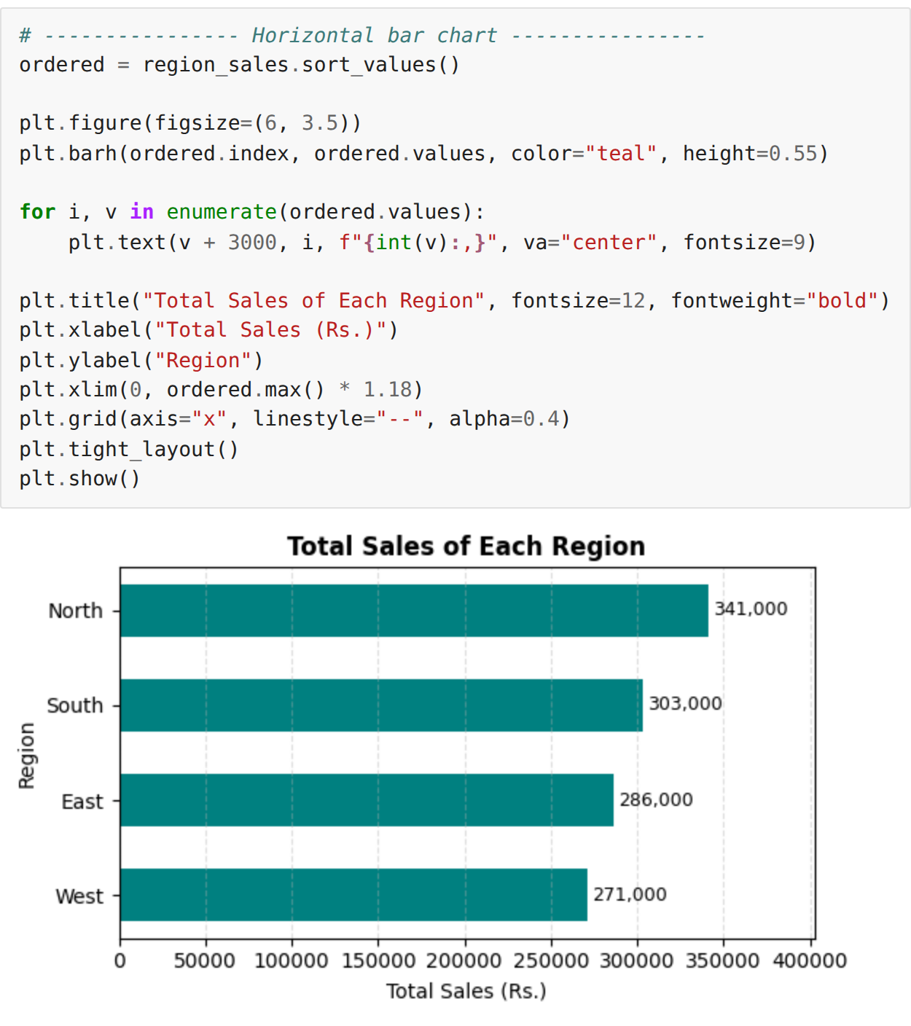
Step 5: Pie chart – percentage contribution of each product
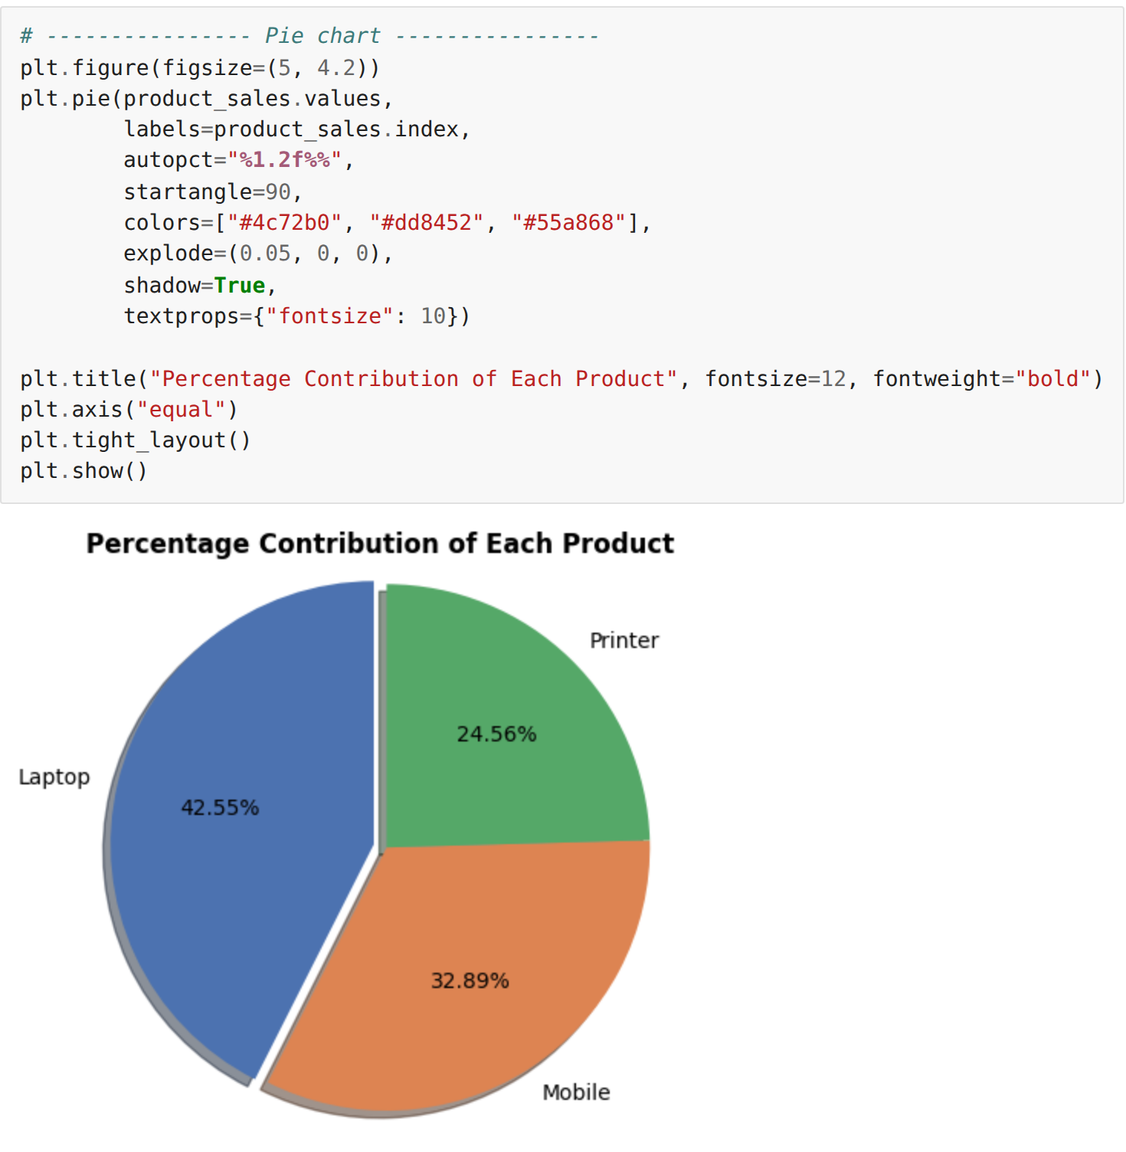
Step 6: Scatter plot – distribution of the individual sale values
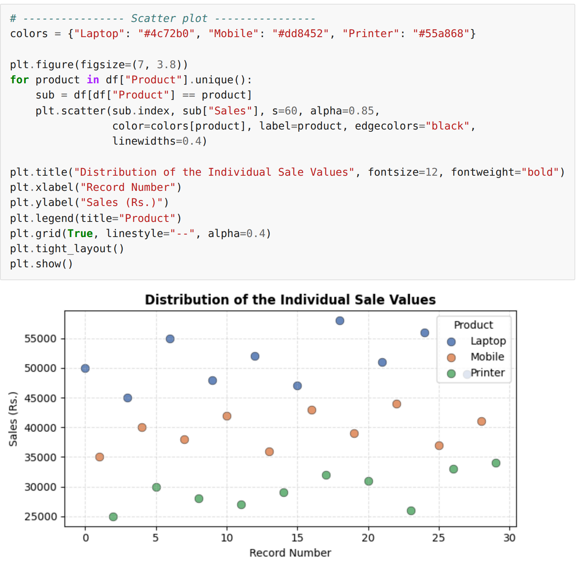
Step 7: Histogram – frequency distribution of the Sales column
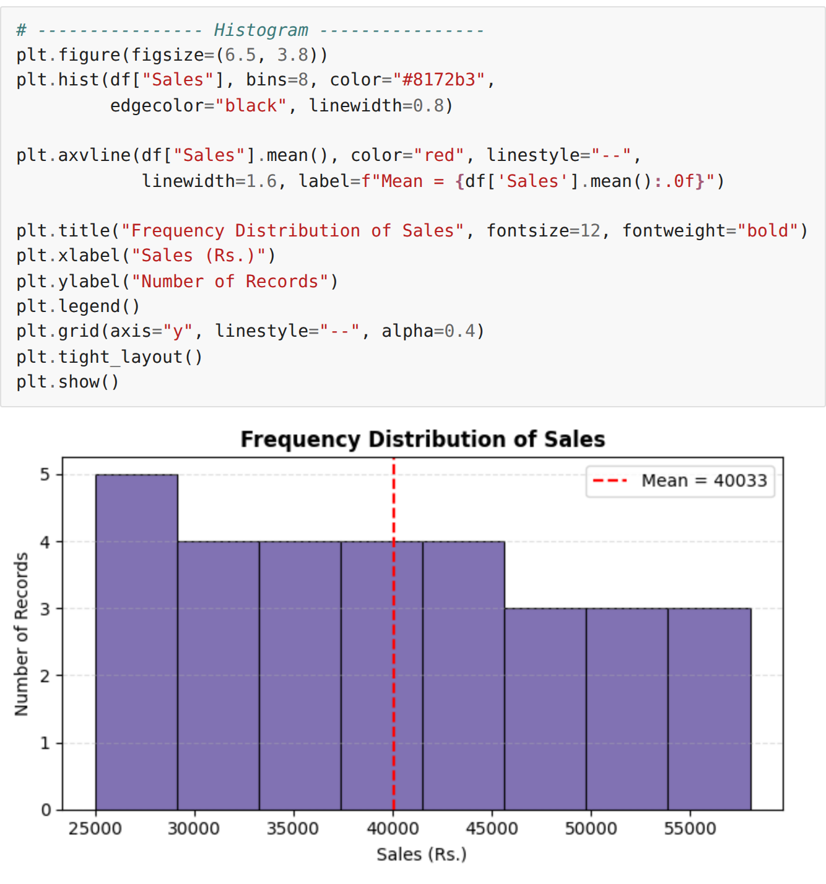
RESULT:
Thus the sales dataset was visualised successfully using the basic Matplotlib plots — line plot, bar chart, horizontal bar chart, pie chart, scatter plot and histogram — and all the plots were customised and displayed in the Jupyter Notebook.

