EX. NO: 5b
DATA VISUALIZATION USING MATPLOTLIB
AIM:
To visualise the sales dataset using the advanced plotting features of Matplotlib — multiple subplots in a single figure, grouped bar charts, stacked bar charts, box plots, area charts, annotated plots and styled figures — and to save the generated figures as image files.
ALGORITHM:
- Import the Matplotlib library along with Pandas and NumPy and load the sales dataset.
- Reshape the data into a Product-versus-Region matrix using a pivot table.
- Draw a grouped bar chart that compares every product across all the regions.
- Draw a stacked bar chart that shows how each region contributes to a product's sales.
- Draw a box plot to compare the spread of the sales of each product.
- Draw an area chart showing the cumulative sales.
- Create a figure containing multiple subplots using the subplots() function.
- Annotate the highest and the lowest sale values on a plot using the annotate() function.
- Apply a built-in Matplotlib style sheet and redraw a plot.
- Save the generated figure as a PNG image file using savefig().
- Display and observe the output of each plot.
PROGRAM:
Step 1: Importing the libraries and reshaping the data
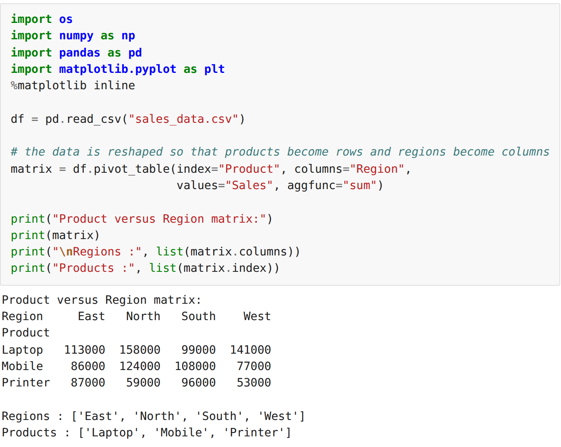
Step 2: Grouped bar chart – product versus region
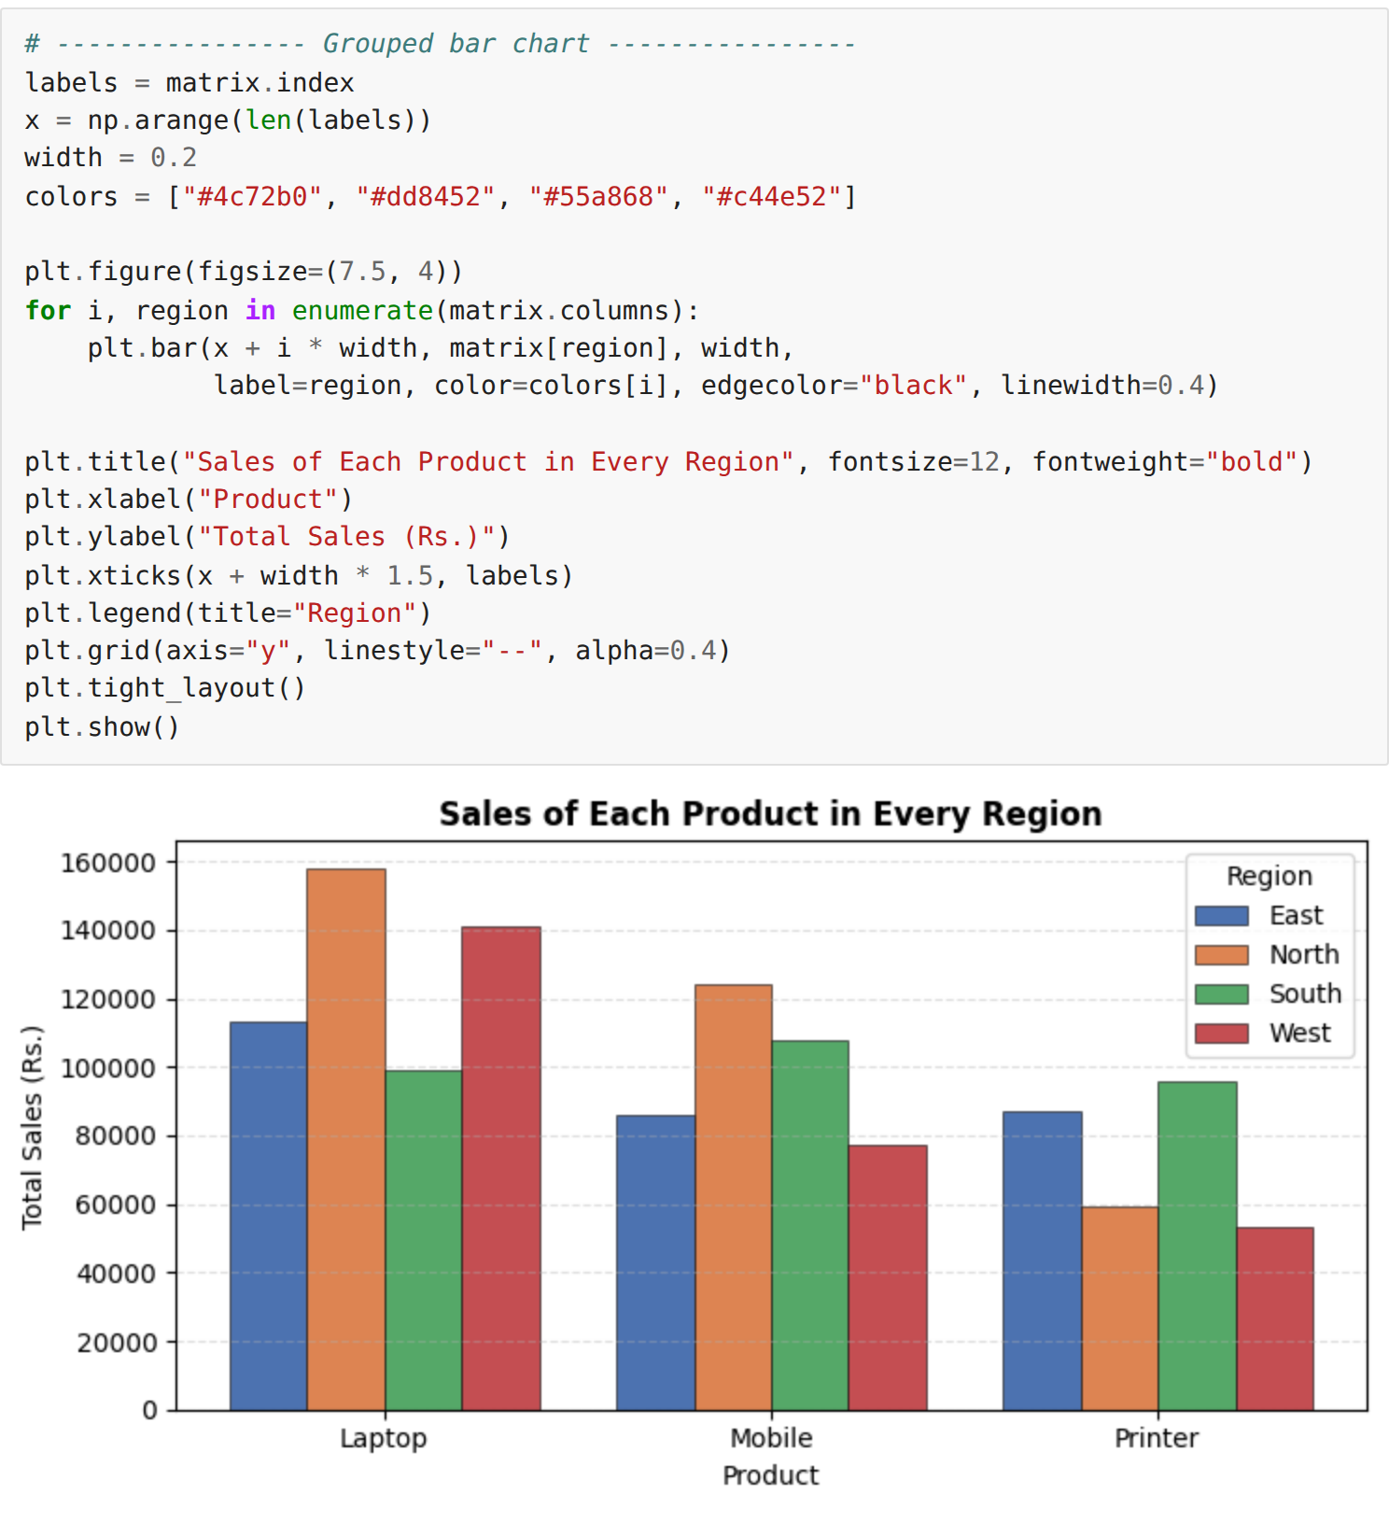
Step 3: Stacked bar chart – contribution of each region to a product
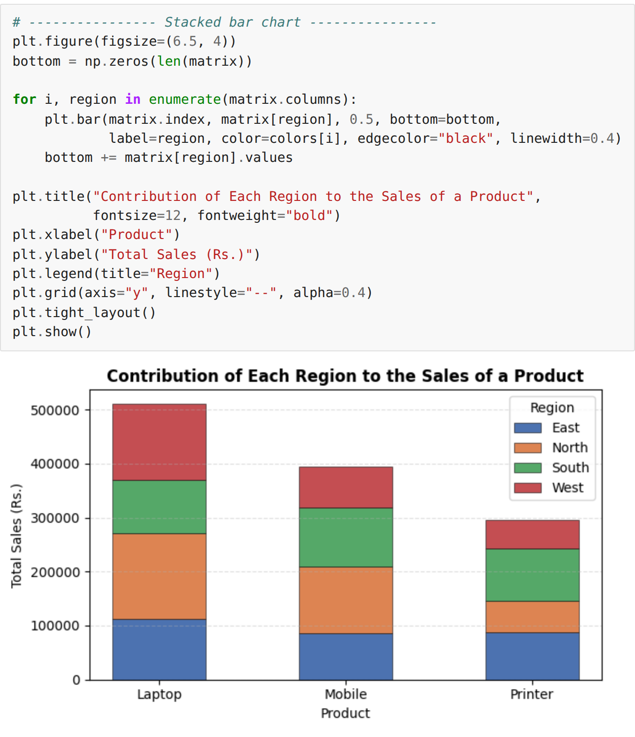
Step 4: Box plot – spread of the sales of each product
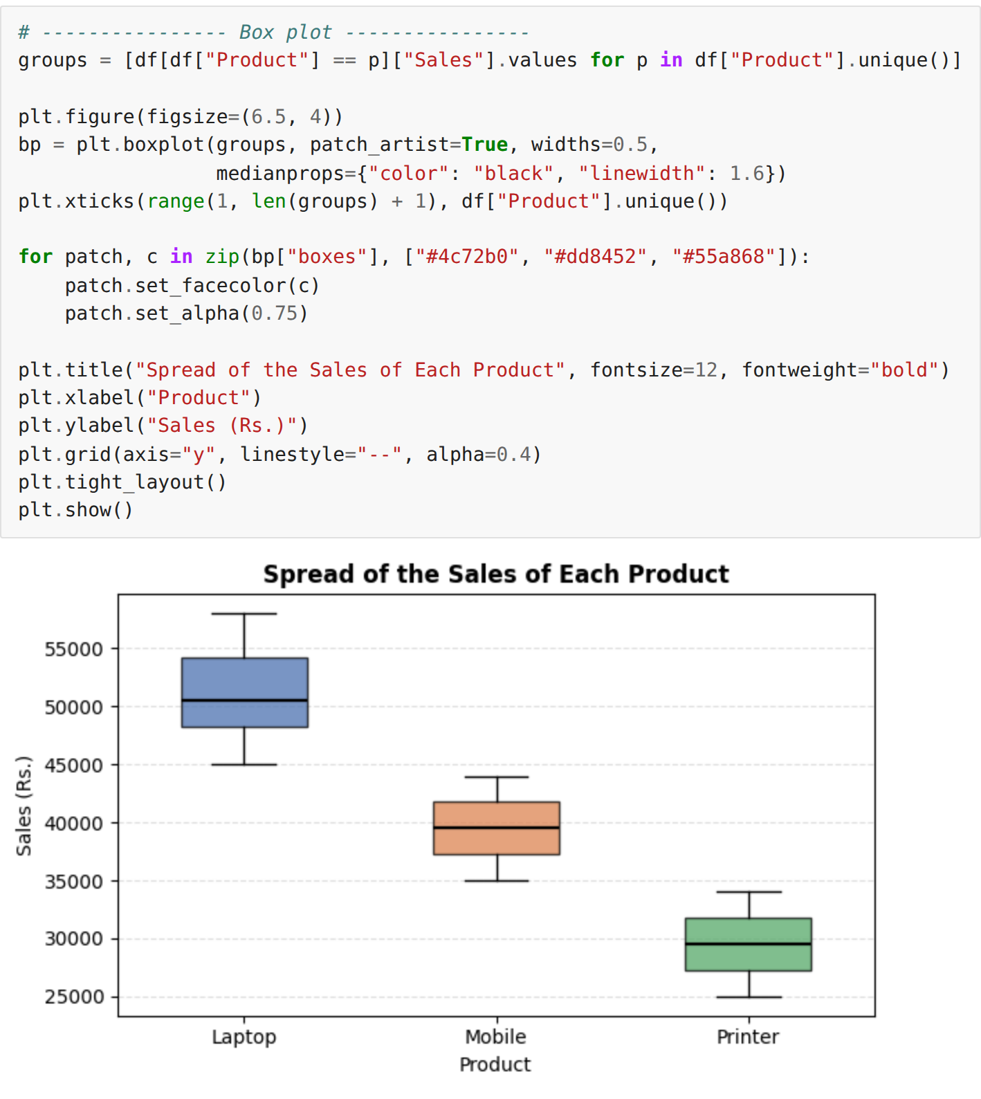
Step 5: Area chart – cumulative sales
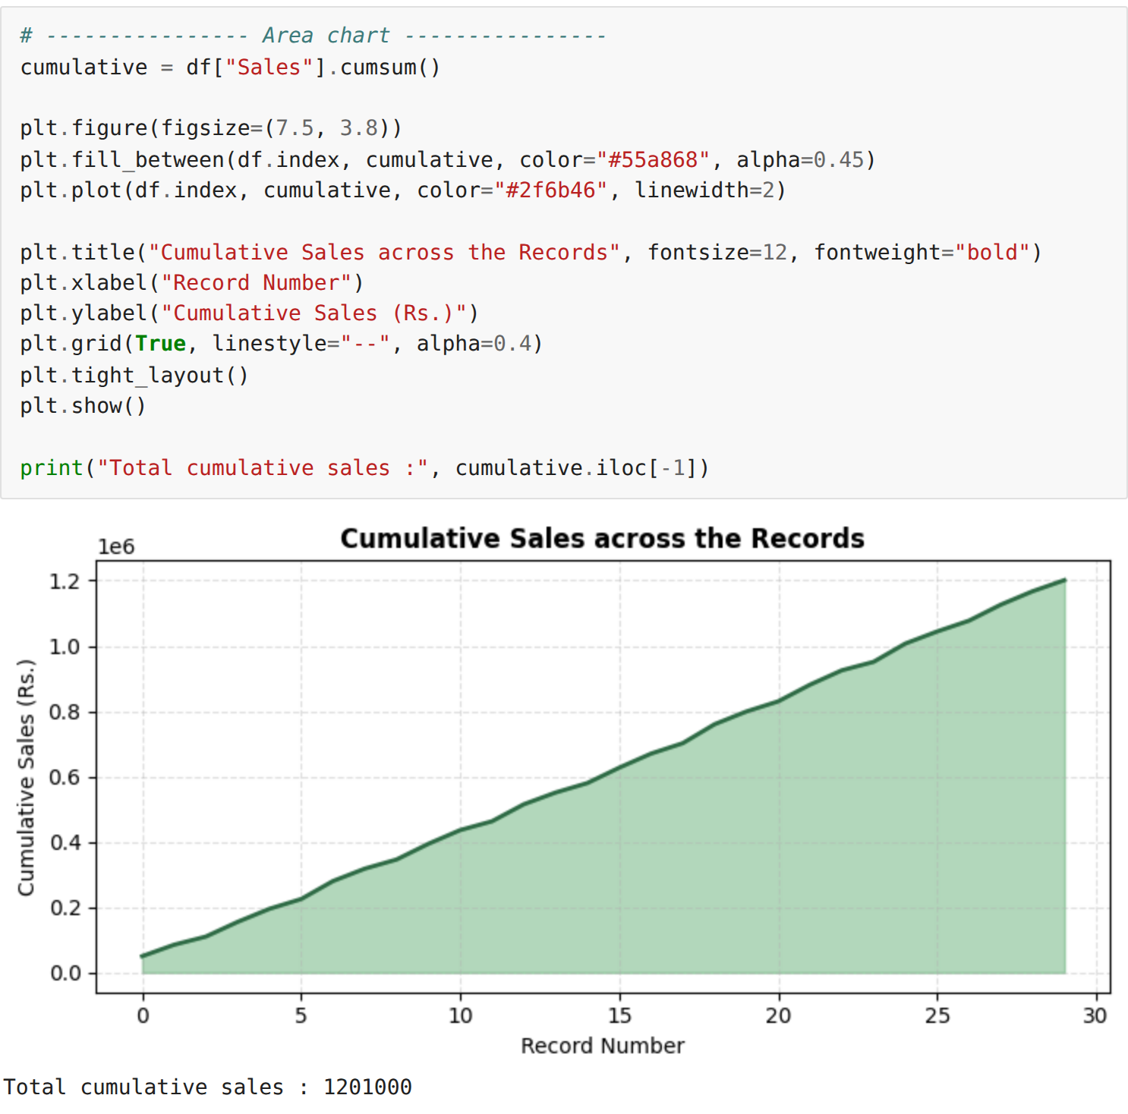
Step 6: Multiple subplots in a single figure
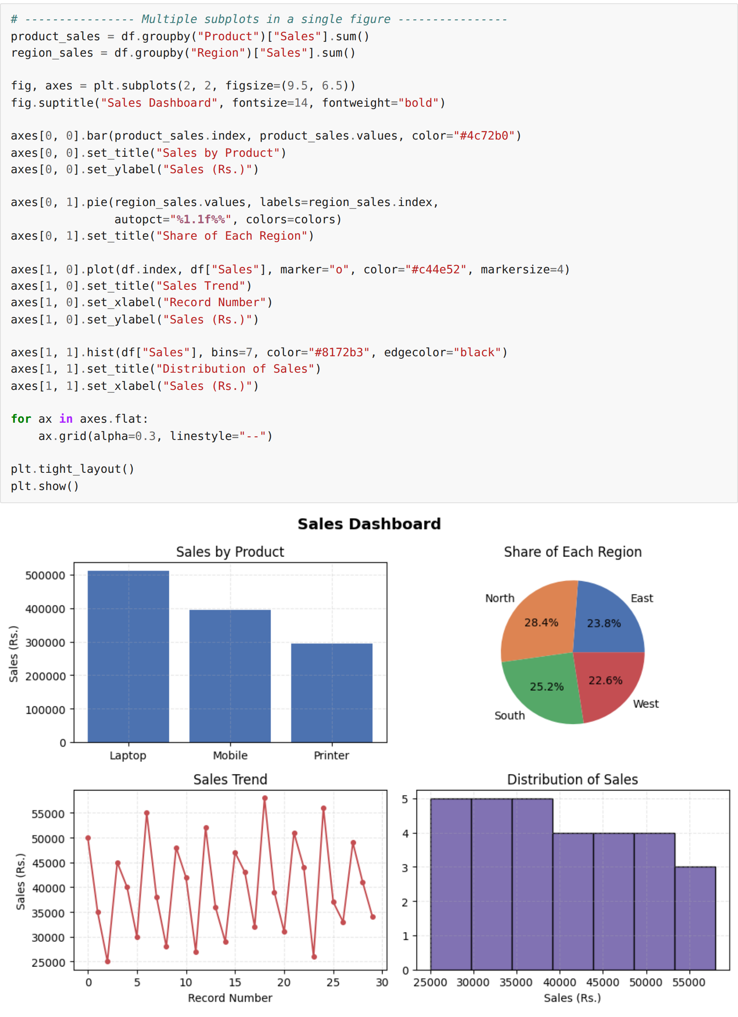
Step 7: Annotating the highest and the lowest sale values
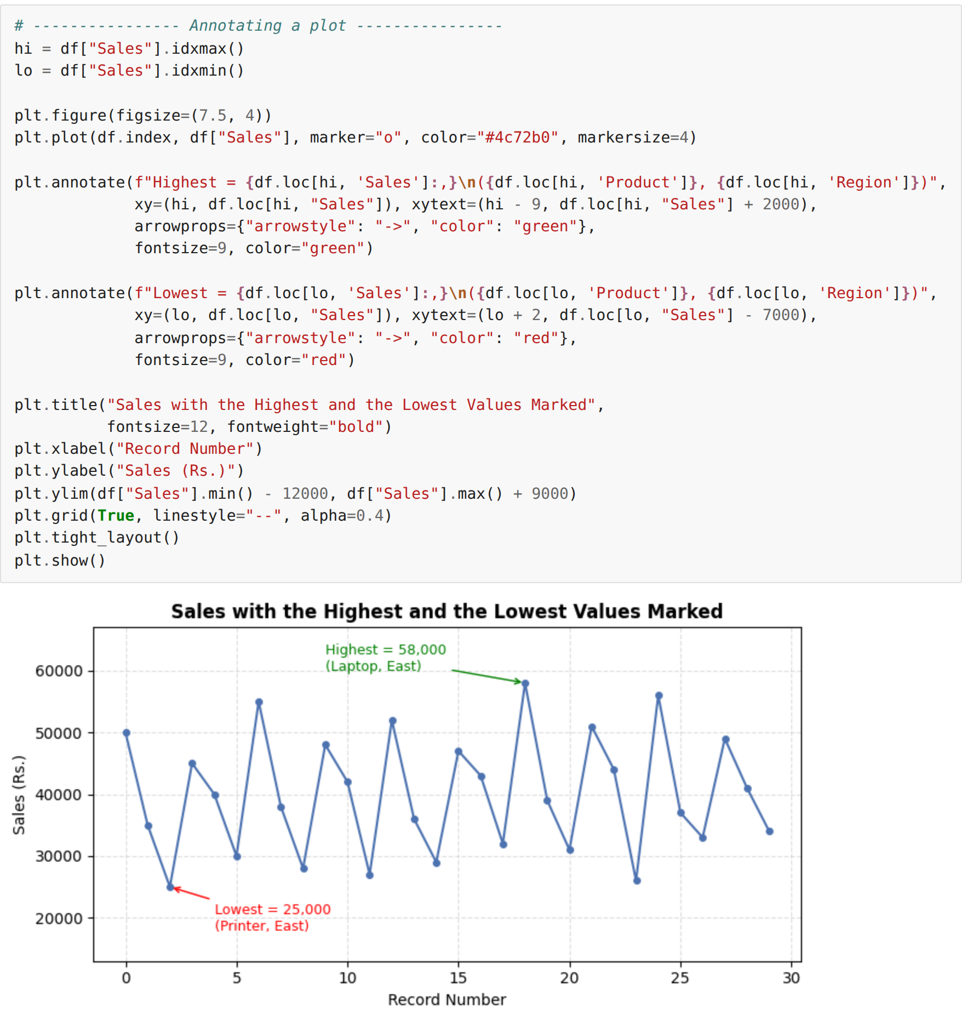
Step 8: Applying a built-in style sheet
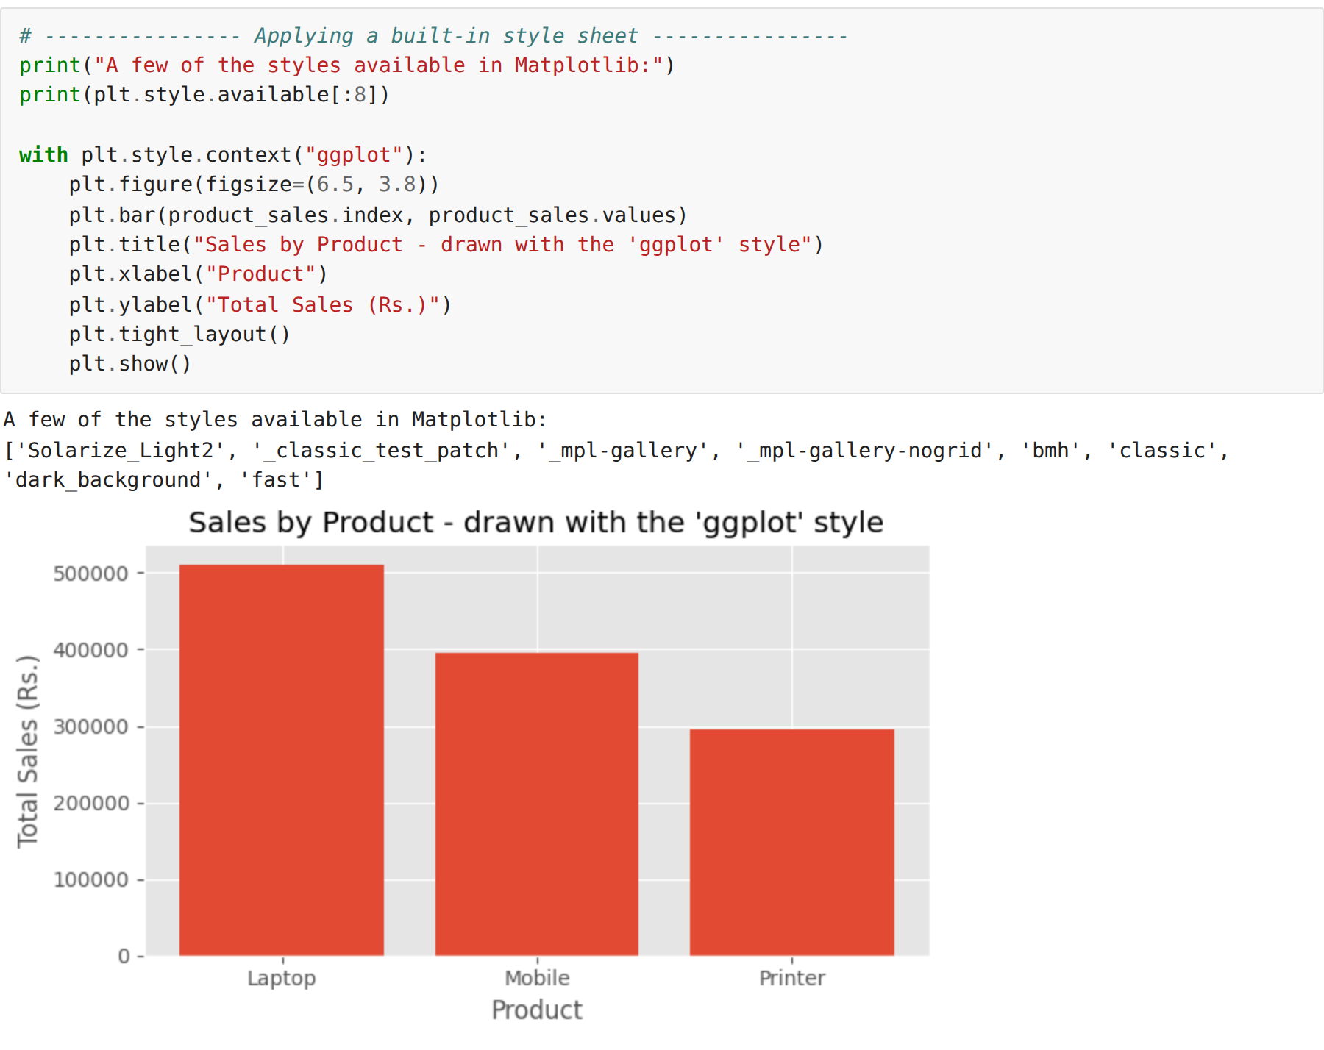
Step 9: Saving the figure as an image file
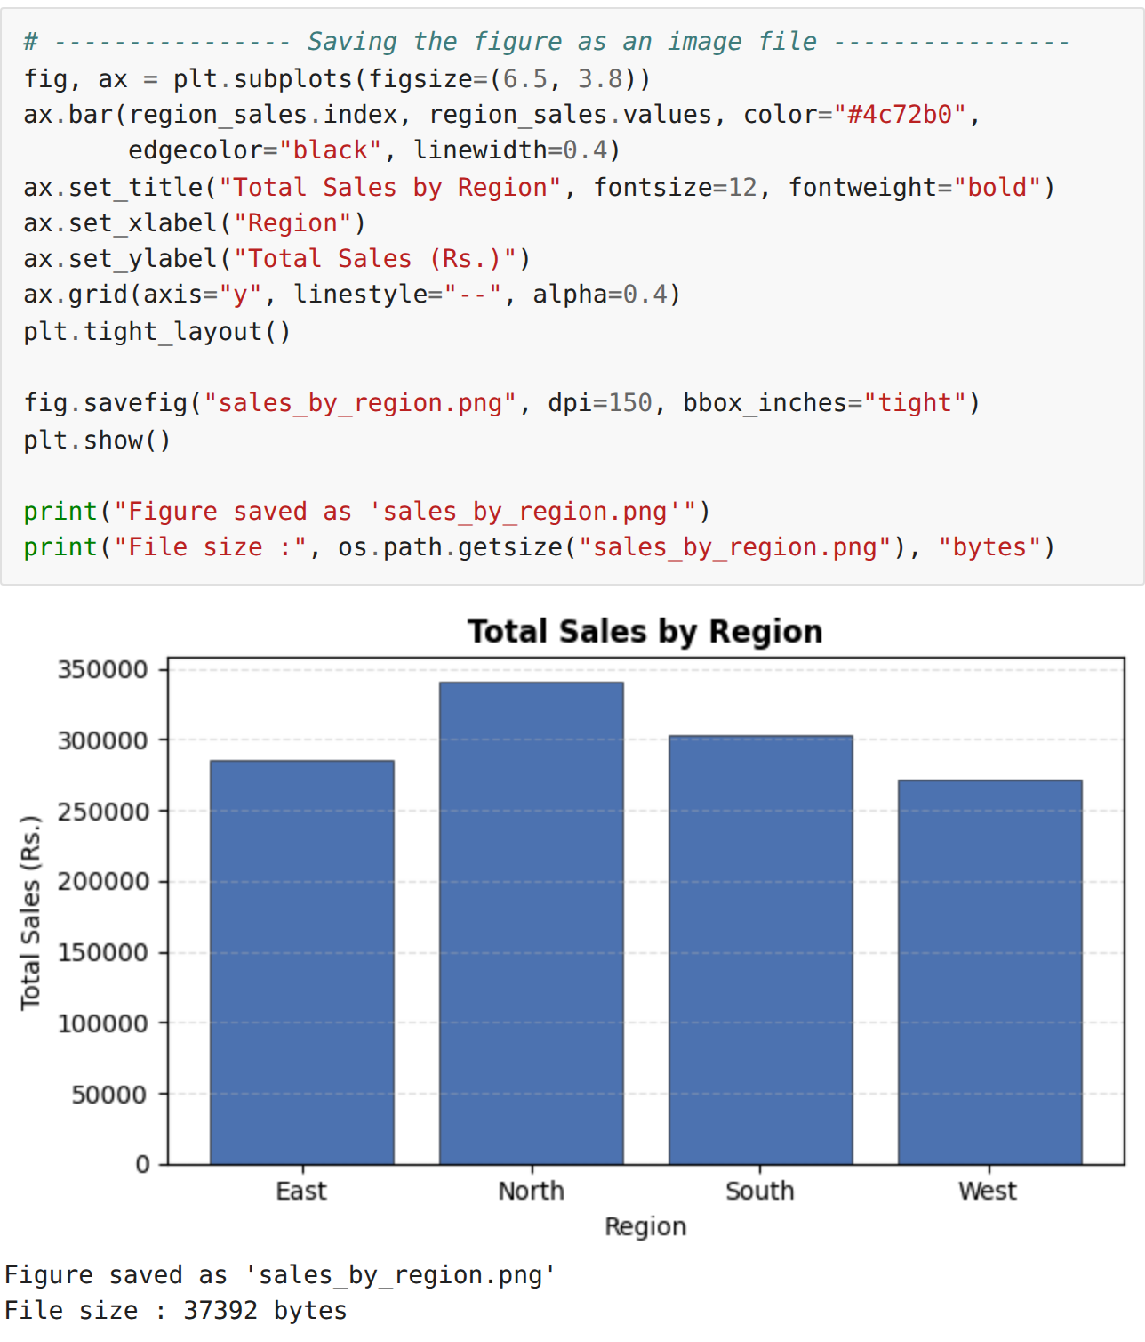
RESULT:
Thus the sales dataset was visualised using the advanced features of Matplotlib — grouped and stacked bar charts, box plot, area chart, multiple subplots, annotations and style sheets — and the generated figure was saved successfully as an image file.

