EX. NO: 1a
SETTING UP PYTHON ENVIRONMENT AND LIBRARIES - JUPYTER NOTEBOOK
AIM:
To install Python, configure the Jupyter Notebook environment, install and verify the core data analytics libraries, understand the notebook interface, execute Python programs in Code cells, create Markdown cells, and confirm that the environment is ready for exploratory data analysis.
ALGORITHM:
- Download the latest stable Python installer from the official Python website.
- Run the installer, tick "Add Python to PATH", and complete the installation.
- Open Command Prompt and verify the installation using the python --version command.
- Install Jupyter Notebook using the command pip install notebook.
- Install the core data analytics libraries using pip install numpy pandas matplotlib seaborn scipy.
- Launch the notebook server with the command jupyter notebook to open the Notebook Dashboard in the browser.
- Create a new Python 3 notebook from the New menu on the dashboard and rename it.
- Create Code cells and Markdown cells using the cell type selector on the toolbar.
- Execute each cell using Shift + Enter and observe the output displayed below the cell.
- Import the installed libraries and print their version numbers to verify the setup.
- Perform sample NumPy and Pandas operations to confirm the libraries are working.
- Read the dataset file into a DataFrame to confirm the environment can access data files.
- Save the notebook and observe the result.
PROGRAM:
Step 1: Verifying the Python installation and the platform details
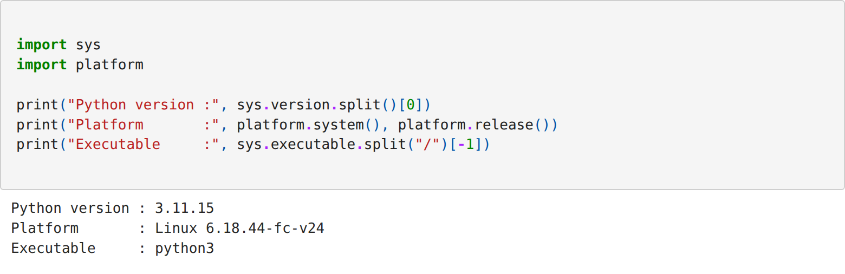
Step 2: Importing the analytics libraries and verifying their versions
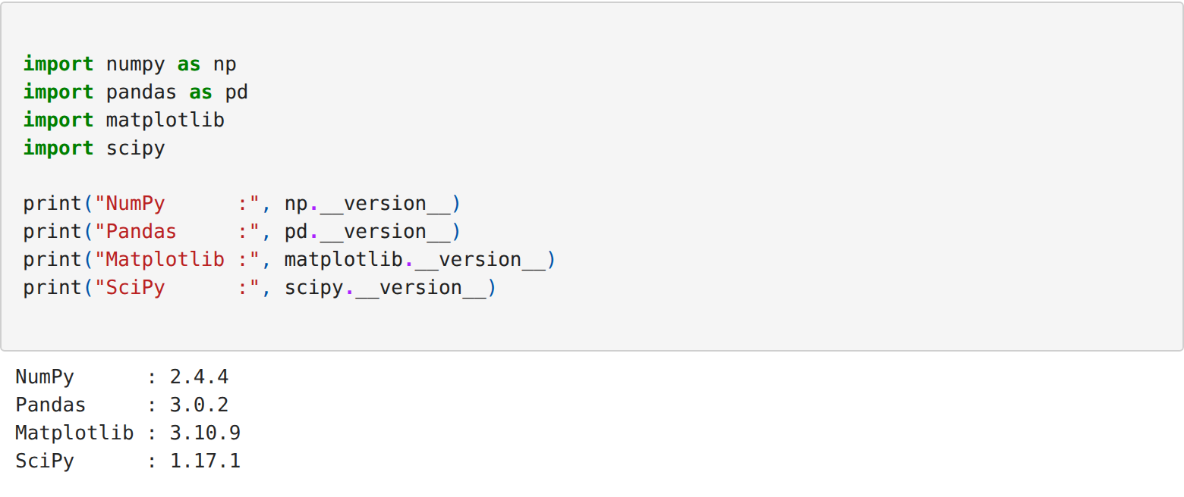
Step 3: Executing a basic NumPy program in a Code cell
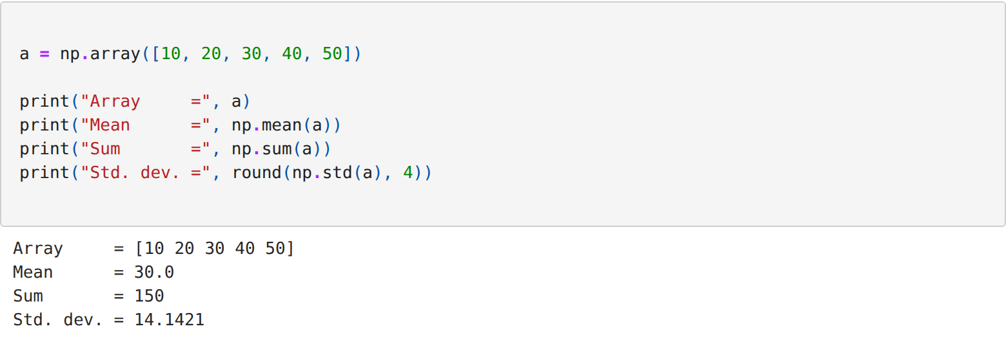
Step 4: Creating a Pandas DataFrame and computing a summary value
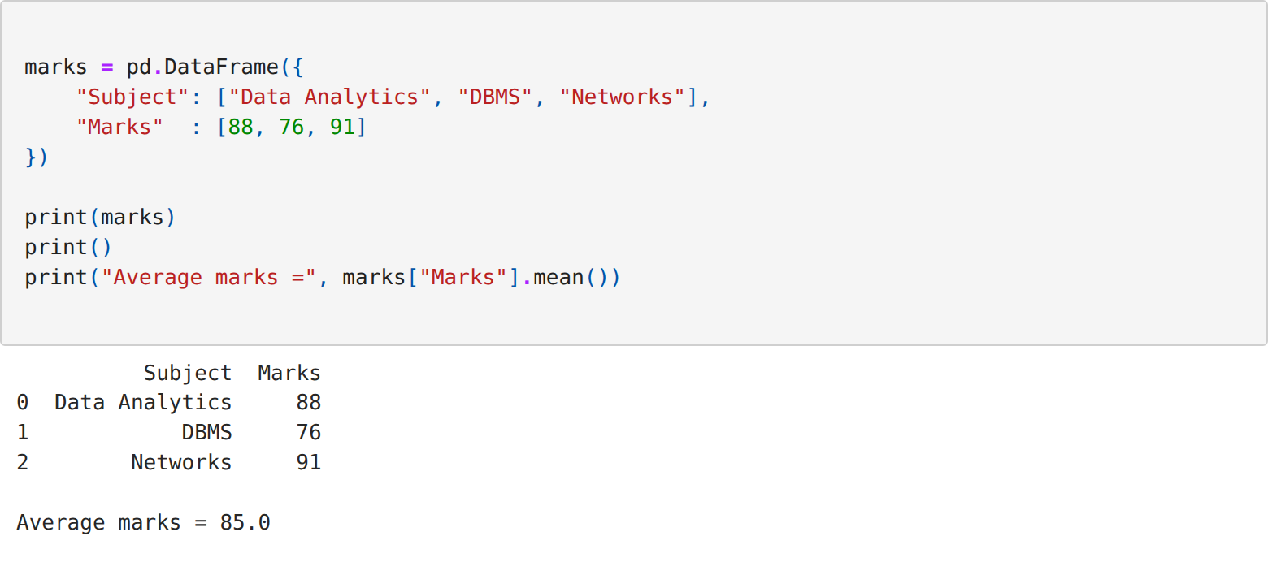
Step 5: Verifying Matplotlib with a simple plot
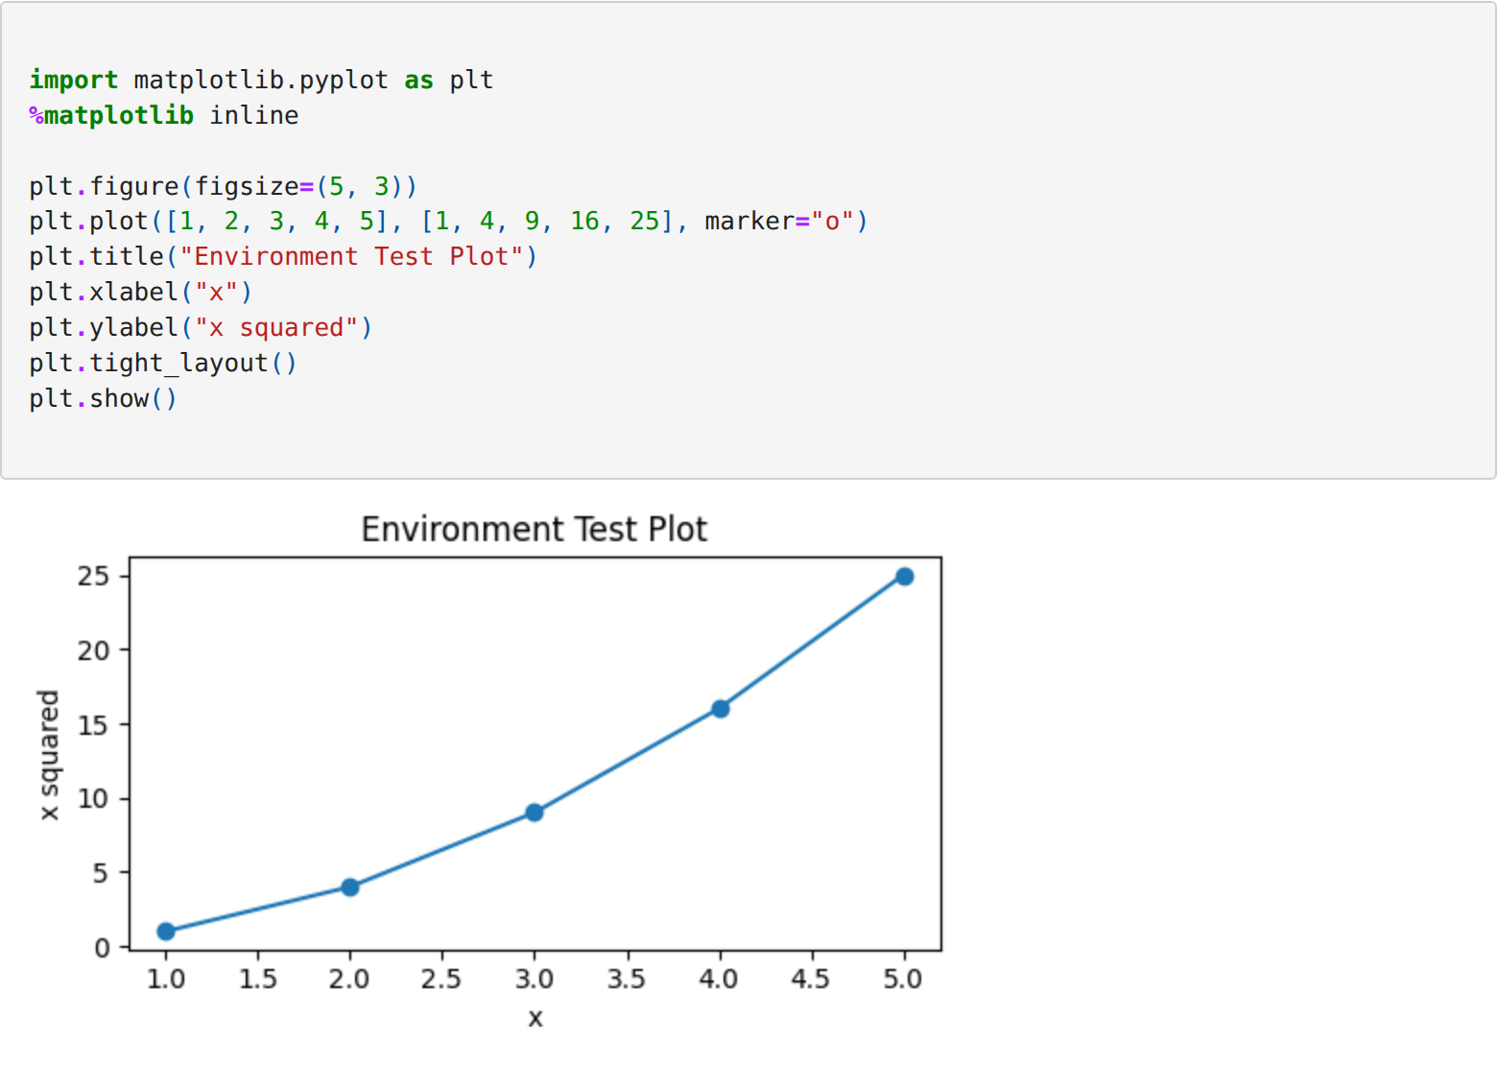
Step 6: Loading the anime dataset into the notebook
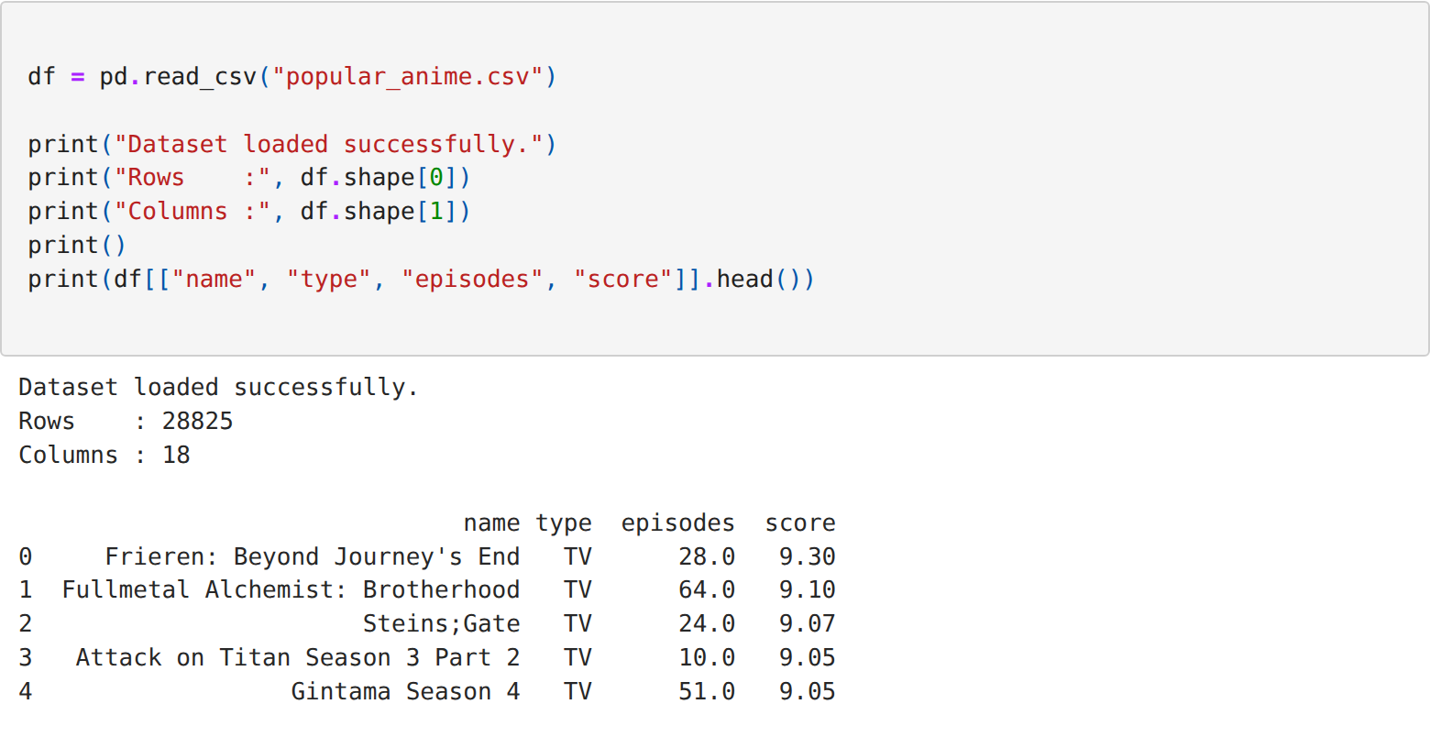
RESULT:
Thus the Python environment was set up successfully, Jupyter Notebook was configured, the required data analytics libraries were installed and their versions verified, Code and Markdown cells were created and executed, and the anime dataset was loaded and plotted successfully.

