EX. NO: 2
EXPLORATORY DATA ANALYSIS (EDA) - DATA IMPORT AND EXPORT
AIM:
To import data into a Pandas DataFrame from different sources and formats, control the import using the available parameters, and export the data to CSV, Excel, JSON and other formats, verifying each exported file by reading it back.
ALGORITHM:
- Import the Pandas library and the required supporting modules.
- Import the dataset from the CSV file using the read_csv function.
- Display the shape, column names and first few records of the imported data.
- Import only the required columns using the usecols parameter.
- Import a limited number of rows using the nrows parameter.
- Import the file in chunks using the chunksize parameter and process each chunk.
- Create a smaller working subset of the data for the export operations.
- Export the subset to a CSV file using the to_csv function.
- Export the subset to an Excel file using the to_excel function.
- Export the subset to a JSON file using the to_json function.
- Export the subset to a pickle file using the to_pickle function.
- Read each of the exported files back into a DataFrame to verify the export.
- List the created files with their sizes and observe the result.
PROGRAM:
Step 1: Importing the complete dataset from the CSV file
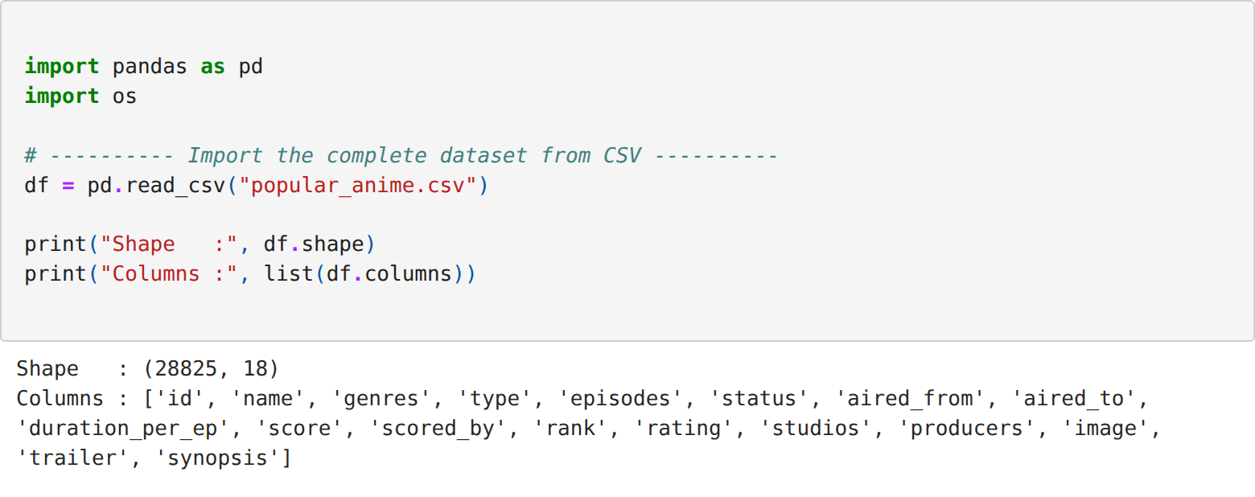
Step 2: Inspecting the imported data and its memory usage
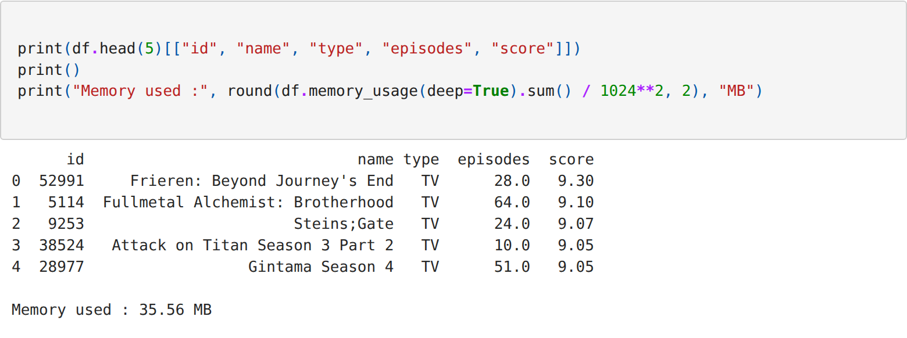
Step 3: Importing only the required columns using the usecols parameter
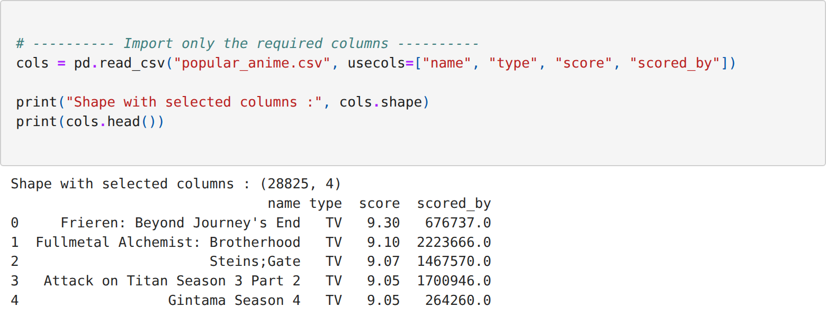
Step 4: Importing a limited number of rows using the nrows parameter
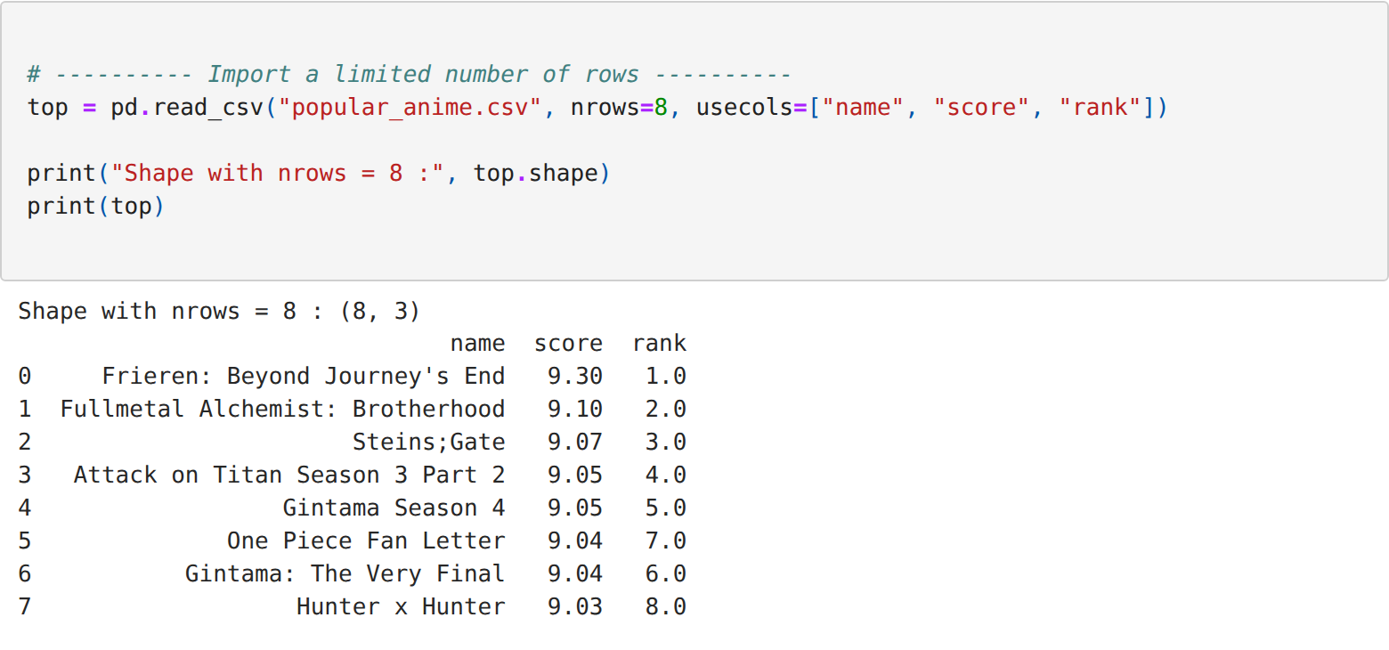
Step 5: Importing the file in chunks using the chunksize parameter
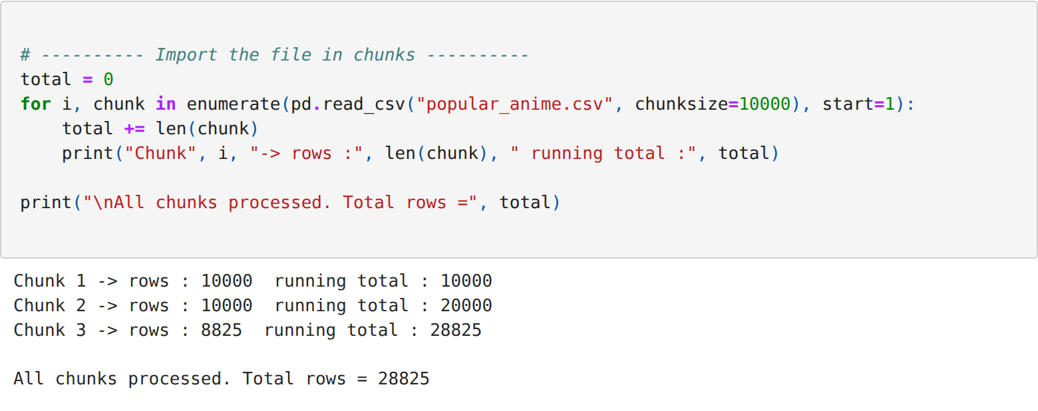
Step 6: Creating a working subset of the data for the export operations
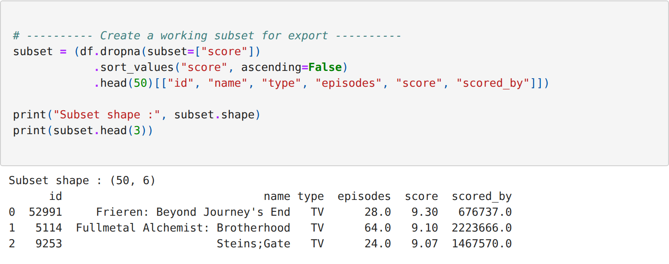
Step 7: Exporting the data to CSV, Excel, JSON and pickle formats
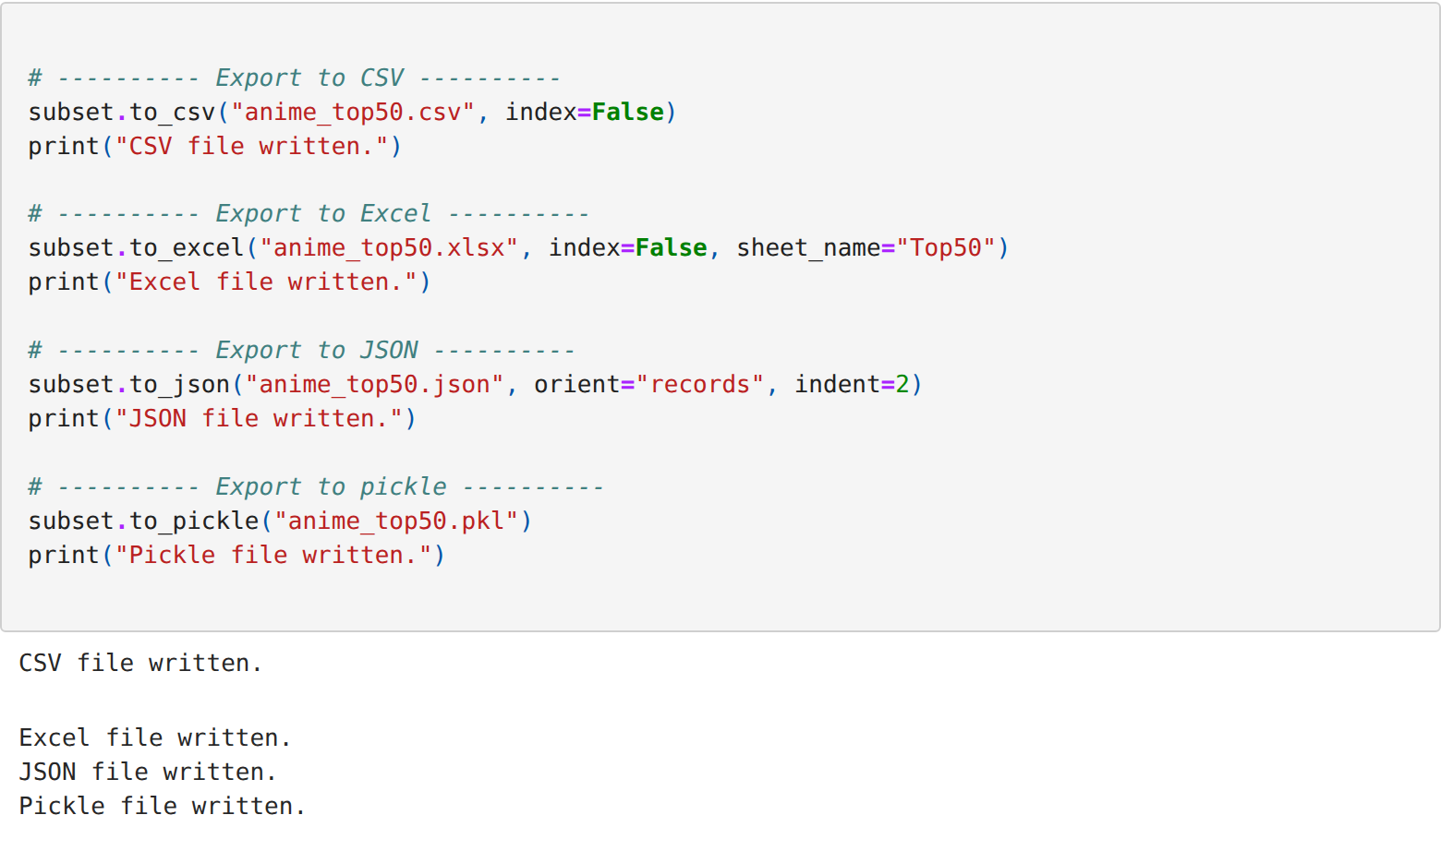
Step 8: Reading the exported files back to verify the export
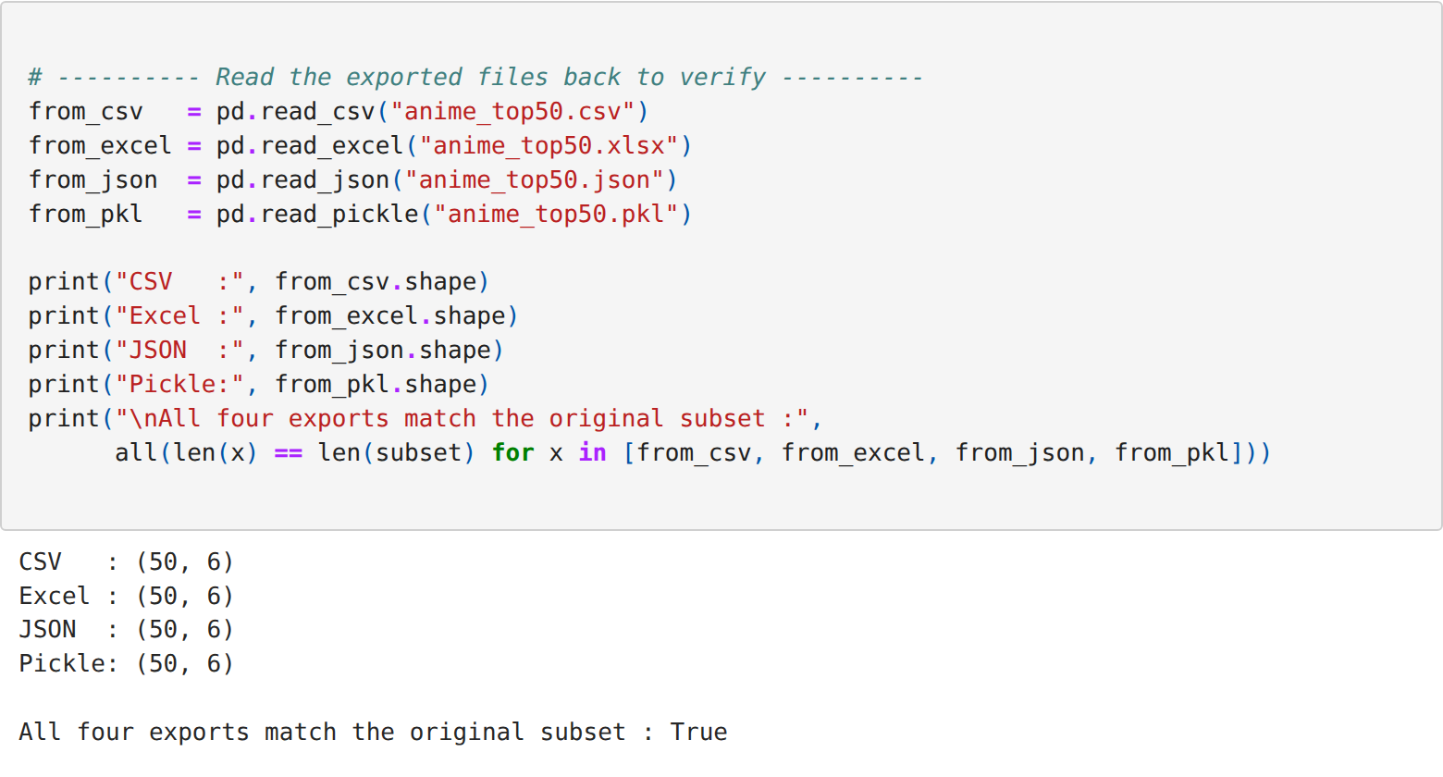
Step 9: Listing the exported files with their sizes
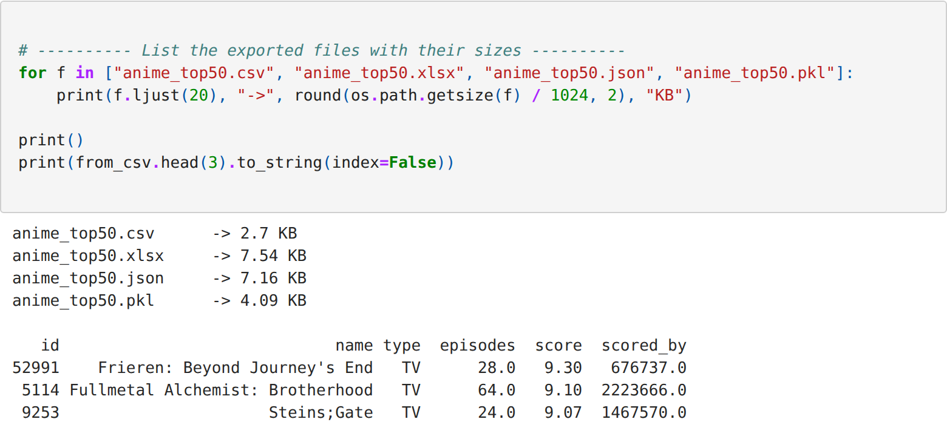
RESULT:
Thus the data was imported into a Pandas DataFrame from the CSV file using the different import parameters, exported to the CSV, Excel, JSON and pickle formats, and every exported file was read back and verified successfully.

