EX. NO: 3
EXPLORATORY DATA ANALYSIS (EDA) - DATA CLEANING AND DATA TRANSFORMATION
AIM:
To identify and handle missing values, remove duplicate records, correct data types, clean textual columns, treat outliers, and transform the anime dataset through derived columns, binning, encoding and scaling so that it becomes fit for analysis.
ALGORITHM:
- Import the required libraries and load the raw dataset.
- Inspect the dataset for missing values column by column.
- Drop the columns that are not required for the analysis.
- Remove the records in which the essential fields are missing.
- Fill the remaining missing values using suitable imputation strategies.
- Detect and remove duplicate records from the dataset.
- Convert the date columns into the datetime data type.
- Extract the numeric duration in minutes from the textual duration column.
- Clean the text columns by trimming whitespace and standardising the case.
- Detect outliers in the numeric columns using the inter-quartile range method.
- Treat the detected outliers by capping them at the computed limits.
- Create derived columns such as the release year and the total watch time.
- Bin the score column into categorical rating bands.
- Encode the categorical columns into numeric form.
- Scale the numeric columns using min-max normalisation.
- Display the shape of the cleaned dataset and observe the result.
PROGRAM:
Step 1: Loading the raw dataset
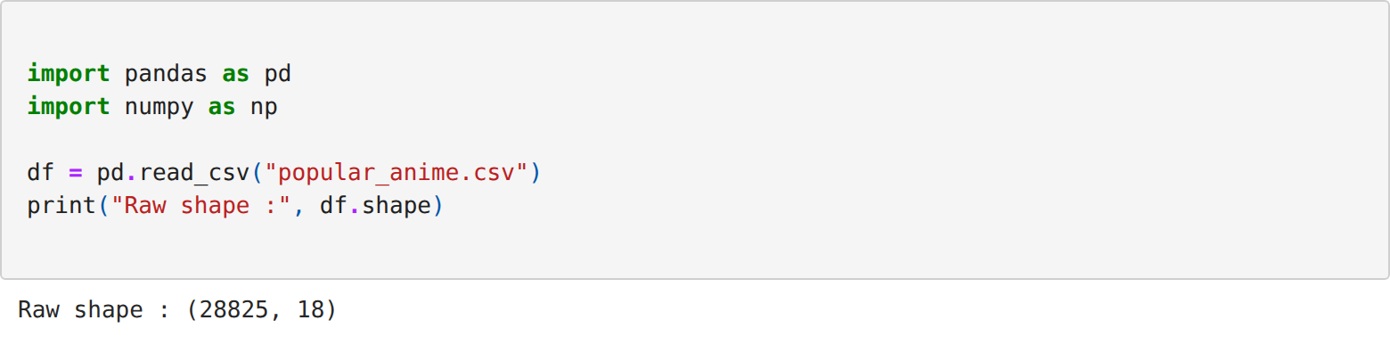
Step 2: Inspecting the missing values column by column
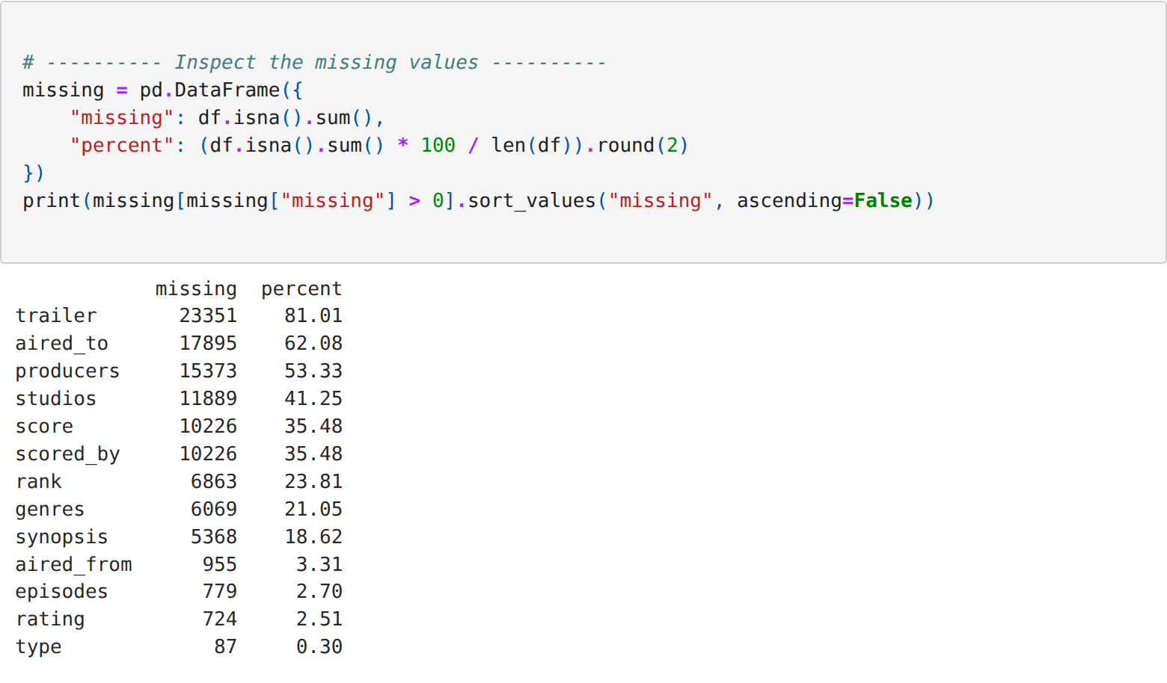
Step 3: Dropping the unwanted columns and the incomplete records
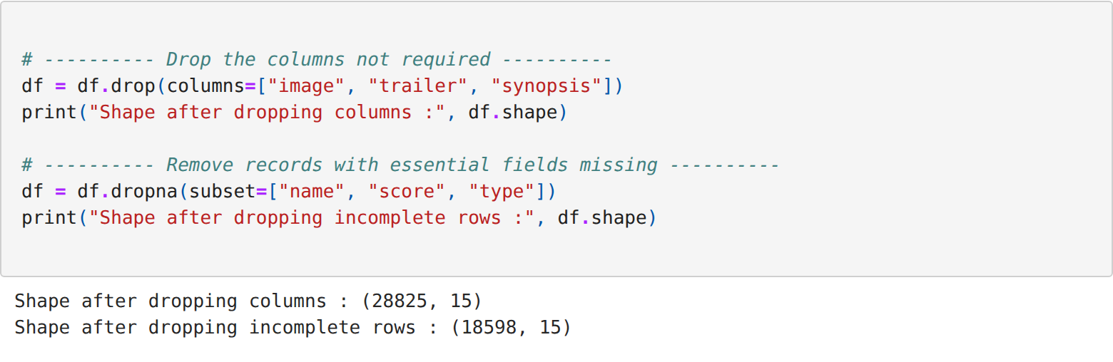
Step 4: Filling the remaining missing values by imputation
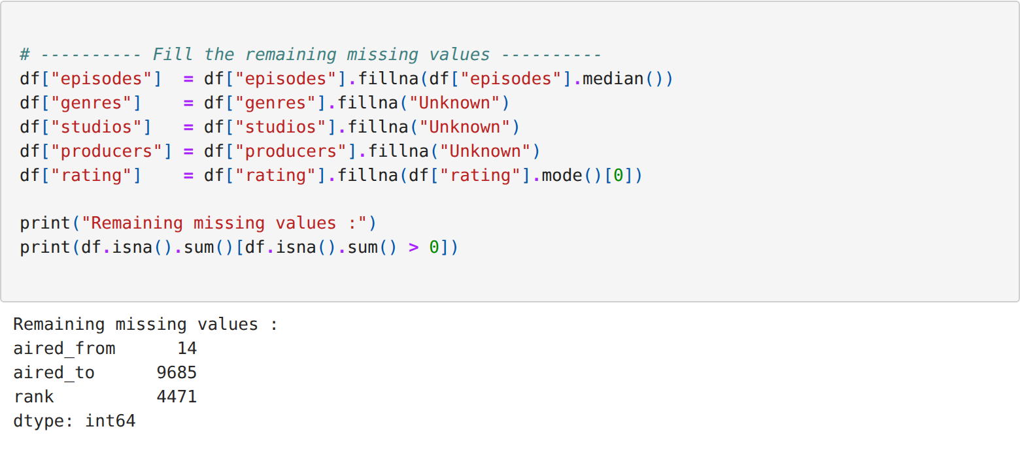
Step 5: Detecting and removing the duplicate records
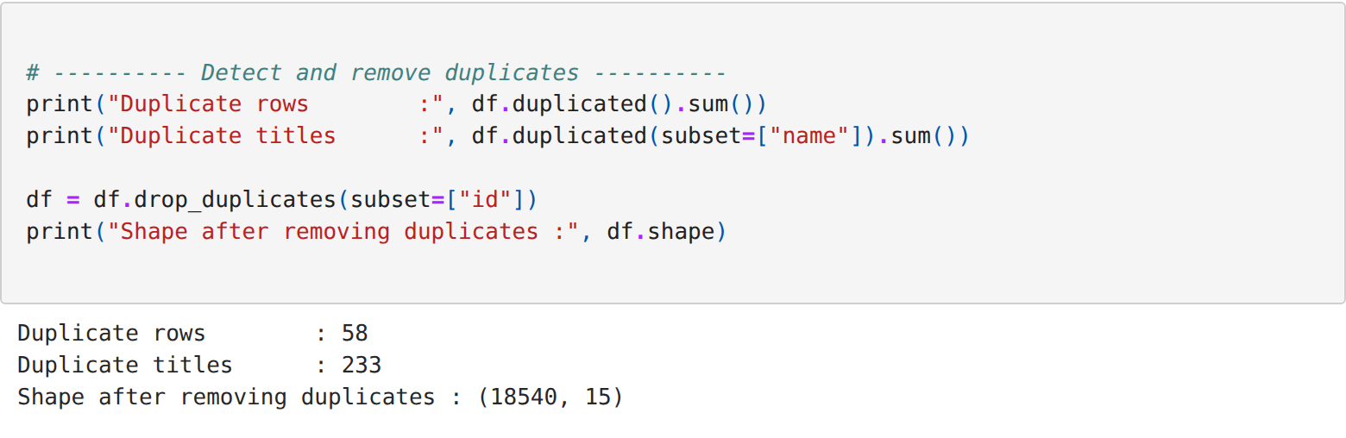
Step 6: Converting the date columns into the datetime data type
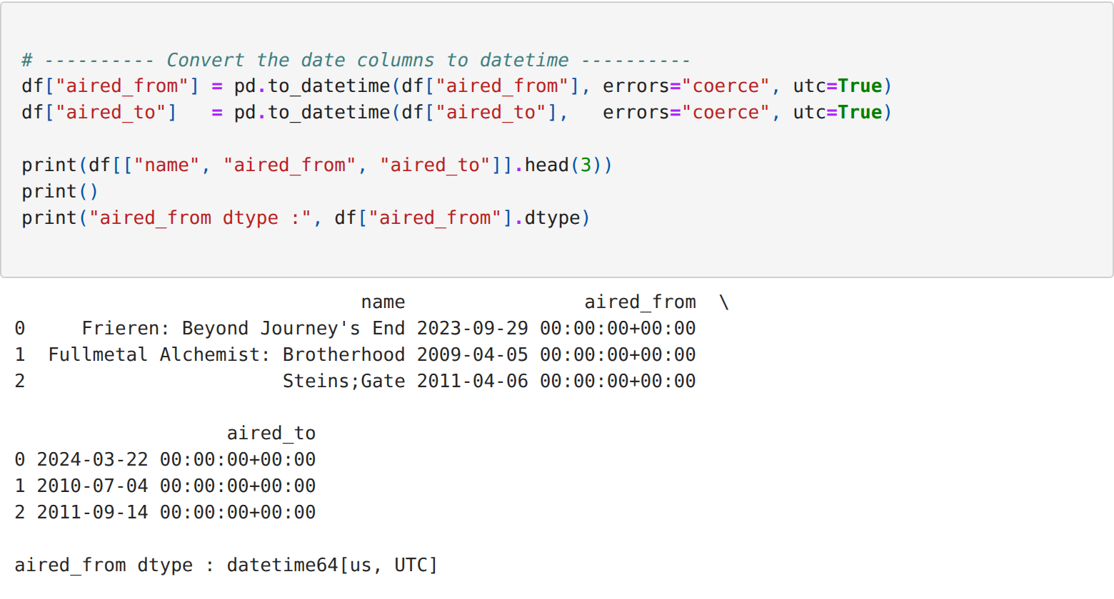
Step 7: Extracting the numeric duration in minutes from the text column
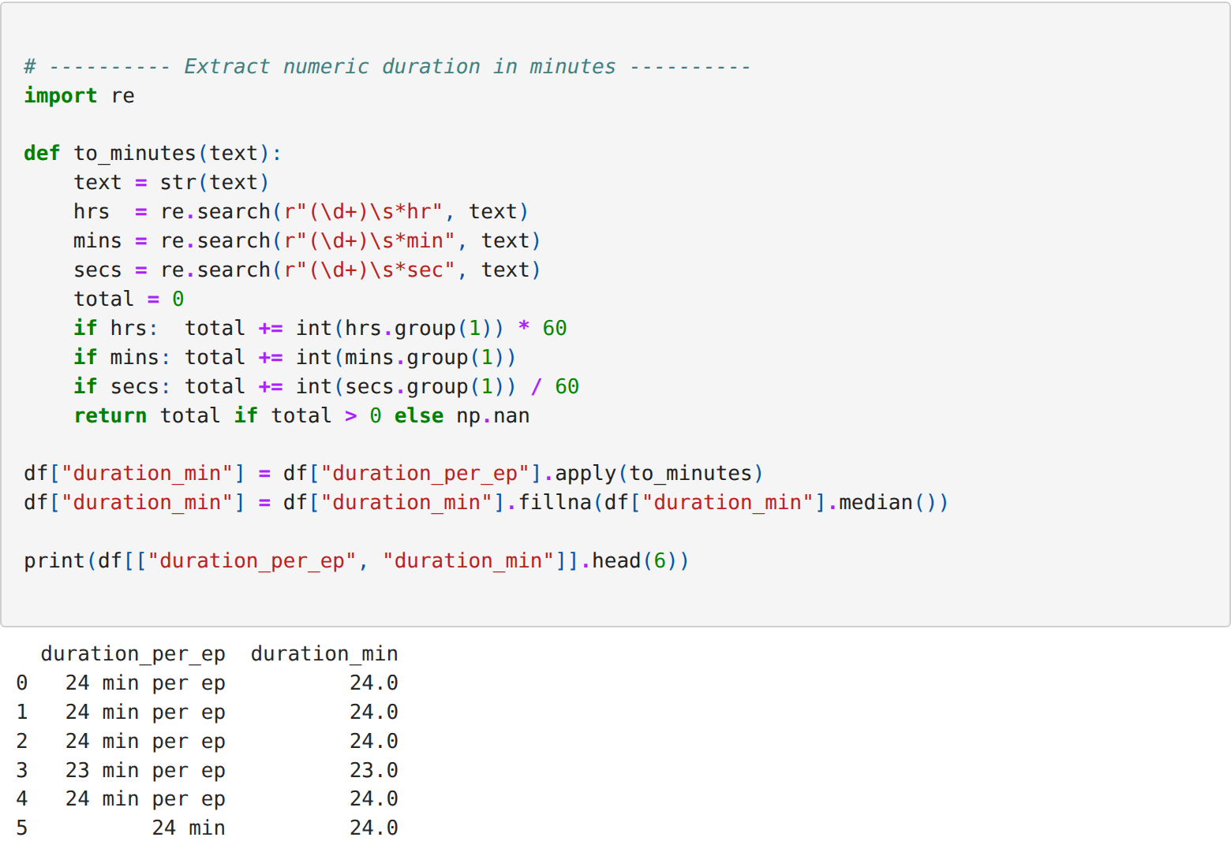
Step 8: Cleaning the text columns by trimming and standardising the case
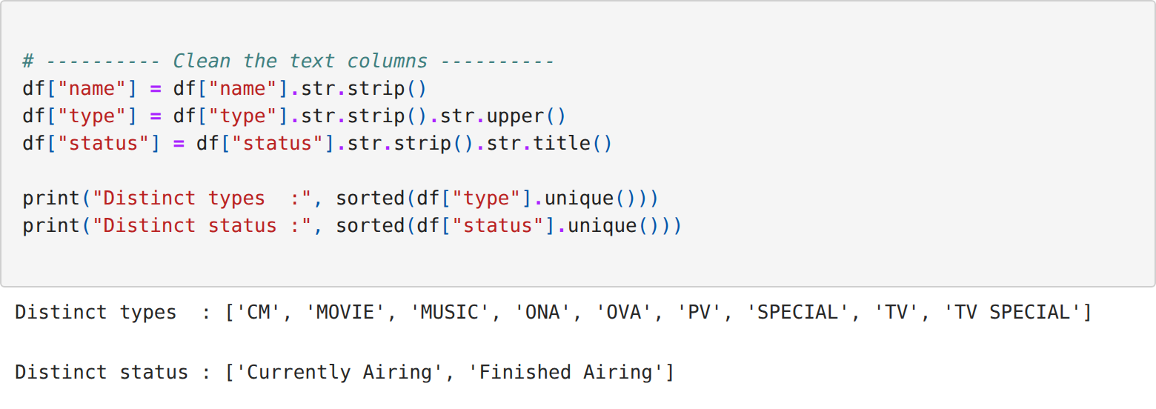
Step 9: Detecting the outliers using the inter-quartile range method
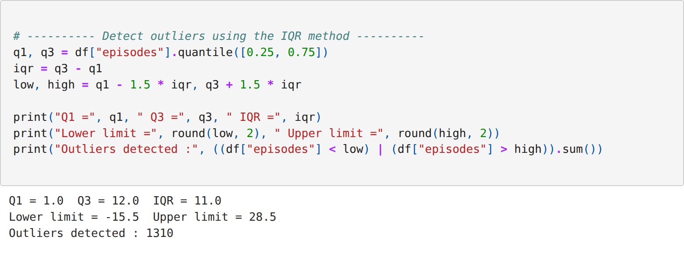
Step 10: Treating the outliers by capping them at the computed limits
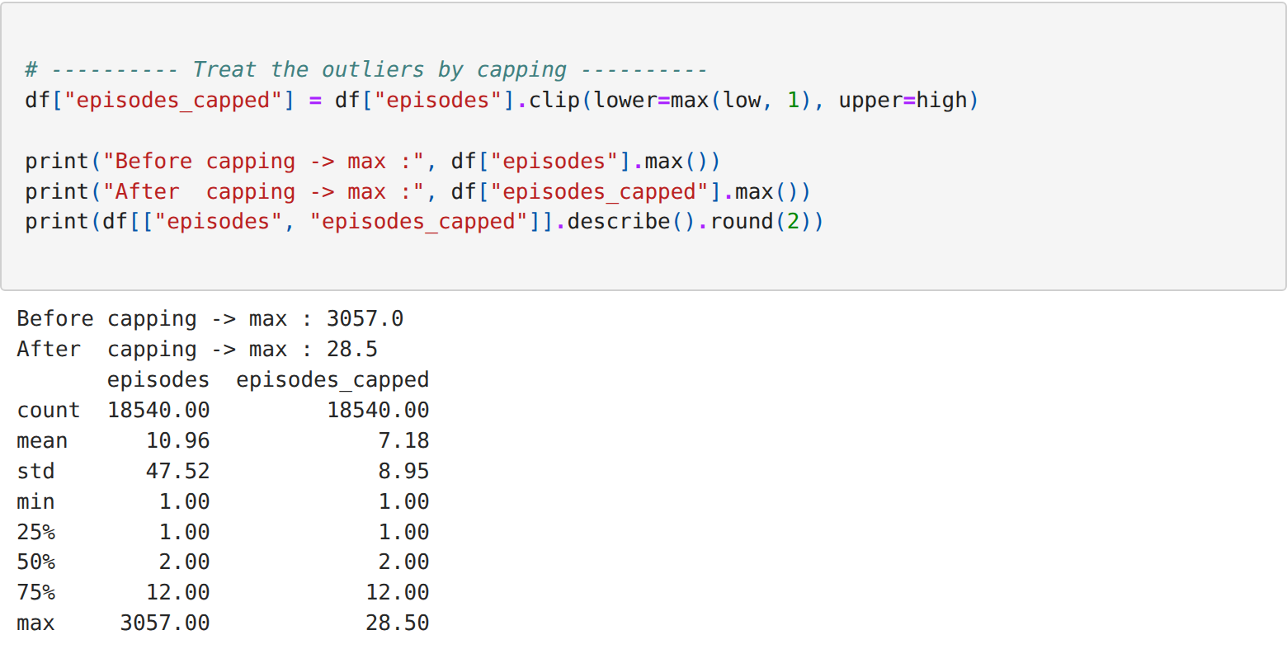
Step 11: Creating the derived columns - release year and total watch time
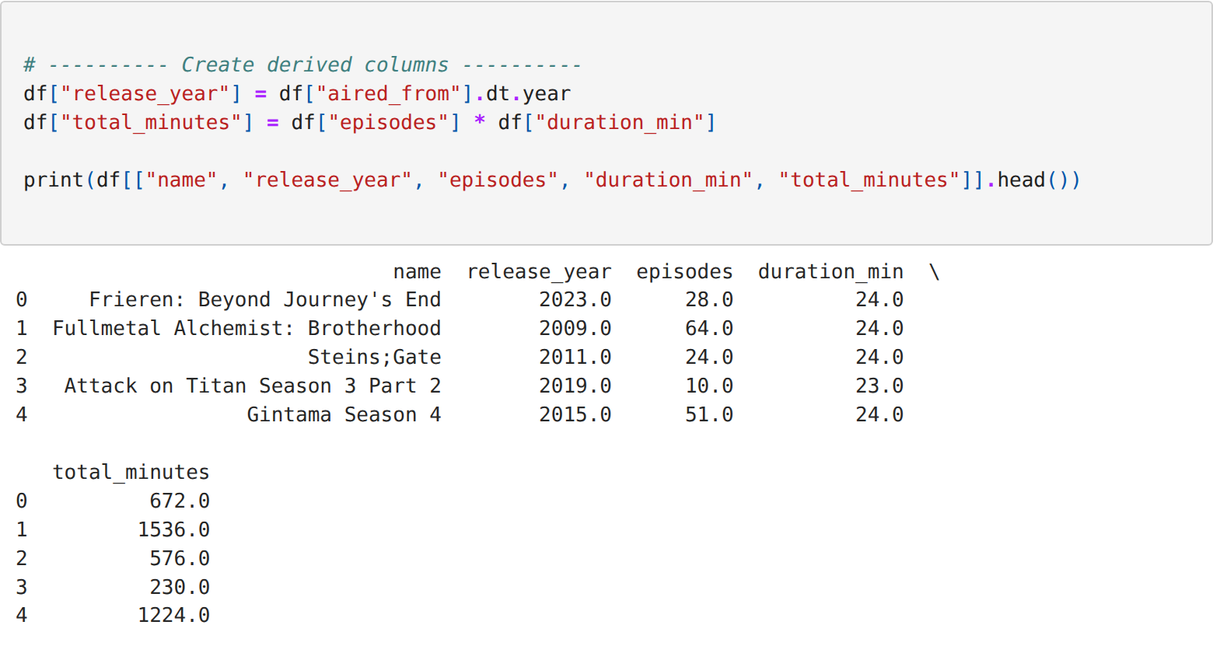
Step 12: Binning the score column into categorical rating bands
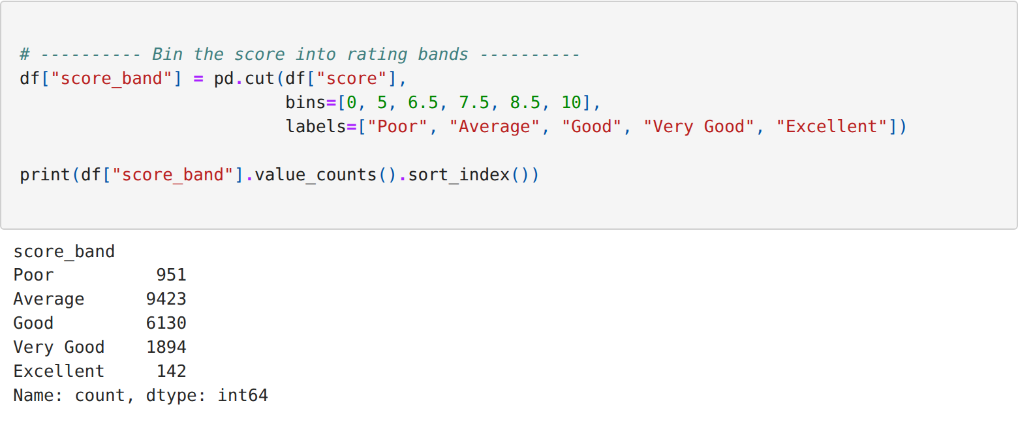
Step 13: Encoding the categorical columns into numeric form
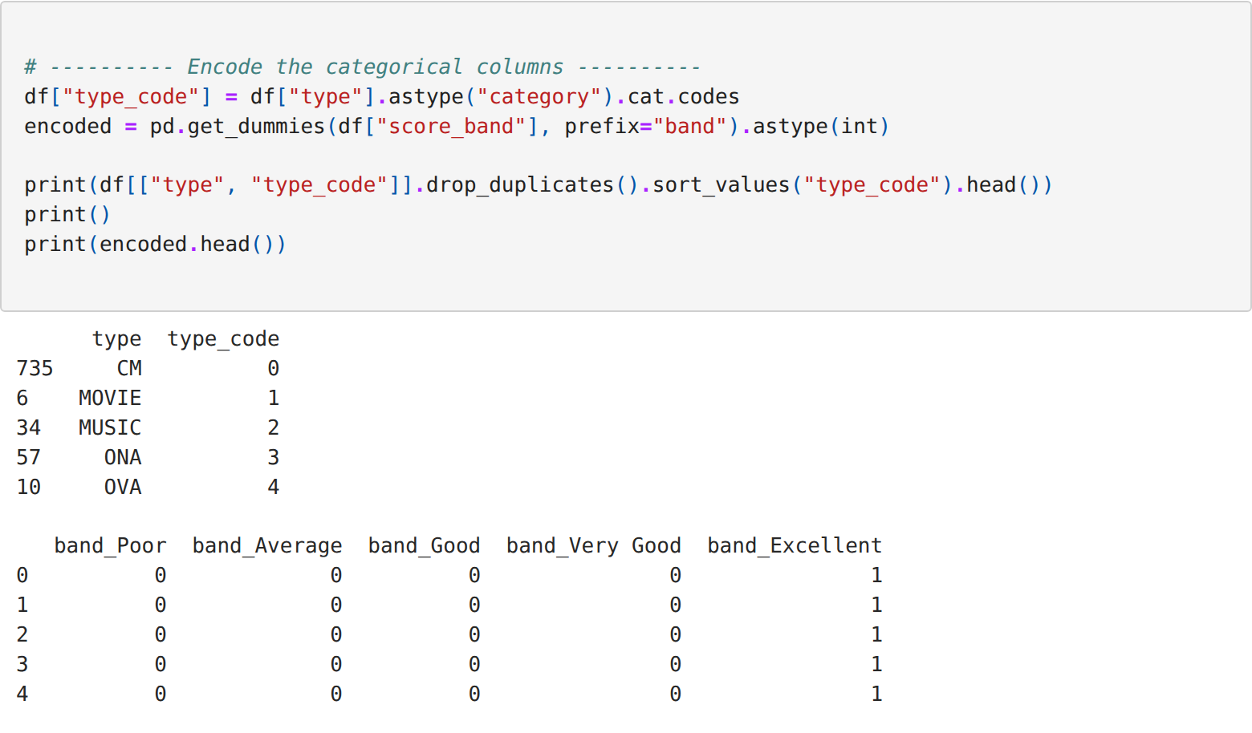
Step 14: Scaling the numeric columns using min-max normalisation
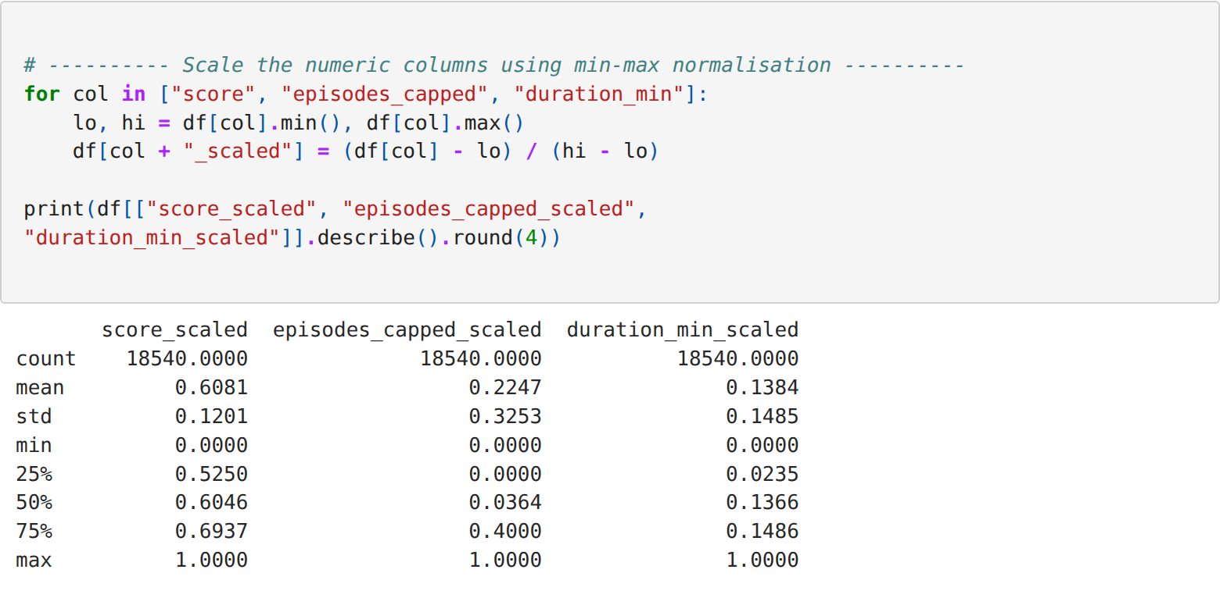
Step 15: Displaying the final cleaned dataset
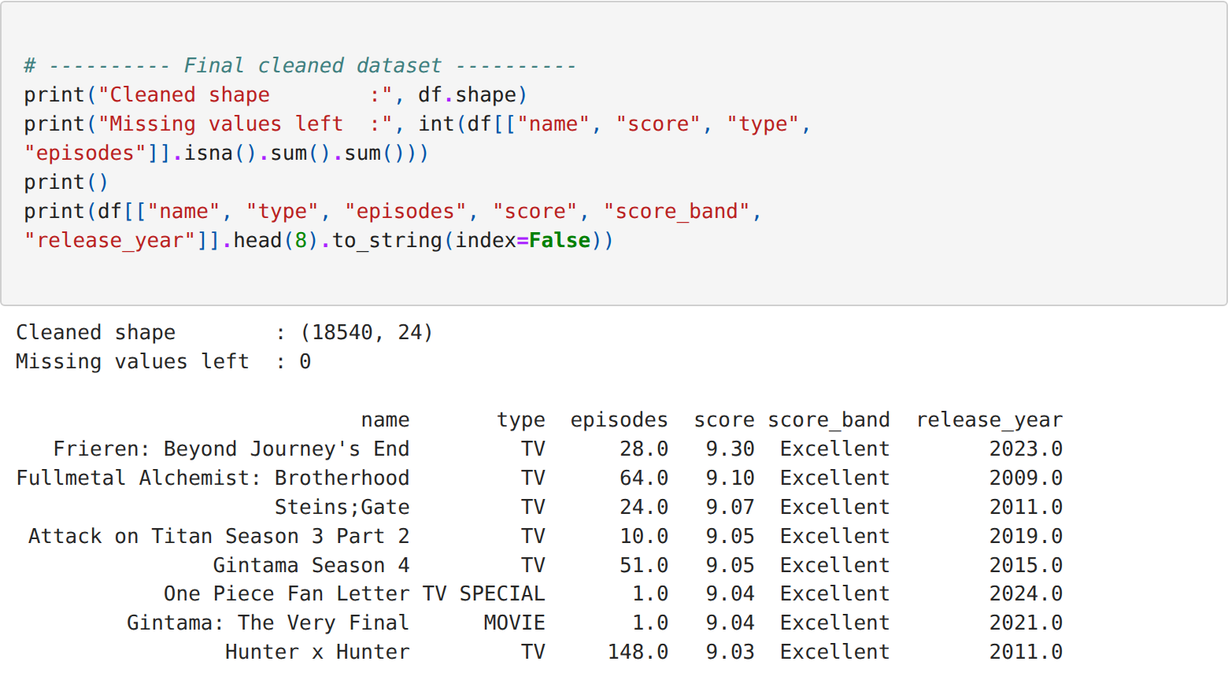
RESULT:
Thus the anime dataset was cleaned by handling the missing values, removing the duplicate records, correcting the data types and treating the outliers, and it was transformed through derived columns, binning, encoding and scaling, and the output was verified successfully.

