EX. NO: 4b
EXPLORATORY DATA ANALYSIS (EDA) - DATA INSPECTION, FILTERING, STATISTICAL ANALYSIS AND CORRELATION
AIM:
To perform an advanced exploratory analysis of the anime dataset using grouped aggregation, pivot tables and cross tabulation, and to measure the strength and the statistical significance of the relationships between the variables using the Pearson, Spearman and Kendall correlation coefficients.
ALGORITHM:
- Import the required libraries including SciPy and load the dataset.
- Prepare the analysis subset by removing the incomplete records and deriving new columns.
- Group the data by category and compute the aggregate statistics for each group.
- Apply multiple aggregate functions simultaneously using the agg function.
- Construct a pivot table summarising one measure across two categorical dimensions.
- Construct a cross tabulation of two categorical columns.
- Filter the grouped results to retain only the significant groups.
- Compute the Pearson correlation coefficient and its p value for a pair of variables.
- Compute the Spearman rank correlation coefficient for the same pair.
- Compute the Kendall tau correlation coefficient for the same pair.
- Compare the three coefficients and interpret the nature of the relationship.
- Compute the full correlation matrix of the derived numeric features.
- Test the statistical significance of every pair in the matrix.
- Visualise the relationship using a scatter plot with the fitted regression line.
- Observe the result.
PROGRAM:
Step 1: Loading the dataset for the advanced analysis
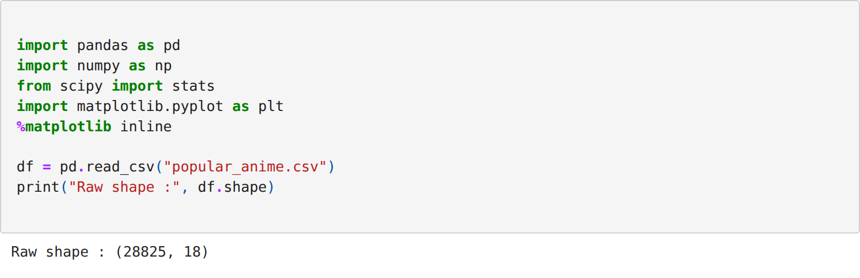
Step 2: Preparing the analysis subset and deriving the new columns
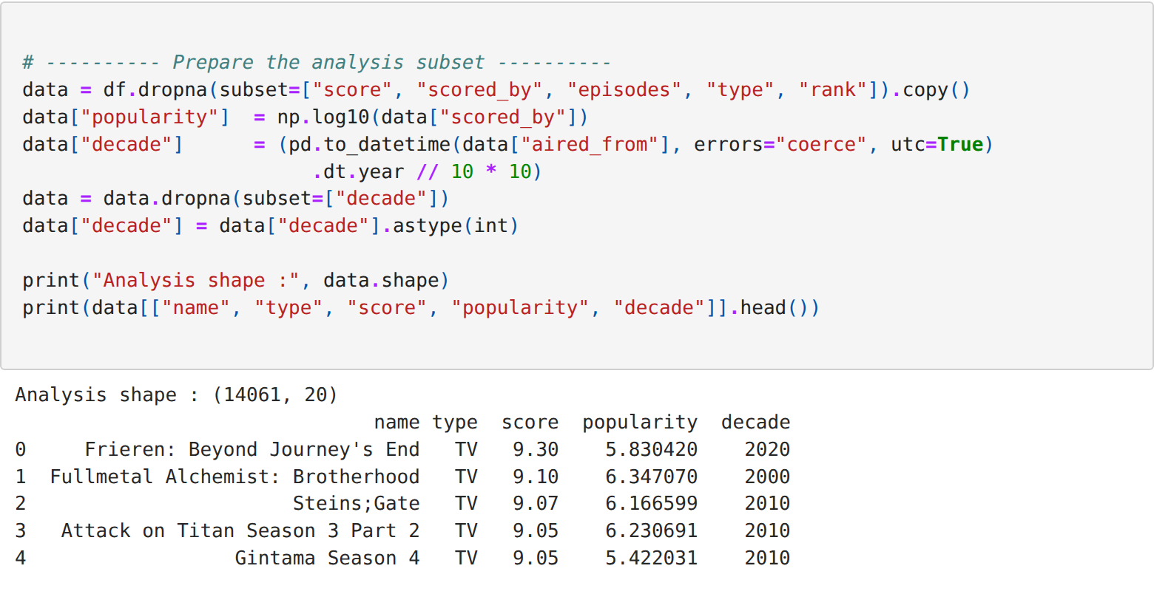
Step 3: Computing the grouped aggregate statistics
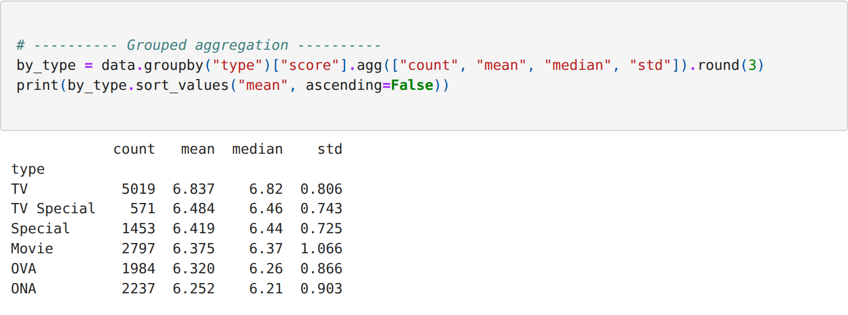
Step 4: Applying multiple aggregate functions simultaneously
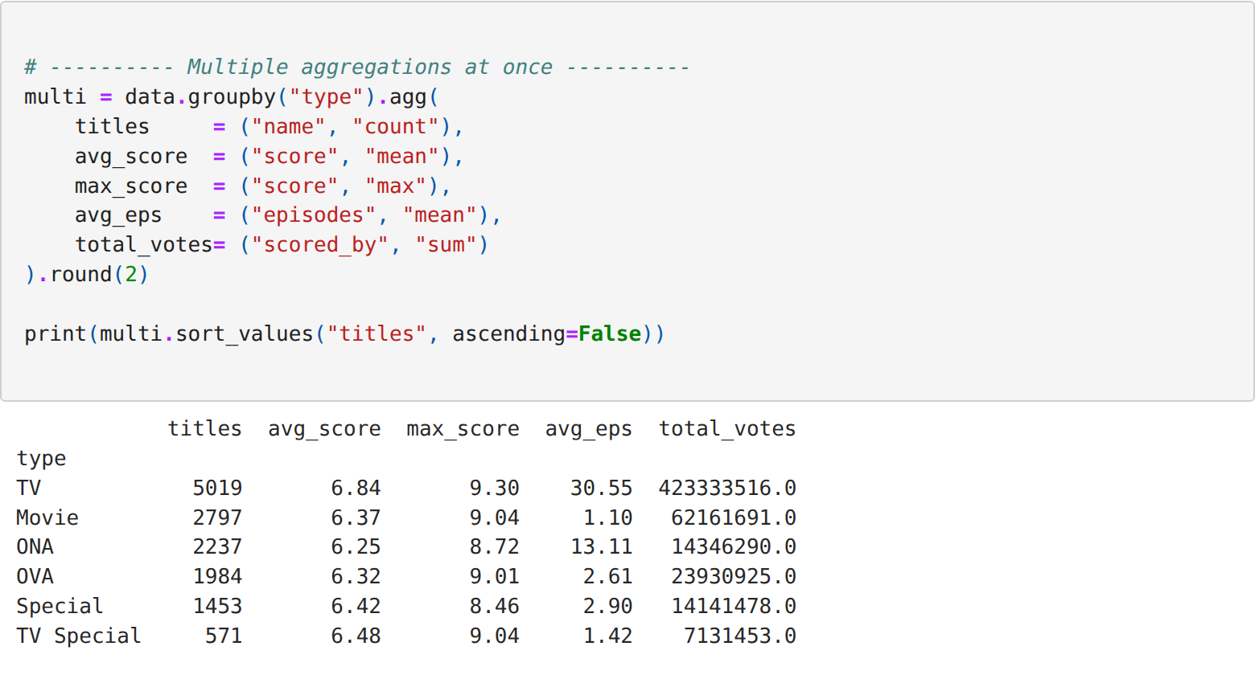
Step 5: Constructing a pivot table across two dimensions
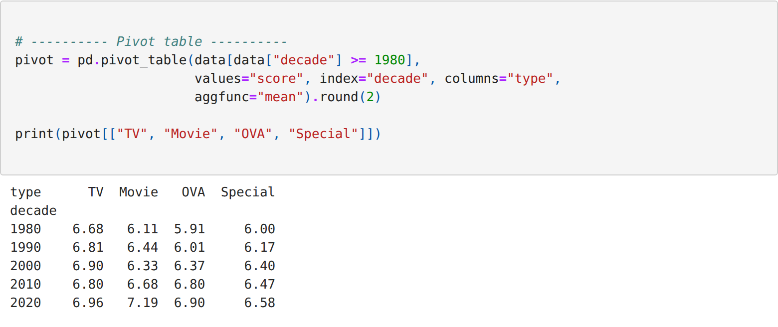
Step 6: Constructing a cross tabulation of two categorical columns
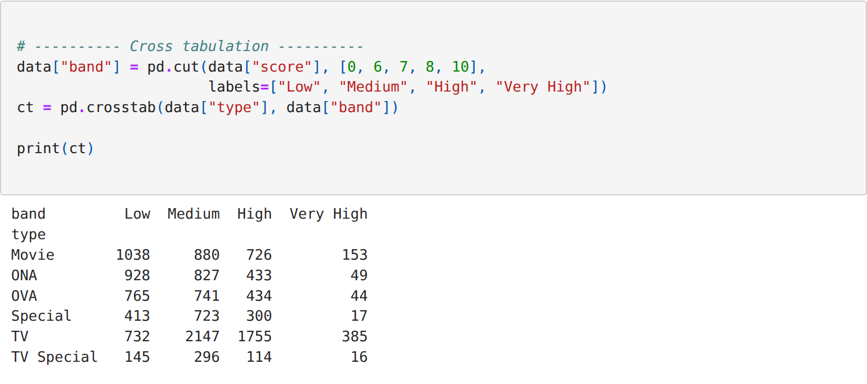
Step 7: Retaining only the statistically significant groups
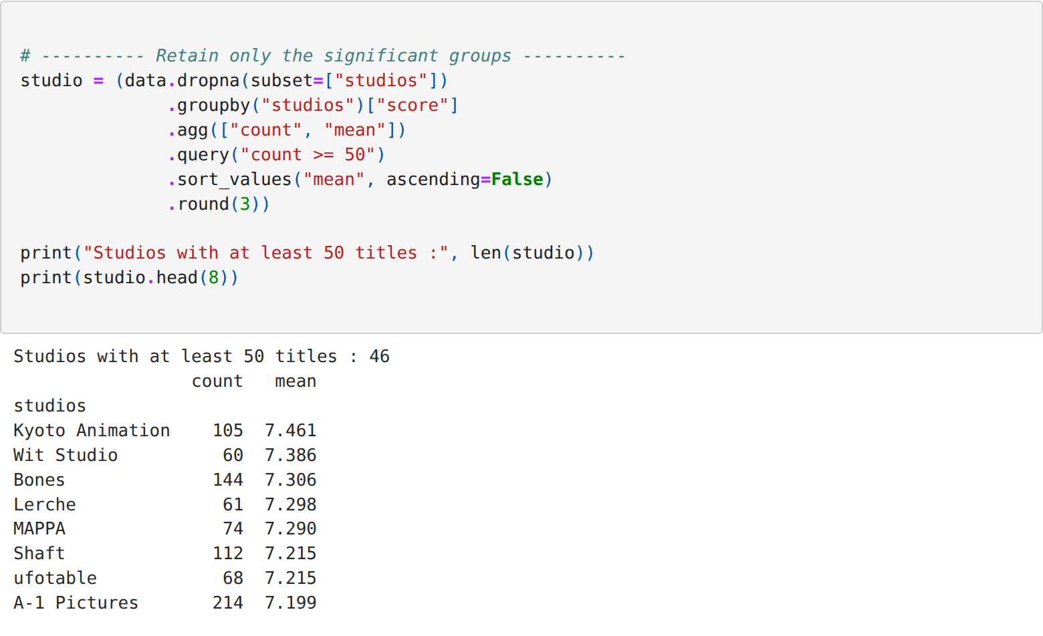
Step 8: Computing the Pearson correlation and its significance
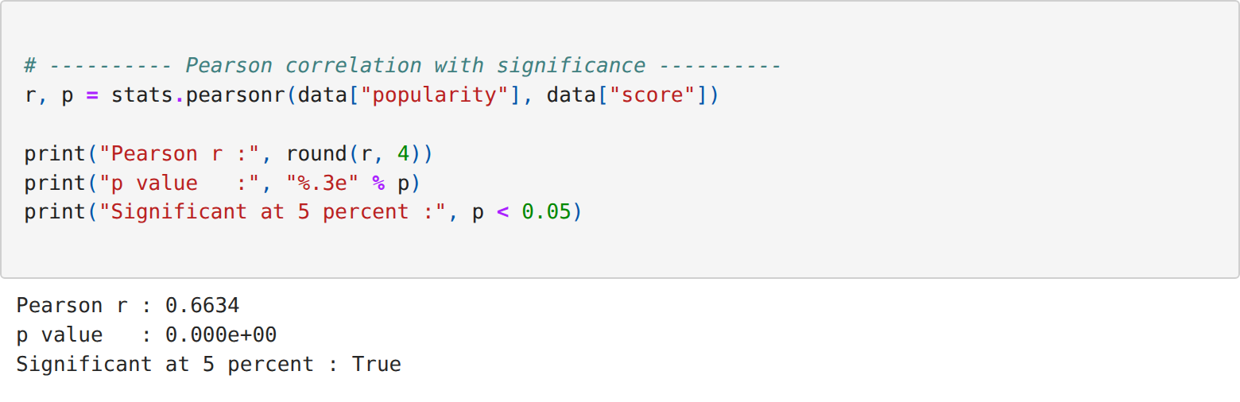
Step 9: Computing the Spearman and the Kendall correlation coefficients
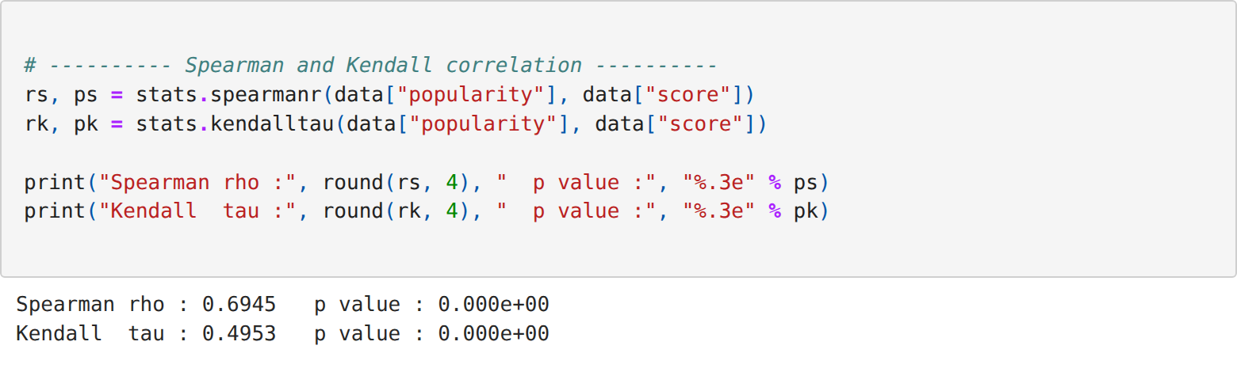
Step 10: Comparing the three correlation coefficients
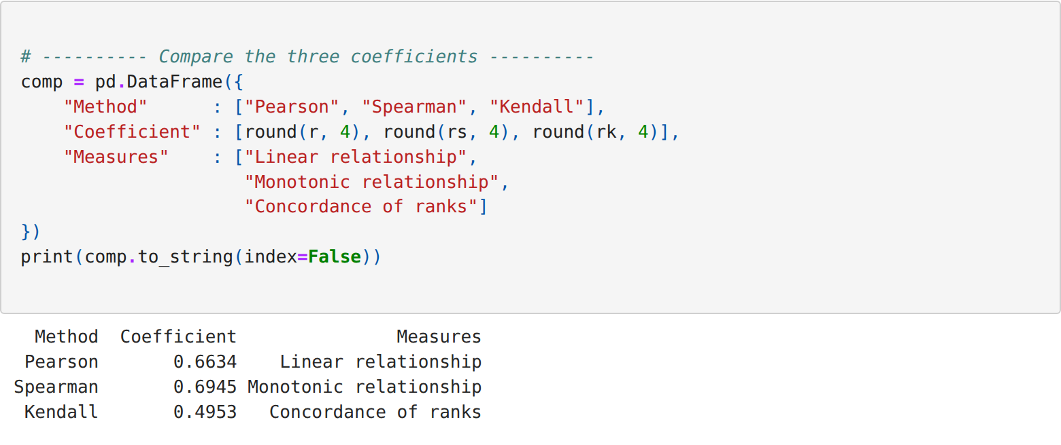
Step 11: Computing the full correlation matrix of the derived features
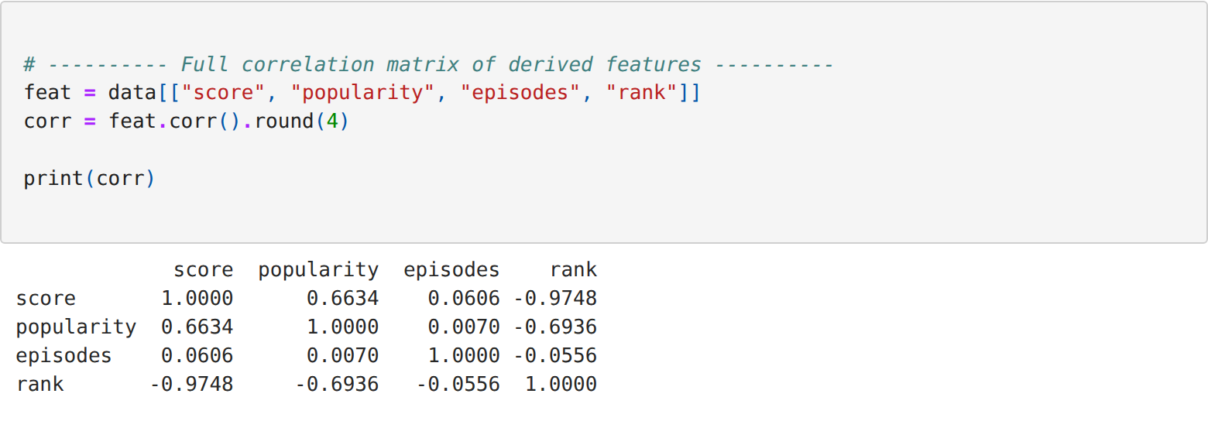
Step 12: Testing the significance of every pair in the matrix
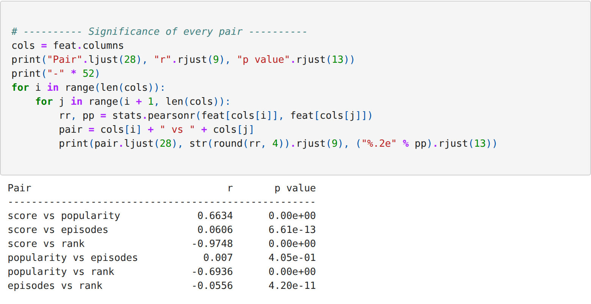
Step 13: Visualising the relationship with a fitted regression line
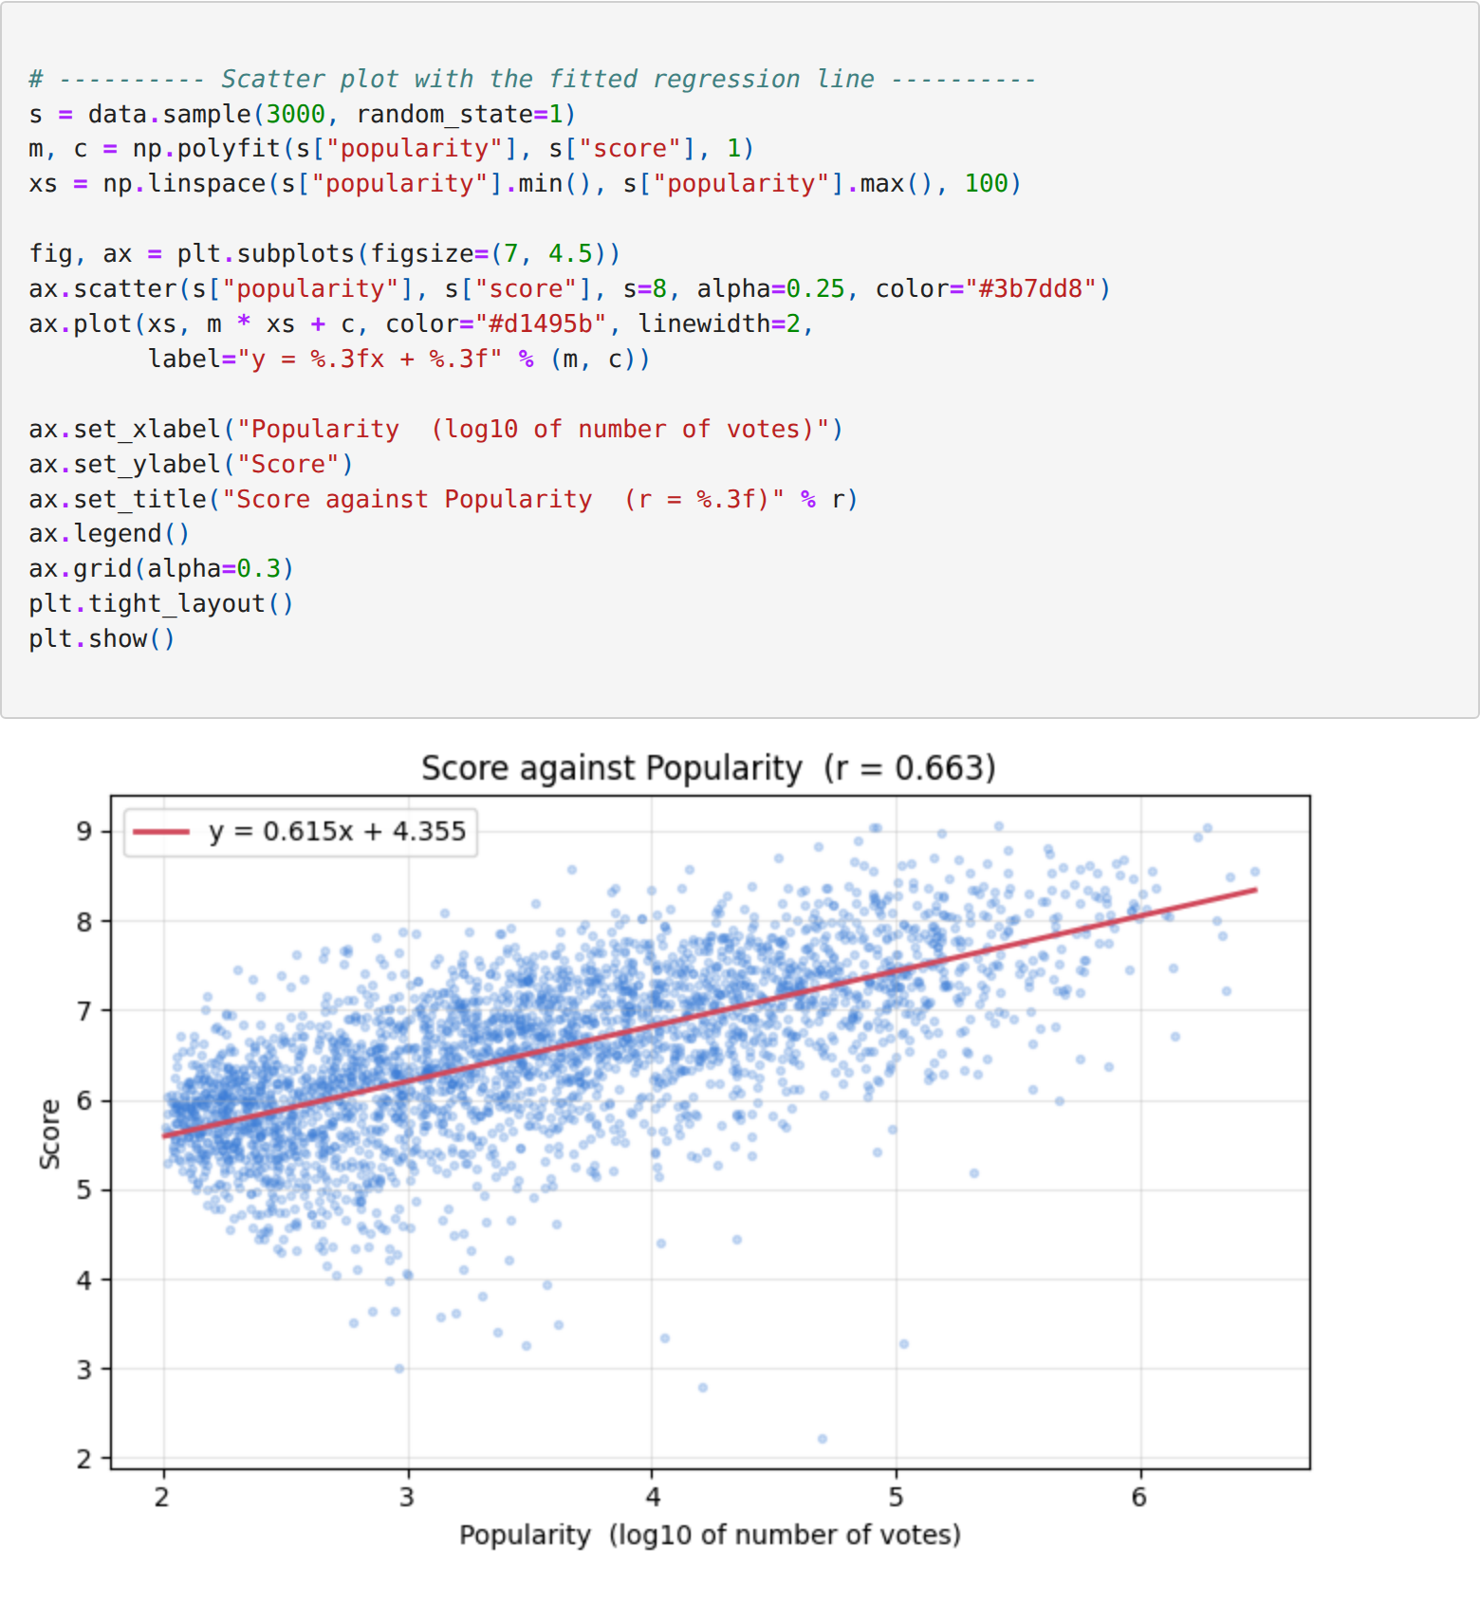
RESULT:
Thus the advanced exploratory analysis of the anime dataset was carried out using grouped aggregation, pivot tables and cross tabulation, the Pearson, Spearman and Kendall correlation coefficients were computed with their significance, and the output was verified successfully.

