EXPERIMENT-1
ROLL NO:240701533 NAME:SRITHIKA.S
USER INTERFACE AND DESIGN COMAPARSION OF UI DESIGN BETWEEN TWO FIGMA CREATION
BAD WEBSITE: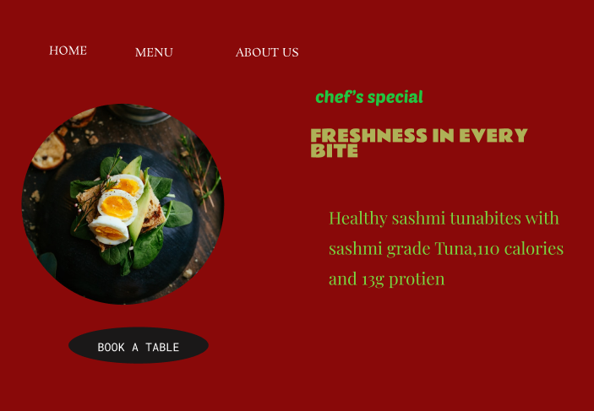

GOOD WEBSITE: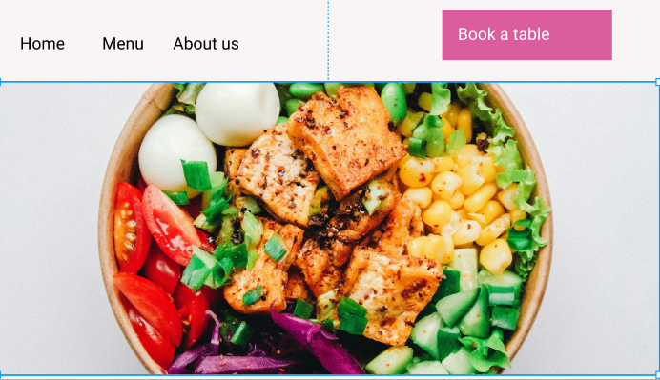

PROTOTYPE LINK:
https://www.figma.com/design/m0HQMKrgyKcmFK1nSLieen/Untitled?node-id=11-25&t=s4GXtjZorkz6yP2L-1
https://www.figma.com/design/m0HQMKrgyKcmFK1nSLieen/Untitled?node-id=1-2&t=s4GXtjZorkz6yP2L-1

The two websites have distinct designs and approaches. Here's a comparison:
BAD DESIGN
1. Design Style
- Harsh background color:
The dark red background is too intense and dominates the screen, making the page feel heavy and uncomfortable.
- Poor color contrast:
Green and yellow text on a dark red background reduces readability and looks visually unbalanced.
2. Navigation
- Navigation items (HOME, MENU, ABOUT US) are:
  - Too small
  - Not clearly separated
  - Not visually highlighted as clickable
3. Content
- Too much text for a hero section.
- No clear spacing between heading and description.
- Information feels cluttered instead of appetizing.

4. Purpose
A restaurant website hero section should:
- Make food look irresistible
- Communicate brand quality
- Encourage action (Book / Order / View Menu)
GOOD DESIGN
1. Design Style
- Clean and minimal layout
Plenty of white space makes the design feel modern and premium.
- Neutral background
Light background allows the food image to stand out naturally.
- Consistent color palette
Pink CTA button contrasts well without being harsh.
- High-quality food image
The image is appetizing, bright, and professionally framed.
2. Navigation
- Navigation items (Home, Menu, About us) are:
  - Clearly visible
  - Properly spaced
  - Easy to understand
- Navigation is placed at the top, where users expect it.
- CTA (Book a table) is separated and highlighted.
3. Content
- No unnecessary text.
- Focus is on the food image, which communicates quality instantly.
- Button text is short and action-oriented: “Book a table”.
- No grammar or spelling mistakes.
4. Purpose
A restaurant homepage should:
- Create appetite
- Build trust
- Encourage action
This design succeeds because:
- Food image triggers hunger
- CTA button is visible and clickable
- Layout guides the eye naturally (left → center → CTA)

