**6 Reasons Why JavaScript’s Async/Await Blows Promises Away (Tutorial)**

In case you missed it, Node now supports async/await out of the box since version 7.6. If you haven’t tried it yet, here are a bunch of reasons with examples why you should adopt it immediately and never look back.

### https://hackernoon.com/6-reasons-why-javascripts-async-await-blows-promises-away-tutorial-c7ec10518dd9

### Async/await 101

For those who have never heard of this topic before, here’s a quick intro

* Async/await is a new way to write asynchronous code. Previous options for asynchronous code are callbacks and promises.
* Async/await is actually built on top of promises. It cannot be used with plain callbacks or node callbacks.
* Async/await is, like promises, non blocking.
* Async/await makes asynchronous code look and behave a little more like synchronous code. This is where all its power lies.

### Syntax

Assuming a function getJSON that returns a promise, and that promise resolves with some JSON object. We just want to call it and log that JSON, then return "done".

This is how you would implement it using promises

const makeRequest = () =>

getJSON()

.then(data => {

console.log(data)

return "done"

})

makeRequest()

-----------------------------------------------------------------------

And this is how it looks with async/await

const makeRequest = async () => {

console.log(await getJSON())

return "done"

}

makeRequest()

There are a few differences here

Our function has the keyword async before it. The await keyword can only be used inside functions defined with async. Any async function returns a promise implicitly, and the resolve value of the promise will be whatever you return from the function (which is the string "done" in our case).

The above point implies that we can’t use await in the top level of our code since that is not inside an async function.

// this will not work in top level

// await makeRequest()

// this will work

makeRequest().then((result) => {

// do something

})

await getJSON() means that the console.log call will wait until getJSON() promise resolves and print it value.

### Why Is It better?

#### 1. Concise and clean

Look at how much code we didn’t write! Even in the contrived example above, it’s clear we saved a decent amount of code. We didn’t have to write .then, create an anonymous function to handle the response, or give a name data to a variable that we don’t need to use. We also avoided nesting our code. These small advantages add up quickly, which will become more obvious in the following code examples.

#### 2. Error handling

Async/await makes it finally possible to handle both synchronous and asynchronous errors with the same construct, good old try/catch. In the example below with promises, the try/catch will not handle if JSON.parsefails because it’s happening inside a promise. We need to call .catch on the promise and duplicate our error handling code, which will (hopefully) be more sophisticated than console.log in your production ready code.

const makeRequest = () => {

try {

getJSON()

.then(result => {

// this parse may fail

const data = JSON.parse(result)

console.log(data)

})

// uncomment this block to handle asynchronous errors

// .catch((err) => {

// console.log(err)

// })

} catch (err) {

console.log(err)

}

}

Now look at the same code with async/await. The catch block now will handle parsing errors.

const makeRequest = async () => {

try {

// this parse may fail

const data = JSON.parse(await getJSON())

console.log(data)

} catch (err) {

console.log(err)

}

}

#### 3. Conditionals

Imagine something like the code below which fetches some data and decides whether it should return that or get more details based on some value in the data.

Just looking at this gives you a headache. It’s easy to get lost in all that nesting (6 levels), braces, and return statements that are only needed to propagate the final result up to the main promise.

This example becomes way more readable when rewritten with async/await.

#### 4. Intermediate values

You have probably found yourself in a situation where you call a promise1and then use what it returns to call promise2, then use the results of both promises to call a promise3. Your code most likely looked like this

If promise3 didn’t require value1 it would be easy to flatten the promise nesting a bit. If you are the kind of person who couldn’t live with this, you could wrap both values 1 & 2 in a Promise.all and avoid deeper nesting, like this

This approach sacrifices semantics for the sake of readability. There is no reason for value1 & value2 to belong in an array together, except to avoid nesting promises.

This same logic becomes ridiculously simple and intuitive with async/await. It makes you wonder about all the things you could have done in the time that you spent struggling to make promises look less hideous.

#### 5. Error stacks

Imagine a piece of code that calls multiple promises in a chain, and somewhere down the chain an error is thrown.

The error stack returned from a promise chain gives no clue of where the error happened. Even worse, it’s misleading; the only function name it contains is callAPromise which is totally innocent of this error (the file and line number are still useful though).

However, the error stack from async/await points to the function that contains the error

This is not a huge plus when you’re developing on your local environment and have the file open in an editor, but it’s quite useful when you’re trying to make sense of error logs coming from your production server. In such cases, knowing the error happened in makeRequest is better than knowing that the error came from a then after a then after a then …

#### 6. Debugging

Last but not least, a killer advantage when using async/await is that it’s much easier to debug. Debugging promises has always been such a pain for 2 reasons

1. You can’t set breakpoints in arrow functions that return expressions (no body).

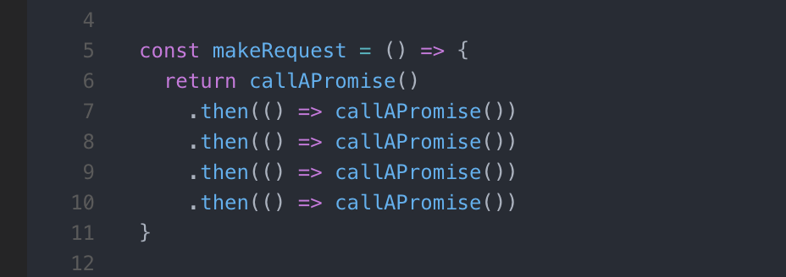

Try setting a breakpoint anywhere here

2. If you set a breakpoint inside a .then block and use debug shortcuts like step-over, the debugger will not move to the the following .then because it only “steps” through synchronous code.

With async/await you don’t need arrow functions as much, and you can step through await calls exactly as if they were normal synchronous calls.

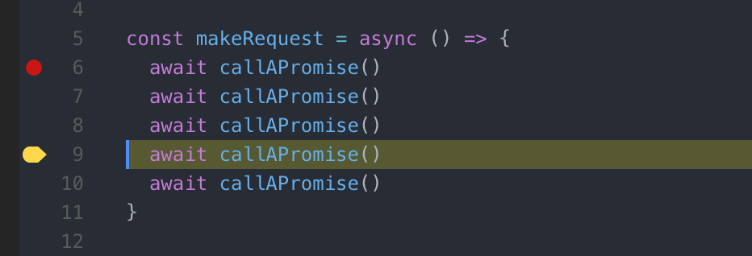

### In Conclusion

Async/await is one of the most revolutionary features that have been added to JavaScript in the past few years. It makes you realize what a syntactical mess promises are, and provides an intuitive replacement.

### Concerns

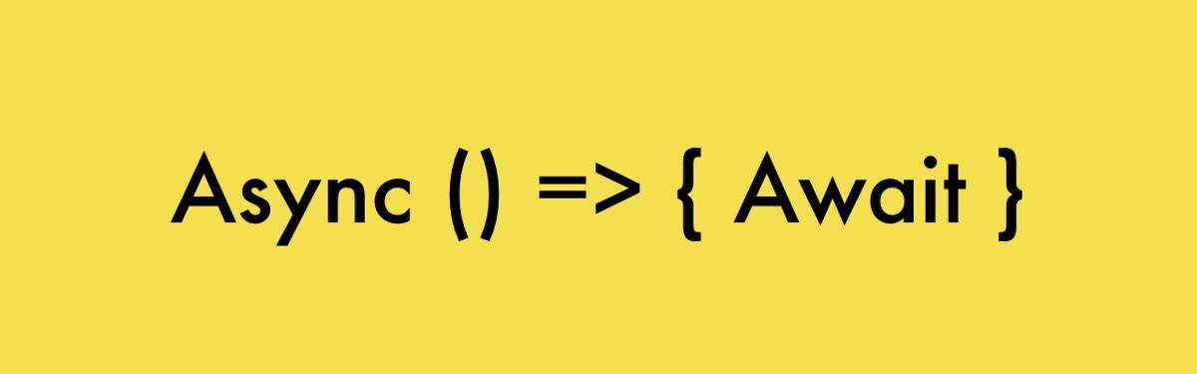

Introduction (callbacks, promises, async/await)

### Introduction

Async/await is a new way to write asynchronous code. It is built on top of promises, therefore, it is also non blocking.

The big difference is that asynchronous code looks and behaves a little more like synchronous code. This is where all its power lies.

Previous options for asynchronous code were **callbacks and promises**.

#### Callbacks in action

setTimeout(() => {  
 console.log('This runs after 1000 milliseconds.');  
}, 1000);

#### Problem with callbacks ****—****The infamous*Callback Hell*

Nesting callbacks within callbacks will soon start to look like this:

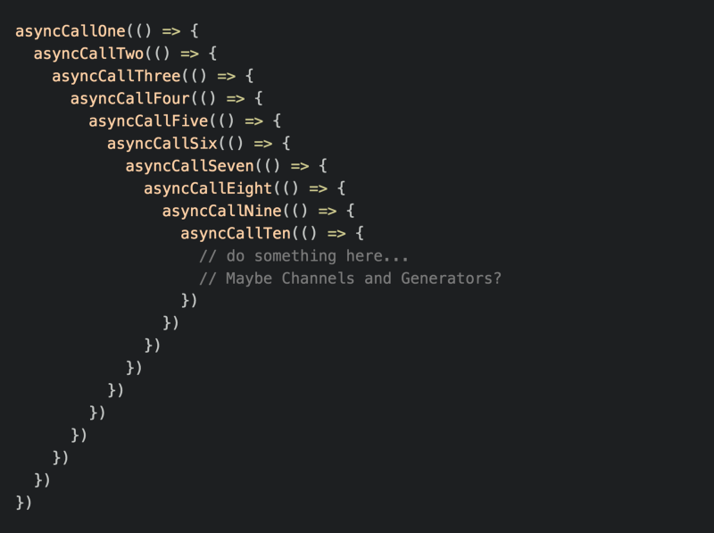

Callback Hell

#### Callback Hell

*The situation where callbacks are nested within other callbacks several levels deep, potentially making it difficult to understand and maintain the code.*

#### Promises in action

const promiseFunction = new Promise((resolve, reject) => {  
 const add = (a, b) => a + b;

resolve(add(2, 2));  
});

promiseFunction.then((response) => {  
 console.log(response);  
}).catch((error) => {  
 console.log(error);  
});

promiseFunction returns a **Promise**that represents the process of that function. The resolve function signals the **Promise**instance that it has finished.

Afterwards, we can call .then() and .catch() on that promise function:   
**then**— Runs a callback you pass to it when the promise has finished.  
**catch** — Runs a callback you pass to it when something went wrong.

### Async Functions

Async function provide us with a **clean and concise syntax** that enables us to write less code to accomplish the same outcome we would get with promises. Async is nothing more than syntactic sugar for promises.

Async functions are created by prepending the word **async** before the function declaration like this:

const asyncFunction = async () => {  
 // Code  
}

Asynchronous functions can be **paused** with **await**, the keyword that can only be used **inside an async function**. Await returns whatever the async function returns when it is done.

This is the difference between promises and async/await:

// Async/Await  
const asyncGreeting = async () => 'Greetings';

// Promises  
const promiseGreeting = () => new Promise(((resolve) => {  
 resolve('Greetings');  
}));

asyncGreeting().then(result => console.log(result));  
promiseGreeting().then(result => console.log(result));

**Async/Await**lookssimilar to synchronous code, and synchronous code is much easier to understand.