**Accessing URL parameters in Angular: Snapshot vs Subscription**

[Tiberiu Oprea](https://medium.com/@tiboprea?source=post_page-----efc4e70f9053--------------------------------)

[Tiberiu Oprea](https://medium.com/@tiboprea?source=post_page-----efc4e70f9053--------------------------------)

[Jan 16, 2019·2 min read](https://medium.com/@tiboprea/accessing-url-parameters-in-angular-snapshot-vs-subscription-efc4e70f9053?source=post_page-----efc4e70f9053--------------------------------)

Image for post

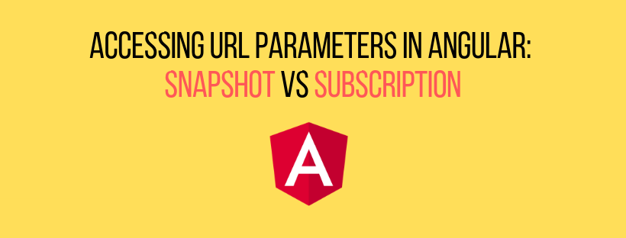

If you’re reading this, you might have asked yourself what’s the best way of accessing the URL parameters in Angular.

Don’t worry, we’ve all been there, so I’ll try to keep this short and not waste your time. Time is money, right? (…wise man, I know ✌)

First, we have to import the ActivatedRoute object and inject it in our component, in order to get the params we want.

import { ActivatedRoute } from "@angular/router";constructor(private route: ActivatedRoute) { }

There are 2 ways of accessing the params. The first one is using route.snapshot.paramMap and the second is through the route.paramMap.subscribe .

1. When to use route.snapshot.paramMap ?

If you intend **not to update** your URL parameter within the same component you are accessing it, then you can use the snapshot.

As the name suggests, the parameter **would only be accessed once, when the component loads**. Hence, it won’t be updated, even if you change its value from within the same component.

ngOnInit() {  
 this.car = this.route.snapshot.paramMap.get("carBrand")  
}

Feel free to visualise this with the following [StackBlitz](https://stackblitz.com/edit/angular-access-url-params-snapshot) example.

2. When to use route.paramMap.subscribe ?

If you intend**to update** the URL parameter within the same component, then you have to use a subscription.

The good news is that it works just like any other subscription in your Angular app. 😎

This technique is only useful if you plan to change the URL parameters within the current route.

ngOnInit() {  
 this.route.paramMap.subscribe(params => {  
 this.car = params.get("carBrand")  
 })  
}

Again, as things are easier to understand in an example, feel free to check the same case as above [here](https://stackblitz.com/edit/angular-access-url-params-subscription) but this time using a subscription.

That’s it! If you found this article useful, please … you know the story, no need to mention it again. 👏👀

If you are a business owner or a marketer who wants to improve 📈 his or her email deliverability, then you need to check out