**Life Cycle Method** <https://angular.io/guide/lifecycle-hooks>

In Angular, every component has a life-cycle, a number of different stages it goes through from initializing to destroying. There are 8 different stages in the component lifecycle. Every stage is called  life cycle hook events. So, we can use these hook events in different phases of our application to obtains fine controls on the components. Since a component is a typescript class, for that reason every component must have a constructor method. The constructor of the component class executes first before the execution of any other life cycle hook event. If we need to inject any dependencies into the component, then the constructor is the best place to inject that dependency. After executing the constructor, Angular executes its life cycle hook methods in a specific order.

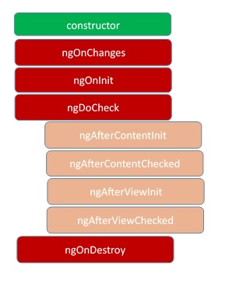

[Hooks for the component](https://codecraft.tv/courses/angular/components/lifecycle-hooks/#_hooks_for_the_component)

**Constructor** This is invoked when Angular creates a component or directive by calling new on the class.

|  |  |
| --- | --- |
| **Hook** | **Purpose and Timing** |
| ngOnChanges() | Respond when Angular (re)sets data-bound input properties. The method receives a [SimpleChanges](https://angular.io/api/core/SimpleChanges) object of current and previous property values.  Called before ngOnInit() and whenever one or more data-bound input properties change. |
| ngOnInit() | Initialize the directive/component after Angular first displays the data-bound properties and sets the directive/component's input properties.  Called once, after the first ngOnChanges(). |
| ngDoCheck() | Detect and act upon changes that Angular can't or won't detect on its own.  Called during every change detection run, immediately after ngOnChanges()and ngOnInit(). |
| [ngAfterContentInit()](https://angular.io/api/router/RouterLinkActive#ngAfterContentInit) | Respond after Angular projects external content into the component's view / the view that a directive is in.  Called once after the first ngDoCheck(). |
| ngAfterContentChecked() | Respond after Angular checks the content projected into the directive/component.  Called after the [ngAfterContentInit()](https://angular.io/api/router/RouterLinkActive" \l "ngAfterContentInit) and every subsequent ngDoCheck(). |
| [ngAfterViewInit()](https://angular.io/api/forms/NgForm#ngAfterViewInit) | Respond after Angular initializes the component's views and child views / the view that a directive is in.  Called once after the first ngAfterContentChecked(). |
| ngAfterViewChecked() | Respond after Angular checks the component's views and child views / the view that a directive is in.  Called after the [ngAfterViewInit()](https://angular.io/api/forms/NgForm" \l "ngAfterViewInit) and every subsequent ngAfterContentChecked(). |
| ngOnDestroy() | Cleanup just before Angular destroys the directive/component. Unsubscribe Observables and detach event handlers to avoid memory leaks.  Called just before Angular destroys the directive/component. |