**https://netbasal.com/understanding-viewchildren-contentchildren-and-querylist-in-angular-896b0c689f6e**

**@ViewChildren —**

*Returns the specified elements or directives from the view DOM as QueryList*

For example, let’s create a simple alert component.

Now let’s use this component multiple times in our app component and use the @ViewChildren decorator.

We can use the @ViewChildren decorator to grab elements from the host view.

The @ViewChildren decorator supports directive or component type as parameter, or the name of a template variable.

When the parameter is a component/directive the return value will be the component/directive instance.

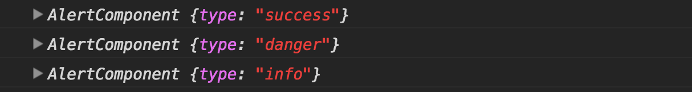

When the parameter is the name of a template variable, the return value will be a reference to the native element.

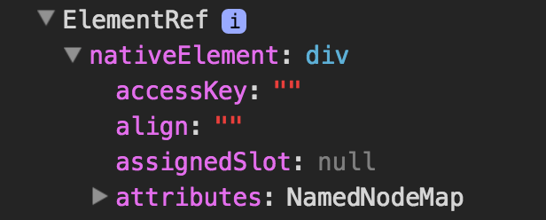

**Note:** In this case, it will make more sense to use the @ViewChild decorator because this is only a single element.

**The read parameter —**

As we said by default, the ViewChildren decorator will return the component instance, but you can ask for other tokens:

* The native DOM element —

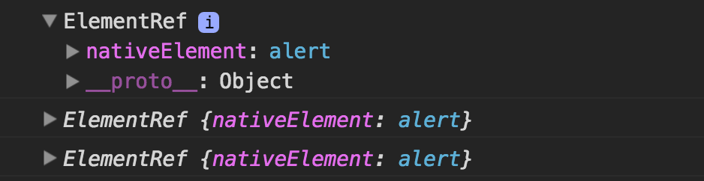

* [ViewContainerRef](https://www.google.co.il/url?sa=t&rct=j&q=&esrc=s&source=web&cd=14&cad=rja&uact=8&ved=0ahUKEwjQyqX67NbSAhVHuhQKHeH2Dt04ChAWCCkwAw&url=https%3A%2F%2Fnetbasal.com%2Fdynamically-creating-components-with-angular-a7346f4a982d&usg=AFQjCNF-3pJQ-kDTlmQaw8NC3FPVyftJLA&sig2=Vc10x9lR4tk4uorupwCnfQ&bvm=bv.149397726,d.d24) — You need this token when you need to create templates or components dynamically

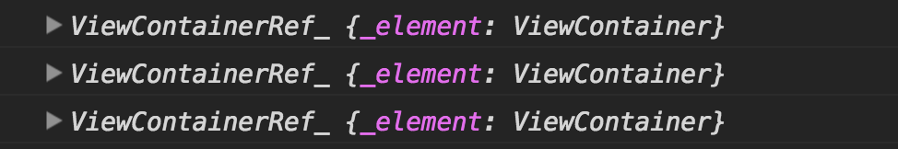

**QueryList —**

The return type of ViewChildren is QueryList. QueryList is just a fancy name for an object that stores a list of items. What is special about this object is when the state of the application changes Angular will automatically update the object items for you.

QueryList implements an iterable interface, therefore, it can be used in Angular templates with the ngFor directive. ( you can read more about this topic [here](https://netbasal.com/angular-2-ngfor-array-with-unique-values-6b15478d6484#.letjx3svz) )

**QueryList API —**

Getters —

* first — get the first item
* last — get the last item
* length — get the items length

Methods —

[map](https://developer.mozilla.org/en-US/docs/Web/JavaScript/Reference/Global_Objects/Array/map)(), [filter](https://developer.mozilla.org/en-US/docs/Web/JavaScript/Reference/Global_Objects/Array/filter)() , [find](https://developer.mozilla.org/en-US/docs/Web/JavaScript/Reference/Global_Objects/Array/find)(), [reduce](https://developer.mozilla.org/en-US/docs/Web/JavaScript/Reference/Global_Objects/Array/reduce)(), [forEach](https://developer.mozilla.org/en-US/docs/Web/JavaScript/Reference/Global_Objects/Array/forEach" \t "_blank)(), [some](https://developer.mozilla.org/en-US/docs/Web/JavaScript/Reference/Global_Objects/Array/some)().

* toArray() — returns the items as javascript array
* changes() — Changes can be observed by subscribing to the changes Observable. Any time a child element is added, removed, or moved, the query list will be updated, and the changes observable of the query list will emit a new value.

**Remember —**

The QueryList is initialized only before the ngAfterViewInit lifecycle hook, therefore, is available only **from** this point.

**ViewChildren vs ContentChildren —**

ViewChildren **don’t** include elements that exist within the ng-content tag.

ContentChildren includes **only** elements that exists within the ng-contenttag.

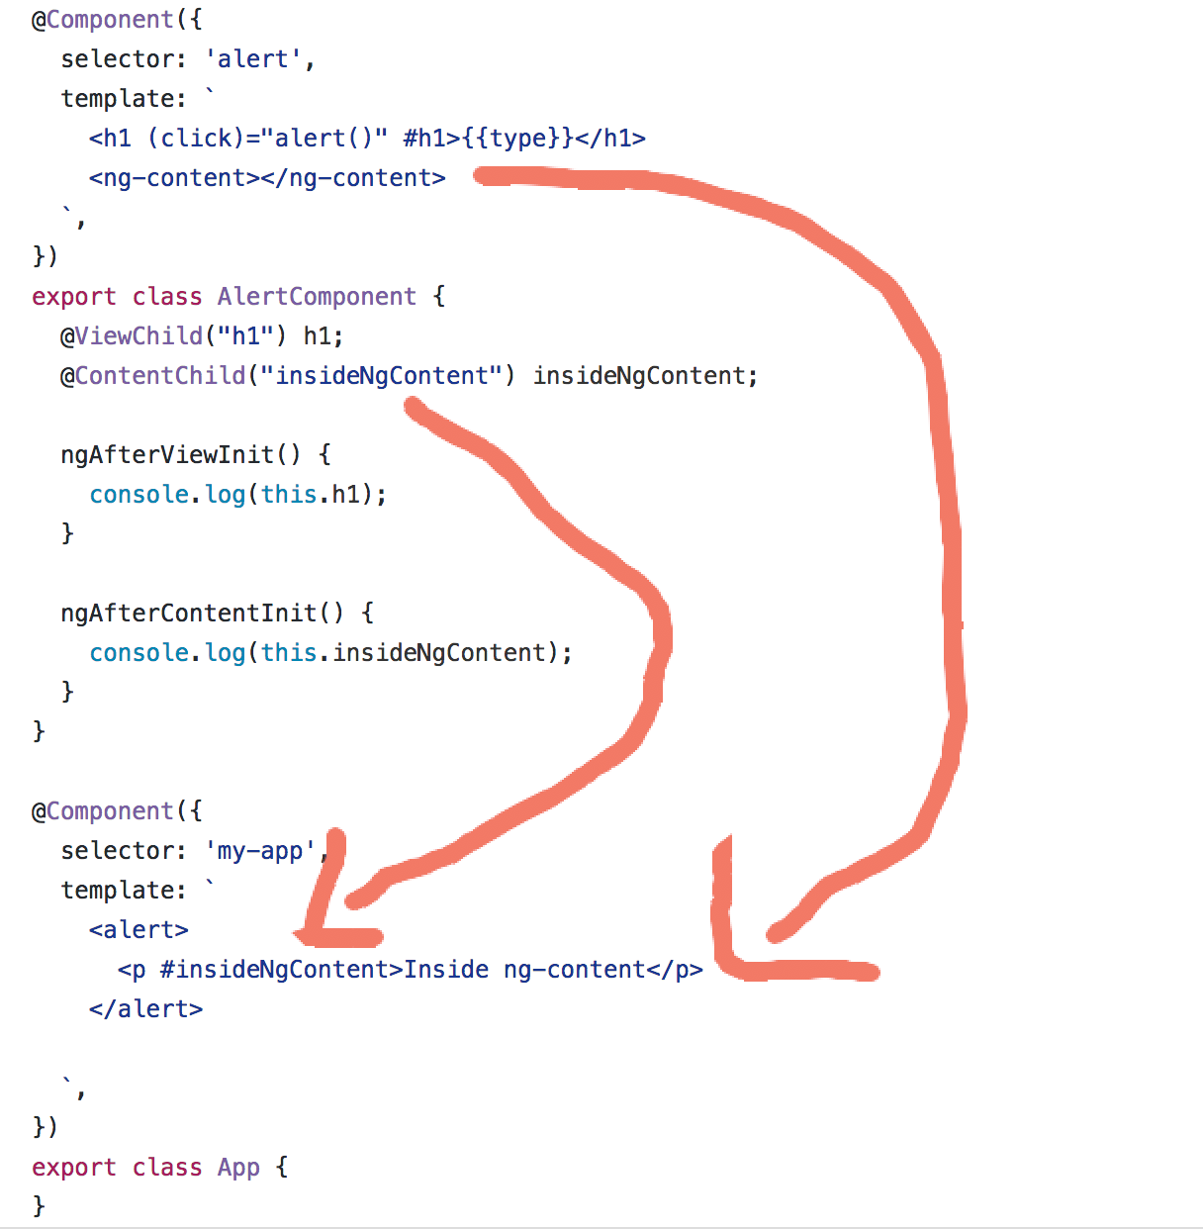

**@ContentChildren —**

*Returns the specified elements or directives from the content DOM as QueryList*

**Remember —**

The QueryList is initialized only before the ngAfterContentInit lifecycle hook, therefore, is available only from this point.