SQL Retail Analytics Project

1. Create Tables
CREATE TABLE customers (
customer_id NUMBER,
customer_name VARCHAR2(50)
);
CREATE TABLE stores (
store_id NUMBER,
store_name VARCHAR2(50)
);
CREATE TABLE products (
product_id NUMBER,
category VARCHAR2(50)
);
CREATE TABLE sales (
sale_id NUMBER,
customer_id NUMBER,
store_id NUMBER,
product_id NUMBER,
sale_date DATE,
amount NUMBER,
quantity NUMBER,
discount NUMBER
);

2. Insert Data (Auto Generate 1000 Rows)
-- Customers
INSERT INTO customers
SELECT LEVEL, 'Cust_'||LEVEL FROM dual CONNECT BY LEVEL<=50;
-- Stores
INSERT INTO stores VALUES (1,'CMR');
INSERT INTO stores VALUES (2,'SR');
INSERT INTO stores VALUES (3,'Lucky');
-- Products
INSERT INTO products VALUES (1,'Electronics');
INSERT INTO products VALUES (2,'Fashion');
INSERT INTO products VALUES (3,'Grocery');
INSERT INTO products VALUES (4,'Home');
-- Sales (1000 rows)
INSERT INTO sales
SELECT
LEVEL,
MOD(LEVEL,50)+1,
MOD(LEVEL,3)+1,
MOD(LEVEL,4)+1,
DATE '2025-01-01' + MOD(LEVEL,90),
ROUND(DBMS_RANDOM.VALUE(100,10000)),
MOD(LEVEL,5)+1,
CASE WHEN MOD(LEVEL,4)=0 THEN NULL ELSE ROUND(DBMS_RANDOM.VALUE(10,500)) END
FROM dual
CONNECT BY LEVEL <= 1000;

1. Data Understanding
Manager Requirement:
Give me overall business performance summary for the last quarter.
Questions:
- Find total number of transactions.
select count(sale_id) from sales;

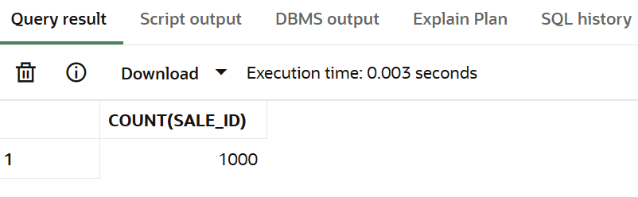

- Find total revenue generated.
select sum(amount) as revenue from sales;

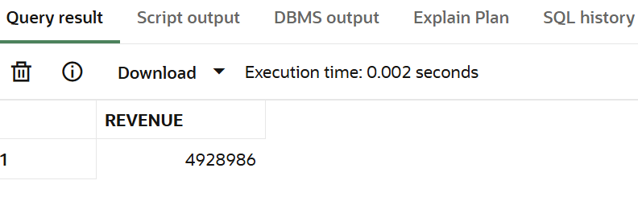
- Find total unique customers.

select count(distinct CUSTOMER_ID) as unique_cust from customers;

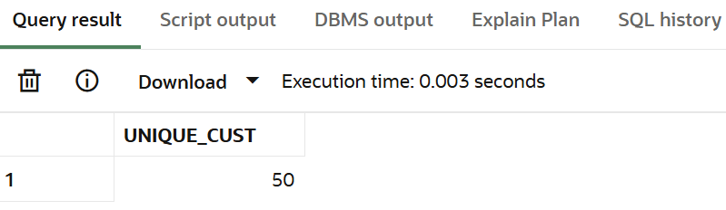

- Find average order value.
select sum(amount)/count(*) as average from sales;

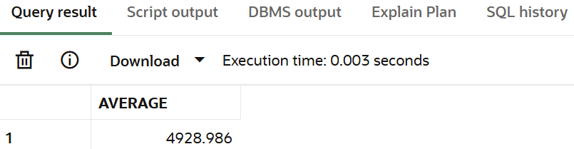

- Find total quantity sold.
select sum(quantity) as quantity_sold from sales;

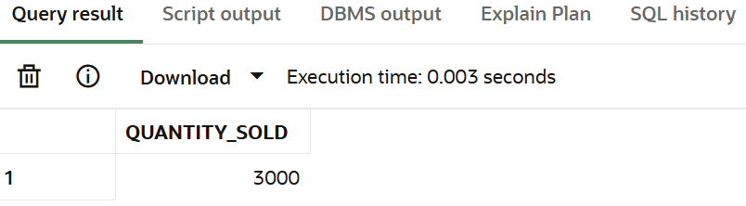

- Find minimum and maximum sale amount.
select max(amount) as max_val ,min(amount) as min_val from sales;
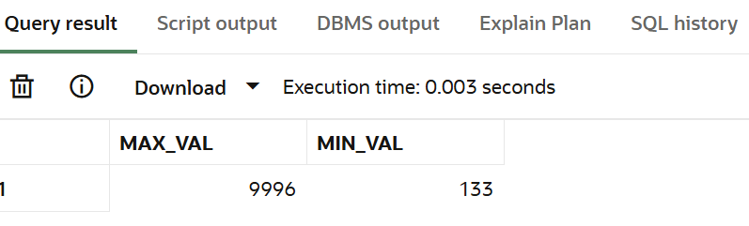

- Find average discount given.
select avg(discount) from sales;

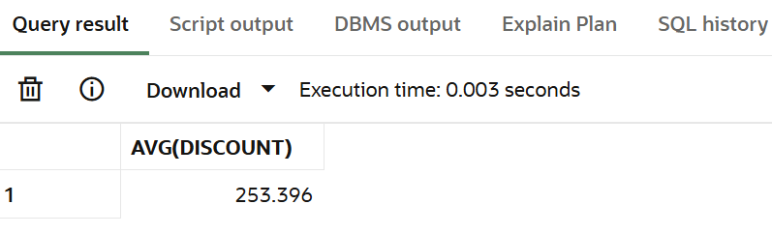

- Find total sales per store.
select s.store_name, sum(sa.amount) as rev from stores s join sales sa on s.store_id=sa.store_id group by s.store_name;

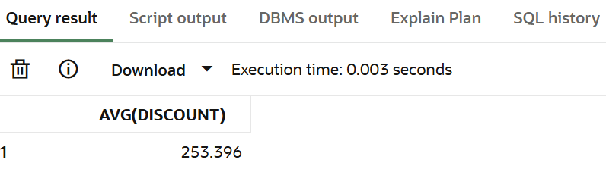

- Find total sales per category.
select p.category, sum(sa.amount) as rev from products p join sales sa on p.PRODUCT_ID=sa.product_id group by p.CATEGORY;

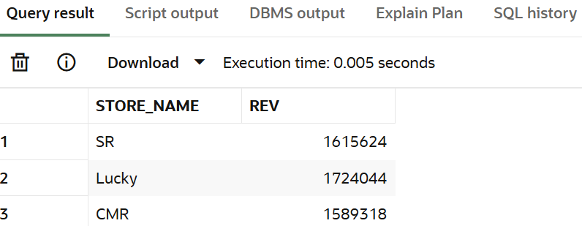

- Find number of transactions per day.
select sale_date,count(*) as daily_tnsn from sales group by sale_date ORDER by sale_date;

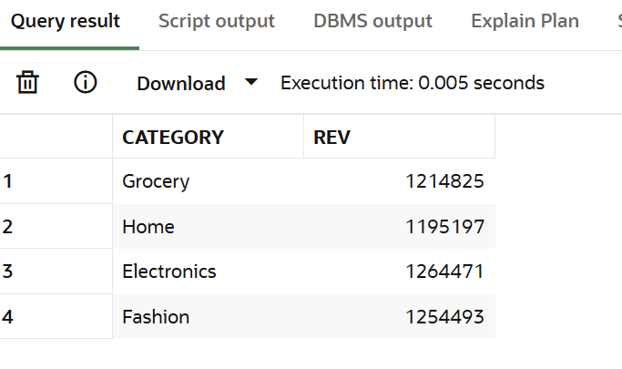

2. Data Cleaning
Manager Requirement:
Data looks inconsistent, fix NULL issues before analysis.
Questions:
- Replace NULL discount with 0.
select sale_id,nvl(discount,0) as rep from sales;

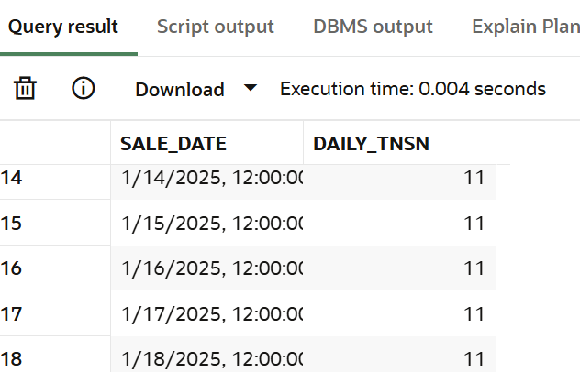

- Find number of NULL discounts.
select count(*) as null_val from sales where discount is null;

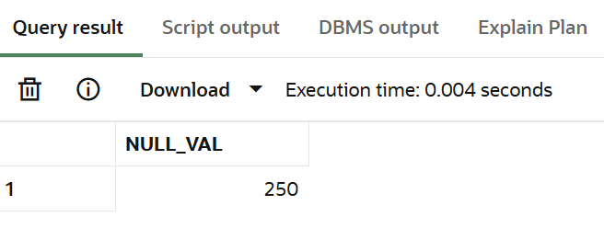

- Calculate net revenue (amount - discount).

select sum(amount-nvl(discount,0)) as net_rev from sales;

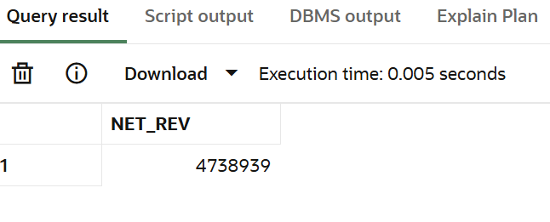

- Replace NULL quantity with 1.

select nvl(quantity,1) from sales;

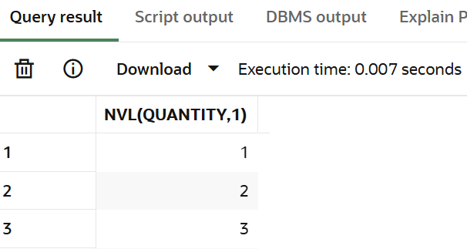

- Identify rows where amount is NULL.

SELECT * FROM sales WHERE amount IS NULL;

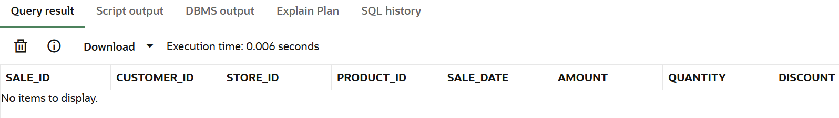

- Use COALESCE to handle multiple NULL columns.

Select sale_id, COALESCE(amount, 0) as amount_cleaned, COALESCE(quantity, 1) as quantity_cleaned, COALESCE(discount, 0) as discount_cleaned from sales;

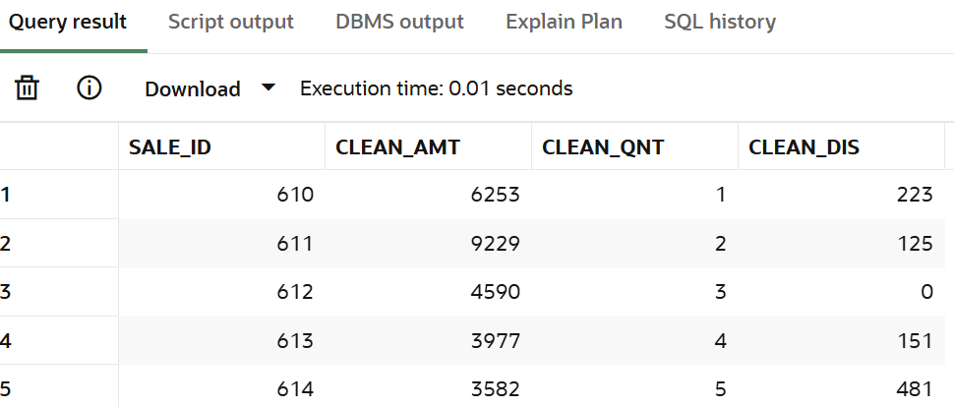

- Create a cleaned column for revenue.

select sale_id,nvl(amount,0)- nvl(discount,0) as rev from sales;

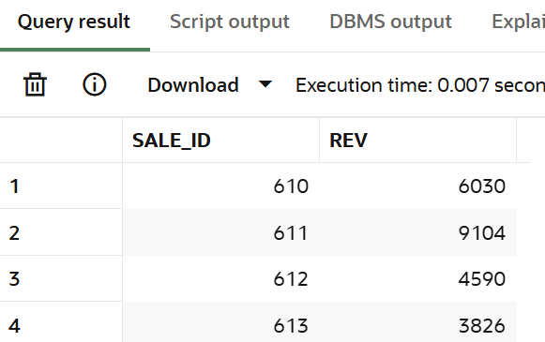

- Check percentage of missing data.
select count(case when amount is null then 1 END) /count(*) * 100 as per_amt,
count(case when quantity is null then 1 END) /count(*) * 100 as per_qnt,count(case when discount is null then 1 END) /count(*) * 100 as per_dis from sales;

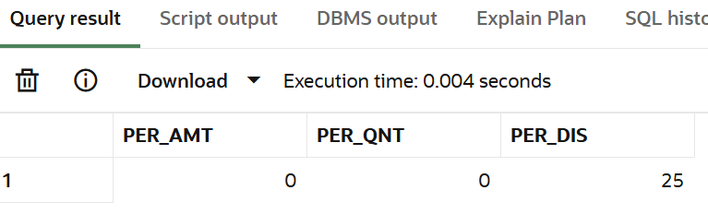

- Flag rows with missing values.
select sale_id ,case when amount is null or quantity is null or discount is null then 'Missing' else 'Complete' end as flag from sales;

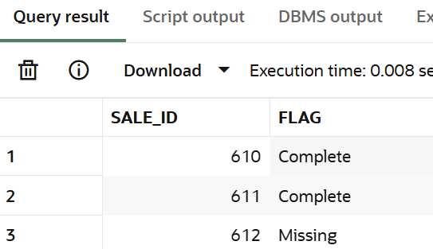

- Prepare dataset for analysis.

create or replace view sales_cleaned as select sale_id,customer_id,store_id, product_id, sale_date, nvl(amount,0) as amount,nvl(quantity,1) as quantity, nvl(discount,0) as discount, (nvl(amount,0) - nvl(discount,0)) as net_revenue from sales;

3. Filtering (WHERE)
Manager Requirement:
I want specific insights based on conditions.
Questions:
- Find sales in last 30 days.
select * from sales where sale_date > sysdate-30;
select * from sales where sale_date between date '2025-02-01' and date '2025-03-01';

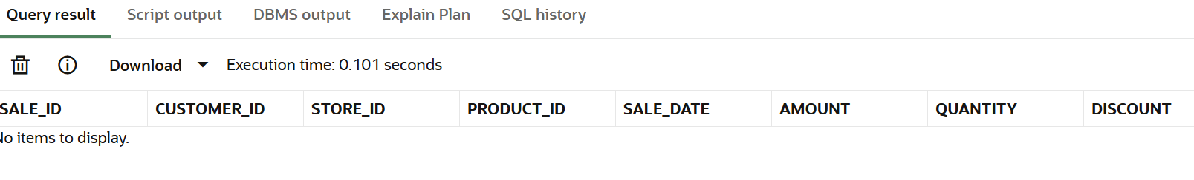

- Find sales above 5000.
select sale_id,amount from sales where amount>5000;

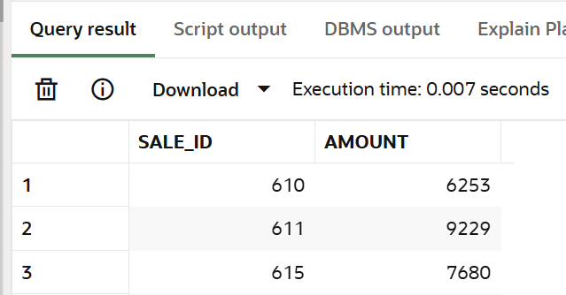

- Find sales between 1000 and 5000.
select sale_id,amount from sales where amount between 1000 and 5000;

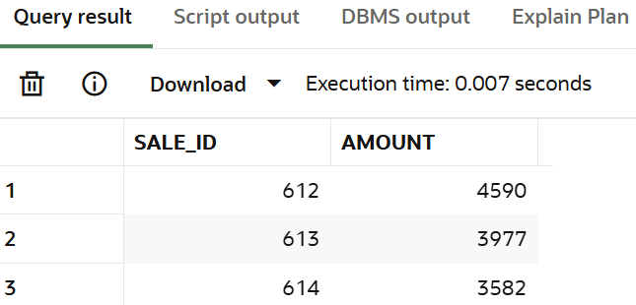

- Find sales from CMR store.
select sale_id,s.STORE_NAME from sales sa join stores s on sa.store_id=s.store_id where s.store_name='CMR';

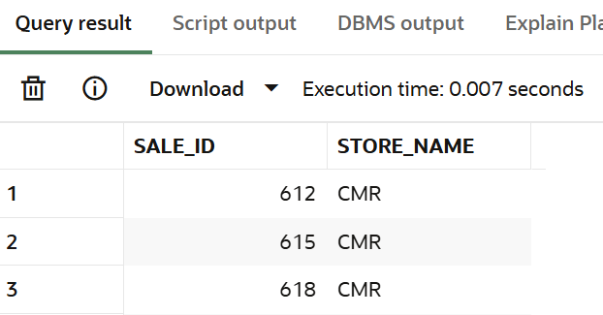

- Find Electronics category sales.
select sa.sale_id,p.category from sales sa join products p on p.product_id=sa.product_id where p.category='Electronics';

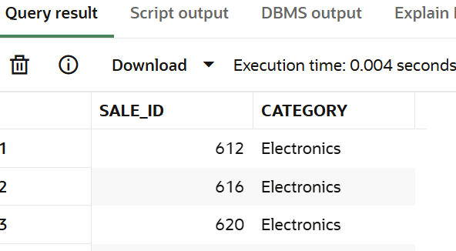

- Find sales excluding Grocery category.
select sale_id,p.category from sales sa join products p on p.product_id=sa.product_id where p.category not in('Grocery');
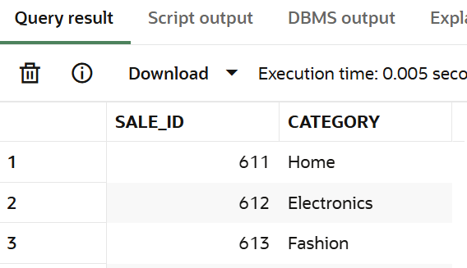

- Find customers from specific store.
SELECT DISTINCT c.customer_name,s.store_name FROM sales sa JOIN customers c ON sa.customer_id = c.customer_id JOIN stores s ON sa.store_id = s.store_id WHERE s.store_name = 'CMR';

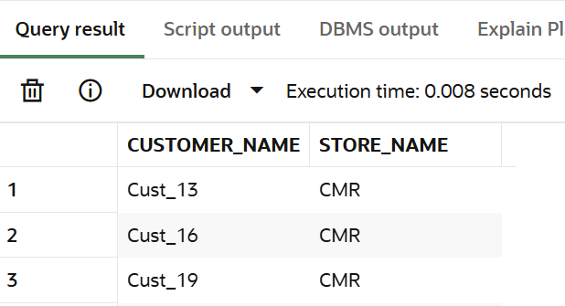

- Find high discount transactions.
select sale_id,quantity from sales where discount>300;

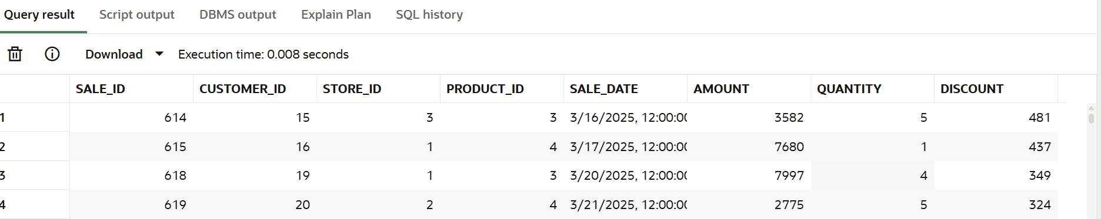

- Find low quantity sales.
select * from sales where quantity <2;

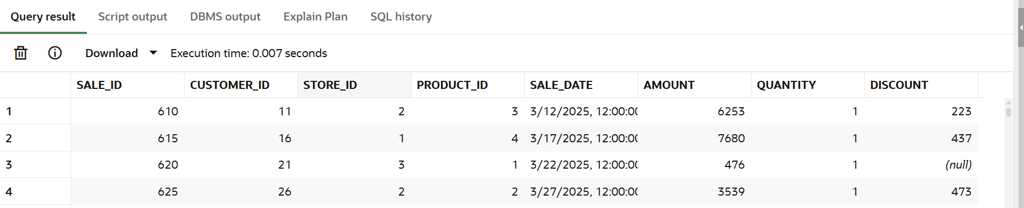

- Find recent transactions.
select * from sales where sale_date between date '2025-03-21' and date '2025-03-30' ;
select * from sales where sale_date =sysdate-10;

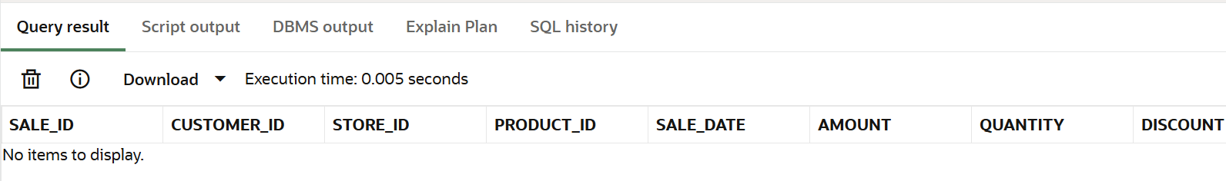

4. Aggregation (GROUP BY)
Manager Requirement:
Break down performance across business segments.
Questions:
- Revenue per store.
SELECT s.store_name, SUM(sa.amount) AS revenue FROM sales sa JOIN stores s ON sa.store_id = s.store_id GROUP BY s.store_name ORDER BY revenue DESC;

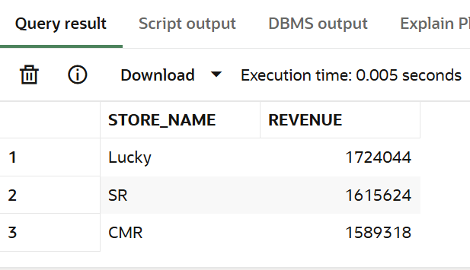

- Revenue per category.
SELECT p.category, SUM(s.amount) AS revenue FROM sales s JOIN products p ON p.product_id = s.product_id GROUP BY p.CATEGORY ORDER BY revenue DESC;

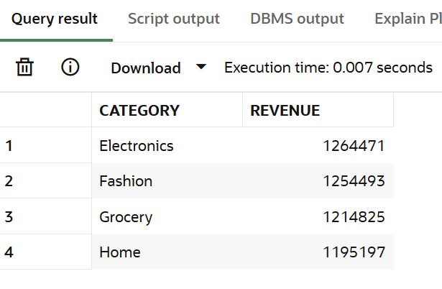

- Revenue per customer.
SELECT c.customer_name, SUM(sa.amount) AS revenue FROM sales sa left JOIN customers c ON sa.customer_id = c.customer_id GROUP BY c.customer_name ORDER BY revenue desc ;
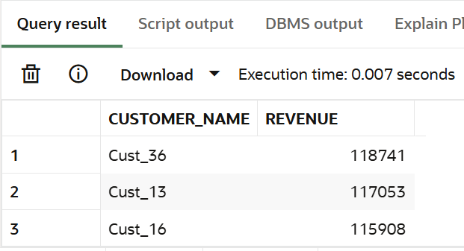

- Monthly revenue.

SELECT EXTRACT(MONTH FROM sale_date) AS month,SUM(amount) AS revenue FROM sales GROUP BY EXTRACT(MONTH FROM sale_date) ORDER BY month;

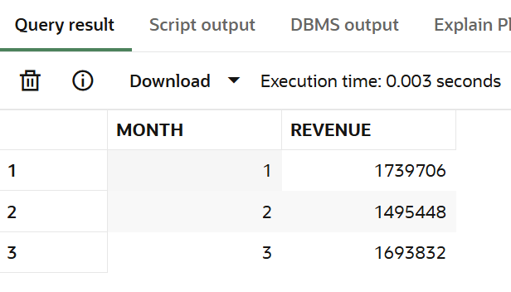

- Daily revenue.
SELECT sale_date, SUM(amount) AS daily_revenue FROM sales GROUP BY sale_date ORDER BY sale_date;
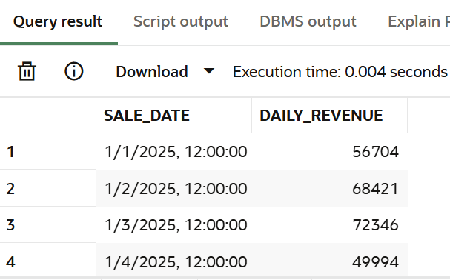

- Average sales per store.

SELECT s.store_name, round(avg(sa.amount),2) AS revenue FROM sales sa JOIN stores s ON sa.store_id = s.store_id GROUP BY s.store_name ORDER BY revenue DESC;

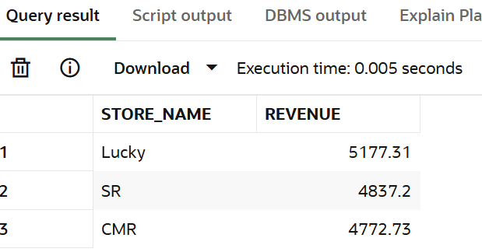

- Total quantity per category.

SELECT p.category, SUM(s.quantity) AS quantity_per_category FROM sales s JOIN products p ON p.product_id = s.product_id GROUP BY p.CATEGORy;

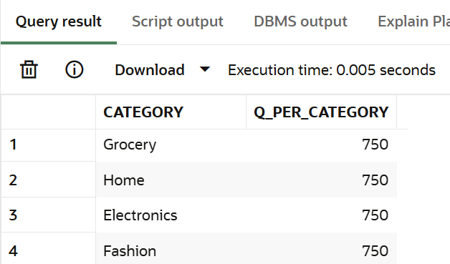

- Total discount per store.
SELECT s.store_name, sum(nvl(sa.discount,0)) AS total_discount FROM sales sa JOIN stores s ON sa.store_id = s.store_id GROUP BY s.store_name;

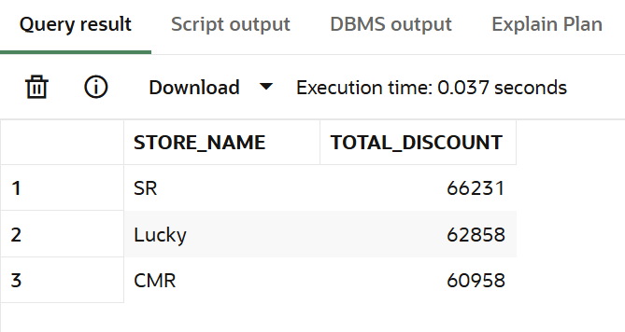

- Customer-wise total spending.
SELECT c.customer_name, SUM(sa.amount) AS revenue FROM sales sa left JOIN customers c ON sa.customer_id = c.customer_id GROUP BY c.customer_name;

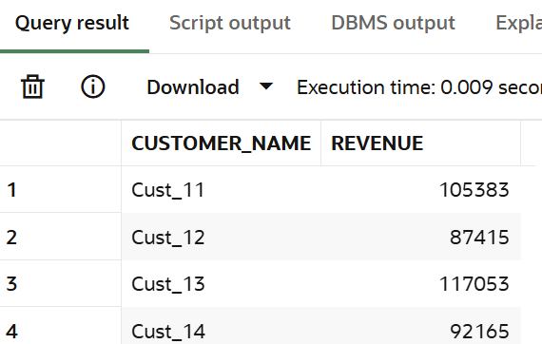

- Store-wise transaction count.

SELECT s.store_name, count(*) AS trans_count FROM sales sa JOIN stores s ON sa.store_id = s.store_id GROUP BY s.store_name order by trans_count desc;
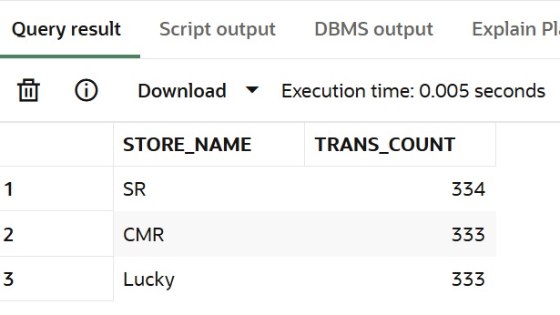

5. HAVING
Manager Requirement:
Find top performing segments.
Questions:
- Customers with revenue > 20000.

SELECT c.customer_name, SUM(sa.amount) AS revenue FROM sales sa left JOIN customers c ON sa.customer_id = c.customer_id GROUP BY c.customer_name having SUM(sa.amount) > 110000 order by revenue DESC;

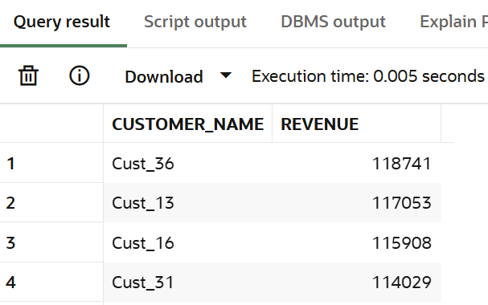

- Stores with revenue > 100000.

SELECT s.store_name, sum(amount) AS revenue FROM sales sa left JOIN stores s ON sa.store_id = s.store_id GROUP BY s.store_name having sum(amount) > 100000;

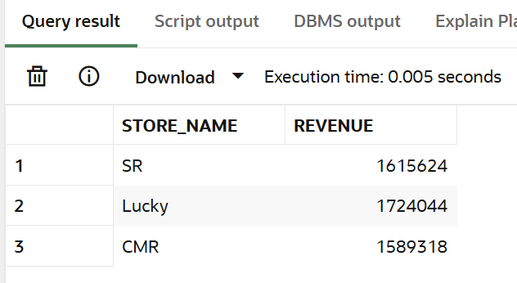

- Categories with avg sales > 3000.

SELECT p.category, avg(s.amount) AS avg_sales FROM sales s JOIN products p ON p.product_id = s.product_id GROUP BY p.CATEGORy having avg(s.amount)>3000;

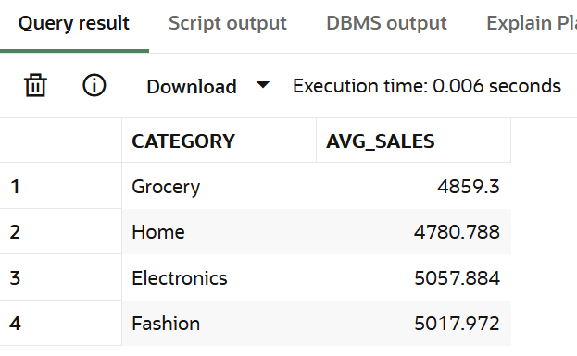

- Customers with more than 5 transactions.

SELECT c.customer_name, count(*) as transactions FROM sales sa left JOIN customers c ON sa.customer_id = c.customer_id GROUP BY c.customer_name having count(*)>5;

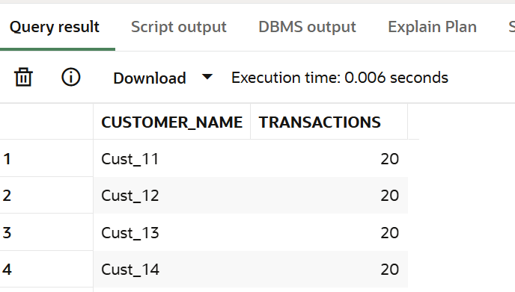

- Stores with high discount usage.

SELECT s.store_name, sum(nvl(sa.discount,0)) AS total_discount FROM sales sa left JOIN stores s ON sa.store_id = s.store_id GROUP BY s.store_name having sum(nvl(sa.discount,0))>62000;

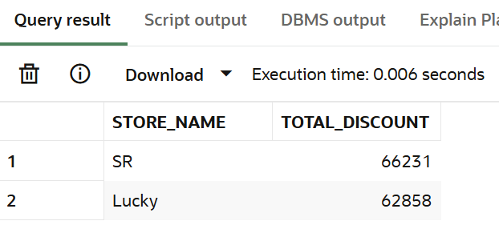

- Categories with low performance.

SELECT p.category,EXTRACT(MONTH FROM s.sale_date) AS month,SUM(s.amount) AS revenue FROM sales s JOIN products p ON p.product_id = s.product_id GROUP BY p.category, EXTRACT(MONTH FROM s.sale_date) HAVING SUM(s.amount) < 1190000 ORDER BY month;

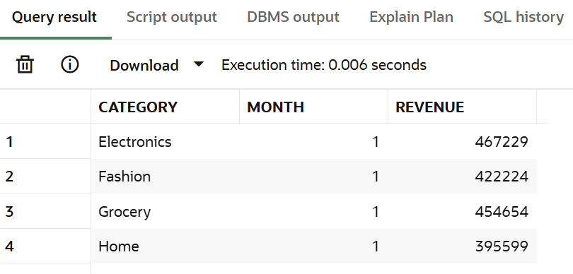

- Customers with high avg order value.

SELECT c.customer_name, avg(sa.amount) as avg_order_val FROM sales sa left JOIN customers c ON sa.customer_id = c.customer_id GROUP BY c.customer_name having avg(sa.amount)>4000;
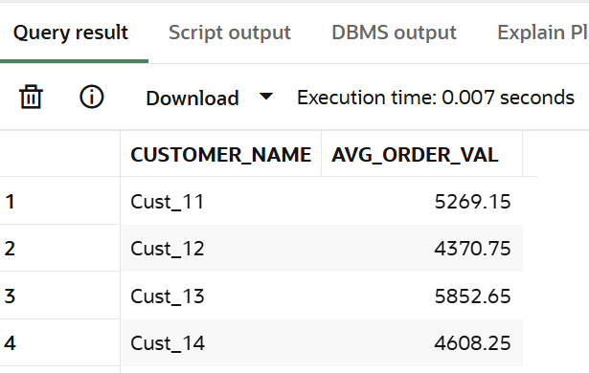
- Find top 5 customers using HAVING.
SELECT c.customer_name, SUM(s.amount) AS total_revenue FROM sales s JOIN customers c ON s.customer_id = c.customer_id GROUP BY c.customer_name HAVING SUM(s.amount) > 100000 ORDER BY total_revenue DESC
FETCH FIRST 5 ROWS ONLY;

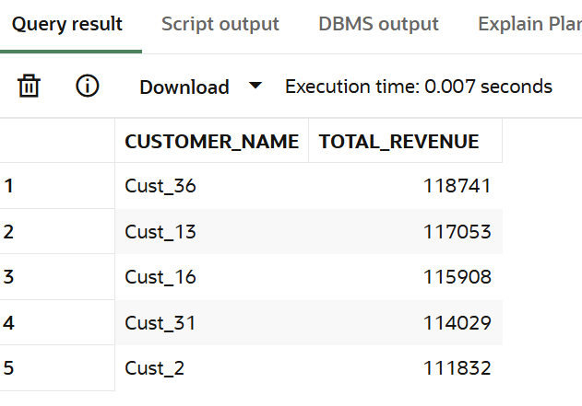

- Stores with max transactions.

SELECT s.store_name, COUNT(*) AS transactions FROM sales sa JOIN stores s ON sa.store_id = s.store_id GROUP BY s.store_name ORDER BY transactions DESC FETCH FIRST 1 ROW ONLY;

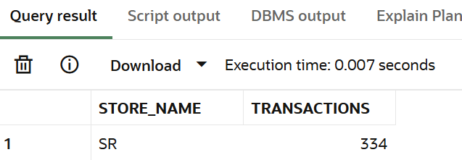

- Categories with high growth.
select p.category,
sum(case when extract(month from s.sale_date) = 1 then s.amount end) as jan_revenue, sum(case when extract(month from s.sale_date) = 2 then s.amount end) as feb_revenue,(sum(case when extract(month from s.sale_date) = 1 then s.amount end) sum(case when extract(month from s.sale_date) = 2 then s.amount end)) as growth from sales s
join products p on p.product_id = s.product_id group by p.category
having
(sum(case when extract(month from s.sale_date) = 1 then s.amount end)
sum(case when extract(month from s.sale_date) = 2 then s.amount end)) > 0
order by growth desc;

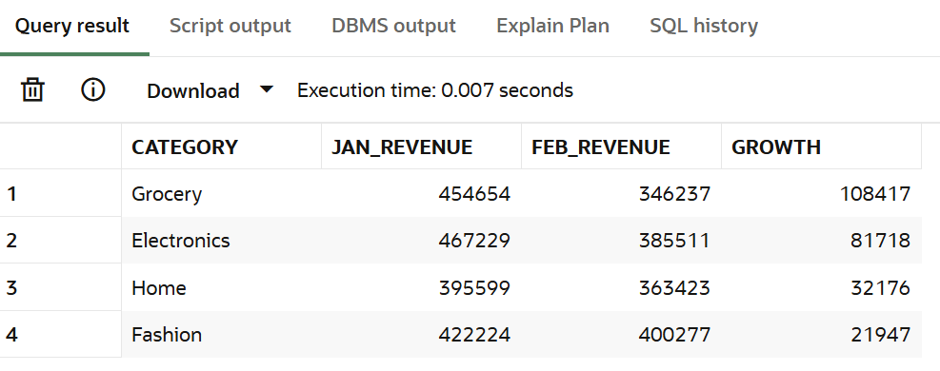

6. CASE WHEN
Manager Requirement:
Segment customers for business decisions.
Questions:
- Classify customers as High/Medium/Low spenders.
SELECT c.customer_name,
SUM(s.amount) AS total_spent,
CASE
WHEN SUM(s.amount) >= 100000 THEN 'High Spender'
WHEN SUM(s.amount) BETWEEN 90000 AND 100000 THEN 'Medium Spender'
ELSE 'Low Spender'
END AS spender_type
FROM sales s
JOIN customers c ON s.customer_id = c.customer_id GROUP BY c.customer_name;
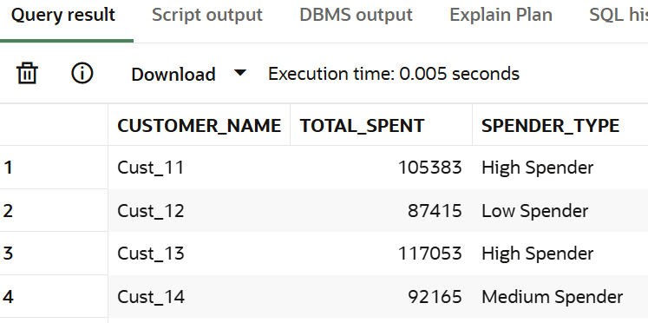

- Classify transactions as Big/Small.

select sale_id,amount,(case
when amount>7000 then 'Big' else 'Small' end)
as transactions from sales;

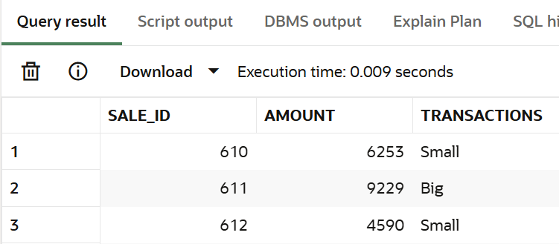

- Create discount flag.

select sale_id,discount,(case when discount>300 then 'Discount Applied' else 'Discount Not Applied' end) as flag from sales;

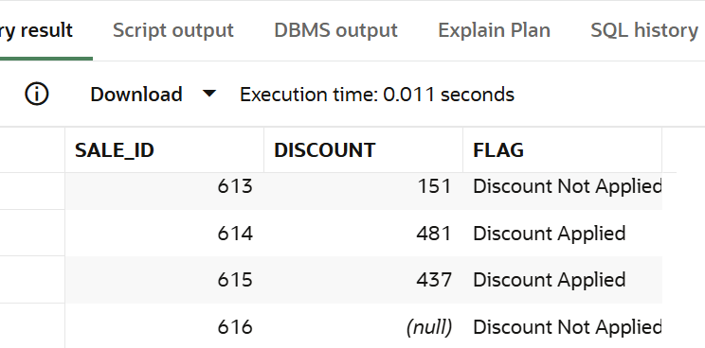

- Segment stores based on revenue.

select sa.store_name,sum(s.amount) as revenue, (case
when sum(s.amount)>1700000 then 'Tier 1 store'
when sum(s.amount) between 1570000 and 1700000 then 'Tier 2 store'
else 'tier 3 store' end ) as segment_stores
from sales s left join stores sa on s.store_id=sa.store_id group by sa.store_name;

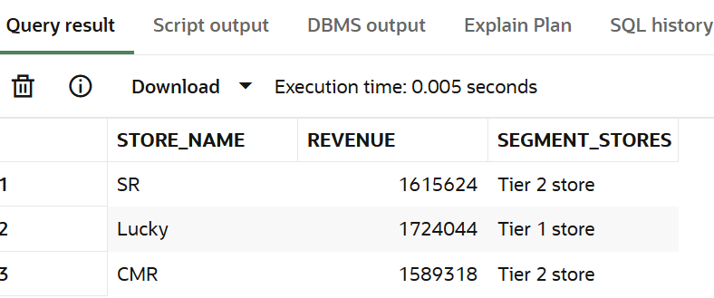

- Categorize customers based on frequency.

select c.customer_name,count(*) as transactions,(case
when count(*) >15 then 'Frequent customer'
when count(*) between 11 and 15 then 'Moderate customer ' else 'rare' end) as customer_frequency from sales s left join customers c on s.customer_id=c.customer_id group by c.customer_name;

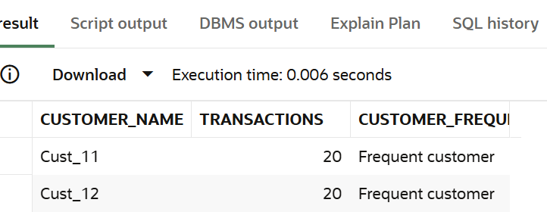

- Create sales buckets.

select sale_id , amount,
case
when amount < 1000 then 'bucket a: small'
when amount between 1000 and 5000 then 'bucket b: medium'
when amount between 5001 and 10000 then 'bucket c: large'
else 'bucket d: very large' end as sales_bucket from sales;

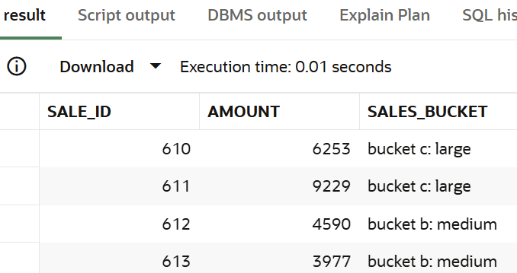

- Identify premium customers.

select c.customer_name, count(*) as transactions,
case
when count(*) > 15 then 'premium_customer'
when count(*) between 10 and 15 then 'regular_customer'
else 'rare_customer' end as prem_customers from sales s
left join customers c on s.customer_id = c.customer_id group by c.customer_name;

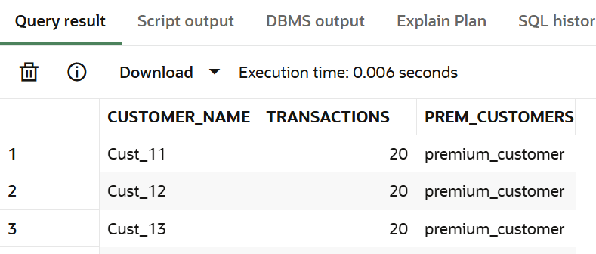

- Mark high-value transactions.

select sale_id,amount,(case when amount>9000 then 'High Value' else 'Low value' end) as tns from sales ;

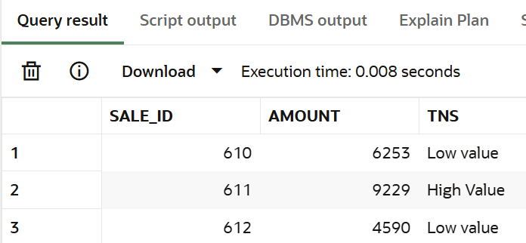

- Classify categories based on performance.
select p.category, sum(s.amount) as revenue,
case
when sum(s.amount) >= 1230000 then 'high performing'
when sum(s.amount) between 1000000 and 1230000 then 'medium performing'
else 'low performing'
end as performance from sales s join products p on s.product_id = p.product_id group by p.category;

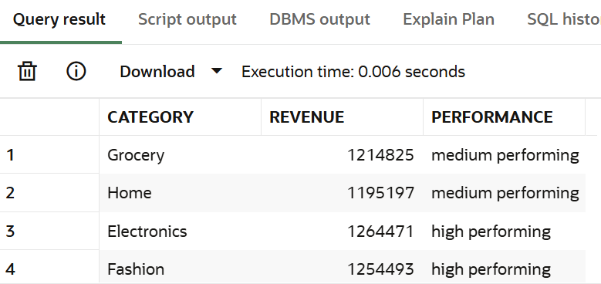

- Create custom labels for reporting.
select sale_id,amount,case when amount>9000 then 'first'
when amount between 5000 and 9000 then 'Second'
else 'Third' end as tns from sales ;

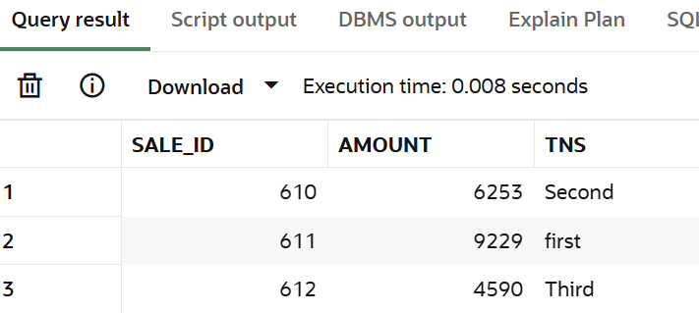

7. JOINS (Multiple Tables)
Manager Requirement:
Combine customer, product, and store data for insights.

Questions:
- Join sales with customers table.

SELECT s.sale_id, s.amount, c.customer_name
FROM sales s
left JOIN customers c ON s.customer_id = c.customer_id;

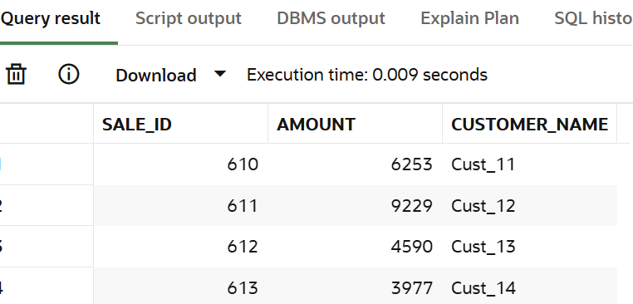

- Join sales with stores table.

SELECT s.sale_id, s.amount, sa.store_name
FROM sales s
left JOIN stores sa ON s.store_id = sa.store_id;

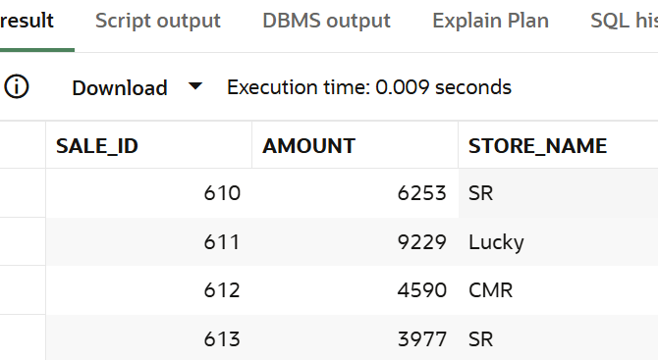

- Join sales with products table.

SELECT s.sale_id, s.amount, p.product_id,p.category
FROM sales s
left JOIN products p ON s.product_id = p.product_id;
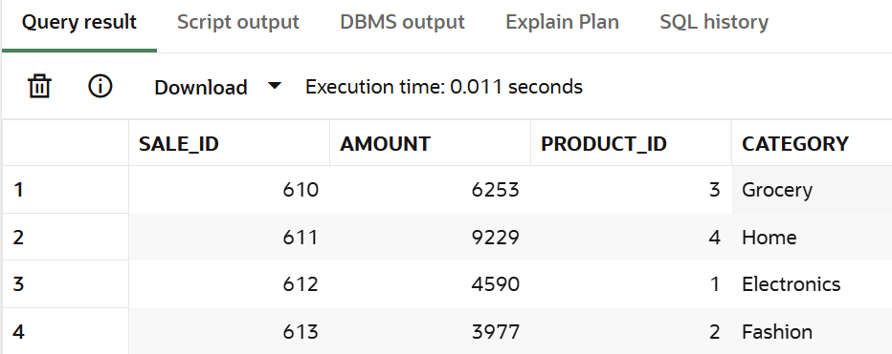

- Find customer name with store name and sales.

select c.customer_name,sa.store_name,sum(s.amount) as revenue from sales s left join customers c on s.customer_id=s.customer_id left join
stores sa on s.store_id=sa.store_id group by c.customer_name,sa.store_name;

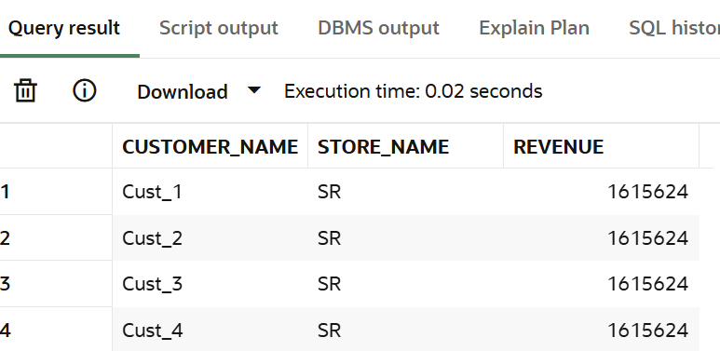

- Find category-wise revenue using joins.

select p.category,sum(s.amount) as revenue from sales s left join products p on s.product_id=p.product_id group by p.category order by revenue desc;

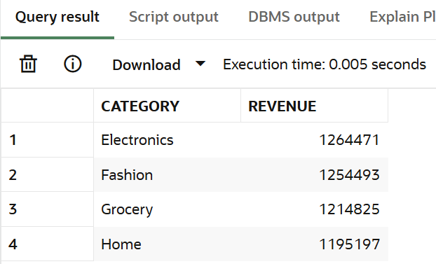

- Find store-wise customer count.

select s.store_name,count(distinct sa.customer_id) as cc from sales sa left join stores s on s.store_id=sa.store_id group by s.store_name;

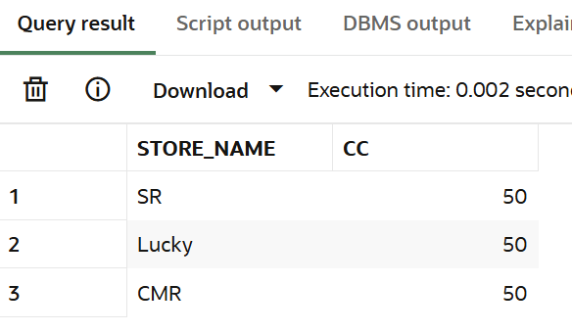

- Find top product per store.

select store_name, category, revenue from (
select st.store_name, p.category, sum(s.amount) as revenue rank() over (partition by st.store_name order by sum(s.amount) desc) as rnk from sales s
join stores st on s.store_id = st.store_id
join products p on s.product_id = p.product_id
group by st.store_name, p.category
) t
where rnk = 1;

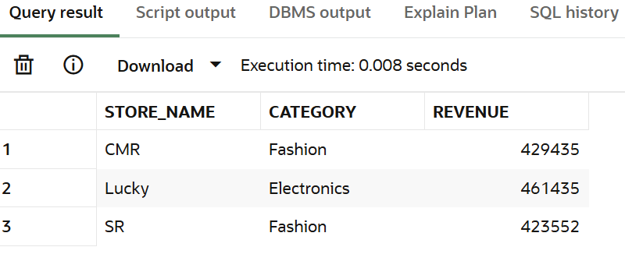

- Find customers who purchased from multiple stores.
select c.customer_name from sales sa left join customers c on c.customer_id=sa.customer_id
group by c.customer_name having count(distinct sa.store_id)>1;

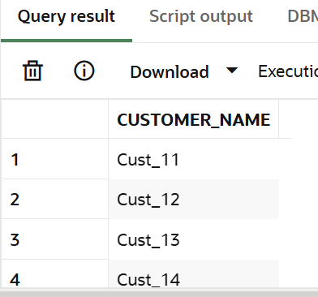

- Find sales with product category.

select sa.sale_id,sa.amount,p.category from sales sa left join products p on p.product_id=sa.product_id;

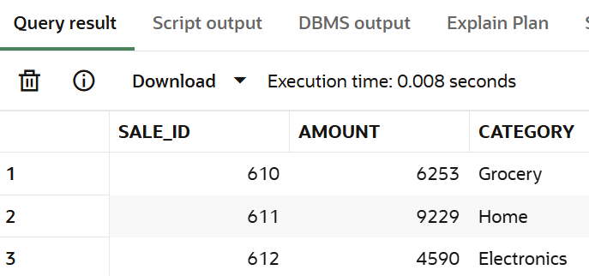

- Find revenue per customer per store.

select c.customer_name,st.store_name,sum(s.amount) as revenue from sales s left join customers c on s.customer_id=c.customer_id
left join stores st on s.store_id=st.store_id group by c.customer_name,st.store_name;

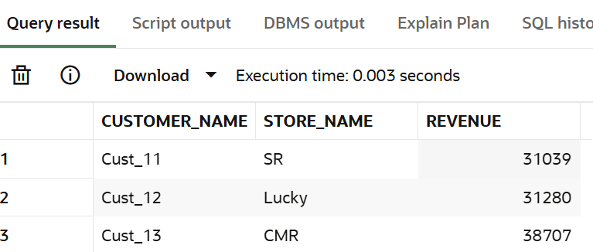

- Find customers with no transactions (LEFT JOIN).

select c.customer_name from customers c left join sales s on c.customer_id=s.customer_id where s.sale_id is null;

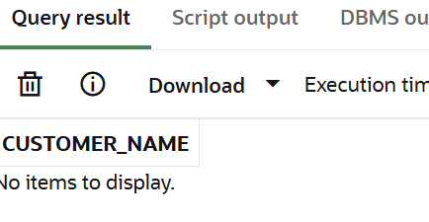

- Find missing product mappings.

select s.sale_id from sales s left join products p on s.product_id=p.product_id where p.product_id is null;
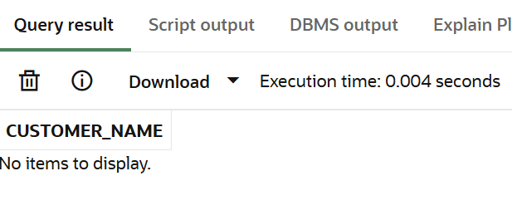

- Find store performance using joins.
SELECT st.store_name, SUM(s.amount) AS total_revenue
FROM sales s JOIN stores st ON s.store_id = st.store_id
GROUP BY st.store_name ORDER BY total_revenue DESC;

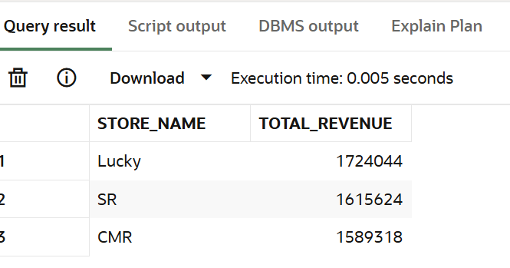

- Find cross-category purchases.

select c.customer_name from sales s
join customers c on s.customer_id = c.customer_id
join products p on s.product_id = p.product_id
group by c.customer_name having count(distinct p.category) > 1;

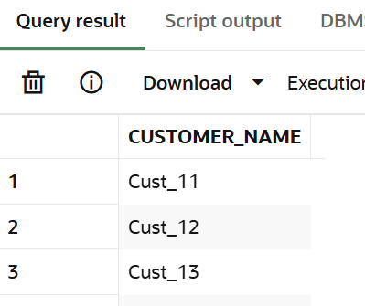

- Find total revenue using joins.
select st.store_name, sum(s.amount) as total_revenue from sales s join stores st on s.store_id = st.store_id group by st.store_name order by total_revenue desc;

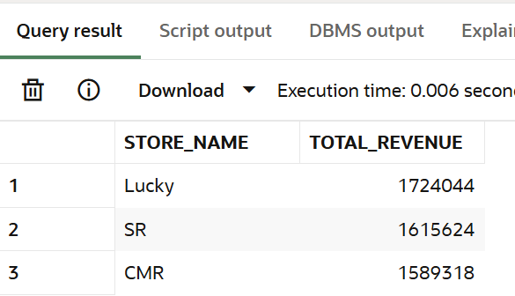

8. Window Functions
Manager Requirement:
Provide advanced analytics without losing row-level data.
Questions:
- Calculate total spend per customer using window function.

select customer_id,amount,sum(amount) over(partition by customer_id) as spend from sales;

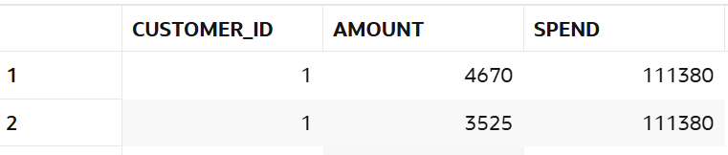

- Rank customers by revenue.

select customer_id,sum(amount) as revenue,rank() over (order by sum(amount) desc) as rank from sales group by customer_id;

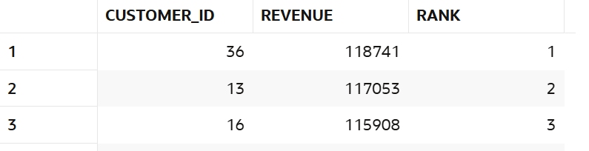

- Find top customer per store.
select *
from (
select st.store_name,
c.customer_name,
sum(s.amount) as rev,
rank() over (partition by st.store_name order by sum(s.amount) desc) as rnk
from sales s
join customers c on c.customer_id = s.customer_id
join stores st on st.store_id = s.store_id
group by st.store_name, c.customer_name
)where rnk = 1;

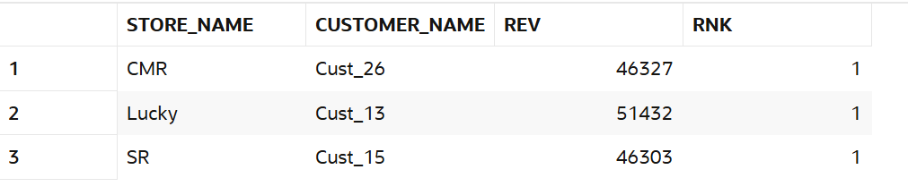

- Calculate running total of sales.

select sale_date,amount,sum(amount) over (order by sale_date rows between unbounded preceding and current row) as running_total
from sales;

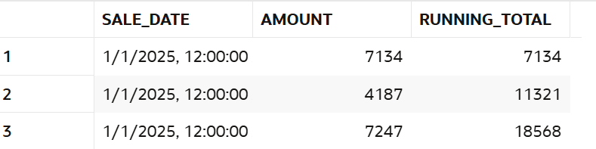

- Find previous sale using LAG.

select sale_id, sale_date, amount, lag(amount) over (order by sale_date) as previous_sale
from sales;

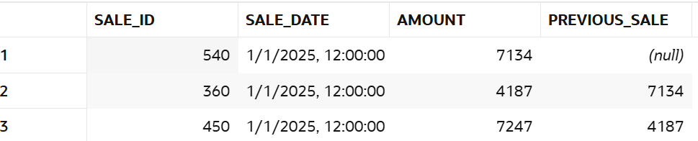

- Find next sale using LEAD.
select sale_id, sale_date, amount, lead(amount) over (order by sale_date) as nextday_sale from sales;

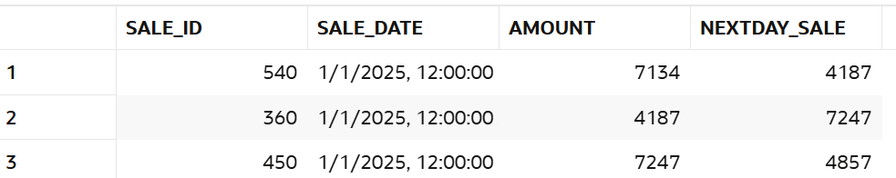

- Calculate sales growth.

select sale_id,sale_date,amount, lag(amount) over (order by sale_date) as lag,
amount - lag(amount) over (order by sale_date) as sales_growth from sales;

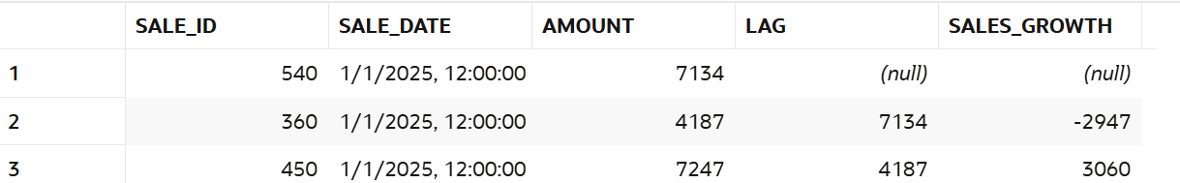

- Find difference between transactions.

select sale_id, sale_date, amount, amount - lag(amount) over (order by sale_date) as diff
from sales;

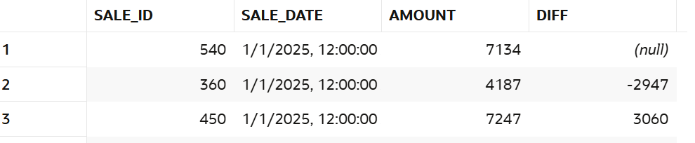

- Calculate cumulative revenue.

select sale_date,amount,sum(amount) over (order by sale_date rows between unbounded preceding and current row) as cumulative_revenue
from sales;

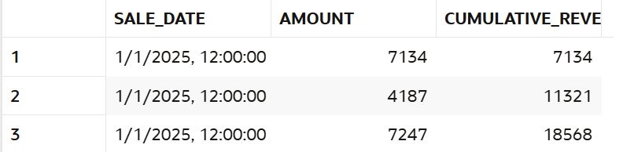

- Find moving average of sales.

select sale_id,sale_date,amount,avg(amount) over (order by sale_date rows between 2 preceding and current row) as moving_avg from sales;

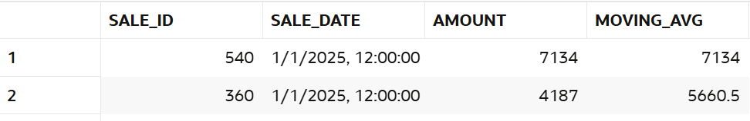

- Rank stores by revenue

select st.store_name,sum(s.amount) as revenue,rank() over (order by sum(s.amount) desc) as store_rank from sales s join stores st on s.store_id = st.store_id
group by st.store_name;

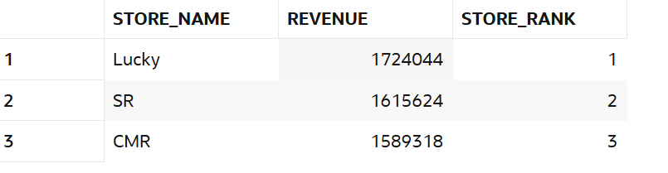

- Find second highest sale.

select amount from (select amount,dense_rank() over (order by amount desc) as rnk
from sales)where rnk = 2;

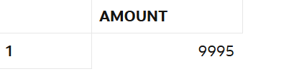

- Partition data by store and analyze.

select st.store_name,s.sale_id,s.amount,sum(s.amount) over (partition by st.store_name) as store_total from sales s join stores st on s.store_id = st.store_id;

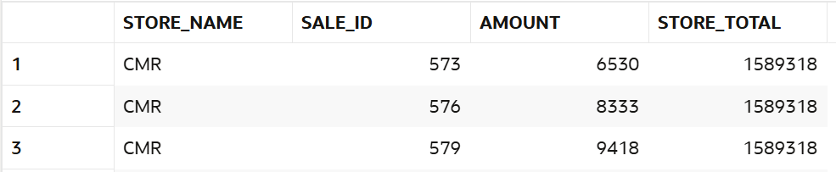

- Find customer ranking per store.

select st.store_name,c.customer_name,sum(s.amount) as revenue,
rank() over (partition by st.store_name order by sum(s.amount) desc) as rank_in_store from sales s join stores st on s.store_id = st.store_id
join customers c on c.customer_id = s.customer_id
group by st.store_name, c.customer_name;

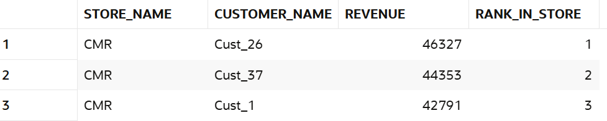
- Calculate frequency using window.

select customer_id,sale_id,
count(*) over (partition by customer_id) as transaction_count from sales;

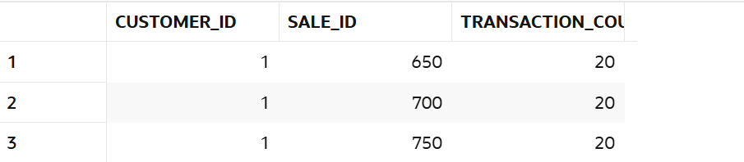

9. NTILE / Segmentation
Manager Requirement:
Segment customers for marketing.
Questions:
- Divide customers into 4 segments.
select customer_id,sum(amount) as revenue,ntile(4) over (order by sum(amount) desc) as segment from sales group by customer_id;

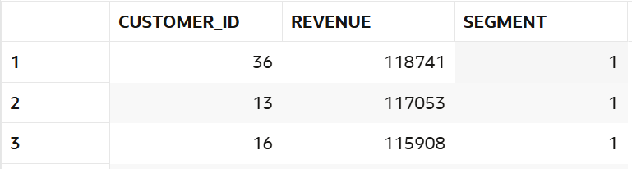

- Identify top 25% customers.

select customer_id,sum(amount) as revenue,ntile(4) over (order by sum(amount) desc) as quartile,
case
when ntile(4) over (order by sum(amount) desc) = 1
then 'top 25% customer'
else 'bottom 75% customer'
end as segment
from sales group by customer_id

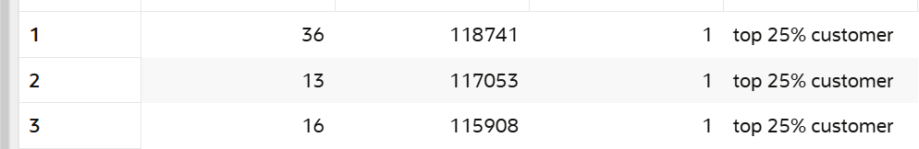

- Identify bottom 25% customers.

select customer_id, sum(amount) as revenue,ntile(4) over (order by sum(amount) desc) as quartile,
case
when ntile(4) over (order by sum(amount) desc) = 4
then 'bottom 25% customer'
else 'top 75% customer'
end as segment
from sales group by customer_id;

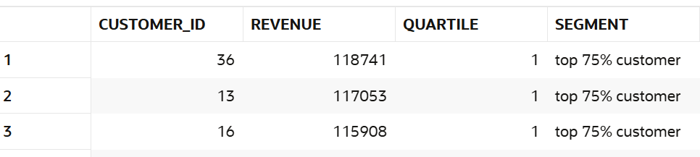

- Segment stores into 3 groups.

select store_id, sum(amount) as revenue,
ntile(3) over (order by sum(amount) desc) as store_segment from sales group by store_id;

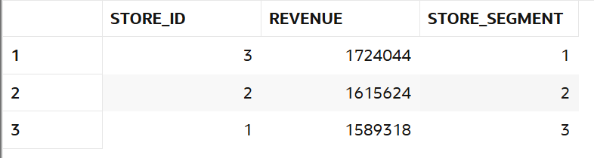

- Create quartiles based on revenue.

select customer_id,sum(amount) as revenue,ntile(4) over (order by sum(amount) desc) as revenue_quartile from sales group by customer_id;

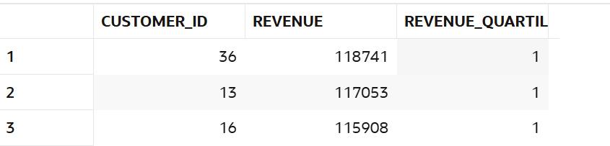

- Segment customers per store.

select st.store_name, c.customer_name, sum(s.amount) as revenue, ntile(4) over (partition by st.store_name order by sum(s.amount) desc) as segment_in_store
from sales s join stores st
on s.store_id = st.store_id join customers c on c.customer_id = s.customer_id group by st.store_name, c.customer_name;

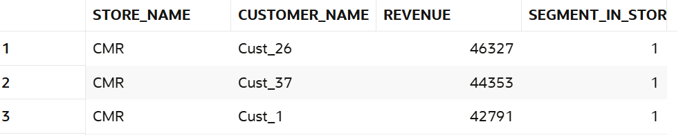

- Identify premium segment.

select customer_id,
sum(amount) as revenue,
ntile(4) over (order by sum(amount) desc) as quartile,
case
when ntile(4) over (order by sum(amount) desc) = 1
then 'top 25% customer'
else 'other'
end as segment
from sales group by customer_id;

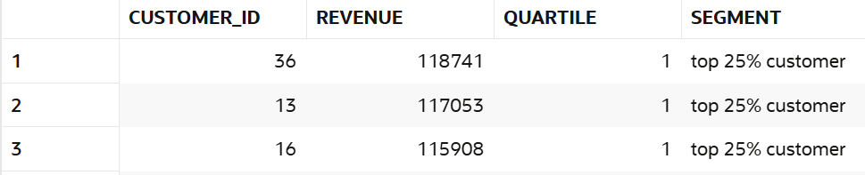

- Find mid-level customers.

select customer_id,
sum(amount) as revenue,
ntile(4) over (order by sum(amount) desc) as quartile,
case
when ntile(4) over (order by sum(amount) desc) in (2,3)
then 'mid-level customer'
else 'other'
end as segment
from sales group by customer_id;

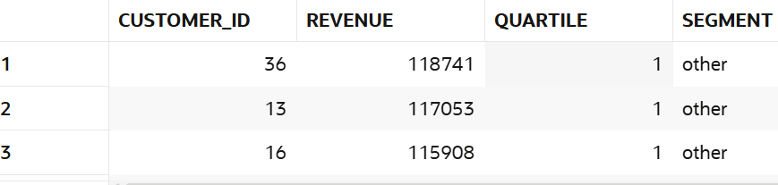

- Analyze bucket distribution.

select customer_id, sum(amount) as revenue,
ntile(5) over (order by sum(amount) desc) as five_dis from sales group by customer_id;

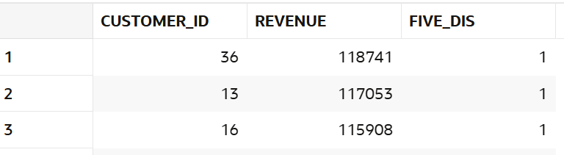

- Create marketing segments.

select customer_id,
sum(amount) as revenue,
case
when ntile(4) over (order by sum(amount) desc) = 1 then 'premium'
when ntile(4) over (order by sum(amount) desc) = 2 then 'high'
when ntile(4) over (order by sum(amount) desc) = 3 then 'medium'
else 'low'
end as marketing_segment
from sales
group by customer_id;

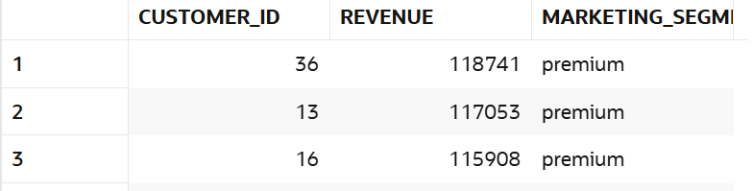

10. FIRST_VALUE / LAST_VALUE
Manager Requirement:
Compare performance with best and worst.
Questions:
- Find highest sale.

select first_value(amount) over(order by amount desc) as high_value from sales;

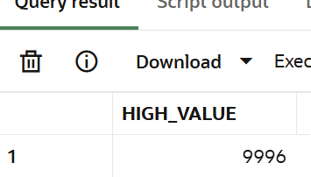

- Find lowest sale.

select last_value(amount) over(order by amount desc rows between unbounded preceding and unbounded following ) as low_value from sales;
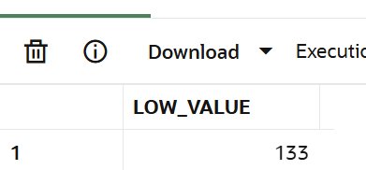

- Compare each sale with highest.

select sale_id,amount,first_value(amount) over(order by amount desc) as highest_sale,amount-first_value(amount) over(order by amount desc) as compare from sales;

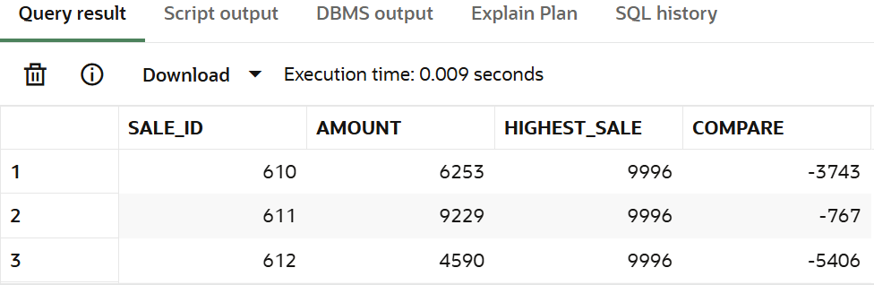

- Compare each sale with lowest.

select sale_id, amount,
last_value(amount) over ( order by amount desc
rows between unbounded preceding and unbounded following) as lowest_sale,
amount - last_value(amount) over (order by amount desc rows between unbounded preceding and unbounded following ) as compare from sales;

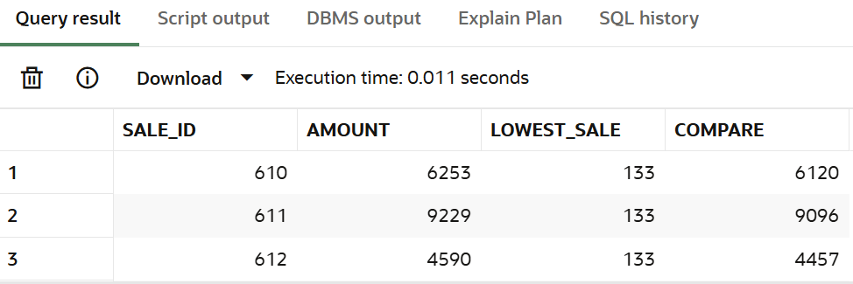

- Find highest sale per store.

select distinct st.store_name,first_value(s.amount) over(partition by st.store_name order by s.amount desc) as high_sale from sales s join stores st on s.store_id=st.store_id;

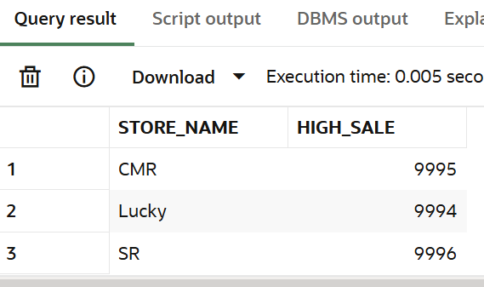

- Find lowest sale per store.

select distinct st.store_name,last_value(s.amount) over(partition by st.store_name order by s.amount desc rows between unbounded preceding and unbounded following) as low_sale from sales s join stores st on s.store_id=st.store_id;

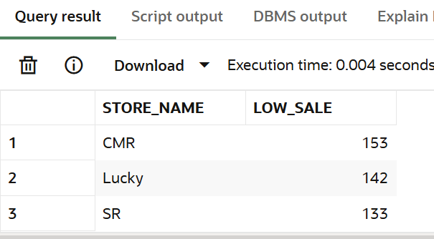

- Compare category performance.

select p.category,sum(s.amount) as revenue,
first_value(p.category) over (order by sum(s.amount) desc) as best_category,
last_value(p.category) over (order by sum(s.amount) desc rows between unbounded preceding and unbounded following ) as worst_category from sales s
join products p on s.product_id = p.product_id group by p.category;

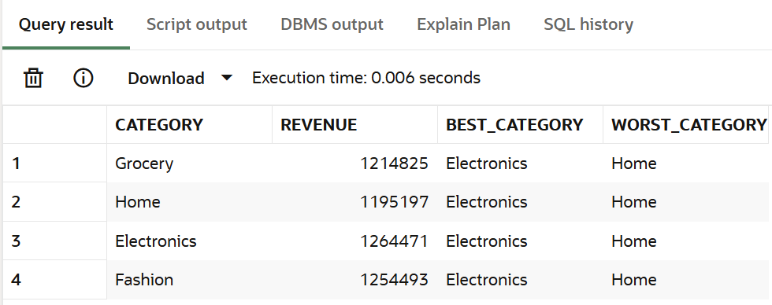

- Find best customer per store.

select st.store_name, c.customer_name, sum(s.amount) as revenue,
first_value(c.customer_name) over (partition by st.store_name order by sum(s.amount) desc) as best_customer from sales s
join stores st on s.store_id = st.store_id
join customers c on c.customer_id = s.customer_id group by st.store_name, c.customer_name;

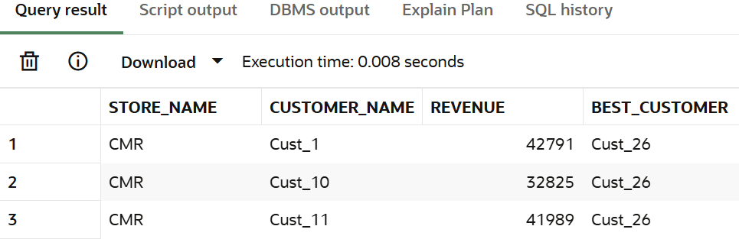

- Find worst performing category.

select category,
sum(s.amount) as revenue, last_value(category) over ( order by sum(s.amount) desc
rows between unbounded preceding and unbounded following ) as worst_category from sales s
join products p on s.product_id = p.product_id group by category;
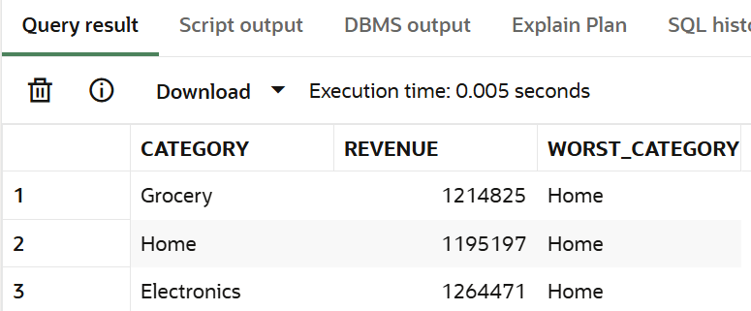

- Analyze gap between best and worst.

select distinct
first_value(amount) over (order by amount desc) as best_amount,
last_value(amount) over (order by amount desc rows between unbounded preceding and unbounded following ) as worst_amount,
(first_value(amount) over (order by amount desc) -last_value(amount) over ( order by amount desc rows between unbounded preceding and unbounded following)) as gap
from sales;
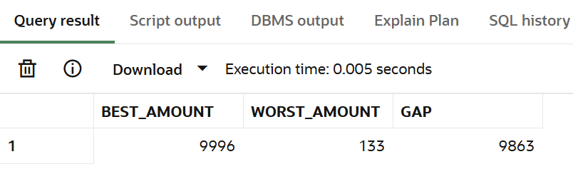

11. Date Analysis
Manager Requirement:
Analyze time-based trends.
Questions:
- Find daily sales.

select extract(day from sale_date) as day,sum(amount) as daily_sales
from sales group by extract(day from sale_date) order by day;

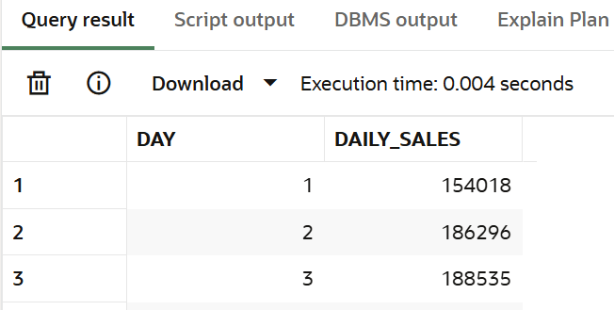

- Find monthly sales.

select extract(month from sale_date) as month, extract(day from sale_date) as day, sum(amount) as monthly_sales from sales group by extract(month from sale_date), extract(day from sale_date)
order by month, day;

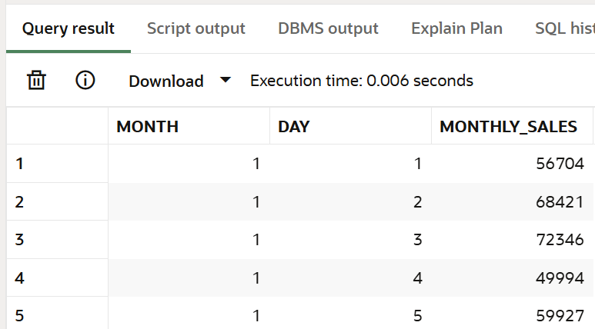

- Find weekend sales.

select sale_date, sum(amount) as weekend_sales from sales
where to_char(sale_date,'dy') in ('sat','sun') group by sale_date order by sale_date;

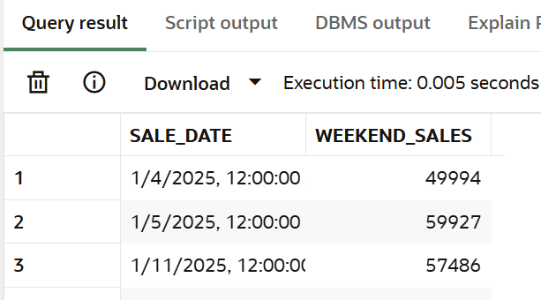

- Find first sale date.

select min(sale_date) as first_day_sale from sales;

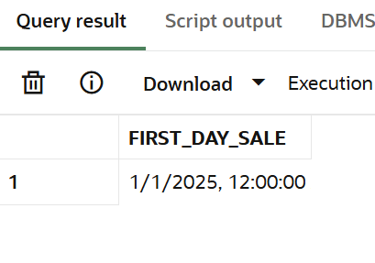

- Find last sale date.
Select max(sale_date) as last_day_sale from sales;

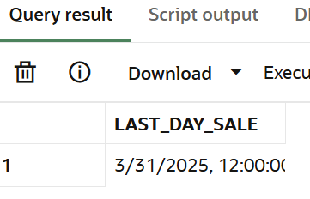

- Find sales in specific month.

select sale_id,sale_date,amount from sales where extract(year from sale_date) = 2025
and extract(month from sale_date) = 3 order by sale_date;

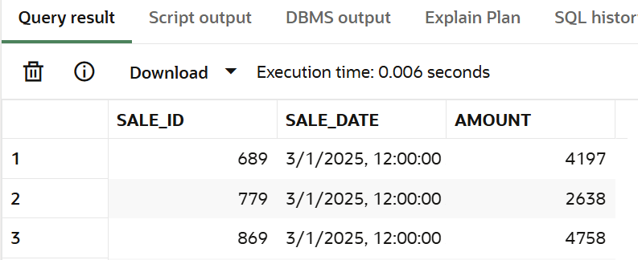

- Find sales growth month-wise.

select year, month, monthly_sales, monthly_sales - lag(monthly_sales) over (order by year, month) as growth from (
select extract(year from sale_date) as year, extract(month from sale_date) as month,
sum(amount) as monthly_sales from sales group by extract(year from sale_date), extract(month from sale_date)
) t;

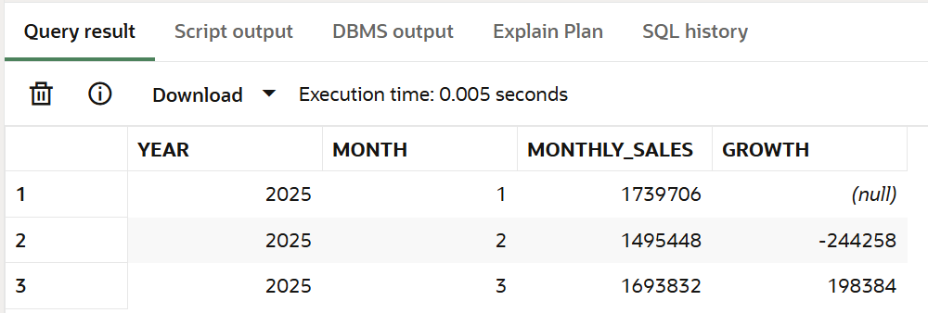

- Find inactive customers (30 days).

select c.customer_name from customers c left join sales s on c.customer_id = s.customer_id group by c.customer_name having max(s.sale_date) < current_date - interval '30' day;

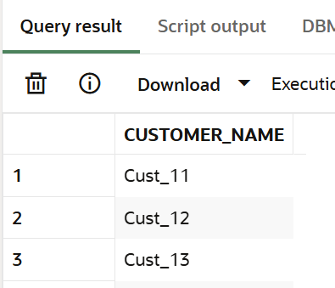

- Find repeat customers.

select c.customer_name from sales s join customers c on s.customer_id = c.customer_id group by c.customer_name having count(*) > 1;

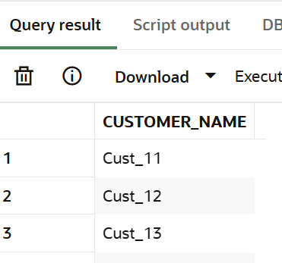

- Find sales trend.

select sale_date, sum(amount) as daily_sales from sales group by sale_date
order by sale_date;

