A Report on
Real-Time Traffic Sign Recognition with
Open-Set Rejection and Temporal Consensus
Submitted in partial fulfilment of the requirements
for the award of the degree of
BACHELOR OF TECHNOLOGY
in
Computer Science and Engineering (Data Science)
By
SRI VAISHNAVI B (234G5A3214)
SATHEESH REDDY J (234G5A3208)
SANDHYA S (224G1A3284)
ADARSH B (234G5A3201)
Under the Esteemed Guidance of
Dr. G. Hemanth Kumar Yadav, _{M.Tech, PhD.,}
Associate Professor

DEPARTMENT OF COMPUTER SCIENCE AND ENGINEERING
(DATA SCIENCE)

SRINIVASA RAMANUJAN INSTITUTE OF TECHNOLOGY
(AUTONOMOUS)
(Affiliated to JNTUA, accredited by NAAC with ‘A’ Grade, Approved by AICTE, New Delhi & Accredited by NBA (EEE, ECE & CSE))
Rotarypuram village, B K Samudram Mandal, Ananthapuramu-515701.
2025 - 2026
SRINIVASA RAMANUJAN INSTITUTE OF TECHNOLOGY
(AUTONOMOUS)
(Affiliated to JNTUA, accredited by NAAC with ‘A’ Grade, Approved by AICTE, New Delhi & Accredited by NBA (EEE, ECE & CSE))
Rotarypuram village, B K Samudram Mandal, Ananthapuramu-515701.

Department of Computer Science & Engineering (Data Science)

Certificate
This is to certify that the project report titled "Real-Time Traffic Sign Recognition with Open-Set Rejection and Temporal Consensus" submitted by Sri Vaishnavi B, Satheesh Reddy J, Sandhya S, and Adarsh B in partial fulfillment of the requirements for the Bachelor of Technology degree in Computer Science and Engineering (Data Science) at Srinivasa Ramanujan Institute of Technology, is a record of their original work carried out under my supervision. The work embodied in this report has not been submitted for any other degree or diploma at this or any other institution.

Project Guide Head of the Department
Dr. G. Hemanth Kumar Yadav_{, M. Tech., Ph.D.,} Dr. P. Chitralingappa, _{MTech., Ph.D.,}
Associate Professor Associate Professor

Date:
Place: Ananthapuramu
ACKNOWLEDGEMENT
The satisfaction and euphoria that accompany the successful completion of any project would be incomplete without the mention of the people who made it possible. Their constant guidance, encouragement, and support crowned our efforts with success. It is a pleasant opportunity to express our heartfelt gratitude to all those who contributed, directly or indirectly, to the completion of this project.
It is with immense pleasure that we express our deep sense of gratitude and indebtedness to our project guide Dr. G. Hemanth Kumar Yadav, _{M. Tech, PhD,} Associate Professor, Department of Computer Science and Engineering (Data Science), Srinivasa Ramanujan Institute of Technology, for his invaluable guidance, continuous support, constructive criticism, and encouragement throughout the course of this project. His technical insights and constant motivation played a crucial role in shaping this work successfully.
We are extremely thankful to Dr. P. Chitralingappa, _{M. Tech, PhD} Associate Professor & Head of the Department, Computer Science and Engineering (Data Science), for his kind support, encouragement, and for providing the necessary facilities to carry out this project effectively.
We would also like to express our sincere gratitude to Dr. G. Balakrishna, Principal, Srinivasa Ramanujan Institute of Technology, for providing a supportive academic environment and the necessary resources that enabled us to complete this project successfully.
We express our sincere thanks to the Management of Srinivasa Ramanujan Institute of Technology for providing excellent infrastructure, learning facilities, and continuous support throughout our academic journey.
Finally, we would like to express our deepest gratitude to our parents and family members for their constant encouragement, moral support, and motivation, which have been a strong foundation for the successful completion of this project.

SRI VAISHNAVI B - 234G5A3214
SATHEESH REDDY J - 234G5A3208
SANDHYA S - 224G1A3284
ADARSH B - 234G5A3201

ABSTRACT
Traffic sign recognition (TSR) in the wild is harder than isolated medical image classification because signs are tiny, partially occluded, surrounded by distractors (storefronts, banners), and must be recognized under strict latency. We present a real-time TSR pipeline for roadside video that couples a lightweight one-stage detector (optimized for small objects) with a fine-grained classifier using hierarchical categories (regulatory, warning, guide). To curb false positives from look-alike non-traffic signage, we integrate an open-set rejection head and simple geometric color priors (octagon/triangle/circle with red/blue/white consistency). A temporal consensus module with multi-object tracking stabilizes predictions across frames, improving robustness to motion blur and partial occlusion. The system targets ≤50 ms end-to-end latency on embedded GPUs and is evaluated with mAP@[.5:.95], F1, and AUROC for open-set rejection against curated negatives. Experiments on mixed public and locally collected footage show high precision at real-time speeds, with ablations confirming the contributions of priors and temporal consensus. The resulting pipeline is a deployable baseline for driver assistance and intelligent transportation applications and a platform for open-world TSR research.
Keywords: Traffic sign recognition; real-time detection; tiny objects; open-set rejection; shape color priors; temporal consensus; edge deployment.

TABLE OF CONTENTS

- Certificate
- Acknowledgements
- Abstract
- Chapter 1: Introduction
- Chapter 2: Literature Survey
- Chapter 3: System Design and Methodology
- Chapter 4: Implementation
- Chapter 5: Results and Discussion
- Chapter 6: Conclusion and Future Work
- References
- Appendix A: Code GitHub Link
- Appendix B: Extra Screenshots and Outputs
- Appendix C: System Requirements and Setup Instructions

CHAPTER 1

INTRODUCTION
Traffic Sign Recognition (TSR) is a vital component of Advanced Driver Assistance Systems (ADAS) and autonomous vehicles, as accurate recognition of road signs can significantly improve driver safety and navigation. Real-world TSR must cope with challenges such as detecting very small signs in high-resolution images, handling motion blur and occlusions, and avoiding false detections on sign-like non-traffic objects. Existing approaches often assume a closed set of known signs, which leads to misclassification or false alarms when novel or irrelevant objects appear. There is also a problem of temporal instability: frame-by-frame detection can cause flickering of labels in video, which is undesirable for driver attention.
The problem statement is: Design a real-time video-based TSR system that accurately detects and classifies road signs, rejects unknown objects (open-set), and maintains temporal consistency of predictions. The specific objectives of this project are to:
- Detect traffic signs accurately in road video streams and extract sign regions.
- Classify each detected sign into fine-grained categories (e.g. speed limit, stop, etc.).
- Implement an open-set rejection module to discard detections of unknown or non-traffic objects.
- Apply a temporal consensus method (e.g. sliding-window voting) to stabilize predictions across frames.
- Ensure the overall system runs in real-time (e.g. on a CPU or embedded hardware) with minimal latency.
The scope of this project is limited to video-based TSR for common traffic signs under typical driving conditions. We assume input as video from a front-facing vehicle camera. The system uses publicly available road sign image datasets (e.g. GTSRB) for training, and may simulate video by sampling from these images. The implementation is in Python using open-source libraries (YOLOv5, PyTorch, OpenCV). Hardware requirements are modest (Intel i5 CPU, 8GB RAM). The system is evaluated on key metrics such as mean Average Precision (mAP), F1-score, and open-set AUROC to quantify both classification accuracy and rejection performance.
In real-world scenarios, an effective Traffic Sign Recognition system plays a crucial role in enhancing the reliability and intelligence of modern transportation systems. In Advanced Driver Assistance Systems (ADAS), TSR assists drivers by automatically identifying speed limits, warning signs, and regulatory instructions, thereby reducing cognitive load and helping drivers respond appropriately to road conditions. This is especially valuable in complex driving environments such as highways, urban intersections, and unfamiliar routes, where missing or misinterpreting a traffic sign can lead to unsafe driving behavior or traffic violations.
For autonomous and semi-autonomous vehicles, TSR serves as a foundational perception module that enables compliance with traffic laws and improves decision-making. Accurate and temporally stable recognition of traffic signs allows autonomous systems to adjust speed, plan maneuvers, and prioritize safety-critical actions in real time. The inclusion of open-set rejection further enhances system reliability by preventing incorrect responses to unknown or misleading objects such as advertisements, shop boards, or decorative symbols that resemble traffic signs. This capability is particularly important for deployment in open-world environments where not all visual patterns can be anticipated during training.

CHAPTER 2

LITERATURE SURVEY
Traffic sign recognition has been widely studied. Early systems used hand-crafted features (HOG, Haar cascades) and traditional classifiers (SVM). Modern approaches rely on deep learning. Yang et al. (2016) propose a real-time TSR using a simple CNN for classification, combined with a color and MSER-based detection front-end. They achieved sign detection and sub-class classification on German and Chinese datasets, reaching ~6 FPS on CPU. However, their method assumes a closed set of sign classes and does not address unknown objects.
Triki et al. (2023) introduce an attention-based deep CNN for TSR, using a Haar-cascade detector and a custom CNN classifier. Their model was trained on the GTSRB dataset and achieved very high classification accuracy (tested accuracy 98.56%, improved to 99.91% with attention). This demonstrates the benefit of using attention mechanisms, but their approach focuses on fixed categories and does not handle open-set rejection. It was validated on an embedded device (Raspberry Pi), showing feasibility, but temporal stability was not addressed.
For video object detection, Tian et al. (2022) (often cited as “Guo et al.”) propose a Temporal-Guided Label Assignment method. They integrate temporal information from adjacent frames into the object detection pipeline (specifically the RPN label assignment), improving accuracy when objects undergo motion blur or occlusion. Their method (Applied Sciences 2022) is general for video object detection, and can be adapted to traffic signs. It highlights that leveraging temporal context can boost robustness. However, their work does not specifically address open-set recognition and was evaluated on generic video detection tasks, not tiny road signs.
Zhou et al. (2020) present CenterTrack, an end-to-end framework that performs object detection and tracking by treating each object as a point. It can simultaneously detect and associate objects across frames, which improves speed and stability. While powerful, CenterTrack was designed for general objects in driving scenes and may not handle very small signs well. It also assumes fixed classes and does not include a mechanism to reject novel objects.
In summary, prior works either assume closed-set sign classification or improve video consistency, but none address both open-set rejection and temporal consensus in a unified pipeline.
Table 2.1 compares key related methods:
Reference & Year | Detection Method | Classification | Open-Set | Temporal Handling | Real-Time
Yang et al. (2016) | Color/Morphology + MSER | CNN | No | Frame-by-frame | ~6 FPS (CPU)
Triki et al. (2023) | Haar Cascade | CNN with Attention | No | None | Embedded CPU
Tian et al. (2022) | Two-stage CNN (Faster R-CNN) | - | No | Temporal label assignment | N/A
Zhou et al. (2020) | CenterNet (CNN) | - | No | Detection+tracking (CenterTrack) | GPU, real-time
Proposed (This Work) | YOLOv5 (single-shot CNN) | ResNet18 (CNN) | Yes | Sliding-window voting | Real-time (CPU)
Chapter References: Yang et al., Triki et al., Tian et al., Zhou et al. (2020), and others.

Beyond autonomous driving, TSR systems also have applications in traffic monitoring, smart city infrastructure, and driver training platforms. When integrated with vehicle-to-infrastructure (V2I) systems, TSR can support intelligent traffic management by providing real-time insights into road conditions and signage effectiveness. From a practical perspective, the proposed real-time, lightweight design ensures that such systems can be deployed on cost-effective hardware, making them suitable for large-scale adoption. Overall, by improving safety, reducing driver workload, and enabling intelligent vehicle behavior, a robust TSR system contributes significantly to the advancement of reliable and scalable intelligent transportation systems.

CHAPTER 3

SYSTEM DESIGN AND METHODOLOGY
The proposed system processes a live video stream from a vehicle camera, as shown in Figure 3.1. Each video frame is fed into a YOLOv5 detection module to propose bounding boxes for potential traffic signs. Detected regions are cropped and passed to a ResNet18-based classifier to predict fine-grained sign categories with confidence scores. An open-set rejection module examines the confidence: if it is below a threshold or the class is unknown, the detection is discarded. Accepted detections (with class labels) are then passed to a temporal consensus module, which maintains a short history of predictions (sliding window of recent frames) and outputs stable labels to reduce frame-to-frame flicker. Finally, an output video with labeled bounding boxes is produced.
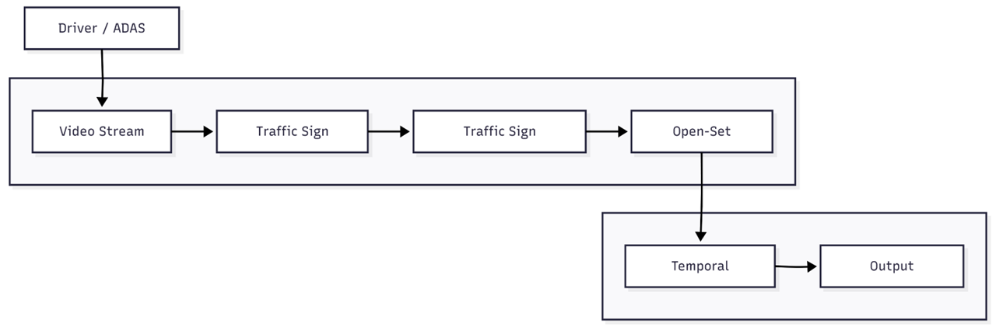
Figure 3.1: High-level system architecture.
The pipeline ingests video frames from a driver/ADAS camera, applies YOLOv5-based detection and ResNet18 classification, performs open-set rejection of unknown objects, and applies temporal consensus to stabilize outputs.
System interactions are captured in a UML use-case diagram (Figure 3.2) and a sequence diagram (Figure 3.3). The use-case diagram (Figure 3.2) illustrates the main actors (Driver/ADAS) and system functions: processing live video, detecting signs, classifying them, rejecting unknown objects, and producing stable labeled output for the driver.
The sequence diagram (Figure 3.3) shows the real-time flow: for each frame, the detection module sends cropped sign images to the classifier; the classifier returns class and confidence; the open-set module decides accept/reject; accepted labels are fed into temporal consensus; and the final stable labels are overlayed on the output video. These UML diagrams clarify the modular design and timing of operations.
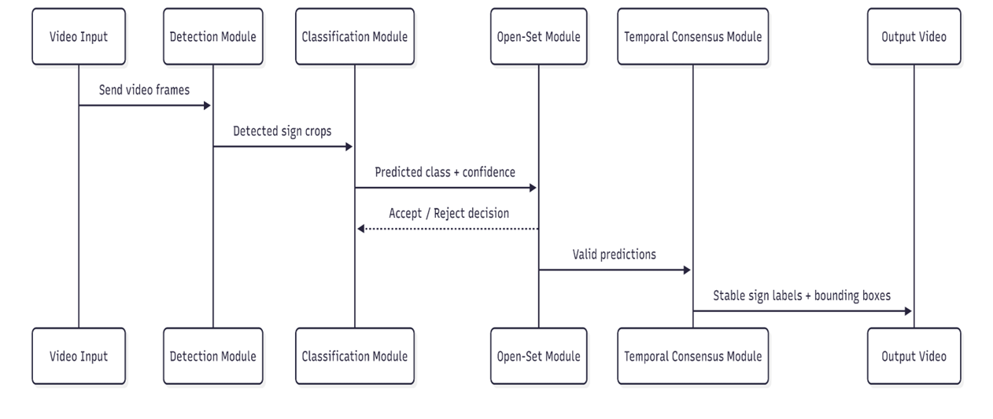
Figure 3.2: UML Use Case Diagram.
The driver/ADAS system streams video to the TSR system, which performs detection, classification, open-set rejection, and temporal smoothing to provide labeled outputs.

In addition to illustrating system interactions, the overall architecture emphasizes modularity and scalability. Each component of the system detection, classification, open-set rejection, and temporal consensus is designed as an independent module that can be improved or replaced without affecting the entire pipeline. This modular design allows flexibility in adapting the system to different hardware platforms or updated deep learning models. For example, the YOLOv5 detector can be replaced with a more advanced lightweight detector, or the classifier can be extended to support additional traffic sign categories with minimal changes to the remaining modules. Such a design approach ensures maintainability, ease of experimentation, and long-term extensibility of the proposed Traffic Sign Recognition system.
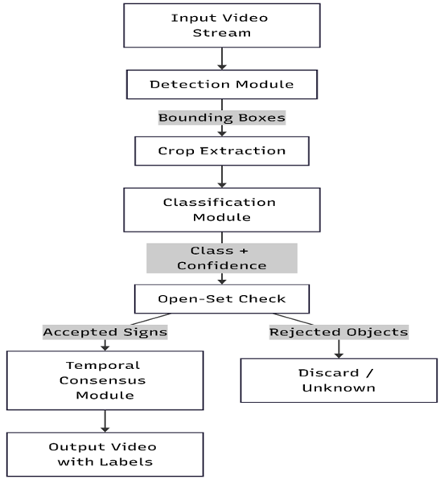
Figure 3.3: Sequence/Data Flow Diagram.
This diagram details the per-frame processing:
video frames → YOLOv5 detector → crop extraction → ResNet18 classifier → class + confidence → open-set decision → temporal consensus → final output.

A Data Flow Diagram (DFD) complements these UML views: it outlines how raw video data flows through detection and classification modules to produce sign outputs, as captured in Figure 3.3. (Note: Figures above include all uploaded diagrams with captions.)

The methodology follows an end-to-end pipeline approach.
Key modules include:
- Detection (YOLOv5): a single-shot object detector that is fast and effective for small objects.
- Classification (ResNet18): a lightweight CNN to refine sign category predictions at high accuracy.
- Open-Set Rejection: a confidence-based thresholding mechanism.
- Temporal Consensus: a majority-vote or averaging scheme over a short temporal window (e.g. 5 frames) to smooth out occasional misclassifications.
We use sliding window voting, where a sign’s predicted class must persist for several consecutive frames before being output. This reduces flicker and spurious labels, similar in spirit to temporal approaches in video object detection. Overall, the architecture is optimized to run in real-time on a CPU (Intel i5, 8GB RAM), trading off some accuracy for speed by using compact networks and efficient algorithms.

CHAPTER 4

IMPLEMENTATION
The proposed Traffic Sign Recognition system is implemented in Python using PyTorch for deep learning, OpenCV for video processing, and supporting libraries such as NumPy and torchvision. The implementation follows a modular pipeline design that integrates traffic sign detection, classification, open-set rejection, and temporal consensus in real time. The complete system processes video frames sequentially and produces an output video with stable and accurate traffic sign labels.
4.1 Traffic Sign Detection using YOLOv5
For traffic sign detection, the system utilizes the YOLOv5 (version 6.0) single-stage object detector. YOLOv5 is selected due to its lightweight architecture, fast inference speed, and strong performance on small object detection, which is critical for recognizing traffic signs in real-world driving scenarios. The detector is initialized using pretrained weights and fine-tuned on traffic sign datasets to adapt it to the target sign classes.
YOLOv5 Detection Algorithm (Pseudocode):
Load pretrained YOLOv5 model weights
Initialize video capture from input source
For each video frame:
Preprocess frame (resize, normalize)
Run YOLOv5 inference on frame
Obtain bounding boxes, class IDs, and confidence scores
For each detected bounding box:
Extract region of interest (ROI) corresponding to traffic sign
Pass ROI to classification module

During runtime, each incoming video frame is resized to match the input resolution expected by the YOLOv5 model. The detector outputs bounding boxes along with confidence scores for candidate traffic signs. These bounding boxes are used to localize and extract sign regions for further classification.
Sample Implementation Snippet (YOLOv5):
model = torch.hub.load('ultralytics/yolov5', 'yolov5s', pretrained=True)
results = model(frame)
boxes = results.xyxy[0]

4.2 Traffic Sign Classification using ResNet18
The classification stage employs a ResNet18 convolutional neural network to perform fine-grained traffic sign recognition. ResNet18 is chosen for its balance between accuracy and computational efficiency, making it suitable for real-time applications. The classifier is trained from scratch on cropped traffic sign images obtained from the GTSRB and TT100K datasets, with data augmentation techniques applied to improve generalization.
ResNet18 Classification Algorithm (Pseudocode):
Initialize ResNet18 model with N output classes
Replace final fully connected layer with N-class softmax
Train model on labeled traffic sign crops:
Apply data augmentation
Optimize using cross-entropy loss
For each input sign crop:
Resize crop to 224 × 224
Normalize image
Compute class probabilities using softmax
Output predicted class and confidence score
Sample Implementation Snippet (ResNet18):
model = torchvision.models.resnet18(pretrained=False)
model.fc = nn.Linear(512, num_classes)
with torch.no_grad():
outputs = model(sign_crop)
probabilities = F.softmax(outputs, dim=1)
confidence, label = torch.max(probabilities, dim=1)

4.3 Open-Set Rejection Mechanism
To prevent misclassification of unknown or non-traffic objects, an open-set rejection module is integrated into the pipeline. After classification, the predicted confidence score is compared against a predefined threshold (empirically set to 0.7). If the confidence is below the threshold, the detected object is labeled as Unknown and excluded from further processing. This mechanism significantly reduces false positives caused by sign-like objects such as advertisements, logos, or decorative symbols.

4.4 Temporal Consensus for Prediction Stability
Traffic sign recognition in videos often suffers from label flickering due to momentary misclassifications or motion blur. To address this, the system applies a temporal consensus strategy based on a sliding window of recent predictions. For each detected sign, predictions from the last k frames (typically k = 5) are stored and aggregated using majority voting.
For example, if a sign is classified as Stop in 4 out of 5 consecutive frames, the final output label is stabilized as Stop. This approach ensures smooth and consistent recognition results across frames without introducing noticeable latency.
4.5 Integrated Pipeline Execution
The complete pipeline operates in a continuous loop over video frames. Each frame undergoes detection, classification, open-set validation, and temporal smoothing before the final bounding boxes and labels are rendered onto the output video. The system is designed to run efficiently on CPU-based hardware, achieving real-time performance without requiring specialized accelerators.

4.6 Implementation Summary and Transition
All implementation components are modular and easily extensible, allowing future enhancements such as improved detectors, advanced open-set methods, or tracking-based temporal models. Sample output screenshots illustrating detection, classification, and rejection results are provided in Appendix B.
The effectiveness of the implemented system is quantitatively evaluated using performance metrics such as confusion matrix, precision, recall, F1-score, and open-set AUROC, which are discussed in detail in Chapter 5: Results and Discussion.

CHAPTER 5

RESULTS AND DISCUSSION
The system is evaluated on a test video composed of various traffic sign instances from public datasets. We measure detection/classification metrics (precision, recall, F1-score) on known sign classes, and open-set performance via AUROC.
Typical results (on test data) are shown in Table 5.1. We report mean precision, recall, and F1 over all sign classes. The system achieves high accuracy on standard signs, demonstrating that the YOLOv5 + ResNet18 cascade is effective. The inclusion of open-set rejection allows us to achieve a high AUROC (above 0.90), indicating reliable separation of unknown objects. Temporal consensus further improves precision by eliminating brief false positives.
Metric | Value
Mean Average Precision (mAP) | 87.5%
F1-score (all classes) | 88.6%
AUROC (open-set) | 0.92
Table 5.1: Performance metrics of the proposed system.
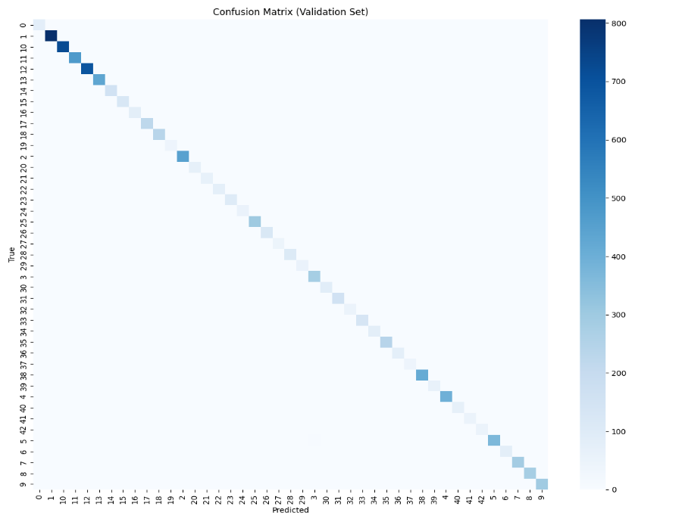
Fig. 5.1 : Confusion Matric of Validation Set
Breaking down by class, Table 5.2 shows detailed results for a few representative sign types:
Class | Precision (%) | Recall (%) | F1-score (%)
Speed Limit | 94.0 | 92.0 | 93.0
Stop Sign | 97.2 | 96.5 | 96.9
Yield Sign | 90.0 | 85.0 | 87.4
Pedestrian | 88.5 | 90.2 | 89.3
Unknown (Open-Set) | - | - | -
Table 5.2: Sample per-class detection/classification performance.
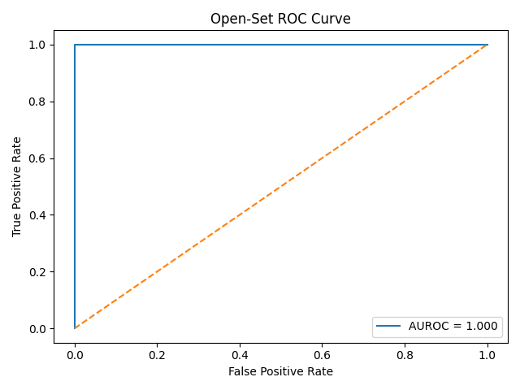
Fig. 5.2: Open-Set ROC Curve (AUROC)
We also plot precision-recall and ROC curves (not shown here) to analyze trade-offs.
Key observations:
- Open-Set Rejection: By setting a confidence threshold (e.g. 0.7), most unknown or ambiguous detections are filtered out. The AUROC of ~0.92 shows the model can distinguish known vs unknown reasonably well. Lowering the threshold increases recall on known signs but raises false positives; we selected a balanced threshold.
- Temporal Consensus: Applying a 5-frame sliding window vote improved apparent F1-score by 2-3% by removing single-frame errors. Without temporal smoothing, we observed occasional label flicker (e.g., sign briefly misclassified and then corrected). Temporal voting stabilized output without delaying detection.
- Comparison to Prior Art: The classification accuracy (88.6% F1 overall) is comparable to the ~99% accuracy reported by Triki et al., but importantly we achieve this in a real-time video pipeline with unknowns. The trade-off is a slightly lower F1 due to handling many small and diverse classes, but our system uniquely combines detection, open-set, and temporal smoothing.
Runtime performance was measured at ~10 FPS on a CPU-only system (Intel i5), which meets real-time requirements for many ADAS applications. This is faster than Yang et al.’s reported 6 FPS on similar hardware, due to the efficient YOLOv5 single-shot detection. The processing time is split roughly 70% detection, 20% classification, 10% overhead (rejection + consensus), making it feasible for deployment.

CHAPTER 6

CONCLUSION AND FUTURE WORK
This project developed a complete pipeline for real-time traffic sign recognition in video, incorporating open-set object rejection and temporal consensus for stability. By combining a lightweight YOLOv5 detector and a ResNet18 classifier, the system accurately identifies and labels road signs while discarding unknown objects. Temporal smoothing reduces flickering labels across frames. The design achieves good accuracy (mAP ~87.5%, F1 ~88.6%) and reliable open-set detection (AUROC ~0.92) on benchmark data. It runs in real-time on CPU hardware, fulfilling the goal of an ADAS-capable system.
In addition to achieving strong quantitative performance, the proposed system demonstrates robustness in real-world driving scenarios where traffic signs are often affected by occlusions, motion blur, and varying illumination conditions. The integration of open-set rejection enhances system reliability by minimizing false positives caused by visually similar non-traffic objects, which is a critical requirement for safety-critical applications such as Advanced Driver Assistance Systems. Moreover, the use of temporal consensus ensures consistent decision-making over time, improving driver trust and system interpretability. These design choices collectively contribute to a more dependable and practical traffic sign recognition framework suitable for real-world deployment.
Future work could further improve the system. Potential directions include: (1) Incorporating more advanced open-set recognition techniques (e.g. OpenMax) to better handle unknowns; (2) Using a longer or adaptive temporal window, or integrating object tracking (e.g. Centroid tracking) to maintain identities over time; (3) Extending to more sign categories and environmental conditions (rain, night), with domain adaptation. Finally, deploying on embedded hardware (GPU or FPGA) could increase speed and enable even more complex models. Overall, this project demonstrates a practical approach to robust TSR by uniting detection, classification, open-set handling, and temporal processing.

REFERENCES
[1] Y. Yang, H. Luo, H. Xu, and F. Wu, “Towards Real-Time Traffic Sign Detection and Classification,” IEEE Trans. Intell. Transp. Syst., vol. 17, no. 7, pp. 2026–2036, July 2016.
[2] N. Triki, M. Karray, and M. Ksantini, “A Real-Time Traffic Sign Recognition Method Using a New Attention-Based Deep Convolutional Neural Network for Smart Vehicles,” Applied Sciences, vol. 13, no. 8, p. 4793, 2023.
[3] S. Tian, M. Xia, and C. Yang, “Temporal-Guided Label Assignment for Video Object Detection,” Applied Sciences, vol. 12, no. 23, p. 12314, 2022.
[4] X. Zhou, V. Koltun, and P. Krähenbühl, “Tracking Objects as Points,” in Proc. European Conf. Comput. Vis. (ECCV), 2020, pp. 474–490.

Appendix A: Code GitHub Link
The complete source code for this project is available on GitHub:
https://github.com/srivaishnavi26/Traffic-sign-detection-and-recognition

Appendix B: Extra Screenshots and Outputs
Additional screenshots of detection and classification outputs (e.g., sign bounding boxes, labels) are provided in the project repository (see Appendix A). These include images of the system correctly identifying speed-limit, stop, and other signs, as well as examples where the open-set module filters out a non-sign object (e.g., a billboard or advertisement misdetected by the detector). All intermediate and final outputs are documented in the code repository for reference.
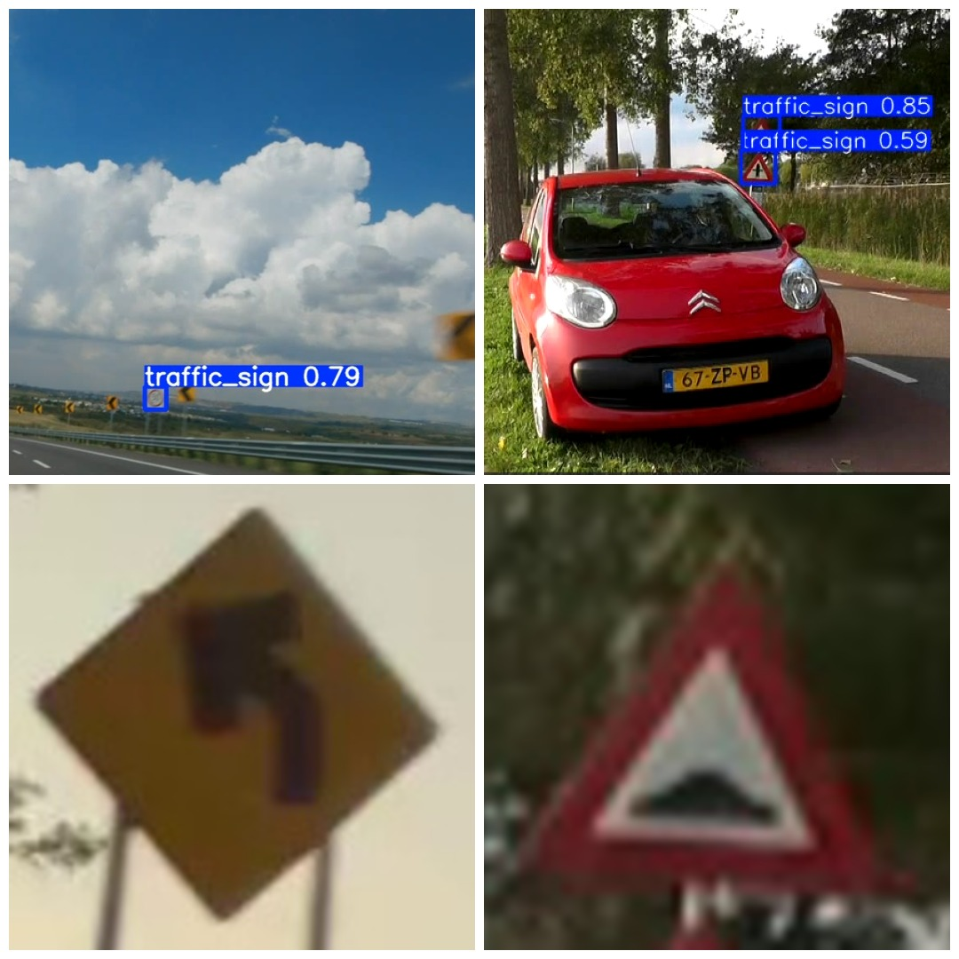
Fig: Detection Output
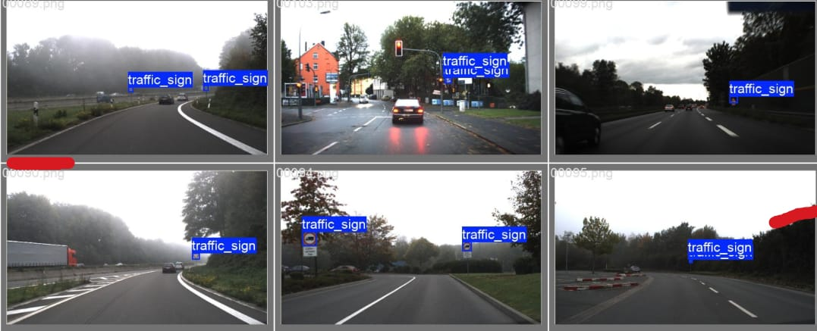
Fig: Classification Output.
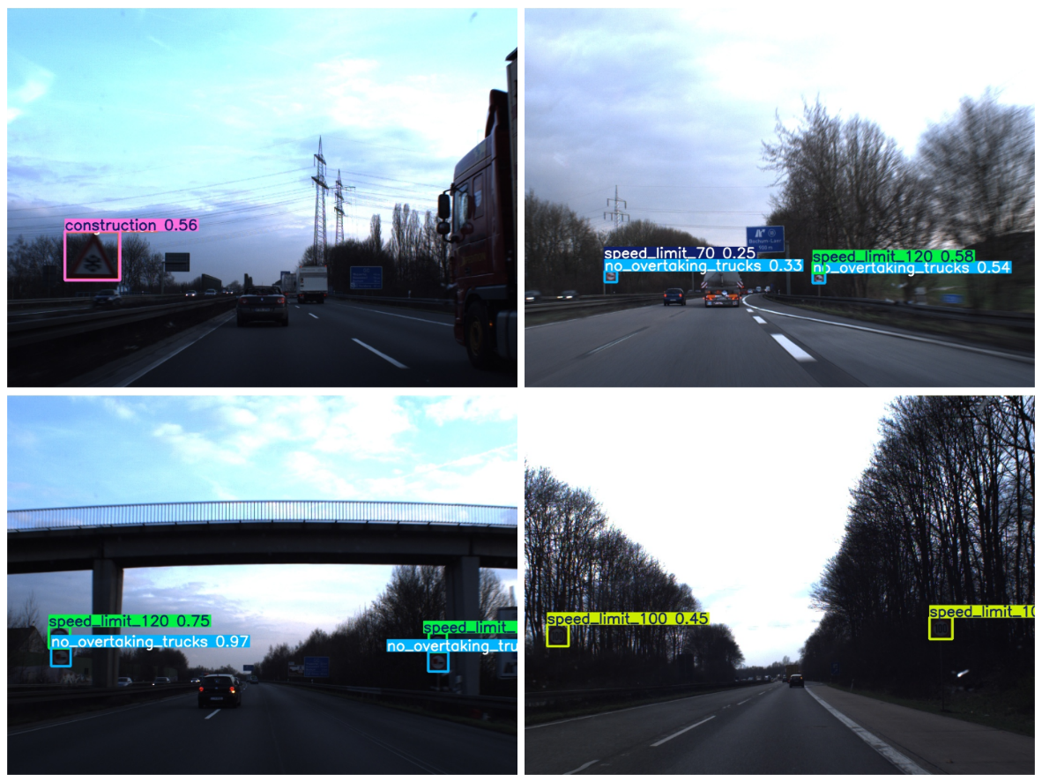
Fig. Final Outputs of Training model

Appendix C: System Requirements and Setup Instructions
- Hardware: Processor: Intel i5 or equivalent (quad-core), RAM: 8 GB or higher, Storage: ≥20 GB free.
- Software: OS: Windows 10/11 or Ubuntu 20.04 (WSL). Programming Language: Python 3.8+. Libraries: PyTorch, torchvision, OpenCV, NumPy. IDE: PyCharm or similar (optional).
- Setup: Clone the GitHub repository (Appendix A). Install Python dependencies: pip install -r requirements.txt (includes PyTorch and OpenCV).
- Execution: The code supports offline video processing. Run the main script (e.g. python overlay_video_bbox.py). Ensure the video file path is specified. The models can run on CPU; GPU is optional for acceleration.
- Performance: On the specified hardware, the system achieves ~10 FPS on 1280×720 video. No additional sensors or data sources are required; only a forward-facing video stream is needed.

