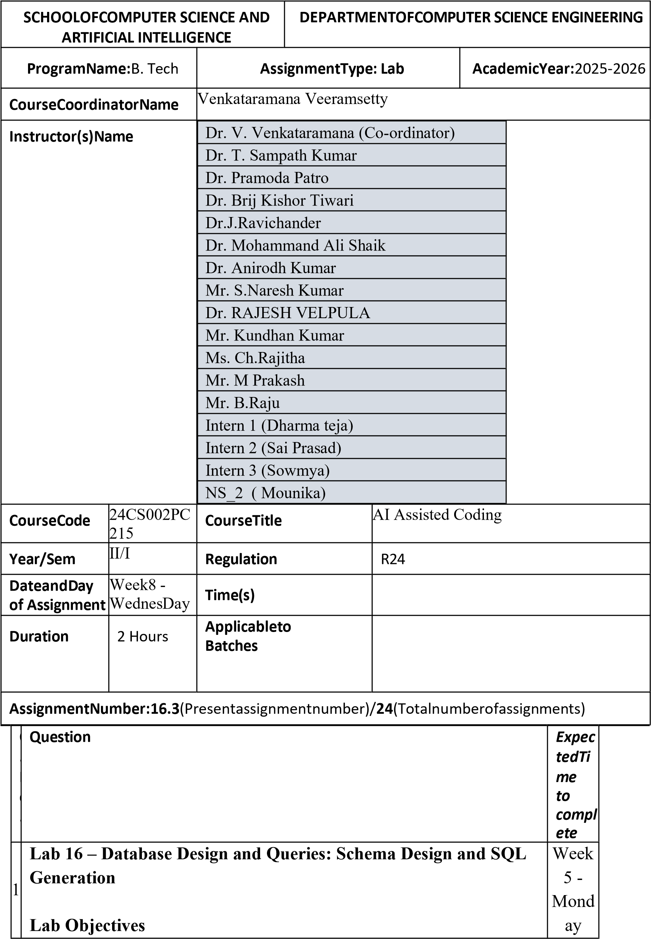

- To practice basic SQL query generation with AI assistance.
- To analyze AI-suggested queries for correctness and efficiency.
- To understand how AI can help in documenting and improving database logic.
Learning Outcomes
After completing this lab, students will be able to:
- Use AI tools to design a simple ER diagram / schema for a given scenario.
- Generate CREATE TABLE statements using AI.
- Write and refine basic SQL queries (SELECT, INSERT, UPDATE, DELETE).
- Validate correctness and efficiency of AI-generated SQL.
- Compare AI-generated vs manually written queries.
Task Description #1 – Schema Generation
Task: Ask AI to design a schema for a Library Management System (Tables: Books, Members, Loans).

SQL Code
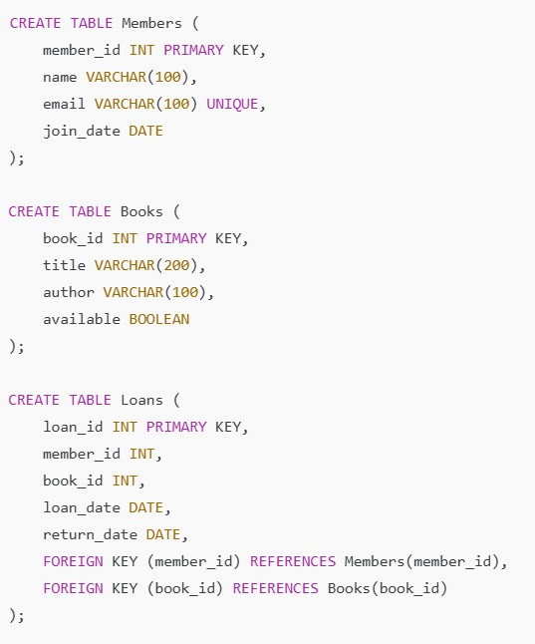

OUTPUT:

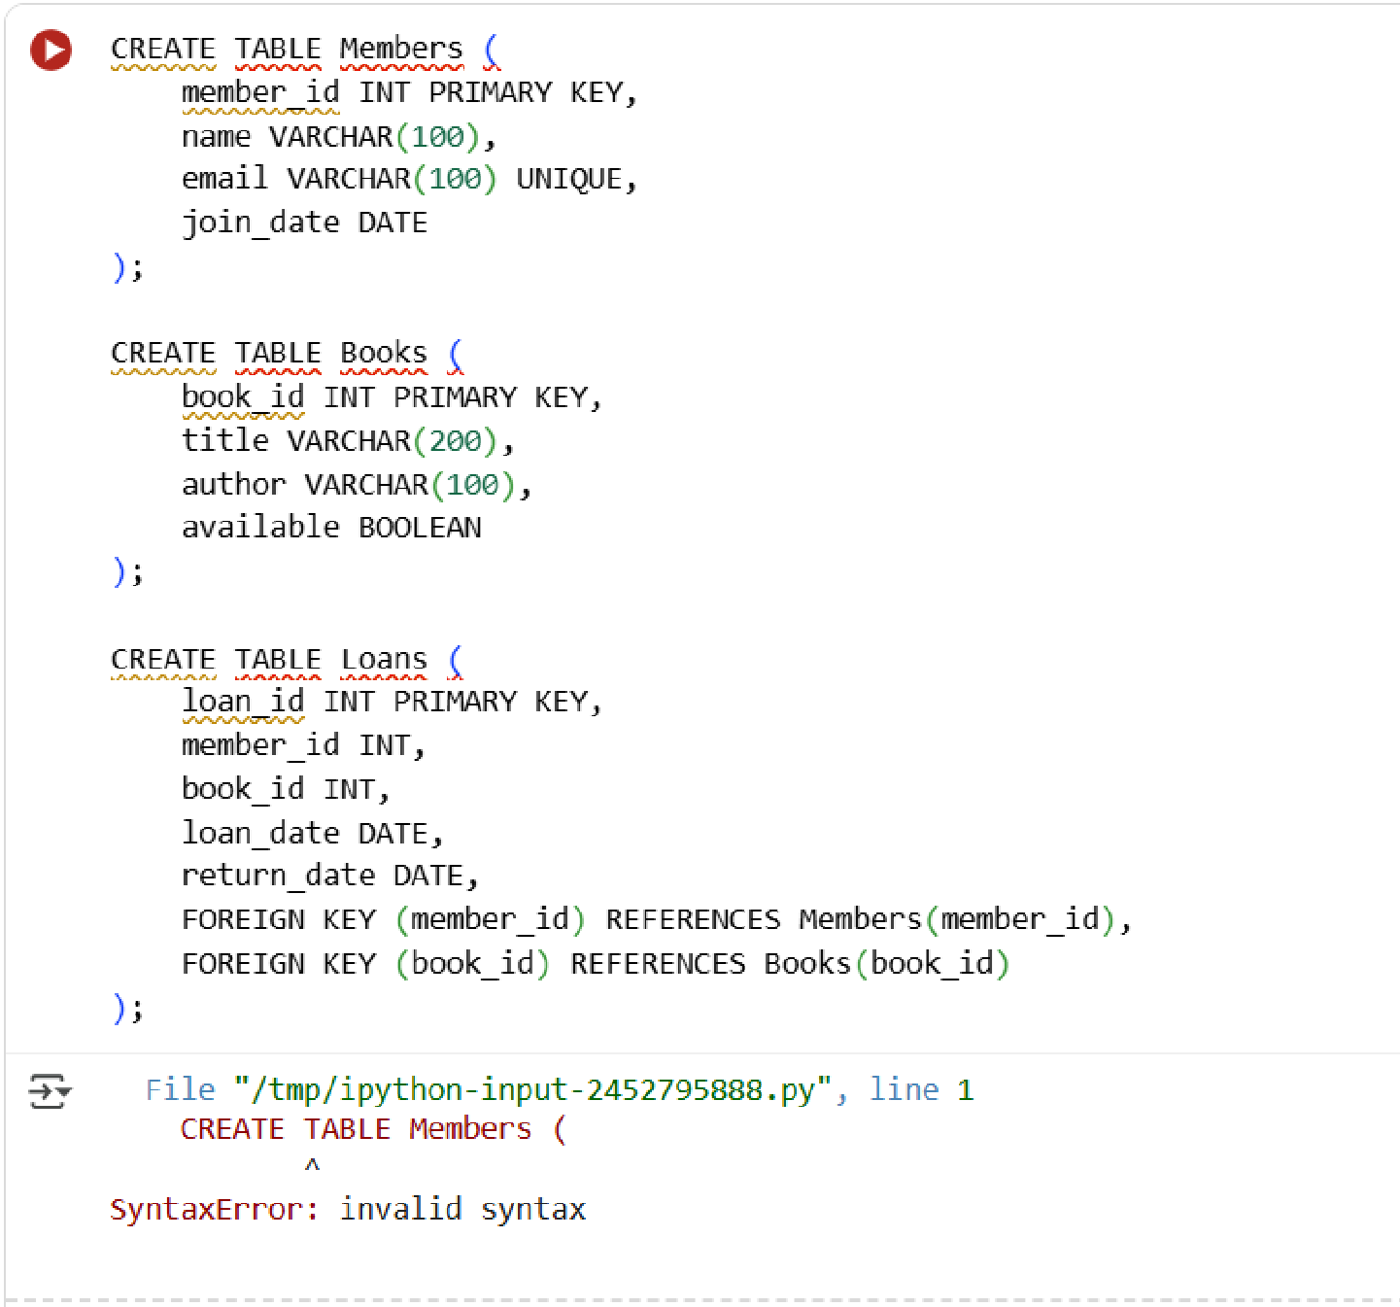

OBSERVATION:

The schema defines three tables:
Members

(
stores member info with
unique IDs),
Books

(
stores book info with unique IDs and availability),
and
Loans

records who borrowed which book and when, linking
(
members and books via foreign keys).

Task Description #2

–

Error
Insert Data

Task:
Ask AI to generate INSERT INTO queries for the
schema above
sample records per table
(3
).

OUTPUT:

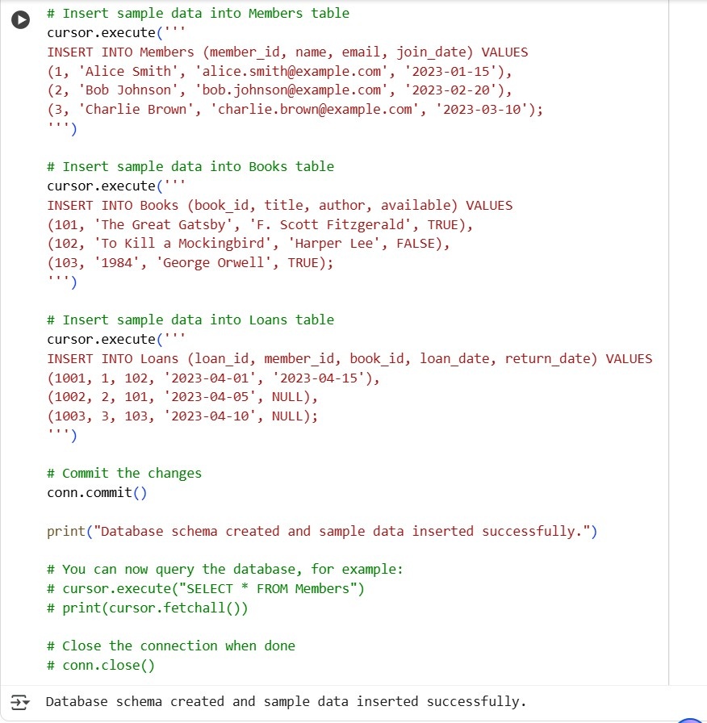

OBSERVATION:

The
INSERT

queries in the successful cell populate the
Members
,
Books
, and
Loans

tables with sample data, allowing you to work with
the database.

Task Description #3

–

Basic Queries

Task: Use AI to generate a query to list all books borrowed by a
specific member

OUTPUT:

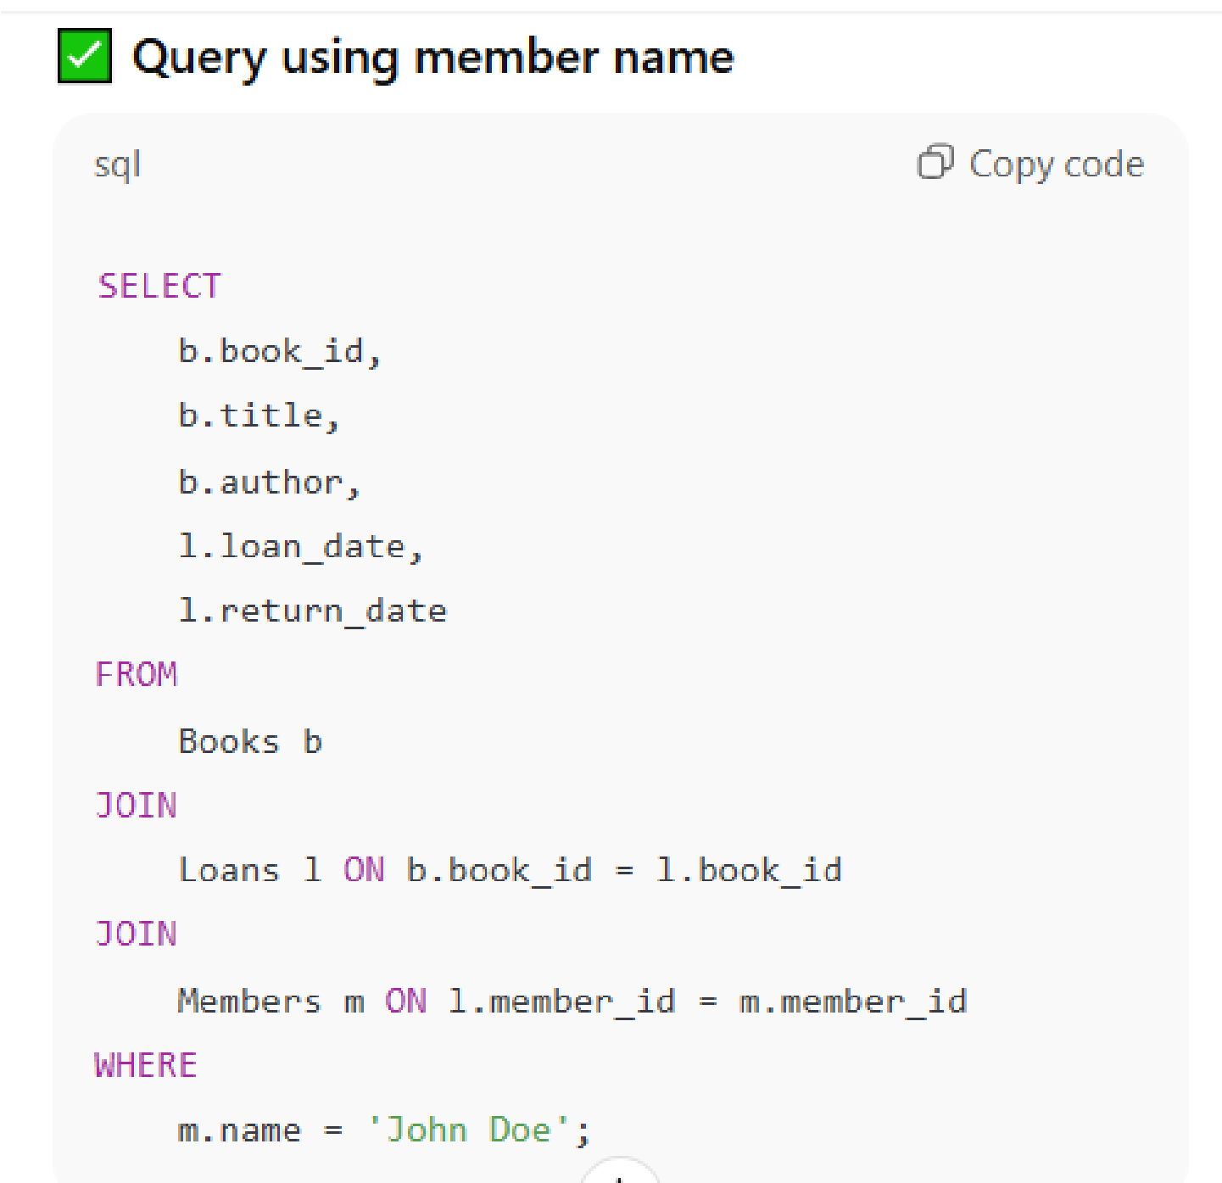

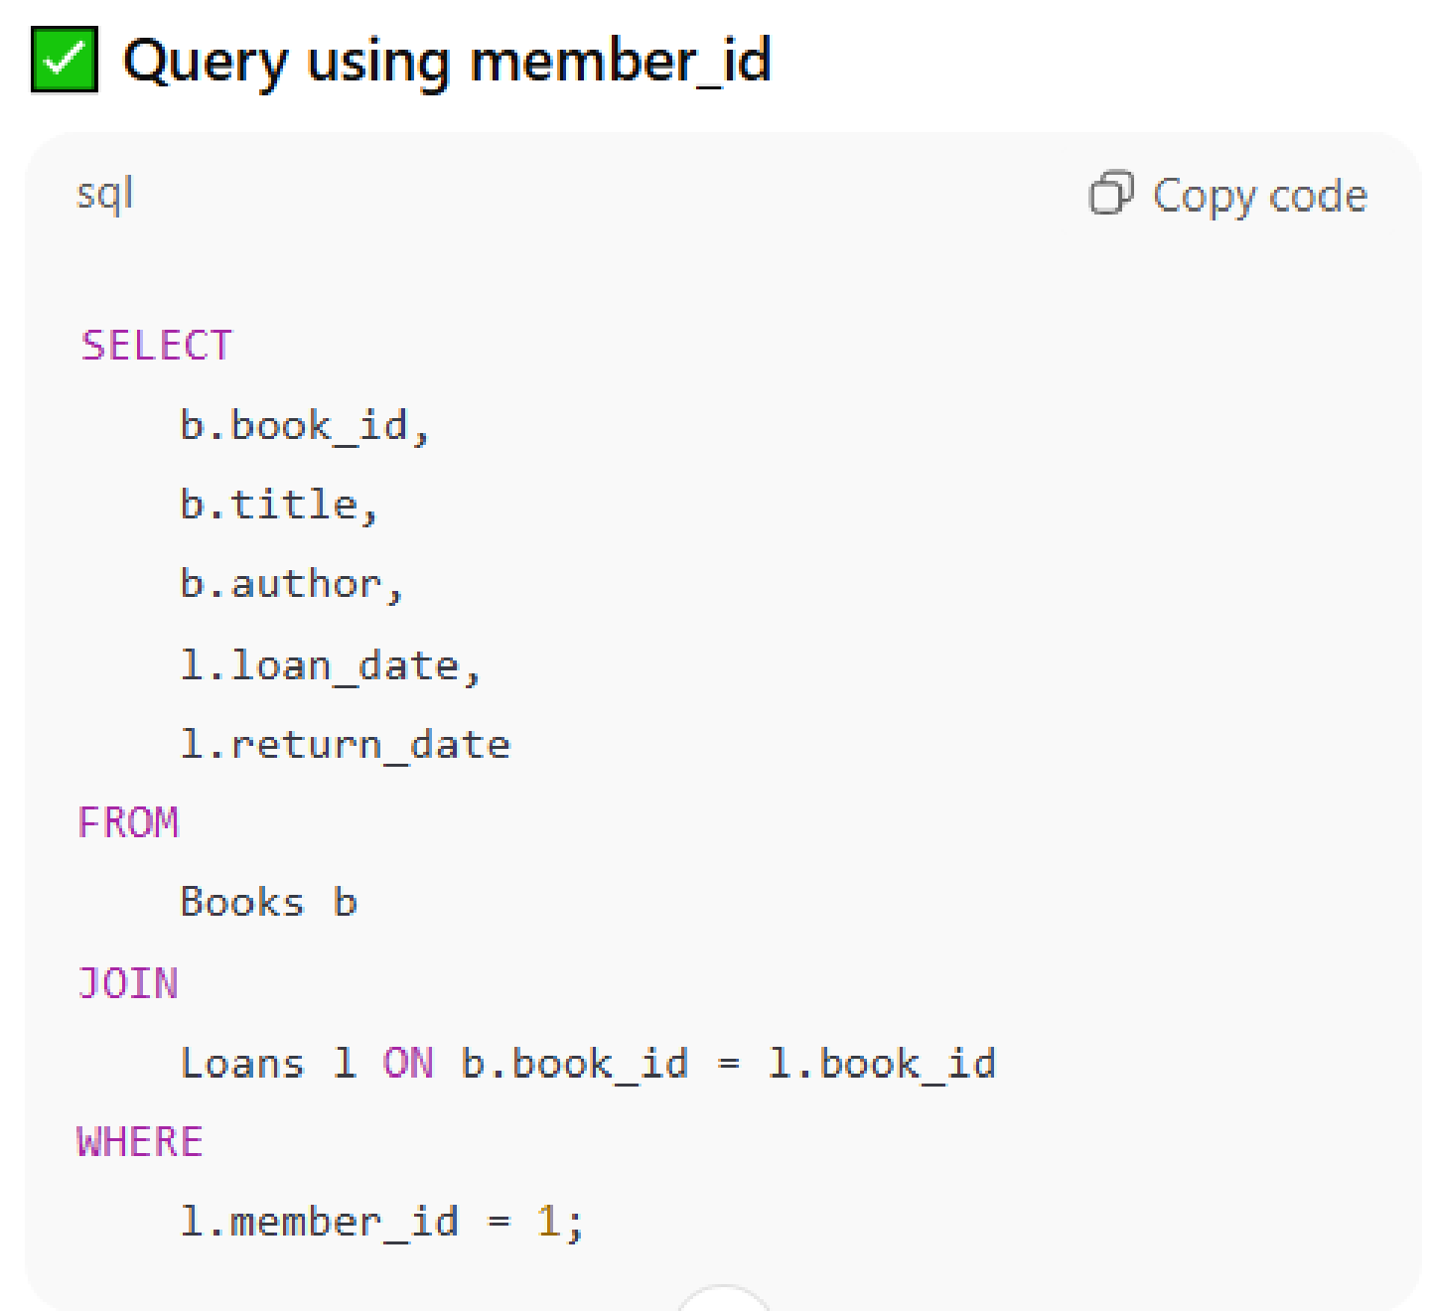
OBSERVATION
:

The query retrieves all books borrowed by a specific member by
joining the
Members
,
Loans
, and
Books

tables. It displays each
book’s title, author, and loan details based on the member’s ID or
name.

Task Description #4

–

Update and Delete Queries

Task:
Generate queries with AI for:

•

Updating a book’s availability to FALSE when borrowed.

•

Deleting a member record safely.

OUTPUT:

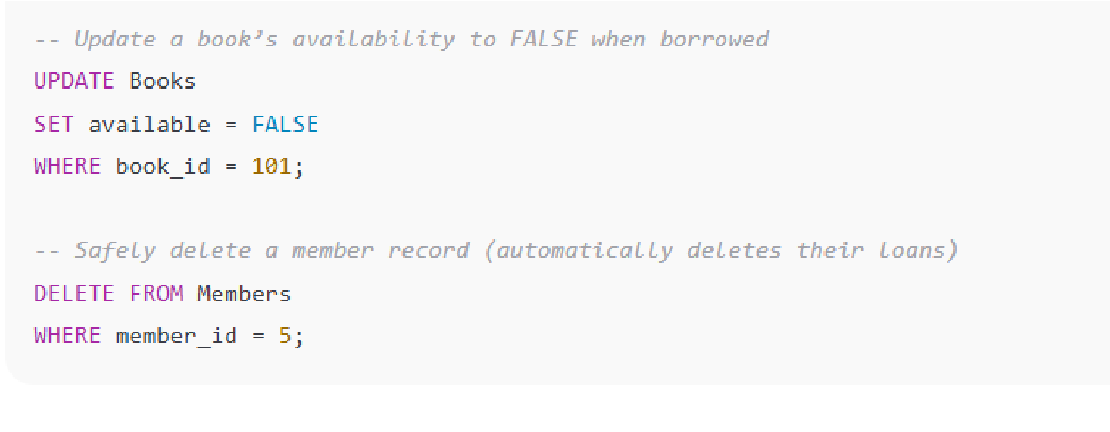
OBSERVATION:
- The query updates the available status to prevent multiple borrowings of the same book.
- The ON DELETE CASCADE ensures that when a member is deleted, their related loan records are automatically removed — maintaining data integrity.

