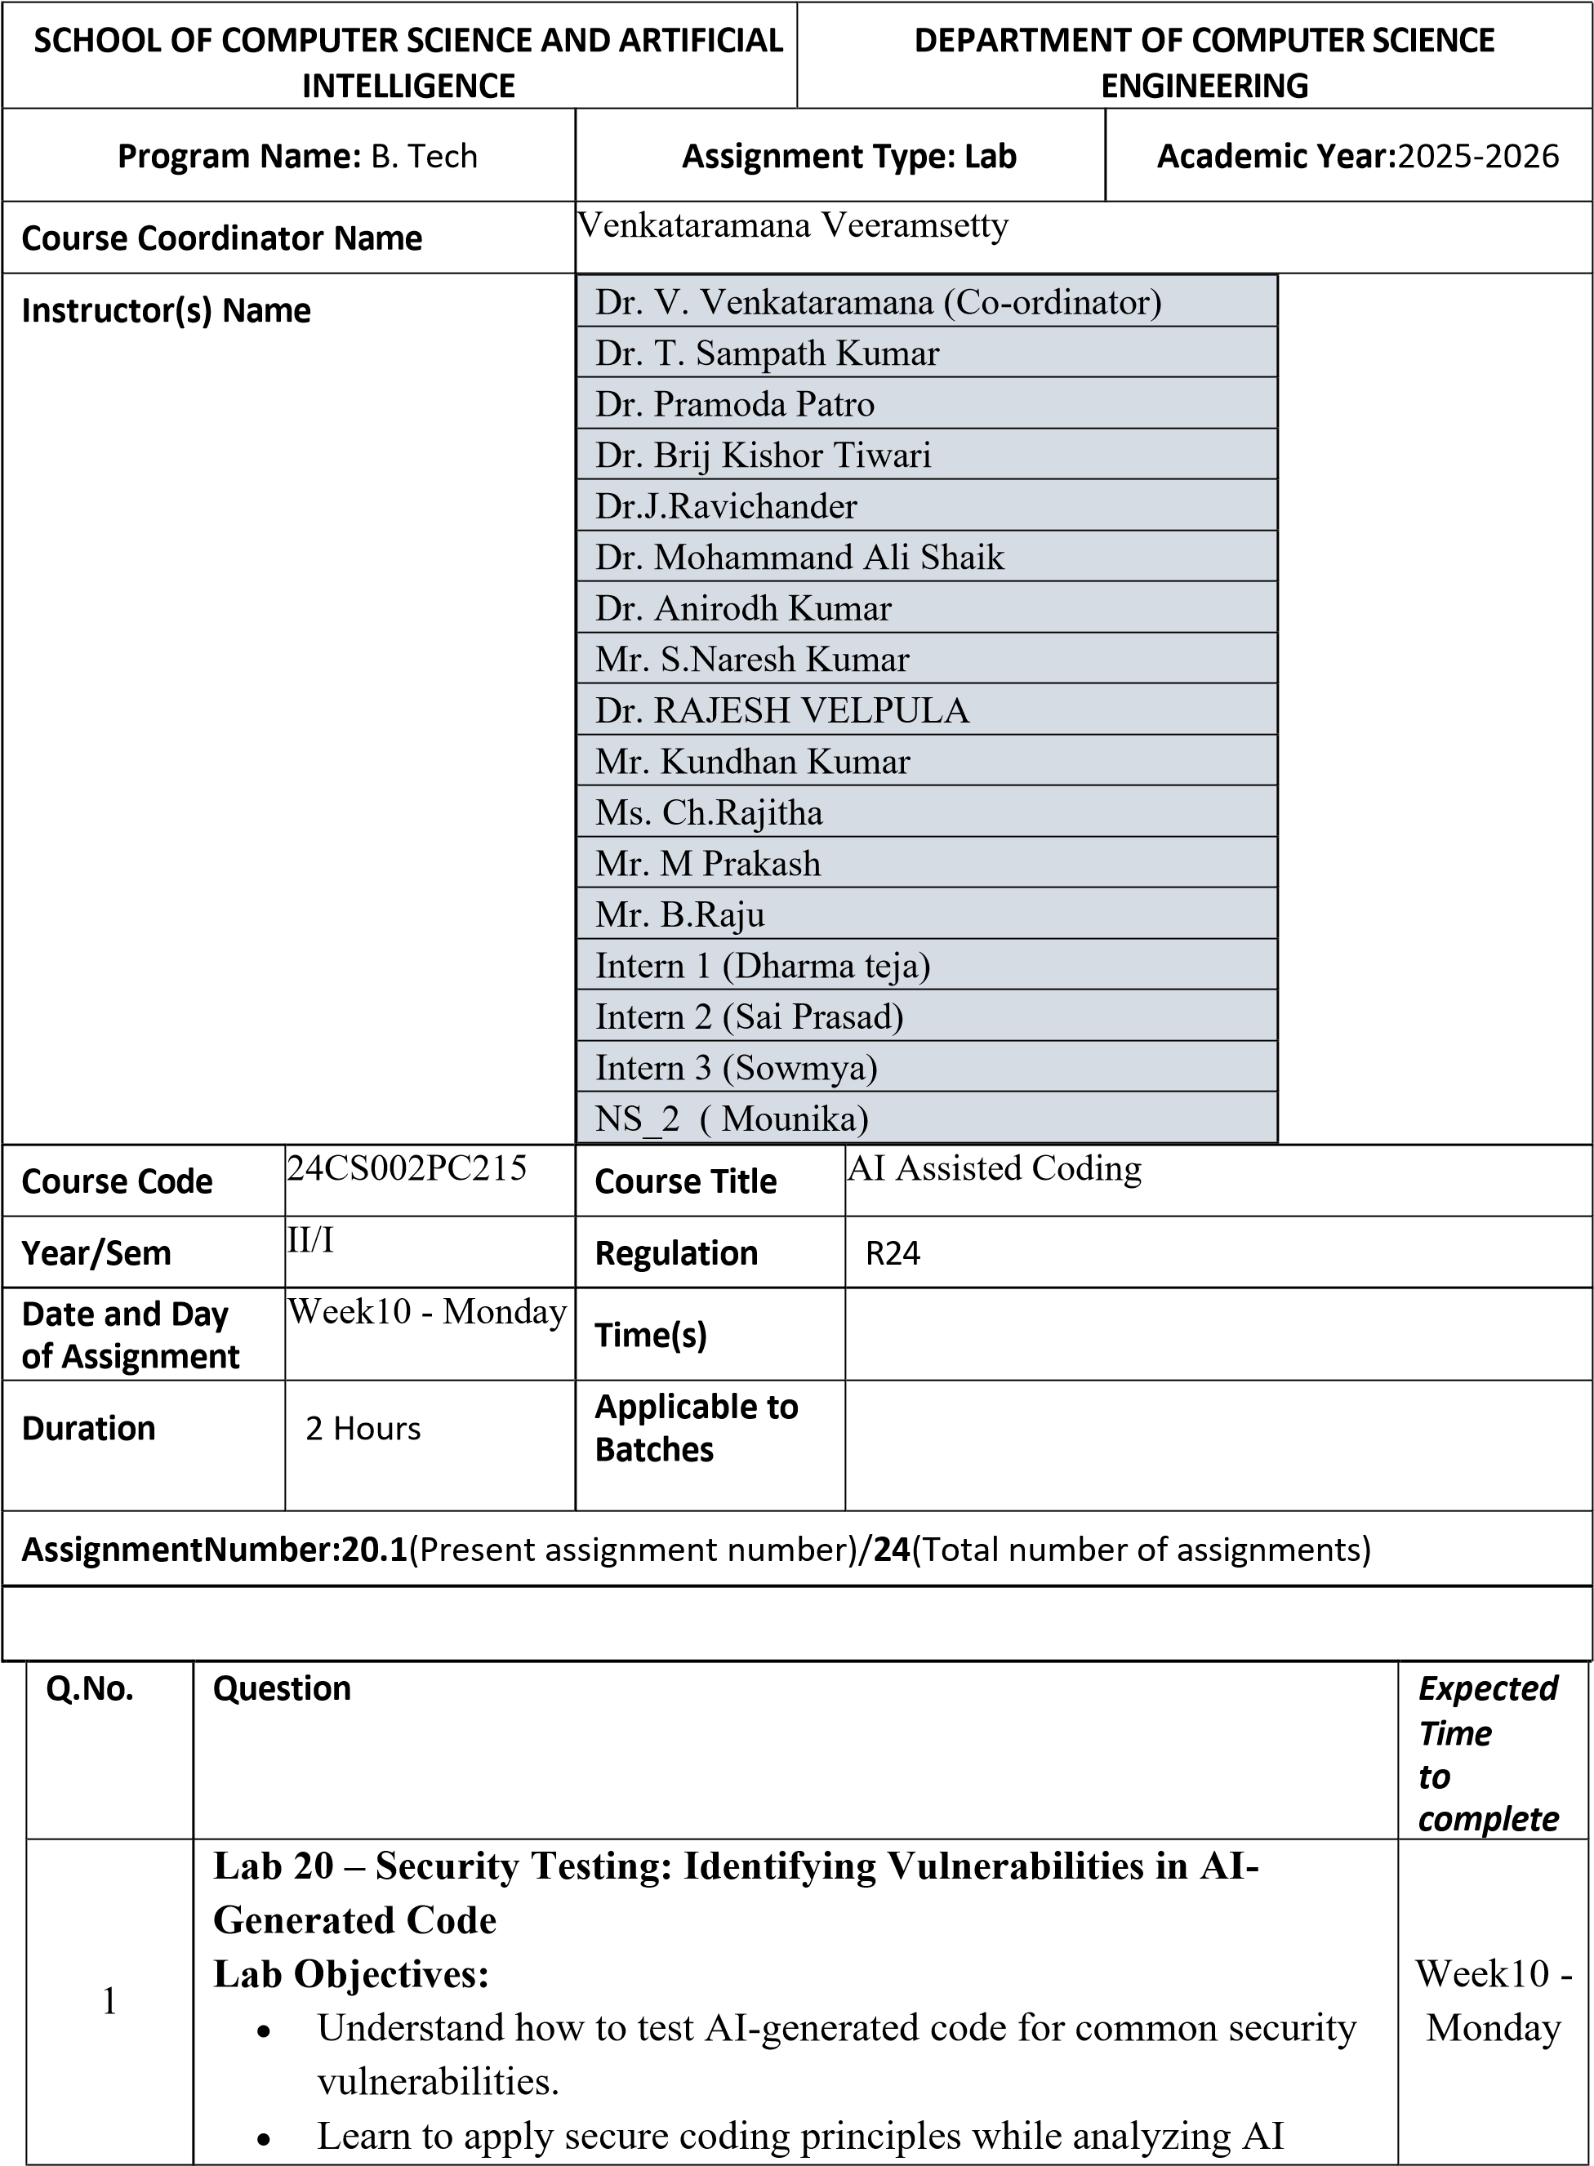
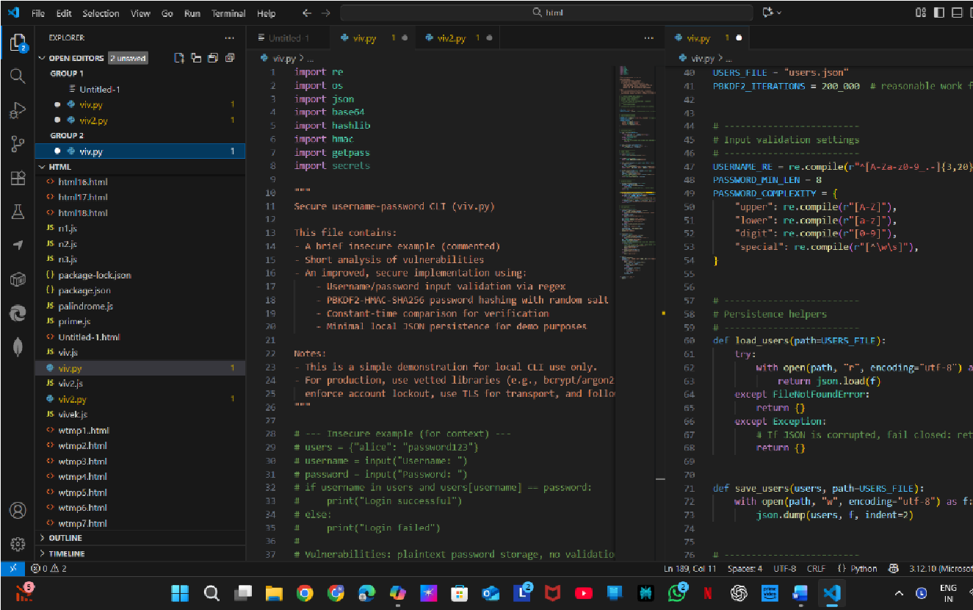
outputs.

•

Practice detecting risks such as
SQL injection, XSS, hardcoded
credentials, and weak encryption
.

•

Enhance code reliability and safety by using AI for secure
refactoring.

Task 1
–

Input Validation Check

Task:

Analyze an AI
-
generated
Python login script

for input validation
vulnerabilities.

Instructions:

•

Prompt AI to generate a simple username
-
password login
program.

•

Review whether input sanitization and validation are
implemented.

•

Suggest secure improvements (e.g., using re for input validation).

Expected Output:

•

A secure version of the login script with proper input validation.

•

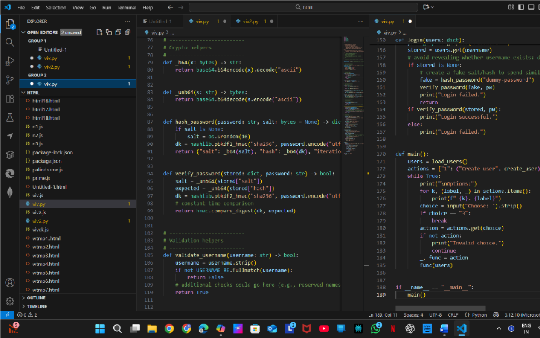
•

•

E
xplanation:

CLI for local user management: create accounts and
log in, storing data in users.json.

•

Username validated with a regex; passwords must meet length
and complexity rules and have no control/leading
-
trailing
whitespace.

•

Passwords are hashed with PBKDF2
-
HMAC
-
SHA256 using a
random 16
-
byte salt and 200,000 iterations; salt and hash are
base64
-
stored.

•

Verification uses hmac.compare_digest for constant
-
time

comparison and performs a fake verify on missing users to reduce
timing leaks.

•

Exposes create_user, login, and a menu loop; includes comments
advising stronger production practices (bcrypt/argon2, TLS,
account lockout).

•

Task 2
–

SQL Injection Prevention

Task:

Test an AI
-
generated script that performs SQL queries on a database.

Instructions:

•

Ask AI to generate a Python script using SQLite/MySQL to fetch
user details.

•

Identify if the code is vulnerable to
SQL injection

(
e.g., using
string concatenation in queries).

•

Refactor using
parameterized queries (prepared statements)
.

Expected Output:

•

A secure database query script resistant to SQL injection.

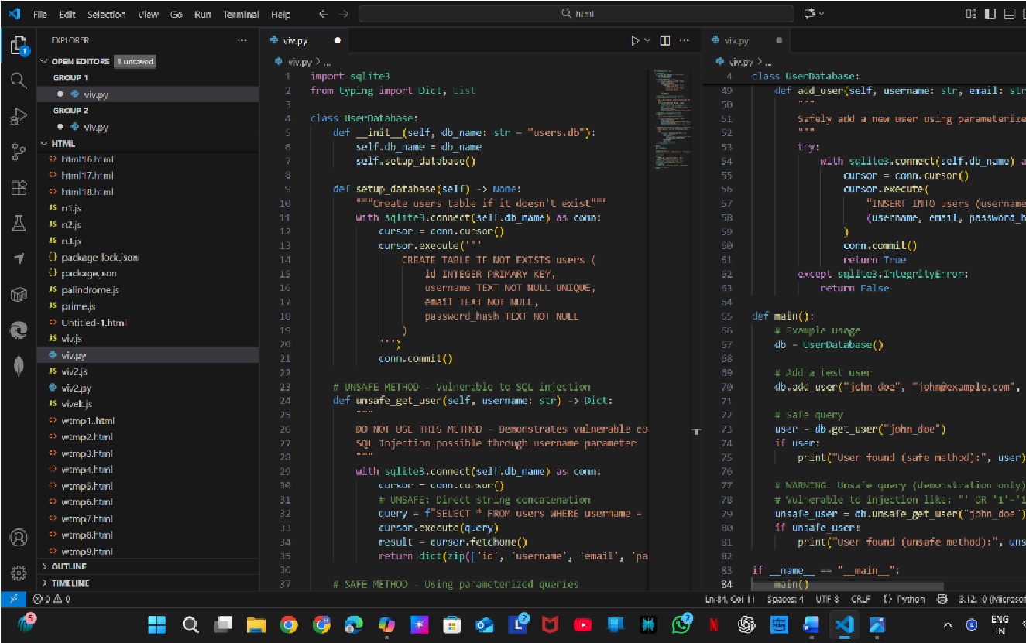
•

•

E
xplanation:

Manages an SQLite users database and ensures the
users table exists via setup_database().

•

unsafe_get_user shows an insecure string
-
built query vulnerable
to SQL injection (do not use).

•

get_user uses parameterized queries to safely fetch a user by
username.

•

add_user inserts a new user with parameterized queries and
returns False on IntegrityError (e.g., duplicate username).

•

main demonstrates usage: create DB, add a test user, then fetch
with the safe method and (for demonstration) the unsafe method.

•

Task 3
–

Cross
-
Site Scripting (XSS) Check

Task:

Evaluate an AI
-
generated
HTML form with JavaScript

for XSS
vulnerabilities.

Instructions:

•

Ask AI to generate a feedback form with JavaScript
-
based output.

•

Test whether untrusted inputs are directly rendered without
escaping.

•

Implement secure measures (e.g., escaping HTML entities, using
CSP).

Expected Output:

•

A secure form that prevents XSS attacks.

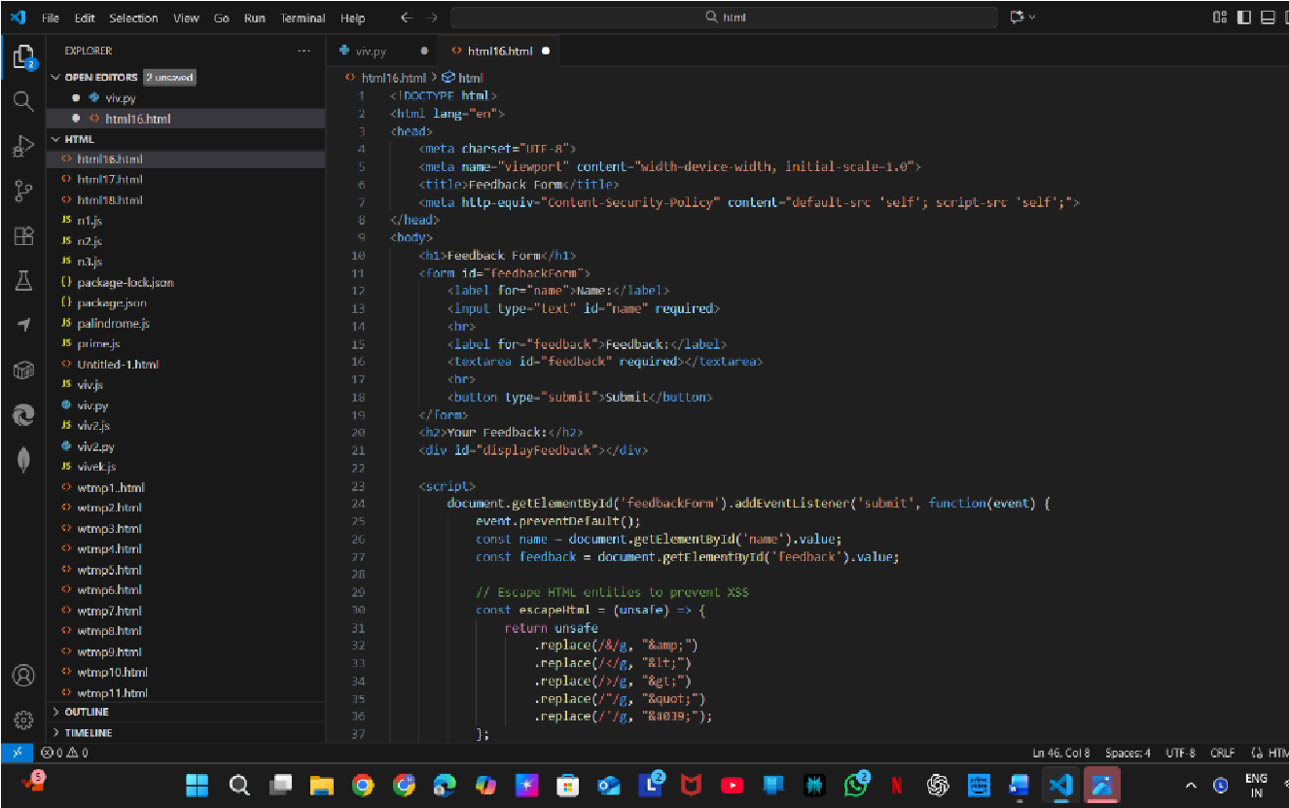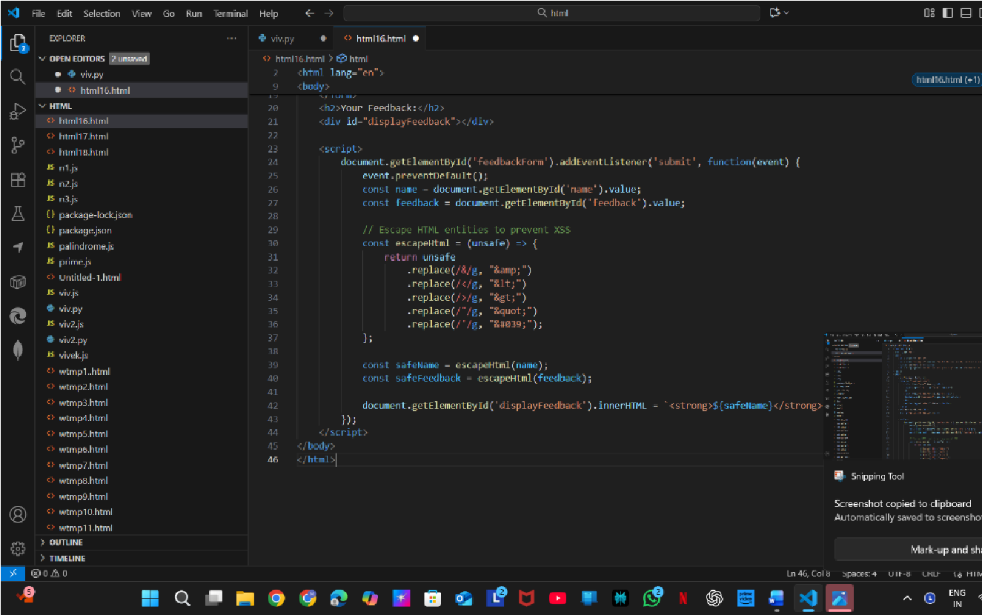
•

•

•

E
xplanation:

Simple client
-
side feedback form with a Content
-
Security
-
Policy limiting scripts to 'self'.

•

JavaScript intercepts the form submit, prevents default behavior,
and reads the name and feedback inputs.

•

escapeHtml replaces &, <, >, ", and ' with HTML entities to
mitigate XSS.

•

The code injects the escaped name and feedback into the page
using innerHTML (name wrapped in <strong>).

•

No server persistence
—

data stays in the browser; escaping +
CSP reduce XSS risk but server
-
side handling would be needed
for storage.

•

Task 4
–

Real
-
Time Application: Security Audit of AI
-
Generated
Code

Scenario:
Students pick an AI-generated project snippet (e.g., login form, API integration, or file upload).
Instructions:
- Perform a security audit to detect possible vulnerabilities.
- Prompt AI to suggest secure coding practices to fix issues.
- Compare insecure vs secure versions side by side.
Expected Output:
- A security-audited code snippet with documented vulnerabilities and fixes.
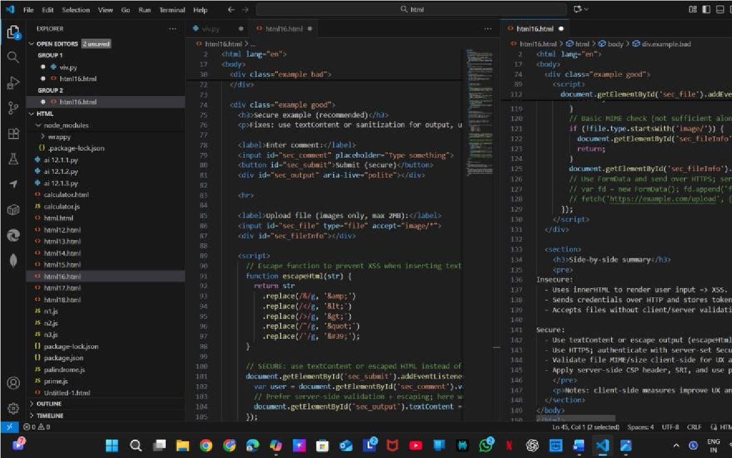
• 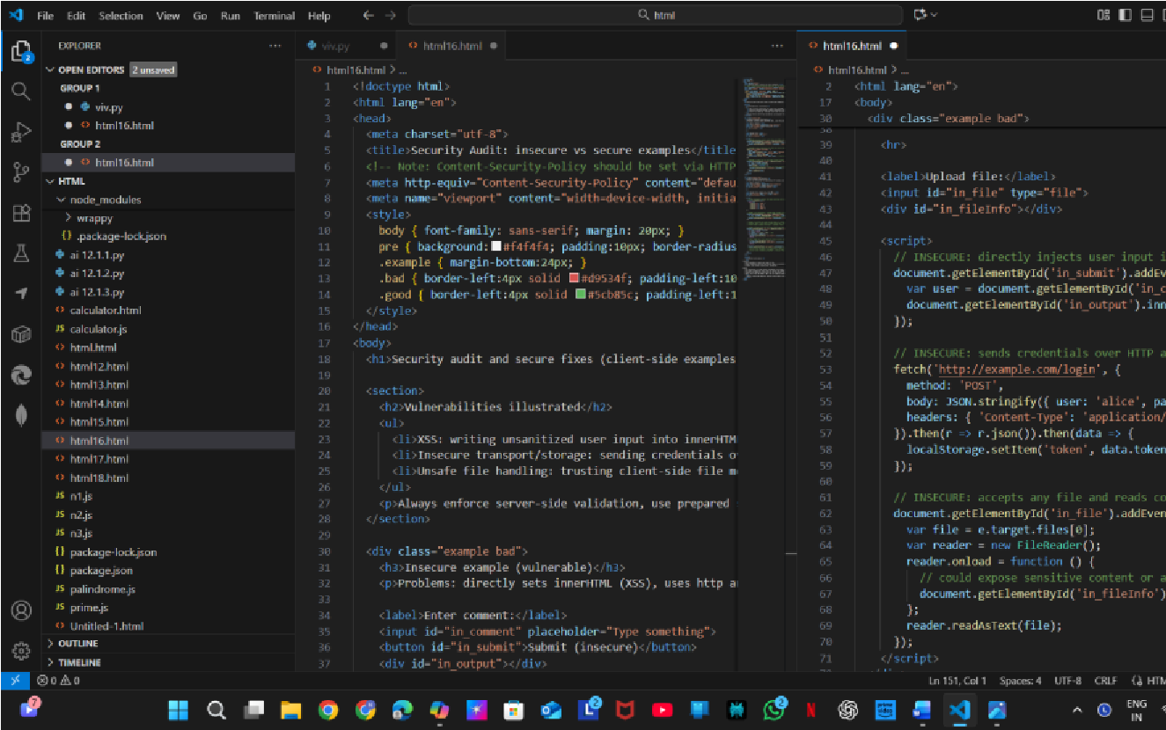
•
- Explanation: HTML page demonstrating client-side insecure vs secure patterns and includes a meta Content-Security-Policy note.
- Insecure example: injects unsanitized input via innerHTML (XSS), posts credentials over HTTP and stores tokens in localStorage, and reads uploaded files with no validation.
- Secure example: escapes input (escapeHtml) or uses textContent to prevent XSS, recommends HTTPS and server-set
Secure/HttpOnly cookies instead of localStorage, and performs basic client-side file type/size checks.
- File handling: secure code restricts to images and max 2MB for UX, but explicitly notes the server must re-validate, scan, and enforce stricter checks.
- Page includes a side-by-side summary and emphasizes that clientside measures help UX but all security-critical checks must be implemented on the server (CSP headers, prepared statements, HTTPS, etc.).
•

Deliverables (For All Tasks)
- AI-generated prompts for code and test case generation.
- At least 3 assert test cases for each task.
- AI-generated initial code and execution screenshots.
- Analysis of whether code passes all tests.
- Improved final version with inline comments and explanation.
- Compiled report (Word/PDF) with prompts, test cases, assertions, code, and output.

