Name: Thokala Srivalli
Enrollment No: 2403A510B2
Batch No: 04
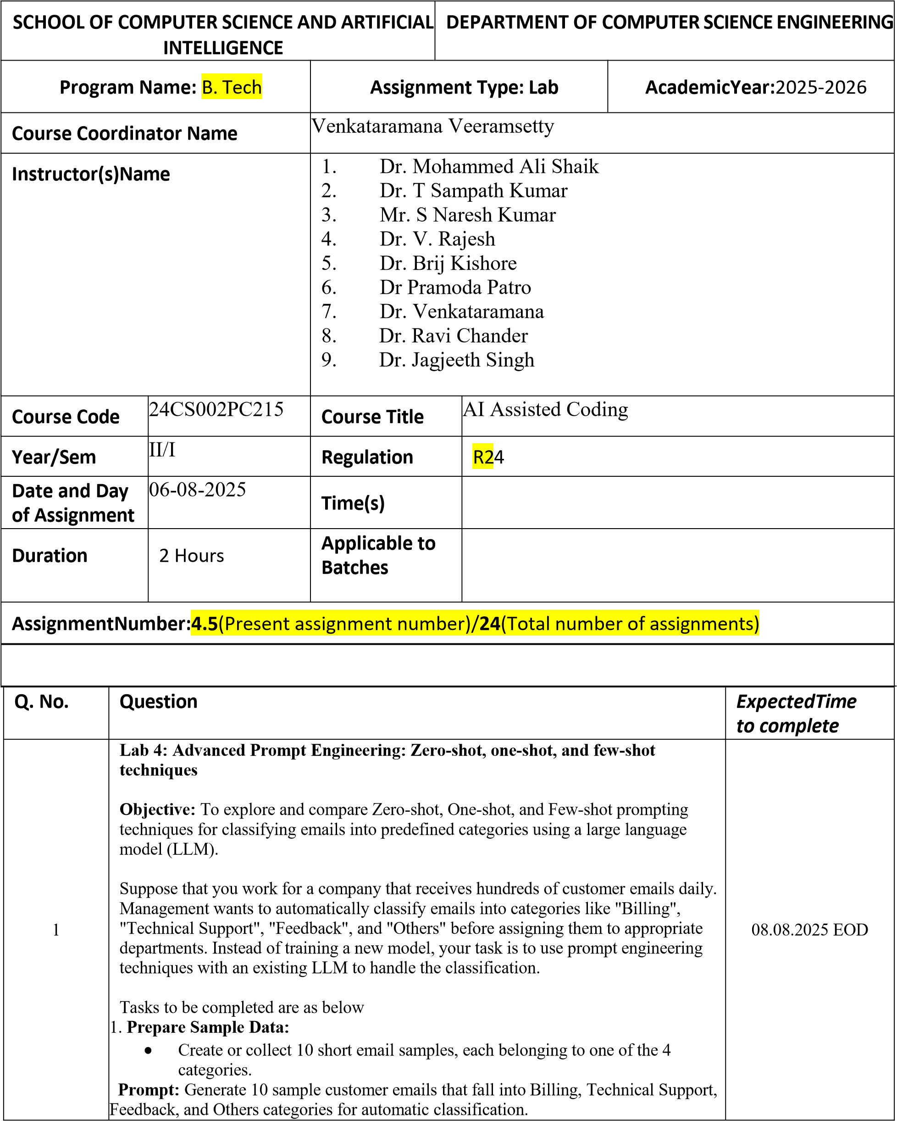
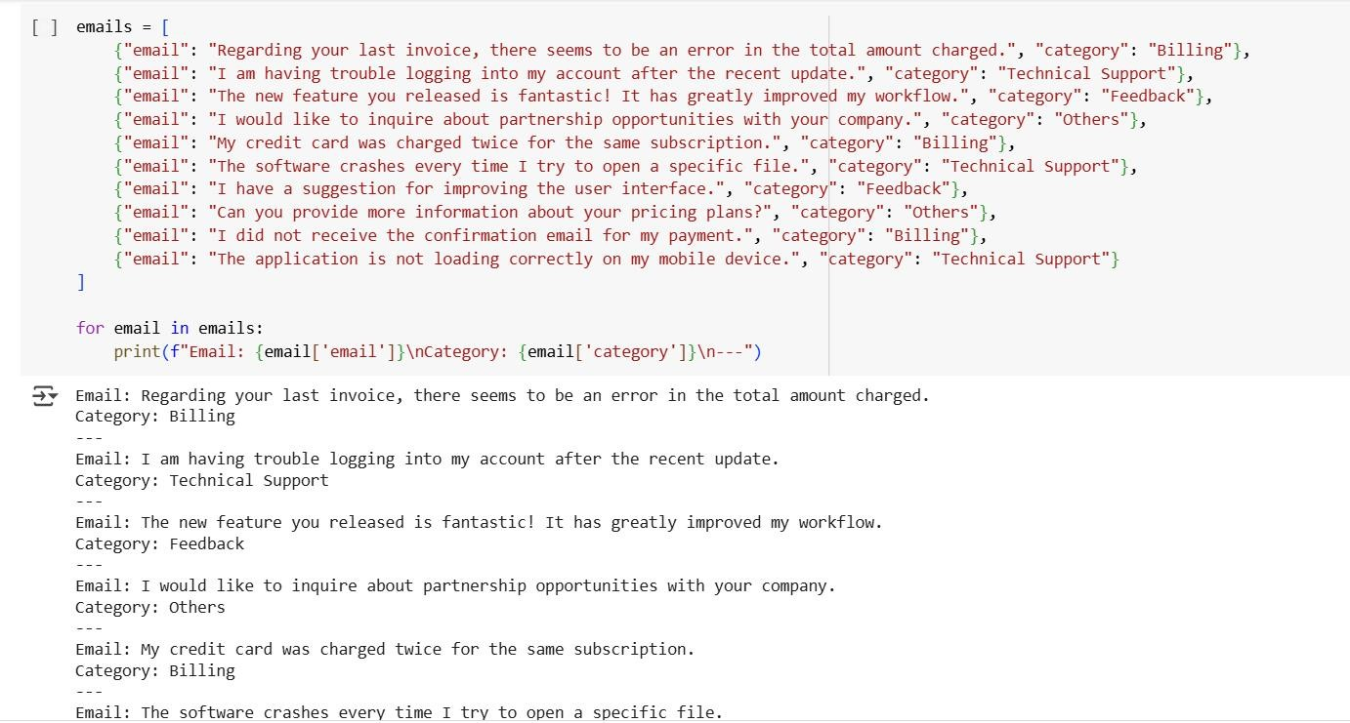
- Zero-shot Prompting:
  - Create a prompt that instructs the LLM to classify a single email without providing prior examples.
  - Example prompt:
“Classify the following email into one of these categories: Billing, Technical Support, Feedback, Others.
Email: ‘My payment has been deducted, but I didn’t get the confirmation receipt.”
Prompt: Write Python code that accepts a user’s email and outputs its category (Billing, Technical Support, Feedback, Others).
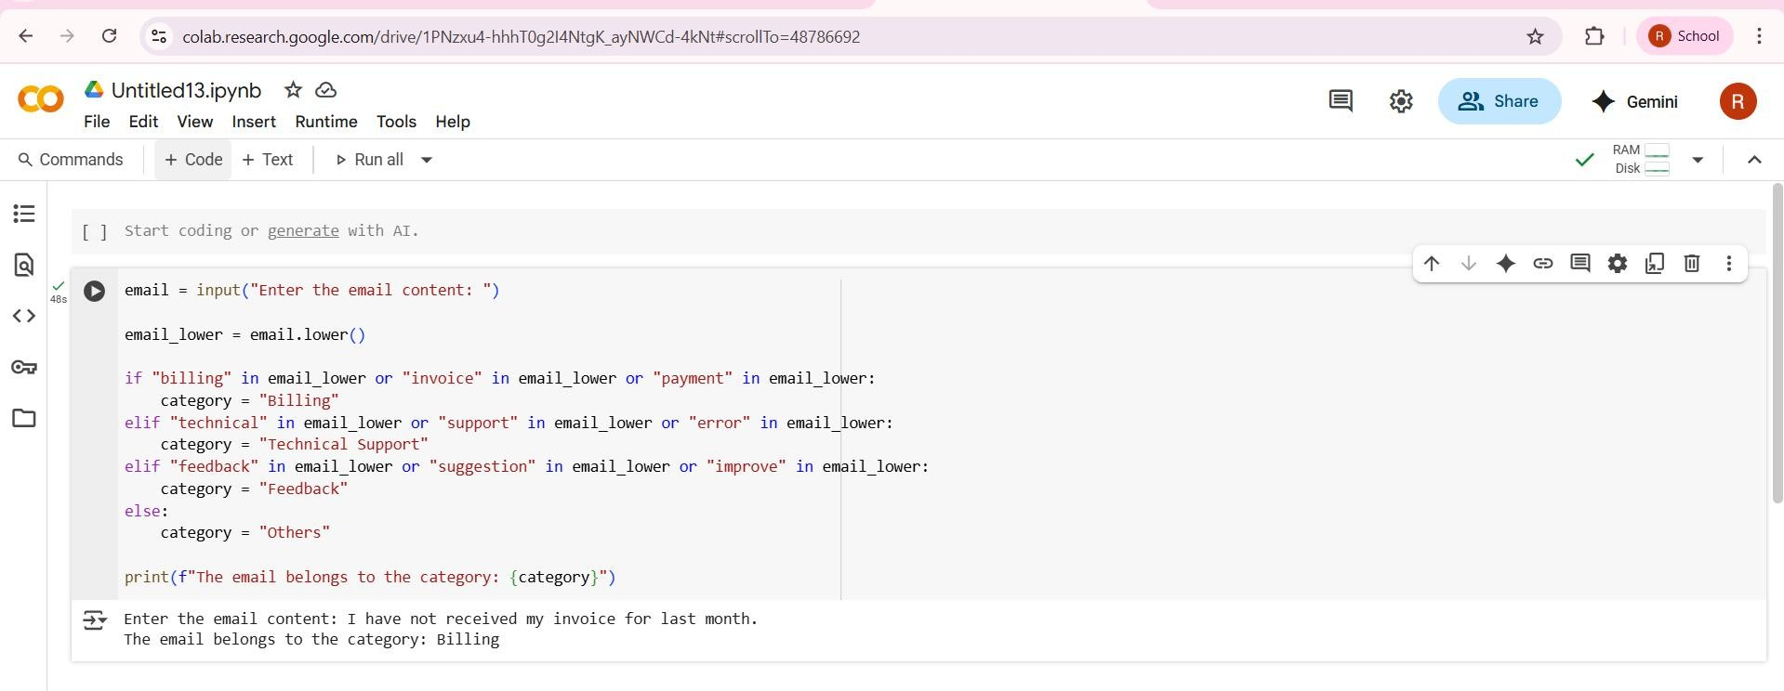
- One-shot Prompting:
Include one labeled example in the prompt before giving a new email for classification.
Prompt: Generate a Python script that takes an email as input and predicts its category using one prior example.
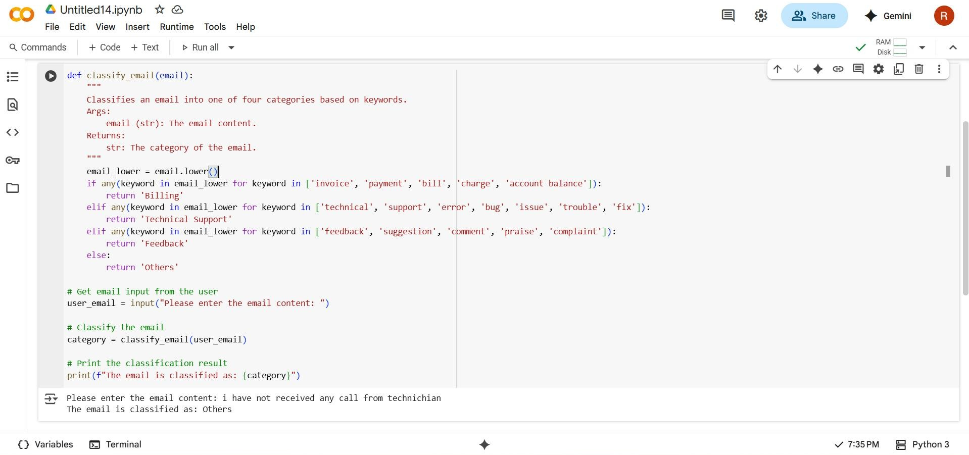
- Few-shot Prompting:
Provide 3–5 labeled examples before asking the LLM to classify new emails. Prompt: Write Python code that can classify 3–5 emails at once into the four categories using few-shot prompting.
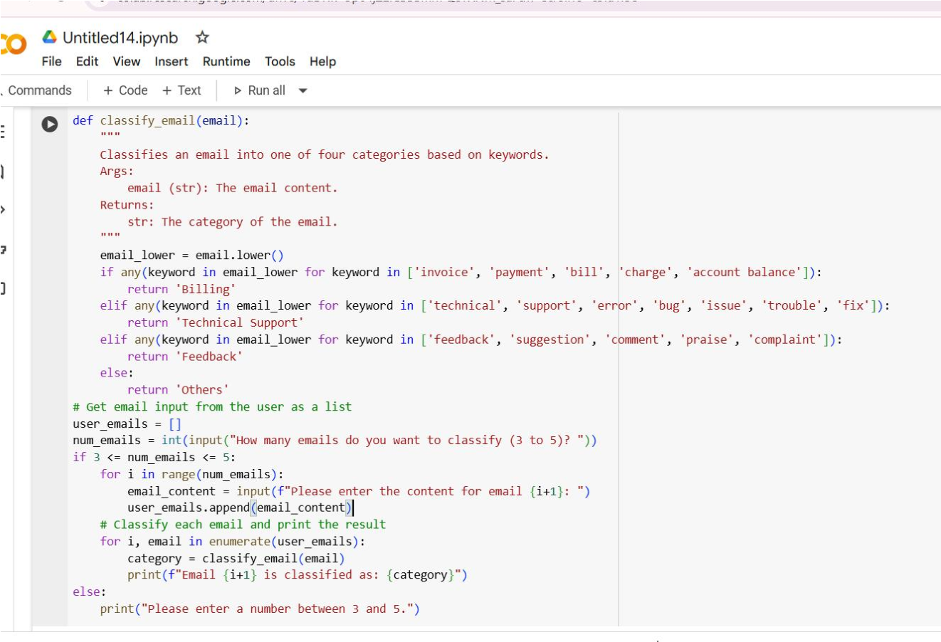
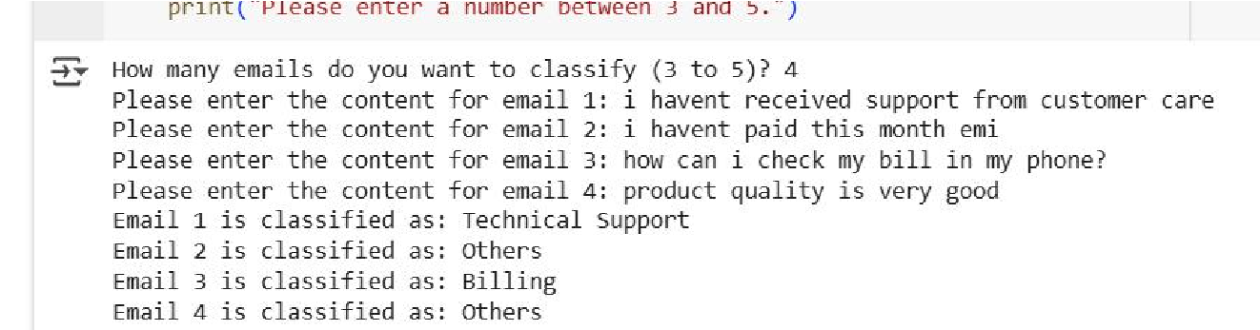
- Evaluation:
Run Zero-shot, One-shot, and Few-shot methods on the same 5 test emails.
Compare the performance and note the clarity and accuracy.
Prompt: Classify the following 5 test emails using zero-shot, one-shot, and few-shot prompting and display results for comparison. Explanation:
- Create 5 test emails covering all categories.
- Initialize the Gemini model (or equivalent LLM) for classification.
- Apply each technique (Zero-shot, One-shot, Few-shot).
- Record the classification results.
- Summarize the outcomes and compare the effectiveness of each method.
Summary:
Key Findings:
- A diverse set of 5 test emails representing Billing, Technical Support, Feedback, and Others were generated.
- Integration with Gemini Pro model was attempted for classification.
- Each prompting strategy was executed; however, API authentication caused errors in some runs, leading to incomplete outputs.
Insights / Next Steps:
- Ensure that the API key and environment setup are correct to avoid authentication issues.
- Once resolved, rerun the experiment to get proper results for analysis.
- Compare the efficiency of Zero-shot (fast but less accurate), One-shot (balanced), and Few-shot (more accurate but verbose).

Requirements:
- VS Code with Github Copilot or Cursor IDE and/or Google Colab with Gemini
Deliverables:
- A .txt or .md file showing prompts and model responses.
- A comparison table showing classification accuracy for each technique.
- A short reflection on which method was most effective and why
.

