Software Requirements Specification (SRS)
AI-Powered Content Management System (AICMS)
Version: 1.0 | Date: 09-10-2026 | Status: Stage 1 – Proposed design / planning
Team / Author: Shreeverdhan M | SRN: PES1UG24AM265
Sripada Krishna Sameer Aditya | SRN: PES1UG24AM285
Srivamshi Chikkireddi | SRN: PES1UG24AM287
Shamanth SK | SRN: PES1UG24AM258
Submission boundary: This submission defines requirements, proposed design, and planned verification. It does not claim that a working implementation exists or that tests have been executed.

Revision History
Version | Date | Author | Change summary | Approval
1.0 | 09-10-2026 | AICMS Team (Shreeverdhan M, Sripada Krishna Sameer Aditya, Srivamshi Chikkireddi, Shamanth SK) | Initial Stage 1 SRS for AICMS | Pending

Approvals
Role | Name | Signature / Email | Date
Course Coordinator
Team Representative

Table of Contents
• 1. Introduction
• 2. Overall description
• 3. External interface requirements
• 4. System features (detailed)
• 5. Non-functional requirements (detailed)
• 5.1 Security objectives and requirements
• 6. Quality attributes and acceptance tests
• 7. System models and diagrams
• 8. Requirements Traceability Matrix (RTM)

1. Introduction

1.1 Purpose
This Software Requirements Specification (SRS) defines the proposed requirements, interfaces, acceptance criteria, and verification references for the AI-Powered Content Management System (AICMS).

1.2 Scope
AICMS is a document organization and discovery layer. It accepts supported documents, extracts text and available metadata, suggests categories, extracts keywords/topics, creates semantic embeddings, indexes searchable content, and supports natural-language search. Authorized users can review and correct AI-generated metadata. The system does not replace a source-of-truth repository or perform unrelated content authoring in this Stage 1 scope.

1.3 Audience
Project evaluators, end users, content editors, administrators, security reviewers, developers, testers, and future maintainers.

1.4 Definitions
Term | Definition
AICMS | AI-Powered Content Management System.
Semantic search | Retrieval based on meaning/context in addition to exact keyword matches.
Embedding | A numeric vector representation of text used for semantic comparison.
OCR | Optical Character Recognition for text extraction from scanned pages.
RBAC | Role-Based Access Control.
API | Application Programming Interface.
RTM | Requirements Traceability Matrix.
PII | Personally Identifiable Information.
TLS | Transport Layer Security.
WCAG | Web Content Accessibility Guidelines.
p90 | 90th percentile: 90% of measured values are at or below this value.
STP | Software Test Plan.

2. Overall Description

2.1 Product Perspective
AICMS is proposed as a browser-based system with a server-side API, file/object storage, metadata database, document-processing workers, AI enrichment services, and a search index. The high-level pipeline is upload and validation → extraction → AI enrichment → metadata/index update → permission-filtered semantic search. Processing is asynchronous to accommodate variable parser and model latency.

2.2 Major Product Functions (Detailed)
• Upload and validate supported documents; detect probable duplicates.
• Extract document text and available metadata; optionally use OCR for scans.
• Suggest categories and extract keywords/topics; generate document embeddings.
• Index eligible text and metadata for semantic retrieval.
• Accept natural-language queries and return relevance-ranked results.
• Filter results by approved metadata fields.
• Allow authorized editors to correct AI-generated metadata.
• Enforce authentication and document-level authorization.
• Maintain audit events, processing states, operational metrics, taxonomy administration, and re-index jobs.
• Support deletion from active indexes in accordance with a future-approved retention policy.

2.3 User Roles and Characteristics
Role | Needs and permitted activities
General user | Upload permitted documents, search accessible documents, view authorized result details.
Content editor | Review and correct AI-generated categories, keywords, topics, and allowed metadata.
Administrator | Manage roles and taxonomy, request re-indexing, inspect system metrics and audit records.
Auditor / evaluator | Review approved audit/traceability evidence without unauthorized content modification.

2.4 Operating Environment
A modern browser communicates with a secured API. The server-side environment comprises a relational metadata store, protected document storage, background job execution, document parsing/OCR adapters, an approved model/embedding service, a search index, and monitoring/logging. Deployment may be institution-approved cloud or on-premises; the final target is not yet selected.

2.5 Constraints and Assumptions
• Only defined and tested file types, languages, and upload-size limits will be supported; the proposed initial scope is PDF, DOCX and TXT files up to 20 MB, English language.
• AI-generated labels are suggestions, not guaranteed facts; authorized human correction is supported.
• Search quality depends on extraction quality, language, model selection, and the evaluation corpus.
• Document permission checks must occur before returning result titles, snippets, embeddings, or content.
• Any external model service must be approved for the data classification and retention policy.

3. External Interface Requirements

3.1 User Interfaces
• Upload view: supported formats, progress, processing state, and safe validation errors.
• Search view: natural-language query, filters, relevance-ranked results, snippet, category, and clear no-results state.
• Document detail/editor view: available metadata and editable AI suggestions gated by role.
• Administration view: user/role management, taxonomy, re-index job status, audit, and aggregated metrics.
• Accessibility: keyboard navigation, visible focus, clear labels, adequate contrast, and understandable error/empty states.

3.2 Hardware Interfaces
No dedicated end-user hardware is required beyond a browser-capable device. Optional OCR or model acceleration hardware is a deployment choice and is not an assumed Stage 1 dependency.

3.3 Software Interfaces
• Document parser and optional OCR adapter for agreed file types.
• Approved model interface for categorization, keyword/topic extraction, and text/query embeddings.
• Metadata database and protected file/object storage.
• Search/index service supporting vector similarity and metadata filters.
• Optional institution identity provider.
• Logging, metrics, alerting, and background-job queue interfaces.

3.4 Communications
Browser/API and service-to-service traffic shall use HTTPS/TLS 1.2 or higher. Protected APIs require authentication and authorization, validate inputs, apply suitable request limits, and use sanitized errors. Logs shall not contain credentials or unnecessary raw document content.

4. System Features (Detailed)
Each functional requirement uses a stable AICMS-F identifier and includes a priority, stakeholder/source, measurable acceptance criterion, test-case reference, and dependency note.

4.1 Document Intake and Validation
Req ID | Requirement (shall...) | Type | Priority | Source / Stakeholder | Acceptance criteria / Test case reference | Comments / Dependencies
AICMS-F-001 | The system shall allow an authenticated user to upload a supported document. | Functional | High | Content users | A valid supported file is accepted and assigned a unique document ID. Test: TC-UP-01 | Requires authenticated session and storage.
AICMS-F-002 | The system shall reject unsupported file types and files exceeding the configured size limit. | Functional | High | Security / operations | The file is rejected before processing and a safe explanatory message is displayed. Test: TC-UP-02 | Allowed types and size limit must be configured.
AICMS-F-003 | The system shall detect probable duplicate uploads using a configured content fingerprint or metadata policy. | Functional | Medium | Content users | Duplicate content triggers the configured warning or duplicate-handling action. Test: TC-UP-03 | Duplicate policy is a configuration decision.
AICMS-F-004 | The system shall show each uploaded document’s processing status and any safe, actionable failure reason. | Functional | Medium | Content users | Queued, processing, completed, and failed states are distinguishable. Test: TC-UP-04 | Avoid exposing internal stack traces.

4.2 Text Extraction and AI Enrichment
Req ID | Requirement (shall...) | Type | Priority | Source / Stakeholder | Acceptance criteria / Test case reference | Comments / Dependencies
AICMS-F-005 | The system shall extract searchable text from supported text-based documents. | Functional | High | Content discovery | Text is linked to the correct document and can be indexed. Test: TC-EXT-01 | Depends on supported format parsers.
AICMS-F-006 | The system shall extract available document metadata such as title, author, creation date, and file type. | Functional | Medium | Content discovery | Available metadata is stored; unavailable fields remain empty rather than being invented. Test: TC-EXT-02 | Metadata availability varies by format.
AICMS-F-007 | The system shall route scanned documents through OCR when OCR is enabled for the file type. | Functional | Medium | Content discovery | OCR text is stored and uncertain/poor extraction is marked for review. Test: TC-EXT-03 | OCR may be an optional integration.
AICMS-F-008 | The system shall suggest one or more categories for a processable document. | Functional | High | Content editors | A category suggestion and model/version or review information is stored. Test: TC-AI-01 | Suggestions are not guaranteed to be correct.
AICMS-F-009 | The system shall extract representative keywords and topics from document text. | Functional | High | Content editors | Keywords/topics are stored for documents with sufficient extractable text. Test: TC-AI-02 | Language/model coverage must be evaluated.
AICMS-F-010 | The system shall generate semantic embeddings for eligible document content. | Functional | High | Search users | Embedding creation succeeds or a visible retryable/failed processing state is recorded. Test: TC-AI-03 | Depends on approved embedding model/service.

4.3 Indexing and Semantic Search
Req ID | Requirement (shall...) | Type | Priority | Source / Stakeholder | Acceptance criteria / Test case reference | Comments / Dependencies
AICMS-F-011 | The system shall index extracted text and approved metadata for search. | Functional | High | Search users | A successfully processed document becomes discoverable through the search interface. Test: TC-IDX-01 | Index writes must be idempotent.
AICMS-F-012 | The system shall accept natural-language queries for document discovery. | Functional | High | Search users | A valid query returns authorized results or an understandable no-results state. Test: TC-SR-01 | Depends on availability of search index.
AICMS-F-013 | The system shall order semantic search results using a defined relevance-scoring strategy. | Functional | High | Search users | Relevant seeded documents rank above unrelated items in the agreed test set. Test: TC-SR-02 | Ranking quality target requires benchmark corpus.
AICMS-F-014 | The system shall support filtering search results by supported metadata fields, including category and file type. | Functional | Medium | Search users | Returned results satisfy all selected filter conditions. Test: TC-SR-03 | Filterable fields must be defined.
AICMS-F-015 | The system shall show authorized result titles, relevant snippets, categories, and available metadata. | Functional | Medium | Search users | Only permitted fields appear and empty/missing metadata is handled gracefully. Test: TC-SR-04 | Authorization must be applied before formatting results.

4.4 Metadata, Permissions, and Audit
Req ID | Requirement (shall...) | Type | Priority | Source / Stakeholder | Acceptance criteria / Test case reference | Comments / Dependencies
AICMS-F-016 | The system shall allow authorized content editors to correct AI-generated categories, keywords, and topics. | Functional | Medium | Content editors | Changes persist and are reflected in subsequent details/search indexing. Test: TC-MD-01 | Edits require role authorization and audit.
AICMS-F-017 | The system shall enforce user- and document-level access permissions for reading, editing, and deleting content. | Functional | High | Data owners | Unauthorized requests reveal no document body, title, snippet, or protected metadata. Test: TC-SEC-01; TC-SEC-05 | Permission filtering applies to direct IDs and search.
AICMS-F-018 | The system shall audit document access and administrative actions with actor, timestamp, action, and outcome. | Functional | High | Administrators / auditors | Representative actions create searchable audit events without logging credentials or raw secrets. Test: TC-SEC-02 | Retention duration is policy-dependent.
AICMS-F-023 | The system shall allow a registered user to log in and log out with credentials (or the institution identity provider) and shall establish an authenticated session. | Functional | High | All users | Valid credentials create a session; invalid credentials are rejected with a generic error; logout invalidates the session. Test: TC-SEC-09 | Credential storage and lock-out per AICMS-SR-007 and SR-008.

4.5 Administration, Re-indexing, Deletion, and Monitoring
Req ID | Requirement (shall...) | Type | Priority | Source / Stakeholder | Acceptance criteria / Test case reference | Comments / Dependencies
AICMS-F-019 | The system shall allow an authorized administrator to manage the approved category taxonomy. | Functional | Medium | Administrators | Only administrators can create, edit, or deactivate categories; changes are validated and audited. Test: TC-ADM-01 | Taxonomy changes may trigger re-indexing.
AICMS-F-020 | The system shall allow an authorized administrator to request re-indexing after taxonomy or model configuration changes. | Functional | Medium | Administrators | A re-index job is queued with visible status and a traceable job identifier. Test: TC-ADM-02 | Requires background job processing.
AICMS-F-021 | The system shall remove a deleted document from searchable results and associated indexes, subject to approved retention policy. | Functional | High | Data owners | Deleted content is not returned by search after deletion completes, and the event is audited. Test: TC-DATA-01 | Backups/retention exceptions must be defined.
AICMS-F-022 | The system shall expose basic operational metrics for upload failures, processing latency, search latency, and errors. | Functional | Medium | Administrators | Authorized administrators can inspect aggregated metrics without sensitive document content. Test: TC-OPS-02 | Requires monitoring integration.
AICMS-F-024 | The system shall allow an authorized administrator to create and deactivate user accounts and assign roles. | Functional | High | Administrators | Only administrators can change accounts or roles; changes take effect on the user's next request and are audited. Test: TC-ADM-03 | Underpins RBAC (AICMS-SR-001); initial admin account seeded at deployment.

5. Non-functional Requirements (Detailed)
The following targets are proposed acceptance targets for a later test environment. The availability target requires an operating period to measure and is not asserted as achieved.
Req ID | Requirement | Category | Priority | Acceptance criteria / Measurement
AICMS-NF-001 | For the agreed benchmark corpus and normal test load, 90% of search requests shall return results within 3 seconds. | Performance | High | p90 search latency is ≤ 3 s in the documented test environment. Test: TC-PERF-01
AICMS-NF-002 | The proposed service shall target at least 99.5% monthly availability, excluding approved maintenance. | Reliability | Medium | Availability is calculable from monitoring records over a representative operating period. Test: TC-OPS-03
AICMS-NF-003 | All browser-to-service and service-to-service network communications shall use HTTPS/TLS 1.2 or higher. | Security | High | Transport configuration review confirms modern TLS is enforced. Test: TC-SEC-03
AICMS-NF-004 | Document parsing and AI enrichment shall run asynchronously so long-running jobs do not block unrelated upload or search requests. | Scalability | High | A long processing job is queued while independent API requests remain responsive under the agreed load. Test: TC-PERF-02
AICMS-NF-005 | Core workflows shall support keyboard navigation, visible focus, accessible labels, and adequate contrast consistent with WCAG 2.1 AA where applicable. | Accessibility | Medium | Accessibility review finds no critical barrier in upload, search, and metadata-edit flows. Test: TC-UX-01
AICMS-NF-006 | Logs shall include timestamps and correlation IDs but shall exclude passwords, authentication tokens, and unnecessary raw document content. | Privacy / maintainability | High | Representative logs support diagnosis without secrets or excess content. Test: TC-SEC-06
AICMS-NF-007 | Document records, metadata, and search indexes shall remain consistent after successful update and deletion operations. | Data integrity | High | Consistency checks find no stale deleted entries or untracked orphan records. Test: TC-DATA-02
AICMS-NF-008 | The system shall clearly identify failed AI processing and shall not silently represent incomplete enrichment as successful. | Reliability | High | Simulated model failure produces a failed/retryable state and operational event. Test: TC-OPS-01
AICMS-NF-009 | For the agreed labelled test set, at least 80% of documents shall receive a correct top category suggestion (matching the reviewed label). | Accuracy / AI quality | High | Accuracy >= 80% on the held-out labelled test set. Test: TC-AI-04
AICMS-NF-010 | Automatic processing of a 10-page text-based document (extraction, categorization, keywords/topics, embedding, indexing) shall complete within 60 seconds under normal test load. | Performance | Medium | Median and p90 processing time <= 60 s in the named environment. Test: TC-PERF-03

5.1 Security Objectives and Requirements

5.1.1 Security Objectives
1. Confidentiality: only authenticated, authorized users may discover, preview, download, edit, or delete a document and its protected metadata.
2. Integrity and accountability: metadata, indexes, permissions, and administrative changes shall be protected from unauthorized modification and critical actions shall be auditable.
3. Availability: the system shall resist abusive input and request patterns (oversized or malicious uploads, repeated invalid logins, request flooding) so that legitimate users can continue to upload and search.

5.1.2 Security Requirements
Req ID | Requirement (shall...) | Type | Priority | Acceptance criteria / Test case reference
AICMS-SR-001 | The system shall authenticate users and enforce least-privilege, role-based, document-level authorization for each protected operation. | Security – Access control | High | Unauthorized read/edit/delete and search attempts are denied. Test: TC-SEC-01
AICMS-SR-002 | The system shall validate uploaded content and isolate parsers/OCR components when handling untrusted files. | Security – Input safety | High | Malformed, disguised, or disallowed files are rejected or safely contained. Test: TC-SEC-04
AICMS-SR-003 | The system shall encrypt network traffic using HTTPS/TLS 1.2 or higher and shall disable insecure transport paths. | Security – Transport security | High | Configuration scan confirms secure transport; insecure requests are rejected or redirected safely. Test: TC-SEC-03
AICMS-SR-004 | The system shall not disclose restricted document IDs, names, snippets, metadata, embeddings, or content in search results. | Security – Information protection | High | Cross-role tests reveal no restricted document information. Test: TC-SEC-05
AICMS-SR-005 | The system shall store secrets in approved secret/configuration storage and shall not emit them in logs or client errors. | Security – Secrets management | High | Secret/configuration and error/log inspection reveals no credential leakage. Test: TC-SEC-06
AICMS-SR-006 | The system shall record permission changes, taxonomy changes, metadata edits, and document deletion in an auditable event trail. | Security – Auditability | Medium | Each action produces an event with actor, time, action, and outcome. Test: TC-SEC-02
AICMS-SR-007 | The system shall store user passwords only as salted hashes (e.g., bcrypt or Argon2) and shall never display or log them. | Security – Credential protection | High | User store contains no plaintext passwords; passwords are absent from logs and responses. Test: TC-SEC-07
AICMS-SR-008 | The system shall expire inactive sessions after 30 minutes and temporarily lock an account after 5 consecutive failed login attempts. | Security – Session protection | Medium | Expired session requires re-login; the 6th attempt after five failures is blocked and audited. Test: TC-SEC-08

6. Quality Attributes and Acceptance Tests
Quality attribute | Verification approach | Proposed acceptance / exit criterion
Functional completeness | Run mapped functional cases from the test register. | All high-priority requirements pass; failures are logged and triaged.
Search relevance | Evaluate a reviewed query-document benchmark. | Evaluate about 20–50 reviewed queries; target: a relevant document in the top 5 results for at least 80% of queries. Report Precision@5 and relevant-document coverage.
Performance | Run a documented search workload and concurrent processing workload. | AICMS-NF-001 and AICMS-NF-004 meet the targets in the named environment.
Security / privacy | Run role-bypass, upload-safety, transport, secret/log, and restricted-snippet tests. | No unresolved critical/high confidentiality or access-control defect at release gate.
Accessibility / usability | Keyboard-only checks and accessibility review of upload/search/edit flows. | No critical blockers; documented issues are remediated or formally accepted.
Data integrity | Update and delete documents; reconcile database metadata against search index. | No deleted document appears in search after completed deletion; reconciliation exceptions are handled.

Acceptance exit criteria: high-priority functional and security requirements are verified; no critical defects remain open; non-functional test results are recorded; and the RTM contains a disposition for every in-scope requirement. These are future release criteria, not current test results.

7. System Models and Diagrams

7.1 UML Use-Case Diagram 1 — General User and Content Editor
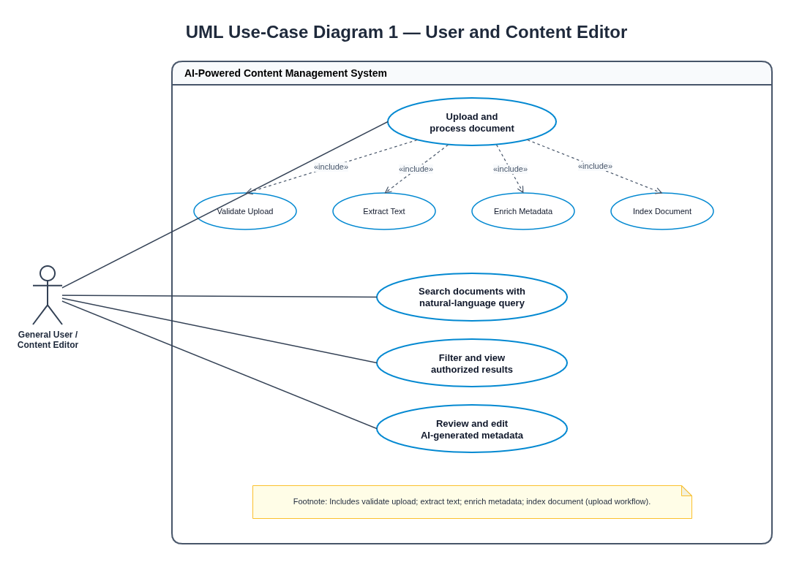
Figure 1. User/editor use cases within the AICMS system boundary.

7.2 UML Use-Case Diagram 2 — Administrator
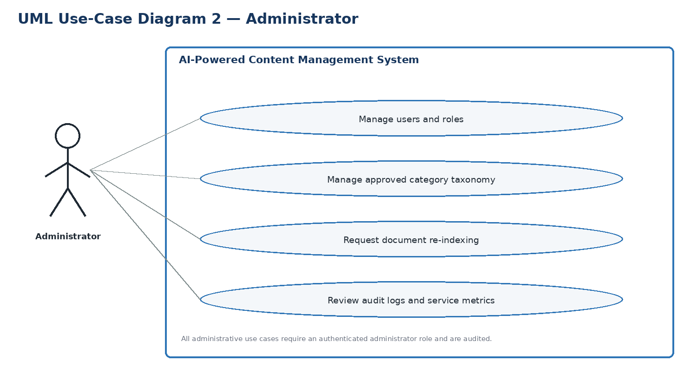
Figure 2. Administration use cases; privileged actions require administrator authorization.

7.3 Use-Case Notes
Use case | Precondition | Main success path | Alternative / exception
UC-01 Upload and process | User is authenticated and has upload permission. | Select file → validate → store → queue processing → extract/enrich/index → show status. | Unsupported file, duplicate policy, parser/model failure, or permission failure is shown safely.
UC-02 Search documents | User has an authenticated session if the repository is protected. | Enter natural-language query → embed/retrieve → apply permission filters → rank → display authorized snippets. | No results, index outage, timeout, or empty query produces a clear response.
UC-03 Review metadata | Editor has permission for the target document. | Review categories/keywords/topics → edit → validate → save → update index/audit. | Unauthorized edit is denied; re-index failure is visible.
UC-04 Administer system | Administrator is authenticated with required privileges. | Manage roles/taxonomy → request re-index → inspect audit/metrics. | Invalid changes are rejected; each administrative action is audited.

8. Requirements Traceability Matrix (RTM)
Status legend: N = Not run / planned; P = test passed; A = formally accepted by the project authority. All entries are currently N because no implementation or test execution is in scope for Stage 1.
Req ID | Requirement short | Section ref / Design Spec | Module | Test case(s) | Status (N/P/A) | Comments
AICMS-F-001 | Upload supported document | 4.1 / SAD §3.4 | Web UI; Application API; Document Intake | TC-UP-01 | N | Planned; Requires authenticated session and storage.
AICMS-F-002 | Reject invalid files | 4.1 / SAD §3.4 | Document Intake | TC-UP-02 | N | Planned; Allowed types and size limit must be configured.
AICMS-F-003 | Detect duplicate uploads | 4.1 / SAD §3.4 | Document Intake; Metadata Service / DB | TC-UP-03 | N | Planned; Duplicate policy is a configuration decision.
AICMS-F-004 | Show processing status | 4.1 / SAD §3.4 | Web UI; Async Queue / Worker | TC-UP-04 | N | Planned; Avoid exposing internal stack traces.
AICMS-F-005 | Extract document text | 4.2 / SAD §3.4 | Text Extraction / OCR | TC-EXT-01 | N | Planned; Depends on supported format parsers.
AICMS-F-006 | Extract document metadata | 4.2 / SAD §3.4 | Text Extraction / OCR; Metadata Service / DB | TC-EXT-02 | N | Planned; Metadata availability varies by format.
AICMS-F-007 | OCR for scanned files | 4.2 / SAD §3.4 | Text Extraction / OCR | TC-EXT-03 | N | Planned; OCR may be an optional integration.
AICMS-F-008 | Suggest categories | 4.2 / SAD §3.4 | AI Enrichment Pipeline | TC-AI-01; TC-AI-04 | N | Planned; Suggestions are not guaranteed to be correct.
AICMS-F-009 | Extract keywords and topics | 4.2 / SAD §3.4 | AI Enrichment Pipeline | TC-AI-02 | N | Planned; Language/model coverage must be evaluated.
AICMS-F-010 | Generate embeddings | 4.2 / SAD §3.4 | AI Enrichment Pipeline; Search Index | TC-AI-03 | N | Planned; Depends on approved embedding model/service.
AICMS-F-011 | Index text and metadata | 4.3 / SAD §3.4 | Search Index; Async Queue / Worker | TC-IDX-01 | N | Planned; Index writes must be idempotent.
AICMS-F-012 | Natural-language query | 4.3 / SAD §3.4 | Search / Retrieval API; Web UI | TC-SR-01 | N | Planned; Depends on availability of search index.
AICMS-F-013 | Rank results by relevance | 4.3 / SAD §3.4 | Search / Retrieval API; Search Index | TC-SR-02 | N | Planned; Ranking quality target requires benchmark corpus.
AICMS-F-014 | Filter search results | 4.3 / SAD §3.4 | Search / Retrieval API | TC-SR-03 | N | Planned; Filterable fields must be defined.
AICMS-F-015 | Show authorized result details | 4.3 / SAD §3.4 | Search / Retrieval API; Web UI | TC-SR-04 | N | Planned; Authorization must be applied before formatting results.
AICMS-F-016 | Correct AI-generated metadata | 4.4 / SAD §3.4 | Metadata Service / DB; Web UI | TC-MD-01 | N | Planned; Edits require role authorization and audit.
AICMS-F-017 | Document-level access control | 4.4 / SAD §3.4 | Application API (RBAC); Metadata Service / DB | TC-SEC-01; TC-SEC-05 | N | Planned; Permission filtering applies to direct IDs and search.
AICMS-F-018 | Audit access and admin actions | 4.4 / SAD §3.4 | Audit / Observability | TC-SEC-02 | N | Planned; Retention duration is policy-dependent.
AICMS-F-023 | Login / logout and session | 4.4 / SAD §3.4 | Web UI; Application API (authentication) | TC-SEC-09 | N | Planned; Credential rules per SR-007/SR-008.
AICMS-F-019 | Manage category taxonomy | 4.5 / SAD §3.4 | Admin UI; Metadata Service / DB | TC-ADM-01 | N | Planned; Taxonomy changes may trigger re-indexing.
AICMS-F-020 | Request re-indexing | 4.5 / SAD §3.4 | Admin UI; Async Queue / Worker; Search Index | TC-ADM-02 | N | Planned; Requires background job processing.
AICMS-F-021 | Remove deleted documents from index | 4.5 / SAD §3.4 | Metadata Service / DB; Search Index; Async Queue / Worker | TC-DATA-01 | N | Planned; Backups/retention exceptions must be defined.
AICMS-F-022 | Operational metrics | 4.5 / SAD §3.4 | Audit / Observability | TC-OPS-02 | N | Planned; Requires monitoring integration.
AICMS-F-024 | Manage users and roles | 4.5 / SAD §3.4 | Admin UI; Application API (RBAC); Metadata Service / DB | TC-ADM-03 | N | Planned; Underpins RBAC.
AICMS-NF-001 | Search p90 response time <= 3 seconds | 5 / SAD §3.4 | Search / Retrieval API; Search Index | TC-PERF-01 | N | Planned verification
AICMS-NF-002 | Monthly availability target >= 99.5% | 5 / SAD §3.4 | Whole system; Audit / Observability | TC-OPS-03 | N | Planned verification
AICMS-NF-003 | HTTPS/TLS 1.2+ for network traffic | 5 / SAD §3.4 | Application API | TC-SEC-03 | N | Planned verification
AICMS-NF-004 | Asynchronous processing for long-running jobs | 5 / SAD §3.4 | Async Queue / Worker | TC-PERF-02 | N | Planned verification
AICMS-NF-005 | Accessible keyboard, focus, labels and contrast | 5 / SAD §3.4 | Web UI | TC-UX-01 | N | Planned verification
AICMS-NF-006 | Sanitized logs with timestamps and correlation IDs | 5 / SAD §3.4 | Audit / Observability | TC-SEC-06 | N | Planned verification
AICMS-NF-007 | Consistency across records, metadata and index | 5 / SAD §3.4 | Metadata Service / DB; Search Index | TC-DATA-01; TC-DATA-02 | N | Planned verification
AICMS-NF-008 | Visible/retryable AI failure; no false success | 5 / SAD §3.4 | AI Enrichment Pipeline; Async Queue / Worker | TC-AI-03; TC-OPS-01; TC-UP-04 | N | Planned verification
AICMS-NF-009 | ≥ 80% categorization accuracy | 5 / SAD §3.4 | AI Enrichment Pipeline | TC-AI-04 | N | Planned verification
AICMS-NF-010 | Processing ≤ 60 s per 10-page document | 5 / SAD §3.4 | Async Queue / Worker; AI Enrichment Pipeline | TC-PERF-03 | N | Planned verification
AICMS-SR-001 | Authentication and least-privilege document-level RBAC | 5.1 / SAD §3.9 | Application API (RBAC) | TC-ADM-01; TC-ADM-03; TC-SEC-01; TC-SEC-09 | N | Planned verification
AICMS-SR-002 | Validate uploads and isolate parsers/OCR | 5.1 / SAD §3.9 | Document Intake; Text Extraction / OCR | TC-SEC-04; TC-UP-02 | N | Planned verification
AICMS-SR-003 | Encrypt traffic using HTTPS/TLS 1.2+ | 5.1 / SAD §3.9 | Application API; network configuration | TC-SEC-03 | N | Planned verification
AICMS-SR-004 | No restricted data in results or snippets | 5.1 / SAD §3.9 | Search / Retrieval API | TC-SEC-05; TC-SR-04 | N | Planned verification
AICMS-SR-005 | Secure secret storage; exclude secrets from logs | 5.1 / SAD §3.9 | Configuration / secrets; Audit / Observability | TC-SEC-06 | N | Planned verification
AICMS-SR-006 | Audit permission, taxonomy, metadata and deletion changes | 5.1 / SAD §3.9 | Audit / Observability | TC-ADM-01; TC-MD-01; TC-SEC-02 | N | Planned verification
AICMS-SR-007 | Salted password hashing | 5.1 / SAD §3.9 | Application API (authentication) | TC-SEC-07 | N | Planned verification
AICMS-SR-008 | Session expiry and account lock-out | 5.1 / SAD §3.9 | Application API (authentication) | TC-SEC-08 | N | Planned verification

Appendix A — References
• ISO/IEC/IEEE 29148, requirements engineering (reference framework).
• OWASP Application Security Verification Standard and File Upload guidance.
• W3C Web Content Accessibility Guidelines (WCAG) 2.1.
• Selected parser, OCR, model, database, and search documentation to be confirmed when technology decisions are made.

