Software Engineering Lab 1
Problem Statement #02 — Campus & Academic Operations
Project Title | Automated Rubric Assignment Evaluator
Primary Domain | Campus & Academic Operations
Target Actors | Student, Faculty Evaluator (primary); Peer Reviewer, Notification Service (secondary)

1. Requirements Table
Exactly five Functional Requirements (FR-001 – FR-005) and two Non-Functional Requirements (NFR-001 – NFR-002), each with Req ID, Type, Description, Priority, Acceptance Criteria, and Rationale. FR-001 and NFR-001 reproduce the requirements given in the problem statement; the remaining rows were authored to complete the set.
Req ID | Type | Description | Priority | Acceptance Criteria | Rationale
FR-001 | Functional | The system shall automatically queue uploaded student project zip files, execute pre-configured unit test suites, and generate an itemized rubric score breakdown. | High | Pass: Rubric breakdown is rendered with test results within 10 seconds of submission. Fail: File queue stalls or invalid rubric tally. | Automates the core evaluation loop, removing manual test execution by faculty.
FR-002 | Functional | The system shall allow a Faculty Evaluator to configure rubric criteria (categories and weights) and associate a pre-built unit test suite with each assignment before submissions open. | High | Pass: A saved rubric configuration is applied to every subsequent score breakdown for that assignment. Fail: A submission is scored using default or mismatched rubric weights. | Lets grading criteria be customised per assignment without code changes.
FR-003 | Functional | The system shall automatically assign each submitted project to at least two peer reviewers, excluding the submission's own author, once automated evaluation completes. | Medium | Pass: Every evaluated submission has the configured number of reviewers assigned within 1 minute, with zero self-assignments. Fail: A submission remains unassigned or is assigned to its own author. | Removes the manual overhead of distributing peer reviews described in the problem context.
FR-004 | Functional | The system shall allow a Faculty Evaluator to manually override or annotate an automatically generated rubric score before it is released to the student. | High | Pass: The revised score and comment are saved, shown to the student, and both the original and revised scores are recorded in an audit log. Fail: The override is not persisted or the original score is still displayed. | Preserves instructor judgement for edge cases such as flagged anomalies or plagiarism.
FR-005 | Functional | The system shall notify a student and their assigned peer reviewers when rubric scoring and/or peer review assignment for their submission is complete. | Medium | Pass: A notification is delivered (dashboard alert and email) within 2 minutes of the triggering event. Fail: No notification is sent, or it arrives more than 5 minutes late. | Keeps students and reviewers informed without requiring manual follow-up.
NFR-001 | Nonfunctional | The system shall handle up to 100 concurrent project submissions without dropping queue items or exceeding a 1.5 GB memory footprint. | High | Pass: Benchmarking tests confirm target latency and stability under simulated peak load. Fail: Queue items are dropped or memory exceeds 1.5 GB. | Ensures reliability during high-traffic periods such as assignment deadlines.
NFR-002 | Nonfunctional | The system shall execute each submission's test suite inside an isolated sandbox so that submitted code cannot access other submissions, the host filesystem, or the network beyond its sandbox. | High | Pass: Security/fuzz testing across 50 runs shows zero cross-container filesystem or network access violations. Fail: Any sandbox escape or cross-submission access is observed. | Prevents malicious or faulty student code from compromising grading infrastructure or other students' work.

2. UML Use-Case Diagram
Actors and use cases identified from the requirements above:

Actors
- Student (Primary) — uploads code submissions, views results, submits peer reviews.
- Faculty Evaluator (Primary) — configures rubrics/test suites, assigns peer reviews, overrides scores.
- Peer Reviewer (Secondary) — a Student in the reviewer role who submits peer feedback.
- Notification Service (Secondary) — external system that delivers alerts/emails to Students and Reviewers.

Use Cases
- UC-01: Upload Code Submission
- UC-02: Execute Test Suite (sandboxed)
- UC-03: Generate Rubric Score Breakdown
- UC-04: View Score Breakdown
- UC-05: Assign Peer Reviews
- UC-06: Submit Peer Review
- UC-07: Manually Override Score (extends UC-03)
- UC-08: Flag Plagiarism / Anomaly (extends UC-02)
- UC-09: Send Notification
«include» relations: UC-01 → UC-02, UC-02 → UC-03, UC-03 → UC-09. «extend» relations: UC-07 extends UC-03, UC-08 extends UC-02.
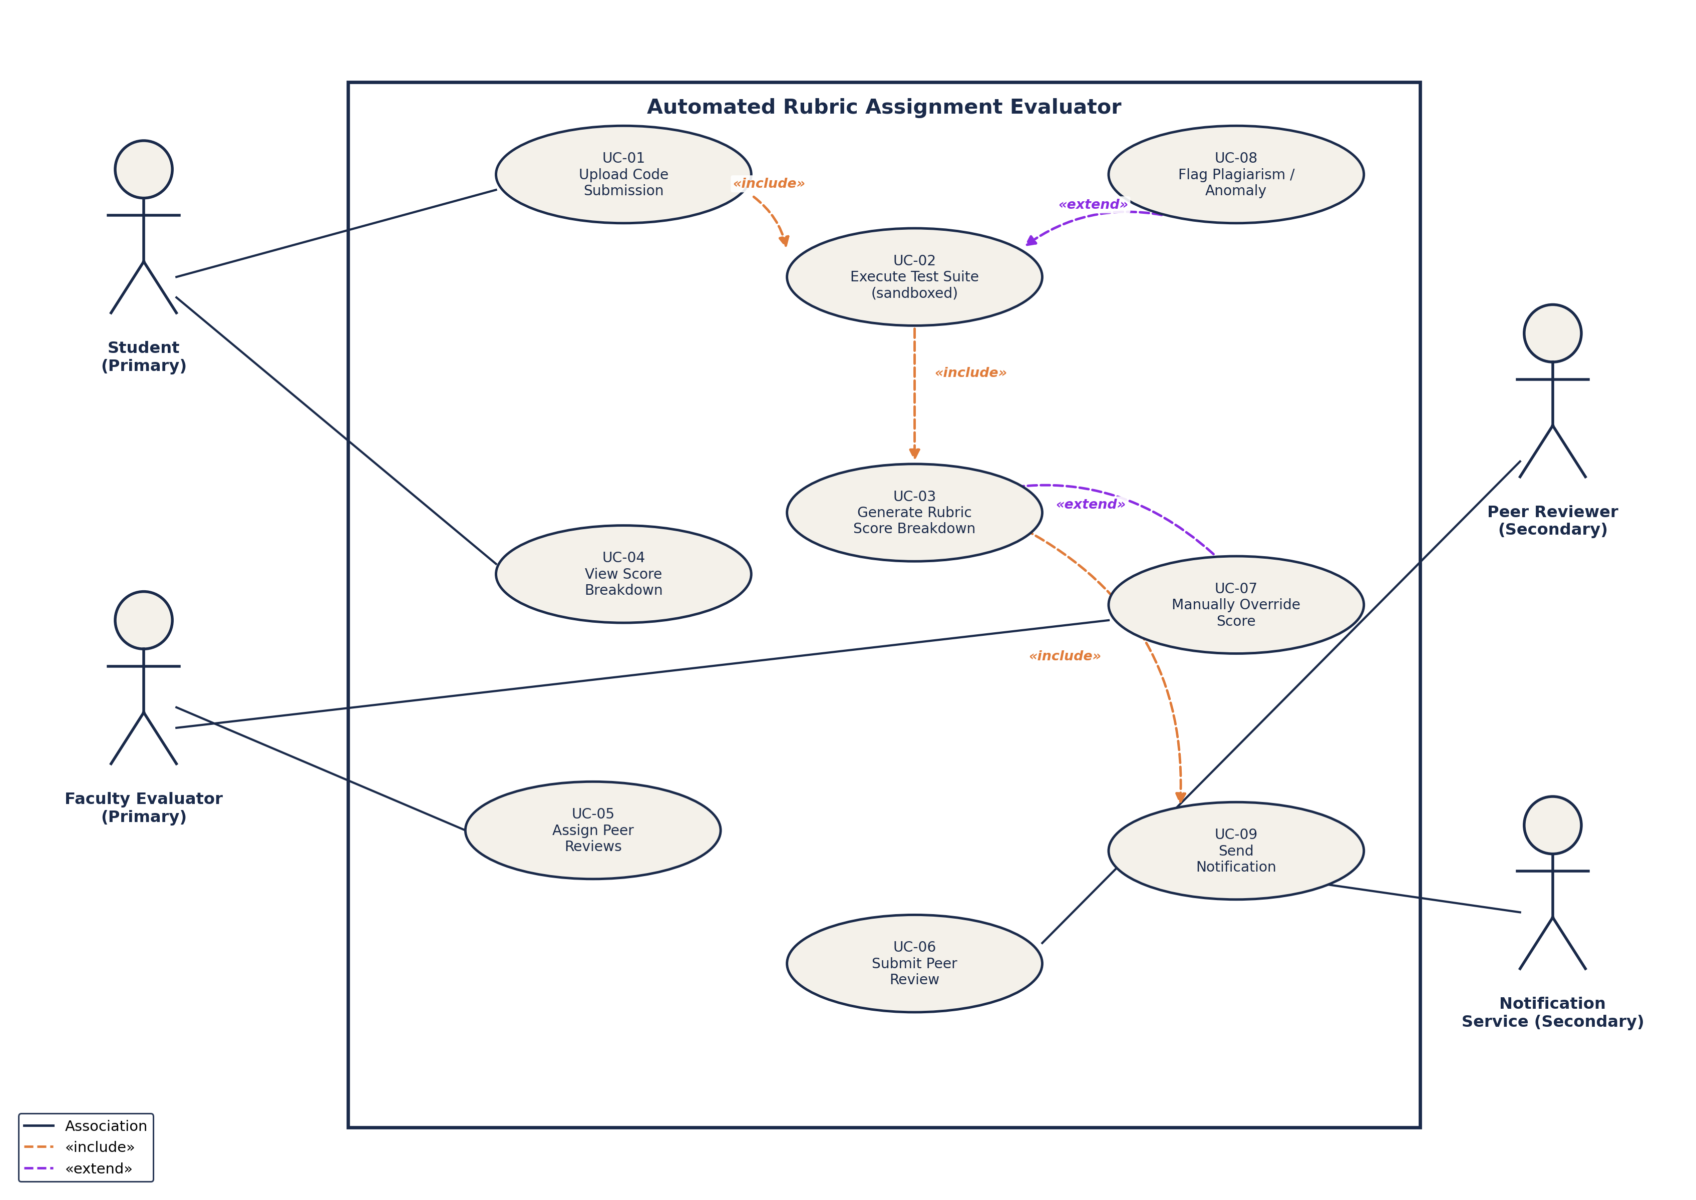

3. Use-Case Flow Specification

Use Case: Submit and Evaluate Project Code (UC-01 → UC-02 → UC-03)
Preconditions:
- The Student is authenticated and enrolled in the course associated with the assignment.
- The Faculty Evaluator has configured a rubric and an associated unit test suite for the assignment (FR-002).
- The assignment's submission window is currently open.
Postconditions:
- Success: The submission is stored, its test suite results and itemized rubric score breakdown are generated and saved, and the Student is notified that results are available.
- Failure: The submission is marked "Evaluation Failed" with a logged error, and the Student is notified to resubmit.

Main Success Scenario
- Student logs into the platform and selects the target assignment.
- Student uploads a zipped project submission (UC-01).
- System validates the file format and size, then adds the submission to the processing queue.
- System dequeues the submission and executes the pre-configured unit test suite inside an isolated sandbox (UC-02).
- System scores each rubric criterion from the test outcomes and generates an itemized rubric score breakdown (UC-03).
- System stores the score breakdown and timestamps the submission as evaluated.
- System sends a notification to the Student that results are available (UC-09).
- Student views the rubric score breakdown on the dashboard (UC-04).
- Use case ends successfully.

Alternate Flow
4a. Test Suite Execution Timeout / Crash
- System detects that test execution exceeds the configured time limit, or the sandbox crashes.
- System marks the submission as "Evaluation Failed" and logs the error.
- System notifies the Student and the Faculty Evaluator of the failure.
- Student may resubmit corrected code within the remaining submission window.
5a. Plagiarism / Anomaly Flagged
- System's plagiarism/anomaly check (UC-08) flags the submission during test execution.
- System withholds the automated score and routes the submission to the Faculty Evaluator for manual review.
- Faculty Evaluator reviews the flag and manually overrides or confirms the score (UC-07).
- System releases the finalized score to the Student and resumes the main flow at step 6.

