WEEK 2 PROJECT REPORT
ADVANCED DATA VISUALIZATION AND STORYTELLING WITH PYTHON
Netflix Movies and TV Shows – Data Storytelling
Submitted by
M. Srivani
Virtual Data Science with Python Apprentice Intern
2026

1. Introduction
Data visualization converts raw data into visual patterns that are easier to understand, compare, and communicate. This Week 2 project focuses on advanced visualization and storytelling using the Netflix Movies and TV Shows dataset.
The analysis explores content type, growth over time, geographic distribution, genres, audience ratings, movie duration, and the relationship between release year and the year content was added to Netflix.
The report follows a story-driven approach: first understanding what the catalog contains, then examining how it changed over time, where content comes from, what genres dominate, what ratings are common, how long movies typically run, and how old the available content is.

2. Objectives
- Understand the structure and characteristics of the Netflix dataset.
- Clean and prepare the data for meaningful visual analysis.
- Create at least five sophisticated visualizations using Python.
- Use visualizations to communicate patterns and trends clearly.
- Explain how each visualization contributes to the overall data story.
- Identify potential business and analytical implications from the observed patterns.

3. Dataset Description
The Netflix dataset contains 8,807 records and 12 columns in the uploaded CSV file. Important attributes include show ID, type, title, director, cast, country, date added, release year, rating, duration, listed-in categories, and description.
After removing duplicate rows, the working dataset contains 8,807 records. The dataset contains both Movies and TV Shows, making it suitable for comparative and time-based storytelling.
Dataset Metric | Value
Rows before cleaning | 8,807
Columns | 12
Duplicate rows removed | 0
Rows after cleaning | 8,807
Missing values before cleaning | 4,307
Movies | 6,131 (69.6%)
TV Shows | 2,676 (30.4%)

4. Tools and Technologies
The project was implemented using Python in Google Colab. Pandas was used for data loading, cleaning, transformation, and aggregation. NumPy supported numerical operations. Matplotlib and Seaborn were used for data visualization. Microsoft Word was used to prepare the final report.

5. Methodology
- Load the Netflix CSV dataset into a Pandas DataFrame.
- Inspect the rows, columns, data types, missing values, and duplicate records.
- Remove duplicate rows and handle selected missing categorical values.
- Convert date_added into a datetime field and derive year_added.
- Split multi-valued country and genre fields for frequency analysis.
- Extract movie duration in minutes for duration analysis.
- Create multiple visualizations to answer different analytical questions.
- Interpret each visualization and connect it to the overall story.
- Summarize the findings and discuss potential business implications.

6. Data Cleaning and Preparation
The original dataset contained 0 duplicate rows and 4,307 missing values across its columns. Duplicate records were removed. The date_added column was converted to datetime format and a new year_added column was created.
Missing values in director, cast, country, and rating were replaced with the value 'Unknown' so that records could remain available for analysis. Multi-valued country and genre fields were split into individual entries before counting them.
For movie-duration analysis, the numeric portion of the duration field was extracted and converted into minutes. This made it possible to study the distribution of movie runtimes.

1. Visualization 1: Distribution of Movies and TV Shows
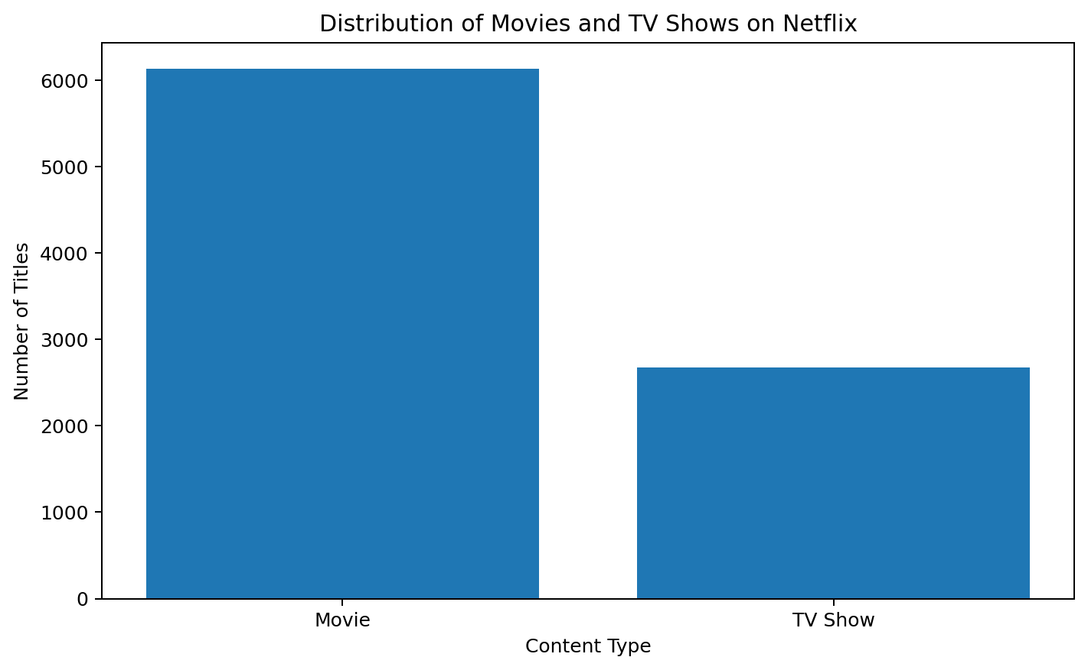
Figure 1: Visualization 1: Distribution of Movies and TV Shows

Observation
The bar chart compares the two main content types. The dataset contains 6,131 Movies (69.6%) and 2,676 TV Shows (30.4%). Movies therefore form the larger share of the catalog represented in this dataset.

How this visualization enhances the narrative
This is the starting point of the story because it answers the basic question: what type of content is present? A simple comparison makes the overall catalog structure easy to understand before moving to more detailed patterns.

Potential implication
The content-type mix can be used as a foundation for further analysis of viewing behavior, genres, ratings, and content acquisition patterns.

2. Visualization 2: Netflix Content Added by Year
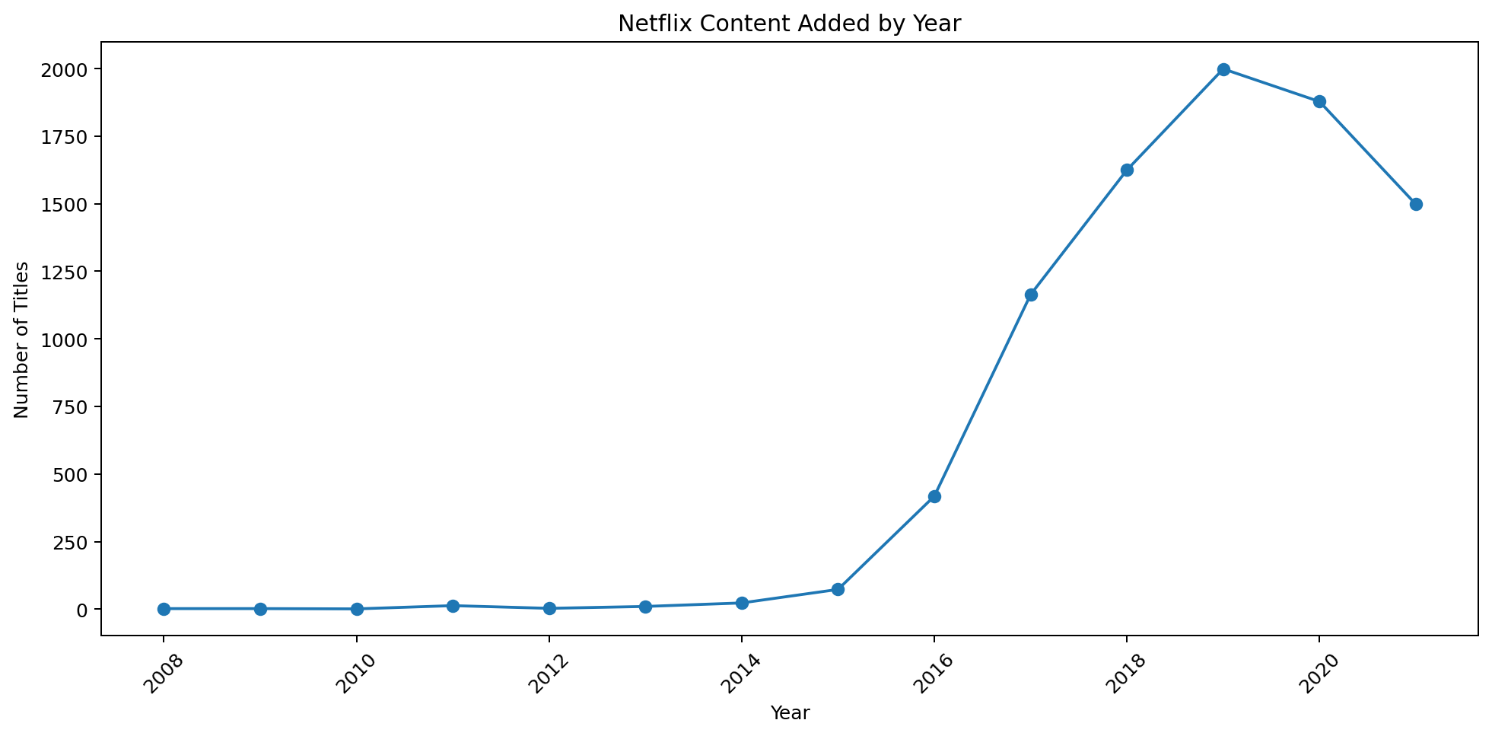
Figure 2: Visualization 2: Netflix Content Added by Year

Observation
The line chart shows how many titles were added in each year for records with available date_added information. The highest annual addition visible in this dataset occurs in 2019, with 1,999 titles.

How this visualization enhances the narrative
A line chart is useful because time is naturally ordered. It makes periods of increase and decrease easy to see and turns individual yearly counts into a clear growth story.

Potential implication
Periods with high additions can be investigated further to understand catalog expansion, acquisition patterns, or changes in the type of content being added.

3. Visualization 3: Top 10 Countries by Number of Netflix Titles
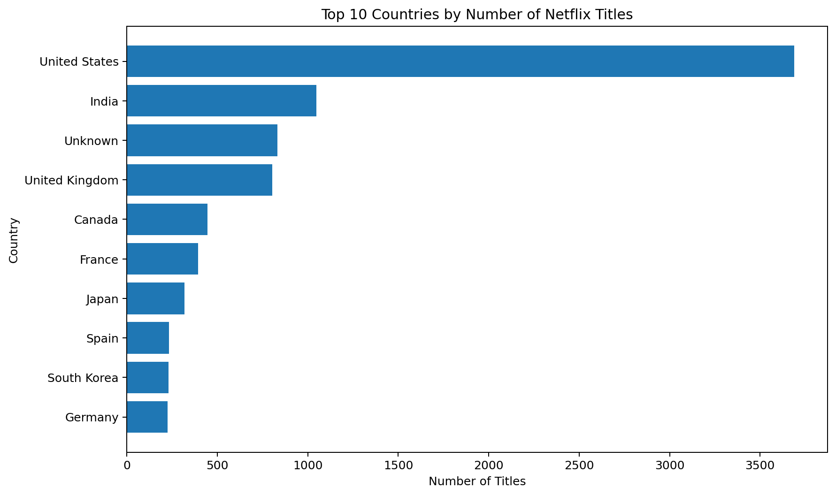
Figure 3: Visualization 3: Top 10 Countries by Number of Netflix Titles

Observation
After splitting titles that contain multiple countries, United States appears as the leading country with 3,689 title associations among the top countries.

How this visualization enhances the narrative
The horizontal bar chart makes country-to-country comparisons easy to read. It shows that the catalog is not limited to one geographic region and allows the audience to quickly identify the largest contributors.

Potential implication
Country-level patterns can support analysis of regional content availability, international diversity, and geographic content strategies.

4. Visualization 4: Top 10 Genres on Netflix
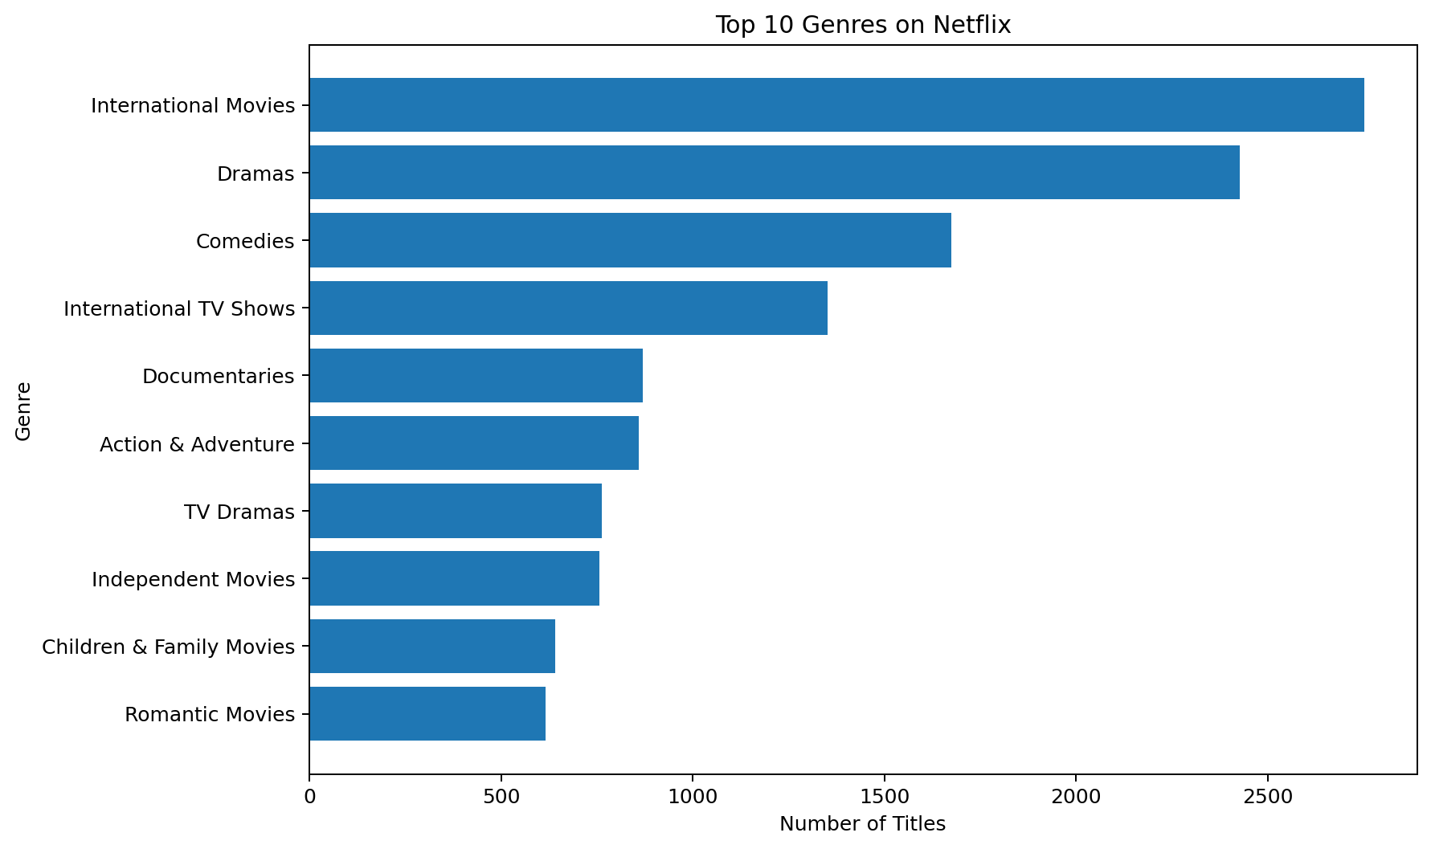
Figure 4: Visualization 4: Top 10 Genres on Netflix

Observation
The genre analysis identifies International Movies as the most frequently listed genre association, with 2,752 associations. Because a title can have multiple listed genres, these values represent genre associations rather than unique titles.

How this visualization enhances the narrative
Genre analysis moves the story from where content comes from to what type of content is available. The horizontal ranking allows common categories to be compared quickly.

Potential implication
Genre patterns can support audience segmentation, recommendation-system analysis, content classification, and studies of changing content preferences.

5. Visualization 5: Netflix Content by Rating
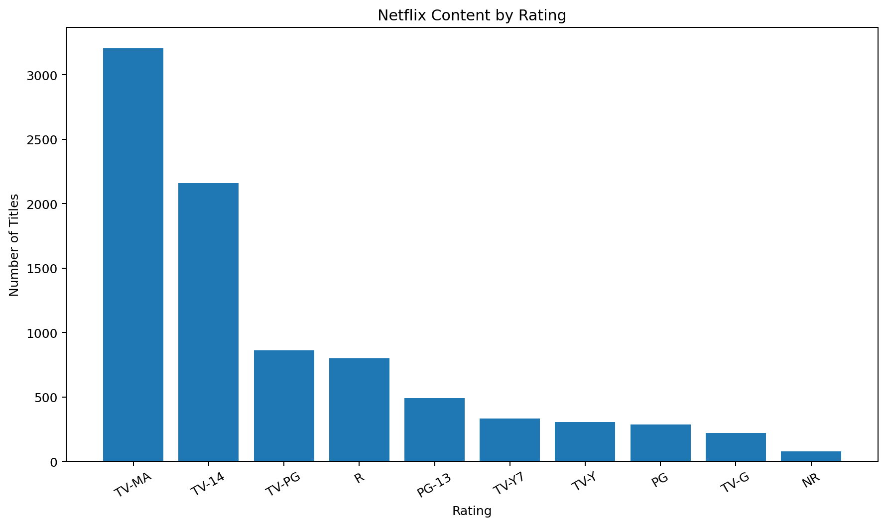
Figure 5: Visualization 5: Netflix Content by Rating

Observation
The rating chart shows the distribution of the most common rating categories. TV-MA is the largest displayed rating category, with 3,207 titles.

How this visualization enhances the narrative
Ratings provide an audience-oriented perspective. After seeing the catalog composition, time trends, countries, and genres, the rating chart adds information about the maturity classification of the content.

Potential implication
Rating distributions can help analysts study the intended audience mix and compare content categories with demographic or market-oriented questions.

6. Visualization 6: Distribution of Movie Durations
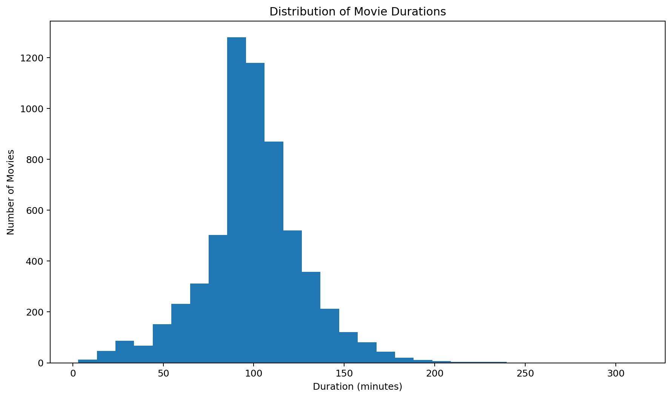
Figure 6: Visualization 6: Distribution of Movie Durations

Observation
The histogram shows the distribution of movie runtimes. Among movies with parseable duration values, the average duration is approximately 99.6 minutes and the median is 98.0 minutes.

How this visualization enhances the narrative
A histogram is appropriate for showing the shape and spread of a numerical variable. Instead of only reporting an average, it shows how movie lengths are distributed across different runtime ranges.

Potential implication
Duration patterns can be useful for catalog profiling and for comparing runtime distributions across different genres, release periods, or other categories.

7. Visualization 7: Release Year vs Year Added to Netflix
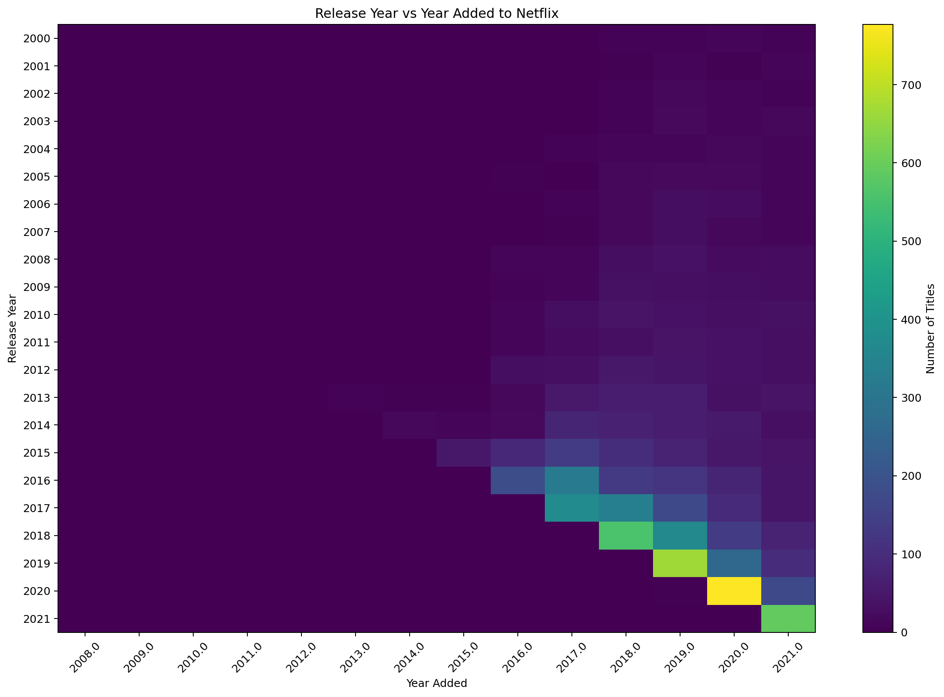
Figure 7: Visualization 7: Release Year vs Year Added to Netflix

Observation
The heatmap compares the original release year of a title with the year in which it was added to Netflix. Darker areas represent larger concentrations of titles for a particular release-year and added-year combination.

How this visualization enhances the narrative
This visualization adds a lifecycle perspective to the story. It helps distinguish newer content from older titles that were added later and shows that the catalog contains both recent releases and back-catalog content.

Potential implication
The relationship between release year and addition year can be used to study catalog freshness, older-content availability, and how quickly different groups of titles enter the platform catalog.

14. Overall Key Insights
- The dataset contains 8,807 unique records after cleaning.
- Movies account for 69.6% of the catalog, while TV Shows account for 30.4%.
- The highest number of titles added in a single year in the available date_added records occurs in 2019, with 1,999 titles.
- United States is the leading country by title association in the top-country analysis.
- International Movies is the most frequently listed genre association.
- TV-MA is the largest rating category among the displayed ratings.
- The median movie duration is 98.0 minutes, showing the typical runtime around which the movie distribution is centered.
- The release-year versus year-added heatmap shows a mixture of recent content and older titles that were added later.

15. Potential Business Implications
The following implications are analytical possibilities derived from the dataset. They do not represent internal Netflix business decisions or confidential company strategy.
- Catalog composition: The Movies-versus-TV-Shows distribution provides a baseline for studying the overall content mix.
- Content acquisition: Yearly addition patterns can identify periods of rapid catalog expansion that may deserve further investigation.
- Global content: Country-level patterns demonstrate geographic diversity and can support studies of regional content availability.
- Genre strategy: Frequent genres provide useful categories for audience segmentation, recommendation analysis, and trend monitoring.
- Audience classification: Rating patterns can help characterize the maturity profile of the catalog.
- Content format: Movie-duration patterns can help analysts understand common runtime ranges and compare formats across categories.
- Catalog lifecycle: Comparing release year with year added can help distinguish recently released content from older back-catalog titles.

16. Conclusion
This project demonstrates how advanced data visualization can transform a large content dataset into a clear and understandable data story. The analysis begins with the basic catalog composition and then moves through time trends, geographic distribution, genres, ratings, movie duration, and content lifecycle.
Each visualization answers a different analytical question and contributes to the overall narrative. The project also demonstrates the importance of data cleaning, feature creation, appropriate chart selection, and careful interpretation when communicating data to a non-technical audience.
Overall, the Netflix dataset provides a useful example of how visualization can reveal patterns that are difficult to identify from raw rows and columns alone.

17. References
- Netflix Movies and TV Shows dataset – netflix_titles.csv (dataset used for this analysis).
- Pandas Documentation – https://pandas.pydata.org/docs/
- Matplotlib Documentation – https://matplotlib.org/stable/
- Seaborn Documentation – https://seaborn.pydata.org/
- NumPy Documentation – https://numpy.org/doc/

18. Submission Checklist
☐ Public dataset selected and analyzed.
☐ Data cleaning and preparation completed.
☐ At least five sophisticated visualizations included; seven visualizations are included in this report.
☐ Each visualization has an observation and explanation of how it supports the narrative.
☐ Overall key insights included.
☐ Potential business implications included.
☐ Conclusion and references included.
☐ All content consolidated into one Word document.

