WEEK 4 PROJECT REPORT
Machine Learning Model Development and Evaluation
Breast Cancer Classification Using Logistic Regression

Submitted by
M. Srivani
Virtual Data Science with Python Apprentice Intern
2026

Abstract
This project demonstrates an end-to-end supervised machine learning workflow using Python. The Breast Cancer Wisconsin Diagnostic dataset available through Scikit-learn was used to train a Logistic Regression classifier to distinguish between benign and malignant observations. The workflow includes dataset inspection, a stratified train-test split, feature standardization, model training, and evaluation with accuracy, precision, recall, F1-score, and ROC-AUC. A confusion matrix and ROC curve were generated to make model performance easier to interpret. On the held-out test set, the model achieved 98.2% accuracy and a ROC-AUC of 0.995. The report also considers misclassification risk, generalization, limitations, and possible future improvements. This is an educational demonstration and must not be used to make medical decisions.

1. Introduction
Machine learning enables computers to learn patterns from data and use those patterns to make predictions. In supervised learning, a model is trained using examples with known labels. Classification is a supervised learning task in which the model predicts a category. This project builds a binary classifier and follows the major steps of a practical machine learning pipeline.

2. Objectives
- Load and inspect a publicly available dataset.
- Prepare features and target labels for a classification task.
- Split the data into training and testing subsets without fitting the model on the test data.
- Train a Logistic Regression model using Scikit-learn.
- Evaluate the model with multiple metrics and visualizations.
- Discuss potential errors, overfitting, underfitting, limitations, and improvements.

3. Dataset Description
The project uses the Breast Cancer Wisconsin Diagnostic dataset distributed with Scikit-learn. It contains 569 observations and 30 numeric features computed from digitized images of breast mass samples. The target contains two categories: malignant and benign. Scikit-learn encodes malignant as 0 and benign as 1.

Dataset property | Description
Total observations | 569
Input features | 30
Target classes | Malignant (0), Benign (1)
Malignant observations | 212
Benign observations | 357
Missing numeric feature values | 0
Training set | 455 observations (80%)
Testing set | 114 observations (20%)
The dataset is loaded directly from Scikit-learn, so a separate dataset download is not required. The feature matrix has no missing numeric values according to the NumPy missing-value check used in the code.
- Dataset: Breast Cancer Wisconsin Diagnostic Dataset
- Algorithm: Logistic Regression

4. Tools and Technologies
Tool / library | Purpose
Python | Programming language for the complete workflow.
Scikit-learn | Dataset access, splitting, scaling, model training, and evaluation metrics.
NumPy | Numerical operations and missing-value checks.
Matplotlib | Plot creation and saving figures.
Seaborn | Heatmap-style confusion matrix visualization.

5. Data Preparation and Preprocessing
The feature matrix X contains the 30 numeric measurements, while y contains the class labels. The data is split into 80% training data and 20% testing data using random_state=42 for reproducibility. The stratify=y argument preserves the approximate class proportions in both subsets. The StandardScaler transforms features to comparable scales. It is included inside a Scikit-learn Pipeline so that scaling parameters are learned from training data only and then applied to the test data. This helps prevent data leakage.
The data is already numeric and the inspected feature matrix contains no missing values, so no imputation or categorical encoding is required for this dataset. The code still checks the missing-value count so the step is documented.
6. Algorithm Selection and Justification
Logistic Regression was selected because it is a widely used baseline for binary classification, is available in Scikit-learn, and produces probability estimates that can be used to draw an ROC curve. It is relatively simple to train and interpret compared with many complex models. Feature scaling is used because Logistic Regression is optimized numerically and the dataset features have different numeric ranges.
The chosen pipeline consists of Standard Scaler followed by LogisticRegression (max_iter=5000). The higher iteration limit allows the optimizer sufficient iterations to converge.
7. Model Training and Testing
The model is fitted only on X_train and y_train. Predictions are then generated for X_test, which was held out during fitting. Test-set performance provides an estimate of how well the trained model generalizes to unseen observations from a similar data source. The random seed and stratified split make the experiment repeatable.
8. Evaluation Metrics
Accuracy is the fraction of all predictions that are correct. Precision measures the fraction of predicted positive labels that are correct. Recall measures the fraction of actual positive labels identified by the model. The F1-score is the harmonic mean of precision and recall. ROC-AUC measures how well the model ranks examples from the two classes across decision thresholds. In this report, Scikit-learn label 1 (benign) is the positive class for the displayed precision, recall, F1-score, and ROC-AUC. Because this is a medical-themed dataset, per-class results and error types should be reviewed rather than relying on accuracy alone.

Metric | Value | Percentage (where applicable)
Accuracy | 0.9825 | 98.25%
Precision (class 1: benign) | 0.9861 | 98.61%
Recall (class 1: benign) | 0.9861 | 98.61%
F1-score (class 1: benign) | 0.9861 | 98.61%
ROC-AUC (class 1: benign) | 0.9954 | 99.54%

9. Visualization 1 — Confusion Matrix
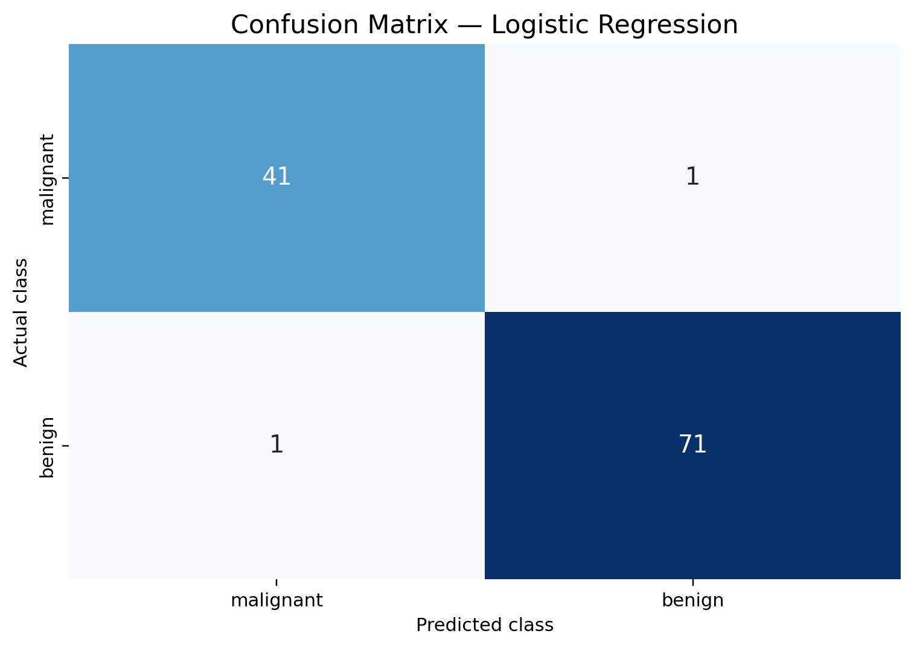
The confusion matrix compares the actual labels with predicted labels. With class order [malignant, benign], the matrix is [[41, 1], [1, 71]]. It contains 41 correct malignant predictions (true negatives for label 1), 1 malignant observations predicted as benign, 1 benign observations predicted as malignant, and 71 correct benign predictions (true positives for label 1). A false negative for the malignant class can be particularly consequential in a real medical setting. For that reason, the class labels and clinical context must be considered carefully.
10. Visualization 2 — ROC Curve
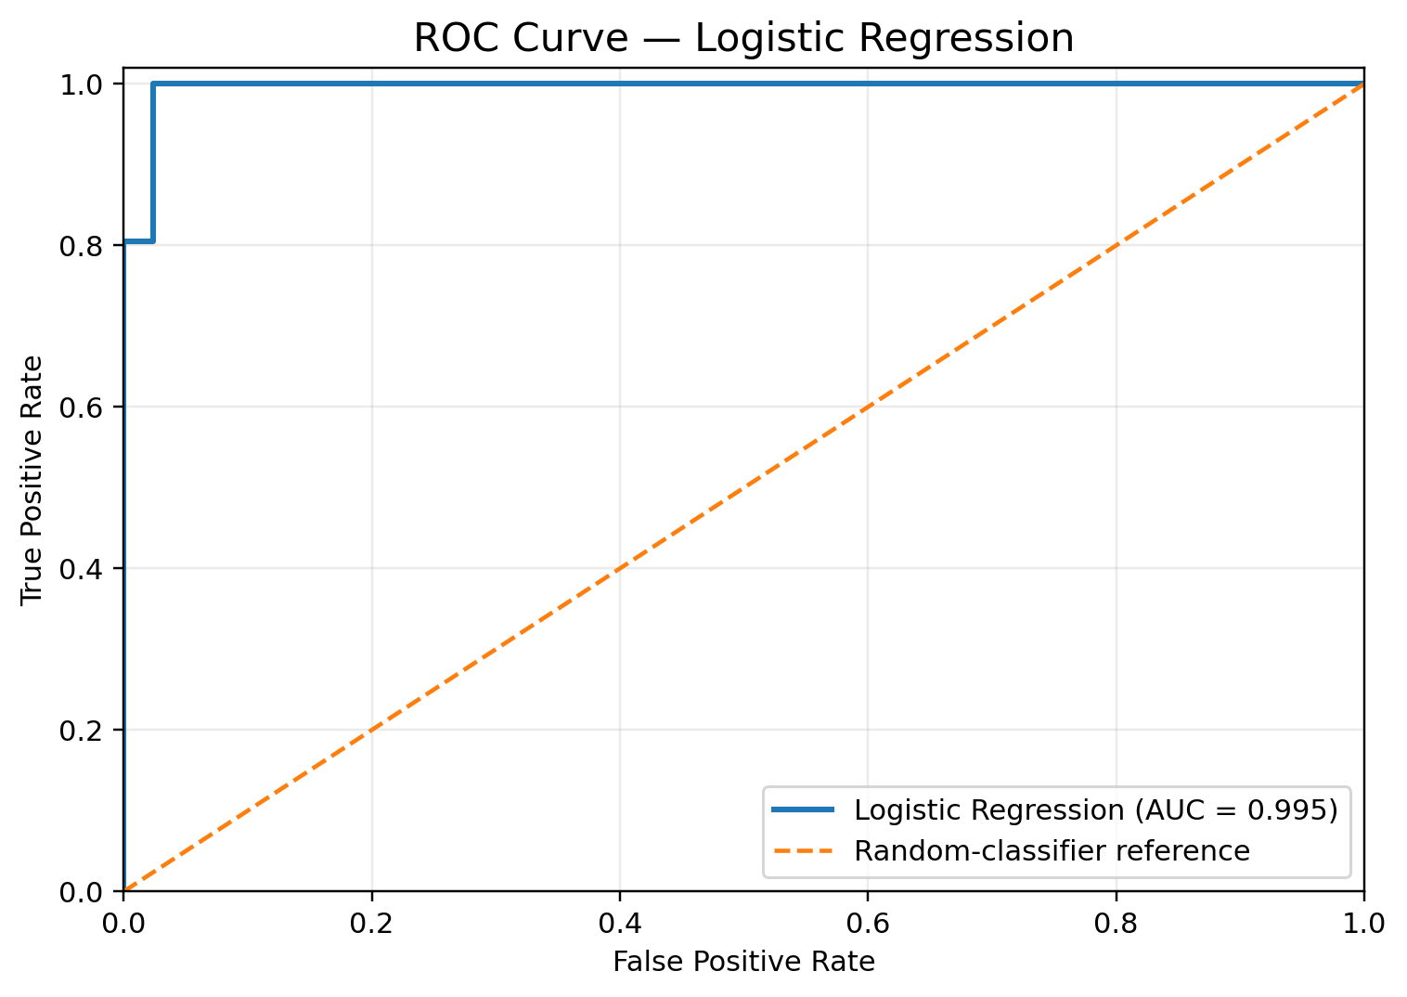
The ROC curve plots the true positive rate against the false positive rate as the classification threshold changes. The model's test-set ROC-AUC is 0.995. A curve closer to the upper-left region generally indicates better separation, while the diagonal line represents a random-ranking reference. A high AUC does not by itself guarantee that a chosen decision threshold is appropriate for every use case.

11. Results and Discussion
The model achieved a test accuracy of 98.2%, with precision of 98.6%, recall of 98.6%, and F1-score of 98.6% for the benign class. The ROC-AUC was 0.995. These results indicate that the model separates the classes effectively on this particular held-out split. They should not be treated as a guarantee of performance on new institutions, populations, or data collection processes.

Generalization check | Accuracy
Training accuracy | 0.9890 (98.9%)
Testing accuracy | 0.9825 (98.2%)
Train-test gap | 0.0066
The training and testing accuracies are close in this run, which does not show a large accuracy gap. However, one train-test split is only an initial check; cross-validation and external validation would provide stronger evidence about generalization.

12. Error Analysis
- False positives: benign observations predicted as malignant. These can lead to unnecessary concern or follow-up in a hypothetical workflow.
- False negatives: malignant observations predicted as benign. In a real medical context, this type of error may be especially serious.
- Threshold effects: changing the probability threshold changes the balance between false positives and false negatives.
- Sampling effects: the selected test subset may not represent all possible future cases.
- Measurement effects: feature quality, measurement noise, and differences in data collection can affect predictions.
For this run, the confusion matrix contains 1 malignant observations predicted as benign and 1 benign observations predicted as malignant (using malignant=0, benign=1). These counts should be read alongside the stated label order to avoid confusing the positive class with the medical meaning of the class.

13. Overfitting and Underfitting
Overfitting occurs when a model fits training-specific patterns that do not generalize, often producing much better training performance than test performance. Underfitting occurs when a model is too simple or insufficiently trained to capture useful patterns, resulting in weak performance on both training and test data. The train-test accuracy comparison in this experiment is a basic diagnostic, not a definitive proof that overfitting or underfitting is absent. A cross-validation score distribution and learning curves would provide more information.

14. Limitations
- Limited Model Evaluation: Only one algorithm, Logistic Regression, and one train-test split were evaluated. Therefore, the results may differ with other algorithms or data splits.
- Dataset Limitations: The Breast Cancer Wisconsin Diagnostic Dataset is a curated historical dataset that may not represent current clinical settings or diverse real-world populations.
- Evaluation Metrics: Accuracy and ROC-AUC provide useful performance summaries but do not fully explain the consequences of false-positive and false-negative predictions.
- Lack of Further Validation: External validation, probability calibration analysis, subgroup fairness assessment, and clinical evaluation were not performed.
- Not for Clinical Use: This model was developed for educational purposes only. It must not be used to diagnose or screen patients or guide treatment decisions.

15. Suggestions for Improvement
- Model Comparison: Compare Logistic Regression with Decision Tree, Random Forest, and Support Vector Machine (SVM) using the same train-test split and evaluation metrics.
- Cross-Validation: Use stratified cross-validation to evaluate model performance across multiple folds and understand its variability.
- Hyperparameter Tuning: Apply GridSearchCV or RandomizedSearchCV to identify suitable model parameters using cross-validation.
- Detailed Evaluation: Examine per-class precision, recall, F1-score, and the confusion matrix. Consider classification thresholds based on the relative costs of false-positive and false-negative predictions.
- Probability Calibration and Independent Testing: Evaluate whether predicted probabilities are well calibrated and test the final model on independent data before considering real-world applications.
- Documentation and Reproducibility: Document the dataset source, limitations, preprocessing steps, software libraries, and random seeds to support reproducibility.

16. Conclusion
This project completed a basic machine learning pipeline using Python and Scikit-learn. The dataset was inspected, split into training and test sets, standardized within a pipeline, and used to train a Logistic Regression classifier. The model was assessed using accuracy, precision, recall, F1-score, ROC-AUC, a confusion matrix, and an ROC curve. The test accuracy was 98.2% and the ROC-AUC was 0.995 for the specified split. The exercise demonstrates that model evaluation requires multiple metrics and critical discussion of errors, not just a single accuracy value. Additional cross-validation, model comparison, and external validation are recommended.
17. References
- UCI Machine Learning Repository. Breast Cancer Wisconsin (Diagnostic) Dataset.
https://archive.ics.uci.edu/dataset/17/breast+cancer+wisconsin+diagnostic
- Scikit-learnDevelopers.LogisticRegression.
https://scikit-learn.org/stable/modules/linear_model.html#logistic-regression
- Scikit-learn Developers. Model Evaluation: Quantifying the Quality of Predictions.
https://scikit-learn.org/stable/modules/model_evaluation.html
- Scikit-learnDevelopers.ConfusionMatrix.
https://scikitlearn.org/stable/modules/generated/sklearn.metrics.confusion_matrix.html
- Scikit-learnDevelopers.ReceiverOperatingCharacteristic(ROC).
https://scikit-learn.org/stable/modules/generated/sklearn.metrics.roc_curve.html

Appendix A: Source Code and Execution Instructions
The complete, runnable Python source file is provided separately as week4_ml_model.py. It loads the Breast Cancer Wisconsin Diagnostic Dataset, trains the Logistic Regression pipeline, calculates evaluation metrics, and saves the confusion matrix and ROC curve visualizations.
A.1 Installing Dependencies
Install the required Python libraries by running the following command in a terminal:
pip install scikit-learn matplotlib seaborn numpy
A.2 Running the Program
Navigate to the directory containing week4_ml_model.py and execute:
python week4_ml_model.py
A.3 Expected Outputs
After successful execution, the program should:
- Train and evaluate the Logistic Regression model.
- Display evaluation metrics, including accuracy, precision, recall, F1-score, and ROC-AUC.
- Generate and save the confusion matrix visualization.
- Generate and save the ROC curve visualization.

Appendix B — Reproducibility Notes
The experiment uses train_test_split with test_size=0.20, random_state=42, and stratify=y to divide the dataset into training and testing sets while preserving class proportions.
The machine learning pipeline consists of StandardScaler for feature standardization and LogisticRegression(max_iter=5000) for classification.
The evaluation metrics and visualizations presented in this report were generated using this configuration. Results may vary if the dataset, software library versions, preprocessing steps, or experimental configuration are changed.

