WEEK 5 PROJECT REPORT
Comprehensive Data Science Project Reporting and Strategic Recommendations
From Data Preparation to Machine Learning and Strategic Insights

Submitted by
M. Srivani
Virtual Data Science with Python Apprentice Internship
Yuva Intern

1. Executive Summary
This comprehensive report consolidates the major data science activities completed during the Virtual Data Science with Python Apprentice Internship. The work progressed through an end-to-end data science workflow: data acquisition and cleaning, exploratory data analysis, visualization and storytelling, statistical hypothesis testing, machine learning model development and evaluation, and finally strategic interpretation and recommendations.
Week 1 focused on the Titanic dataset and demonstrated practical data preparation and exploratory analysis. Week 2 used the Netflix Movies and TV Shows dataset to develop visual storytelling skills. Week 3 analyzed retail sales data using Welch's two-sample t-test to investigate whether average sales differed between discounted and non-discounted orders. Week 4 developed a Logistic Regression model using the Breast Cancer Wisconsin Diagnostic Dataset and evaluated its classification performance.
Together, these projects strengthened practical skills in Python, Pandas, NumPy, Matplotlib, Seaborn, and Scikit-learn. The report also translates analytical findings into responsible strategic recommendations while recognizing limitations and the need for further validation.

2. Introduction
Data science combines data preparation, statistical reasoning, visualization, and machine learning to transform raw information into meaningful insights. A reliable data science project begins with understanding and preparing the data, continues through exploratory and statistical analysis, and may use predictive models to support decision-making.
The internship provided practical exposure to these stages through multiple datasets and analytical questions. Because different datasets were used across the weekly projects, the projects are presented as complementary demonstrations of the data science lifecycle rather than as one single dataset pipeline.
This final project demonstrates an end-to-end data science workflow, from data acquisition and preprocessing to visualization, statistical analysis, machine learning, evaluation, and strategic recommendations.

3. Objectives
- Acquire, inspect, clean, and preprocess real-world datasets.
- Perform exploratory data analysis and identify meaningful patterns.
- Create effective visualizations and communicate findings clearly.
- Apply statistical hypothesis testing and interpret statistical evidence.
- Develop and evaluate a machine learning classification model.
- Translate analytical findings into responsible strategic recommendations.
- Identify limitations and propose future improvements.

4. Tools and Technologies
Category | Technologies
Programming Language | Python
Data Processing | Pandas, NumPy
Visualization | Matplotlib, Seaborn
Machine Learning | Scikit-learn
Development Environment | Jupyter Notebook / Google Colab
Datasets | Titanic, Netflix Movies and TV Shows, Retail Sales, Breast Cancer Wisconsin Diagnostic

5. Week 1 – Data Acquisition, Cleaning, and Exploratory Data Analysis

5.1 Project Overview
The Week 1 project, titled “Data Acquisition, Cleaning, and Exploratory Data Analysis of the Titanic Dataset,” focused on understanding the essential data preparation workflow used in a data science project.

5.2 Data Preparation
The Titanic dataset was acquired using Python and the Seaborn library. The original dataset contained 891 records and 15 columns. The dataset was inspected for structure, dimensions, column names, data types, missing values, duplicate records, and statistical characteristics.
- Duplicate records were identified and removed.
- Missing Age values were handled using median imputation.
- Missing values in Embarked and Embark_town were handled using the mode.
- The Deck column was removed because a large proportion of its values were missing.

Code Snippet – Data Acquisition, Cleaning, and Validation
# Data acquisition
df = sns.load_dataset("titanic")

# Cleaning
clean_df = df.copy()
clean_df = clean_df.drop_duplicates()
clean_df["age"] = clean_df["age"].fillna(clean_df["age"].median())
clean_df["embarked"] = clean_df["embarked"].fillna(clean_df["embarked"].mode()[0])
clean_df["embark_town"] = clean_df["embark_town"].fillna(clean_df["embark_town"].mode()[0])
clean_df = clean_df.drop(columns=["deck"])
clean_df = clean_df.drop_duplicates()

# Validation
print(clean_df.shape)
print(clean_df.isnull().sum().sum())
print(clean_df.duplicated().sum())

5.3 Final Dataset and EDA
After preprocessing and validation, the cleaned dataset contained 780 rows and 14 columns with no missing values or duplicate records. Exploratory analysis used summary statistics and visualizations including survival counts, age distribution, survival by gender, survival by passenger class, and a correlation heatmap.
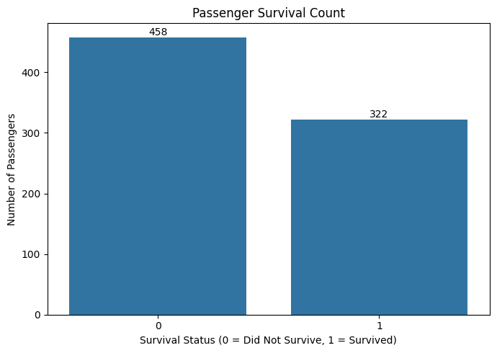
Figure 1: Survival Count Distribution
The visualization shows the number of passengers who survived compared with those who did not survive.
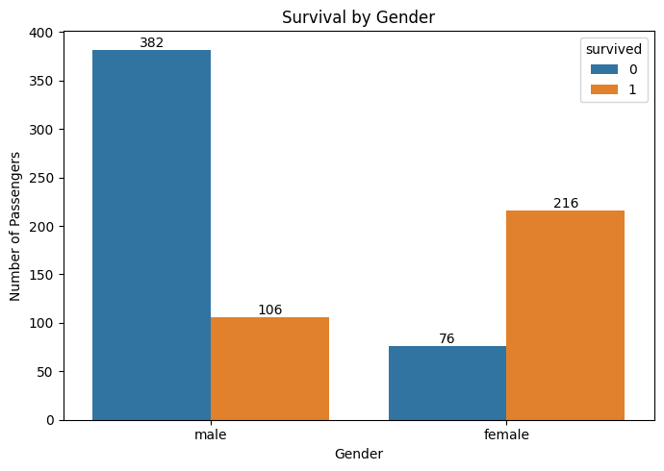
Figure 2: Survival Distribution by Gender
The visualization indicates a noticeable difference in survival outcomes between male and female passengers.
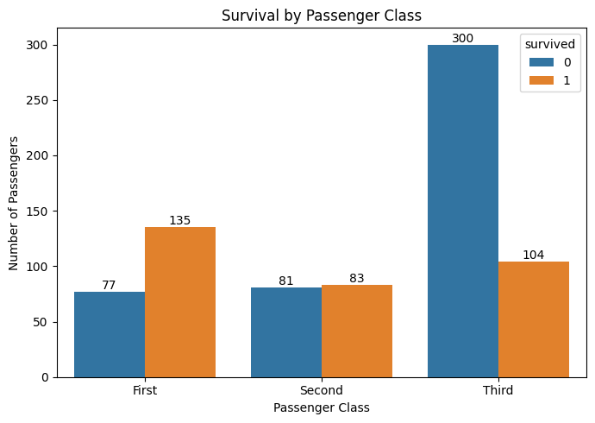
Figure 3: Survival Distribution by Passenger Class
The visualization shows differences in survival outcomes across passenger classes.

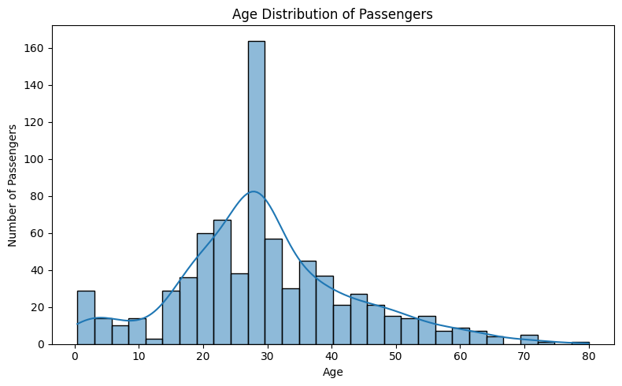
Figure 4: Age Distribution of Titanic Passengers
The age distribution visualization shows the distribution of passenger ages in the Titanic dataset. It helps identify the most common age ranges and the overall spread of passenger ages.
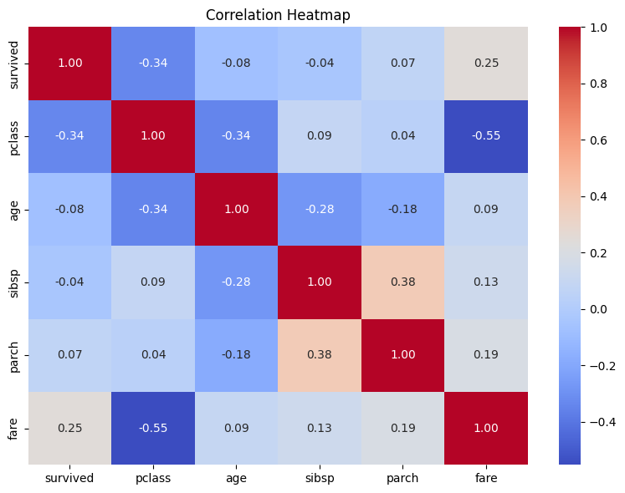
Figure 4: Correlation Heatmap of Numerical Variables
The correlation heatmap illustrates the relationships among numerical variables in the dataset and helps identify variables that show stronger or weaker linear associations.
Key finding: Observable differences in survival were associated with gender and passenger class, while the correlation analysis helped identify relationships among numerical variables.
5.4 EDA Visualization Code
Code Snippet 1: Survival Count Visualization
# Survival count
plt.figure(figsize=(7, 5))
sns.countplot(data=clean_df, x="survived")
plt.title("Survival Count")
plt.xlabel("Survived")
plt.ylabel("Number of Passengers")
plt.tight_layout()
plt.show()

Code Snippet 2: Age Distribution Visualization
# Age distribution
plt.figure(figsize=(8, 5))
sns.histplot(data=clean_df, x="age", bins=30, kde=True)
plt.title("Age Distribution of Passengers")
plt.xlabel("Age")
plt.ylabel("Number of Passengers")
plt.tight_layout()
plt.show()

Code Snippet 3: Survival by Gender Visualization
# Survival by gender
plt.figure(figsize=(7, 5))
sns.countplot(data=clean_df, x="sex", hue="survived")
plt.title("Survival by Gender")
plt.xlabel("Gender")
plt.ylabel("Number of Passengers")
plt.tight_layout()
plt.show()

Code Snippet 4: Survival by Passenger Class Visualization
# Survival by passenger class
plt.figure(figsize=(7, 5))
ax = sns.countplot(data=clean_df, x="class", hue="survived")
plt.title("Survival by Passenger Class")
plt.xlabel("Passenger Class")
plt.ylabel("Number of Passengers")
for container in ax.containers:
ax.bar_label(container)

plt.tight_layout()
plt.show()

Code Snippet 5: Correlation Heatmap
# Correlation heatmap
plt.figure(figsize=(10, 7))
corr = clean_df.select_dtypes(include="number").corr()
sns.heatmap(corr, annot=True, cmap="coolwarm", fmt=".2f")
plt.title("Correlation Heatmap of Numerical Variables")
plt.tight_layout()
plt.show()

6. Week 2 – Advanced Data Visualization and Storytelling with Python

6.1 Project Overview
Week 2 focused on transforming the Netflix Movies and TV Shows dataset into a clear visual story using Python. The project emphasized effective communication of patterns and trends through data visualization.

6.2 Data Preparation
- Loaded and explored the Netflix dataset using Pandas.
- Removed duplicate records.
- Converted the date_added column into a proper datetime format.
- Handled selected missing categorical values.
- Created a year_added feature.
- Processed multi-valued country and genre fields for frequency-based analysis.

Visualizations
- Distribution of Movies and TV Shows.
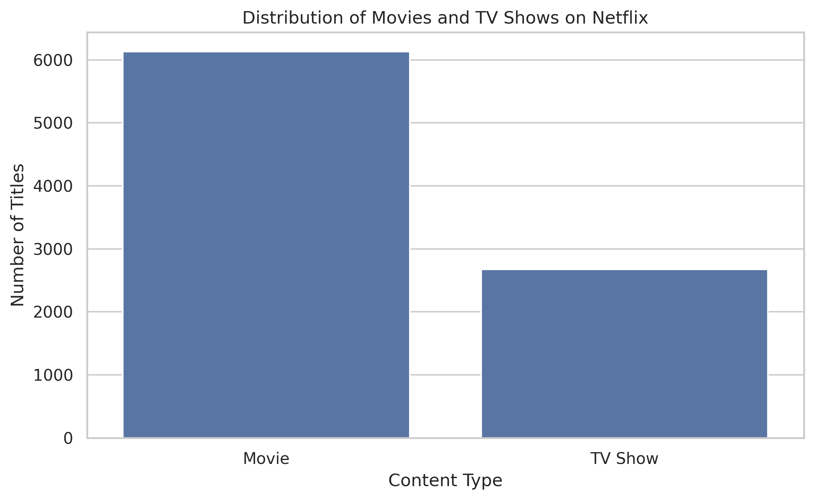
The visualization compares the number of Movies and TV Shows available in the Netflix dataset. Movies represent the larger share of the catalog, indicating that the dataset contains a greater volume of movie content than television content.

- Netflix content added by year.
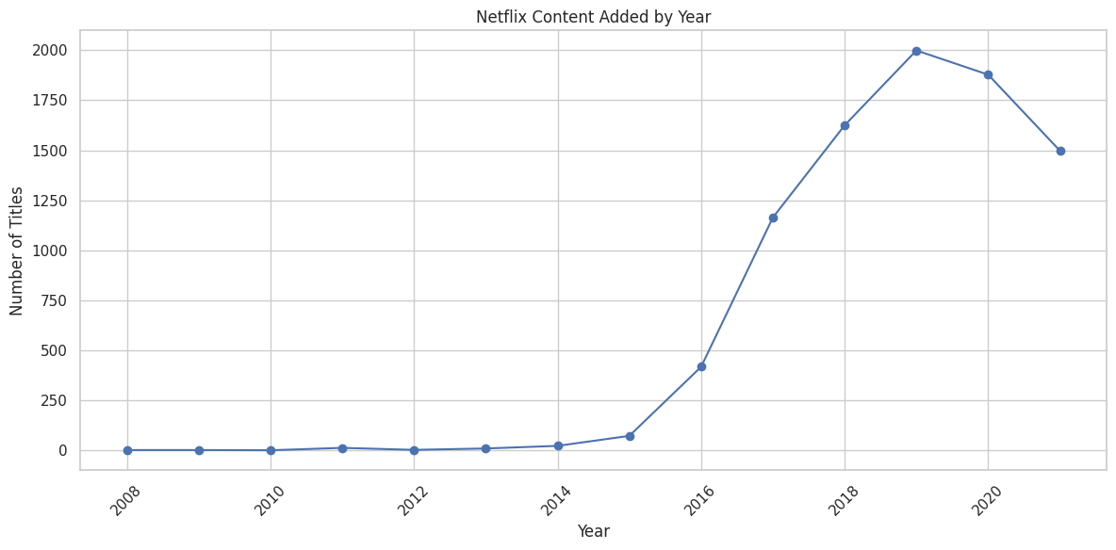
The visualization shows how the number of titles added to Netflix changed over the years. It helps identify periods of increased or decreased content additions and provides insight into the growth and evolution of the Netflix catalog.

- Top countries by number of titles.

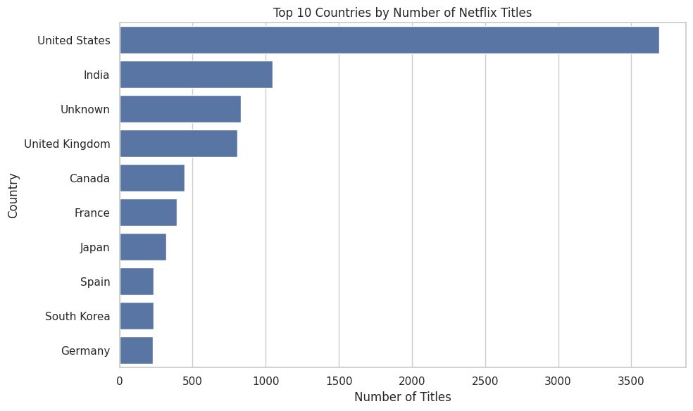

The chart presents the countries contributing the highest number of titles in the Netflix dataset. It demonstrates the geographical diversity of Netflix content and highlights countries with a strong presence in the catalog
- Most common genres.
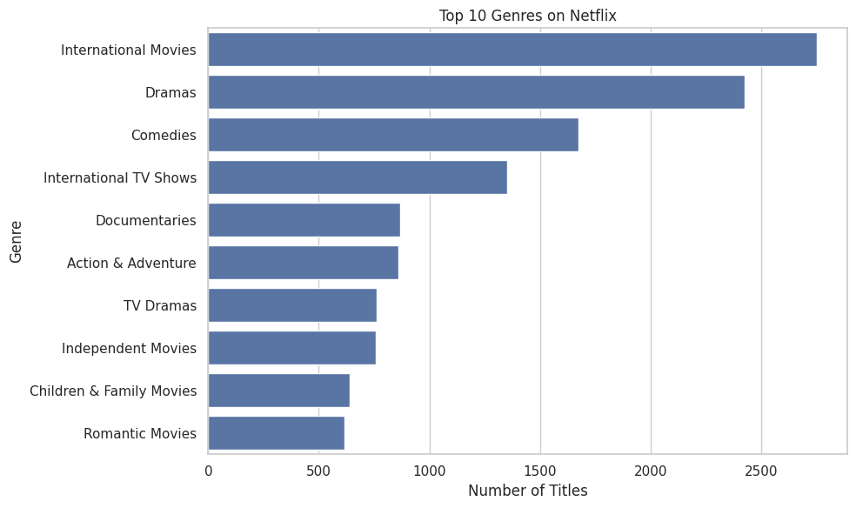
The visualization identifies the most frequently occurring genres in the Netflix catalog. Understanding genre distribution helps reveal the types of content that are most widely represented on the platform.

- Content distribution by rating.
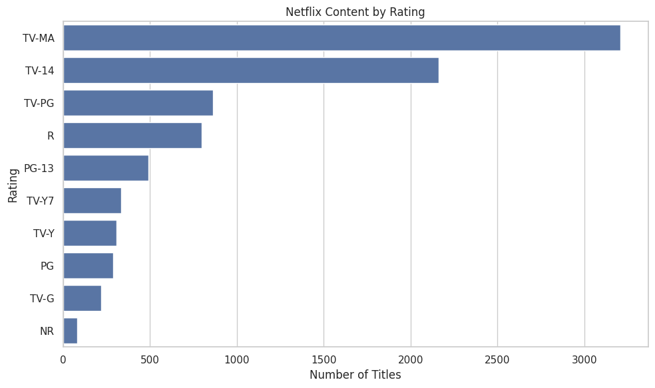
The chart shows the distribution of Netflix titles across different content ratings. This provides insight into the target audience classification of the catalog and the types of content available for different age groups.

- Distribution of movie durations.
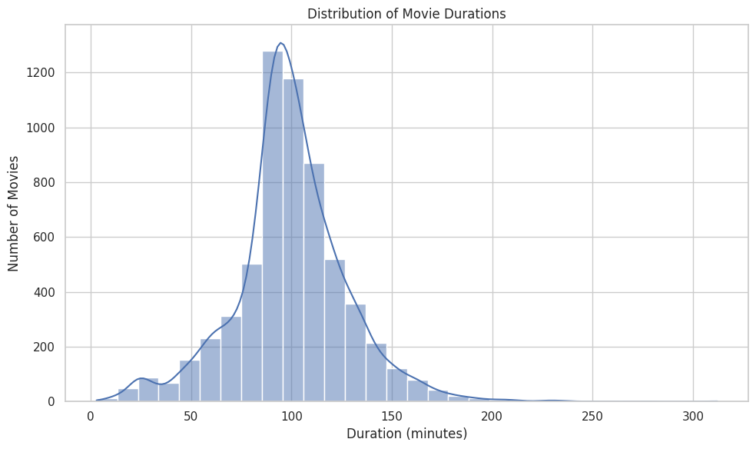
This visualization shows the distribution of movie durations in the Netflix dataset. It provides an overview of the typical length of movies available on the platform and helps identify common duration patterns.

7.Release Year vs Year Added Heatmap
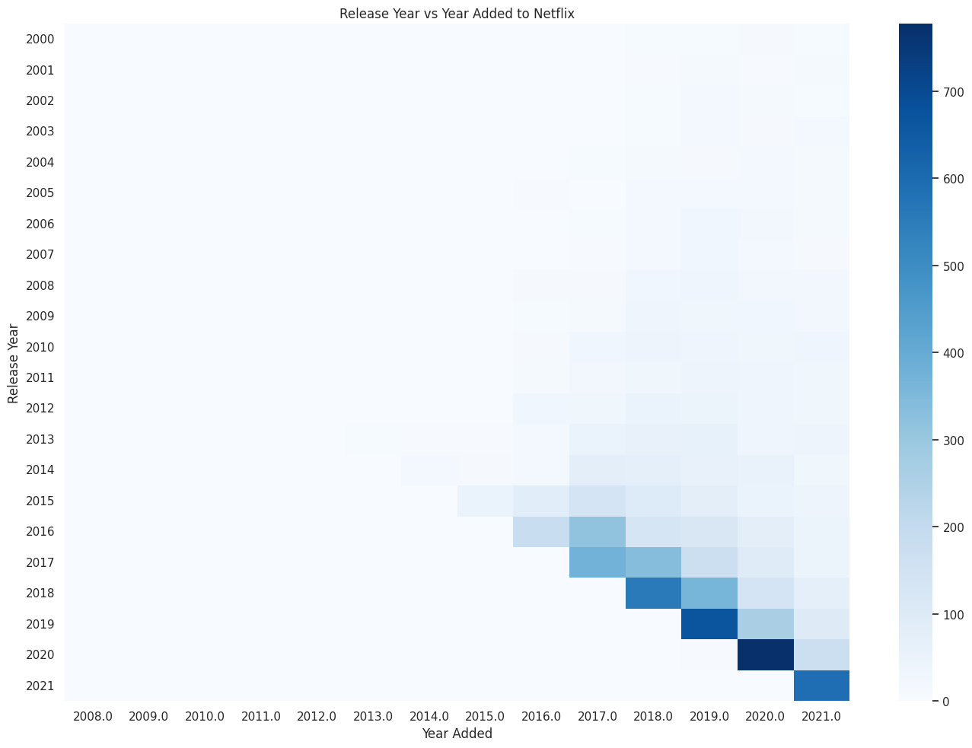
The heatmap compares the release year of content with the year it was added to Netflix. It helps identify patterns in the addition of older and newer content to the platform.

6.4 Key Insights and Business Implications
The analysis showed that Movies represented a larger portion of the catalog than TV Shows. The time-based analysis revealed changes in the number of titles added across years. Country and genre analysis demonstrated geographic and thematic diversity, while rating and duration visualizations provided additional insight into audience classification and content format.
These insights can support decisions related to content composition, content acquisition, geographic diversity, genre trends, audience classification, movie duration, and catalog lifecycle.
6.5 EDA Visualization Code
1. Distribution of Movies and TV Shows
# Distribution of Movies and TV Shows
plt.figure(figsize=(8, 5))
sns.countplot(data=data, x="type")
plt.title("Distribution of Movies and TV Shows on Netflix")
plt.xlabel("Content Type")
plt.ylabel("Number of Titles")
plt.tight_layout()
plt.show()

2. Netflix Content Added by Year
# Netflix content added by year
plt.figure(figsize=(12, 6))
plt.plot(
content_by_year.index,
content_by_year.values,
marker="o"
)
plt.title("Netflix Content Added by Year")
plt.xlabel("Year")
plt.ylabel("Number of Titles")
plt.xticks(rotation=45)
plt.tight_layout()
plt.show()

3. Top 10 Countries by Number of Titles
# Top 10 countries by number of Netflix titles
plt.figure(figsize=(10, 6))
sns.barplot(
x=country_counts.values,
y=country_counts.index
)
plt.title("Top 10 Countries by Number of Netflix Titles")
plt.xlabel("Number of Titles")
plt.ylabel("Country")
plt.tight_layout()
plt.show()

4. Top 10 Genres
# Top 10 genres on Netflix
plt.figure(figsize=(10, 6))
sns.barplot(
x=genre_counts.values,
y=genre_counts.index
)
plt.title("Top 10 Genres on Netflix")
plt.xlabel("Number of Titles")
plt.ylabel("Genre")
plt.tight_layout()
plt.show()

5. Content Distribution by Rating
# Netflix content by rating
plt.figure(figsize=(10, 6))
sns.barplot( x=rating_counts.values,
y=rating_counts.index
)
plt.title("Netflix Content by Rating")
plt.xlabel("Number of Titles")
plt.ylabel("Rating")
plt.tight_layout()
plt.show()

6.Distribution of Movie Durations
# Distribution of movie durations
plt.figure(figsize=(10, 6))
sns.histplot(
movies["duration_minutes"].dropna(),
bins=30,
kde=True
)
plt.title("Distribution of Movie Durations")
plt.xlabel("Duration (minutes)")
plt.ylabel("Number of Movies")
plt.tight_layout()
plt.show()

7.Release Year vs Year Added Heatmap
# Release year vs year added
plt.figure(figsize=(14, 10))
sns.heatmap(
heatmap_data,
cmap="Blues"
)

plt.title("Release Year vs Year Added to Netflix")
plt.xlabel("Year Added")
plt.ylabel("Release Year")

plt.tight_layout()
plt.show()

7. Week 3 – Statistical Hypothesis Testing

7.1 Research Question
Does the average sales amount differ between orders with a discount and orders without a discount?

7.2 Hypotheses
H₀ (Null): There is no difference in average sales amount between discounted and non-discounted orders.
H₁ (Alternative): There is a difference in average sales amount between discounted and non-discounted orders.

7.3 Data Preparation and Method
The analysis used the sales_amount and discount_pct columns from the retail sales dataset. Rows missing either value were excluded. Orders with discount_pct greater than zero were classified as discounted, while orders without a discount formed the comparison group.
Measure | Result
Discounted orders | 4,098
Non-discounted orders | 45
Statistical test | Welch's two-sample t-test
t-statistic | −1.154
Degrees of freedom | 44
p-value | 0.255
Mean difference (discounted − non-discounted) | −443,314.19
95% confidence interval | −1,217,272.46 to 330,644.07

7.4 Result and Interpretation
Because p = 0.255 is greater than the 0.05 significance level, the analysis did not find statistically significant evidence of a difference in average sales amounts between discounted and non-discounted orders.
This result does not prove that the averages are equal. Interpretation is limited by the very small non-discount group, high variability, and the observational nature of the data. The analysis cannot establish that discounts cause changes in sales.
7.5 Visualizations
Figure 7.1 — Sales Amount Distribution by Discount Status
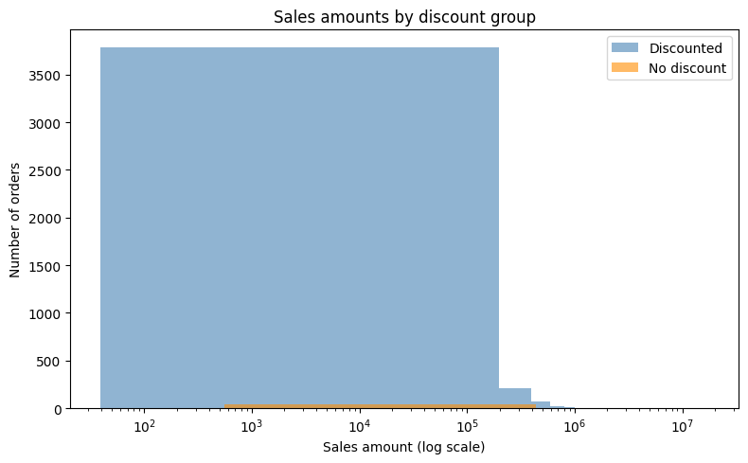
The histogram shows the distribution of sales amounts for discounted and non-discounted orders. The distribution is highly variable, which supports the use of a statistical test rather than relying only on visual comparison.
Figure 7.2 — Sales Amount by Discount Status
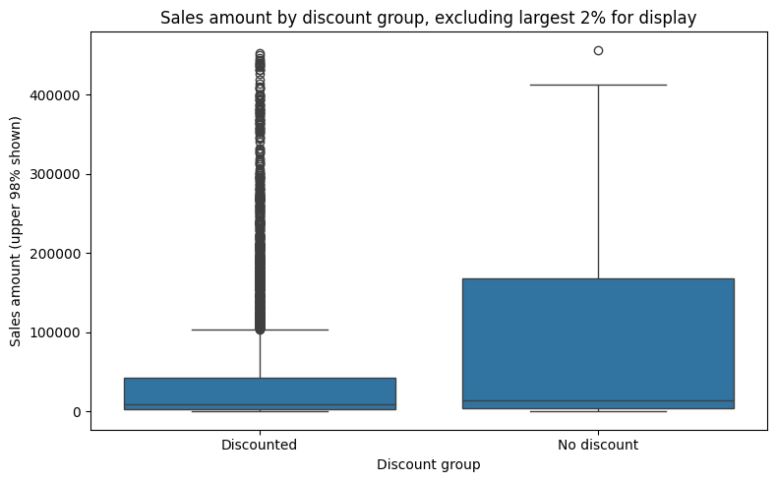
The boxplot compares sales amounts between discounted and non-discounted orders. The visualization highlights the variability and extreme values in the sales data. The largest 2% of values were omitted from the displayed boxplot only to improve readability; all usable observations were retained for the statistical test.
7.6 Statistical Interpretation
Welch’s two-sample t-test was selected because the two groups had substantially different sample sizes and variability. The resulting p-value of 0.255 is greater than the 0.05 significance level. Therefore, the null hypothesis was not rejected. The analysis did not provide statistically significant evidence that the average sales amount differed between discounted and non-discounted orders. However, the result should not be interpreted as proof that the two averages are equal, particularly because the non-discounted group contained only 45 observations.
7.7 Statistical Analysis Code
1. Data Preparation and Discount Grouping
import pandas as pd
df = pd.read_csv("retail_sales_dataset.csv")
print(df.shape)
print(df.columns.tolist())
print(df[["sales_amount", "discount_pct"]].head())
print(df[["sales_amount", "discount_pct"]].isna().sum())
# Keep rows that have both sales amount and discount information
analysis_df = df[["sales_amount", "discount_pct"]].dropna().copy()
# Treat a discount greater than 0 as "discounted"
analysis_df["discount_group"] = analysis_df["discount_pct"].apply(
lambda value: "Discounted" if value > 0 else "No discount"
)
print(analysis_df["discount_group"].value_counts())
print(
analysis_df.groupby("discount_group")["sales_amount"]
.agg(["count", "mean", "median", "std"])
)

2. Sales Amount Distribution
import matplotlib.pyplot as plt
# A few very large values can hide most orders, so use a log scale for readability
plt.figure(figsize=(8, 5))
for group in ["Discounted", "No discount"]:
values = analysis_df.loc[
analysis_df["discount_group"] == group, "sales_amount"
]
plt.hist(values, bins=40, alpha=0.6, label=group)
plt.xscale("log")
plt.xlabel("Sales amount (log scale)")
plt.ylabel("Number of orders")
plt.title("Sales Amounts by Discount Group")
plt.legend()
plt.tight_layout()
plt.show()

3. Welch's Two-Sample t-Test
from scipy import stats
import numpy as np
discounted = analysis_df.loc[
analysis_df["discount_group"] == "Discounted", "sales_amount"
]
no_discount = analysis_df.loc[
analysis_df["discount_group"] == "No discount", "sales_amount"
]
# Welch's two-sample t-test
result = stats.ttest_ind(
discounted,
no_discount,
equal_var=False
)
# Difference in means: discounted minus no discount
mean_difference = discounted.mean() - no_discount.mean()
# Welch confidence interval for the difference in means
n1, n2 = len(discounted), len(no_discount)
v1, v2 = discounted.var(ddof=1), no_discount.var(ddof=1)
se = np.sqrt(v1 / n1 + v2 / n2)
df_welch = (
(v1 / n1 + v2 / n2) ** 2
/ (
(v1 / n1) ** 2 / (n1 - 1)
+ (v2 / n2) ** 2 / (n2 - 1)
)
)
t_critical = stats.t.ppf(0.975, df_welch)
ci_low = mean_difference - t_critical * se
ci_high = mean_difference + t_critical * se

print(f"Mean difference (discounted - no discount): {mean_difference:,.2f}")
print(f"Welch t-statistic: {result.statistic:.3f}")
print(f"Degrees of freedom: {df_welch:.2f}")
print(f"p-value: {result.pvalue:.6g}")
print(
f"95% confidence interval: "
f"[{ci_low:,.2f}, {ci_high:,.2f}]"
)

4. Boxplot
import seaborn as sns
import matplotlib.pyplot as plt
# Keep the middle 98% of sales values just for this display
upper_limit = analysis_df["sales_amount"].quantile(0.98)
plot_df = analysis_df[
analysis_df["sales_amount"] <= upper_limit
]
plt.figure(figsize=(8, 5))
sns.boxplot(
data=plot_df,
x="discount_group",
y="sales_amount"
)
plt.xlabel("Discount Group")
plt.ylabel("Sales Amount (Upper 98% Shown)")
plt.title(
"Sales Amount by Discount Group, "
"Excluding Largest 2% for Display"
)
plt.tight_layout()
plt.show()

8. Week 4 – Machine Learning Model Development and Evaluation

8.1 Project Overview
Week 4 developed a binary classification model using the Breast Cancer Wisconsin Diagnostic Dataset. The objective was to understand a complete machine learning workflow and evaluate classification performance.

8.2 Methodology
- Used the Breast Cancer Wisconsin Diagnostic Dataset.
- Applied an 80:20 training/testing split.
- Used stratification to preserve class distribution.
- Standardized input features using StandardScaler.
- Trained a Logistic Regression classifier.
- Evaluated the model using accuracy, precision, recall, F1-score, and ROC-AUC.
- Generated a confusion matrix and ROC curve.

8.3 Model Results
Metric | Recorded Result
Model | Logistic Regression
Dataset | Breast Cancer Wisconsin Diagnostic Dataset
Train/Test Split | 80% / 20%
Training Accuracy | 98.90%
Testing Accuracy | 98.25%
Precision | 98.61%
Recall | 98.61%
F1-score | 98.61%
ROC-AUC | 99.54%

8.4 Confusion Matrix and ROC Curve
Figure 8.1 — Confusion Matrix of Logistic Regression Model
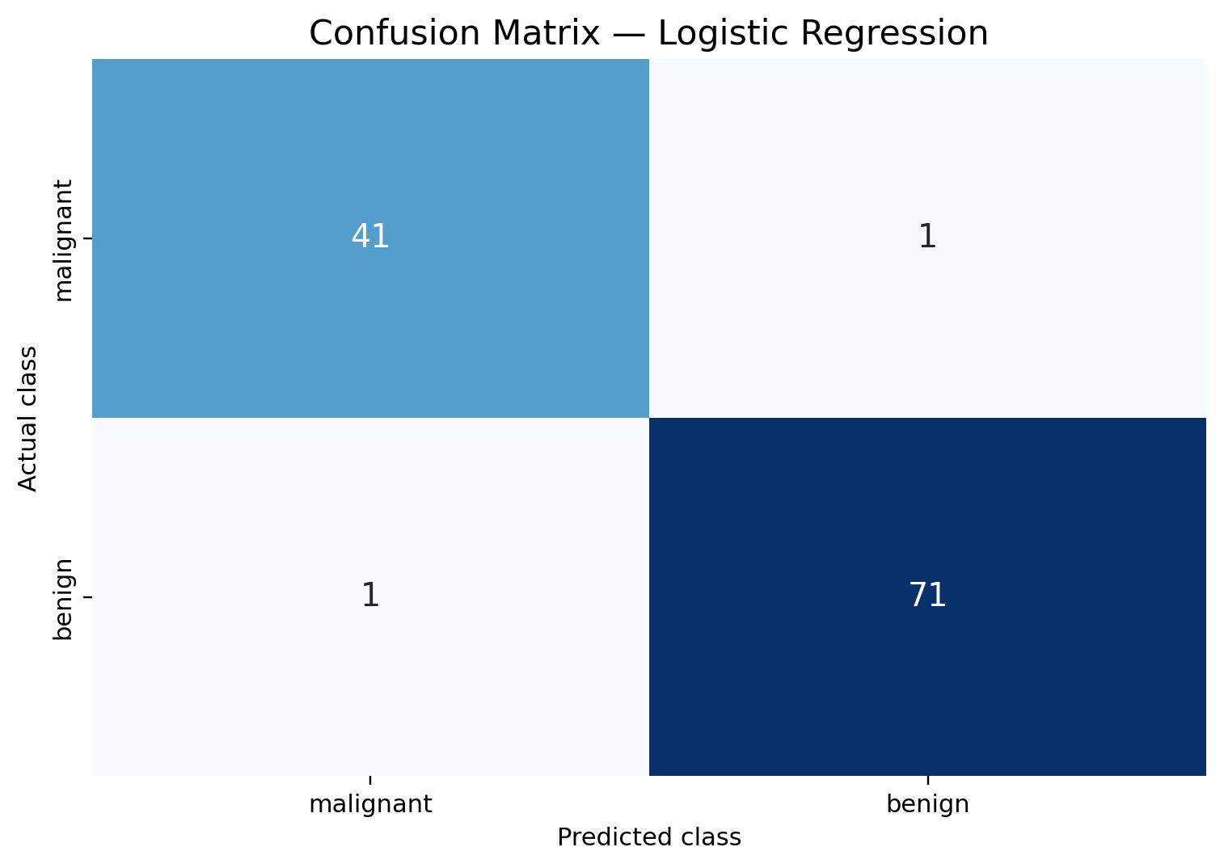
The confusion matrix shows the actual and predicted class labels produced by the Logistic Regression model. It helps identify correct classifications as well as incorrect predictions for the two classes. This provides a clear view of the model's classification performance and the types of errors made on the test data.
Figure 8.2 — ROC Curve of Logistic Regression Model
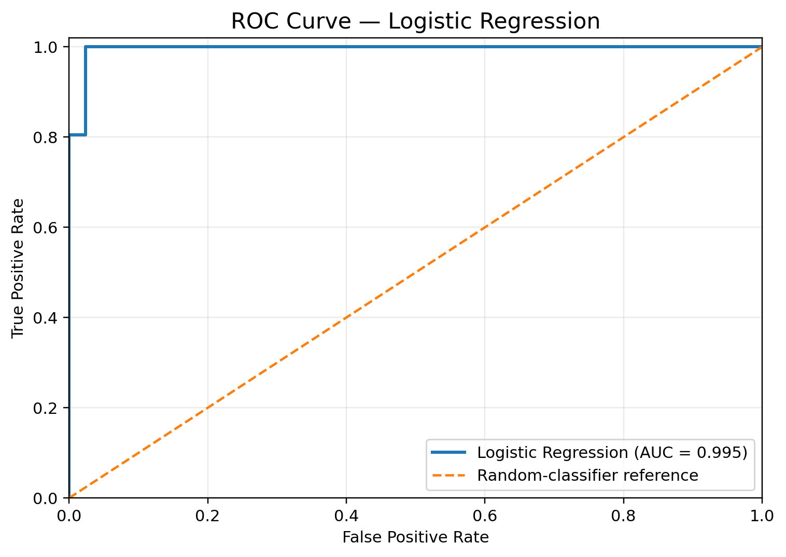
The ROC curve illustrates the model's ability to distinguish between the two classes across different classification thresholds. The curve plots the True Positive Rate against the False Positive Rate. The ROC-AUC value provides an overall measure of the model's classification ability, with a higher value indicating better discrimination.

8.5 Interpretation and Limitations
The model achieved strong performance on the selected test split, with 98.25% accuracy and a 99.54% ROC-AUC. However, these results do not establish clinical reliability or guarantee similar performance on independent datasets.
The model is intended for educational purposes only and must not be used for medical diagnosis or treatment decisions.
8.6 Machine Learning Code
# Week 4 - Machine Learning Model Development and Evaluation
import numpy as np
import matplotlib.pyplot as plt
import seaborn as sns
from sklearn.datasets import load_breast_cancer
from sklearn.model_selection import train_test_split
from sklearn.preprocessing import StandardScaler
from sklearn.pipeline import make_pipeline
from sklearn.linear_model import LogisticRegression
from sklearn.metrics import (
accuracy_score,
precision_score,
recall_score,
f1_score,
confusion_matrix,
classification_report,
roc_curve,
roc_auc_score
)
data = load_breast_cancer()
X = data.data
y = data.target
print("Dataset shape:", X.shape)
print("Feature names:", data.feature_names)
print("Target classes:", data.target_names)
print("Missing values:", np.isnan(X).sum())
X_train, X_test, y_train, y_test = train_test_split(
X,
y,
test_size=0.20,
random_state=42,
stratify=y
)
print("Training samples:", len(X_train))
print("Testing samples:", len(X_test))
model = make_pipeline(
StandardScaler(),
LogisticRegression(max_iter=5000)
)
model.fit(X_train, y_train)
y_pred = model.predict(X_test)
print("\nModel Evaluation")
print("----------------")
print("Accuracy:", accuracy_score(y_test, y_pred))
print("Precision:", precision_score(y_test, y_pred))
print("Recall:", recall_score(y_test, y_pred))
print("F1-score:", f1_score(y_test, y_pred))

print("\nClassification Report:")
print(
classification_report(
y_test,
y_pred,
target_names=data.target_names
)
)
cm = confusion_matrix(y_test, y_pred)
plt.figure(figsize=(7, 5))
sns.heatmap(
cm,
annot=True,
fmt="d",
xticklabels=data.target_names,
yticklabels=data.target_names
)
plt.title("Confusion Matrix - Logistic Regression")
plt.xlabel("Predicted Label")
plt.ylabel("Actual Label")
plt.tight_layout()
plt.savefig("confusion_matrix.png", dpi=300)
plt.show()
y_prob = model.predict_proba(X_test)[:, 1]
fpr, tpr, thresholds = roc_curve(y_test, y_prob)
roc_auc = roc_auc_score(y_test, y_prob)
plt.figure(figsize=(7, 5))
plt.plot(
fpr,
tpr,
label=f"Logistic Regression (AUC = {roc_auc:.3f})"
)
plt.plot([0, 1], [0, 1], linestyle="--", label="Random Classifier")
plt.title("ROC Curve - Logistic Regression")
plt.xlabel("False Positive Rate")
plt.ylabel("True Positive Rate")
plt.legend()
plt.tight_layout()
plt.savefig("roc_curve.png", dpi=300)
plt.show()

print("ROC-AUC:", roc_auc)
train_accuracy = model.score(X_train, y_train)
test_accuracy = model.score(X_test, y_test)
print("\nTraining Accuracy:", train_accuracy)
print("Testing Accuracy:", test_accuracy)

9. Integrated Findings
The four weekly projects collectively demonstrate complementary stages of the data science lifecycle:
- Week 1 – Data quality and exploratory understanding: What does the data contain, and is it reliable enough to analyze?
- Week 2 – Visualization and storytelling: What patterns can be communicated clearly to technical and non-technical audiences?
- Week 3 – Statistical evidence: Is an observed difference supported by statistical evidence?
- Week 4 – Predictive modeling: Can a machine learning model classify outcomes effectively?
- Week 5 – Strategic interpretation: How can analytical evidence inform responsible decisions?
The combined workflow can be summarized as:
Data Cleaning → Exploratory Analysis → Visualization → Statistical Analysis → Machine Learning → Interpretation → Strategic Recommendations.

10. Strategic Recommendations
- Improve Data Quality: Establish systematic data-cleaning and validation procedures before analysis because missing values, duplicates, and inconsistent fields can affect downstream results.
- Use Visualization for Decision-Making: Use dashboards and visual analytics to communicate trends and patterns to stakeholders without requiring advanced technical knowledge.
- Support Visual Findings with Statistical Evidence: Do not base important decisions only on apparent visual differences; apply appropriate statistical tests where relevant.
- Validate Machine Learning Models Thoroughly: Use cross-validation, independent datasets, hyperparameter tuning, and error analysis before considering a model for real-world deployment.
- Combine Multiple Analytical Methods: A robust workflow should combine data cleaning, EDA, visualization, statistics, and machine learning rather than relying on a single technique.
- Avoid Unsupported Causal Claims: Observational data does not automatically establish causation. Additional experimental, longitudinal, or controlled analysis may be needed.

11. Potential Business Impact and Research Outcomes
- Retail: analytical evidence can support evaluation of sales patterns and discount strategies.
- Entertainment: catalog analysis can support content composition, acquisition, geographic diversity, and genre decisions.
- Healthcare research: classification techniques can demonstrate how machine learning may assist research workflows, while requiring rigorous independent validation before any clinical use.
- General analytics: systematic data preparation and evidence-based analysis can improve the quality of organizational decision-making.

12. Limitations
- Different datasets and questions were used across the weekly projects, so findings should not be interpreted as one causal study.
- Some analyses were based on observational data and therefore cannot establish causality.
- Week 3 contained only 45 non-discounted orders, creating a substantial group-size imbalance.
- The Week 4 machine learning experiment used a single 80:20 train-test split.
- Dataset-specific findings may not generalize to other populations or datasets.
- High test performance does not guarantee real-world or independent-dataset performance.
- The Week 4 medical classification model is educational and not suitable for clinical diagnosis or treatment decisions.

13. Future Improvements
- Use larger and more representative datasets.
- Apply stratified cross-validation.
- Perform hyperparameter optimization.
- Compare multiple machine learning algorithms.
- Perform deeper error and feature-importance analysis.
- Develop interactive dashboards for stakeholder communication.
- Evaluate models on independent datasets.
- Apply probability calibration where appropriate.
- Automate the data-processing and model-evaluation pipeline.

14. Conclusion
The internship provided practical exposure to the complete data science lifecycle. The projects demonstrated how raw data can be cleaned and explored, transformed into meaningful visual stories, evaluated using statistical methods, and used to develop and assess machine learning models.
The Week 3 statistical analysis demonstrated the importance of distinguishing an observed difference from a statistically supported conclusion, while Week 4 demonstrated the importance of evaluating predictive models using multiple performance measures and appropriate validation. Overall, the internship strengthened practical Python and data science skills and emphasized responsible interpretation of analytical results.

15. GitHub Project
The complete internship project files and weekly assignments are available in the GitHub repository:
https://github.com/srivani-04/YuvaIntern-Virtual-Data-Science-with-Python

Appendix – Suggested Visual and Code Inserts
To complete the final submission, insert the actual figures and selected code excerpts from the original Week 1–4 assignments. Recommended figures include the Titanic survival and correlation charts, the seven Netflix visualizations, the retail-sales histogram and boxplot, and the Week 4 confusion matrix and ROC curve.
Recommended code excerpts should show representative data cleaning, visualization, statistical testing, and machine learning steps rather than reproducing every line of code from the weekly assignments.

