WEEK 1 DATA SCIENCE ASSIGNMENT
Data Acquisition, Cleaning, and Exploratory Data Analysis
of the Titanic Dataset
Submitted by: M. SRIVANI
Program: Virtual Data Science with Python Apprentice Intern

1. Introduction
This project demonstrates a complete data analysis workflow using the Titanic passenger dataset. The workflow includes data acquisition, inspection, cleaning, preprocessing, exploratory data analysis, visualization, and interpretation. Python libraries including Pandas, NumPy, Matplotlib, and Seaborn were used.

2. Objectives
- Acquire a publicly available dataset using Python.
- Inspect dataset dimensions, attributes, data types, missing values, and duplicates.
- Handle missing values and duplicate records using appropriate methods.
- Remove an attribute with excessive missing information.
- Perform descriptive statistical analysis.
- Create meaningful visualizations and identify patterns.
- Summarize findings and conclusions.

3. Dataset Description
The Titanic dataset contains passenger demographic, travel, fare, and survival information. It was loaded using Seaborn's built-in publicly available Titanic dataset.
Attribute | Type | Description
survived | Integer | 0 = did not survive, 1 = survived
pclass | Integer | Passenger class
sex | Categorical | Passenger gender
age | Numeric | Passenger age
sibsp | Integer | Siblings/spouses aboard
parch | Integer | Parents/children aboard
fare | Numeric | Passenger fare
embarked | Categorical | Port of embarkation
class | Categorical | Passenger class category
who | Categorical | Man, woman, or child
adult_male | Boolean | Adult male indicator
embark_town | Categorical | Embarkation town
alive | Categorical | Survival status as text
alone | Boolean | Travelled alone indicator

4. Tools and Technologies
- Python 3
- Google Colab
- Pandas
- NumPy
- Matplotlib
- Seaborn

5. Data Acquisition
The dataset was acquired using the Seaborn library, providing a reproducible way to load the publicly available Titanic dataset.
import pandas as pd
import numpy as np
import matplotlib.pyplot as plt
import seaborn as sns
df = sns.load_dataset("titanic")
print(df.head())
The original dataset contained 891 rows and 15 columns.

6. Initial Data Inspection
print("Dataset Shape:", df.shape)
print(df.columns)
df.info()
print(df.isnull().sum())
print("Duplicate Rows:", df.duplicated().sum())
print(df.describe())
Initial inspection identified missing values in age, embarked, deck, and embark_town, along with 107 duplicate rows.

7. Data Cleaning and Preprocessing
Cleaning Task | Method Used | Justification
Duplicate rows | drop_duplicates() | Prevents repeated records affecting analysis.
Missing age | Median imputation | Median is less affected by extreme values.
Missing embarked | Mode imputation | Appropriate for a categorical variable.
Missing embark_town | Mode imputation | Appropriate for a categorical variable.
Deck | Column removed | Approximately 74% of values were missing at the cleaning stage.
Final duplicate check | drop_duplicates() | Some rows became identical after deck was removed.

7.1 Cleaning Code
clean_df = df.copy()
clean_df = clean_df.drop_duplicates()
median_age = clean_df["age"].median()
clean_df["age"] = clean_df["age"].fillna(median_age)
clean_df["embarked"] = clean_df["embarked"].fillna(clean_df["embarked"].mode()[0])
clean_df["embark_town"] = clean_df["embark_town"].fillna(clean_df["embark_town"].mode()[0])
clean_df = clean_df.drop(columns=["deck"])
clean_df = clean_df.drop_duplicates()
After the first duplicate removal, 784 rows remained. Age had 106 missing values, while embarked and embark_town each had 2. Deck had 582 missing values, so it was removed instead of imputing a very large proportion of unknown values.

8. Final Data Validation
print("Final dataset shape:", clean_df.shape)
print("Missing values:", clean_df.isnull().sum().sum())
print("Duplicate rows:", clean_df.duplicated().sum())
Validation Item | Final Result
Rows | 780
Columns | 14
Missing values | 0
Duplicate rows | 0

9. Exploratory Data Analysis
EDA was performed using frequency analysis, cross-tabulation, descriptive statistics, five visualizations, and correlation analysis.

9.1 Passenger Survival Count
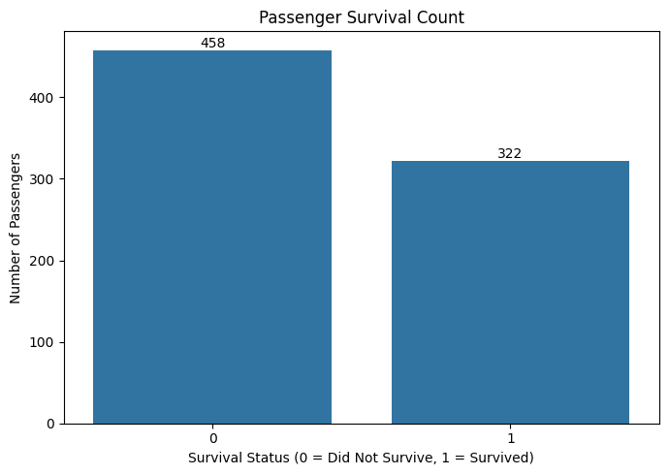
458 passengers (58.72%) did not survive and 322 (41.28%) survived.

9.2 Age Distribution
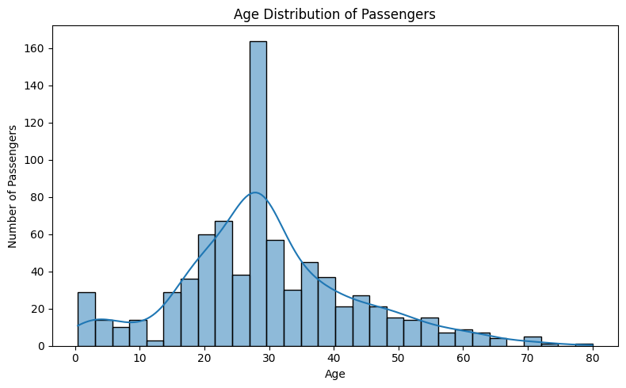
The average passenger age was 29.60 years, with ages ranging from 0.42 to 80 years and a median of 28.25 years.

9.3 Survival by Gender
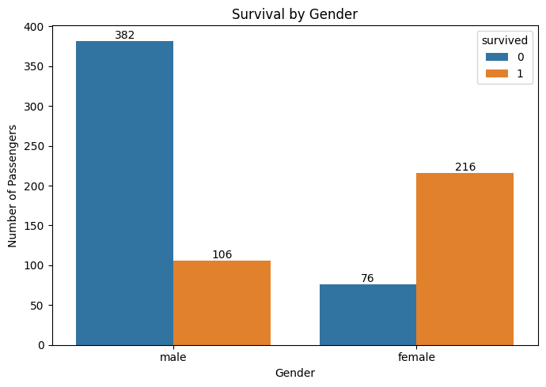
Female passengers had a survival rate of 73.97%, while male passengers had a survival rate of 21.72%.

9.4 Survival by Passenger Class
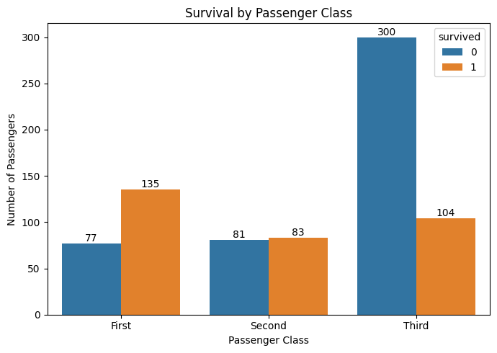
First-class passengers had a survival rate of 63.68%, second-class 50.61%, and third-class 25.74%.

9.5 Correlation Heatmap
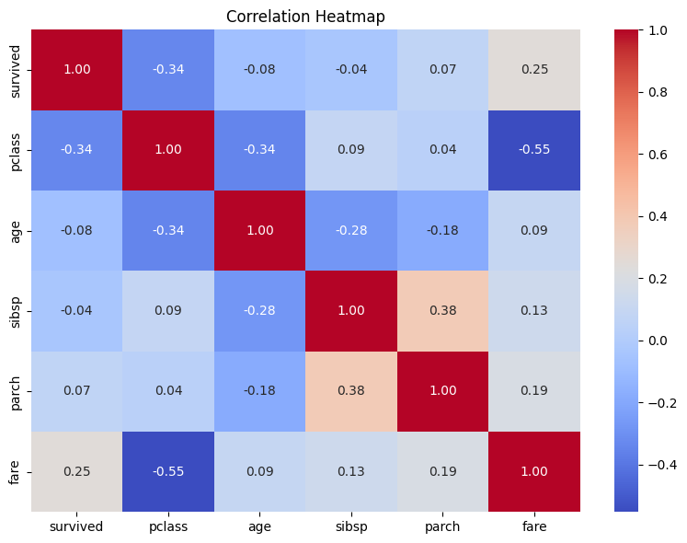
Passenger class had a correlation of -0.34 with survival, while fare had a correlation of 0.25. Correlation indicates association rather than causation.

10. Statistical Analysis and Key Findings

10.1 Survival Analysis
Among 780 passengers, 458 (58.72%) did not survive and 322 (41.28%) survived.

10.2 Gender-wise Analysis
Gender | Did Not Survive | Survived | Survival Rate
Female | 76 | 216 | 73.97%
Male | 382 | 106 | 21.72%

10.3 Class-wise Analysis
Class | Did Not Survive | Survived | Survival Rate
First | 77 | 135 | 63.68%
Second | 81 | 83 | 50.61%
Third | 300 | 104 | 25.74%

10.4 Age Statistics
Count: 780 | Mean: 29.60 | Standard deviation: 13.72 | Minimum: 0.42 | Median: 28.25 | Maximum: 80.00

10.5 Correlation Findings
Correlation with survival: pclass = -0.34, fare = 0.25, age = -0.08, sibsp = -0.04, and parch = 0.07. These values describe linear associations and do not establish causation.

11. Key Findings
- The final cleaned dataset contains 780 rows and 14 columns.
- All missing values and duplicate records were successfully handled.
- Overall survival was 41.28%.
- Female passengers had a higher observed survival percentage than male passengers.
- First-class passengers had a higher observed survival percentage than second- and third-class passengers.
- The average passenger age was 29.60 years.
- Passenger class showed a moderate negative correlation with survival, while fare showed a modest positive correlation.

12. Conclusion
This project successfully demonstrated the complete process of data acquisition, cleaning, preprocessing, and exploratory data analysis using the Titanic dataset. Missing values and duplicate records were systematically handled. Age was imputed using the median, categorical missing values were filled using the mode, and the deck column was removed because a large proportion of its values were missing. The final dataset contained 780 rows and 14 columns with no missing or duplicate values. Statistical analysis and visualizations revealed patterns related to passenger survival, gender, passenger class, age, and fare.

13. Future Scope
The analysis can be extended using machine learning classification algorithms such as Logistic Regression, Decision Tree, Random Forest, and Support Vector Machine. Feature engineering, cross-validation, model comparison, and evaluation using accuracy, precision, recall, F1-score, and ROC-AUC could also be performed.

14. Complete Python Code
# Data acquisition
df = sns.load_dataset("titanic")
# Cleaning
clean_df = df.copy()
clean_df = clean_df.drop_duplicates()
clean_df["age"] = clean_df["age"].fillna(clean_df["age"].median())
clean_df["embarked"] = clean_df["embarked"].fillna(clean_df["embarked"].mode()[0])
clean_df["embark_town"] = clean_df["embark_town"].fillna(clean_df["embark_town"].mode()[0])
clean_df = clean_df.drop(columns=["deck"])
clean_df = clean_df.drop_duplicates()
# Validation
print(clean_df.shape)
print(clean_df.isnull().sum().sum())
print(clean_df.duplicated().sum())
# Example EDA
print(clean_df["survived"].value_counts())
print((clean_df["survived"].value_counts(normalize=True)*100).round(2))
print(pd.crosstab(clean_df["sex"], clean_df["survived"]))
print(pd.crosstab(clean_df["class"], clean_df["survived"]))
print(clean_df["age"].describe().round(2))
print(clean_df.select_dtypes(include="number").corr().round(2))

