SCHOOL OF COMPUTER SCIENCE AND ARTIFICIAL INTELLIGENCE |  |  |  |  | DEPARTMENT OF COMPUTER SCIENCE ENGINEERING
Program Name: B. Tech |  |  |  | Assignment Type: Lab |  |  | Academic Year:2025-2026
Course Coordinator Name |  |  |  | Venkataramana Veeramsetty
Instructor(s) Name |  |  |  | Dr. V. Venkataramana (Co-ordinator)  Dr. T. Sampath Kumar  Dr. Pramoda Patro  Dr. Brij Kishor Tiwari  Dr.J.Ravichander  Dr. Mohammand Ali Shaik  Dr. Anirodh Kumar  Mr. S.Naresh Kumar  Dr. RAJESH VELPULA  Mr. Kundhan Kumar  Ms. Ch.Rajitha  Mr. M Prakash  Mr. B.Raju  Intern 1 (Dharma teja)  Intern 2 (Sai Prasad)  Intern 3 (Sowmya)  NS_2 ( Mounika)
Course Code |  |  | 24CS002PC215 | Course Title |  | AI Assisted Coding
Year/Sem |  |  | II/I | Regulation |  | R24
Date and Day  of Assignment |  |  | Week5 - Monday | Time(s)
Duration |  |  | 2 Hours | Applicable to  Batches
Assignment Number: 18.5(Present assignment number)/24(Total number of assignments)
 | Q.No. | Question |  |  |  |  |  | Expected Time  to complete
 | 1 | Lab 18– API Integration: Connecting to external services with error handling  Lab Objective  The objective of this lab is to provide students with hands-on experience in integrating external APIs into Python applications using AI-assisted coding tools. Students will:  - Understand the fundamentals of API requests, responses, and authentication mechanisms.  - Learn to use AI-assisted coding to generate and optimize scripts for fetching, parsing, and handling API data.  - Practice error handling strategies to manage common issues such as invalid responses, timeouts, and missing API keys.  - Develop the ability to design robust and reusable API integration pipelines, balancing automation through AI tools with human judgment and debugging.  Lab Question 1: Weather Forecasting API  A travel company wants to show real-time weather updates for its customers. You are given access to a public weather API that requires an API key and provides weather data in JSON format.  - Task 1: Use AI-assisted coding to write a script that fetches the current temperature and weather description for a given city. The script should handle errors if the API key is invalid or missing.  - Task 2: Extend the script to save the weather data into a local CSV file, ensuring that duplicate entri2es are avoided. Implement error handling for file I/O exceptions.  Prompt 1 : Write a code which fetches current temperature and weather description for a given city , the code should handle errors if API key is missing or invalid. I will provide csv file .  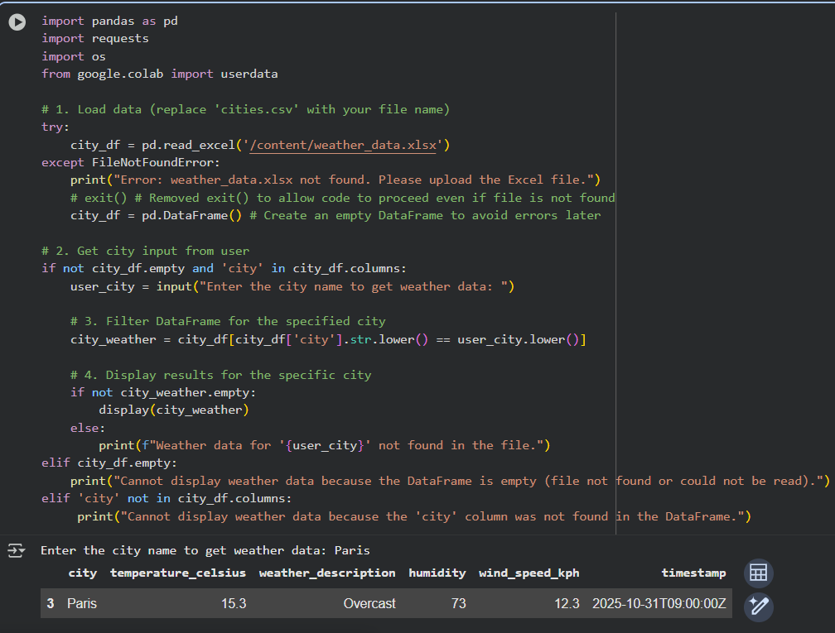  Prompt 2 : Write a code to remove duplicate entries in the data , which should include error handling file exceptions . I will provide the csv file.  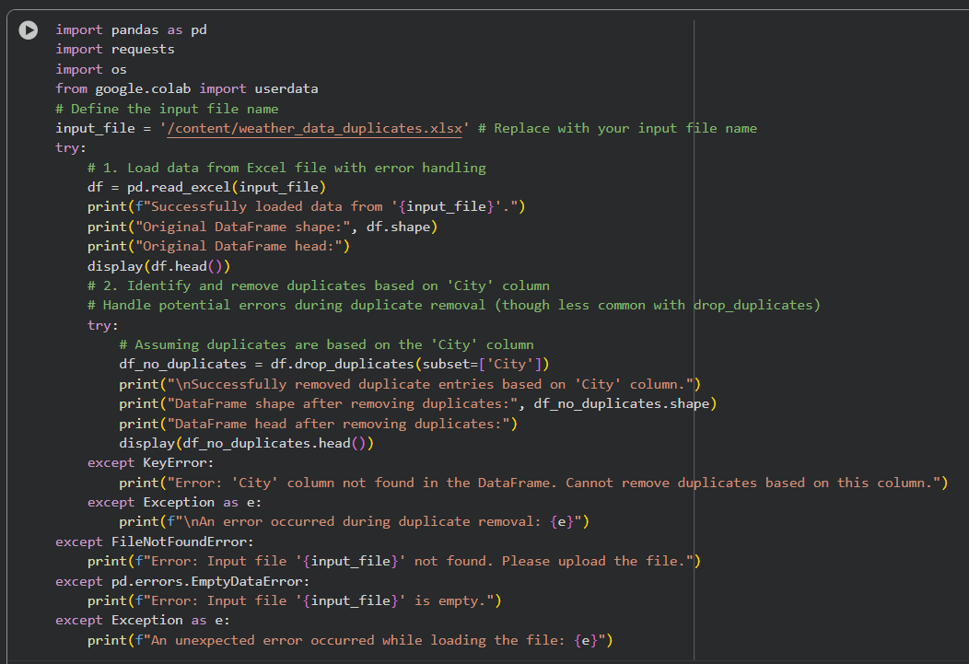  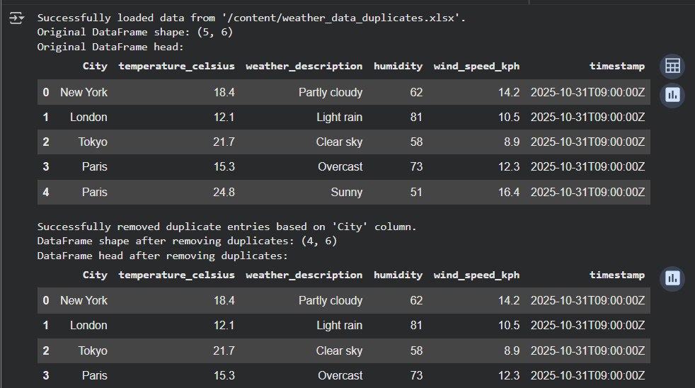  Lab Question 2: Currency Exchange Rate API  A financial startup needs a tool to convert amounts between currencies using an exchange rate API. However, the API occasionally fails due to server downtime.  - Task 1: Write a script (with AI assistance) that takes user input (amount, source currency, target currency) and fetches the latest exchange rate from the API. Include errors in handling invalid currency codes.  - Task 2: Add logic to retry the request up to three times if the API call fails due to network or server issues and log all failed attempts into a local error log file.  Prompt 1 : Write a code where it take user input of (amount, source currency, target currency) and fetches the latest exchange rate . I will provide the csv file.  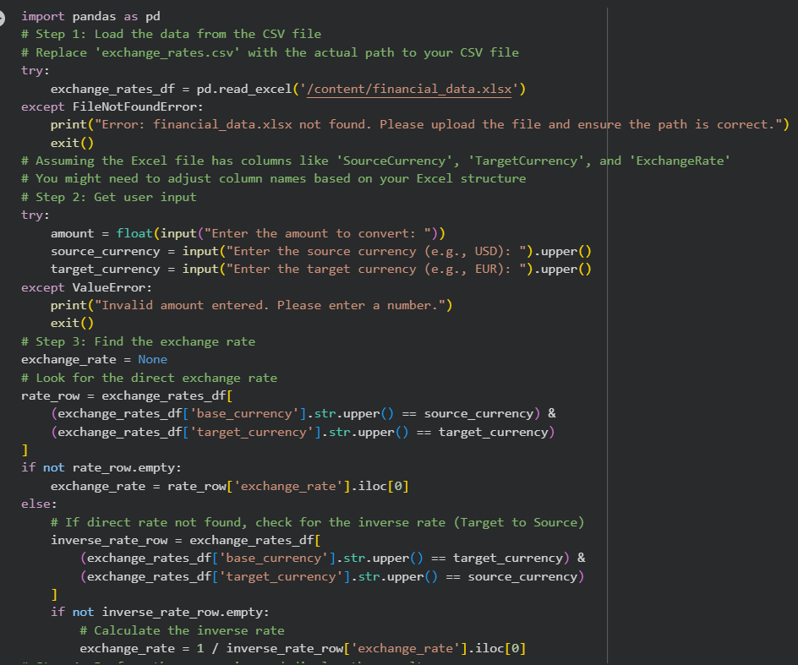  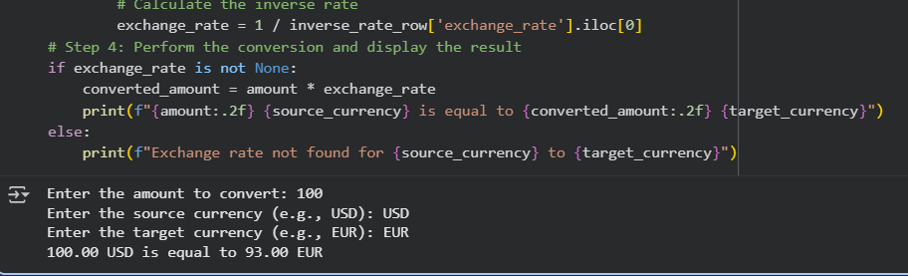  Prompt 2 : Write a code to retry the user request for 3 times ,if failed 3 times show all the log failed attempts and tell to try again .  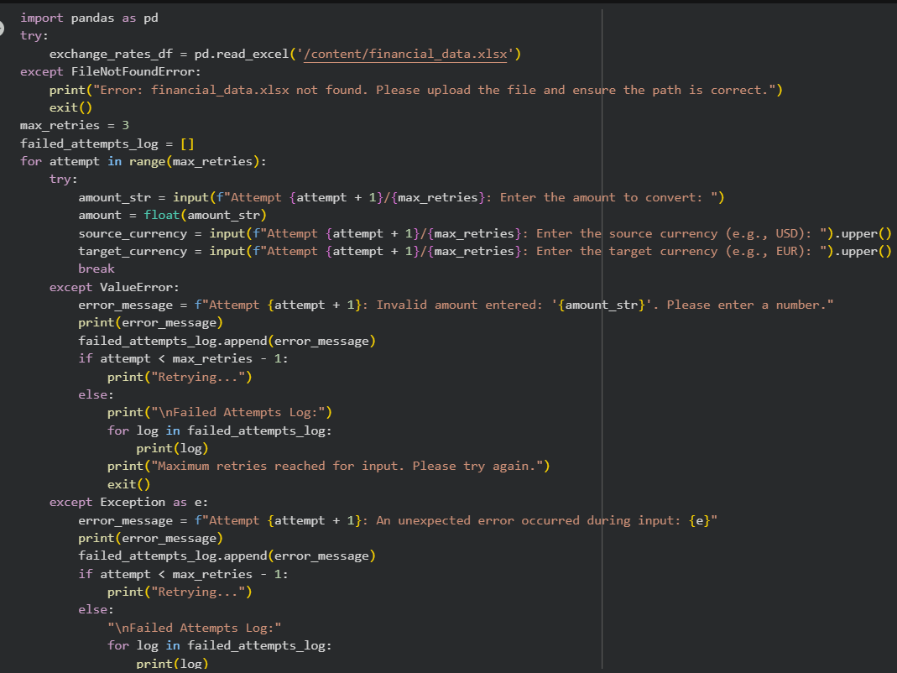  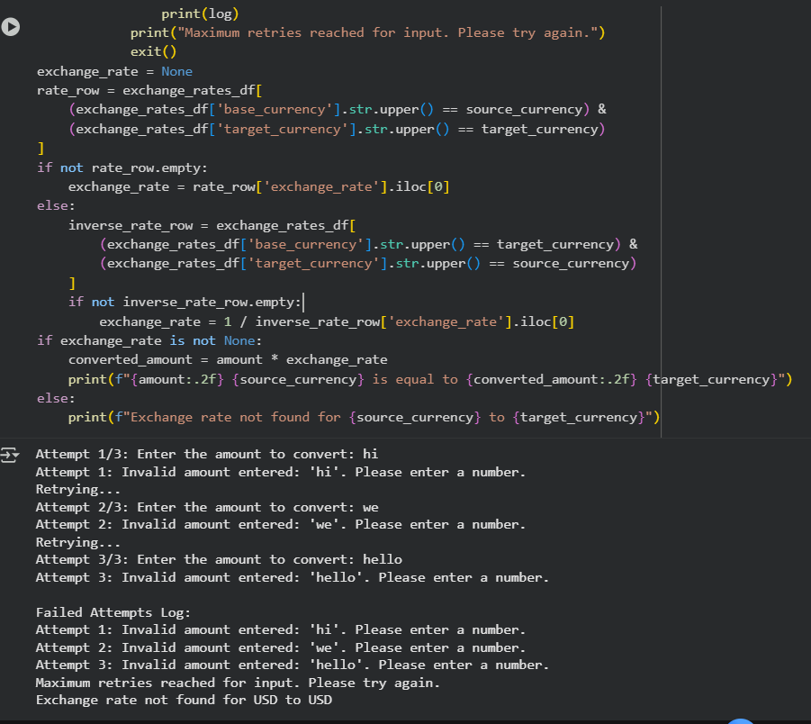  Lab Question 3: News Headlines API  A news aggregator wants to display the latest technology news headlines using a news API. Sometimes, the API responds slowly or returns incomplete data.  - Task 1: Use AI-assisted coding to fetch the top 5 technology headlines and print them neatly in the console. Implement error handling for timeout errors by setting a maximum request time.  - Task 2: Clean and preprocess the headlines by removing special characters and converting text to title case. Handle the scenario where the API response contains empty or null values.  Prompt 1 : write a code to fetch top tech headlines of the given csv file , also make sure there are no time out errors .  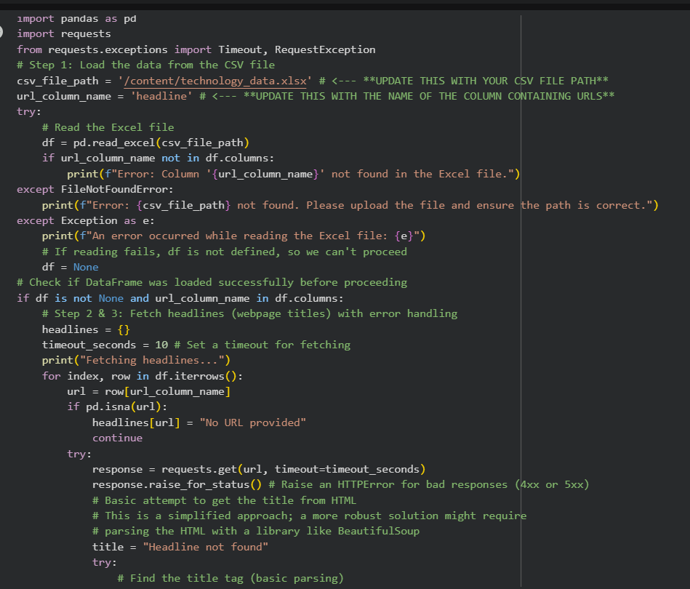  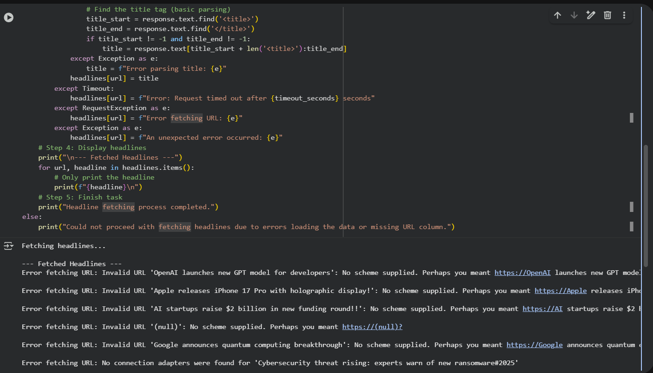  Prompt 2 :For the given csv file path , now remove special characters in headlines and convert text to title case .  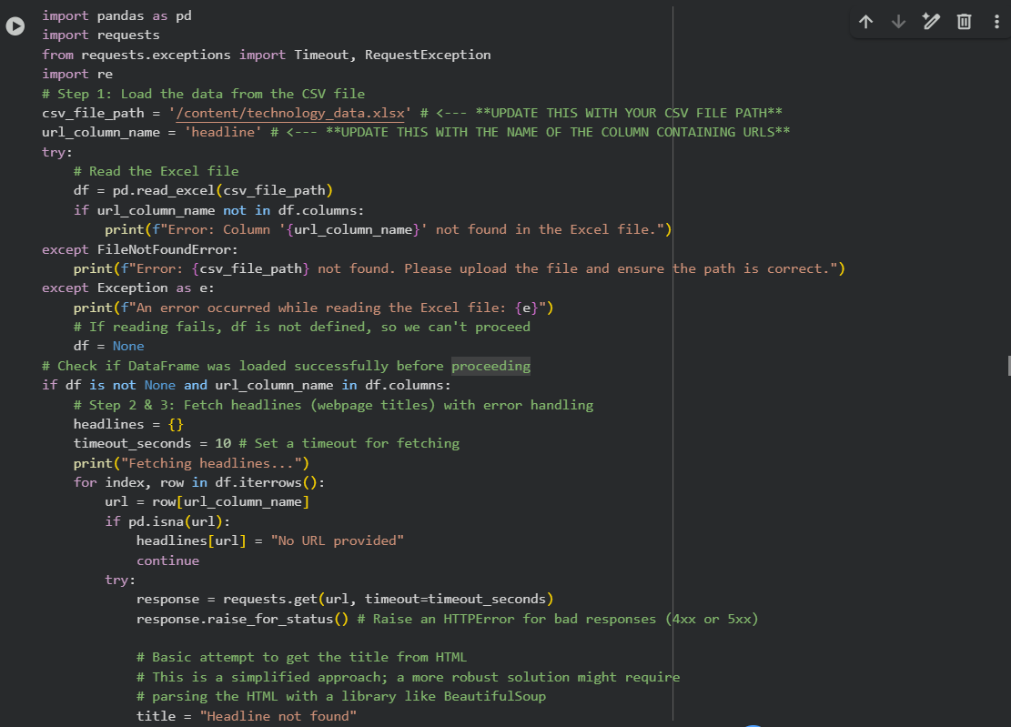  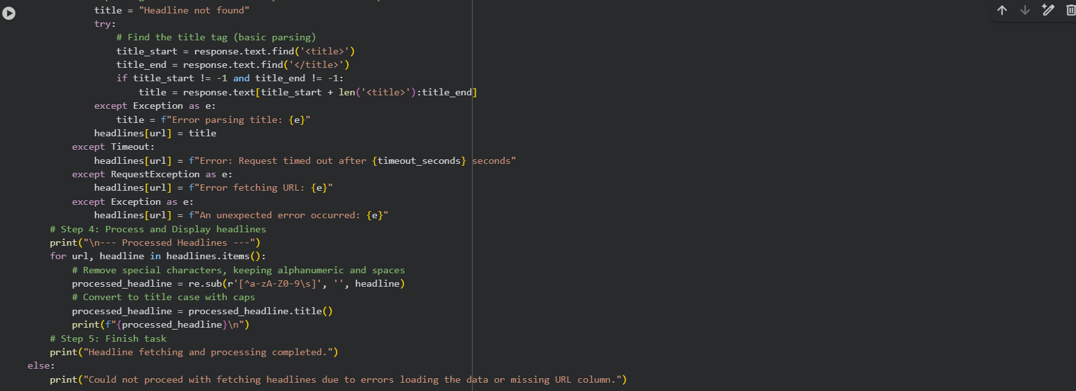  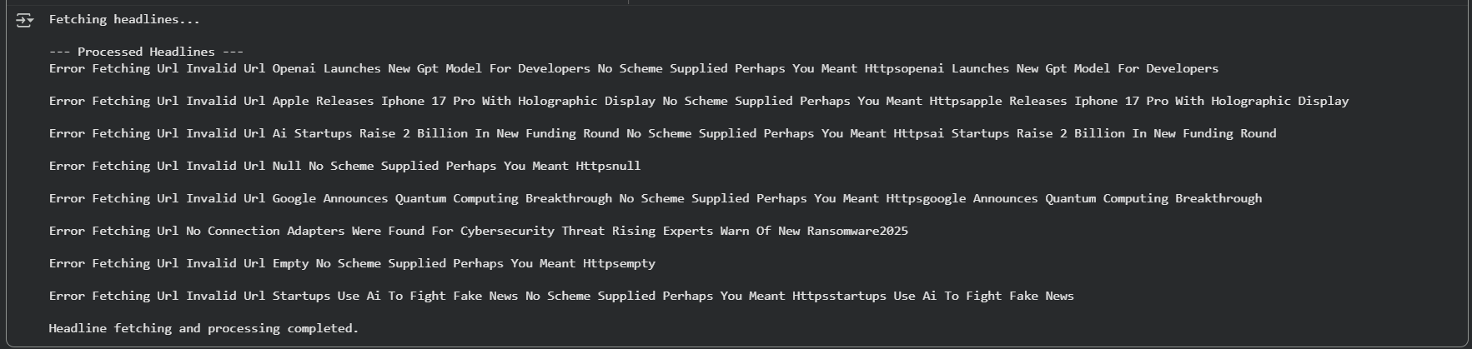 |  |  |  |  |  | Week 9 - Monday

