SIMATS ENGINEERING ASSESSMENT TOOL 2

COURSE NAME: DESIGN AND ANALYSIS OF ALGORITHMS COURSE CODE: CSA06

COURSE OUTCOME COVERED

CO 4: Solve optimization problems using dynamic programming and greedy strategies. (BL4, BL5)

Assessment Tool Weightage: 20%

QUESTIONS: 7 Total Marks: 35

Annexure A

Industry Problem Solving Task

Code of Conduct:

I (Name / Reg No) certify that this submission is my original work and that I have adhered to the guidelines specified for this assessment.
I understand that any violation of academic integrity rules will result in disciplinary action.

Signature of the student:

Annexure A

Industry Problem Solving Task

Q1. Knapsack – Industry Resource Allocation

A cloud service provider must allocate limited server memory (100 GB) among multiple client applications, each having different memory requirements and revenue values. Analyze the problem and explain how the 0/1 Knapsack algorithm can be applied to maximize total revenue. Design a feasible solution using dynamic programming and justify the selection of this approach. Discuss how overlapping subproblems and optimal substructure are utilized. Suggest suitable tools or platforms for implementation. Analyze the performance in terms of time and space complexity and interpret the results in an industry context.
Q2. TSP – Logistics Optimization

A delivery company must visit 15 cities exactly once and return to the depot while minimizing travel cost. Analyze how the Travelling Salesman Problem can be solved using Dynamic Programming (Held-Karp algorithm). Design a solution by explaining state representation and recurrence relation. Discuss the feasibility of this approach in real-world logistics. Suggest appropriate tools for implementation. Analyze scalability issues as the number of cities increases and evaluate performance limitations.
Q3. Floyd–Warshall – Network Routing

A telecom company needs to compute shortest paths between all pairs of routers in a network. Analyze how the Floyd–Warshall algorithm can be applied to optimize routing. Design a solution by explaining how intermediate nodes improve shortest path computation. Suggest suitable tools or technologies for implementation. Analyze the time and space complexity of the algorithm. Interpret the results in terms of network efficiency and real-world applicability.
Q4. OBST – Database Optimization

A database system stores records with known access probabilities and aims to minimize search time. Analyze how the Optimal Binary Search Tree (OBST) can be used to improve query performance. Design the solution by explaining the cost function and recurrence

relation. Discuss how probabilities influence tree construction. Suggest tools for implementing this solution. Analyze the efficiency and interpret the results in terms of database optimization.
Q5. Dijkstra – Navigation System

A navigation system computes shortest paths between locations in real-time. Analyze how Dijkstra’s algorithm can be applied to solve this problem efficiently. Design a solution by explaining step-by-step execution and the use of priority queues. Suggest appropriate data structures and tools for implementation. Analyze time complexity using different approaches. Interpret the performance in real-world navigation systems.
Q6. Huffman Coding – Data Compression

A video streaming platform compresses data based on symbol frequencies to optimize storage and transmission. Analyze how Huffman coding can be used to generate optimal prefix codes. Design the solution by explaining tree construction and encoding process. Suggest tools for implementing compression. Analyze compression efficiency and time complexity. Interpret the results in terms of bandwidth and storage optimization.
Q7. Minimum Spanning Tree – Network Design

An ISP wants to connect multiple cities with minimum cable cost. Analyze how Prim’s or Kruskal’s algorithm can be applied to construct a Minimum Spanning Tree. Design a feasible solution by comparing both algorithms. Suggest appropriate tools and data structures for implementation. Analyze the time complexity of each approach. Interpret the results in terms of cost optimization and practical network design.

Q1. Knapsack – Industry Resource Allocation
1. Understanding the Industry Problem
A cloud provider has a fixed pool of server memory (100 GB) and a set of client applications, each requesting a specific amount of memory and generating a specific revenue if hosted. Because each application is either fully allocated the memory it needs or not deployed at all (partial allocation is not meaningful for a running service), this is a classic 0/1 selection problem: choose a subset of applications whose total memory demand does not exceed 100 GB while maximising total revenue.
2. Modelling as 0/1 Knapsack
Each application i is treated as an item with weight w[i] (memory required) and value v[i] (revenue generated). The knapsack capacity W = 100 GB represents total available memory. The goal is to choose a 0/1 selection vector x[i] ∈ {0,1} that maximises Σ v[i]·x[i] subject to Σ w[i]·x[i] ≤ W.
3. Dynamic Programming Design
Let dp[i][c] denote the maximum revenue achievable using the first i applications with c GB of memory available. The recurrence is:
dp[i][c] = dp[i-1][c] if w[i] > c
dp[i][c] = max( dp[i-1][c], dp[i-1][c-w[i]] + v[i] ) otherwise
dp[0][c] = 0 for all c, and the answer is dp[n][W]. Backtracking through the table (comparing dp[i][c] to dp[i-1][c]) recovers which applications were actually deployed.
4. Why Dynamic Programming (Optimal Substructure & Overlapping Subproblems)
- Optimal substructure: the best allocation for capacity c using i applications is built from the best allocation for a smaller capacity/item set — an optimal solution to the whole problem contains optimal solutions to its subproblems.
- Overlapping subproblems: a brute-force recursive solution recomputes dp[i-1][c] repeatedly for many different branches; DP stores each (i,c) result exactly once in a table, which a naive greedy-by-ratio or exhaustive search cannot exploit as cleanly (greedy on value/weight ratio is provably sub-optimal for the 0/1 variant since items can't be split).
This makes DP the correct choice over a plain greedy heuristic, which only guarantees optimality for the fractional knapsack, not the 0/1 case relevant here.
5. Suggested Tools / Platforms
- Python (NumPy) or Java for the core DP implementation; C++ for latency-critical allocators.
- Kubernetes resource quotas / VPA (Vertical Pod Autoscaler) as the deployment layer that enforces the chosen allocation.
- Prometheus + Grafana to monitor actual memory utilisation and feed real usage data back into future allocation decisions.
6. Complexity Analysis
Aspect | Complexity / Value
Time Complexity | O(n × W) — pseudo-polynomial in capacity W and number of applications n
Space Complexity | O(n × W); reducible to O(W) using a rolling 1-D array
Practical scale | For W = 100 GB expressed in whole GB units and n in the hundreds, this is fast enough for periodic (e.g., hourly) re-allocation
7. Interpretation in Industry Context
The DP solution guarantees the mathematically optimal revenue for a given snapshot of demand, which is valuable for billing-sensitive cloud environments. In practice, capacity is discretised into GB units to keep W small, and the table is recomputed on a rolling window as applications arrive/leave, giving cloud operators a provably optimal, auditable allocation policy rather than a heuristic approximation.
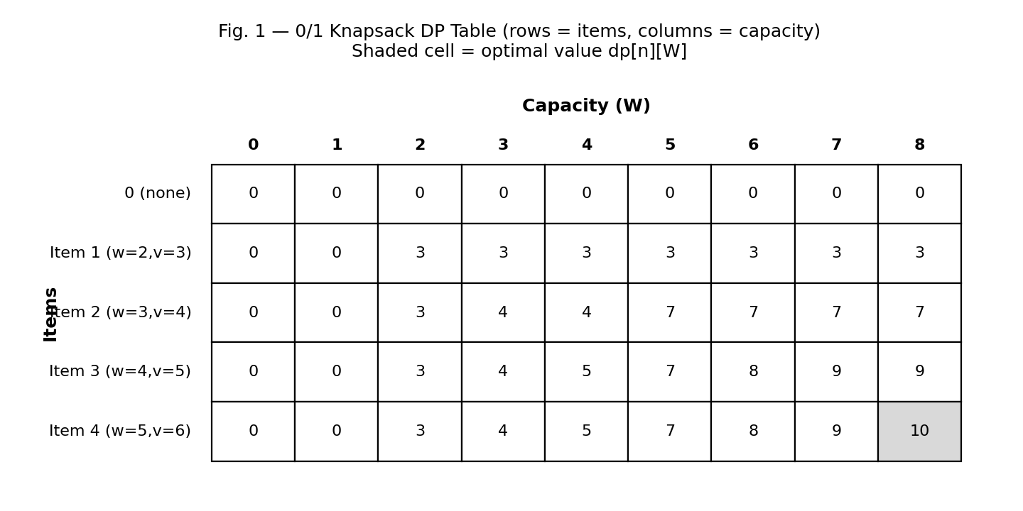
Fig. 1 — 0/1 Knapsack DP table: rows are items, columns are capacity; the shaded cell is the optimal revenue.

Q2. TSP – Logistics Optimization
1. Understanding the Industry Problem
A delivery company must visit all 15 client cities exactly once and return to the depot, minimising total travel cost — the classic Travelling Salesman Problem (TSP). Since the number of cities (15) is small enough for an exact exponential-but-tractable method, Dynamic Programming (Held-Karp) is preferred over pure brute force.
2. State Representation and Recurrence (Held-Karp)
Let the depot be city 1. For every subset S ⊆ {2,...,n} of visited cities and every city j ∈ S, define dp[S][j] as the minimum cost of a path that starts at the depot, visits exactly the cities in S, and ends at city j.
dp[{j}][j] = cost(1, j) (base case)
dp[S][j] = min over k in S\{j} of ( dp[S\{j}][k] + cost(k, j) )
Answer = min over j of ( dp[Full][j] + cost(j, 1) )
3. Solution Design
Subsets S are encoded as bitmasks (since n = 15 fits in a 16-bit integer), so dp is stored as a 2-D table of size 2^(n-1) × n. The algorithm iterates over subsets in increasing order of size, ensuring dp[S\{j}][k] is already computed when dp[S][j] is evaluated — this is what makes the DP well-defined (optimal substructure) and efficient (overlapping subsets are computed once, not recomputed per path).
4. Feasibility in Real-World Logistics
Held-Karp is exact and practical up to roughly 20 cities; beyond that its exponential state space (2^n) becomes prohibitive, so real logistics systems typically fall back to heuristics (nearest-neighbour, 2-opt, Christofides, or metaheuristics such as simulated annealing / genetic algorithms) once the number of stops grows into the hundreds.
5. Suggested Tools
- Google OR-Tools (Routing Library) — industry-standard VRP/TSP solver with Held-Karp-style exact solvers for small instances and metaheuristics for large ones.
- Python + NetworkX for prototyping and visualisation.
- Gurobi / CPLEX for exact ILP formulations when exact optimality is required commercially.
6. Scalability and Performance Limitations
Aspect | Complexity / Value
Time Complexity | O(n² × 2ⁿ)
Space Complexity | O(n × 2ⁿ)
At n = 15 | ≈ 15² × 2¹⁵ ≈ 7.4 million operations — fast (milliseconds to a few seconds)
At n = 30+ | 2ⁿ explodes; Held-Karp becomes infeasible and heuristic/approximate methods must be substituted
For 15 cities Held-Karp is an excellent fit, giving an exact optimum with reasonable resource usage; the exponential growth is the key limitation to flag if the client base scales up.
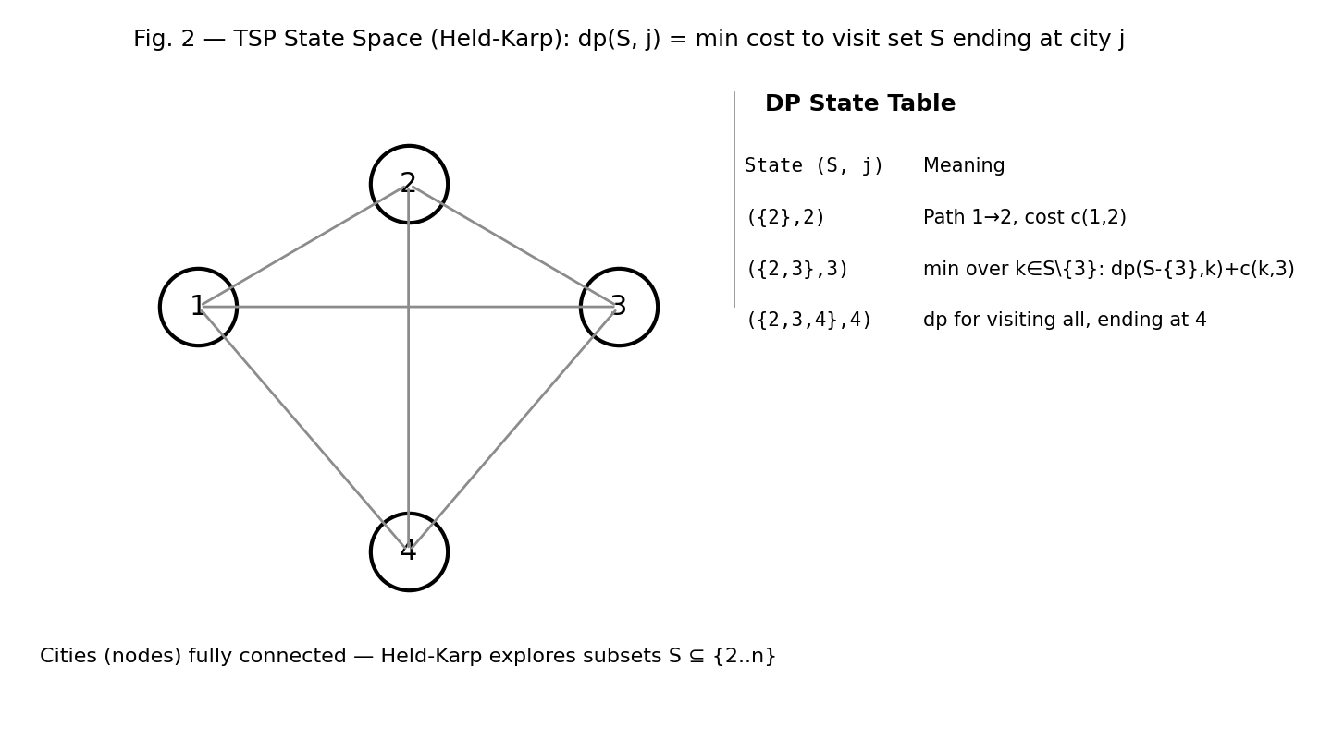
Fig. 2 — TSP state space for the Held-Karp DP: dp(S, j) = min cost to visit set S ending at city j.
Q3. Floyd–Warshall – Network Routing
1. Understanding the Industry Problem
A telecom company must know the shortest path between every pair of routers in its network so it can route traffic optimally regardless of source/destination. Because paths between *all* pairs are needed simultaneously (not just from a single source), an all-pairs shortest path algorithm is required.
2. Applying Floyd–Warshall
Represent the network as a weighted directed graph where nodes are routers and edge weights are link costs (latency, hop cost, or bandwidth-inverse). Floyd–Warshall incrementally improves a distance matrix by testing, for every pair (i, j), whether routing through an intermediate router k gives a shorter path.
for k in 1..n:
for i in 1..n:
for j in 1..n:
dist[i][j] = min( dist[i][j], dist[i][k] + dist[k][j] )
3. Role of Intermediate Nodes
The outer loop over k progressively allows every router to act as a potential relay. After the k-th iteration, dist[i][j] is guaranteed optimal considering only intermediate routers from {1,...,k}; after all n iterations every router has been considered as a possible relay, so the matrix holds true shortest paths for all pairs — this is the algorithm's optimal substructure guarantee.
4. Suggested Tools / Technologies
- NetworkX / SciPy sparse graph routines for prototyping and validation.
- OSPF / BGP routing daemons (e.g., FRRouting, Quagga) which use related shortest-path computations in production networks.
- C++/Rust for the core matrix computation where routers number in the thousands and cache-efficient loops matter.
5. Complexity Analysis
Aspect | Complexity / Value
Time Complexity | O(n³) for n routers
Space Complexity | O(n²) for the distance matrix
Update cost on topology change | Full O(n³) recomputation, or incremental variants for large dynamic networks
6. Interpretation — Network Efficiency and Applicability
Floyd–Warshall is ideal for moderately sized, relatively static networks (hundreds of routers) where all-pairs information is precomputed and cached for fast lookups. For very large or rapidly changing topologies, the O(n³) cost becomes a bottleneck, and telecom operators typically combine it with hierarchical routing or run it only within smaller routing domains (areas/autonomous systems) to keep n manageable.
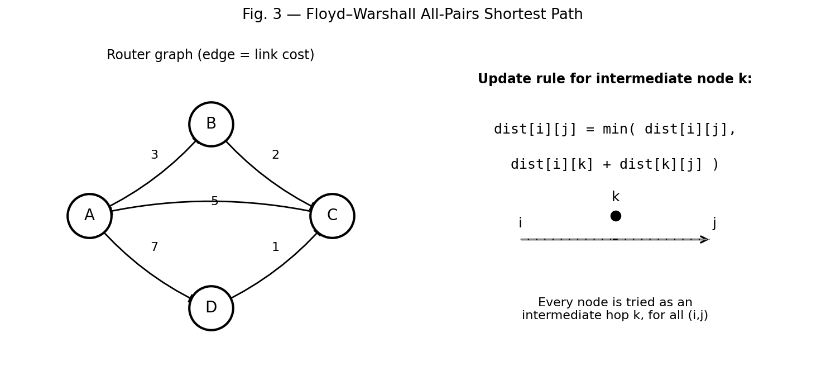
Fig. 3 — Floyd–Warshall all-pairs shortest path: every node k is tried as an intermediate hop between i and j.
Q4. OBST – Database Optimization
1. Understanding the Industry Problem
A database stores keys (records) that are looked up with different, known access frequencies. A standard balanced BST ignores these frequencies and can place frequently-accessed keys deep in the tree, wasting comparisons on every hot query. The Optimal Binary Search Tree (OBST) problem asks for the BST arrangement that minimises the expected number of comparisons, given each key's access probability.
2. Cost Function
For keys k1 < k2 < ... < kn with probabilities p1...pn, the expected search cost of a tree is Σ pi × (depth(ki) + 1). OBST minimises this sum over all possible binary search tree shapes.
3. Recurrence Relation (DP Design)
Let cost[i][j] be the minimum search cost of a tree built from keys ki..kj, and w(i,j) = Σ (from i to j) pℓ. Trying every key kr as the root of the subrange gives:
cost[i][j] = min over r in [i,j] of ( cost[i][r-1] + cost[r+1][j] ) + w(i,j)
cost[i][i-1] = 0 (empty subtree base case)
The +w(i,j) term accounts for the fact that every key in the subrange drops one level deeper when it becomes part of a subtree rooted below the current level — this is what actually captures the weighted depth cost.
4. How Probabilities Influence Tree Construction
Keys with higher access probability are pulled toward the root wherever the recurrence finds it cheaper overall, directly reducing the expected number of comparisons for the most common queries — this is the key difference from an unweighted balanced BST.
5. Suggested Tools
- Custom DP implementation in C++/Java embedded in the query planner/index-builder layer.
- B-Tree/B+Tree index engines (as used in MySQL InnoDB, PostgreSQL) can be tuned using OBST-style cost estimation for read-heavy, skewed workloads.
6. Complexity and Interpretation
Aspect | Complexity / Value
Time Complexity | O(n³) naive DP, improvable to O(n²) using Knuth's optimal split-point monotonicity
Space Complexity | O(n²) for the cost and root tables
Interpretation | Reduces average query comparisons in skewed-access workloads, improving effective query latency without changing the underlying storage engine
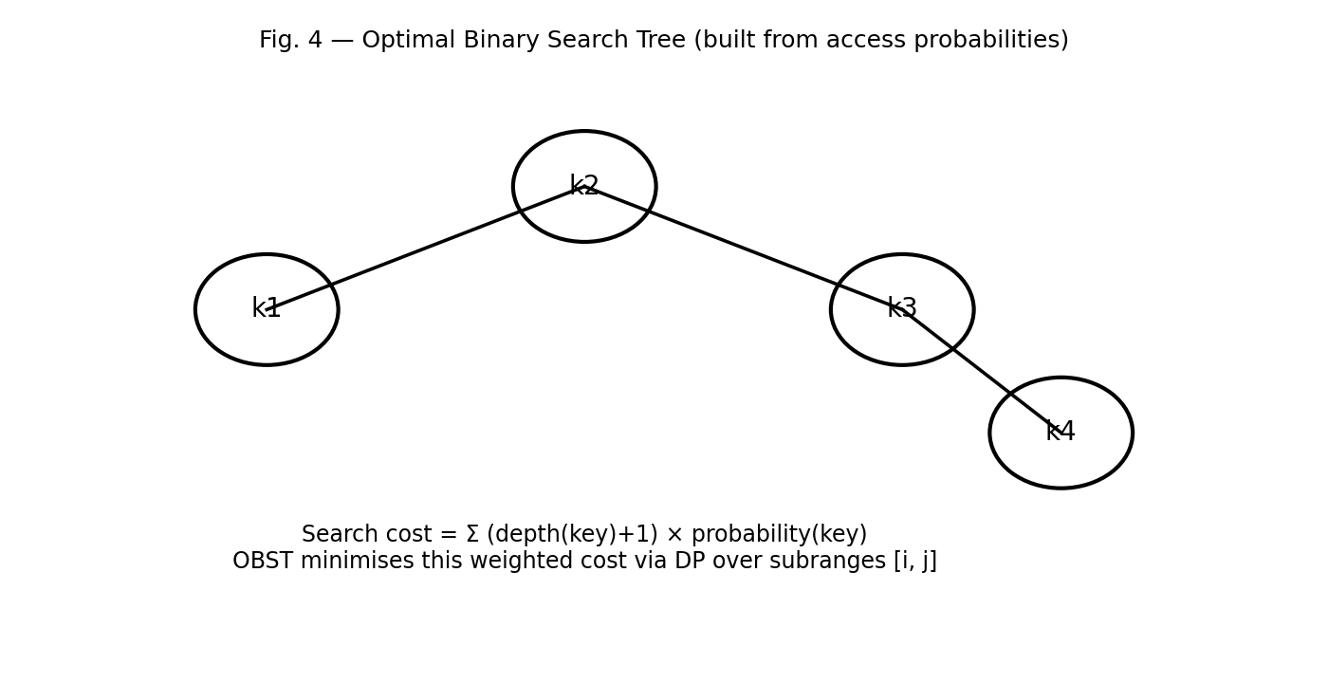
Fig. 4 — Optimal Binary Search Tree built from key access probabilities.
Q5. Dijkstra – Navigation System
1. Understanding the Industry Problem
A navigation system must compute the shortest route between two points on a road network in real time, where the graph is weighted (distance or travel-time) and all weights are non-negative — the conditions under which Dijkstra's algorithm is both correct and efficient.
2. Applying Dijkstra's Algorithm
Dijkstra maintains a tentative shortest-distance value for every node, greedily and repeatedly extracting the unvisited node with the smallest tentative distance (via a min-priority queue), and relaxing its outgoing edges.
dist[source] = 0; all others = ∞
while priority queue not empty:
u = extract-min(queue)
for each edge (u, v, w):
if dist[u] + w < dist[v]:
dist[v] = dist[u] + w
decrease-key(queue, v)
3. Step-by-Step Execution and Priority Queues
Each extraction of the minimum-distance node is guaranteed final (never revisited) because all weights are non-negative — this greedy choice is what gives Dijkstra its optimality, without needing dynamic-programming-style table storage over subsets. The priority queue (typically a binary or Fibonacci heap) is what makes repeated 'find current minimum' operations efficient.
4. Suggested Data Structures and Tools
- Binary heap (O(log n) per operation) for general use; Fibonacci heap for theoretically optimal asymptotics on dense graphs.
- Graph engines: Neo4j (graph database with built-in shortest-path), GraphHopper / OSRM (open-source routing engines built on road-network data).
- A* (Dijkstra + heuristic) is commonly layered on top for faster real-time navigation using geographic distance as a heuristic.
5. Time Complexity Under Different Implementations
Aspect | Complexity / Value
Array-based (no heap) | O(V²) — fine for dense/small graphs
Binary heap + adjacency list | O((V + E) log V) — the standard practical choice
Fibonacci heap + adjacency list | O(E + V log V) — best asymptotic bound, higher constant factors
6. Interpretation for Real-World Navigation
Binary-heap Dijkstra (or A* for point-to-point queries) offers the best practical trade-off for city-scale road networks, computing routes in milliseconds. For continent-scale maps, production systems add speed-up techniques (contraction hierarchies, ALT) on top of the same core algorithm to keep response times real-time.
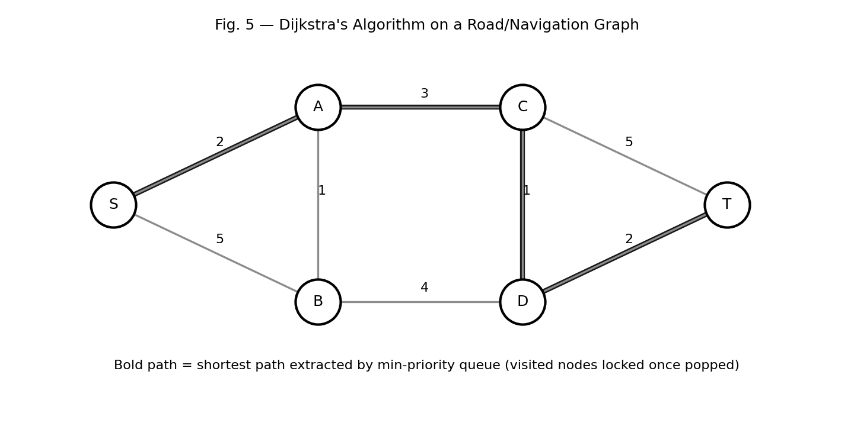
Fig. 5 — Dijkstra's algorithm: bold path is the shortest route extracted via the min-priority queue.
Q6. Huffman Coding – Data Compression
1. Understanding the Industry Problem
A video streaming platform must compress data efficiently before storage/transmission. Symbols (bytes, pixel values, or motion vectors) occur with different frequencies, and encoding each with a fixed-length code wastes bits on common symbols. Huffman coding assigns variable-length, prefix-free codes so that frequent symbols get shorter codes.
2. Building the Huffman Tree (Greedy Design)
All symbols start as leaf nodes in a min-priority queue keyed by frequency. Repeatedly extract the two lowest-frequency nodes, merge them into a new internal node whose frequency is their sum, and reinsert it into the queue. This continues until one node (the root) remains.
while queue.size() > 1:
a = extract-min(queue)
b = extract-min(queue)
merged = Node(freq = a.freq + b.freq, left = a, right = b)
insert(queue, merged)
3. Why Greedy Works Here
At every step, merging the two least-frequent nodes is provably part of some optimal solution (an exchange argument shows any optimal tree can be rearranged so the two lowest-frequency symbols are siblings at maximum depth), which is why the greedy choice yields a globally optimal prefix code — unlike 0/1 knapsack, greedy is correct here.
4. Encoding Process
After the tree is built, each symbol's code is the sequence of left/right branch labels (0/1) from root to leaf. Frequent symbols end up closer to the root and therefore get shorter bit strings, directly minimising the total encoded length.
5. Suggested Tools for Implementing Compression
- zlib/DEFLATE, gzip — use Huffman coding as the final entropy-coding stage after LZ77.
- FFmpeg / x264/x265 codecs — apply Huffman-style or arithmetic entropy coding to residual video data.
- Custom C/C++ implementation for platform-specific streaming pipelines.
6. Compression Efficiency and Time Complexity
Aspect | Complexity / Value
Time Complexity | O(n log n) for n distinct symbols (priority-queue operations)
Space Complexity | O(n) for the tree and code table
Compression Efficiency | Achieves the entropy-optimal prefix code length for the given symbol distribution (optimal among prefix codes)
7. Interpretation — Bandwidth and Storage Optimization
For skewed symbol distributions (typical in video residuals and text), Huffman coding meaningfully reduces stream size, lowering both storage cost and the bandwidth needed for streaming — directly improving playback quality on constrained networks.
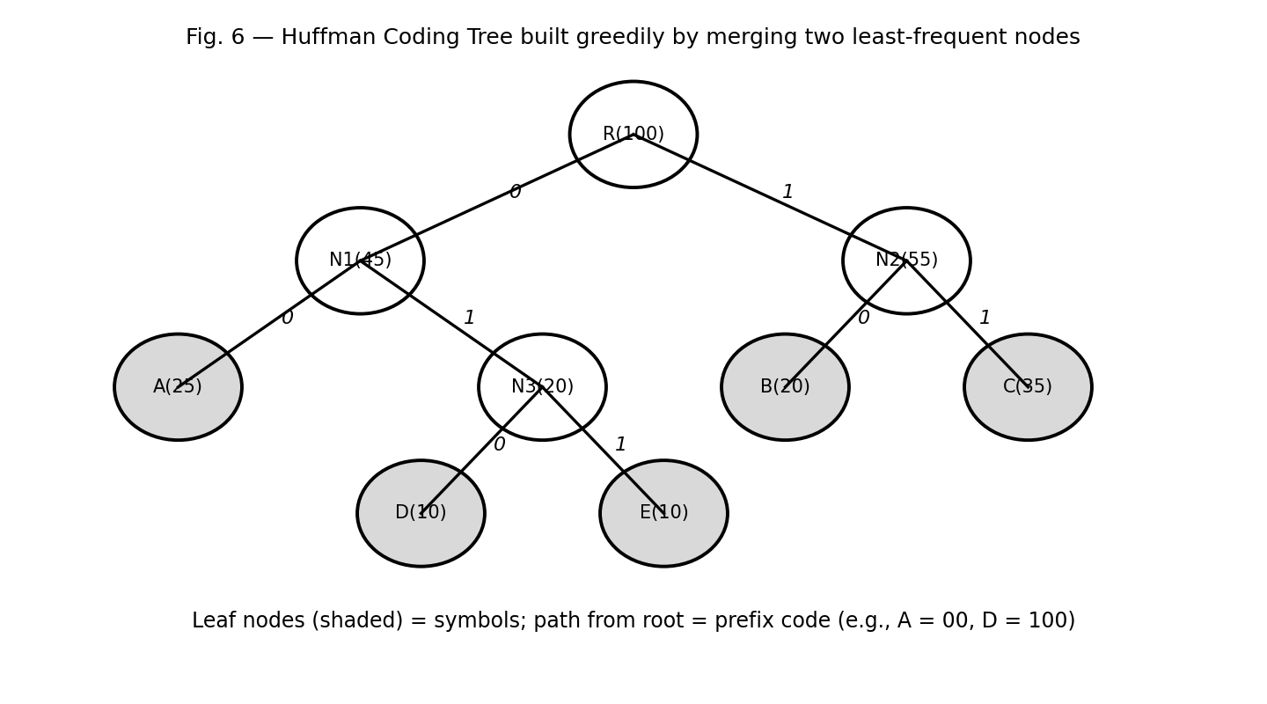
Fig. 6 — Huffman coding tree built greedily; leaf paths give each symbol's prefix code.
Q7. Minimum Spanning Tree – Network Design
1. Understanding the Industry Problem
An ISP wants to connect multiple cities with cable while minimising total cost. Modelling cities as graph nodes and possible cable routes as weighted edges (cost of laying cable), the requirement — connect all nodes with minimum total edge weight and no cycles — is exactly the Minimum Spanning Tree (MST) problem.
2. Applying Prim's / Kruskal's Algorithm
Prim's algorithm grows a single tree from an arbitrary start node, repeatedly adding the cheapest edge that connects the current tree to a new node (using a priority queue). Kruskal's algorithm instead sorts all edges by weight and greedily adds each edge that does not form a cycle, using a Union-Find (Disjoint Set) structure to detect cycles efficiently.
Kruskal:
sort edges by weight
for each edge (u, v, w) in sorted order:
if find(u) != find(v):
union(u, v); add edge to MST
Prim:
start from any node; maintain a min-heap of frontier edges
repeatedly extract the cheapest edge to an unvisited node and add it
3. Comparing Both Algorithms
- Prim's is preferable for dense graphs (many possible cable routes between cities) since its complexity depends on V, not E, when using adjacency-matrix/heap implementations.
- Kruskal's is preferable for sparse graphs (few candidate routes) since it primarily depends on sorting the edge list.
- Both are greedy and provably optimal via the cut property of MSTs (the minimum-weight edge crossing any cut of the graph must belong to some MST).
4. Suggested Tools and Data Structures
- Union-Find with path compression and union-by-rank for Kruskal's cycle detection.
- Binary/Fibonacci heap for Prim's frontier management.
- NetworkX / igraph for prototyping; GIS tools (QGIS, ArcGIS) for overlaying candidate cable routes on real geography before running the MST solver.
5. Complexity Analysis
Aspect | Complexity / Value
Kruskal's Time | O(E log E) — dominated by sorting edges
Prim's Time (binary heap) | O(E log V)
Space | O(V + E) for both
6. Interpretation — Cost Optimization and Practical Network Design
The MST gives the ISP the cheapest possible cable layout that still connects every city, which is directly actionable capital-expenditure guidance. In practice, ISPs often adapt the pure MST with extra constraints (redundancy/reliability requirements mean a small number of extra edges beyond the strict MST are added deliberately, trading a bit of cost for fault tolerance).
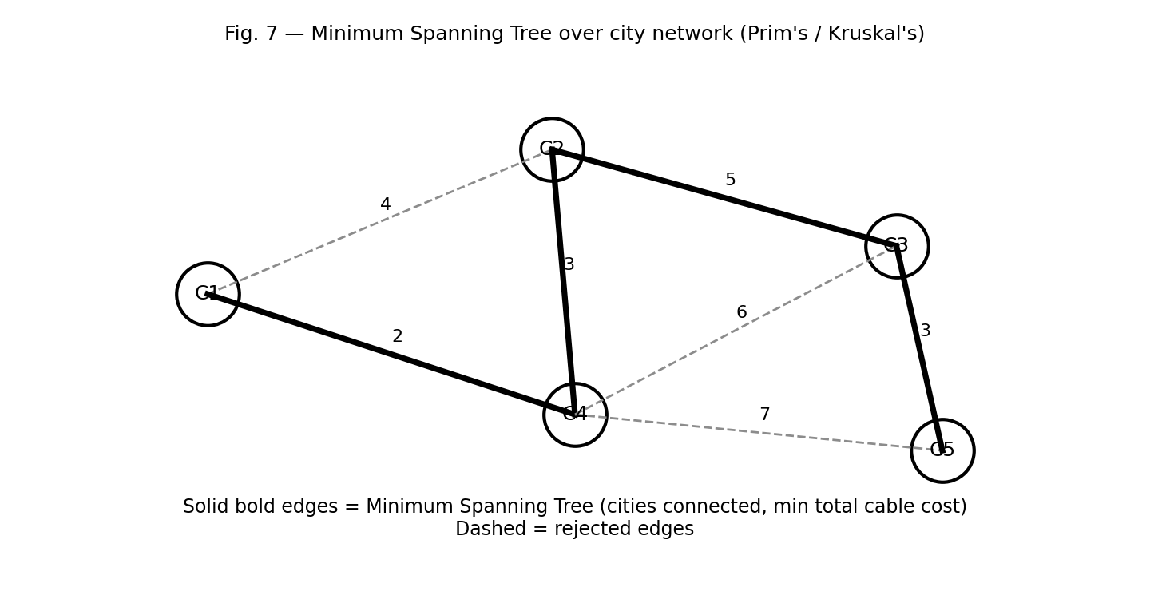
Fig. 7 — Minimum Spanning Tree over the city network; bold edges are the selected cable routes

.
RUBRICS FOR CALCULATION
Industry Problem Solving Task

Criteria | Weig htage | Level 4 – Exemplary | Level 3 – Proficient | Level 2 – Developing | Level 1 – Beginning
Understan ding of Industry Problem | 20% | Comprehensive understanding of real-world problem and  constraints | Good understanding with minor  gaps in  requirements | Basic understanding; some  requirements unclear | Poor understandin g;  misinterprets problem context
Applicatio n of Engineeri ng  Concepts | 25% | Applies advanced and relevant  concepts effectively to  solve the problem | Applies  appropriate concepts with minor errors | Limited application of concepts | Incorrect or no application of concepts
Solution Design | 25% | Innovative, practical, and  feasible solution aligned with industry  standards | Logical and feasible solution with minor gaps | Basic solution with limited feasibility | Unclear or impractical solution
Use of Tools | 15% | Effective use of modern tools, technologies, and real data | Appropriate use of tools with correct implementatio  n | Limited or inconsistent use of tools | Minimal or incorrect use of tools
Analysis | 10% | Thorough analysis with  validated results and performance evaluation | Good analysis with  reasonable validation | Basic analysis with limited validation | Poor or no analysis
Profession alism | 5% | Highly professional,  well-documented, and clearly presented work | Good documentation and presentation | Basic documentation with some  gaps | Poor documentati on and presentation

