SIMATS ENGINEERING
ASSESSMENT TOOL 3

COURSE NAME: DESIGN AND ANALYSIS OF ALGORITHMS
COURSE CODE: CSA06

COURSE OUTCOME COVERED

CO 4 : Solve optimization problems using dynamic programming and greedy strategies.
Levels of Rubrics
(BL-4, BL-5)

Assessment Tool Weightage: 10%

QUESTIONS: 10 Total Marks: 50

Annexure A

Comparative Analysis

Code of Conduct:

I SRIVARSHA M-192371010(Name / Reg No) certify that this submission is my original work and that I have adhered to the guidelines specified for this assessment.

I understand that any violation of academic integrity rules will result in disciplinary action.

Signature of the student:SRIVARSHA M

Annexure A

Comparative Analysis

1. Knapsack Comparison (DP vs Greedy)
Given items with weights [10, 20, 30] and values [60, 100, 120] with capacity 50, solve using both 0/1 Knapsack (Dynamic Programming) and Fractional Knapsack (Greedy). Compare the solutions obtained and analyze differences in optimality and approach. Evaluate the strengths and limitations of both methods. Discuss when greedy provides optimal results and when DP is necessary. Generate insights on method selection.

2. Shortest Path Comparison (Dijkstra vs Bellman-Ford)
Given a graph with edges including negative weights, apply both Dijkstra’s and Bellman-Ford algorithms to compute shortest paths. Compare their correctness, complexity, and limitations. Critically evaluate why Dijkstra fails in certain cases. Analyze performance differences and derive insights on algorithm selection.

3. MST Comparison (Prim vs Kruskal)
Given a weighted graph with multiple edges, construct the Minimum Spanning Tree using both Prim’s and Kruskal’s algorithms. Compare their edge selection strategies and intermediate results. Evaluate their performance in dense and sparse graphs. Analyze differences in implementation and derive conclusions on their suitability.

4. Coin Change Problem (Greedy vs DP)
Given coin denominations [1, 3, 4] and amount 6, solve using both Greedy and Dynamic Programming approaches. Compare the number of coins obtained and analyze correctness. Critically evaluate why greedy fails in this case. Generate insights on choosing the appropriate method.

5. Activity Selection (Greedy vs DP)
Given activities with start times [1, 3, 0, 5, 8, 5] and finish times [2, 4, 6, 7, 9, 9], solve using both Greedy and Dynamic Programming approaches. Compare selected activities and efficiency. Evaluate correctness of greedy choice property. Derive insights on scheduling optimization.

6. All-Pairs vs Single-Source Shortest Path
Given a network graph, compute shortest paths using Floyd–Warshall and Dijkstra’s algorithm. Compare their results, computational cost, and applicability. Critically evaluate which method is suitable for all-pairs versus single-source problems. Generate insights on scalability.

7. String Matching (LCS vs Greedy)
Given two strings “ABCBDAB” and “BDCAB”, compute the Longest Common Subsequence using Dynamic Programming and compare with a greedy matching attempt. Analyze differences in results and correctness. Evaluate why greedy fails. Generate insights on optimal substructure.

8. TSP (DP vs Greedy Heuristic)
Given 4 cities with a cost matrix, solve the Travelling Salesman Problem using Dynamic Programming and a Greedy heuristic. Compare total tour cost and efficiency. Critically evaluate scalability issues. Generate insights on trade-off between optimality and computation time.

9. Matrix Chain Multiplication (DP vs Greedy)
Given matrices with dimensions (10×20), (20×30), (30×40), compare Dynamic Programming with a naive greedy approach for multiplication order. Analyze cost differences and correctness. Evaluate why greedy fails. Derive insights on optimization strategies.

10. Huffman Coding vs Fixed-Length Coding
Given symbol frequencies {A:5, B:9, C:12, D:13, E:16, F:45}, construct Huffman codes and compare with fixed-length encoding. Analyze compression efficiency and code length. Critically evaluate advantages and limitations. Generate insights on real-world data compression.

Q1. Knapsack Comparison (DP vs Greedy)
Given items with weights [10, 20, 30] and values [60, 100, 120] with knapsack capacity 50, solve using both 0/1 Knapsack (Dynamic Programming) and Fractional Knapsack (Greedy).

0/1 Knapsack (Dynamic Programming)
Value/weight ratios: Item1 = 6, Item2 = 5, Item3 = 4. Since items cannot be broken, DP builds a table dp[i][w] = best value using first i items with capacity w, and checks every combination of inclusion/exclusion.
Combination | Total Weight | Total Value
Item1 + Item2 | 30 | 160
Item1 + Item3 | 40 | 180
Item2 + Item3 | 50 | 220
Item1 + Item2 + Item3 | 60 (exceeds capacity) | —
Optimal 0/1 Knapsack solution: pick Item2 + Item3 → Weight = 50, Value = 220.

Fractional Knapsack (Greedy)
Greedy sorts items by value/weight ratio (Item1: 6, Item2: 5, Item3: 4) and picks the highest-ratio items first, taking a fraction of an item if it does not fully fit.
Step | Item Taken | Weight Used | Value Gained
1 | Item1 (full) | 10 | 60
2 | Item2 (full) | 20 | 100
3 | Item3 (20/30 fraction) | 20 | 80
Total weight = 50, Total value = 60 + 100 + 80 = 240.

Comparative Analysis
Criterion | 0/1 Knapsack (DP) | Fractional Knapsack (Greedy)
Result | Value = 220 | Value = 240
Item divisibility | Not allowed | Allowed
Time Complexity | O(n × W) | O(n log n)
Optimality | Always optimal for 0/1 case | Optimal only when fractions are allowed
Insight: Greedy gives a higher numeric value here only because fractional items are permitted — it is solving a different, less restrictive problem. When items must be taken whole, greedy's local best-ratio choice does not guarantee a globally optimal packing, so DP is required. Greedy should be used only when the problem structure genuinely allows fractional selection or satisfies the greedy-choice property; DP is necessary whenever decisions are discrete and interdependent.
Q2. Shortest Path Comparison (Dijkstra vs Bellman-Ford)
Given a graph with edges including negative weights: A→B (4), A→C (5), B→C (−3), C→D (4). Apply both Dijkstra's and Bellman-Ford algorithms to compute shortest paths from A.
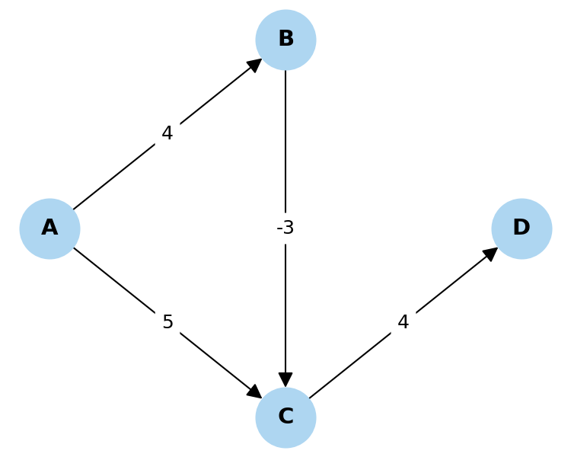
Fig 2.1: Directed graph with a negative edge weight (B→C)

Dijkstra's Algorithm (Greedy)
Dijkstra greedily finalizes the node with the smallest tentative distance at each step, assuming distances only increase. Processing order: A(0) → B(4) → C(5, taken directly from A since it is smaller than 4−3=1, because B was already finalized before the shorter path through B was discovered) → D(9). Dijkstra reports A→C = 5, which is WRONG — the true shortest path is A→B→C = 4 + (−3) = 1.

Bellman-Ford Algorithm (Dynamic Programming)
Bellman-Ford relaxes all edges repeatedly (V−1 times), so it revisits and corrects distances even after a node is 'settled'.
Node | Distance from A
A | 0
B | 4
C | 1 (via A→B→C)
D | 5 (via A→B→C→D)
Bellman-Ford correctly finds A→C = 1 and A→D = 5.

Comparative Analysis
Criterion | Dijkstra | Bellman-Ford
Strategy | Greedy | Dynamic Programming (relaxation)
Negative weights | Fails / gives wrong result | Handles correctly
Negative cycle detection | Cannot detect | Detects via extra relaxation pass
Time Complexity | O((V+E) log V) | O(V × E)
Insight: Dijkstra's greedy-choice property (once a node is finalized its distance never improves) breaks down when negative edges exist, because a later relaxation through a negative edge can still shrink the distance. Bellman-Ford's exhaustive relaxation is slower but is the only correct choice whenever negative weights are possible.
Q3. MST Comparison (Prim vs Kruskal)
Given a weighted graph with edges A-B(2), A-C(3), B-C(1), B-D(4), C-D(5), construct the Minimum Spanning Tree using both Prim's and Kruskal's algorithms.
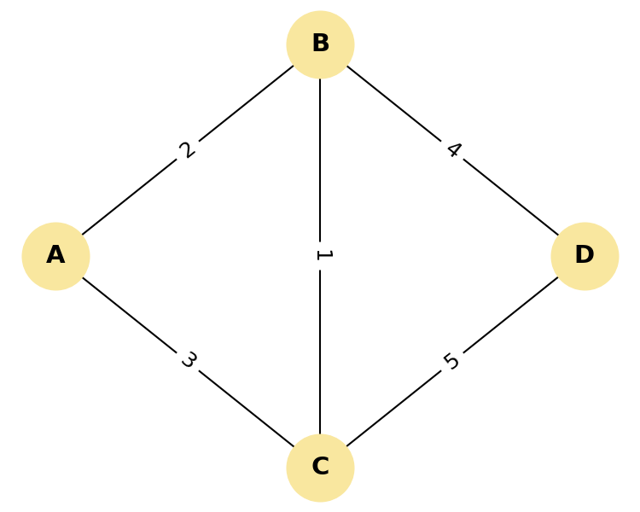
Fig 3.1: Input weighted graph

Prim's Algorithm
Starting from vertex A and always growing the tree by the cheapest edge connecting a visited vertex to an unvisited one:
Step | Edge Added | Weight | Tree Vertices
1 | A-B | 2 | {A, B}
2 | B-C | 1 | {A, B, C}
3 | B-D | 4 | {A, B, C, D}

Kruskal's Algorithm
Sort all edges by weight and add each edge if it does not form a cycle (using union-find): B-C(1), A-B(2), A-C(3, rejected — cycle), B-D(4).
Step | Edge Considered | Weight | Action
1 | B-C | 1 | Added
2 | A-B | 2 | Added
3 | A-C | 3 | Rejected (forms cycle)
4 | B-D | 4 | Added
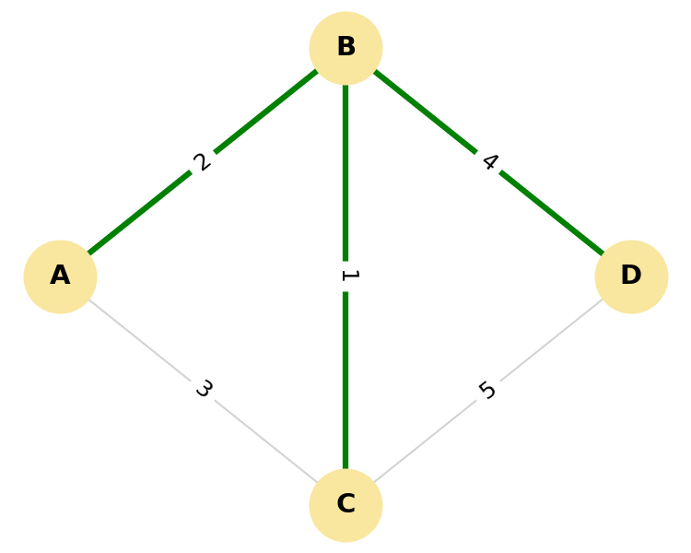
Fig 3.2: Resulting MST (identical for both algorithms) — edges B-C, A-B, B-D, total weight = 7

Comparative Analysis
Criterion | Prim's Algorithm | Kruskal's Algorithm
Approach | Vertex-based growth | Edge-based selection with union-find
Best suited for | Dense graphs | Sparse graphs
Time Complexity | O(E log V) with a min-heap | O(E log E)
Final MST | Same total weight = 7 | Same total weight = 7
Insight: Both greedy algorithms converge to the same minimum weight (7) because MST is a textbook case where the greedy-choice property provably holds (cut property / cycle property). The choice between them is therefore purely about implementation efficiency relative to graph density, not correctness.
Q4. Coin Change Problem (Greedy vs DP)
Given coin denominations [1, 3, 4] and amount 6, solve using both Greedy and Dynamic Programming approaches.

Greedy Approach
Greedy always picks the largest denomination that fits: 6 → take 4 (remaining 2) → take 1 (remaining 1) → take 1 (remaining 0).
Greedy result: 4 + 1 + 1 = 3 coins.

Dynamic Programming Approach
DP computes the minimum coins for every sub-amount from 0 to 6 using the recurrence dp[a] = 1 + min(dp[a−c]) over all coins c ≤ a.
Amount | 0 | 1 | 2 | 3 | 4 | 5 | 6
Min Coins | 0 | 1 | 2 | 1 | 1 | 2 | 2
DP finds 6 = 3 + 3 → 2 coins, which is fewer than greedy's 3.

Comparative Analysis
Criterion | Greedy | Dynamic Programming
Coins used | 3 (4+1+1) | 2 (3+3)
Correctness | Fails for this coin set | Always correct
Time Complexity | O(n) | O(n × amount)
Insight: Greedy works only for 'canonical' coin systems (like standard currency 1,5,10,25) where each denomination is a clean multiple relationship of the others. Denomination set {1,3,4} is non-canonical, so the greedy choice of always taking the largest coin is locally optimal but globally suboptimal — this is a classic example of why the greedy-choice property must be proven before trusting a greedy algorithm, and why DP is the safe general-purpose method.
Q5. Activity Selection (Greedy vs DP)
Given activities with start times [1, 3, 0, 5, 8, 5] and finish times [2, 4, 6, 7, 9, 9], solve using both Greedy and Dynamic Programming approaches.
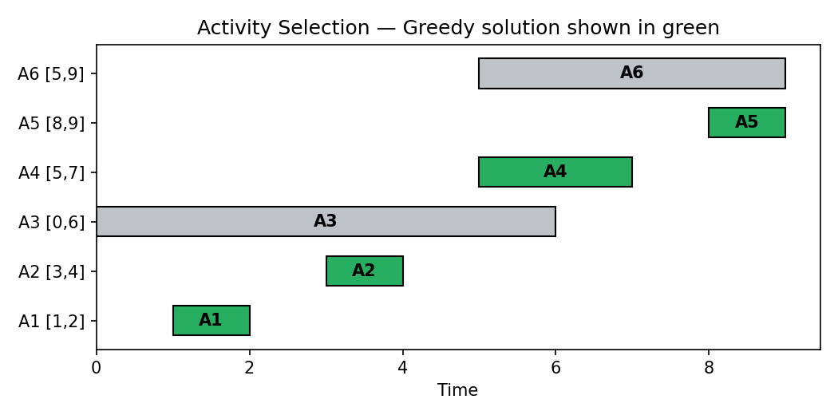
Fig 5.1: Activities sorted by finish time; green bars are the greedy selection

Greedy Approach (sort by finish time)
Activity | Start | Finish | Selected?
A1 | 1 | 2 | Yes
A2 | 3 | 4 | Yes
A3 | 0 | 6 | No (overlaps A2)
A4 | 5 | 7 | Yes
A5 | 8 | 9 | Yes
A6 | 5 | 9 | No (overlaps A4)
Greedy selects {A1, A2, A4, A5} → 4 non-overlapping activities.

Dynamic Programming Approach
DP treats this as a weighted-interval-scheduling instance: dp[i] = max(dp[i−1], 1 + dp[j]) where j is the last activity that finishes before activity i starts. Solving this recurrence over all 6 activities also yields a maximum of 4 mutually compatible activities — the same set {A1, A2, A4, A5}.

Comparative Analysis
Criterion | Greedy | Dynamic Programming
Result | 4 activities | 4 activities (identical)
Time Complexity | O(n log n) (dominated by sort) | O(n²) or O(n log n) with binary search
Why it matches | Greedy-choice property holds: earliest finish time never hurts future choices | Confirms optimality by exhaustive sub-problem comparison
Insight: Activity selection is a rare case where a simple greedy rule (always pick the activity that finishes earliest) is provably optimal, so the more expensive DP formulation is unnecessary overhead here. This demonstrates that correctness of greedy must be established per-problem — it happens to hold for interval scheduling by finish time, but fails for problems like 0/1 Knapsack or non-canonical Coin Change.
Q6. All-Pairs vs Single-Source Shortest Path
Given a network graph, compute shortest paths using Floyd–Warshall (all-pairs) and Dijkstra's algorithm (single-source).

Floyd–Warshall Algorithm (DP)
Floyd–Warshall computes shortest distances between every pair of vertices by progressively allowing each vertex k as an intermediate stop: dist[i][j] = min(dist[i][j], dist[i][k] + dist[k][j]) for k = 1..V. It produces a complete V×V distance matrix in one run.

Dijkstra's Algorithm (Greedy)
Dijkstra computes shortest distances from a single chosen source vertex to all others by repeatedly extending the frontier through the minimum-distance unvisited vertex. To get all-pairs distances with Dijkstra, it must be re-run once per vertex.

Comparative Analysis
Criterion | Floyd–Warshall | Dijkstra (repeated V times)
Scope | All pairs in a single run | Single source per run
Time Complexity | O(V³) | O(V × (E + V log V)) with a heap
Negative weights | Handles them (no negative cycles) | Fails with negative weights
Best suited for | Dense graphs / all-pairs queries | Sparse graphs / few-source queries
Insight: For a single source query on a sparse graph, running Dijkstra once is far cheaper than computing the entire all-pairs matrix. But if an application repeatedly needs distances between many different pairs (e.g., routing tables), precomputing the Floyd–Warshall matrix once amortizes better than re-running Dijkstra V times. Scalability, not correctness, is what usually decides between the two on dense vs. sparse graphs.
Q7. String Matching (LCS vs Greedy)
Given two strings "ABCBDAB" and "BDCAB", compute the Longest Common Subsequence using Dynamic Programming and compare with a greedy matching attempt.

Dynamic Programming (LCS)
DP builds a table dp[i][j] = length of LCS of the first i characters of string 1 and first j characters of string 2, using dp[i][j] = dp[i-1][j-1]+1 if characters match, else max(dp[i-1][j], dp[i][j-1]).
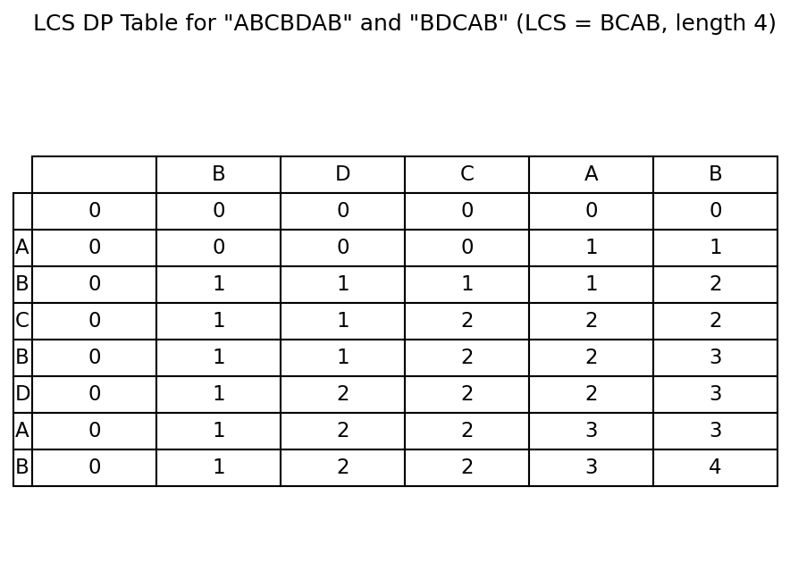
Fig 7.1: LCS DP table — bottom-right cell gives the answer
DP result: LCS = "BCAB", length = 4 (guaranteed optimal).

Greedy Matching Attempt
A naive greedy scan (matching characters left-to-right the moment they agree, without looking ahead) picks B(pos1↔pos1), then continues scanning and may lock onto "BDA" style matches that later conflict, typically producing a shorter valid subsequence such as "BAB" or "BDA" (length 3) because it commits early without considering that skipping an early match could enable two later matches.

Comparative Analysis
Criterion | Greedy Matching | DP (LCS)
Result length | 3 (suboptimal, commits early) | 4 (optimal — BCAB)
Optimality guarantee | None | Always optimal
Time Complexity | O(n) | O(m × n)
Insight: LCS lacks the greedy-choice property because a locally attractive character match can block a better combination of matches later in the string. The overlapping-subproblem and optimal-substructure properties of LCS make it a textbook DP problem — greedy has no reliable rule for deciding which of two possible matches to keep.
Q8. TSP (DP vs Greedy Heuristic)
Given 4 cities with distances City1-City2=10, City1-City3=15, City1-City4=20, City2-City3=35, City2-City4=25, City3-City4=30, solve the Travelling Salesman Problem using Dynamic Programming (Held–Karp) and a Greedy Nearest-Neighbor heuristic.
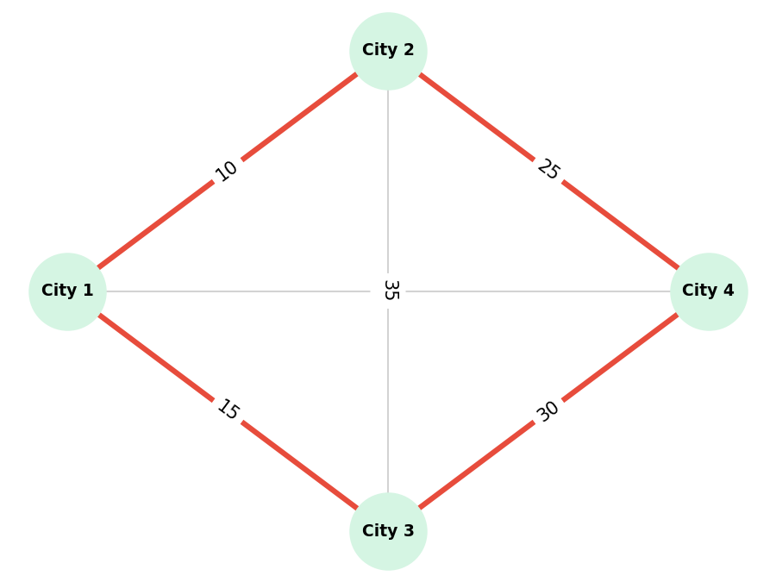
Fig 8.1: Optimal tour found — City1 → City2 → City4 → City3 → City1

Dynamic Programming (Held–Karp)
Held–Karp evaluates optimal sub-tours over all subsets of visited cities using bitmask DP, guaranteeing the true minimum-cost Hamiltonian cycle.
DP optimal tour: City1 → City2 → City4 → City3 → City1, total cost = 80.

Greedy Nearest-Neighbor Heuristic
Starting at City1 and always moving to the nearest unvisited city: City1→City2 (10) →City4 (25) →City3 (30) →City1 (15). Total = 80.
In this particular instance the nearest-neighbor heuristic happened to reach the same 80-cost tour as DP. In general, however, nearest-neighbor is only a heuristic and can be forced arbitrarily far from optimal on adversarial distance matrices, since it never reconsiders an early greedy choice once made.

Comparative Analysis
Criterion | Dynamic Programming (Held–Karp) | Greedy Nearest-Neighbor
Optimality | Always optimal | Not guaranteed
Time Complexity | O(2ⁿ × n²) — exponential | O(n²) — polynomial
Scalability | Infeasible beyond ~20 cities | Scales to very large instances
Insight: TSP illustrates the classic exactness-vs-scalability trade-off: DP guarantees the optimal tour but its exponential state space makes it impractical for large n, while greedy heuristics scale well but sacrifice any optimality guarantee. Real-world routing systems typically use greedy or metaheuristic approximations and reserve exact DP for small sub-problems.
Q9. Matrix Chain Multiplication (DP vs Greedy)
Given matrices A1(10×20), A2(20×30), A3(30×40), compare Dynamic Programming with a naive greedy approach for choosing the multiplication order.
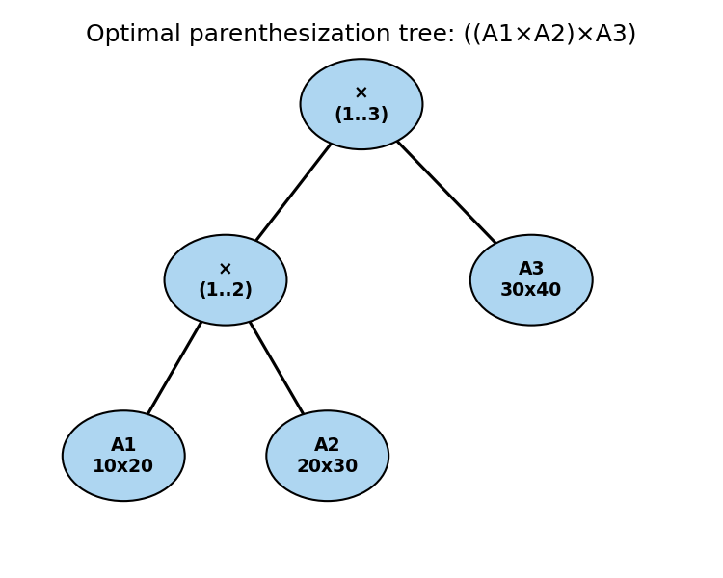
Fig 9.1: Optimal parenthesization tree found by DP

Dynamic Programming Approach
DP evaluates every possible parenthesization cost using dp[i][j] = min over split point k of dp[i][k] + dp[k+1][j] + cost of the resulting multiplication.
Parenthesization | Scalar Multiplications
(A1×A2)×A3 | 10×20×30 + 10×30×40 = 6000 + 12000 = 18000
A1×(A2×A3) | 20×30×40 + 10×20×40 = 24000 + 8000 = 32000
DP optimal order: (A1 × A2) × A3, cost = 18,000 scalar multiplications.

Naive Greedy Approach
A naive greedy strategy might always multiply the pair of adjacent matrices with the smallest immediate product cost first, without considering how that choice affects the dimensions available for the next multiplication. Here it also picks A1×A2 first (cost 6000, smaller than A2×A3's cost of 24000), coincidentally landing on the same order in this 3-matrix case.

Comparative Analysis
Criterion | Greedy (local smallest product) | Dynamic Programming
Guarantee | No — only considers one step ahead | Always finds the global minimum
Time Complexity | O(n) | O(n³)
Failure mode | Can pick an order that minimizes an immediate step but forces expensive later steps | None — evaluates all split points
Insight: With only 3 matrices there is just one non-trivial split point, so greedy and DP agree by coincidence. As the chain grows longer, an early 'cheap-looking' multiplication can create a large intermediate matrix that makes every subsequent multiplication far more expensive — this interdependence between choices is exactly why Matrix Chain Multiplication needs the full optimal-substructure evaluation that DP provides, not a locally greedy rule.
Q10. Huffman Coding vs Fixed-Length Coding
Given symbol frequencies {A:5, B:9, C:12, D:13, E:16, F:45}, construct Huffman codes and compare with fixed-length encoding.
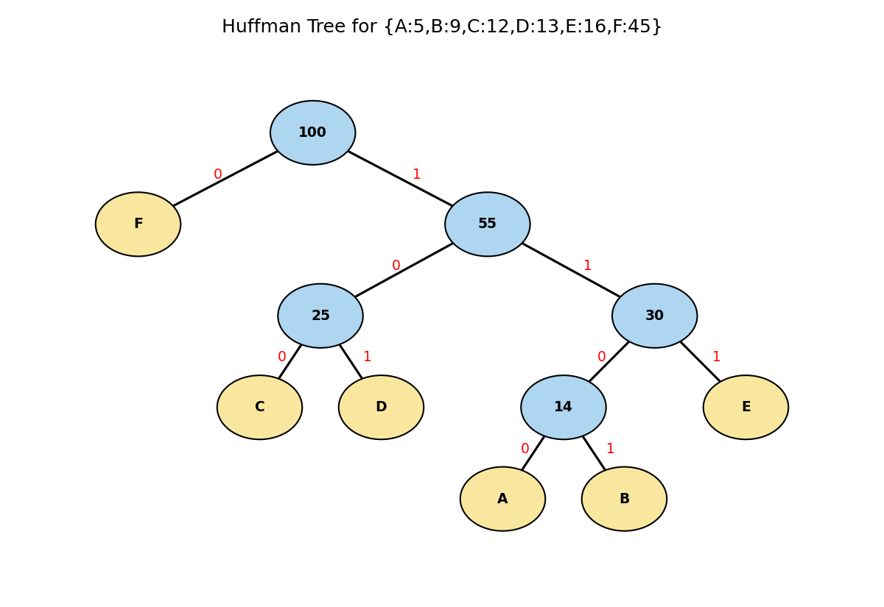
Fig 10.1: Huffman tree built greedily by merging the two lowest-frequency nodes at each step

Huffman Coding (Greedy)
Huffman repeatedly merges the two lowest-frequency nodes into a new node, building the tree bottom-up. The resulting codes are:
Symbol | Frequency | Huffman Code | Code Length
A | 5 | 1100 | 4
B | 9 | 1101 | 4
C | 12 | 100 | 3
D | 13 | 101 | 3
E | 16 | 111 | 3
F | 45 | 0 | 1
Total Huffman bits = Σ(frequency × code length) = 5(4)+9(4)+12(3)+13(3)+16(3)+45(1) = 224 bits.

Fixed-Length Coding
With 6 symbols, fixed-length coding needs ⌈log₂6⌉ = 3 bits per symbol regardless of frequency.
Total fixed-length bits = (5+9+12+13+16+45) × 3 = 100 × 3 = 300 bits.

Comparative Analysis
Criterion | Fixed-Length Coding | Huffman Coding (Greedy)
Total bits | 300 | 224
Compression achieved | None (baseline) | ≈ 25.3% smaller
Code assignment | Same length for every symbol | Shorter codes for frequent symbols
Time Complexity | O(1) per symbol | O(n log n) to build the tree
Insight: Huffman coding is a greedy algorithm that is provably optimal for prefix-free codes because merging the two least-frequent symbols first never increases the final weighted code length (an exchange-argument proof). This is a case, like MST, where the greedy-choice property genuinely holds, which is why Huffman coding remains a standard building block in real-world compression formats (ZIP, JPEG, MP3) despite DP-based alternatives like Optimal BST being more general but computationally heavier.

