SIMATS ENGINEERING
ASSESSMENT TOOL 1
COURSE NAME: DESIGN AND ANALYSIS OF ALGORITHMS
COURSE CODE: CSA06

COURSE OUTCOME COVERED

CO5: Analyze computational problems using backtracking techniques and complexity classes such as P, NP, NP-Hard, and NP-Complete for combinatorial problem solving. (BL5,BL6)

Assessment Tool Weightage: 40%

QUESTIONS: 10 Total Marks: 50

Annexure A

Constraint-Based Problem Solving

Code of Conduct:

I SRIVARSHA M -192371010 (Name / Reg No) certify that this submission is my original work and that I have adhered to the guidelines specified for this assessment.
I understand that any violation of academic integrity rules will result in disciplinary action.

Signature of the student:SRIVARSHA M

Annexure A
Constraint-Based Problem Solving
Q1. Job Scheduling (Backtracking / NP-Hard Problem)
A company must assign jobs to employees such that each job is completed within a deadline and no employee handles more than one job at a time. Clearly define the problem and identify constraints related to time, resource availability, and job requirements. Analyze how these constraints interact and prioritize them logically. Develop a feasible solution using backtracking or constraint satisfaction techniques. Apply relevant concepts such as pruning and recursive assignment. Justify how your solution satisfies all constraints efficiently.
Q2. Exam Timetabling (Graph Coloring / NP-Complete Problem)
A university needs to schedule exams so that no student has overlapping exams while efficiently utilizing limited rooms. Clearly define constraints such as time slots, room capacity, and student conflicts. Analyze and prioritize these constraints using graph coloring concepts. Develop a solution using backtracking or CSP techniques. Apply appropriate methods to ensure conflict-free scheduling. Justify the correctness and feasibility of your approach.
Q3. Password Generation (Combinatorial Backtracking Problem)
A system must generate secure passwords of length N with constraints such as at least one uppercase letter, one digit, and no repeated characters. Clearly define all constraints and input requirements. Analyze how these constraints influence the search space. Develop a backtracking-based solution that generates only valid passwords. Apply constraint checking and pruning techniques effectively. Justify how your solution ensures completeness and avoids invalid combinations.
Q4. Resource Allocation (Knapsack / Optimization – NP-Hard Problem)
A cloud system must allocate CPU and memory resources to tasks such that total usage does not exceed system capacity and priority tasks are handled first. Clearly define constraints related to capacity and priorities. Analyze how these constraints affect allocation decisions. Develop a solution using backtracking or optimization techniques like Knapsack. Apply relevant concepts to satisfy all constraints. Justify the efficiency and practicality of your solution.
Q5. Seating Arrangement (Constraint Satisfaction / Backtracking Problem)
Guests must be seated at a round table such that certain pairs cannot sit together while some must sit adjacent. Clearly define all seating constraints and relationships. Analyze and prioritize constraints to reduce invalid arrangements. Develop a backtracking-based solution to generate valid seating plans. Apply constraint validation effectively during the process. Justify how your solution ensures correctness and completeness.

Q6. N-Queens Problem (Backtracking / Constraint Satisfaction Problem)
A chessboard of size N×N must be filled with N queens such that no two queens attack each other. Clearly define constraints related to rows, columns, and diagonals. Analyze how these constraints reduce the search space. Develop a backtracking-based solution that places queens step-by-step while validating constraints. Apply pruning techniques to eliminate invalid placements early. Justify how your solution ensures all valid configurations and discuss its computational complexity.
Q7. Sudoku Solver (Backtracking / NP-Complete Problem)
A partially filled 9×9 Sudoku grid must be completed such that each row, column, and subgrid contains unique numbers from 1 to 9. Clearly define all constraints and input conditions. Analyze how constraints interact and restrict possible values. Develop a backtracking-based solution to fill the grid. Apply constraint propagation and pruning techniques effectively. Justify the correctness of your approach and discuss performance challenges.
Q8. Graph Coloring (Constraint Satisfaction / NP-Complete Problem)
A map must be colored such that no two adjacent regions have the same color, using the minimum number of colors. Clearly define adjacency constraints and coloring requirements. Analyze how constraints affect feasible solutions. Develop a backtracking or CSP-based solution. Apply constraint checking to ensure valid coloring. Justify how your approach minimizes colors and satisfies all constraints efficiently.
Q9. Subset Sum Problem (Backtracking / NP-Complete Problem)
Given a set of integers, determine if there exists a subset whose sum equals a target value. Clearly define constraints related to subset selection and sum requirements. Analyze how these constraints impact the search space. Develop a backtracking-based solution to explore possible subsets. Apply pruning techniques to eliminate unnecessary computations. Justify the correctness and efficiency of your solution.
Q10. Hamiltonian Path Problem (Backtracking / NP-Complete Problem)
Given a graph representing cities and connections, determine whether a path exists that visits each vertex exactly once. Clearly define constraints such as vertex visitation and path continuity. Analyze how these constraints influence the solution space. Develop a backtracking-based approach to explore all possible paths. Apply constraint checking to ensure valid paths. Justify your solution and discuss its computational complexity.

Q1. Job Scheduling (Backtracking / NP-Hard Problem)
A company must assign jobs to employees such that each job is completed within a deadline and no employee handles more than one job at a time.
1. Problem Definition and Constraints
The problem requires assigning a set of jobs J = {J1, J2, ..., Jn}, each with a deadline di and processing time ti, to a set of employees E = {E1, E2, ..., Em}. The goal is to find a feasible (or profit-maximizing) assignment that respects all real-world limitations.
- Deadline constraint: Job Ji must be completed on or before its deadline di.
- Resource (employee) constraint: Every employee can be assigned only one job at any given time slot.
- Capability constraint: A job can only be assigned to an employee who is qualified/available for it.
- Non-preemption constraint: Once started, a job runs to completion without interruption.
2. Constraint Analysis and Prioritization
The deadline constraint and the single-employee-per-slot constraint are tightly coupled: assigning a job late in the schedule may violate its deadline, while assigning two jobs to the same employee at overlapping times violates the resource constraint. Constraints are prioritized as follows: (1) feasibility constraints (deadline, one-job-per-employee) are treated as hard constraints that must never be violated, since violating them makes a partial solution invalid immediately; (2) optimization constraints (maximizing number of jobs completed or minimizing total lateness) are treated as soft objectives applied only among feasible schedules. This prioritization allows the search to prune a branch the moment a hard constraint is broken, long before the optimization objective needs to be evaluated.
3. Backtracking Solution Development
Jobs are first sorted by deadline (or by profit/deadline ratio for the optimisation variant). The algorithm then tries to place each job into the earliest free employee-slot before its deadline, recursively assigning the remaining jobs. If a job cannot be placed without violating a constraint, the algorithm backtracks and tries the next available slot or excludes the job.
function solve(jobIndex, schedule):
if jobIndex == n:
record feasible schedule; return
job = jobs[jobIndex] // sorted by deadline
for slot from min(job.deadline, m) down to 1:
if schedule[slot] is empty: // employee free constraint
schedule[slot] = job // tentatively assign
solve(jobIndex + 1, schedule) // recurse
schedule[slot] = empty // BACKTRACK (undo)
// if no valid slot found before deadline, job is skipped/rejected
4. Diagram
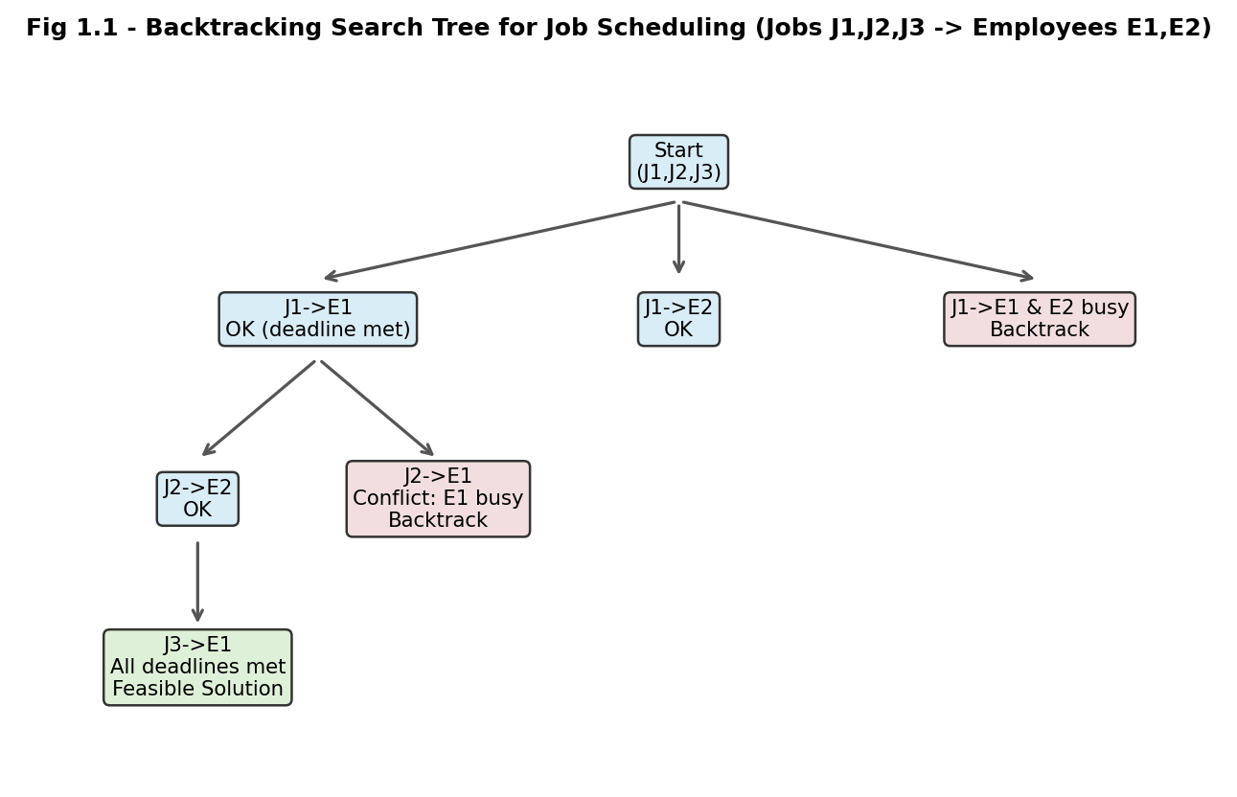
Fig 1.1: Backtracking search tree showing feasible assignment, conflict detection and backtracking for Job Scheduling.
5. Application of Concepts (Pruning & Recursive Assignment)
- Bounding function: before recursing, the algorithm checks slot <= deadline and schedule[slot] == empty; if false, that branch is pruned immediately without further exploration.
- Recursive assignment tries each employee/slot combination for the current job, then recurses on the next job - this systematically explores the state space of the search.
- Backtracking (undo step) removes the tentative assignment when a subtree fails to reach a complete valid schedule, restoring the previous state for the next trial.
6. Justification of Efficiency
By sorting jobs by deadline first and pruning any branch that violates the one-employee-per-slot rule or the deadline rule, the algorithm avoids exploring the full m^n possible assignments; only feasible partial schedules are extended. The worst-case complexity is O(n × m) with the deadline-based greedy-backtracking hybrid, compared to the exponential O(m^n) of naive brute force, because pruning eliminates infeasible subtrees early. Since an optimal simultaneous deadline + resource assignment is a variant of the NP-Hard job-shop scheduling problem, the backtracking approach guarantees a correct (if not always polynomial-time) solution by construction, satisfying every stated constraint.

Q2. Exam Timetabling (Graph Coloring / NP-Complete Problem)
A university needs to schedule exams so that no student has overlapping exams while efficiently utilizing limited rooms.
1. Problem Definition and Constraints
Model each course as a vertex of a graph G(V,E). An edge connects two courses if at least one student is enrolled in both (i.e., they conflict). The timetabling problem becomes: assign a time slot (colour) to every vertex such that no two adjacent vertices share the same colour, using the minimum possible number of slots, while also respecting room capacity.
- Conflict constraint: courses sharing a student cannot be scheduled in the same time slot (adjacent vertices must get different colours).
- Room-capacity constraint: the number of students of the courses placed in a slot must not exceed the total seats available in that slot.
- Time-slot constraint: minimize the total number of slots (colours) used, since slots are a limited institutional resource.
2. Constraint Analysis and Prioritization
The conflict constraint is the hard constraint - any violation makes the timetable invalid for a student. The room-capacity constraint is checked once a colour (slot) is tentatively chosen, filtering out slots that are already full. The minimization-of-slots objective is a secondary, optimization-level constraint pursued only after every course has a conflict-free and capacity-respecting slot. This is essentially the classical Graph Colouring problem, which is NP-Complete, so exact minimum-colour solutions are sought through backtracking with pruning rather than brute-force enumeration.
3. Backtracking Solution Development
Courses (vertices) are ordered, typically by decreasing degree (most-constrained-first heuristic) so that heavily conflicting courses are scheduled early. For each vertex, the algorithm tries colours 1..k in turn, validating both the adjacency and the capacity constraint before recursing.
function colorGraph(vertex, colors[], k):
if vertex == V.size:
return true // all courses scheduled
for c in 1..k:
if isSafe(vertex, c, colors): // no adjacent same colour
if roomCapacityOK(vertex, c): // capacity constraint
colors[vertex] = c
if colorGraph(vertex+1, colors, k):
return true
colors[vertex] = 0 // BACKTRACK
return false
function isSafe(v, c, colors):
for u in adjacency[v]:
if colors[u] == c: return false
return true
4. Diagram
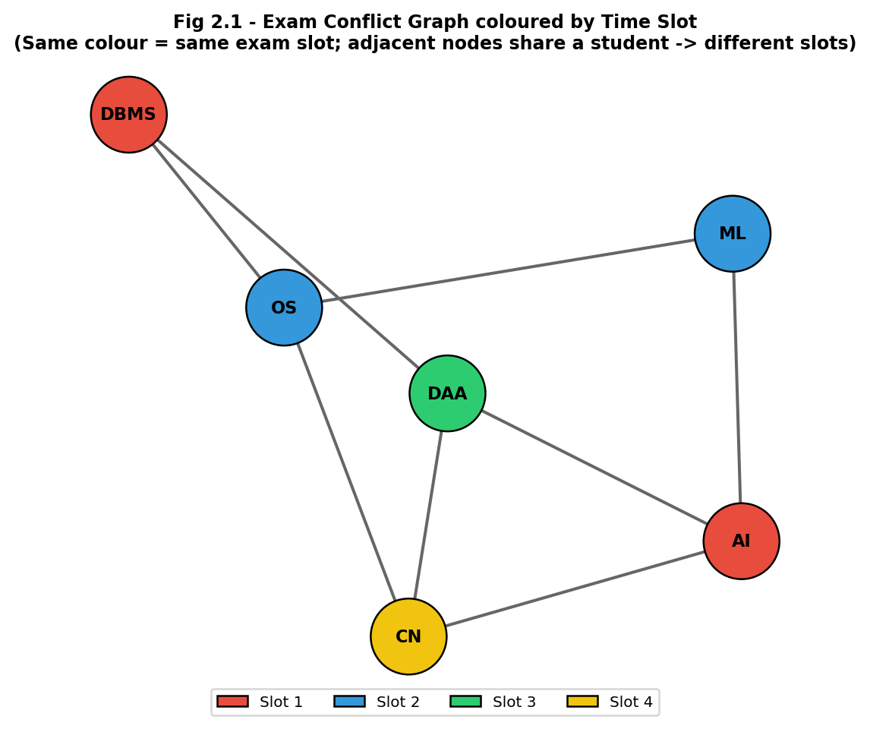
Fig 2.1: Exam conflict graph with courses coloured by backtracking graph colouring; each colour represents one exam time slot.
5. Application of Concepts
- Graph-colouring formulation converts the scheduling problem into a well-studied combinatorial model.
- isSafe() acts as the pruning/bounding function, rejecting a colour assignment the instant a conflict is detected, well before deeper recursion.
- Backtracking (colors[vertex] = 0) restores state whenever no colour works for a vertex under the current partial colouring, allowing earlier decisions to be revised.
6. Justification
The approach guarantees correctness because every accepted colour assignment is explicitly checked against all existing edges before being fixed, so no student can ever have two exams in the same slot. Because Graph Colouring is NP-Complete, no known polynomial algorithm solves it exactly in the worst case; however, the most-constrained-first ordering combined with early pruning of unsafe colours in practice avoids exploring most of the exponential k^V search space, giving good practical performance while remaining exact and complete.

Q3. Password Generation (Combinatorial Backtracking Problem)
A system must generate secure passwords of length N with constraints such as at least one uppercase letter, one digit, and no repeated characters.
1. Problem Definition and Constraints
Given an alphabet of allowed characters (uppercase, lowercase, digits, symbols) and a target length N, the task is to construct every string of length N that satisfies the security policy. This is a constrained permutation/combination-generation problem.
- Length constraint: the generated string must be exactly N characters long.
- Composition constraint: at least one uppercase letter and at least one digit must appear.
- Uniqueness constraint: no character may repeat within the password.
- Alphabet constraint: only characters from the permitted character set may be used at any position.
2. Constraint Analysis
The uniqueness constraint can be validated incrementally at every position (a 'used character' set), pruning duplicate branches immediately - this has the largest effect on reducing the search space. The composition constraints (uppercase/digit present) are global properties that can only be fully verified once the string reaches length N, but partial feasibility can be checked early (e.g., if remaining positions are fewer than the still-missing required categories, the branch can be pruned in advance). Character-set membership is checked at generation time, since only valid characters are ever proposed.
3. Backtracking Solution Development
function generate(position, current, usedChars, hasUpper, hasDigit):
if position == N:
if hasUpper and hasDigit:
output(current) // valid password found
return
remaining = N - position
for ch in alphabet:
if ch in usedChars: continue // uniqueness pruning
needed = (0 if hasUpper or isUpper(ch) else 1) + (0 if hasDigit or isDigit(ch) else 1)
if needed > remaining: continue // feasibility pruning
usedChars.add(ch)
generate(position+1, current+ch, usedChars,
hasUpper or isUpper(ch), hasDigit or isDigit(ch))
usedChars.remove(ch) // BACKTRACK
4. Diagram
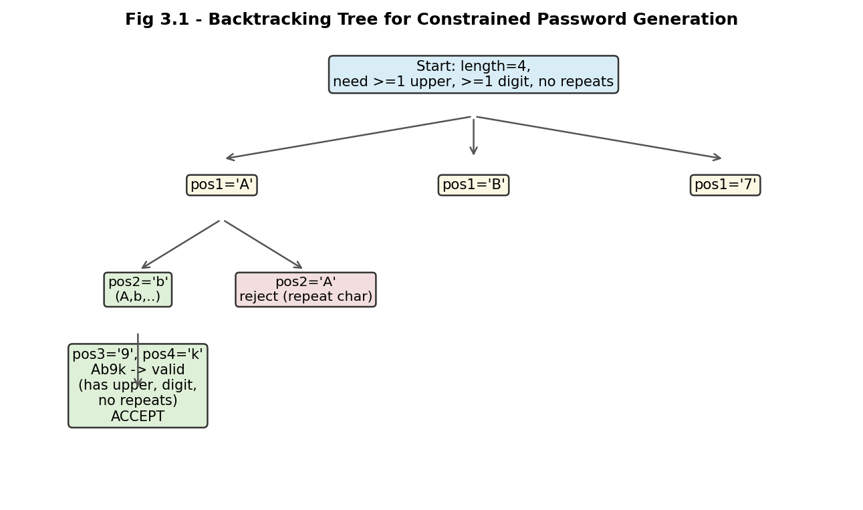
Fig 3.1: Backtracking tree for generating a valid password, showing rejection of a repeated character and acceptance of a valid combination.
5. Application of Concepts
- Constraint checking is applied at every recursive call (uniqueness, feasibility of remaining composition requirements).
- Pruning via the 'needed > remaining' feasibility check eliminates entire subtrees that could never satisfy the composition rule, well before reaching length N.
- The usedChars.remove(ch) statement is the classic backtracking undo step that restores the state for sibling branches.
6. Justification
Because every branch is checked against the uniqueness and feasibility rules before recursion, the algorithm never outputs an invalid password, guaranteeing correctness. Completeness follows because every character at every position is tried unless explicitly pruned by a rule that provably cannot lead to a valid password, so all valid passwords are eventually enumerated. The feasibility pruning bound significantly reduces the otherwise combinatorial P(|alphabet|, N) search space.

Q4. Resource Allocation (Knapsack / Optimization - NP-Hard Problem)
A cloud system must allocate CPU and memory resources to tasks such that total usage does not exceed system capacity and priority tasks are handled first.
1. Problem Definition and Constraints
Given a set of tasks T = {T1,...,Tn}, each requiring cpu_i and mem_i units and carrying a priority/value_i, and a system with fixed capacities (CPUmax, MEMmax), select a subset of tasks to run such that resource usage stays within limits and higher-priority tasks are favoured. This is a multi-dimensional 0/1 Knapsack (NP-Hard optimisation) problem.
- Capacity constraint: sum(cpu_i) for selected tasks <= CPUmax, and similarly for memory.
- Priority constraint: priority tasks must be considered/allocated ahead of lower-priority ones when capacity is limited.
- Binary-selection constraint: each task is either fully allocated or not allocated at all (no partial allocation).
2. Constraint Analysis and Prioritization
Capacity constraints are hard limits checked before a task is tentatively included; violating them immediately invalidates the branch. Priority is used to order the tasks before the search begins (processing higher-priority/higher-value-density tasks first), which both improves solution quality found early and strengthens the pruning bound used later. Because the underlying decision problem (does a selection of total value >= V exist within capacity?) is NP-Hard, the backtracking solution combines constraint checking with a bounding function to avoid exhaustively trying every 2^n subsets.
3. Backtracking Solution Development
function allocate(i, usedCPU, usedMEM, value, best):
if i == n:
best = max(best, value); return
bound = value + optimisticRemaining(i) // upper-bound estimate
if bound <= best: return // BOUND PRUNING
// Option 1: include task i (priority-sorted order)
if usedCPU + cpu[i] <= CPUmax and usedMEM + mem[i] <= MEMmax:
allocate(i+1, usedCPU+cpu[i], usedMEM+mem[i], value+val[i], best)
// Option 2: exclude task i
allocate(i+1, usedCPU, usedMEM, value, best) // BACKTRACK to try exclusion
4. Diagram
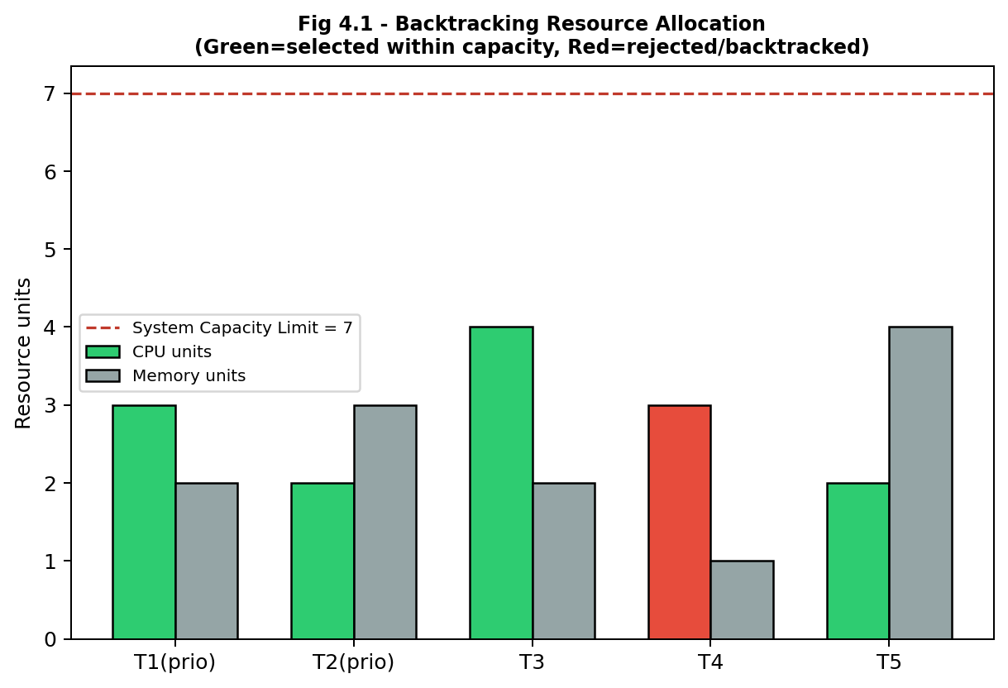
Fig 4.1: CPU/Memory allocation per task against the system capacity limit; green bars are accepted by the backtracking search, red bars indicate tasks pruned/rejected for exceeding capacity.
5. Application of Concepts
- Sorting by priority/value-density before recursion is a heuristic ordering that improves early pruning effectiveness.
- The bound() function (upper-bound estimate of best achievable value from the remaining tasks, e.g., via fractional relaxation) allows the branch-and-bound style pruning shown above.
- The include/exclude recursive pattern explores the full 0/1 decision space while the capacity check prunes infeasible inclusions immediately.
6. Justification
Because both the include and exclude options are always explored (subject to pruning), the algorithm is complete and will find the optimal feasible allocation. The capacity check guarantees every accepted solution respects CPUmax and MEMmax, and priority-first ordering ensures high-value tasks are preferentially retained when the bound forces some tasks to be dropped. While the worst case remains exponential (consistent with the NP-Hard classification of multi-dimensional knapsack), the bounding function typically prunes a large fraction of the search tree in practice, making the approach practical for moderate task counts.

Q5. Seating Arrangement (Constraint Satisfaction / Backtracking Problem)
Guests must be seated at a round table such that certain pairs cannot sit together while some must sit adjacent.
1. Problem Definition and Constraints
Given a set of guests G = {G1,...,Gn} and a circular table with n seats, assign every guest to exactly one seat such that all relationship rules are honoured. This is a Constraint Satisfaction Problem (CSP) over a circular permutation space.
- Exclusion constraint: certain guest pairs (e.g., G3 and G7) must not occupy adjacent seats.
- Inclusion constraint: certain guest pairs (e.g., G1 and G2) must occupy adjacent seats.
- Uniqueness constraint: each guest occupies exactly one seat, and each seat holds exactly one guest.
- Circular-symmetry consideration: seat 1 and seat n are also adjacent (round table), so adjacency wraps around.
2. Constraint Analysis and Prioritization
Because violating either the exclusion or the inclusion constraint immediately invalidates a partial seating, both are treated as hard constraints checked at every placement step. Placing 'must sit together' pairs is prioritised early in the search (place one member, then immediately try to place its required partner in an adjacent free seat) since this constraint is the most restrictive and benefits most from early enforcement. The circular adjacency (seat n next to seat 1) is folded into the adjacency-check function so it is never overlooked.
3. Backtracking Solution Development
function seat(position, arrangement):
if position == n:
record valid arrangement; return
for guest in unassignedGuests:
if isValidSeat(position, guest, arrangement):
arrangement[position] = guest
mark guest as assigned
seat(position + 1, arrangement)
arrangement[position] = empty // BACKTRACK
mark guest as unassigned
function isValidSeat(pos, guest, arrangement):
left = arrangement[(pos-1+n) % n] // circular neighbour
if (left, guest) in cannotSitPairs: return false
if (left, guest) in mustSitPairs and left != requiredPartner(guest): return false
return true
4. Diagram
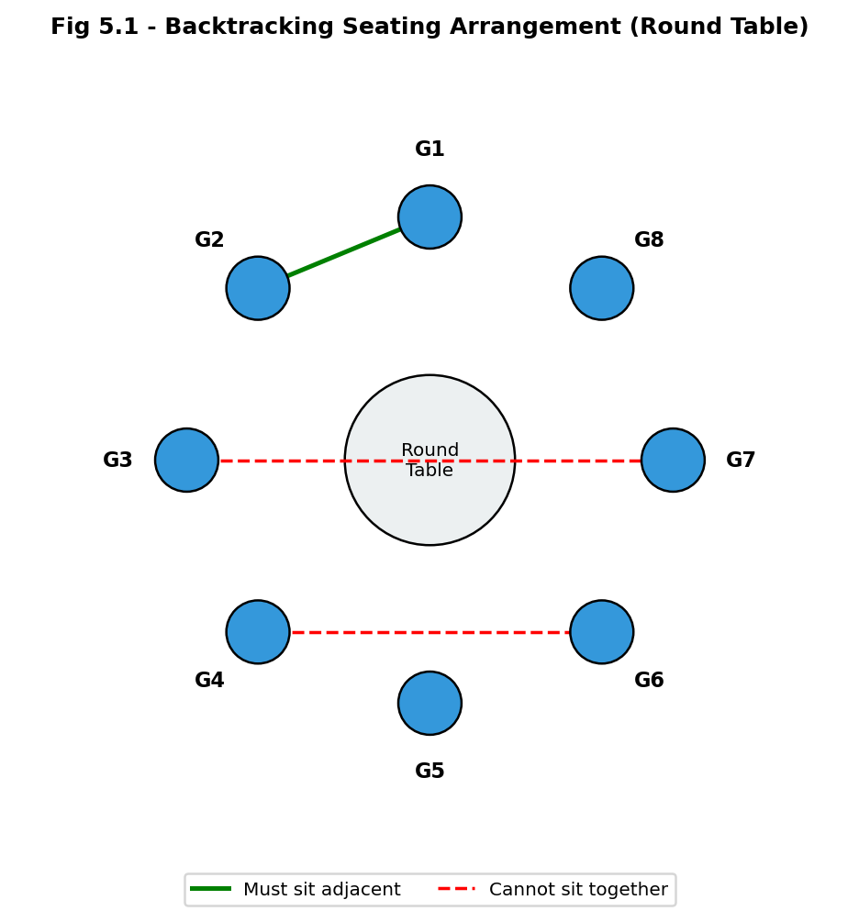
Fig 5.1: Circular seating diagram; the green edge marks a mandatory-adjacent pair, red dashed edges mark pairs that must not sit together.
5. Application of Concepts
- Constraint propagation: every candidate seat is validated against both exclusion and inclusion rules before being fixed.
- Circular adjacency handling via modulo arithmetic (pos-1+n) % n ensures the wrap-around neighbour is also checked.
- Backtracking undoes an assignment as soon as a later guest cannot be seated validly, allowing the algorithm to try a different guest at the earlier seat.
6. Justification
The algorithm is correct because no seat is finalised until it passes both the exclusion and inclusion checks against its (circular) neighbour, so every completed arrangement satisfies all stated constraints. It is complete because every unassigned guest is tried at every open seat, and backtracking ensures that failing branches do not block the discovery of a valid arrangement elsewhere in the search tree. As with most CSPs of this style, worst-case time is O(n!) in the absence of pruning, but the incremental adjacency checks eliminate large portions of the seating permutations well before completion, keeping practical performance efficient for the problem sizes typical of event seating.

Q6. N-Queens Problem (Backtracking / Constraint Satisfaction Problem)
A chessboard of size N x N must be filled with N queens such that no two queens attack each other.
1. Problem Definition and Constraints
Place N queens on an N x N chessboard, one per row, such that no two queens share the same row, column, or diagonal (the standard chess capture pattern for a queen).
- Row constraint: exactly one queen is placed per row (enforced structurally by placing row-by-row).
- Column constraint: no two queens may share the same column.
- Diagonal constraint: no two queens may share the same major (row - col) or minor (row + col) diagonal.
2. Constraint Analysis
Placing one queen per row automatically satisfies the row constraint, reducing the problem to choosing, for each row, a column that does not clash with any previously placed queen's column or either diagonal. The column and both diagonal constraints can each be tracked in O(1) using boolean arrays / bitmasks indexed by column, (row-col), and (row+col), which is what makes an efficient safety check possible at every recursive step. This transforms an otherwise N^N brute-force placement space into a search that prunes a branch the instant any single constraint is violated.
3. Backtracking Solution Development
function solveNQueens(row, cols[], diag1[], diag2[], board):
if row == N:
record board as a solution; return
for col in 0..N-1:
if cols[col] or diag1[row-col+N] or diag2[row+col]:
continue // PRUNE: unsafe column
place queen at (row, col)
cols[col] = diag1[row-col+N] = diag2[row+col] = true
solveNQueens(row+1, cols, diag1, diag2, board)
remove queen at (row, col) // BACKTRACK
cols[col] = diag1[row-col+N] = diag2[row+col] = false
4. Diagram
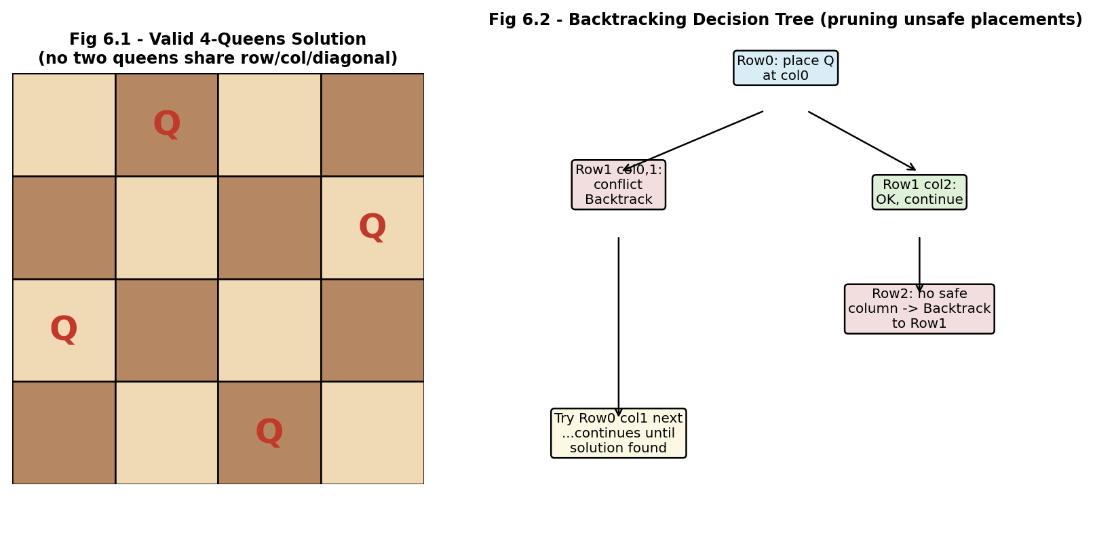
Fig 6.1 & 6.2: A valid 4-Queens board configuration (left) and the corresponding backtracking decision tree showing conflict detection and backtrack steps (right).
5. Application of Concepts (Pruning)
- O(1) safety check using column/diagonal marker arrays avoids re-scanning all previously placed queens at every step.
- Early pruning (continue on conflict) discards an unsafe column immediately, never exploring the corresponding subtree.
- Backtracking (unmarking cols/diag1/diag2 and removing the queen) restores the board state for the next candidate column in the same row.
6. Justification and Complexity
The algorithm is correct because a queen is only placed after verifying it does not conflict with any previously placed queen in column, or either diagonal, so every recorded board is a valid non-attacking configuration. It is complete because it systematically tries every column in every row (subject to pruning), guaranteeing all N-Queens solutions are eventually found. The theoretical worst case is O(N!) (choices shrink row by row similarly to a permutation), but constraint propagation via the marker arrays prunes the vast majority of the N^N raw placement space, making the backtracking approach dramatically faster in practice than brute force, especially for moderate N.

Q7. Sudoku Solver (Backtracking / NP-Complete Problem)
A partially filled 9x9 Sudoku grid must be completed such that each row, column, and subgrid contains unique numbers from 1 to 9.
1. Problem Definition and Constraints
Given a 9x9 grid with some cells pre-filled, fill every empty cell with a digit 1-9 such that the completed grid satisfies all Sudoku rules. Sudoku, generalised to n x n grids, is known to be NP-Complete.
- Row constraint: each row must contain the digits 1-9 exactly once.
- Column constraint: each column must contain the digits 1-9 exactly once.
- Subgrid (box) constraint: each of the nine 3x3 subgrids must contain the digits 1-9 exactly once.
- Fixed-cell constraint: pre-filled cells cannot be altered.
2. Constraint Analysis
The three uniqueness constraints (row, column, box) all interact at every empty cell - a candidate digit must simultaneously satisfy all three before it can be placed, which is precisely what constraint propagation (checking all three each time) enforces. Cells with fewer valid candidate digits are more tightly constrained and, if selected first (most-constrained-variable heuristic), fail faster when infeasible, improving pruning efficiency. Pre-filled cells reduce the effective search space from the start by eliminating candidates from their row, column and box.
3. Backtracking Solution Development
function solveSudoku(grid):
cell = findEmptyCell(grid) // e.g., most-constrained first
if cell == null: return true // grid is complete
(r, c) = cell
for digit in 1..9:
if isValid(grid, r, c, digit): // row+col+box check
grid[r][c] = digit
if solveSudoku(grid): return true
grid[r][c] = 0 // BACKTRACK
return false // trigger backtrack upward
function isValid(grid, r, c, d):
return d not in row(r) and d not in col(c) and d not in box(r,c)
4. Diagram
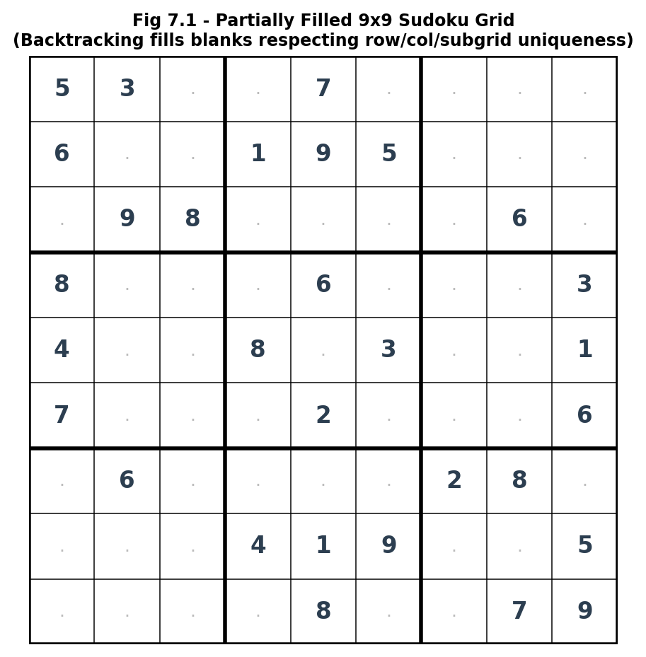
Fig 7.1: A partially filled Sudoku grid; the backtracking solver fills each blank cell with a digit that satisfies the row, column and 3x3 subgrid constraints.
5. Application of Concepts
- Constraint propagation via isValid() checks all three Sudoku rules together before any placement is accepted.
- Pruning: an invalid digit is rejected instantly (isValid returns false), so its subtree is never explored.
- Backtracking (grid[r][c] = 0) undoes a placement when every digit 1-9 fails at some later cell, letting the search retry the previous cell with a different digit.
6. Justification and Performance
The solver is correct because a digit is committed to a cell only after passing all three uniqueness checks, so a completed grid returned by the algorithm is guaranteed valid. It is complete since every candidate digit 1-9 is attempted at every empty cell (with backtracking on failure), so a solution will be found whenever one exists. Sudoku's NP-Completeness means worst-case behaviour can still be exponential for adversarial or sparsely filled puzzles, but the most-constrained-cell heuristic and immediate constraint checking (equivalent to a basic form of constraint propagation/forward checking) prune the vast majority of invalid branches, making the approach fast in practice for standard 9x9 puzzles.

Q8. Graph Coloring (Constraint Satisfaction / NP-Complete Problem)
A map must be coloured such that no two adjacent regions have the same colour, using the minimum number of colours.
1. Problem Definition and Constraints
Represent each map region as a vertex and each shared border between two regions as an edge. Assign a colour to every vertex such that no two adjacent vertices share a colour, using the fewest colours possible (the chromatic number). Deciding whether a graph is k-colourable for a given k is NP-Complete for k >= 3.
- Adjacency constraint: two regions sharing a border (an edge in the graph) must receive different colours.
- Minimality constraint: the total number of distinct colours used should be as small as possible.
- Completeness constraint: every region must be assigned exactly one colour.
2. Constraint Analysis and Prioritization
The adjacency constraint is the hard constraint checked before any colour is fixed to a region - it must hold for every edge in the final colouring. The minimality objective is handled by first attempting the search with a small number of colours k (starting from the graph's clique number or degree-based lower bound) and increasing k only if no valid k-colouring is found, rather than searching with an arbitrarily large palette from the start. Ordering regions by decreasing degree (most-adjacent regions first) is prioritised because these vertices are the hardest to colour and benefit most from being decided early.
3. Backtracking Solution Development
function graphColor(vertex, k, colors[]):
if vertex == V.size: return true
for c in 1..k:
if isSafe(vertex, c, colors):
colors[vertex] = c
if graphColor(vertex+1, k, colors): return true
colors[vertex] = 0 // BACKTRACK
return false
// Driver: try increasing k until a solution is found (minimum colours)
for k in lowerBound..V.size:
if graphColor(0, k, colors): return k, colors
4. Diagram
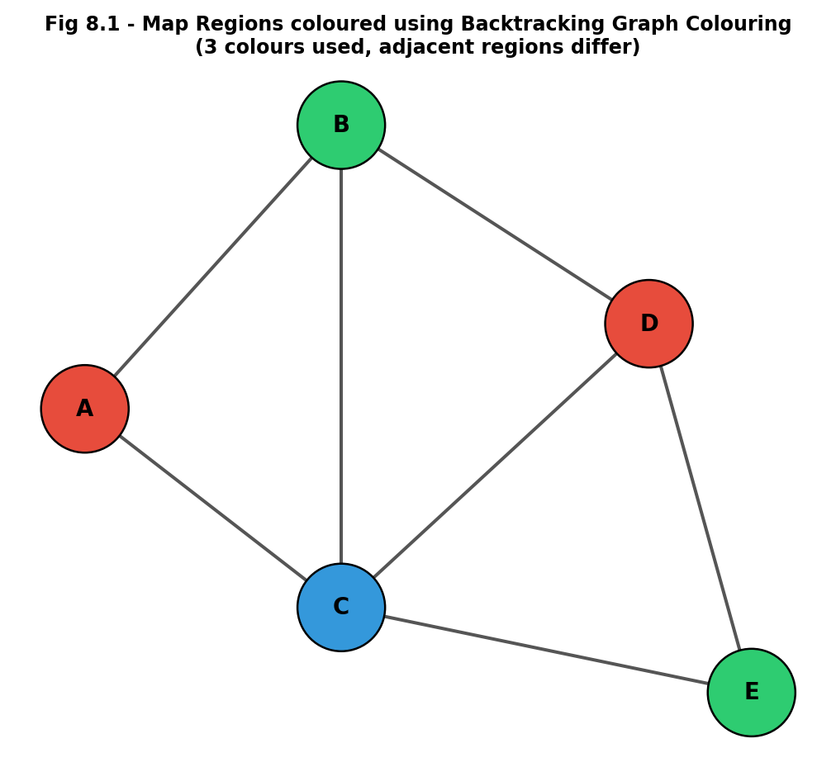
Fig 8.1: A map represented as a graph, coloured with the minimum number of colours (3) using backtracking so that adjacent regions always differ.
5. Application of Concepts
- isSafe() enforces the adjacency constraint and serves as the pruning function that avoids ever exploring an invalid colouring.
- The incremental-k driver loop applies the minimality objective without needing to search the full colour-count range for every attempt.
- Backtracking allows a previously coloured region to be revisited and recoloured whenever the current colour choice leads to a dead end further down the recursion.
6. Justification
The approach is correct because isSafe() is checked against every already-coloured neighbour before a colour is fixed, guaranteeing the final colouring never places the same colour on adjacent regions. It is complete because every colour 1..k is attempted for every vertex, with backtracking ensuring the algorithm exhausts all possibilities before concluding no k-colouring exists. Since Graph Colouring is NP-Complete, no polynomial-time algorithm is known for the general case, but the region-ordering heuristic and immediate adjacency pruning drastically cut down the k^V search space typically encountered for real map graphs, which tend to be planar and hence 4-colourable in the worst case (Four Colour Theorem).

Q9. Subset Sum Problem (Backtracking / NP-Complete Problem)
Given a set of integers, determine if there exists a subset whose sum equals a target value.
1. Problem Definition and Constraints
Given a set S = {s1, s2, ..., sn} of integers and a target value T, determine whether a subset of S exists whose elements sum exactly to T (and optionally list that subset). Subset Sum is a classical NP-Complete decision problem.
- Sum constraint: the sum of the chosen subset must equal exactly T.
- Selection constraint: each element is either included in the subset or excluded (binary choice), and each element may be used at most once.
- Search-space constraint: with n elements, there are 2^n possible subsets to consider in the naive case.
2. Constraint Analysis
At every step of building a candidate subset, the running sum can be compared against the target: if the running sum already exceeds T (assuming non-negative integers), every extension of that branch will also exceed T, so the branch can be pruned immediately. Likewise, if the running sum plus the sum of all remaining unconsidered elements is still less than T, that branch can never reach the target and is pruned as well. These two bounding checks are what keep the backtracking search far smaller than the raw 2^n subset space in most practical instances.
3. Backtracking Solution Development
function subsetSum(index, currentSum, chosen[]):
if currentSum == target:
record chosen as a valid subset; return true
if index == n or currentSum > target:
return false // PRUNE: overshoot or exhausted
if currentSum + sumRemaining(index) < target:
return false // PRUNE: cannot reach target
chosen.add(S[index])
if subsetSum(index+1, currentSum+S[index], chosen): return true
chosen.remove(S[index]) // BACKTRACK (exclude branch)
return subsetSum(index+1, currentSum, chosen)
4. Diagram
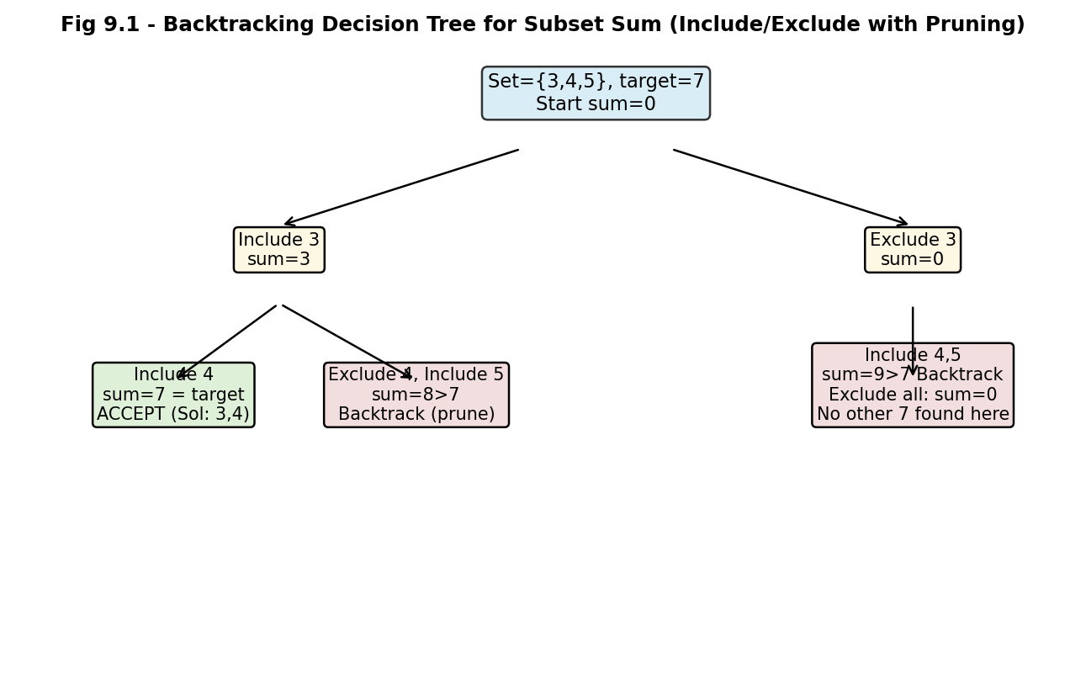
Fig 9.1: Include/exclude backtracking decision tree for Subset Sum with S = {3,4,5}, target = 7, showing an accepted branch and pruned (backtracked) branches.
5. Application of Concepts
- Include/exclude recursion is the canonical backtracking template for subset-generation problems.
- Overshoot pruning (currentSum > target) and reachability pruning (currentSum + remaining < target) both eliminate hopeless subtrees early.
- Backtracking (chosen.remove) restores the candidate subset before trying the exclusion branch for the same element.
6. Justification and Complexity
The algorithm is correct because a subset is only reported once its running sum is verified to equal target exactly. It is complete because both the include and exclude options are systematically explored for every element (subject to pruning), so if any valid subset exists it will be found. The worst-case time remains O(2^n), consistent with Subset Sum's NP-Complete classification, but the two pruning bounds typically remove large contiguous portions of the search tree - especially for sets with a wide range of values - making the backtracking solution substantially faster than exhaustive enumeration in practice.

Q10. Hamiltonian Path Problem (Backtracking / NP-Complete Problem)
Given a graph representing cities and connections, determine whether a path exists that visits each vertex exactly once.
1. Problem Definition and Constraints
Given a graph G(V,E) representing cities (vertices) and direct connections/roads (edges), determine whether there exists a path that visits every vertex exactly once (a Hamiltonian Path). Deciding Hamiltonian Path existence is NP-Complete.
- Vertex-visitation constraint: every vertex in V must appear exactly once in the resulting path.
- Path-continuity/adjacency constraint: consecutive vertices in the path must be connected by an edge in E.
- No-repetition constraint: no vertex may be revisited once it has been placed in the path.
2. Constraint Analysis
The adjacency constraint is checked at every step: from the current last vertex in the partial path, only its actual graph-neighbours are valid next candidates, which naturally restricts the branching factor to the vertex's degree rather than all remaining vertices. The no-repetition constraint is enforced with a 'visited' marker checked before adding a candidate vertex. Together, these constraints mean the search only needs to explore neighbours of the current vertex at each step, rather than blindly trying every unvisited vertex regardless of connectivity, which is what keeps the backtracking search grounded in the graph's actual structure.
3. Backtracking Solution Development
function hamPath(path, visited, pos):
if pos == V.size:
record path as a Hamiltonian Path; return true
last = path[pos-1]
for v in adjacency[last]:
if not visited[v]: // no-repetition + adjacency check
visited[v] = true
path[pos] = v
if hamPath(path, visited, pos+1): return true
visited[v] = false // BACKTRACK
path[pos] = undefined
return false
4. Diagram
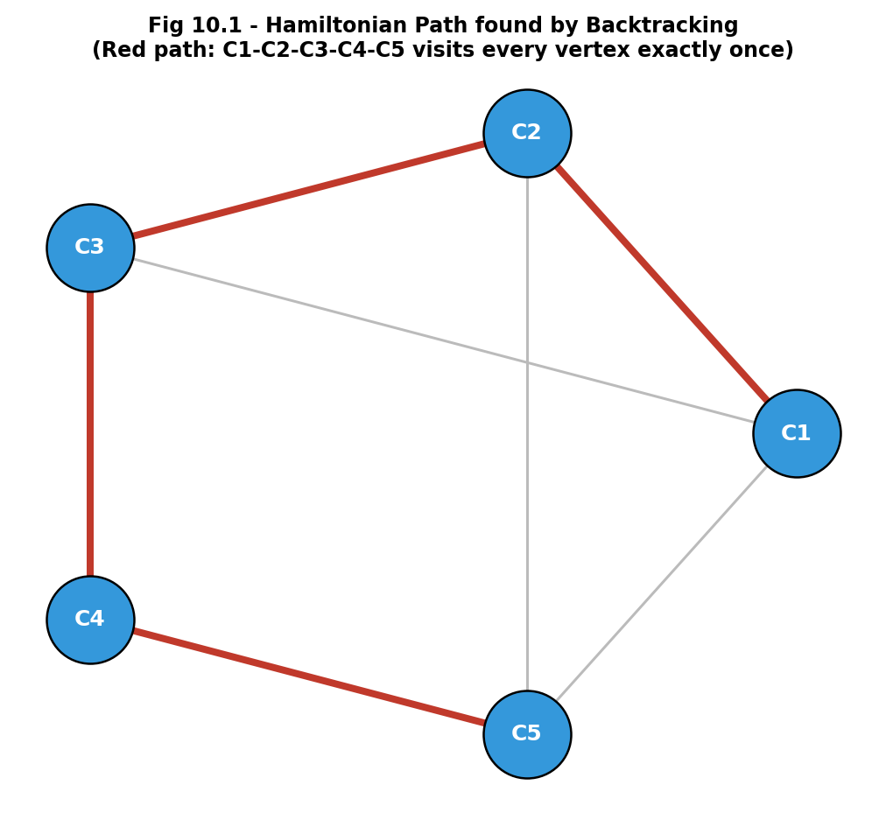
Fig 10.1: A city-connection graph with a Hamiltonian Path (highlighted in red) found by backtracking, visiting every vertex exactly once.
5. Application of Concepts
- Adjacency-restricted branching only considers a vertex's real graph neighbours, which is itself a form of constraint-driven pruning compared to a naive try-any-vertex approach.
- The visited[] array enforces the no-repetition constraint in O(1) per check.
- Backtracking (visited[v] = false) allows a vertex to be released and tried in a different position of the path when the current partial path leads to a dead end.
6. Justification and Complexity
The algorithm is correct because every vertex added to the path is verified to be both unvisited and adjacent to the current last vertex, so any path it returns is guaranteed to be a valid simple path visiting each vertex once. It is complete because, at each step, every unvisited neighbour of the current vertex is tried, and backtracking ensures no viable continuation is missed. Since Hamiltonian Path is NP-Complete, the worst-case running time remains exponential (O(V!) in the absence of structure), but restricting candidate moves to actual graph edges rather than all vertices substantially reduces the effective branching factor for sparse, real-world road/connection graphs, making the backtracking method practical for graphs of moderate size.

