SIMATS ENGINEERING
ASSESSMENT TOOL 2

COURSE NAME: DESIGN AND ANALYSIS OF ALGORITHMS
COURSE CODE: CSA06

COURSE OUTCOME COVERED

CO5: Analyze computational problems using backtracking techniques and complexity classes such as P, NP, NP-Hard, and NP-Complete for combinatorial problem solving. (BL5,BL6)

Assessment Tool Weightage: 20%

QUESTIONS: 10 Total Marks: 50

Annexure A

Pseudocode Writing Task (Algorithm Design)

Code of Conduct:

I SRIVARSHA M – 192371010 (Name / Reg No) certify that this submission is my original work and that I have adhered to the guidelines specified for this assessment.
I understand that any violation of academic integrity rules will result in disciplinary action.

Signature of the student:SRIVARSHA M

Annexure A
Pseudocode Writing Task (Algorithm Design)
Q1. N-Queens Problem
Design a pseudocode using Backtracking to solve the N-Queens problem for an N×N chessboard. Clearly identify inputs (board size) and expected output (valid queen placements). Develop a logically correct algorithm that ensures no two queens attack each other. Use appropriate control structures such as loops and conditional checks for row, column, and diagonal safety. Ensure the pseudocode is well-structured and easy to follow. Handle all possible configurations and optimize by pruning invalid placements.
Q2. Subset Sum Problem
Write a pseudocode to determine whether a subset of given integers sums to a target value using Backtracking. Clearly define inputs (set of numbers and target sum) and output (true/false or subset). Design a complete algorithm with proper branching and pruning conditions. Use control structures effectively to explore subsets. Present the pseudocode in a structured and readable format. Ensure the solution handles all cases and avoids unnecessary computations.
Q3. Graph Coloring Problem
Develop a pseudocode using Backtracking to assign colors to vertices of a graph such that no two adjacent vertices share the same color. Clearly identify inputs (graph, number of colors) and output (valid coloring). Design a correct and efficient algorithm using loops and condition checks. Ensure proper use of recursion and validation functions. Structure the pseudocode clearly and logically. Handle all constraints and ensure completeness of the solution.
Q4. Hamiltonian Cycle Problem
Write a pseudocode to find a Hamiltonian Cycle in a given graph using Backtracking. Clearly define inputs (graph) and output (cycle or no solution). Design a step-by-step algorithm that checks each vertex exactly once and returns to the start. Use appropriate control structures and pruning conditions. Present the pseudocode in a clean and structured format. Ensure the solution handles all cases and avoids invalid paths efficiently.
Q5. Sudoku Solver
Design a pseudocode to solve a Sudoku puzzle using Backtracking. Clearly identify inputs (partially filled grid) and output (completed grid). Develop a logically sound algorithm that fills cells while satisfying Sudoku constraints. Use loops and conditional checks effectively for validation. Ensure the pseudocode is well-structured and easy to understand. Handle all possible cases and optimize by skipping invalid placements.
Q6. Knight’s Tour Problem
Design a pseudocode using Backtracking to find a path where a knight visits every square on an N×N chessboard exactly once. Clearly identify inputs (board size) and output (valid tour path). Develop a logically correct algorithm that follows knight movement rules. Use appropriate control structures for move generation and validation. Ensure the pseudocode is well-structured and readable. Handle all cases and optimize by pruning invalid moves.
Q7. Permutation Generation Problem
Write a pseudocode to generate all possible permutations of a given set of elements using Backtracking. Clearly define inputs (set of elements) and output (all permutations). Design a complete algorithm with proper swapping and backtracking steps. Use loops and recursive calls effectively. Present the pseudocode in a clear and structured format. Ensure all permutations are generated without repetition.
Q8. Maze Solving Problem (Rat in a Maze)
Develop a pseudocode using Backtracking to find a path from the start to the destination in a maze. Clearly identify inputs (maze grid) and output (valid path). Design an algorithm that explores all possible paths using recursion. Use control structures to validate moves and avoid obstacles. Structure the pseudocode clearly and logically. Ensure all valid paths are explored and invalid paths are pruned.
Q9. Combination Sum Problem
Write a pseudocode to find all combinations of numbers that sum to a given target using Backtracking. Clearly define inputs (set of numbers and target) and output (valid combinations). Design an algorithm with proper branching and pruning conditions. Use loops and recursion effectively to explore combinations. Present the pseudocode in a clean format. Ensure completeness while avoiding duplicate solutions.
Q10. Word Search Problem (Grid Search)
Design a pseudocode using Backtracking to determine if a given word exists in a 2D character grid. Clearly identify inputs (grid and word) and output (true/false). Develop an algorithm that explores all possible paths using recursion. Use appropriate control structures to validate character matching and boundaries. Ensure the pseudocode is well-structured and easy to follow. Optimize by pruning invalid paths early.

Q1. N-Queens Problem
Place N queens on an N×N chessboard using Backtracking such that no two queens attack each other (no shared row, column, or diagonal).
Inputs / Outputs
Input: board size N. Output: all safe placements of N queens (row, column positions), or the first valid arrangement.
Pseudocode
ALGORITHM N_Queens(board, row, N)
IF row == N THEN
PRINT board // a complete safe placement found
RETURN
FOR col = 0 TO N-1
IF isSafe(board, row, col, N) THEN
place queen at (row, col)
N_Queens(board, row+1, N) // recurse to next row
remove queen from (row, col) // backtrack

FUNCTION isSafe(board, row, col, N)
FOR i = 0 TO row-1
IF board[i][col] == QUEEN THEN RETURN false // column clash
FOR i,j = row-1,col-1 DOWNTO 0 STEP -1,-1
IF board[i][j] == QUEEN THEN RETURN false // upper-left diagonal
FOR i,j = row-1,col+1 DOWNTO 0, N-1 STEP -1,+1
IF board[i][j] == QUEEN THEN RETURN false // upper-right diagonal
RETURN true
Diagram — one valid solution for N = 4
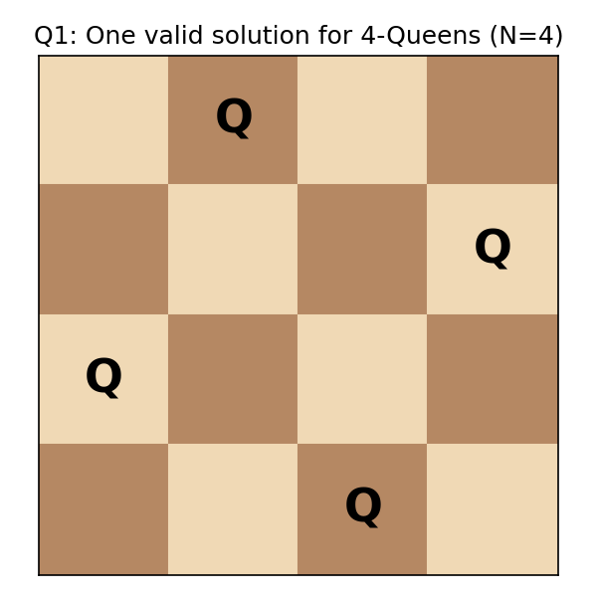
Fig. 1: Safe queen placement (row-wise) for a 4x4 board
Complexity: worst case O(N!) explored placements, pruned heavily by the safety check, giving practical performance far better than brute force O(N^N).

Q2. Subset Sum Problem
Determine whether a subset of a given set of integers sums exactly to a target value, using Backtracking with include/exclude branching.
Inputs / Outputs
Input: set of integers arr[0..n-1], target sum S. Output: true/false, and the qualifying subset if found.
Pseudocode
ALGORITHM SubsetSum(arr, n, index, currentSum, target, subset)
IF currentSum == target THEN
PRINT subset
RETURN true
IF index == n OR currentSum > target THEN
RETURN false // prune: exceeded target or exhausted list

// Choice 1: include arr[index]
subset.add(arr[index])
IF SubsetSum(arr, n, index+1, currentSum+arr[index], target, subset) THEN
RETURN true
subset.remove(arr[index]) // backtrack

// Choice 2: exclude arr[index]
RETURN SubsetSum(arr, n, index+1, currentSum, target, subset)
Complexity: O(2^n) in the worst case; pruning (currentSum > target) removes large parts of the search tree.

Q3. Graph Coloring Problem
Assign colors to graph vertices using Backtracking so that no two adjacent vertices share the same color, using at most M colors.
Inputs / Outputs
Input: graph as adjacency matrix graph[V][V], number of colors M. Output: a valid color assignment color[0..V-1] or failure.
Pseudocode
ALGORITHM GraphColoring(graph, color, vertex, V, M)
IF vertex == V THEN
PRINT color[] // all vertices successfully colored
RETURN true
FOR c = 1 TO M
IF isSafeColor(graph, color, vertex, c, V) THEN
color[vertex] = c
IF GraphColoring(graph, color, vertex+1, V, M) THEN
RETURN true
color[vertex] = 0 // backtrack
RETURN false

FUNCTION isSafeColor(graph, color, vertex, c, V)
FOR i = 0 TO V-1
IF graph[vertex][i] == 1 AND color[i] == c THEN
RETURN false // adjacent vertex has same color
RETURN true
Diagram — example 3-coloring of a graph
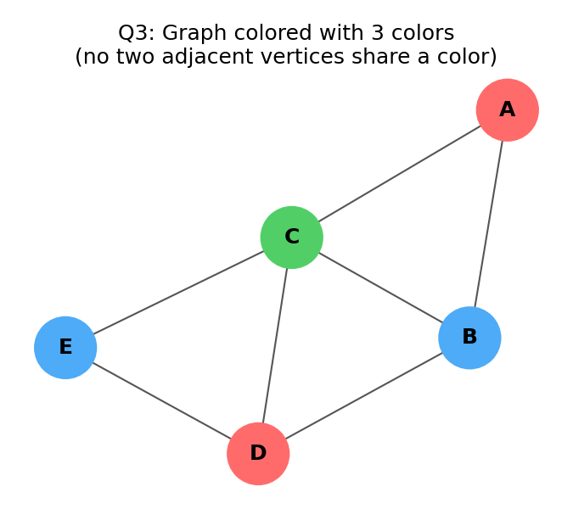
Fig. 2: A graph validly colored with 3 colors
Complexity: O(M^V) in the worst case, reduced substantially through adjacency-based pruning.

Q4. Hamiltonian Cycle Problem
Find a cycle in a given graph that visits every vertex exactly once and returns to the starting vertex, using Backtracking.
Inputs / Outputs
Input: graph as adjacency matrix graph[V][V]. Output: the Hamiltonian cycle (sequence of vertices) or 'no solution'.
Pseudocode
ALGORITHM HamiltonianCycle(graph, path, pos, V)
IF pos == V THEN
IF graph[path[pos-1]][path[0]] == 1 THEN
PRINT path // cycle closes back to start
RETURN true
RETURN false
FOR v = 1 TO V-1
IF isValidVertex(graph, path, v, pos) THEN
path[pos] = v
IF HamiltonianCycle(graph, path, pos+1, V) THEN
RETURN true
path[pos] = -1 // backtrack
RETURN false

FUNCTION isValidVertex(graph, path, v, pos)
IF graph[path[pos-1]][v] == 0 THEN RETURN false // not adjacent
FOR i = 0 TO pos-1
IF path[i] == v THEN RETURN false // already visited
RETURN true
Diagram — Hamiltonian cycle in a sample graph
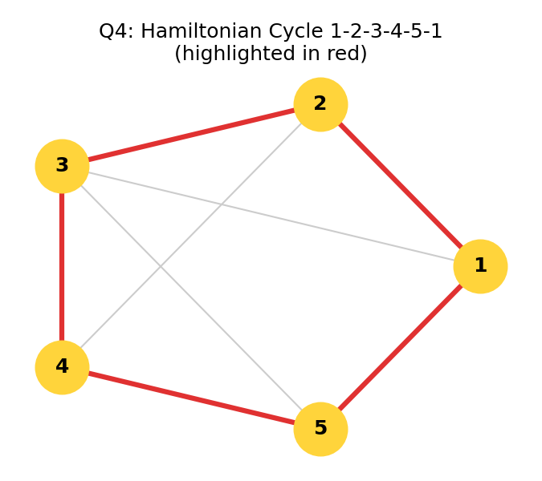
Fig. 3: Cycle 1-2-3-4-5-1 highlighted in red
Complexity: O(V!) worst case; pruning via adjacency and visited checks removes invalid branches early.

Q5. Sudoku Solver
Fill a partially completed 9x9 Sudoku grid using Backtracking so each row, column, and 3x3 subgrid contains digits 1-9 exactly once.
Inputs / Outputs
Input: partially filled grid[9][9] (0 = empty cell). Output: fully completed valid grid.
Pseudocode
ALGORITHM SolveSudoku(grid)
IF no empty cell remains THEN
RETURN true // grid is complete
(row, col) = findEmptyCell(grid)
FOR num = 1 TO 9
IF isSafeSudoku(grid, row, col, num) THEN
grid[row][col] = num
IF SolveSudoku(grid) THEN
RETURN true
grid[row][col] = 0 // backtrack
RETURN false // triggers backtracking to previous cell

FUNCTION isSafeSudoku(grid, row, col, num)
IF num appears in grid[row][*] THEN RETURN false // row check
IF num appears in grid[*][col] THEN RETURN false // column check
IF num appears in the 3x3 subgrid containing (row,col) THEN RETURN false
RETURN true
Diagram — sample input grid
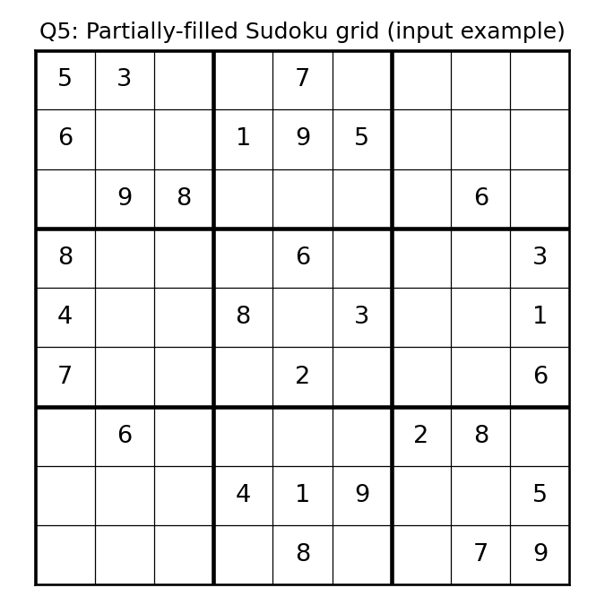
Fig. 4: A partially filled 9x9 Sudoku grid (input)
Complexity: worst case O(9^m) where m = number of empty cells; constraint checks prune invalid branches quickly.

Q6. Knight's Tour Problem
Find a sequence of moves so a knight visits every square of an N×N chessboard exactly once, using Backtracking over valid knight moves.
Inputs / Outputs
Input: board size N, starting position. Output: a full tour (sequence of visited squares) or failure.
Pseudocode
MOVES_X = [2,1,-1,-2,-2,-1,1,2]
MOVES_Y = [1,2,2,1,-1,-2,-2,-1]

ALGORITHM KnightTour(board, x, y, moveCount, N)
IF moveCount == N*N THEN
PRINT board // all squares visited exactly once
RETURN true
FOR i = 0 TO 7
nextX = x + MOVES_X[i]
nextY = y + MOVES_Y[i]
IF isSafeMove(nextX, nextY, board, N) THEN
board[nextX][nextY] = moveCount
IF KnightTour(board, nextX, nextY, moveCount+1, N) THEN
RETURN true
board[nextX][nextY] = UNVISITED // backtrack
RETURN false

FUNCTION isSafeMove(x, y, board, N)
RETURN (0 <= x < N) AND (0 <= y < N) AND board[x][y] == UNVISITED
Diagram — example partial knight's tour
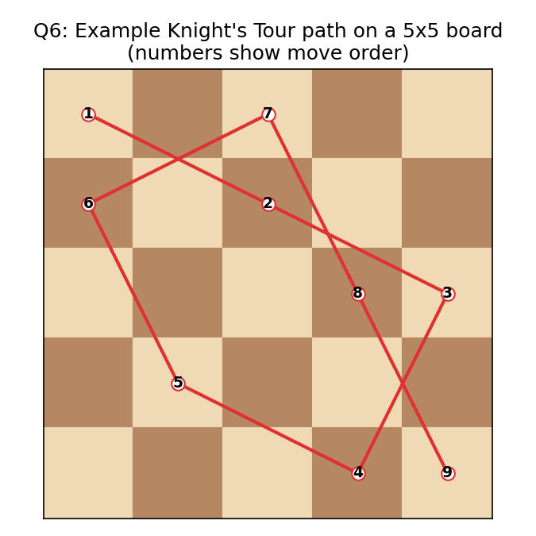
Fig. 5: Sample knight move sequence on a 5x5 board
Complexity: worst case O(8^(N*N)); the Warnsdorff heuristic (choosing the move with fewest onward options) greatly improves practical speed.

Q7. Permutation Generation Problem
Generate all possible permutations of a given set of elements using Backtracking (swap-based approach).
Inputs / Outputs
Input: array arr[0..n-1]. Output: all n! permutations of the elements.
Pseudocode
ALGORITHM Permute(arr, l, r)
IF l == r THEN
PRINT arr // one complete permutation
RETURN
FOR i = l TO r
swap(arr[l], arr[i])
Permute(arr, l+1, r) // recurse for remaining positions
swap(arr[l], arr[i]) // backtrack: restore original order
Complexity: O(n × n!) — n! permutations, each requiring O(n) work to print/copy.

Q8. Maze Solving Problem (Rat in a Maze)
Find a path from a start cell to a destination cell in a maze grid using Backtracking, avoiding blocked cells.
Inputs / Outputs
Input: maze grid[N][N] (1 = open cell, 0 = wall). Output: a valid path from source to destination, or 'no path exists'.
Pseudocode
ALGORITHM SolveMaze(maze, x, y, sol, N)
IF x == N-1 AND y == N-1 AND maze[x][y] == 1 THEN
sol[x][y] = 1
PRINT sol // destination reached
RETURN true
IF isSafeCell(maze, x, y, N) THEN
sol[x][y] = 1 // mark cell as part of path
IF SolveMaze(maze, x+1, y, sol, N) THEN RETURN true // move down
IF SolveMaze(maze, x, y+1, sol, N) THEN RETURN true // move right
sol[x][y] = 0 // backtrack: unmark cell
RETURN false
RETURN false

FUNCTION isSafeCell(maze, x, y, N)
RETURN (0 <= x < N) AND (0 <= y < N) AND maze[x][y] == 1
Diagram — sample maze
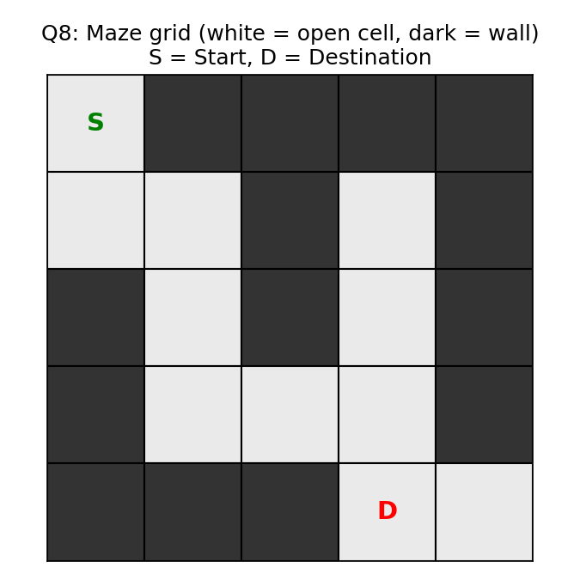
Fig. 6: Maze grid with Start (S) and Destination (D)
Complexity: worst case O(2^(N*N)) for unrestricted movement; pruning invalid/visited cells keeps it practical for typical mazes.

Q9. Combination Sum Problem
Find all combinations of numbers (each number can be reused) from a given set that sum to a target value, using Backtracking.
Inputs / Outputs
Input: candidate array candidates[0..n-1], target sum T. Output: all combinations whose elements sum to T.
Pseudocode
ALGORITHM CombinationSum(candidates, start, target, current, n)
IF target == 0 THEN
PRINT current // valid combination found
RETURN
IF target < 0 THEN
RETURN // prune: sum exceeded target
FOR i = start TO n-1
current.add(candidates[i])
CombinationSum(candidates, i, target-candidates[i], current, n) // reuse allowed
current.removeLast() // backtrack
Complexity: exponential in the worst case, bounded by target/min(candidate); the target<0 pruning avoids exploring invalid sums.

Q10. Word Search Problem (Grid Search)
Determine whether a given word exists in a 2D character grid by moving to horizontally/vertically adjacent cells, using Backtracking.
Inputs / Outputs
Input: character grid[R][C], target word. Output: true/false (word found or not).
Pseudocode
ALGORITHM Exist(grid, word, row, col, index, R, C)
IF index == length(word) THEN
RETURN true // all characters matched
IF row<0 OR row>=R OR col<0 OR col>=C THEN
RETURN false // out of bounds
IF grid[row][col] != word[index] THEN
RETURN false // character mismatch

temp = grid[row][col]
grid[row][col] = '#' // mark cell as visited

found = Exist(grid, word, row+1, col, index+1, R, C) OR
Exist(grid, word, row-1, col, index+1, R, C) OR
Exist(grid, word, row, col+1, index+1, R, C) OR
Exist(grid, word, row, col-1, index+1, R, C)

grid[row][col] = temp // backtrack: restore character
RETURN found

ALGORITHM WordSearch(grid, word, R, C)
FOR row = 0 TO R-1
FOR col = 0 TO C-1
IF Exist(grid, word, row, col, 0, R, C) THEN
RETURN true
RETURN false
Diagram — example grid search
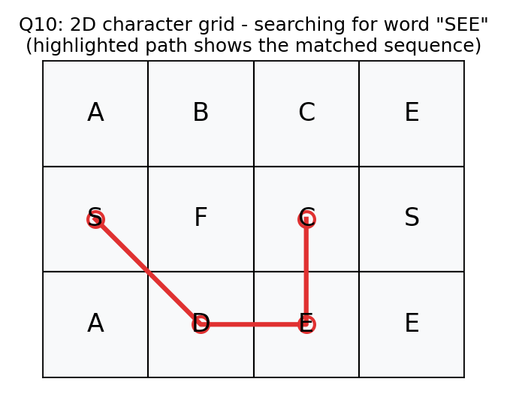
Fig. 7: Word found by tracing adjacent matching cells (highlighted path)
Complexity: O(R × C × 4^L) where L is word length; the '#' marking prevents reusing the same cell within one search path.

