ASSESSMENT TOOL: 02
Scenario Based Assessment
- A drone navigation system determines boundary points of obstacles
using brute-force convex hull approach.
a) Explain how convex hull is computed.
b) Analyze time complexity.
c) Discuss scalability challenges.
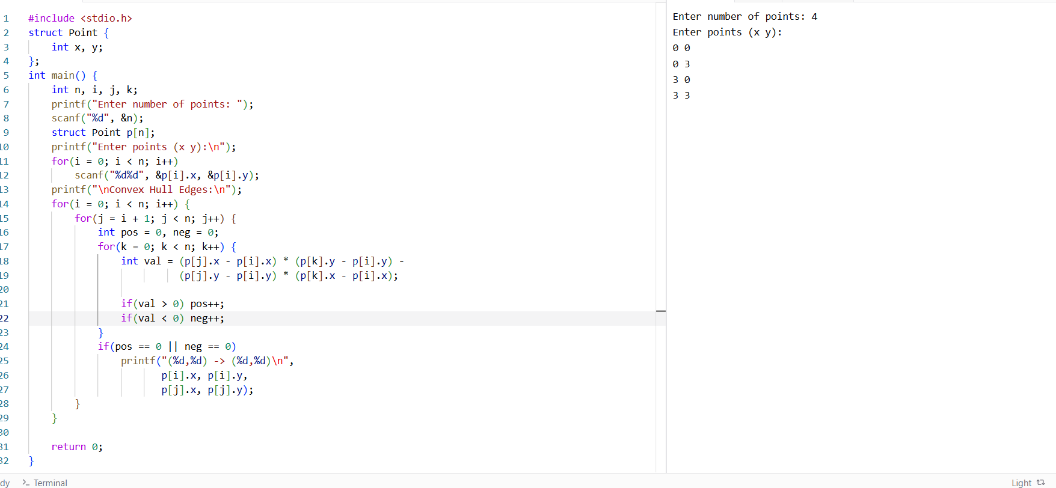

- A data analytics platform processes sensor readings that arrive in random
order and must be sorted periodically for trend visualization.
a) Analyze how Selection Sort and Bubble Sort would behave for this dataset.
b) Compare their performance in terms of comparisons and swaps.
c) Recommend the most suitable sorting method with proper justification.
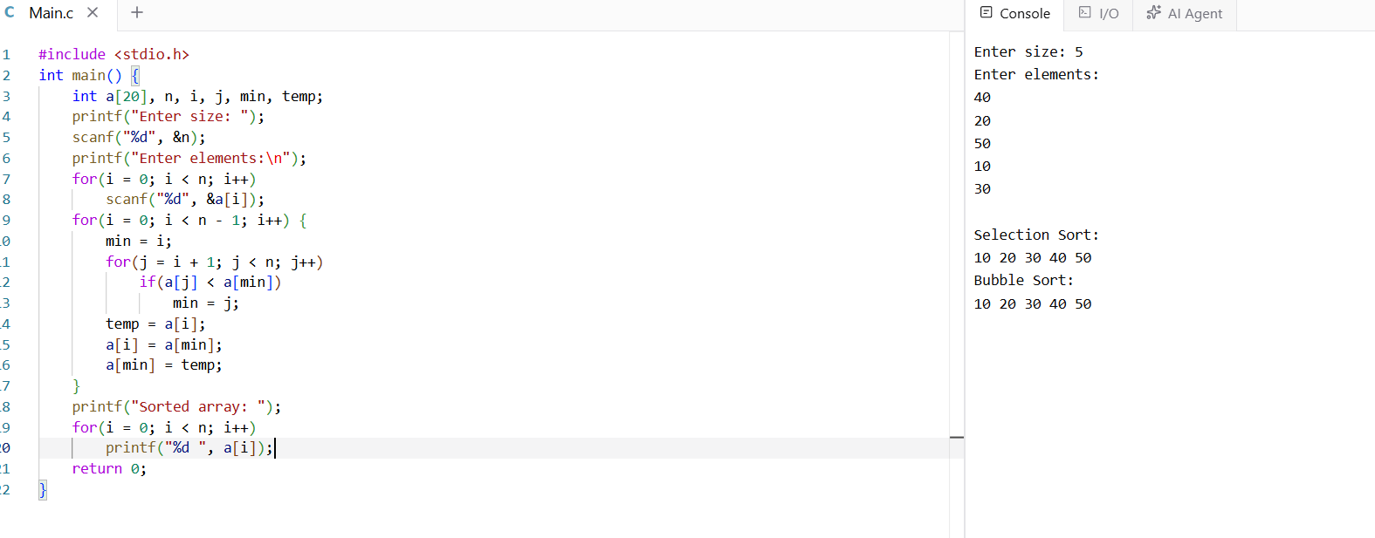

3. A ride-sharing application calculates distances between all driver and
rider locations to assign the nearest driver using brute-force comparison.
a) Explain how the brute-force closest pair approach works in this case.
b) Derive the time complexity for computing all distances.
c) Discuss why scalability becomes an issue as users increase.
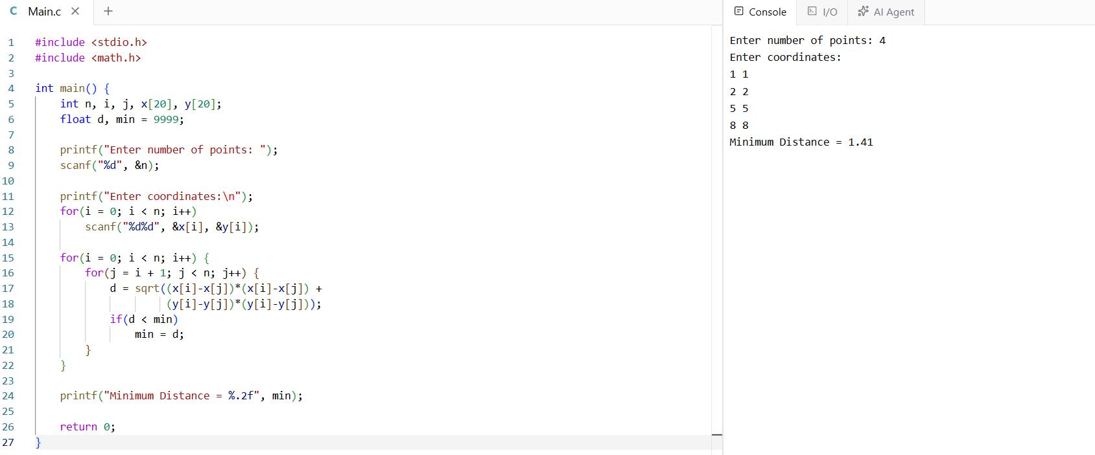
4. A library system stores book IDs in an unsorted list due to frequent
additions and deletions. Users search for books using a basic search feature.
a) Explain how Linear Search is applied in this scenario.
b) Analyze the best, average, and worst-case complexities.
c) Justify whether sorting would improve system efficiency.
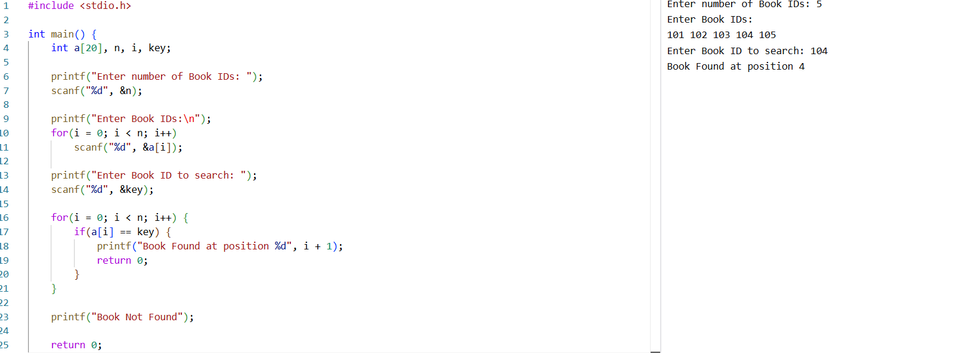
5. A geographic mapping system identifies the outer boundary of terrain
points using a brute-force convex hull algorithm. The number of data points
grows continuously.
a) Explain how the brute-force convex hull algorithm operates.
b) Analyze its computational complexity.
c) Discuss why the approach is inefficient for large datasets.
