ASSESSMENT TOOL 3
DEBUGGING &OPTIMISATION TASK
- Debugging Sorting Code (Mixed Ascending and Descending Conditions)
The following sorting implementation contains inconsistent comparison conditions
across different passes, causing partially sorted and unstable output. Carefully
analyze the logic and identify how conflicting ascending and descending
comparisons break correctness. Apply systematic debugging to make the algorithm
consistent throughout execution. Optimize the implementation to improve readability
and avoid unnecessary operations. Analyze the time complexity of the corrected
version and justify the result. Rewrite the final clean and optimized code with suitable
comments.
def mixed_sort(arr):
n = len(arr)
for i in range(n):
for j in range(0, n-i-1):
if i % 2 == 0:
if arr[j] &gt; arr[j+1]:
arr[j], arr[j+1] = arr[j+1], arr[j]
else:
if arr[j] &lt; arr[j+1]:
arr[j], arr[j+1] = arr[j+1], arr[j]
return arr
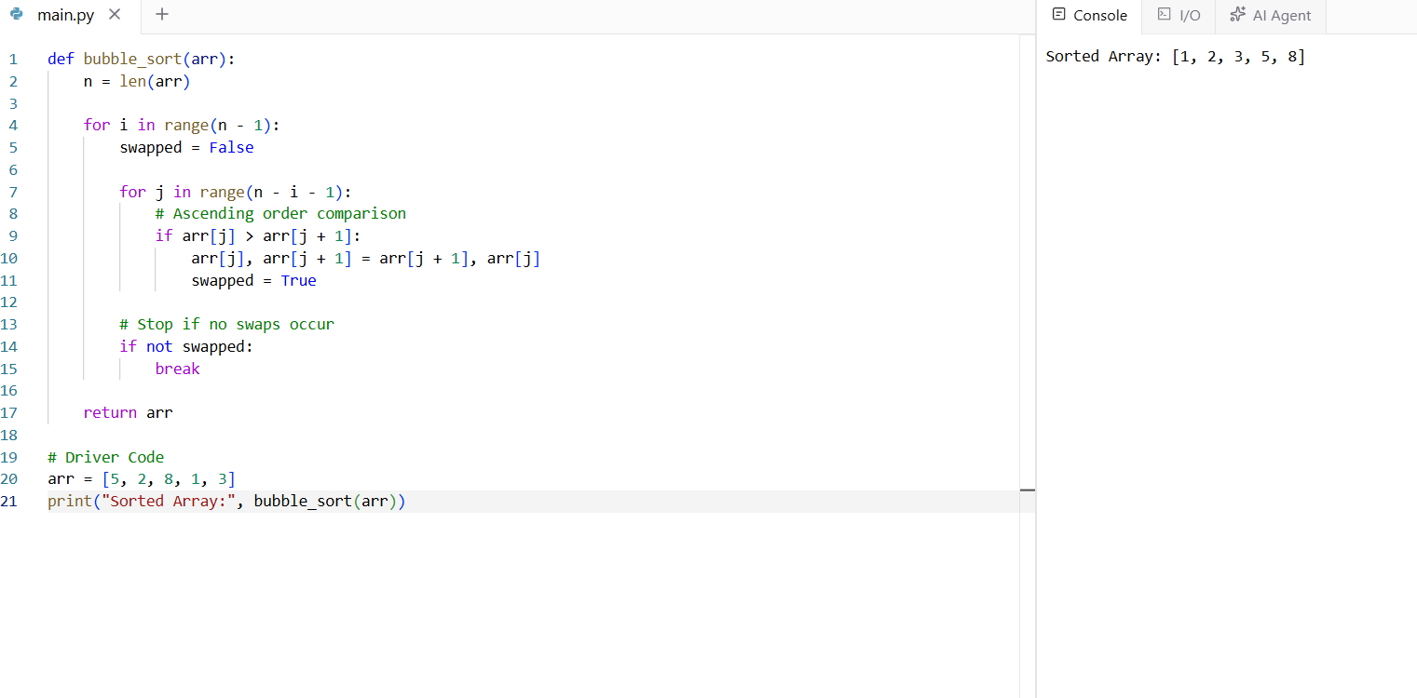

Q2. Debugging Selection Sort Code (Incorrect Outer Loop Range)
The following Selection Sort implementation skips the final required pass because of
an incorrect outer loop boundary, which may leave the array partially unsorted for
certain inputs. Carefully analyze the loop range and explain why the remaining
unsorted portion is not handled correctly. Apply systematic debugging to correct the
iteration structure and ensure complete sorting. Optimize the implementation by
avoiding unnecessary swaps when the minimum element is already in the correct
position. Analyze the time complexity of the corrected version and rewrite the final
optimized code with proper comments.
def selection_sort(arr):
n = len(arr)
for i in range(n-2): # ERROR
min_idx = i
for j in range(i+1, n):
if arr[j] &lt; arr[min_idx]:
min_idx = j
arr[i], arr[min_idx] = arr[min_idx],arr[i]
return arr
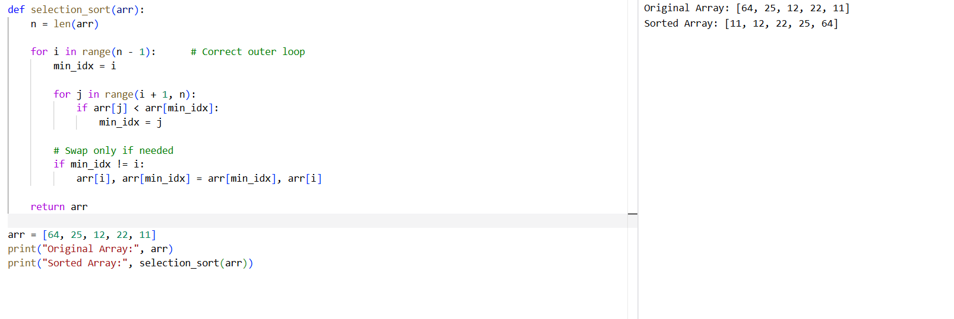
Q3. Debugging Bubble Sort Code (Wrong Inner Loop Limit with Optimization
Attempt)
The following Bubble Sort implementation attempts to reduce comparisons in each
pass, but the inner loop limit is incorrect and causes some adjacent pairs to remain
unchecked. Carefully inspect the loop boundary and explain why certain inversions
survive after execution. Debug the algorithm step-by-step to restore correct sorting
behavior. Optimize the final version using a swap flag so that unnecessary passes
are avoided when the array becomes sorted early. Analyze the corrected algorithm in
best, average, and worst cases and rewrite the final code with proper structure.

def bubble_sort(arr):
n = len(arr)
for i in range(n):
for j in range(0, n-i-2): # ERROR
if arr[j] &gt; arr[j+1]:
arr[j], arr[j+1] = arr[j+1], arr[j]
return arr
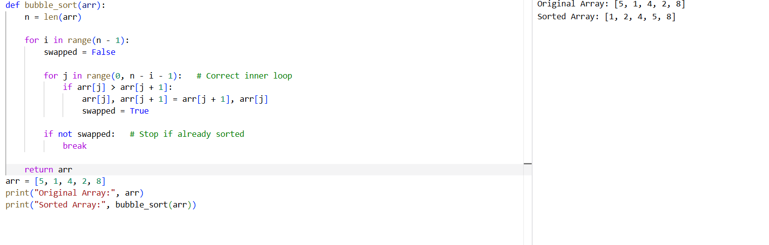
Q4. Debugging Linear Search Code (Incorrect Index Variable Update)
The following Linear Search implementation incorrectly updates the result index
even after finding the target, causing the function to return the last occurrence
instead of the first one. Carefully analyze the logic and identify why the intended
search behavior is violated. Apply systematic debugging to ensure that the first valid
occurrence is returned immediately when found. Optimize the implementation for
readability and correct control flow. Analyze the time complexity of the corrected
solution and rewrite the final code with clear comments.
def linear_search(arr, key):
pos = -1
for i in range(len(arr)):
if arr[i] == key:
pos = i
return pos
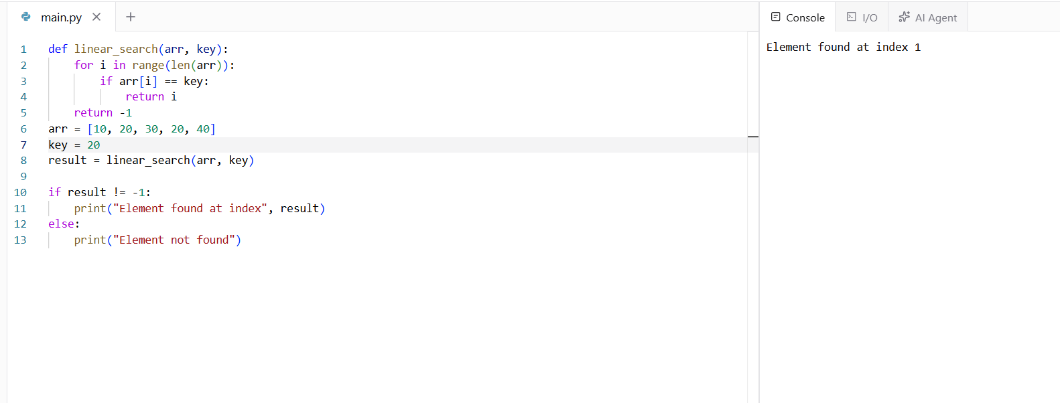
Q5. Debugging Binary Search Code (Incorrect Mid Recalculation Logic)
The following Binary Search code recalculates the midpoint incorrectly because the
boundary updates are inconsistent with the search direction. Carefully inspect the
update rules for low and high and explain why valid regions may be discarded.
Debug the code step-by-step so that the search interval shrinks correctly in all cases.
Optimize the implementation for clarity and proper handling of edge cases. Analyze
best, average, and worst-case time complexity and rewrite the corrected code with
suitable documentation.
def binary_search(arr, key):
low, high = 0, len(arr)-1
while low &lt;= high:
mid = (low + high) // 2
if arr[mid] == key:
return mid
elif arr[mid] &gt; key:
low = mid + 1 # ERROR
else:
high = mid - 1 # ERROR
return -1
