COURSE NAME: Theory of Computation COURSE CODE: CSA13 04

COURSE OUTCOME COVERED

CO3: Construct regular expressions, and use the pumping lemma and closure properties to analyze regular languages. (BL:3)

Assessment Tool Weightage: 40%

QUESTIONS: 5 Total Marks:100
Duration : 1 Hour

Experiments

Code of Conduct:

I M.SRIVARSHA -192371010 (Name / Reg No) certify that this submission is my original work and that I have adhered to the guidelines specified for this assessment.
I understand that any violation of academic integrity rules will result in disciplinary action.

Signature of the student: M.Srivarsha

Sl. No. | Lab Experiments - Questions
1 | Write a C program to check whether a given string belongs to the language defined by a Context Free Grammar (CFG)  S → 0A1 A → 0A | 1A | ε
2 | Write a C program to check whether a given string belongs to the language defined by a Context Free Grammar (CFG)  S → 0S0 | 1S1 | 0 | 1 | ε
3 | Write a C program to check whether a given string belongs to the language defined by a Context Free Grammar (CFG)  S → 0S0 | A A → 1A | ε
4 | Write a C program to check whether a given string belongs to the language defined by a Context Free Grammar (CFG)  S → 0S1 | ε
5 | Write a C program to check whether a given string belongs to the language defined by a Context Free Grammar (CFG)  S → A101A A → 0A | 1A | ε

Programs:

1.Code:

#include <stdio.h>
#include <string.h>

int main() {
char s[100];
scanf("%s", s);

int n = strlen(s);

if (n >= 2 && s[0] == '0' && s[n-1] == '1')
printf("Accepted");
else
printf("Rejected");

return 0;
}
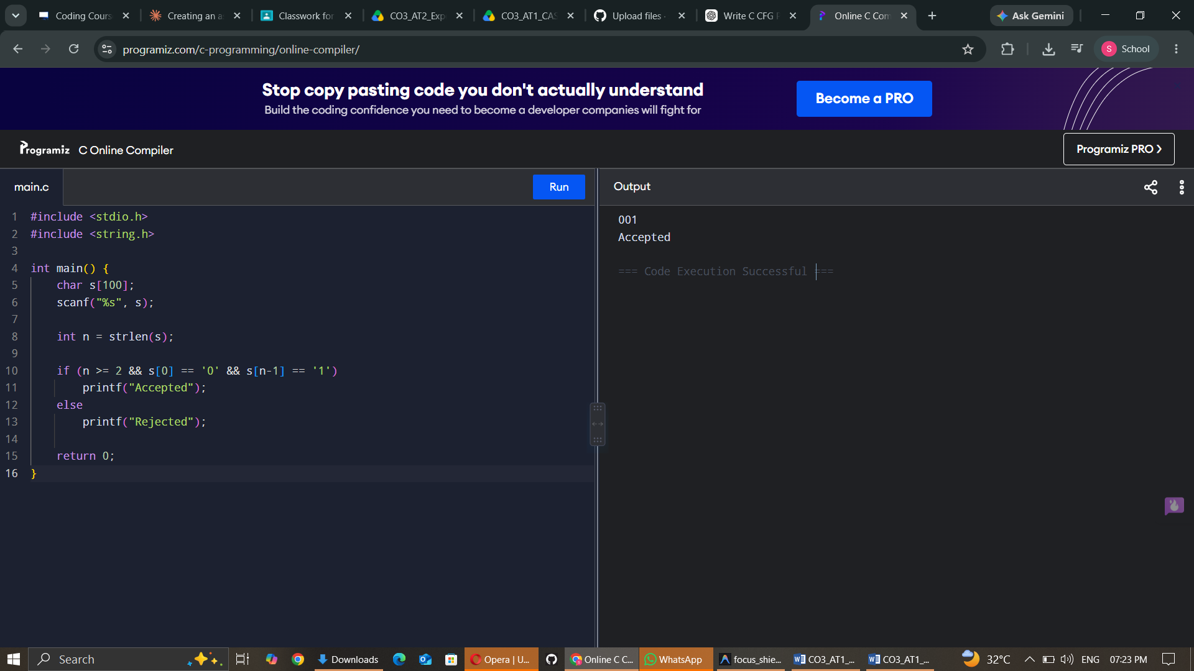

2.Code:

#include <stdio.h>
#include <string.h>

int main() {
char s[100];
scanf("%s", s);

int i = 0, j = strlen(s) - 1;

while (i < j) {
if (s[i] != s[j]) {
printf("Rejected");
return 0;
}
i++;
j--;
}

printf("Accepted");
return 0;
}

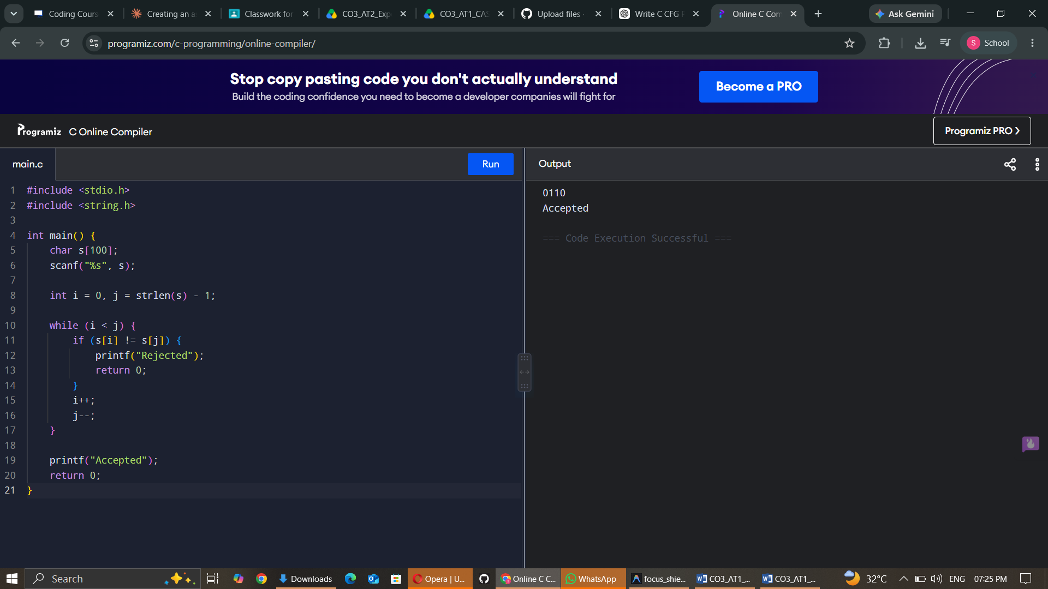

3.Code:

#include <stdio.h>
#include <string.h>

int main() {
char s[100];
int n, i = 0, j, k = 0;

scanf("%s", s);
n = strlen(s);
j = n - 1;

while (i < n && s[i] == '0') i++;
while (j >= 0 && s[j] == '0') j--;

for (int x = i; x <= j; x++)
if (s[x] != '1') {
printf("Rejected");
return 0;
}

int left = i;
int right = n - 1 - j;

if (left == right)
printf("Accepted");
else
printf("Rejected");

return 0;
}
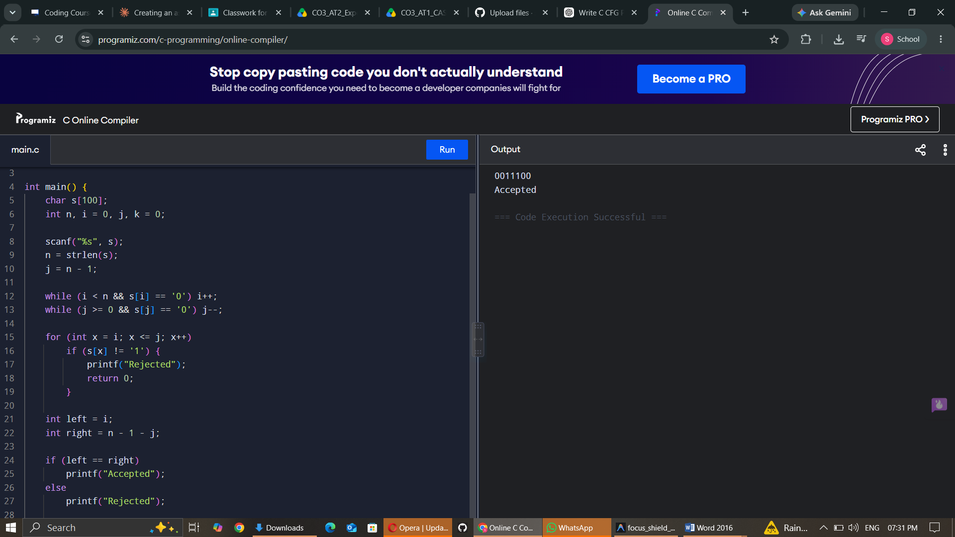

4. Code:

#include <stdio.h>
#include <string.h>

int main() {
char s[100];
int n, i = 0, zeros = 0, ones = 0;

scanf("%s", s);
n = strlen(s);

while (s[i] == '0') {
zeros++;
i++;
}

while (s[i] == '1') {
ones++;
i++;
}

if (i == n && zeros == ones)
printf("Accepted");
else
printf("Rejected");

return 0;
}

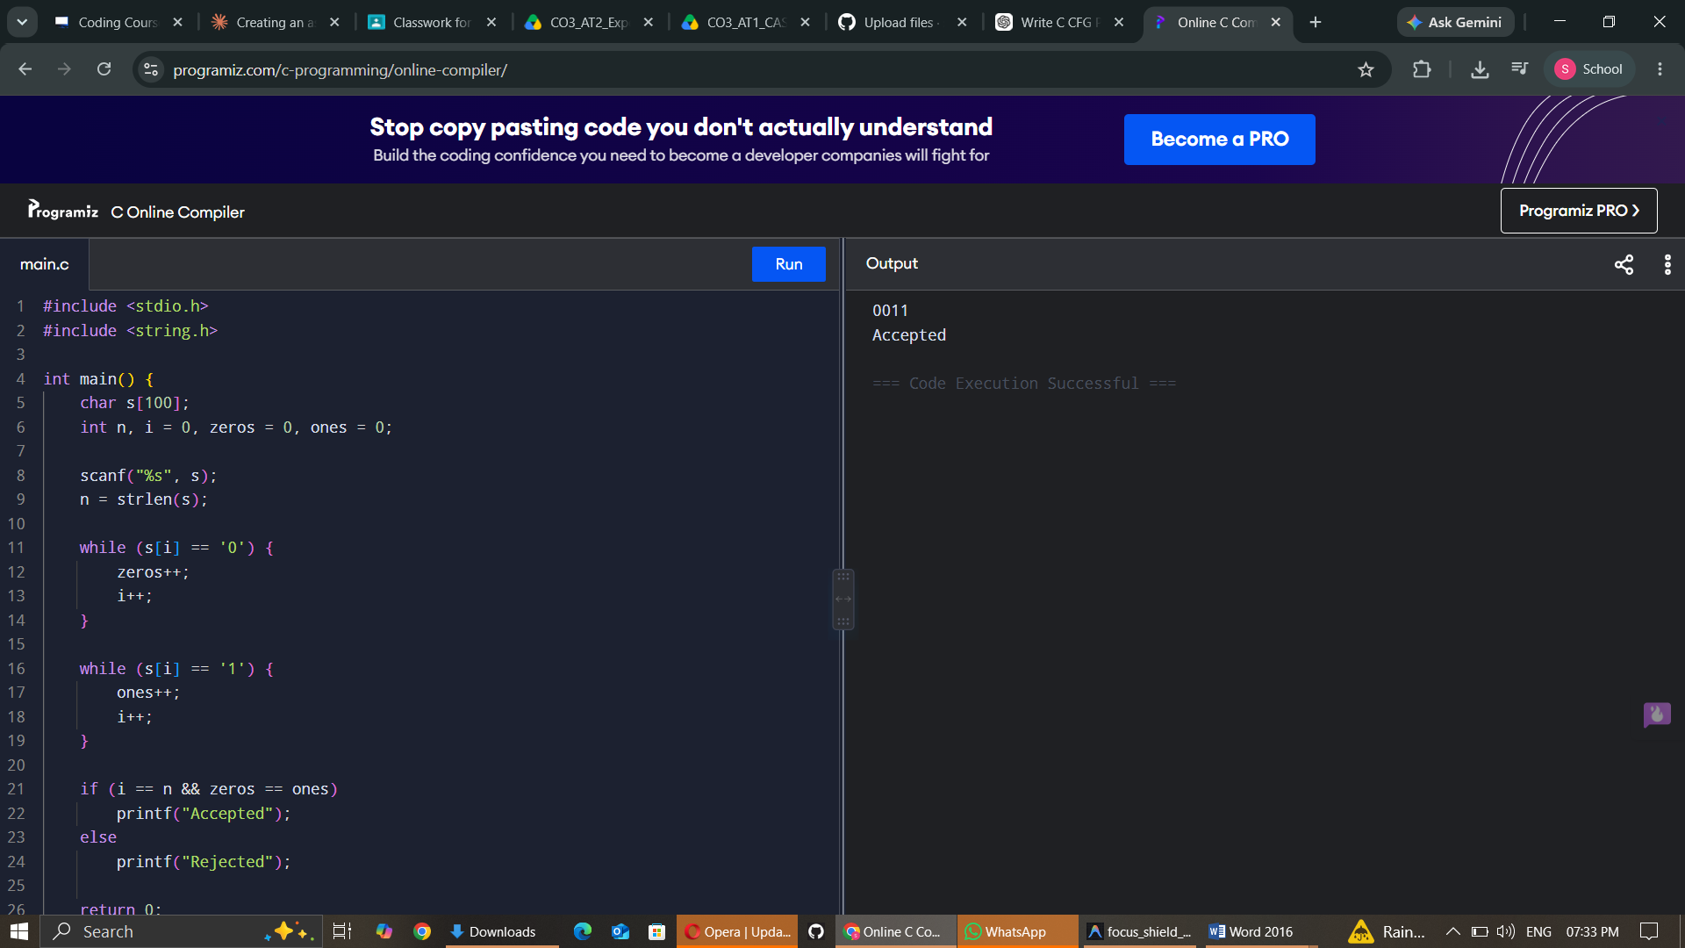

5.Code:

#include <stdio.h>
#include <string.h>

int main() {
char s[100];
int n, found = 0;

scanf("%s", s);
n = strlen(s);

for (int i = 0; i <= n - 3; i++) {
if (s[i] == '1' && s[i+1] == '0' && s[i+2] == '1') {
found = 1;
break;
}
}

if (found)
printf("Accepted");
else
printf("Rejected");

return 0;
}

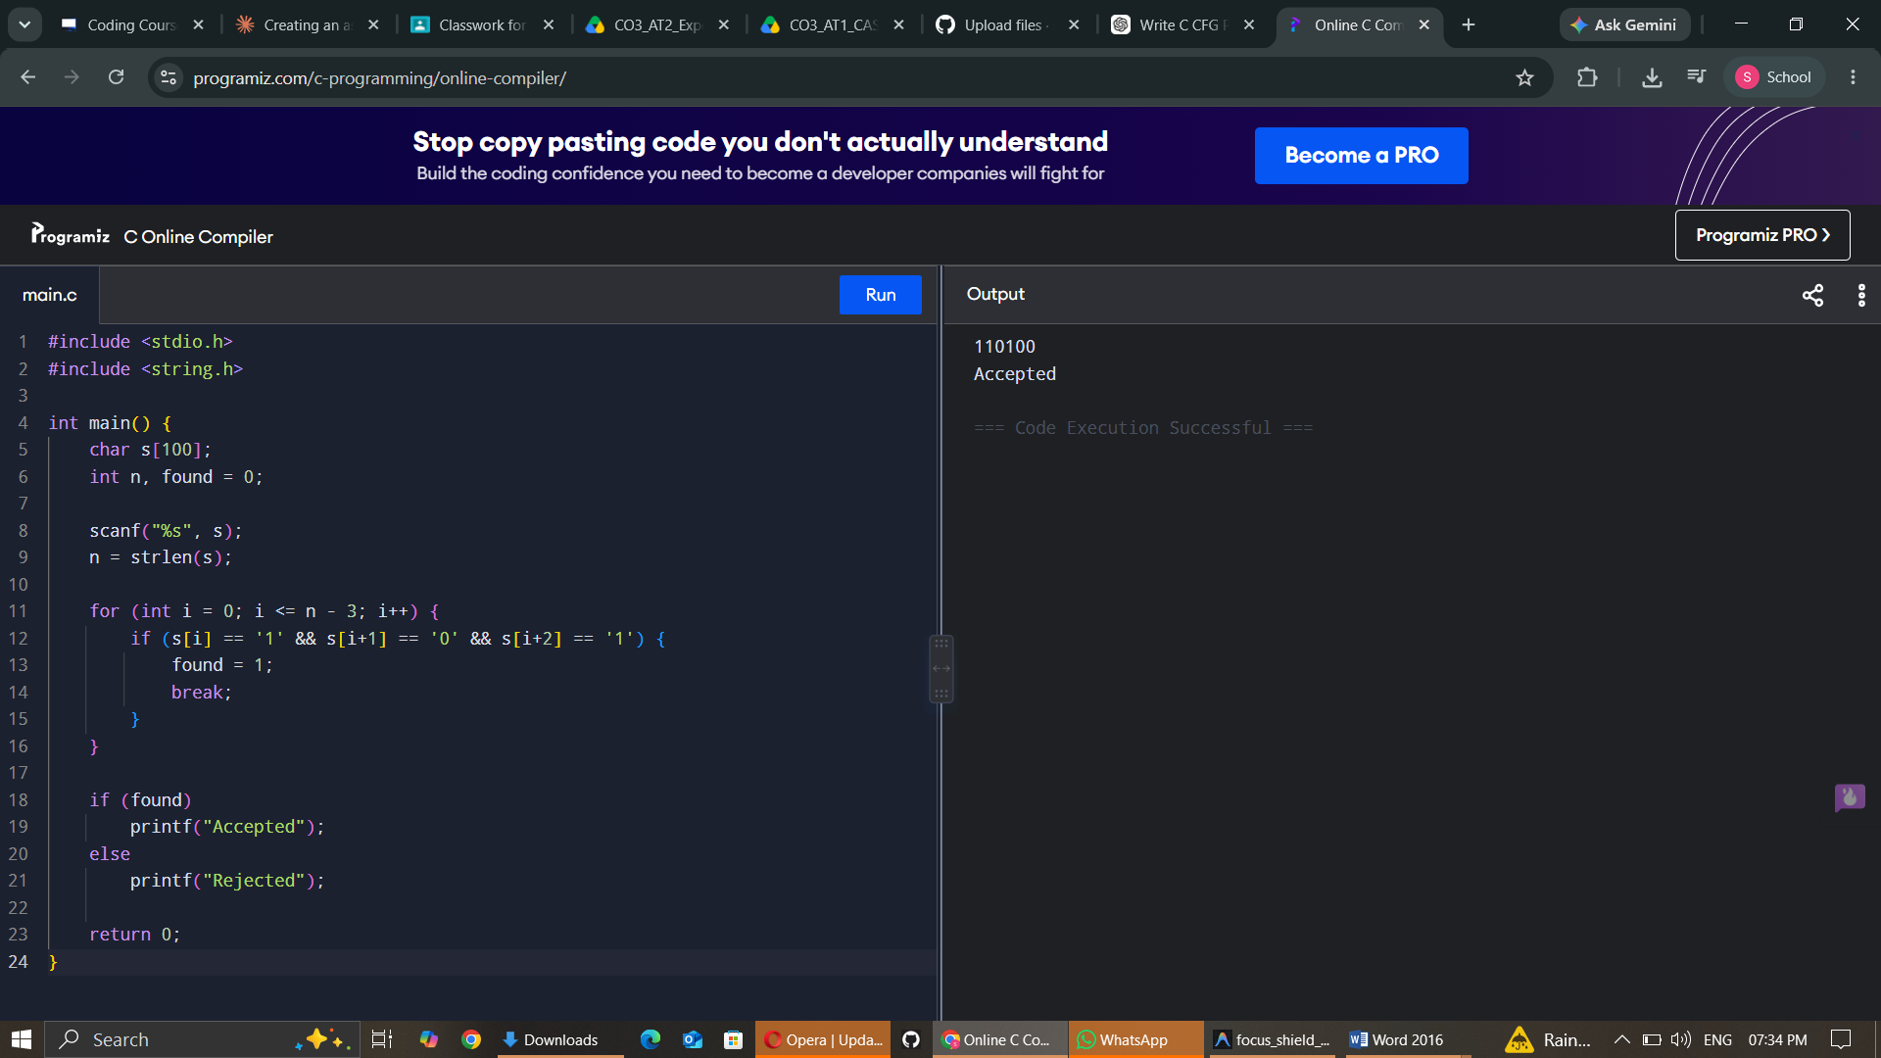

RUBRICS FOR CALCULATION

Criteria | Weightage | Level 4 – Exemplary (5 Marks) | Level 3 – Proficient (4 Marks) | Level 2 – Developing (2–3 Marks) | Level 1 – Beginning (0–1 Mark)
Conceptual Understanding | 30 | Demonstrates clear and complete understanding of the concept | Good understanding with minor gaps | Basic understanding with some misconceptions | Poor or incorrect understanding
Accuracy of Answer | 25 | Completely correct answer with no errors | Mostly correct with minor errors | Partially correct with noticeable errors | Incorrect or irrelevant answer
Application of Knowledge | 20 | Correctly applies concepts to solve the question/problem | Applies concepts with minor mistakes | Limited or partially correct application | No or incorrect application
Completeness of Response | 15 | Covers all required parts of the question | Covers most parts with minor omissions | Covers only some parts | Incomplete or missing response
Clarity & Presentation | 10 | Clear, concise, and well-organized answer | Understandable with minor issues | Somewhat unclear or poorly structured | Difficult to understand

