SIMATS ENGINEERING
ASSESSMENT TOOL

COURSE NAME: Theory of Computation COURSE CODE: CSA13

COURSE OUTCOME COVERED
CO1: Analyze fundamental mathematical concepts of automata theory for formal languages and
decision problems(BL:3)

Assessment Tool Weightage: 20%

QUESTIONS: 5 Total Marks:25
Duration : 1 Hour

Simulation

Code of Conduct:
I SRIVARSHA M (192371010) (Name / Reg No) certify that this submission is my original work and that .I have adhered to the guidelines specified for this assessment.
I understand that any violation of academic integrity rules will result in disciplinary action.

M.SRIVARSHA
Signature of the student

1.Design a Non-Deterministic Finite Automaton (NBA) for an Automatic Door System based on sensor inputs.An automatic door system can be modeled using an NBA to represent different states and transitions. The system consists of four states: Closed, Opening, Open, and Closing. The input symbols are P (Person detected) and N (No person detected). Initially, the door is in the Closed state. When a person is detected (P), the system may non-deterministically transition from Closed to Opening. Once opened, the system moves to the Open state. If no person is detected (N), the door transitions to Closing and eventually returns to the Closed state. Non- determinism occurs when the system may remain in the Open state even if a person is detected or may start closing if no detection occurs.
Automatic Door System using NFA
1. States
- q₀ = Closed (Start State)
- q₁ = Opening
- q₂ = Open (Final State)
- q₃ = Closing
2. Input Alphabet
$$Σ=\{P,N\}$$
where:
- P = Person detected
- N = No person detected

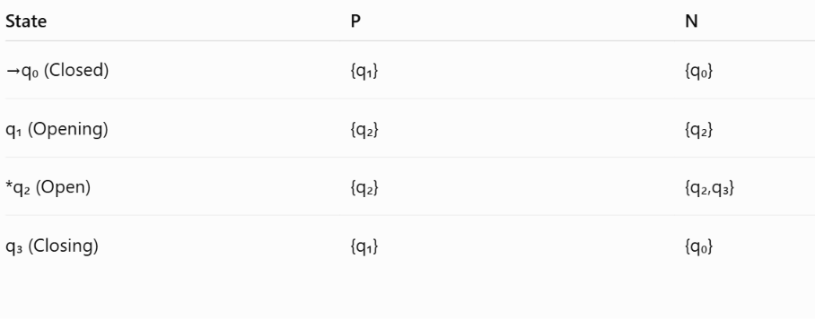
3. NFA Transition Table
4. Formal Definition
$$M=(Q,Σ,δ,q_{0},F)$$
where
- Q = {q₀,q₁,q₂,q₃}
- Σ = {P,N}
- Start State = q₀
- Final State = {q₂}
Transition function:
- δ(q₀,P) = {q₁}
- δ(q₀,N) = {q₀}
- δ(q₁,P) = {q₂}
- δ(q₁,N) = {q₂}
- δ(q₂,P) = {q₂}
- δ(q₂,N) = {q₂,q₃}
- δ(q₃,P) = {q₁}
- δ(q₃,N) = {q₀}
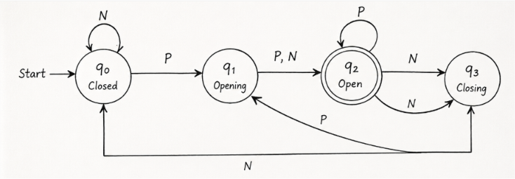
5. NFA Diagram

Explanation
- Initially, the door is in the Closed (q₀) state.
- When a Person (P) is detected, the door moves to Opening (q₁).
- After opening, it enters the Open (q₂) state.
- While open:
  - If another Person (P) is detected, it remains open.
  - If No Person (N) is detected, it may either remain open or start closing (q₃). This is the non-deterministic behavior.
- From Closing (q₃):
  - If a Person (P) is detected, it starts opening again.
  - If No Person (N) is detected, it returns to the Closed (q₀) state.

2.Design a finite automaton to model a traffic light control system at a road intersection. The automaton should represent different states corresponding to the traffic lights, such as Red, Green, and Yellow. Define the transitions between these states based on a timer or control signals, ensuring that the sequence follows the standard order (Red → Green → Yellow → Red). Include considerations for timing constraints, such as how long each light remains active, and describe how the automaton handles continuous cycling of signals. Additionally, explain how this model can be extended to handle pedestrian crossing signals or emergency vehicle overrides, ensuring safe and efficient traffic flow.
Finite Automaton for Traffic Light Control System
1. States (Q)
- q₀ = Red
- q₁ = Green
- q₂ = Yellow
2. Input Alphabet (Σ)
$$Σ=\{T\}$$
Where:
- T = Timer expires (or control signal)
3. Start State
$$q_{0}$$
(Red Light)
4. Final State
Since the traffic light operates continuously, there is no final state.
$$F=∅$$
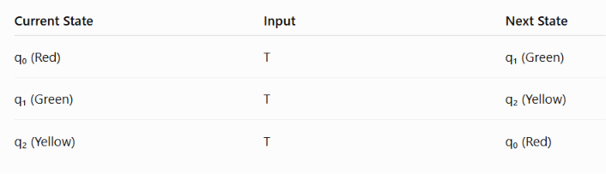
5. Transition Function
6. Formal Definition
The Finite Automaton is defined as
$$M=(Q,Σ,δ,q_{0},F)$$
where
- Q = {q₀, q₁, q₂}
- Σ = {T}
- q₀ = Start State
- F = ∅
- δ is defined by
  - δ(q₀,T) = q₁
  - δ(q₁,T) = q₂
  - δ(q₂,T) = q₀
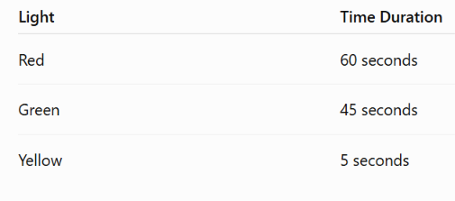
Timing Constraints
The timer automatically changes the signal after the specified duration.
Continuous Cycling
The automaton continuously repeats the sequence:
Red → Green → Yellow → Red → Green → Yellow → ...
This ensures uninterrupted traffic control.
Extension for Pedestrian Crossing
The automaton can be extended by adding pedestrian signals.
- During the Red light, pedestrians receive the Walk signal.
- During the Green light, pedestrians receive the Don't Walk signal.
- A pedestrian button can trigger a safe crossing interval before vehicles receive the Green signal.
Extension for Emergency Vehicle Override
The automaton can also support emergency vehicles.
- When an emergency vehicle is detected, the controller immediately changes the signal to Green for the emergency vehicle's direction.
- Other directions remain at Red.
- After the emergency vehicle passes, the controller resumes the normal cycle.
Working
- Initially, the traffic light is in the Red (q₀) state.
- After 60 seconds, it changes to Green (q₁).
- After 45 seconds, it changes to Yellow (q₂).
- After 5 seconds, it returns to Red (q₀).
- This cycle repeats continuously to ensure smooth traffic flow.

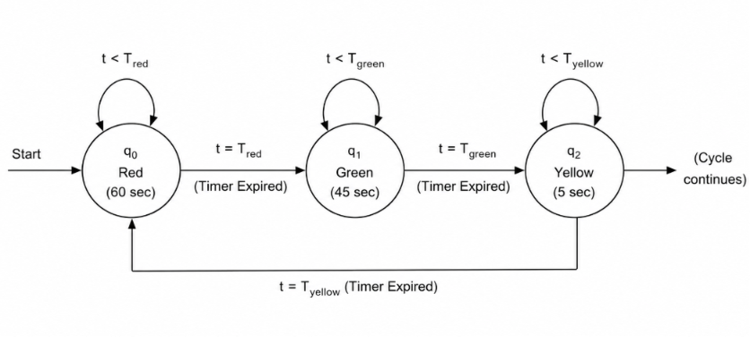
3. Design DFA using simulator to accept the string the end with ab over set {a,b) W= aaabab
1. DFA States
- q₀ = Start state
- q₁ = Last symbol is a
- q₂ = Last two symbols are ab (Final state)
2. Transition Table
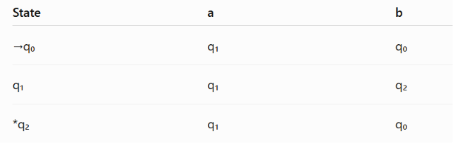

3. DFA Diagram
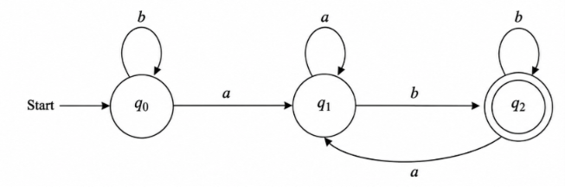

- Start State: q₀
- Final State: q₂
4. String Verification
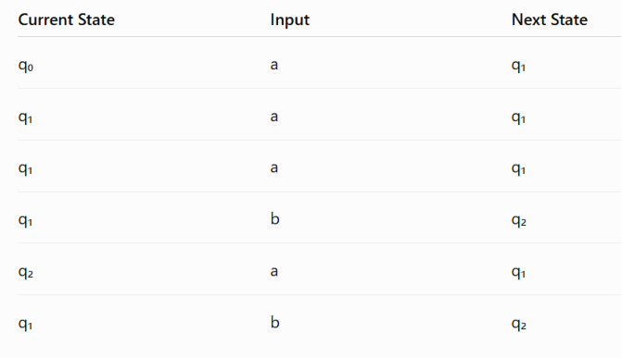
Input: aaabab
Final State = q₂ (Accept State)
Therefore,
W = aaabab is ACCEPTED because it ends with "ab".
4. Design a Deterministic Finite Automaton (DFA) using a simulator to accept only the input strings “c”, “bc”, and “bcaaa” over the alphabet {a, b, c}. The automaton should begin from an initial state and transition through intermediate states based on the sequence of input symbols, ensuring that each valid string follows a unique path. For example, the string “c” should be accepted directly from the start state, while “bc” should pass through states representing “b” and then “c”. Similarly, “bcaaa” should be processed through a sequence of states that track each additional “a” after “bc”. Any deviation from these exact patterns should lead to a dead state, ensuring that no other strings are accepted. Clearly define the states, transition functions, start state, and accepting states, and implement the DFA in a simulator such as Autosim to verify its correctness.

. States
- q₀ = Start State
- q₁ = Read b
- q₂ = Accepted c
- q₃ = Accepted bc
- q₄ = Read bca
- q₅ = Read bcaa
- q₆ = Accepted bcaaa
- qd = Dead State
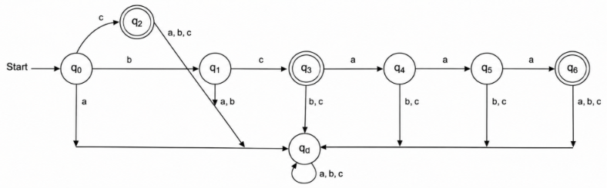
DFA diagram
2. DFA Transition Table
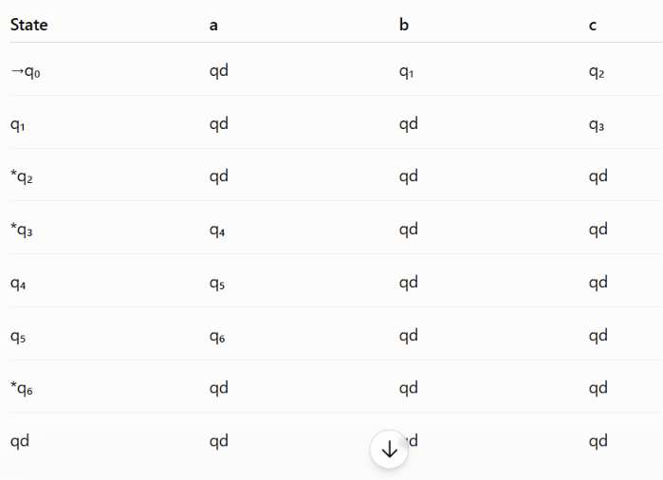

3. Formal Definition
$$M=(Q,Σ,δ,q_{0},F)$$
where
Q$=\{q_{0},q_{1},q_{2},q_{3},q_{4},q_{5},q_{6},q_{d}\}$
Σ$=\{a,b,c\}$
Start State=
$$q_{0}$$

Final States
$$F=\{q_{2},q_{3},q_{6}\}$$
4. Transition Function
- δ(q₀,a)=qd
- δ(q₀,b)=q₁
- δ(q₀,c)=q₂
- δ(q₁,a)=qd
- δ(q₁,b)=qd
- δ(q₁,c)=q₃
- δ(q₂,a)=qd
- δ(q₂,b)=qd
- δ(q₂,c)=qd
- δ(q₃,a)=q₄
- δ(q₃,b)=qd
- δ(q₃,c)=qd
- δ(q₄,a)=q₅
- δ(q₄,b)=qd
- δ(q₄,c)=qd
- δ(q₅,a)=q₆
- δ(q₅,b)=qd
- δ(q₅,c)=qd
- δ(q₆,a)=qd
- δ(q₆,b)=qd
- δ(q₆,c)=qd
- δ(qd,a)=qd
- δ(qd,b)=qd
- δ(qd,c)=qd
5. Accepted Strings
1. c
q₀ → q₂
2. bc
q₀ → q₁ → q₃
3. bcaaa
q₀ → q₁ → q₃ → q₄ → q₅ → q₆
All other strings go to the Dead State (qd) and are rejected.
. Working
- If the first input is c, the DFA reaches q₂ and accepts.
- If the input is bc, it reaches q₃ and accepts.
- If the input is bcaaa, it follows the sequence q₀ → q₁ → q₃ → q₄ → q₅ → q₆ and accepts.
- Any extra symbol or incorrect symbol sends the DFA to the dead state, ensuring that only the strings c, bc, and bcaaa are accepted.

5.Design a Deterministic Finite Automaton (DFA) using a simulator to accept all strings over the alphabet {a, b} that begin with either “a” or “b”. The automaton should start in an initial state and immediately transition to an accepting state upon reading the first input symbol, since any valid string must start with either “a” or “b”. After the first symbol is processed, the DFA should remain in an accepting state regardless of the subsequent sequence of “a” and “b”, thereby allowing any combination of characters to follow. Additionally, include a dead state to handle invalid or empty inputs if required by the simulator. Clearly define the states, transition rules, start state, and accepting states, and verify the design using a simulator such as Autosim to ensure that all valid strings are accepted and invalid ones are rejected.
Language:
Accept all strings over $Σ=\{a,b\}$that begin with either 'a' or 'b'.
Since every non-empty string over {a,b} starts with either a or b, the DFA accepts all non-empty strings and rejects the empty string (ε).

1. States
- q₀ = Start State
- q₁ = Accept State
- qd = Dead State (optional, for simulator)
2. Alphabet
$$Σ=\{a,b\}$$
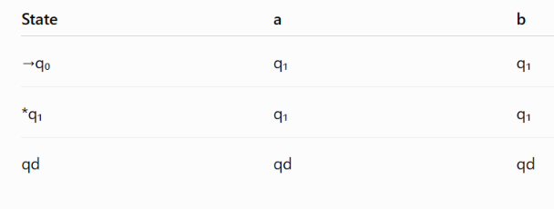
3. Transition Table
4. Formal Definition
$$M=(Q,Σ,δ,q_{0},F)$$
Where
- Q = {q₀, q₁, qd}
- Σ = {a,b}
- Start State = q₀
- Final State = {q₁}

5. Transition Function
- δ(q₀,a) = q₁
- δ(q₀,b) = q₁
- δ(q₁,a) = q₁
- δ(q₁,b) = q₁
- δ(qd,a) = qd
- δ(qd,b) = qd

6. Working
- Initially, the DFA is in q₀.
- On reading the first symbol (a or b), it moves to q₁, which is the accepting state.
- After reaching q₁, it remains there for every subsequent a or b.
- Therefore, every non-empty string over {a,b} is accepted.
- The empty string (ε) is rejected because the DFA never leaves the start state.
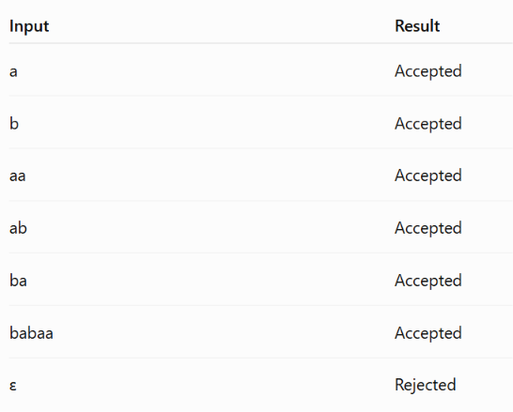
7. Examples
DFA Diagram
