Navigating to the "http://127.0.0.1:8000/tasks"   
  
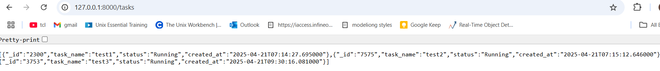

Navigating to the "http://127.0.0.1:8000/docs  
