AI Assisted coding-Assignment
E.Srivarsha
HNo: 2303A52343
Batch-44
Lab 7: Error Debugging with AI: Systematic approaches to
finding and fixing bugs
Task 1 :
Prompt:Provide a Python snippet with a missing parenthesis in a print
statement
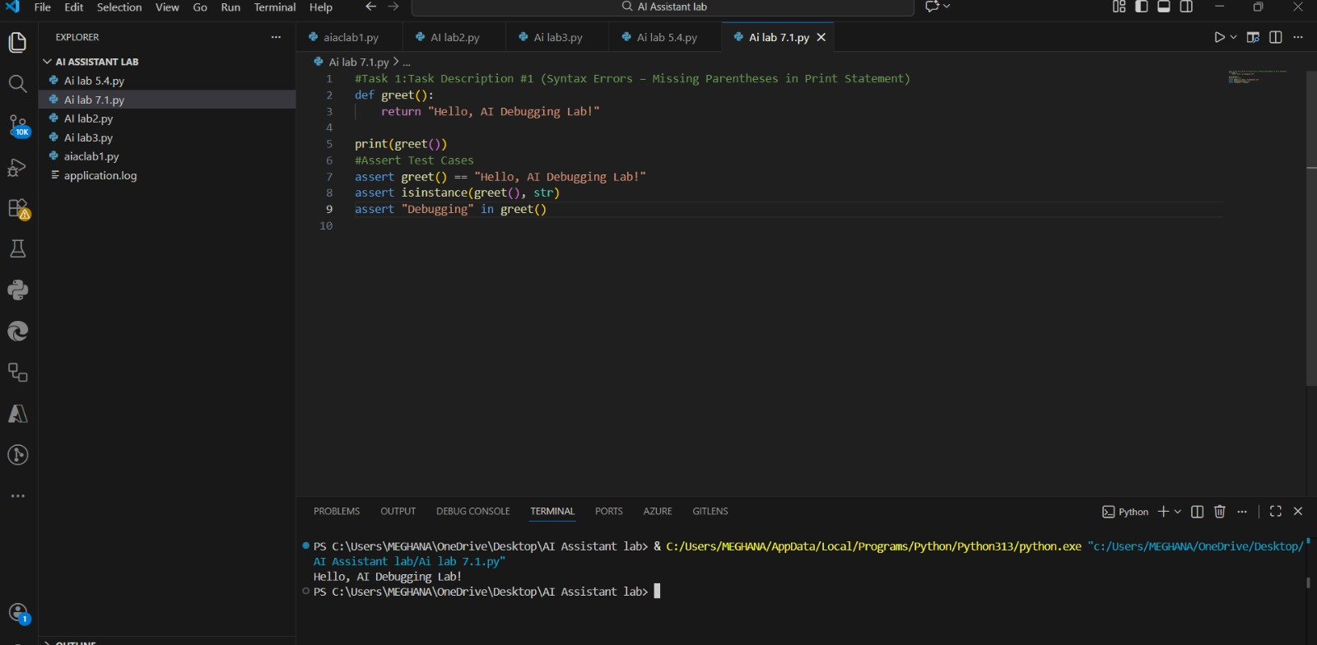

Explantion:
Syntax Error (Missing Parentheses in print)
print without parentheses causes a SyntaxError in Python 3.
Python 3 treats print as a function, not a statement.
AI suggests adding parentheses: print("Hello").
Assert statements confirm correct output and data type.

Task-2:
Supply a function where an if-condition mistakenly uses =
instead of ==. Let AI identify and fix the issue.
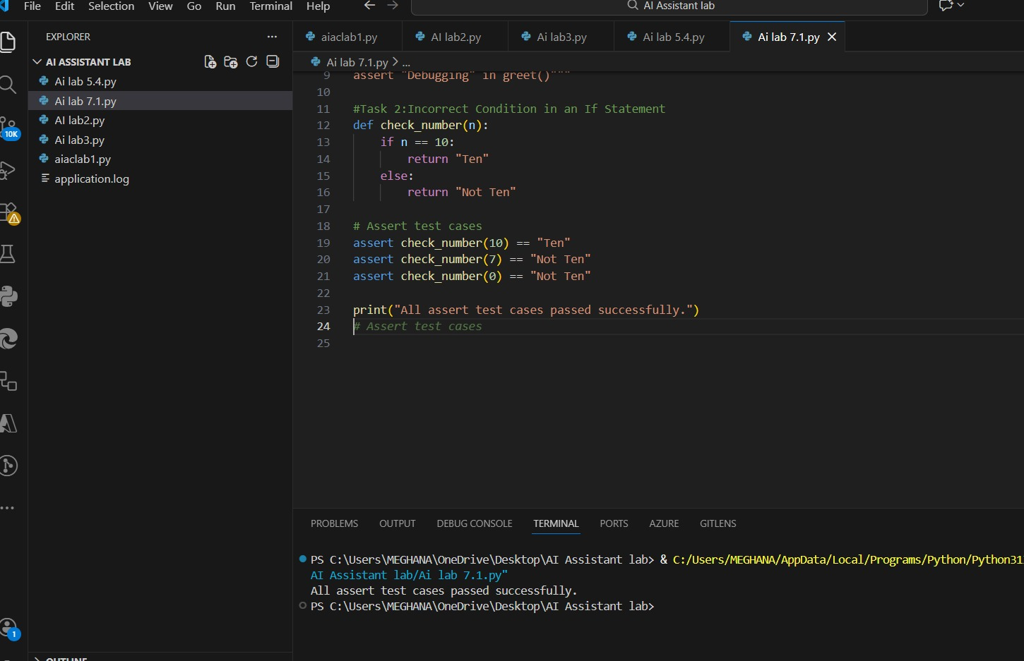Explanation:
Incorrect Condition in If Statement (= vs ==)
Using = instead of == in if causes a SyntaxError.
= is for assignment, == is for comparison.
AI recommends replacing = with == in the condition.
Assert statements confirm function returns correct results.

Task-3:
Provide code that attempts to open a non-existent file and
crashes. Use AI to apply safe error handling.
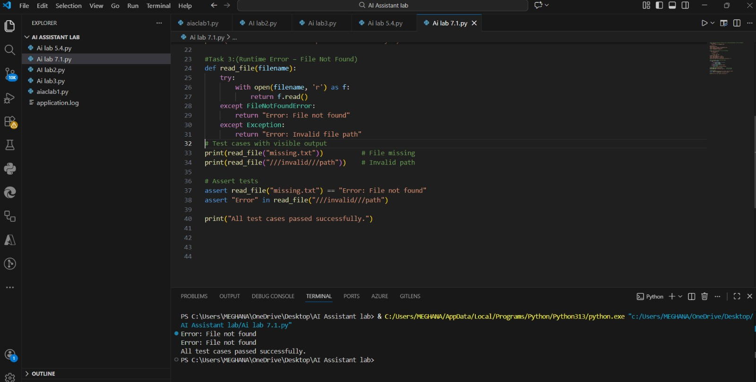 Explanation:
Runtime Error (File Not Found)
Opening a non-existent file raises FileNotFoundError.
AI suggests using try–except blocks for safe error handling.
A user-friendly message is returned if file is missing or path is invalid.
Test cases ensure safe execution for file exists, missing, or invalid path.

Task-4:
Give a class where a non-existent method is called (e.g.,
Obj. undefined_method()). Use AI to debug and fix.

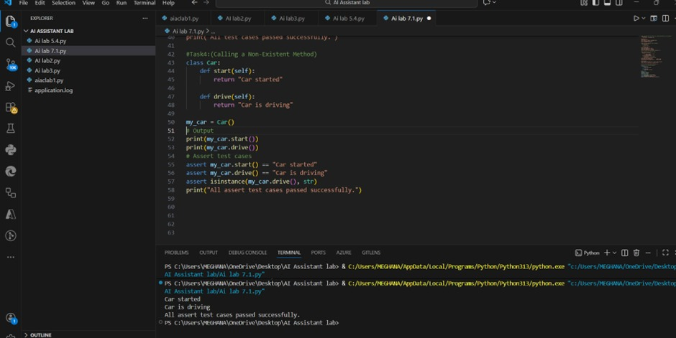Explanation:
Calling an undefined method raises AttributeError.
AI suggests defining the missing method or correcting the method call.
The missing method drive() was added to the Car class.
Assert statements confirm both start() and drive() work correctly.
Task 5:
Provide code that adds an integer and string ("5" + 2) causing
a TypeError. Use AI to resolve the bug.

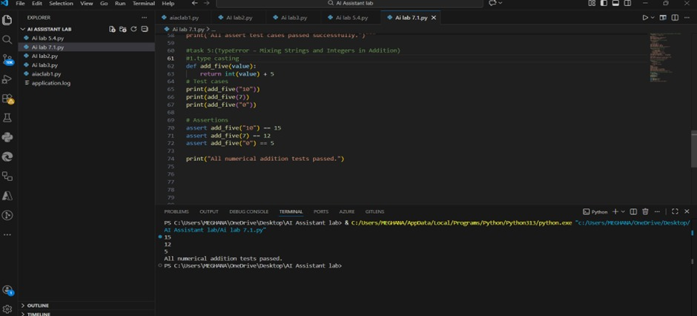
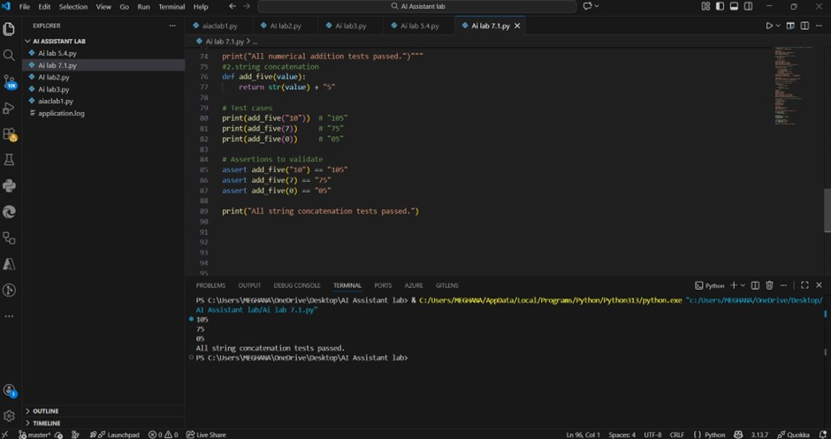Explanation:
TypeError (Mixing Strings and Integers in Addition)
Adding a string and an integer raises TypeError.
AI suggests two fixes:
Type casting: Convert string to int for numeric addition.
String concatenation: Convert integer to string to join as text.
Assert statements verify function works for multiple inputs.
print() statements added to show visible output for lab submission.

