EX NO: 2

CHARACTERISTICS STUDY OF SIDE BAND POWER AND FREQUENCIES IN AM USING MATLAB
Objective 1:
To generate an Amplitude Modulated (AM) signal in MATLAB using specified carrier and
modulating signal parameters
PROGRAM (MATLAB CODE)
clc;
clear;
close all;
Am=1;
fm=500;
Ac=5;
fc=5000;
fs=20*fc;
t=0:1/fs:4/fm;
m = Am*sin(2*pi*fm*t);
c = Ac*sin(2*pi*fc*t);
mu = Am/Ac;
am = Ac*(1+mu*sin(2*pi*fm*t)).*sin(2*pi*fc*t);
dem = abs(hilbert(am)); dem = dem-mean(dem);
N=length(am); f=linspace(-fs/2,fs/2,N);
AM_FFT=abs(fftshift(fft(am)))/N;
USB=fc+fm; LSB=fc-fm;
Pc=Ac^2/2; Psb=(mu^2*Pc)/4;
figure('Name','AM Modulation','NumberTitle','off');
subplot(3,2,1), plot(t,m), title('Message'), grid on

subplot(3,2,2), plot(t,c), title('Carrier'), grid on
subplot(3,2,3), plot(t,am), title('AM Signal'), grid on
subplot(3,2,4), plot(t,dem), title('Demodulated'), grid on
subplot(3,2,5), plot(f,AM_FFT), xlim([fc-3*fm fc+3*fm]), title('Sidebands'), grid on
subplot(3,2,6), bar([Pc Psb Psb]), set(gca,'XTickLabel',{'Carrier','USB','LSB'}),
title('Power'), grid on
fprintf('μ=%.2f | USB=%d Hz | LSB=%d Hz | Pc=%.2f W | Psb=%.3f
W\n',mu,USB,LSB,Pc,Psb);
OUTPUT (GRAPH):
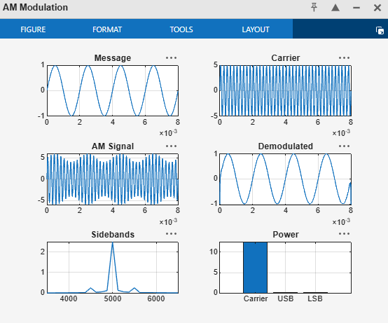

Result:
The AM signal was successfully generated and analyzed in MATLAB.

