TRANSFER LEARNING-BASED CLASSIFICATION OF POULTRY DISEASES FOR ENHANCED HEALTH MANAGEMENT

Submitted by Durgesh Vaigandla Roll No: 234E5A3302

Class: III Year CSM

Siddharth institute of engineering & technology

Submission Date: july

# INTRODUCTION

## Project Overview

This project aims to develop a mobile-friendly, AI-powered poultry disease diagnosis system using transfer learning. It classifies images into four categories: Salmonella, Newcastle Disease, Coccidiosis, and Healthy. This system improves early detection, reduces economic losses, and enhances poultry health management.

## Purpose

To enable farmers and poultry handlers to identify diseases using only fecal images via a simple mobile interface, providing real-time, affordable, and accurate disease classification.

# IDEATION PHASE

## Problem Statement

Farmers often lack access to timely veterinary services and lab testing. This delay in diagnosis leads to disease spread and financial losses. There is a need for a rapid, low-cost diagnostic tool.

## Empathy Map Canvas

Says: "I need a faster way to identify what's wrong with my poultry." Thinks: "Lab tests take too long and cost too much."

Feels: Frustrated, anxious about livelihood.

Does: Uses mobile phone for basic tasks; lacks veterinary knowledge.

## Brainstorming

Ideas evaluated:

* + - Image-based disease recognition
    - Symptom-based chatbot
    - Smart wearable for chickens (rejected due to impracticality)

Finalized idea: Mobile app using transfer learning to classify fecal images.

# REQUIREMENT ANALYSIS

## Customer Journey map

|  |  |  |
| --- | --- | --- |
| **Step** | **Action** | **Experience** |
| 1 | Capture image | Easy with mobile |
| 2 | Upload to app | User-friendly UI |
| 3 | Get prediction | Fast, clear result |
| 4 | Take action | Suggested remedies |

* 1. **Solution Requirement** Dataset with annotated fecal images Pre-trained CNN models

Flask backend for inference Simple frontend with image input

## Data Flow Diagram



User

UI

Flask API

Model

Result

* 1. **Technology Stack** Python, Flask TensorFlow/Keras HTML/CSS (UI)

Google Colab(Not Used)/VS Code(Used) (training)

# PROJECT DESIGN

## Problem Solution Fit

The model addresses a major gap in accessible poultry healthcare by giving immediate diagnosis capability to farmers via smartphones.

## Proposed Solution

Transfer learning-based image classifier (MobileNetV2/VGG16) trained on poultry fecal images to predict the disease class.

* 1. **Solution Architecture**

Front End

Flask

B d

ackEn

Mode

CNN

l

Output P n

redictio

# PROJECT PLANNING & SCHEDULING

* 1. **Project Planning**

|  |  |
| --- | --- |
| **Date** | **Task** |
| June 9 | Defined problem and tech stack |
| June 10-12 | Collected and prepared dataset |
| June 13-15 | Image preprocessing and augmentation |
| June 16-18 | Implemented VGG16 and MobileNetV2 |
| June 19-21 | Model evaluation and hyperparameter tuning |
| June 22-23 | Flask integration |
| June 24-25 | Frontend HTML page creation |
| June 26 | Testing model with UI |
| June 27 | Final evaluation and screenshots |
| June 28 | Documentation and GitHub upload |

# FUNCTIONAL AND PERFORMANCE TESTING

## Performance Testing

Accuracy: ~97% (MobileNetV2)

Precision/Recall/F1 evaluated with confusion matrix Lightweight inference time for real-time prediction

# RESULTS

## Output Screenshots

Screenshot 1: Home Page

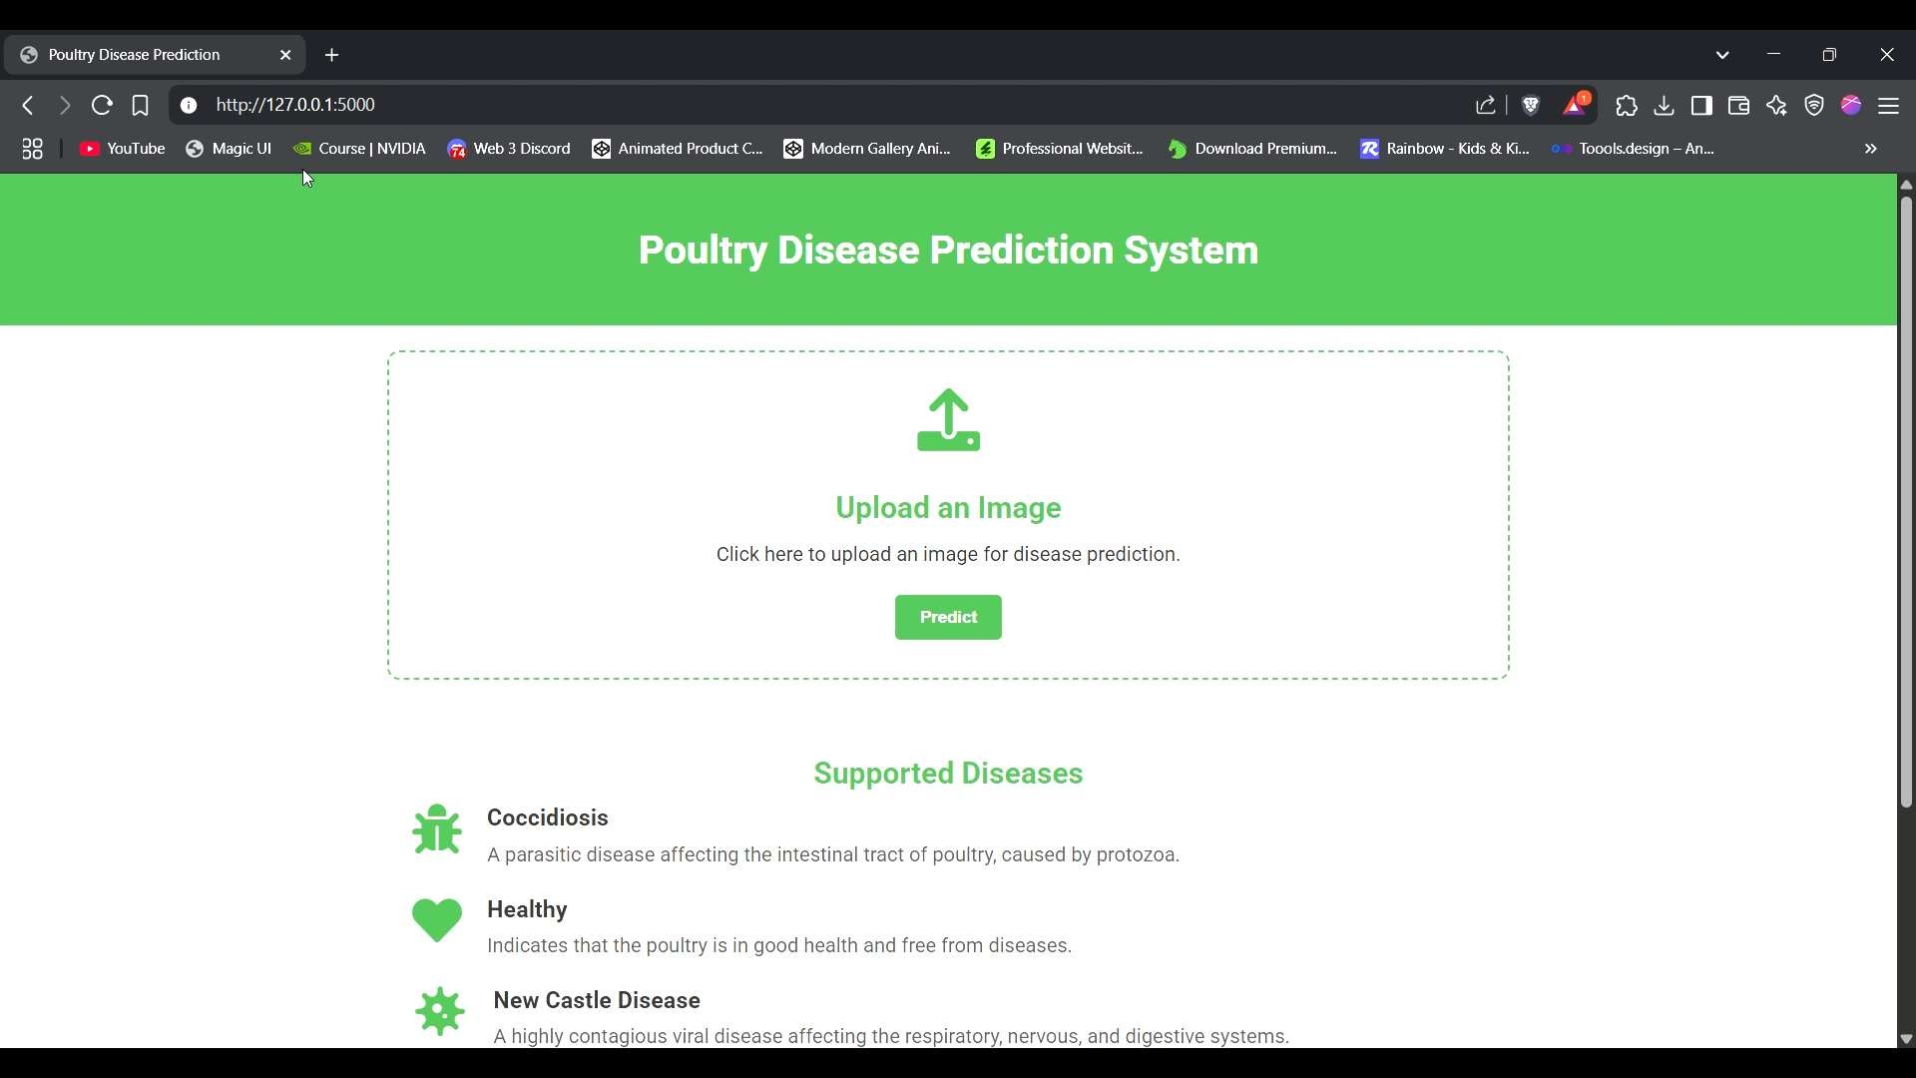

Image Upload

Screenshot 2: Predicted Result Displayed

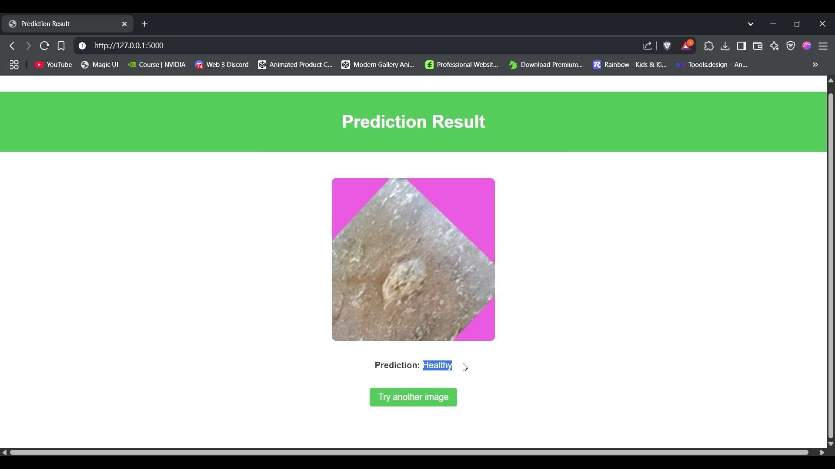

# ADVANTAGES & DISADVANTAGES

## Advantages

* Real-time, accessible, and low-cost
* Lightweight and mobile-compatible
* High accuracy with minimal training data

## Disadvantages

* Limited by quality of training data
* May not work with new/unseen environments
* Needs GPU for initial training

# CONCLUSION

## Conclusion

This system demonstrates that transfer learning can effectively classify poultry diseases from fecal images with high accuracy. Its integration into a mobile app provides a practical solution for farmers.

# FUTURE SCOPE

## Future Enhancements

* Add more diseases
* Convert to TensorFlow Lite for mobile deployment
* Add multilingual support and GPS-based recommendations

# APPENDIX

## Source Code

https://github.com/Durgesh-Vaigandla/Classification-of-Poultry-Diseases/

## Dataset Link

https://[www.kaggle.com/datasets/chandrashekarnatesh/poultry-diseases](http://www.kaggle.com/datasets/chandrashekarnatesh/poultry-diseases)

## Demo Link

Google Drive link (public) – https://drive.google.com/file/d/186y9ZKB6nIT2M6kWaFdqzJxcCw4DQNUO/view?usp=sh aring