DIABETES PREDICTION PROJECT

1. OBJECTIVE

The main objective of this project is to build a Machine Learning model that can predict whether a person is diabetic or not based on medical data.

2. TECHNOLOGIES USED

• Python
• Pandas
• Scikit-learn
• VS Code
• Jupyter Notebook

3. DATASET INFORMATION

• Dataset Name: Diabetes Dataset
• Number of Rows: 768
• Number of Columns: 9

Dataset Columns:

1. Pregnancies

2. Glucose

3. BloodPressure

4. SkinThickness

5. Insulin

6. BMI

7. DiabetesPedigreeFunction

8. Age

9. Outcome

10. PROJECT WORKFLOW

Step 1:
Imported the required Python libraries such as pandas and sklearn.

Step 2:
Loaded the diabetes dataset into the notebook using pandas.

Step 3:
Displayed the first few rows of the dataset using data.head().

Step 4:
Checked dataset information using data.info().

Step 5:
Generated statistical summary using data.describe().

Step 6:
Checked the distribution of diabetic and non-diabetic records using value_counts().

Step 7:
Separated the input features and target variable.

Step 8:
Split the dataset into training and testing data using train_test_split().

Step 9:
Trained the Logistic Regression model.

Step 10:
Calculated the model accuracy using accuracy score.

Step 11:
Generated confusion matrix and classification report for evaluation.

Step 12:
Tested the model with sample input data for prediction.

Step 13:
Saved the trained model using pickle.

5. MODEL ACCURACY

The Logistic Regression model achieved an accuracy of:

Accuracy = 74.67%

6. CONFUSION MATRIX AND CLASSIFICATION REPORT

The confusion matrix and classification report were generated to evaluate the performance of the trained model.

7. PREDICTION RESULT

The model successfully predicted whether the given sample data belongs to a diabetic or non-diabetic person.

8. MODEL SAVING

The trained machine learning model was saved successfully as:

diabetes_model.pkl

9. CONCLUSION

The Diabetes Prediction project was completed successfully using Machine Learning techniques. The Logistic Regression model performed well and achieved good accuracy in predicting diabetes based on medical parameters.

- SCREENSHOTS

• accuracy_result.png

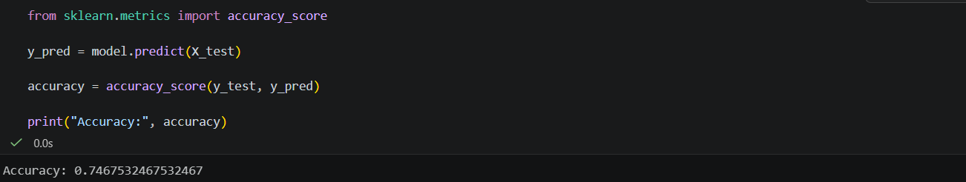

• confusion_matrix_report.png
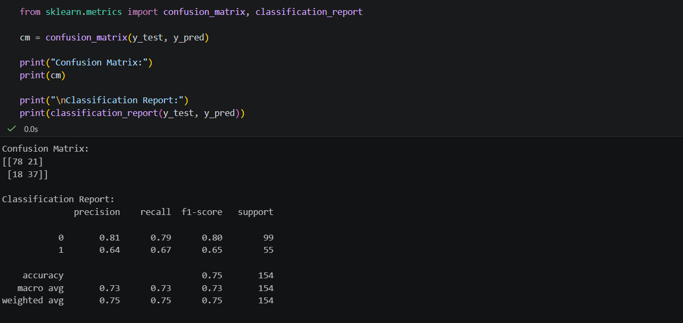

• prediction_result.png

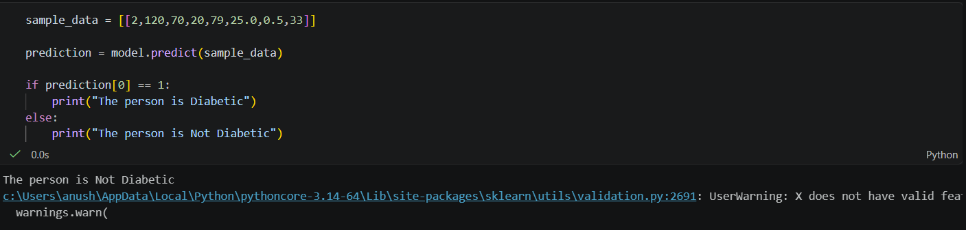

• model_saved.png

