Deep Learning Project Report

Project Title

Sentiment Analysis using Deep Learning

Objective

The main objective of this project is to build a deep learning model that can identify whether a movie review is positive or negative using the IMDB dataset.

Tools and Technologies Used

Python

TensorFlow

Keras

VS Code

Matplotlib

Dataset Used

In this project, the IMDB Movie Review Dataset was used for training and testing the model.

Model Used

An LSTM (Long Short-Term Memory) neural network model was used for sentiment analysis.

Project Procedure

1. Imported required libraries

2. Loaded IMDB dataset

3. Preprocessed and padded text sequences

4. Built the LSTM deep learning model

5. Compiled and trained the model

6. Evaluated the model accuracy

7. Saved the trained model

8. Generated accuracy graph

Accuracy Obtained

The model achieved a test accuracy of approximately 85.6%.

Output

The deep learning model was trained successfully and the accuracy graph was generated successfully. The trained model file was also saved as sentiment_model.h5.

Conclusion

This project successfully implemented a sentiment analysis system using deep learning. The LSTM model performed well on the IMDB dataset and achieved good accuracy in classifying movie reviews.

Screenshots

complete_code.png

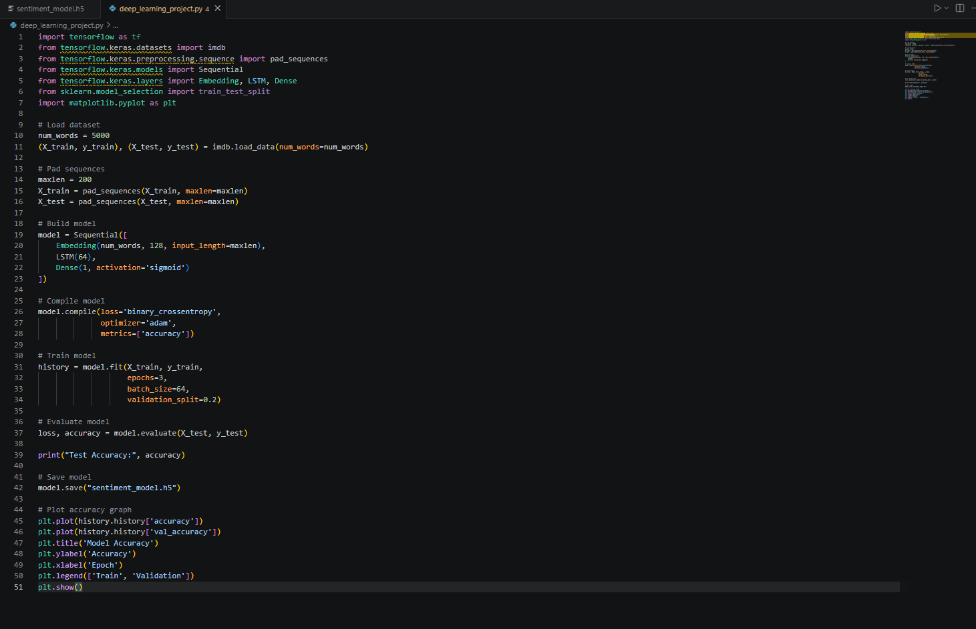

training_output.png
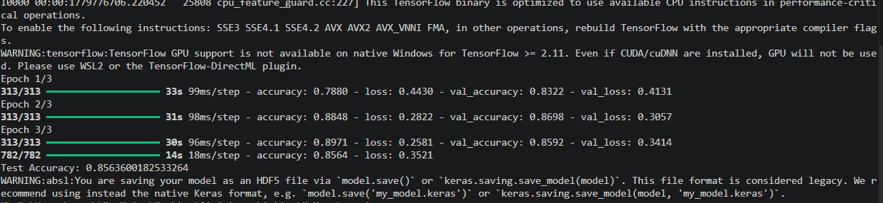
accuracy_graph.png

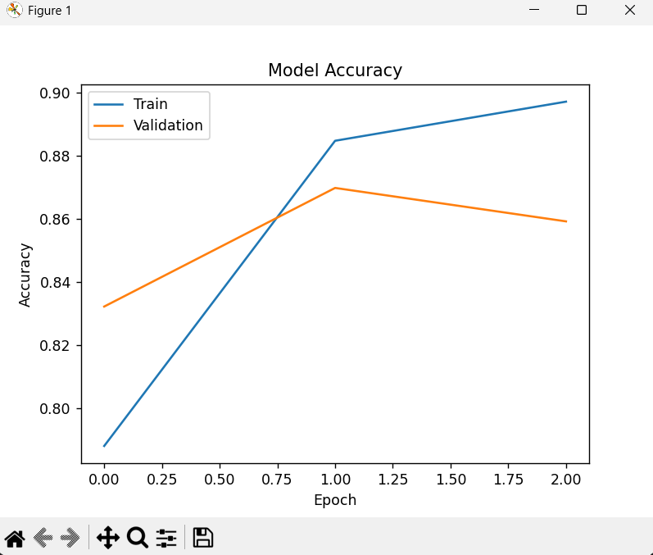
model_file.png