Responsible AI & Model Interpretation Report

Objective

The objective of this task is to perform a simple Responsible AI analysis by visualizing feature importance and discussing fairness and bias in AI models.

Tools and Libraries Used

- Python
- Visual Studio Code (VS Code)
- Matplotlib

Implementation

In this task, a Python program was created to demonstrate Responsible AI concepts using feature importance visualization.

The following features were considered:

- Word Count
- Positive Words
- Negative Words
- Sentence Length

Feature importance values were assigned and displayed using a bar graph with the help of the Matplotlib library.

Code Explanation

The Python program performs the following steps:

1. Imports the Matplotlib library
2. Defines sample feature importance values
3. Creates a bar graph for visualization
4. Saves the graph as an image
5. Displays the graph output
6. Prints a completion message in the terminal

Output

The program successfully generated:

- Feature importance graph
- Terminal completion message

Bias and Fairness Discussion

AI models can become biased if the training data contains unfair or imbalanced information. Proper preprocessing and balanced datasets help in reducing bias and improving fairness.

Mitigation Recommendations

- Use balanced datasets
- Remove biased samples
- Monitor feature importance regularly
- Test models using diverse datasets

Screenshots Included

- Python code screenshot
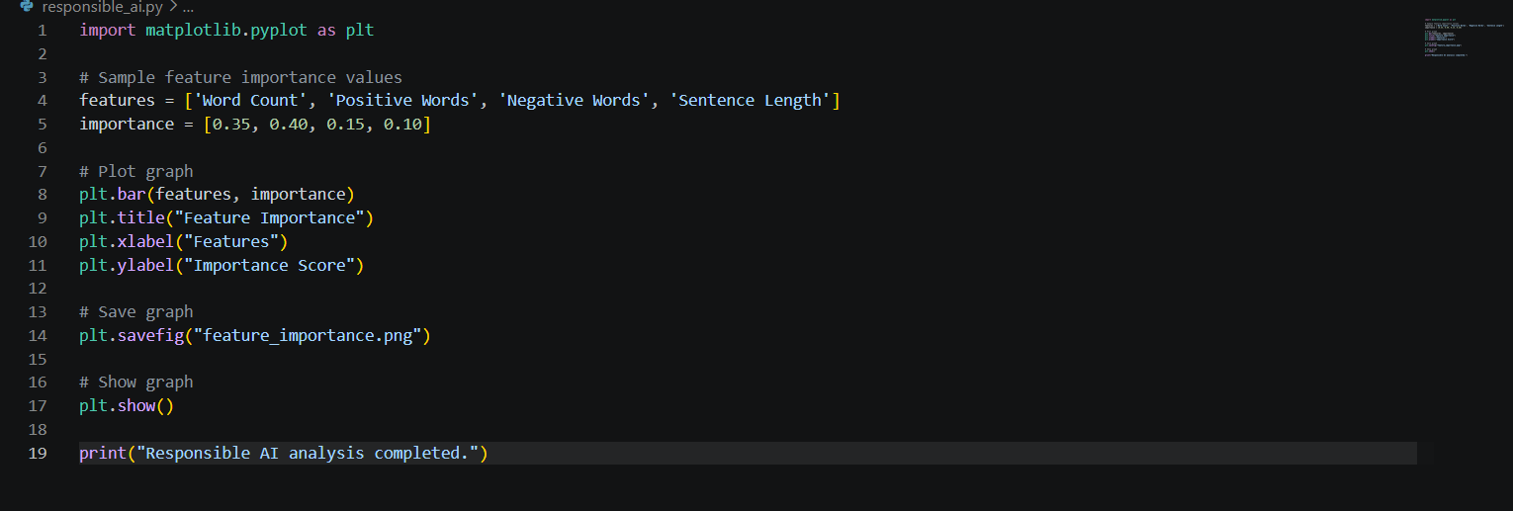
- Graph output screenshot
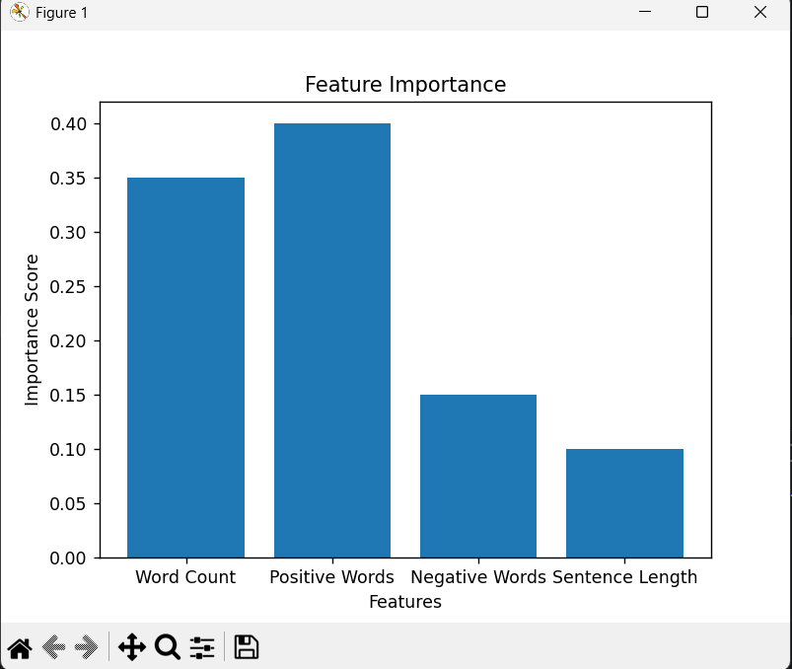
3. Terminal output screenshot

Conclusion

The Responsible AI analysis task was completed successfully. Feature importance visualization was generated, and fairness and bias considerations were discussed.

