**PROFESSIONAL TRAINING REPORT**

**at**

**SATHYABAMA INSTITUITE OF SCIENCE AND TECHNOLOGY**

**(DEEMED TO BE UNIVERSITY)**

Submitted in partial fulfillment of the requirements for the award of Bachelor of Engineering Degree in Computer Science and Engineering

By

**SRIVARSH SAKTHIVELAN**

**REG NO: 39110973**



**DEPARTMENT OF COMPUTER SCIENCE AND ENGINEERING**

**SCHOOL OF COMPUTING**

**SATHYABAMA INSTITUTE OF SCIENCE AND TECHNOLOGY**

**JEPPIAAR NAGAR, RAJIV GANDHI SALAI,**

**CHENNAI – 600119, TAMILNADU**

**NOVEMBER 2021**

|  |  |  |
| --- | --- | --- |
|  | **SATHYABAMA**  **INSTITUTE OF SCIENCE AND TECHNOLOGY**  **(DEEMED TO BE UNIVERSITY)**  **Accredited with Grade “A” by NAAC**  (Established under Section 3 of UGC Act, 1956)  JEPPIAAR NAGAR, RAJIV GANDHI SALAI  CHENNAI– 600119  [**www.sathyabama.ac.in**](http://www.sathyabama.ac.in) |  |

**DEPARTMENT OF COMPUTER SCIENCE AND ENGINEERING**

**BONAFIDE CERTIFICATE**

This is to certify that this Project Report is the bonafide work of **SRIVARSH SAKTHIVELAN (Reg. No: 39110973)** who carried out the project entitled “**SELLING AUTOMOBILES APPLICATION”** under my supervision from Feb 2022 to April 2022.

**Internal Guide**

**Mrs. G Meera Gandhi**



**Submitted for Viva Voce Examination held on**

**Internal Examiner External Examiner**

**DECLARATION**

I, **SRIVARSH SAKTHIVELAN** hereby declare that the project report entitled **SELLING AUTOMOBILES APPLICATION** done by me under the guidance of **Mrs. G Meera Gandhi** is submitted in partial fulfillment of the requirements for the award of Bachelor of Engineering Degree in Computer Science and Engineering.

**DATE: 09/04/2022 SRIVARSH S**

**PLACE: CHENNAI SIGNATURE OF THE CANDIDATE**

**ACKNOWLEDGEMENT**

I am pleased to acknowledge my sincere thanks to **Board of Management** of **SATHYABAMA** for their kind encouragement in doing this project and for completing it successfully. I am grateful to them.

I convey my thanks to **Dr. T. Sasikala M.E., Ph.D.**, **Dean**, School of Computing, **Dr. S. Vigneshwari, M.E., Ph.D. and Dr. L. Lakshmanan, M.E., Ph.D., Heads of the Department** of **Computer Science and Engineering** for providing me necessary support and details at the right time during the progressive reviews.

I would like to express my sincere and deep sense of gratitude to my Project Guide **Mrs G Meera Gandhi** for his valuable guidance, suggestions and constant encouragement paved way for the successful completion of my project work.

I wish to express my thanks to all Teaching and Non-teaching staff members of the **Department of Computer Science and Engineering** who were helpful in many ways for the completion of the project.

**TRAINING CERTIFICATE**

**Table of Contents**

|  |  |  |
| --- | --- | --- |
| **CHAPTER NO.** | **TITLE** | **PAGE NO.** |
|  | ABSTRACT  LIST OF FIGURES  LIST OF ABBREVIATIONS | i  ii  iii |
| **1.** | **INTRODUCTION**  1.1) USED CAR MARKET OF INDIA  1.2) A GLIMPSE INTO HTML AND CSS | 1  1  1 |
| **2.** | **AIM AND SCOPE OF PRESENT INVESTIGATION**  2.1) GOAL AND OBJECTIVE  2.2) SCOPE | 2  2  2 |
| **3.** | **EXPERIMENTAL OR MATERIALS AND METHODS, ALGORITHMS USED**  3.1) MATERIALS USED (HARDWARE)  3.2) MATERIALS USED (SOFTWARE)  3.3) FLOWCHART  3.4) PROJECT OVERVIEW  3.5) METHODOLOGY | 3  3  3  3  4  5 |
| **4.** | **RESULTS DISCUSSIONS AND PERFROMANCE ANALYSIS**  4.1 TESTING  4.2 RESULTS  4.3 PROJECT IMPLEMENTATION | 6  6  7 |
| **5.** | **SUMMARY AND CONCLUSIONS**  5.1 SUMMARY  5.2 CONCLUSION | 9  9 |
|  | **REFERENCES**  **APPENDIX**   1. SCREENSHOTS 2. SOURCE CODE | 10  10  11  11 |

# ABSTRACT

The automotive industry is one of the core sectors of the Indian economy and, to a great extent, serves as a crucial indicator for its current state of our nation. While the Indian automotive industry has faced many recent challenges, especially the devastating COVID-19 pandemic, its growth potential is clear. Today, as some of the effects of the pandemic are slowly wearing off, we can observe the industry overcoming most of its challenges, and many are now in the rearview mirror. The sector is also benefiting from new tailwinds, such as global supply-chain rebalancing, government incentives to increase exports, and technology disruptions that create white spaces. These developments will help create opportunities at all levels of the automotive value chain.

One of the areas in which I observed is the used car industry. The sales of used cars are most often directly proportional to the sale of new cars. I have decided to create a virtual used luxury dealer network called ‘INDICARS’ that prioritizes the sale for used luxury cars. Their inventory will possess various imported luxury cars. The website for this will extensively use **HTML** and **CSS** to create the desired output

**LIST OF FIGURES**

* FIG: 1.1: HTML STRUCTURE
* FIG: 3.1: WORK FLOW DIAGRAM
* FIG: 4.1: HOME PAGE
* FIG: 4.2: TESTIMONIALS
* FIG: 4.3: INVENTORY PAGE
* FIG: 4.3: ABOUT US PAGE

**LIST OF ABBREVIATION**

* HTML- HYPER TEXT MARKUP LANGUAGE
* CSS- CASCADING STYLE SHEETS
* JS-JAVASCRIPT
* VS-VISUAL STUDIO
* IDE- INTEGRATED DEVELOPMENT ENVIRONMENT

**Chapter-1**

**INTRODUCTION**

**1.1) USED CAR MARKET OF INDIA**

The India used car market was valued at USD 27 billion as of 2020, and it is expected to reach USD 50 billion by 2026, registering a massive growth during the forecast period, 2021-2026.

The COVID-19 pandemic has surprisingly had a minimal impact on this particular industry. With the increased number of people preferring individual mobility and more finance options infused into the used car market, the market is set to grow considerably. Reduced cash inflow due to the pandemic has forced buyers to look for alternatives other than new cars, and the used car industry is booming in potential with these terms. As the sales and production of new vehicles rocky due to the pandemic, the immediate option for the buyers is the used car market.

**1.2) A GLIMPSE INTO HTML & CSS**

The full form of HTML is Hypertext Markup Language. This language is used for creating web pages. This language also supports other languages such CSS, PHP, JAVASCRIPT, etc. in creating interactive and responsive pages on the pages. HTML5 is just an updated version of the HTML. It supports new features, new attributes, new HTML elements, full CSS3 support, video and audio, 2D/3D graphics that help users and also help web developers to create new features easily on the website. The structure of HTML5 is shown below

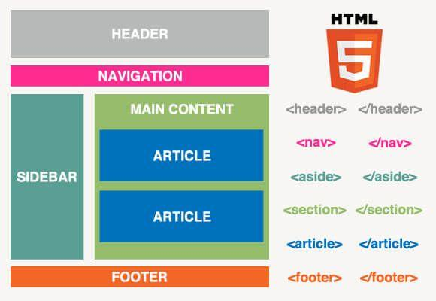

**FIG: 1.1: HTML STRUCTURE**

CSS - (Cascading Style Sheets) technology for building the (visual and aural) layout, for a variety of devices. It is a style sheet language used for describing the presentation of a document written in a markup language such as HTML. CSS is designed to enable the separation of presentation and content, including layout, colors, and fonts.[3] This separation can improve content accessibility; provide more flexibility and control in the specification of presentation characteristics

**Chapter-2**

**AIM AND SCOPE OF THE PRESENT INVESTIGATION**

**2.1) GOAL AND OBJECTIVE**

* The primary objective of this project is to create a viable website that can be used for the sale of used vehicles.
* Prospective customers can view vehicles from the available palette of the lot that the dealer possesses.
* Other information regarding the company of the used car sales company will also be provided in the consequent pages/GUI screens.
* Seamless representation on the information about the vehicles, about us, frequently asked questions, etc.
* The user interface for the client is the first priority.

**2.2) SCOPE**

* Analyzing market trends in the used luxury car market and accurate pricing the vehicle accordingly.
* The trend in the used car market in terms of buyer preference and requirements mimic the trend in the new car market. However, buyers are more likely to experiment with brands in the used car segment. It is not the case with new cars. For example Mercedes has always been the top choice of used car buyers in the luxury segment and also enjoys a majority market share in the new car market.
* How each brand with similar characteristics performs when pitted against each other.
* The various features of each vehicle will be shown in the inventory are as follows:

1. Car brand Make
2. Car brand Model
3. Year
4. Number of owners
5. Kilometers Driven
6. Asking Price

**Chapter-3**

**EXPERIMENTAL OR MATERIALS AND METHODS USED**

**3.1) MATERIALS USED (HARDWARE)**

* Graphics Processing Unit
* Any Operating System

**3.2) MATERIALS USED (SOFTWARE/LANGUAGES)**

* Visual Studio Code is Used as Integrated Development Environment
* HTML
* CSS
* JAVASCRIPT
* Prettier Code Formatter

**3.3) FLOW CHART**

**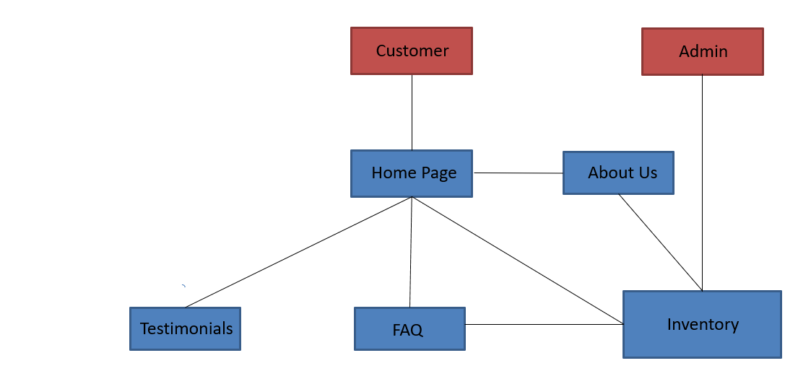****FIG: 3.1: WORK FLOW DIAGRAM**

**3.4) PROJECT OVERVIEW**

The above diagram gives an overview of the implementation / working of the project. Here, INDICARS (The name of our used luxury car sales lot) is loaded Home Page will be shown. It shows a small glimpse of what the company is about. After that it is directed to about page where there will be a small description of our website INDICARS and why it is important for you to go through the things we are providing.

Then will be the main inventory page where all of our used luxury vehicles are uploaded page with the relevant information about the vehicle such as year, make, model, kilometers driven, no of owners, and price. Followed by that there will be the Frequently Asked Questions page with all types of various questions and subsequent answers that prospective customers might have.

**3.5) METHODOLOGY**

HTML provides the structure of the page, CSS the bulk of the visual layout/ user interface, for a variety of devices.

* Publish online documents with headings, text, tables, lists, photos, etc. Retrieve online information via hypertext links, at the click of a button. Design forms for conducting transactions for use in searching for information, making reservations, ordering/booking products, etc.
* It also has the ability to include spread-sheets, video clips, sound clips, and other applications directly in their documents.
* We have created, Home Page, About Page, Inventory Page, FAQ Page. HTML is used to create the above pages with proper classes and attributes so as to structure the pages in order to allow them to work as per use.
* CSS is use to style the HTML structure so as to make them more interactive, user friendly and much more appealing.
* CSS is the language for describing the presentation of Web pages, including colors, layout, and fonts. It allows one to adapt the presentation to different types of devices, such as large screens, small screens, or printers. CSS is independent of HTML and can be used with any XML-based markup language. The separation of HTML from CSS makes it easier to maintain sites, share style sheets across pages, and tailor pages to different environments**.**
* JavaScript is a lightweight, interpreted programming language. It is designed for creating network-centric applications. It is complimentary to and integrated with Java. JavaScript is very easy to implement because it is integrated with HTML. It is open and cross-platform.
* It is used to make the pages dynamic. It allows to execute complex actions and also enables interactions.
* Microsoft Visual Studio – It is an integrated development environment used to develop computer programs, as well as websites, web apps, web services, etc. Out of the box, Visual Studio Code includes basic support for most common programming languages. This basic support includes syntax highlighting, bracket matching, code folding, and configurable snippets.
* Prettier Formatter for Visual Studio Code
* Prettier is an opinionated code formatter. It enforces a consistent style by parsing your code and re-printing it with its own rules that take the maximum line length into account, wrapping code when necessary. It can be enabled in the VS code settings.

**Chapter-4**

**RESULTS, DISCUSSIONS, AND PERFORMANCE ANALYSIS**

**4.1) TESTING**

* Software testing is a critical element quality assurance and represents the ultimate reviews of specification, design and coding. Testing presents an interesting anomaly of the software. During earlier definition and development phases, it was attempted to build software from abstract concept to a tangible implementation.
* The testing phase involves the testing of the developed system using various set data. Presentation of test data plays a vital role in system testing. After preparing the test data the system under study was tested using test data. While testing the system by using test data errors were found and corrected. A series of tests were performed for the proposed system before the system was ready for implementation.
* The various types of testing done on the system are:

1. Unit Testing of software
2. Integration Testing
3. Validation Testing
4. User Acceptance Testing
5. System Testing

* Software to be developed is planned on the basis of requirement of the user. The problem definition statement description of present situation and goal to be achieved by news system.

**4.2) RESULTS**

* The virtual used luxury car dealership was successfully developed using HTML5, CSS3 and java script technology.
* Any consumer/customer can browse vehicles, get some insights about the dealer that is “About us” and “FAQ”.
* Each and every vehicle listed on the site includes detailed information such as year, make & model, kms driven, no of owners, etc.
* This project has successfully used Microsoft Visual Studio, and Google chrome as the project environment.
* The intension of this project is to reduce marketing strain of a luxury dealership to a large extent.
* The customer view will be available only to the customers, they will be able to handle the information updated by the admin such as their make, model, and booking. Also, the customer will be able to pre-book vehicles by paying the fee issued by the dealer.

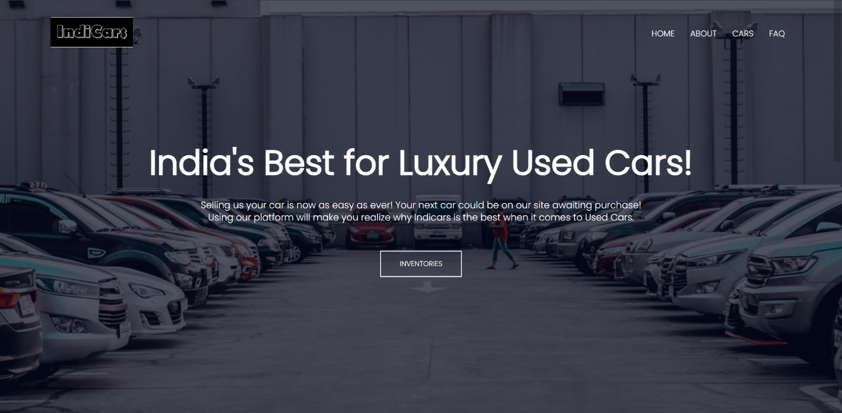

**FIG: 4.1: HOME PAGE**

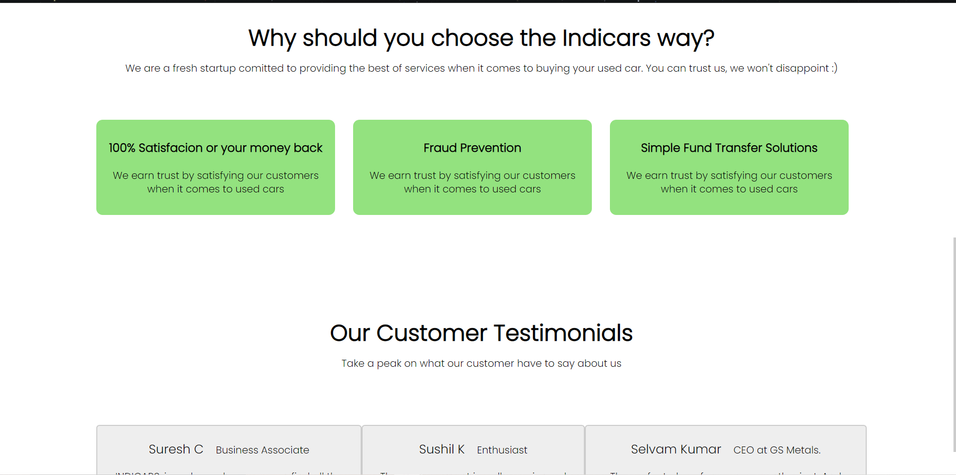

**FIG: 4.2: TESTIMONIALS**

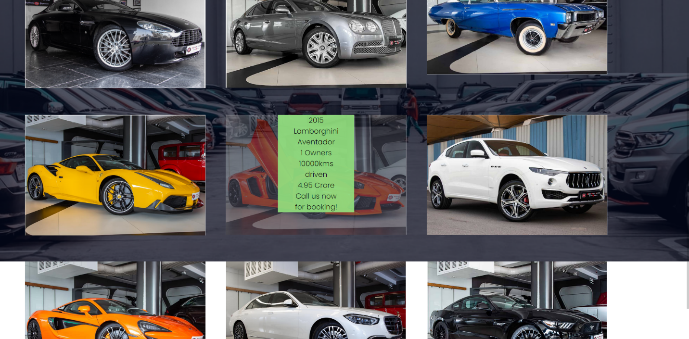

**FIG: 4.3: INVENTORY PAGE**

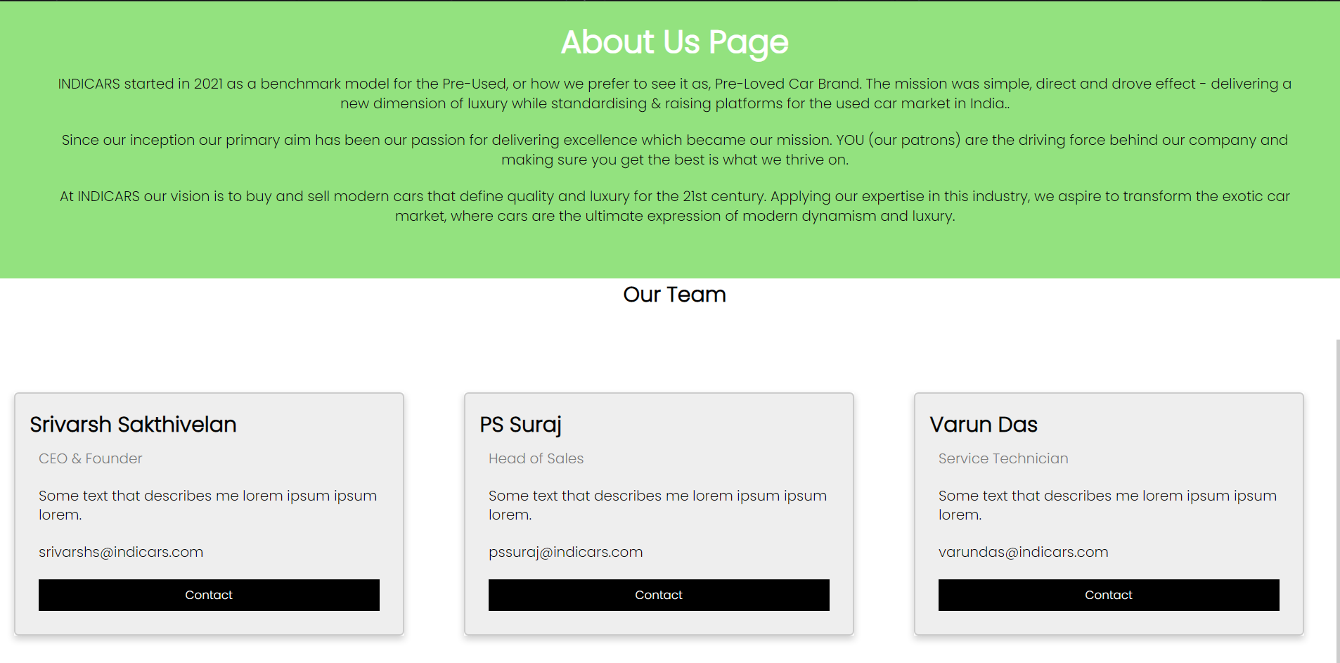

**FIG: 4.4: ABOUT US**

**4.1) PERFORMANCE ANALYSIS**

This project has been implemented successfully. So, the first page is the home page Then the customer can view the vast selection of vehicles according to their choice and go with the booking process.

**4.3) APPLICATIONS**

**Automotive Industry**

* HTML is having a bigger and bigger influence on the automotive industry alone day by day

**Web Documentation**

* Document creation on the internet is dominated by HTML and its basic concept via tag and DOM, i.e., document object model. HTML tags are inserted before and afterwards or phrases to locate their format and location on the page.

**Responsive Images**

* At the elementary level in applications of HTML, queries can be set to utilize the images, which are responsive in nature. With the srcset attribute of img element in HTML and combining it with picture elements, a developer can fully control how the user will render an image.

**Game Development**

* Before the advent of HTML5, game development was an exclusive domain of Flash and Silverlight. Since browsers support new specifications for HTML5, including CSS3 and light-fast JavaScript engine to drive a new rich experience, HTML5 can bring the reality of game development possible, which was earlier the forte of Flash and Silverlight. Every feature of APIs needs not to be implemented, but the most appropriate ones can be utilized while eliminating the rest of the features.

**Chapter-5**

**SUMMARY AND CONCLUSION**

**4.1) SUMMARY**

In this project we have

**4.2) CONCLUSIONS**

* In the process of research, I came to know about the various HTML techniques and its different uses in helping to create a website.
* CSS and webpage design integration.
* The designed application will have an admin view and the public or guest view.
* The customer view will be available only to the customers, they will be able to handle the information updated by the admin such as their make, model, and booking. Also, the customer will be able to pre-book vehicles by paying the fee issued by the dealer.

**REFERENCES**

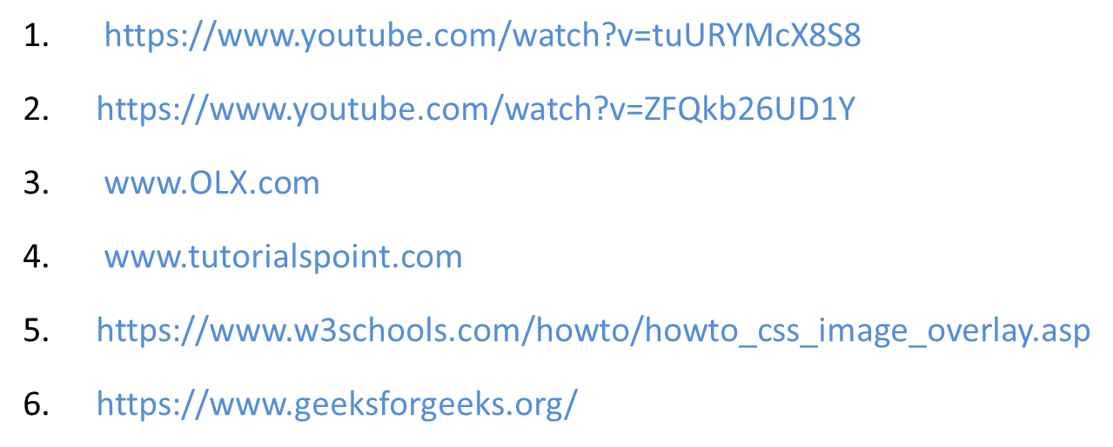

**B. SOURCE CODE**

Inventory Source code

<!DOCTYPE html>

<html>

<head>

<meta name="viewport" content="with=device-width, initial-scale=1.0">

<title>Indicars</title>

<link rel="stylesheet" href="style.css">

<link rel="preconnect" href="https://fonts.googleapis.com">

<link rel="preconnect" href="https://fonts.gstatic.com" crossorigin>

<link href="https://fonts.googleapis.com/css2?family=Poppins:wght@100;200;300&display=swap"

rel="stylesheet">

<link rel="stylesheet" href="https://cdn.jsdelivr.net/npm/@fortawesome/fontawesome-free@5.15.4/css/fontawesome.min.css">

</head>

<body>

<section class="header">

<nav>

<a href="homepage.html"><img src="images/Capture.PNG"></a>

<div class="nav-links">

<i class="fa fa-times"></i>

<ul>

<li><a href="index.html">HOME</a></li>

<li><a href="aboutus.html">ABOUT</a></li>

<li><a href="car.html">CARS</a></li>

<li><a href="">FAQ</a></li>

</ul>

</div>

<i class="fa fa-window-close-o"></i>

</nav>

<div class="aston">

<img src="images/aston.PNG" alt="Avatar" class="image1" style="width:100%">

<div class="middle1">

<div class="text">2009 Aston Martin V8 Vantage</div>

<div class="text">2 Owners</div>

<div class="text">5000kms driven</div>

<div class="text">75 Lakhs</div>

<div class="text">Call us now for booking!</div>

</div>

</div>

<div class="bentley">

<img src="images/bent.PNG" alt="Avatar" class="image2" style="width:100%">

<div class="middle2">

<div class="text1">2012 Bentley Mulsanne</div>

<div class="text1">1 Owners</div>

<div class="text1">10000kms driven</div>

<div class="text1">2.95 Crore</div>

<div class="text1">Call us now for booking!</div>

</div>

</div>

<div class="buick">

<img src="images/buick.PNG" alt="Avatar" class="image3" style="width:100%">

<div class="middle3">

<div class="text3">1969 Buick Skylark</div>

<div class="text3">9 Owners</div>

<div class="text3">50000kms driven</div>

<div class="text3">45 Lakhs</div>

<div class="text3">Call us now for booking!</div>

</div>

</div>

<div class="ferrari">

<img src="images/ferrari.PNG" alt="Avatar" class="image4" style="width:100%">

<div class="middle4">

<div class="text4">2014 Ferrari 488 GTB</div>

<div class="text4">2 Owners</div>

<div class="text4">7500kms driven</div>

<div class="text4">3.54 Crores</div>

<div class="text4">Call us now for booking!</div>

</div>

</div>

<div class="lambo">

<img src="images/lambo.PNG" alt="Avatar" class="image5" style="width:100%">

<div class="middle5">

<div class="text5">2015 Lamborghini Aventador</div>

<div class="text5">1 Owners</div>

<div class="text5">10000kms driven</div>

<div class="text5">4.95 Crore</div>

<div class="text5">Call us now for booking!</div>

</div>

</div>

<div class="maser">

<img src="images/maser.PNG" alt="Avatar" class="image6" style="width:100%">

<div class="middle6">

<div class="text6">2017 Maserati Levante</div>

<div class="text6">2 Owners</div>

<div class="text6">50000kms driven</div>

<div class="text6">99 Lakhs</div>

<div class="text6">Call us now for booking!</div>

</div>

</div>

<div class="mclaren">

<img src="images/mclaren.PNG" alt="Avatar" class="image7" style="width:100%">

<div class="middle7">

<div class="text7">2019 Mclaren 570s</div>

<div class="text7">1 Owners</div>

<div class="text7">2000kms driven</div>

<div class="text7">3.99 Crores</div>

<div class="text7">Call us now for booking!</div>

</div>

</div>

<div class="merc">

<img src="images/merc.PNG" alt="Avatar" class="image8" style="width:100%">

<div class="middle8">

<div class="text8">2022 Mercedes S-class</div>

<div class="text8">0 Owners</div>

<div class="text8">200kms driven</div>

<div class="text8">1.99 Crore</div>

<div class="text8">Call us now for booking!</div>

</div>

</div>

<div class="mustang">

<img src="images/mustang.PNG" alt="Avatar" class="image9" style="width:100%">

<div class="middle9">

<div class="text9">2018 Ford Mustang</div>

<div class="text9">2 Owners</div>

<div class="text9">50000kms driven</div>

<div class="text9">99 Lakhs</div>

<div class="text9">Call us now for booking!</div>

</div>

</div>