COVENTRY UNIVERSITY
FACULTY OF BUSINESS AND LAW



MSc Business Analytics

Postgraduate Project (7015SOM)
Data-Driven Crop Selection for Agricultural Supply Chain Planning: Developing and Evaluating Machine Learning Classification Models Using Soil and Climate Conditions

Student Name: Srivarthini kumar
Student ID: 16477388
Supervisor: Mr Isaac Alade
Submission date: 29/10/2026

DEC|ARATION

I declare that this dissertation represents my own original work and has been completed in accordance with the academic policies and requirements of Coventry University. I take full responsibility for the content presented in this dissertation and confirm that all information, ideas and facts drawn from other sources have been appropriately acknowledged and cited. I also give Coventry University permission to retain and use this dissertation as a reference resource for future students.

Signed: Srivarthini Kumar
Date: 29/10/2026

ACKNOWLEDGEMENTS

I sincerely thank Mr Isaac for his help and valuable feedback throughout this research. His knowledge and expertise played an important role in developing this dissertation.
I am also grateful to the Faculty of Business and Law at Coventry University for the knowledge and support I have gained throughout my academic career.
I sincerely thank my family and friends for their love and encouragement during my studies. I am also grateful to scholars, researchers, and institutions whose work helped in conducting this research. Lastly, I thank everyone who helped prepare this dissertation.

List of Figures :
- Figure 1 Research Onion Model for the Study
- Figure 2 Research Workflow of the Study
- Figure 3 Descriptive Statistics of Predictor Variables
- Figure 4 J48 visualisation
- Figure 5 Naïve Bayes visualisation
- Figure 6 Random Forest visualisation
- Figure 7 Naïve Bayes confusion matrix
- Figure 8 Cohen's Kappa comparison
- Figure 9 Rice–Jute misclassification comparison
10 . Figure A.1–A.7 Appendix figures
List of Tables :
1. Table 1 Information Gain Ranking
2. Table 2 Classification Model Evaluation
3. Table 3 Rice–Jute Environmental Comparison

Table Of Contents

Abstract 7
INTRODUCTION: 8
1.1 Introduction 8
1.2 Research Context and Problem 8
1.3 Relevance to Business Analytics 9
1.4 Research Aim 9
1.5 Research Objectives 9
1.6 Research Questions 9
1.7 Research Scope 10
2 Literature Review 11
2.1 Introduction 11
2.2 Crop Suitability Assessment and Data-Driven Recommendation 11
2.3 Soil and Climate Variables in Crop Classification 11
2.4 Machine Learning for Crop Recommendation 12
2.5 Model Evaluation and Prediction Reliability 12
2.6 Feature Importance and Interpretability 12
2.7 Misclassification and Environmental Overlap 13
2.8 Limitations in Existing Research 13
2.9 Research Gap and Relevance to the Present Study 13
3: Methodology 15
3.1 Introduction 15
3.2 Research Philosophy: Positivism 15
3.3 Research Approach: Deductive 15
3.4 Methodological Choice: Quantitative Mono-Method 15
3.5 Research Strategy and Design 15
3.6 Time Horizon: Cross-Sectional 18
3.7 Dataset and Description 18
3.8 Data Preparation and Variable Definition 18
3.9 Analytical Techniques 18
3.10 Ethical Issues, Reliability and Validity 19
3.11 Limitations of the Methodology 19
4 Data Analysis and Findings 20
4.1 Dataset Analysis 20
4.1.1 Descriptive Statistics of Predictor Variables 20
4.2 Information Gain Analysis 21
4.3 Classification Model Performance 23
4.3.1 Cohen’s Kappa Comparison of the Three Classification Models 26
4.4 Misclassification Analysis and Prediction Reliability 27
4.5 Findings in Relation to Research Objectives 29
5: DISCUSSION 31
5.1 Introduction 31
5.2 Findings in Relation to Research Questions and Literature 31
5.2.1 Environmental Factors and Crop Suitability (RQ1) 31
5.2.2 Classification Performance and Model Comparison (RQ2) 31
5.2.3 Misclassification and Prediction Reliability (RQ3) 32
5.3 Agricultural and Decision-Support Implications 32
5.4 Critical Observations 33
5.5 Limitations 33
6: CONCLUSION 34
6.1 Conclusion 34
6.2 Response to Research Questions 34
6.3 Implications 35
6.4 Recommendations for Future Research 35
References 36
Appendix: 38

Abstract

The main challenge in accurate crop recommendation is that crop suitability depends on interactions between soil and climate. The research seeks to (a) determine the most important variables concerning soil and climate, (b) check the quality of supervised machine learning algorithms, and (c) analyse conditions that lead to wrong classifications. A positivist, deductive, quantitative approach was used with a secondary dataset of 2,200 observations, 22 crop types, and 7 predictors, including nitrogen, phosphorus, potassium, temperature, humidity, pH, and rainfall. WeKA 3.8.7 was used for analysis. We assessed variable importance using Information Gain, and we evaluated J48 Decision Tree, Random Forest, and Naïve Bayes using 10-fold cross-validation for accuracy, precision, recall, F1-score, and the confusion matrix. Humidity had the highest gain (2.50613), and rainfall and potassium were second (2.37) and third (2.37334), respectively; all exceeded 99% accuracy, with Naïve Bayes achieving the highest accuracy at 99.5%. The major classification problem is Rice-Jute, and it constitutes 90.9% of Naïve Bayes mistakes. This shows that accuracy alone is not enough to ensure reliable predictions. Future prediction systems must include analyses of misclassifications and uncertainties, as well as validation using more varied agricultural datasets.

INTRODUCTION:

Introduction

Agriculture is vital for food production and economic development, and crop selection remains important because crop success depends on soil and environmental factors. Conventional crop suitability assessment involves analysing soil conditions, available nutrients, and climate to determine which crops suit a specific environment. With the rise of precision agriculture, more data-driven methods have been used in these decisions. As a result, machine learning has become increasingly relevant for agricultural applications, including crop recommendation and suitability assessment. Machine learning algorithms can analyse multiple environmental variables and identify relationships between soil and climatic conditions and agricultural outcomes (Mlambo et al., 2026). Climatic and soil conditions are key factors in determining crop suitability for certain areas. Nitrogen, phosphorus, and potassium support plant growth, while soil pH affects nutrient availability. Temperature, humidity, and rainfall are other factors affecting the crops. Studies on crop suitability modelling categorisation have shown that climatic and soil factors are key inputs for evaluating the suitability of agricultural lands (Mlambo et al., 2026).

Research Context and Problem

Similarly, machine learning classification algorithms can learn patterns from historical agricultural data and classify new data based on those patterns. Previous research has used machine learning for crop recommendation with soil and environmental factors, developing algorithms such as decision trees and Random Forest (Mlambo et al., 2026). However, high classification accuracy does not imply complete knowledge of crop suitability. It is also important to know which environmental factors have the most discriminative power and under what circumstances classification mistakes occur.
It is one of the problems this research seeks to address. Overall accuracy does not reveal discrepancies between crop categories, whereas classification mistakes can result from overlapping environmental conditions across crops. In addition, recent work has discussed challenges related to interpretability, uncertainty, and the reliability of machine learning-based assessments of crop suitability (Mlambo et al., 2026).

Relevance to Business Analytics

This research is relevant to Business Analytics because it uses data analytics and computing to support decision-making in agriculture. Crop choices affect the use of resources such as land, water, and fertiliser. Machine learning can analyse environmental data and transform structured data into information that improves decisions on crop suitability.
In essence, this research shows how business analytics can be used beyond commercial settings by applying data analysis, prediction, and performance evaluation to support decision-making in agriculture. Model errors support decision-making by showing when predictions are unreliable.

Research Aim

This paper assesses the use of soil and climatic factors to predict crop suitability using machine learning, with a focus on variable importance, classification, and prediction.

Research Objectives

The study has three objectives:
- To identify the soil and climate variables that provide the strongest discriminatory information for crop classification.
- To compare the predictive performance of J48 Decision Tree, Random Forest and Naïve Bayes classification models using soil and climate variables.
- To examine recurring misclassification patterns and identify the soil and climate conditions associated with less reliable crop predictions.
- conditions associated with less reliable crop predictions.

1.6 Research Questions

Three research questions guide the study:
RQ1: To what extent do soil nutrient and climate variables influence crop suitability?
RQ2: How accurately can supervised machine learning classification models predict crop suitability based on soil and climate variables?
RQ3: Which environmental conditions are associated with increased prediction uncertainty and classification errors, and what are the implications for agricultural supply planning?

1.7 Research Scope

This research focuses on crop suitability classification using a secondary dataset with 2,200 instances across 22 crop classes. The study uses seven environmental variables: Nitrogen, Phosphorus, Potassium, Temperature, Humidity, pH, and Rainfall. Crop class is the dependent variable.
The analysis is done using WEKA 3.8.7. Information gain helps determine the contribution of the environmental variables for discrimination. The classification uses the J48 Decision Tree, Random Forest, and Naïve Bayes classifier techniques. We use accuracy, precision, recall, F1-score, and confusion matrices to measure model performance using 10-fold cross-validation. We also assess misclassification to identify environmental patterns associated with misclassifications.
The limitations of this study include the choice of dataset, variables, and classification algorithms. The study does not consider yield prediction, economic predictions, or decision-makingin agriculture.

2 Literature Review

2.1 Introduction

This chapter provides an overview of the existing literature on crop suitability analysis and crop recommendation prediction based on machine learning algorithms. First, the chapter analyses how soil and climate factors influence the selection of appropriate crops, then reviews the literature on supervised machine learning techniques for crop classification. Then, it considers model performance evaluation, feature importance, model interpretability, and prediction uncertainty, paying particular attention to repeated misclassifications and the environmental factors that cause them.

2.2 Crop Suitability Assessment and Data-Driven Recommendation

Evaluating cropland suitability involves assessing environmental conditions for growing specific crops. It is a complex process that takes into account edaphic and climatic features. Hence, the environmental suitability depends on several parameters, not just one. According to Mlambo et al. (2026), machine learning techniques are often used to predict crop suitability, highlighting the growing importance of data-driven approaches in revealing links between environmental conditions and cropland suitability.
Machine learning is relevant because crop recommendation is a classification problem in which samples are assigned to classes based on their environment using classification rules. However, strong performance in one dataset does not mean machine learning techniques will perform equally well in other situations. Therefore, crop recommendation research should consider not only prediction accuracy but also the variables that enable prediction.

2.3 Soil and Climate Variables in Crop Classification

Previous research has identified soil nutrients and climatic conditions as critical factors in crop recommendation. Dey et al. (2024) considered nitrogen, phosphorus, potassium, soil pH, and climatic factors in crop recommendation, highlighting the importance of incorporating soil and environmental data. Afzal et al. (2025) studied the use of soil data in machine learning-based crop recommendation.
According to Bouni et al. (2024), an interpretable crop recommendation algorithm considered factors including nitrogen, phosphorus, potassium, temperature, humidity, pH, and rainfall. Therefore, these factors provide a relevant foundation for crop classification.
However, not all relevant variables contribute equally to discrimination. Therefore, it is crucial to identify the most informative variables for the task at hand. Information Gain is one such tool that ranks variables by their ability to reduce uncertainty about the target class. Most importantly, Information Gain measures discriminatory power, not causation.

2.4 Machine Learning for Crop Recommendation

Machine learning under the supervised learning paradigm has been widely used for crop recommendation. In Shastri et al. (2025), researchers investigated explainable AI, whereas Dey et al. (2024) compared various machine learning techniques for agricultural recommendations. Prity et al. (2024) tested nine models and found that Random Forest achieved the highest accuracy.
This study compares three models, J48 Decision Tree, Random Forest, and Naïve Bayes, on the same dataset. While accuracy may not capture mistakes in particular crop classes, the study also uses class-wise testing and a confusion matrix to evaluate the model.

2.5 Model Evaluation and Prediction Reliability

Accuracy represents the percentage of correctly classified samples, but it may not capture differences in classification performance between crop types. Precision captures the fraction of positive results that are actually correct, recall captures the percentage of existing crop instances detected, and the F1-score combines both. A confusion matrix can provide more insight into misclassification among crops with similar environmental needs.

Bakr et al. (2025) examined machine learning and deep learning algorithms using a crop recommendation dataset with 2,200 samples, 22 crop categories, and 7 environmental predictors, which is directly relevant to the current research because of the similar dataset structure.

2.6 Feature Importance and Interpretability

Explaining machine learning predictions has become increasingly relevant in agriculture. Bouni et al. (2024) used SHAP and LIME to increase the explainability of crop recommendations, while Shastri et al. (2025) used explainability in supervised crop recommendation. Yaganteeswarudu et al. (2025) used LIME to provide local explanations. These studies show a shift from evaluating model accuracy to explaining the information behind the prediction. Explainability and feature selection, however, are different. SHAP and LIME explain the prediction process, but Information Gain ranks variables by the discriminative information each holds about the target class. Therefore, the current study will use Information Gain to select the most informative environmental variables.

2.7 Misclassification and Environmental Overlap

Recent studies emphasise the importance of understanding prediction uncertainty and the trustworthiness of crop recommendations based on machine learning algorithms. In particular, Alam et al. (2025) explored crop recommendations under uncertainty. These issues make it essential to examine misclassifications and the environmental features associated with hard-to-predict crops.
Environmental similarity can explain the existence of consistent classification mistakes. If two crops require similar environmental conditions, their observations will be similar, making them difficult to distinguish. Thus, analysing incorrect observations in terms of environmental features helps identify such patterns.

2.8 Limitations in Existing Research

Despite the proof offered by past studies that show machine learning effectiveness for crop suggestions, there are still some shortcomings that exist within this field. Many studies focus mainly on overall accuracy rather than investigating class-level errors and the environmental conditions associated with them. Also, the dataset diversity, geographical characteristics, and environmental conditions make the conclusions and findings hard to generalise. Moreover, the study examines feature importance, interpretability, and uncertainty separately, rather than within a single analytical context. Thus, it remains unclear how variable importance correlates with crop prediction quality under specific environmental conditions.

2.9 Research Gap and Relevance to the Present Study

Consequently, the literature recognises the need to combine key factors, compare classifications, and thoroughly analyse misclassification when conducting a crop suitability study. Previous studies have shown that both climatic and soil conditions can help rank subjects more accurately. However, little attention has been paid to which variables drive high discriminatory capacity, or to which environmental conditions lead to prediction errors. Therefore, this study fills this gap by using Information Gain to assess the performance of the identified soil and climate factors and by comparing three classification algorithms: J48 Decision Tree, Random Forest, and Naïve Bayes. To assess the chosen method's performance, quantitative metrics such as accuracy, precision, recall, F1-score, and the confusion matrix are used. Analysis of misclassified data helps identify trends linked to unreliable predictions.

3: Methodology

3.1 Introduction

This chapter provides an overview of the methodology used to answer the three research questions, based on Saunders et al.'s (2023) Research Onion paradigm. It rationalises the research philosophy, research approach, methodology, research strategy, and time horizon used in this research. This is followed by an analysis of the data collection and analysis techniques used.

3.2 Research Philosophy: Positivism

This chapter provides an overview of the methodology used to answer the three research questions, based on Saunders et al.'s (2023) Research Onion paradigm. It justifies the research philosophy, research approach, methodology, research strategy, and time horizon used in this research. This is followed by an analysis of the techniques used for data collection and analysis.

3.3 Research Approach: Deductive

The research adopted a deductive methodology, in which research questions derived from extant knowledge are empirically examined. As seen in the literature on crop recommendation, soil and climatic factors are used to differentiate between crops, which influenced the formulation of RQ1 to RQ3 before any analysis was performed. The variables, 22 crop categories, and methodologies were predetermined, and the dataset was used to test their ability to forecast the appropriate crop.

3.4 Methodological Choice: Quantitative Mono-Method

This research uses a quantitative mono-method, in which numerical analysis is conducted using a single method of computation. All seven predictors are numeric, and to answer each research question, numerical results such as Information Gain rankings and classification results are used.

3.5 Research Strategy and Design

The study uses a computational research design, drawing on secondary data from a crop prediction dataset rather than collecting primary data. The analysis uses WEKA 3.8.7 to examine soil and climatic factors and compare supervised classification techniques. The research design follows Saunders, Lewis, and Thornhill's (2023) research onion model, as shown in Figure 1 below.
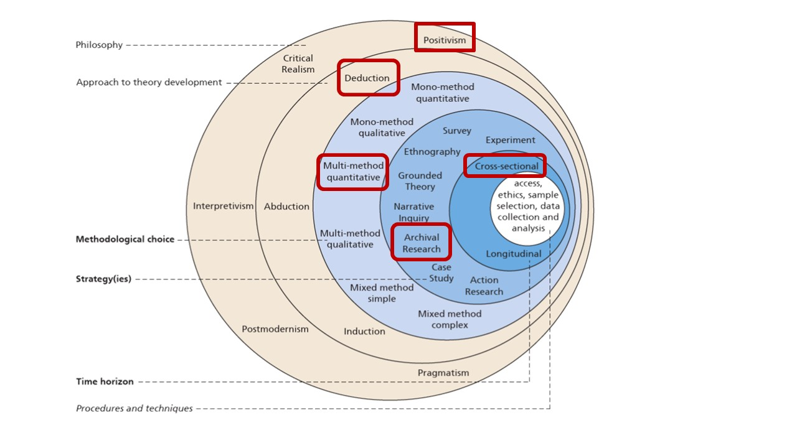

Figure 1: Research Onion Model for the Study (Based on Saunders, Lewis and Thornhill, 2023)

As shown in Figure 3.1, the study adopts a positivist philosophical stance with a deductive approach, quantitative methods, secondary data, and a computational strategy.

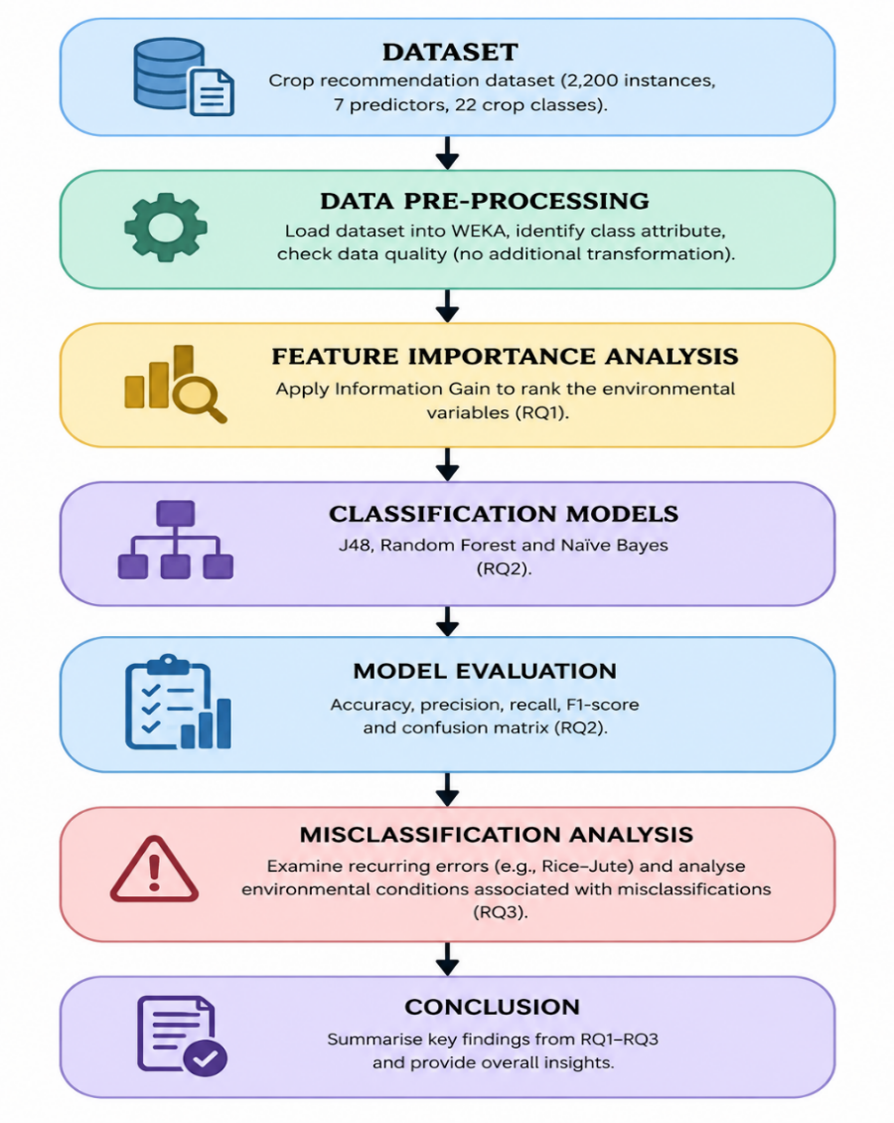
Figure 2: Research Workflow of the Study
source: By using of GPT created the image

As depicted in Figure 3.2, the study's research workflow comprises major steps. Initially, the crop recommendation data is introduced in WEKA. Subsequently, the class attribute is determined, and the dataset is assessed for data quality, including missing values and variable structure, with no other data transformation. Next, Information Gain is applied to measure the discriminative power of environmental variables in crop classification (RQ1). After this, the performance of J48, Random Forest and Naïve Bayes is measured through metrics such as accuracy, precision, recall, F1-score and confusion matrices (RQ2). Finally, the study analyses the confusion matrices to identify common misclassification patterns, especially between Rice and Jute, and to examine the environmental factors related to those misclassifications (RQ3).

3.6 Time Horizon: Cross-Sectional

This is a cross-sectional design because the 2,200 observations are treated as a single dataset at a particular point in time, rather than a longitudinal design that observes the same units over time. Seasonal changes will therefore be outside the scope of the experiment.

3.7 Dataset and Description

The experiment relies on the publicly available Crop Recommendation dataset (Crop_recommendation.csv), which includes 2,200 observations across 22 crop types, with 100 observations per type. The dataset includes seven numeric features: soil nutrients (N, P, K, and pH) and climate parameters such as temperature, humidity, and rainfall. The response is categorical in nature and referred to as crop.

3.8 Data Preparation and Variable Definition

The dataset's structure, variable types, class imbalance, and completeness were examined. There was no missing data, so no imputation or deletion was needed, and the data was analysed in its original form. Since no changes were made to the data, this made it possible to identify any misclassified cases based on their original case numbers. The predictors in WEKA are numerical, and Crop is the class variable.

3.9 Analytical Techniques

Descriptive statistics (minimum, maximum, mean, standard deviation) provided a summary of the predictors. For RQ1, the Information Gain (InfoGainAttributeEval) provided a ranking based on the reduction in uncertainty about the crop class. This measure reflects discrimination and correlation between variables, not causal relationships.
For RQ2, three algorithms were applied: J48 Decision Tree, Random Forest (with 100 trees) and Naïve Bayes. J48 builds a decision tree with interpretable splits according to the predictors; Random Forest combines many decision trees, while Naïve Bayes estimates the probability of classes under conditional independence of predictors given a class. Evaluation used 10-fold cross-validation instead of a manual train/test split: the data is split into 10 folds, 9 folds are used to train a model, and 1 fold is used to test it; the process is repeated until each fold has served as the test set. Accuracy, precision, recall, F1-score and confusion matrices are used as the performance metrics. Since high accuracy is expected, we considered class-level measures and confusion matrices in addition to accuracy, and selected the best model for this dataset and procedure.
For RQ3, we recorded the actual class, predicted class, and classification correctness for each observation using the WEKA prediction option. The confusion matrix was checked for recurring error pairs, and the predictor means of correctly and incorrectly classified observations were compared. The analysis follows this sequence: actual class, predicted class, correct/incorrect classification, environmental conditions, and error pattern. Recurring error patterns across several algorithms are interpreted as environmental overlap, not algorithm weaknesses. No reliability percentage is calculated.

3.10 Ethical Issues, Reliability and Validity

This research uses an existing dataset of agricultural measurements with no personal details and no interaction with individuals; therefore, there are no ethical issues. The dataset was used unaltered, and all sources were cited. The experiment is clearly described and replicable. Algorithms J48 and Naïve Bayes operate deterministically for a fixed set of folds, while fold assignments and Random Forest involve random seeds; therefore, precise results need the same seed to be produced, and employment of three algorithms helps determine whether certain patterns emerge across different methods. Cross-validation is employed to ensure internal validity because no models are applied to instances included in the training process. Construct validity comes from employing Information Gain to measure informativeness rather than causation, and accuracy to measure correspondence to crop labels in the dataset.

3.11 Limitations of the Methodology

The research relies on a single secondary dataset and its underlying conditions. The research is cross-sectional; therefore, it does not investigate seasonal change. The findings are particular to the variables and algorithms used and should not necessarily be generalised. Information Gain does not represent a causal relationship, and any rainfall range identified under hard conditions is characteristic of that dataset, not a general rule.

4 Data Analysis and Findings

The research requires only one secondary dataset and its underlying conditions. The research is cross-sectional; therefore, it does not investigate seasonal change. The findings are particular to the variables and algorithms used and should not necessarily be generalised. Information Gain does not represent a causal relationship, and any rainfall amount range that may be identified under hard conditions is a characteristic of that particular dataset and not a general rule.

4.1 Dataset Analysis

There are 2,200 observations in total in the dataset. The dataset includes 100 observations for each of the 22 crops. The data set includes seven numeric variables: nitrogen (N), phosphorus (P), potassium (K), temperature, humidity, pH, and rainfall. The Crop variable indicates the crop class and serves as the model's dependent variable.
A first inspection of the data set showed no missing values; therefore, no data imputation or observation exclusion was necessary. The data set is completely balanced, and each class represents about 4.55% of the data set. Therefore, a classifier that predicts only one class would have anan accuracy of about 4.55%.
Descriptive statistics were used to characterise the range and dispersion of the predictors.

4.1.1 Descriptive Statistics of Predictor Variables

Rainfall ranges between 20.211 and 298.560 with a standard deviation of 54.958. The standard deviation of the variable Potassium is 50.648, while that of pH is 0.774. From this result, it is evident that there are variations in the range and dispersion of the values; however, it should be remembered that the standard deviations must be considered in terms of their measurement unit.
In the data set, environmental conditions vary by crop types. For example, rainfall and humidity levels are high for rice, but cotton needs more nitrogen. Similarly, phosphorus and potassium values are higher for Apple and grape crops. Humidity levels are higher for Coconut. These predictors may have features useful for predicting crop type. The next section analyses the importance of these predictors using Information Gain.

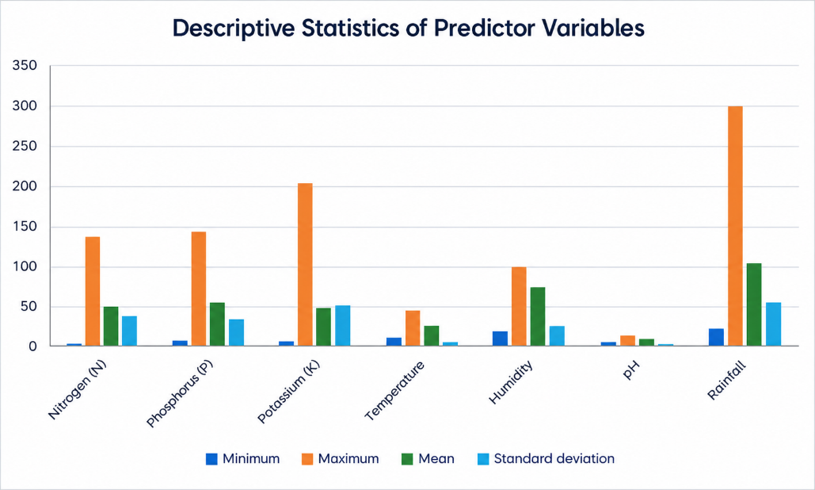

Figure 3:escriptive Statistics of Predictor Variables
Source: Author’s analysis using WEKA 3.8.7 and Microsoft Excel

4.2 Information Gain Analysis

The Information Gain technique is used to rank the seven features by their significance in discriminating the target crop categories. Humidity has the highest Information Gain (2.50613), while rainfall, potassium, phosphorus, nitrogen, temperature, and pH have Information Gains of 2.37744, 2.37334, 1.89664, 1.43941, 1.40620, and 1.00732, respectively.

Rank | Predictor variable | Information Gain
1 | Humidity | 2.50613
2 | Rainfall | 2.37744
3 | Potassium (K) | 2.37334
4 | Phosphorus (P) | 1.89664
5 | Nitrogen (N) | 1.43941
6 | Temperature | 1.4062
7 | pH | 1.00732

Table 1: Information Gain Ranking of Soil and Climate Predictors
Source: Author’s analysis using WEKA 3.8.7 (InfoGainAttributeEval).

Based on the Information Gain results, the seven soil and climatic predictors were ranked by the information they provide for distinguishing crop classes. Humidity had the highest Information Gain score (2.50613), followed by rainfall (2.37744) and potassium (2.37334). From the information, it can be concluded that these predictors provide comparatively more information for discriminating between the crops in the selected sample set. It is important to note that Information Gain predicts association, not causation; therefore, these rankings do not prove that the predictors independently determine the crops' suitability.
The output shows that humidity has the highest information gain. Variables like rainfall and potassium are the ones with relatively high information gain. Phosphorus has moderate information,, while nitrogen and temperature have low information. pH has the lowest information gain, but it still provides some information about the classification problem.
The research question posed above is answered by these findings because the ranking of the predictors is an indication that climatic variables like humidity and rainfall are very important when making distinctions amongst the crop types present in the dataset. Potassium is also among the highly ranked predictor, and this means that there is a possibility of introducing soil nutrient variables into the model.
Information Gain measures the degree of relationship between the predictor and the target class, but not cause-and-effect.

4.3 Classification Model Performance

J48 Decision Tree, Random Forest, and Naïve Bayes classifiers have been analysed based on 10-fold cross-validation in WEKA software. In this technique, the classifier’s performance is measured through many partitions of training and testing giving us results beyond just one training analysis.
J48 was able to accurately classify 2,181 out of 2,200 cases with 19 mistakes, giving an accuracy of 99.1364%. The Random Forest classifier could correctly classify 2,186 cases with 14 mistakes, having an accuracy of 99.3636%. Naïve Bayes could correctly classify 2,189 cases with only 11 mistakes, having 99.5000% accuracy.
 | J48 Decision Tree | Random Forest | Naïve Bayes
Correctly classified instances | 2,181 | 2,186 | 2,189
Incorrectly classified instances | 19 | 14 | 11
Accuracy (%) | 99.1364 | 99.3636 | 99.5
Cohen’s Kappa | 0.991 | 0.9933 | 0.9948
Weighted precision | 0.991 | 0.994 | 0.995
Weighted recall | 0.991 | 0.994 | 0.995
Weighted F1-score | 0.991 | 0.994 | 0.995

Table 2. Evaluation measures for the three classification models under 10-fold cross-validation (n = 2,200)

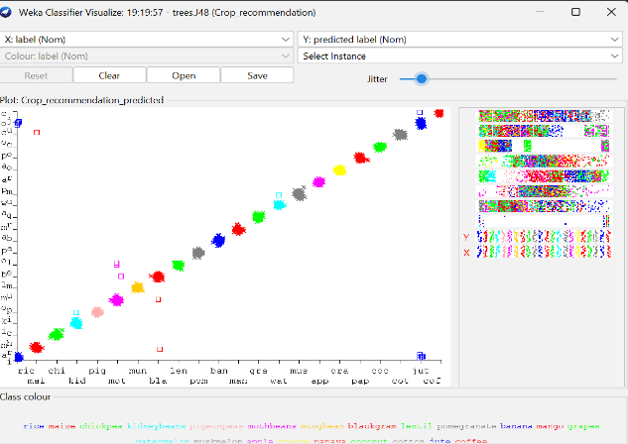
The evaluation metrics for the three classification models, as summarised in Table 2, show that all models achieved an accuracy level exceeding 99%. Specifically, J48 classified 2,181 out of 2,200 observations correctly (99.1364%), Random Forest achieved 2,186 correct classifications (99.3636%), and Naïve Bayes classified 2,189 observations accurately (99.5%). The Kappa statistic, which measures agreement beyond chance, ranged from 0.991 for J48 to 0.9948 for Naïve Bayes. Weighted averages for precision, recall, and F1-score reflected similar patterns: 0.991 for J48, 0.994 for Random Forest, and 0.995 for Naïve Bayes. According to the table, the Naïve Bayes algorithm displayed the highest performance, with only 11 misclassified cases, compared to 14 for Random Forest and 19 for J48, as assessed through 10-fold cross-validation. The differences in accuracy among the models are minimal, with a 0.14 percentage point gap between Naïve Bayes and Random Forest and a 0.36 percentage point difference between Naïve Bayes and J48, corresponding to just three and eight observations, respectively. As illustrated by Table 2, these small discrepancies highlight that Naïve Bayes performed best under the specific conditions of this dataset and validation approach, though this result is not generalizable to all contexts. Thus, the overall accuracy reported in the table reflects the models’ collective performance across all 22 crop types.

Figure 4: WEKA classifier Visualisation for the j48 model

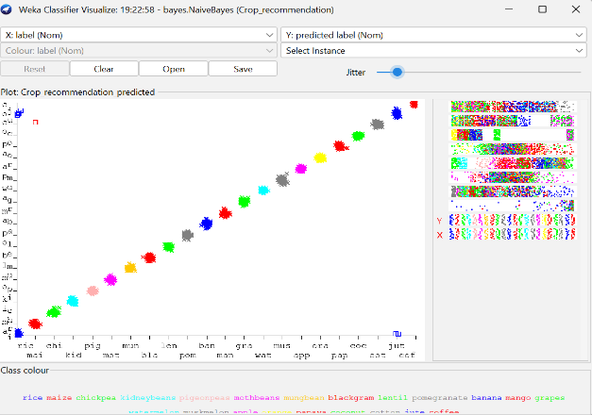

Figure 5: WEKA classifier Visualisation for the Naïve Bayes model
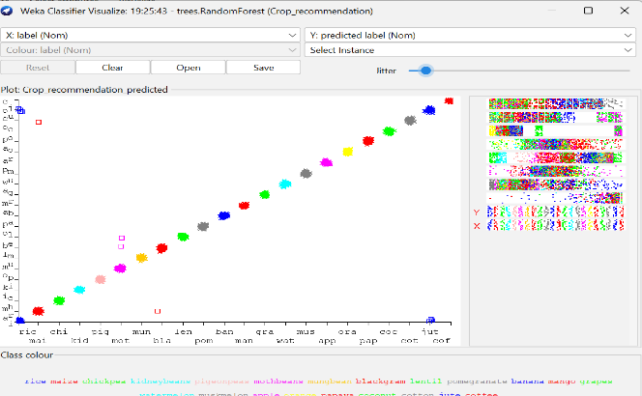

Figure 6: WEKA Classifier Visualisation for the Random Forest Model

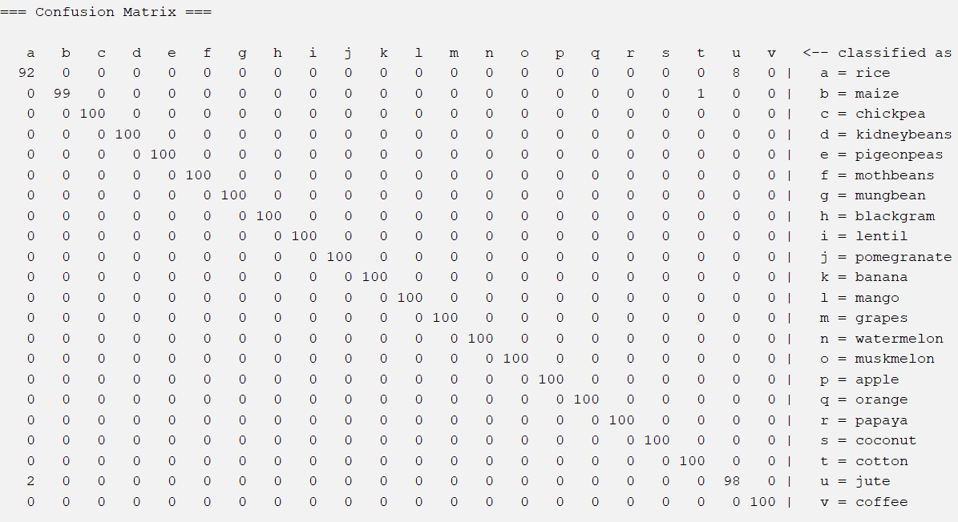

Figure 4.5: Naïve bayes confusion matrix under 10-fold cross-validation

Naïve Bayes Confusion Matrix. This confusion matrix has been shown here to provide an overview of the results of classification of the respective crop class. The comparison matrices for J48 and Random Forest have been provided in Appendix A. This will make it possible to analyse errors of classification by each classifier, with special attention paid to misclassification of Rice and Jute.

4.3.1 Cohen’s Kappa Comparison of the Three Classification Models

The Cohen’s Kappa statistics for J48, Random Forest and Naïve Bayes were 0.9910, 0.9933, and 0.9948, respectively. Naïve Bayes had the highest precision, recall, and F1-score, and thus the best performance. Accuracy, precision, recall, and F1-score are performance measures that complement one another; however, aggregating them may hide errors in classifying crops individually.
The Naïve Bayes algorithm reached an accuracy of 99.50%, compared to the 99.14% achieved by J48, which was a gap of about 0.36%. Overall, all algorithms showed high performance under 10-fold cross-validation, supporting the second hypothesis. However, an external validation was necessary to ascertain whether this would apply to other locations. All the algorithms misclassified Rice and Jute even when they showed high accuracy. The J48 algorithm generated six cases where it classified Rice as Jute and four cases where it classified Jute as Rice (10 errors out of 19; 52.6%).

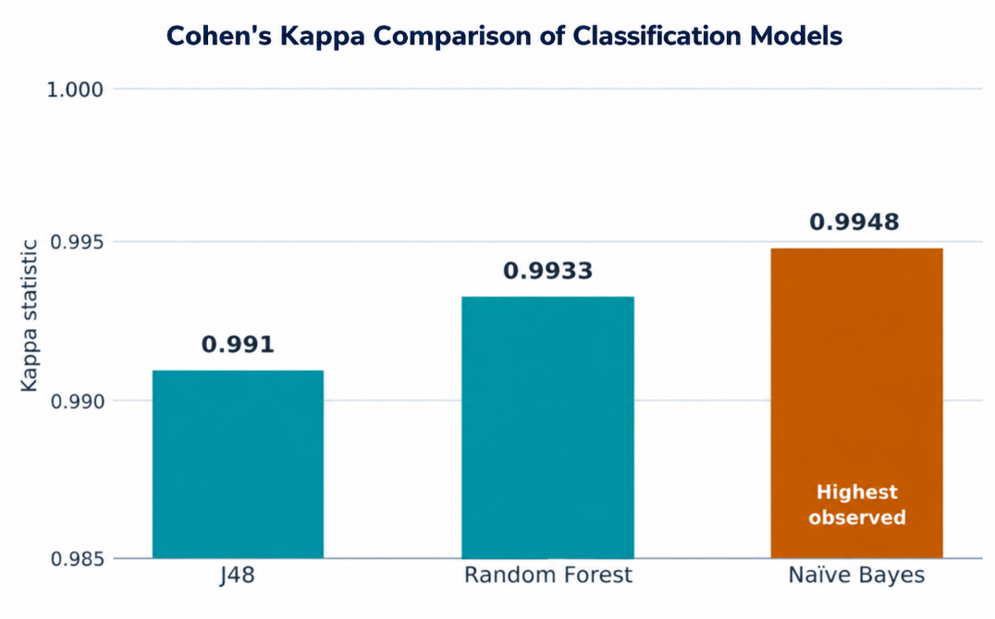
Figure 6: Cohen’s Kappa Comparison of the Three Classification Models
Source: Author’s analysis using WEKA 3.8.7 and Excel

4.4 Misclassification Analysis and Prediction Reliability

All three models got an accuracy above 99%, but most of their errors related to Rice and Jute. As illustrated in Table 4.3 and Figure 4.7, all three models classified 10 Rice as Jute. J48 had six Rice-to-Jute and four Jute-to-Rice errors, accounting for 52.6% of its total 19 errors. Random Forest had seven and three errors, respectively, accounting for 71.4% of its 14 total errors, while Naïve Bayes had eight and two errors, respectively, accounting for 90.9% of its 11 total errors. Hence, although Naïve Bayes had the highest accuracy, most of its errors involved Rice and Jute.

In the case of the Naïve Bayes model, there was a difference in rainfall for correct and incorrect classification of data. The correct classification of Rice had 240.542mm rainfall compared to 186.036 mm rainfall for misclassified Rice. In the case of Jute, the values were 174.392 mm and 194.445 mm. This indicates environmental overlap between both crops in terms of rainfall conditions. However, these rainfall values cannot be used to indicate global crop suitability. Misclassifications under Rice-Jute suggest reduced predictive ability when environments share common profiles, as shown by the formal uncertainty analysis.

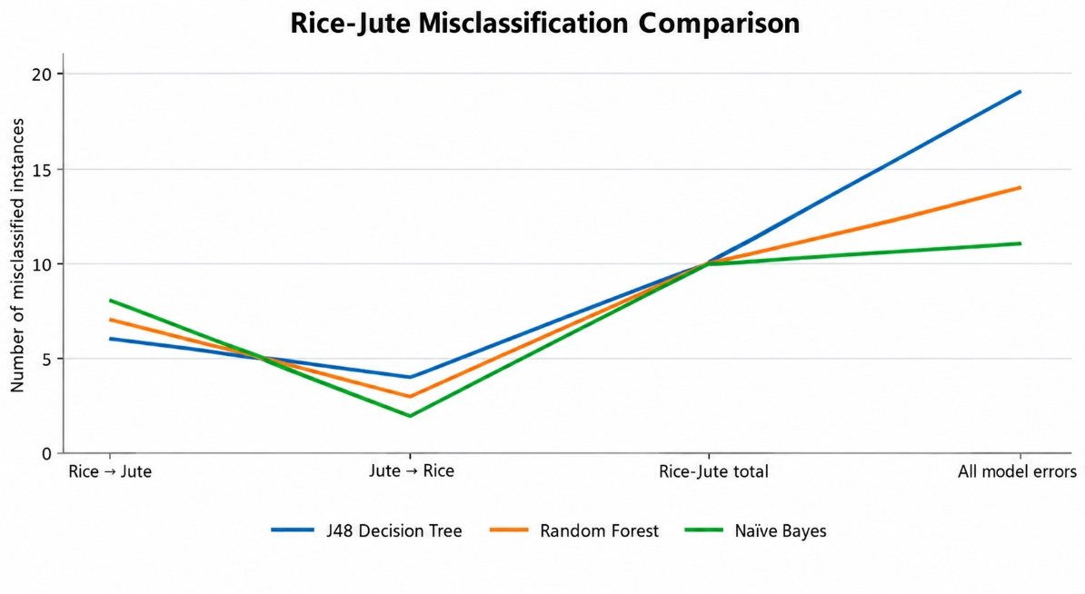

Figure 7: WEKA Misclassification Results for the Three Classification Models
Source: Author’s analysis of WEKA 3.8.7 classification results.

However, despite all three models achieving an accuracy rate above 99%, residual errors occurred only in certain crop classes. It was noticed that Rice and Jute were continuously mixed up, as can be seen in Table 4.3 and Figure 4.7 below. All three models reported 10 errors in Rice–Jute classification. J48 reported 6 errors in Rice-Jute and 4 in Jute-Rice, which made up 52.6% of all errors reported by this model (19). Random Forest had 7 errors in Rice-Jute and 3 in Jute-Rice, accounting for 71.4% of the 14 errors reported. Naïve Bayes had 8 Rice-Jute and 2 Jute-Rice errors, which accounted for 90.9% of all 11 errors reported. Hence, although Naïve Bayes had the highest accuracy rate, most of its other errors occurred when distinguishing Rice from Jute.
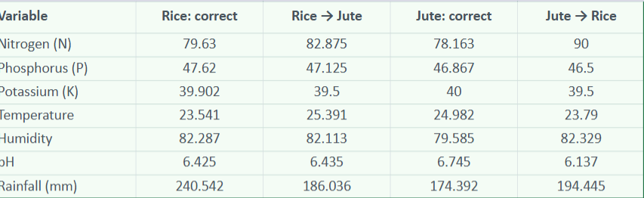
A deeper analysis of Naïve Bayes results also showed differences in rainfall between correctly classified and misclassified observations. The average rainfall for correctly classified Rice amounted to 240.542 mm, while for Rice misclassified as Jute, it was 186.036 mm. For correctly classified Jute, the mean rainfall was 174.392 mm, while for Jute misclassified as Rice, it was 194.445 mm. Hence, misclassified observations had rainfall amounts close to those typical for the opposite crop type. The overlap at 192-197 mm rainfall is typical of this dataset only and may not be a general criterion for crop suitability or the cause of the observed classification errors.

Table 3: WEKA Misclassification Results for the Three Classification Models

4.5 Findings in Relation to Research Objectives

The results show that humidity (2.50613), rainfall (2.37744), and potassium (2.37334) had the highest discriminating power for crop categorisation. However, it is worth noting that Information Gain indicates association, not causation. The three models achieved high accuracy above 99%: J48 (99.1364%), Random Forest (99.3636%), and Naïve Bayes (99.5%). In conclusion, Naïve Bayes outperformed the other models given the chosen validation method. The prediction was least accurate in areas that had an overlapping environment of Rice and Jute, whereby each model made 10 wrong predictions of Rice–Jute. For Naïve Bayes, predictions were made when rainfall overlapped in the 192–197mm range.

5: DISCUSSION

5.1 Introduction

This chapter examines the results in Chapter 4 in relation to the research questions and the existing literature on machine learning-based crop recommendation. It considers the importance of environmental variables, model performance, prediction accuracy, implications for agriculture, unforeseen outcomes, and methodological drawbacks.

5.2 Findings in Relation to Research Questions and Literature

5.2.1 Environmental Factors and Crop Suitability (RQ1)

In RQ1, the study aimed to identify which soil nutrients and climatic variables provide the greatest discriminatory power for crop suitability. Information Gain identified humidity (2.50613), rainfall (2.37744), and potassium (2.37334) as the three highest-ranked variables. This result aligns with earlier findings that underscore the importance of integrating soil and climatic features when recommending crops.
The high importance of humidity and rainfall indicates that climatic features help discriminate crop suitability, while potassium shows that soil nutrients play an important role; nevertheless, Information Gain measures discriminatory information, not cause-and-effect relationships between variables. Thus, the result does not mean that humidity, rainfall, and potassium independently cause crop suitability; rather, they provide discriminatory information.
The crucial point is that variable importance is measured across the entire dataset, but each prediction can rely on a different combination of environmental features. This point is relevant to the misclassification results.

5.2.2 Classification Performance and Model Comparison (RQ2)

RQ2 used accuracy to assess the ability of supervised machine learning algorithms to forecast crop suitability. All algorithms achieved more than 99% accuracy during 10-fold cross-validation. Specifically, J48 algorithm had 99.1364% accuracy, Random Forest had 99.3636% and Naïve Bayes had 99.5%. In addition, weighted precision, recall and F1-scores were also extremely high (they ranged from 0.991 to 0.995).
The obtained results match those of previous studies on the predictive power of machine learning in crop recommendation (Dey et al., 2024; Shastri et al., 2025). These results imply that the seven soil and climate variables contain sufficient information to differentiate between the 22 crop classes within the selected dataset.
However, the slight difference in the overall performance proves that the accuracy measure does not allow one to evaluate the reliability of predictions. Despite Naïve Bayes's highest accuracy, its confusion matrices show that some crop classes are consistently mixed up. As a result, the Naïve Bayes algorithm should be considered the best performer among the studied algorithms only within the selected dataset and validation process.

5.2.3 Misclassification and Prediction Reliability (RQ3)

RQ3 examined circumstances where crop predictions become inaccurate. The most recurrent problem across all models was confusion between Rice and Jute crops. Ten instances of Rice-Jute confusion were found in all three models, accounting for 52.6% of J48 errors, 71.4% of Random Forest errors, and 90.9% of Naïve Bayes errors.
This pattern recurs across all three algorithms, indicating that the difficulty stems from similarities in the environmental profiles of Rice and jute, not a unique feature of any particular algorithm. This conclusion is supported by recent literature that stresses uncertainties and overlapping agro-environmental characteristics in crop suitability classification (Alam et al., 2025).
In the case of Naïve Bayes classifier, the mean rainfall level of misclassified Rice samples was 186.04 mm compared to 240.54 mm of correctly classified Rice samples. In comparison, the mean rainfall level of misclassified Jute samples was 194.45 mm compared to 174.39 mm of correctly classified Jute samples. This means confusion occurred when the rainfall characteristics of the two crops were closer. The range of 192-197 mm rainfall cannot be regarded as a universal threshold but as a dataset-specific sign of an environmental area where classification becomes more difficult.

5.3 Agricultural and Decision-Support Implications

The results can improve agricultural decision-making systems in practice. Humidity, rainfall, and potassium content had the highest discriminatory power and can therefore be used to determine suitability for particular crops. Machine-learning decision-making systems can help farmers and agricultural planners make decisions based on soil and climate characteristics and patterns related to various crops.
At the same time, as shown by the Rice-Jute classification error, the decision should not be considered an automatic one. If conditions for different crops are similar, then more data may be needed. This means machine learning is best used as a decision-support system.

5.4 Critical Observations

The Naïve Bayes Classifier was the most accurate of the three classifiers, proving that a more complicated algorithm is not necessarily the best performer. Further experiments must be done to validate the algorithm's performance in different agricultural settings.
While achieving accuracy above 99%, the classifiers struggled to distinguish rice from Jute crops. This proves the need to study error patterns alongside accuracy rates.
Incorrectly predicted crops may affect resource allocation and production planning in real-world settings. Still, this experiment evaluated model performance but did not estimate its impact on the supply chain.

5.5 Limitations

Several limitations must be kept in mind. To begin with, the study is based on a secondary dataset consisting of 2,200 observations for 22 crop types, which means that the findings will depend upon the environment represented by the data. Secondly, the cross-sectional design of the study does not address issues pertaining to the changes in crop suitability over time and across different seasons. Thirdly, the conclusions drawn are unique to this particular data set, set of variables and algorithms, and cannot be automatically generalised generalise to other environments and regions.
Information gain finds discriminatory information, while the rainfall overlap for Rice and Jute is specific to this particular data set. The study has identified various conditions leading to the possibility of misclassification, but uncertainty quantification was not performed (Alam et al., 2025). Thus, it is clear that the findings have high predictive power within the chosen data set, although reliability may differ for different crops and environments.

6: CONCLUSION

6.1 Conclusion

In this paper, crop suitability recommendation was investigated through soil and climate parameters, supervised machine learning approaches. For the analysis, 2,200 records of 22 crops and seven environmental features like nitrogen, phosphorus, potassium, temperature, humidity, pH and rainfall have been considered. Information Gain, J48 Decision Tree, Random Forest and Naïve Bayes have been used using 10-fold cross-validation approach.
The research findings reveal that humidity, rainfall and potassium had the most discriminative information among crop classifications. Humidity has shown the highest Information Gain value (2.50613) followed by rainfall (2.37744) and potassium (2.37334). Nevertheless, it should be noted that the above-mentioned results reveal statistical associations, not causal ones.
Three algorithms of classification performed with an accuracy higher than 99%. The highest accuracy (99.5%) was shown by Naïve Bayes, while Random Forest (99.3636%) and J48 (99.1364%) performed similarly well. Even with the high accuracy, the error rate analysis reveals that the overall accuracy does not ensure the reliability of crop predictions.

6.2 Response to Research Questions

RQ1. To identify the soil and climate variables that provide the strongest discriminatory information for crop classification.
Humidity, rainfall, and potassium were the variables that showed maximum discrimination between crop types. Humidity had the most information content, followed by rainfall and potassium.
RQ2: How accurately can supervised machine learning classification models predict crop suitability based on soil and climate variables?
All models had an accuracy of over 99%. The highest accuracy among all models was attained by Naive Bayes, which attained 99.5%, although this value is data-dependent.
RQ3: Which environmental conditions are associated with increased prediction uncertainty and classification errors, and what are the implications for agricultural supply planning?
Rice and Jute were the two crops which posed most problems of misclassification, with ten misclassifications between the two being seen in each case. In Naïve Bayes, tough cases involved overlap in rainfall of around 192–197 mm.

6.3 Implications

These results suggest that machine learning could contribute to the decision-making process in assessing the suitability of crops. The determination of influential environmental variables could facilitate the construction of more relevant systems to give advice to farmers and other decision-makers involved in agriculture. Yet, it is important to note that the high degree of accuracy does not mean total reliability..

6.4 Recommendations for Future Research

Moreover, future research will need to verify the effectiveness of the models through using other geographic locations' datasets to check their generalizability (Mlambo et al., 2026). Moreover, other environmental factors such as soil quality, location, water supply, and sunlight should be tested as well to establish whether they would add anything to classification accuracy (Afzal et al., 2025). Uncertainty estimation could be performed as an additional measure for increasing the level of accuracy of decisions (Alam et al., 2025). SHAP and LIME as explainable AI algorithms could help in making sense of the predictions better (Bouni et al., 2024; Shastri et al., 2025).
Finally, multiple growing seasons' worth of data from real life could be analysed to check for changes in performance of the model. Overall, this research proves that soil and climate variables have the potential of delivering high-quality crop suitability classifications. However, the confusion of Rice and Jute shows that analysing classification errors is equally important when it comes to measuring the effectiveness of a model. Variable importance and model comparison combined with misclassification rate provide a much better understanding of the limitations of the recommendation model.

References

Afzal, H., Amjad, M., Raza, A., Munir, K., & Ashraf, I. (2025). Incorporating soil information with machine learning for crop recommendation to improve agricultural output. Scientific Reports, 15(1). https://doi.org/10.1038/s41598-025-88676-z
Akram, M., Batool, I., & Kahraman, C. (2026). An explainable hybrid fuzzy-machine learning framework for multi-crop suitability classification using agro-environmental data. Knowledge-Based Systems, 333, 115008. https://doi.org/10.1016/j.knosys.2025.115008
Alam, Md. S. Bin, Esichaikul, V., Lameesa, A., Ahmed, S. F., & Gandomi, A. H. (2025). An approach for crop recommendation with uncertainty quantification based on machine learning for sustainable agricultural decision-making. Results in Engineering, 26, 105505. https://doi.org/10.1016/j.rineng.2025.105505
Bakr, M. A., Khan, A. J., Khan, S. D., Zafar, M. H., Ullah, M., & Ullah, H. (2025). Evaluation of learning-based models for crop recommendation in smart agriculture. Information, 16(8), 632. https://doi.org/10.3390/info16080632
Bouni, M., Badr Hssina, Khadija Douzi, & Douzi, S. (2024). Interpretable machine learning techniques for an advanced crop recommendation model. Journal of Electrical and Computer Engineering, 2024(1). https://doi.org/10.1155/2024/7405217
Breiman, L. (2001). Random forests. Machine Learning, 45(1), 5–32.
Dey, B., Ferdous, J., & Ahmed, R. (2024). Machine learning based recommendation of agricultural and horticultural crop farming in India under the regime of NPK, soil pH and three climatic variables. Heliyon, 10(3), e25112–e25112. https://doi.org/10.1016/j.heliyon.2024.e25112
Farida Siddiqi Prity, MD. Mehadi Hasan, Shakhawat Hossain Saif, Md. Maruf Hossain, Sazzad Hossain Bhuiyan, Md. Ariful Islam, & Hasan, T. (2024). Enhancing agricultural productivity: A machine learning approach to crop recommendations. Human-Centric Intelligent Systems, 4. https://doi.org/10.1007/s44230-024-00081-3
Hall, M., Frank, E., Holmes, G., Pfahringer, B., Reutemann, P., & Witten, I. H. (2022). The WEKA data mining software. ACM SIGKDD Explorations Newsletter, 11(1), 10. https://doi.org/10.1145/1656274.1656278
John, G. H., & Langley, P. (2013). Estimating continuous distributions in bayesian classifiers (1302.4964V1). arXiv. https://arxiv.org/abs/1302.4964v1
Mlambo, B., Odindi, J., Matongera, T. N., & Mutanga, O. (2026). A critical review of literature on the application of machine learning algorithms in cropland suitability modelling. Agricultural Research. https://doi.org/10.1007/s40003-026-01037-8
Saunders, M., Lewis, P., & Thornhill, A. (2023). Research methods for business students (9th edn). Pearson.
Shastri, S., Kumar, S., Mansotra, V., & Salgotra, R. (2025). Advancing crop recommendation system with supervised machine learning and explainable artificial intelligence. Scientific Reports, 15(1). https://doi.org/10.1038/s41598-025-07003-8
The Morgan Kaufmann series in machine learning. (1993). C4.5, ii. https://doi.org/10.1016/b978-0-08-050058-4.50001-2
Yaganteeswarudu, A., Biswas, S. K., Aruna, V., & Tripathi, D. (2025). Enhancing transparency in smart farming: Local explanations for crop recommendations using LIME. Procedia Computer Science, 258, 1993–2005. https://doi.org/10.1016/j.procs.2025.04.450

Appendix:

Fig: A.1 Crop Recommendation Dataset Loaded in WEKA Explorer.

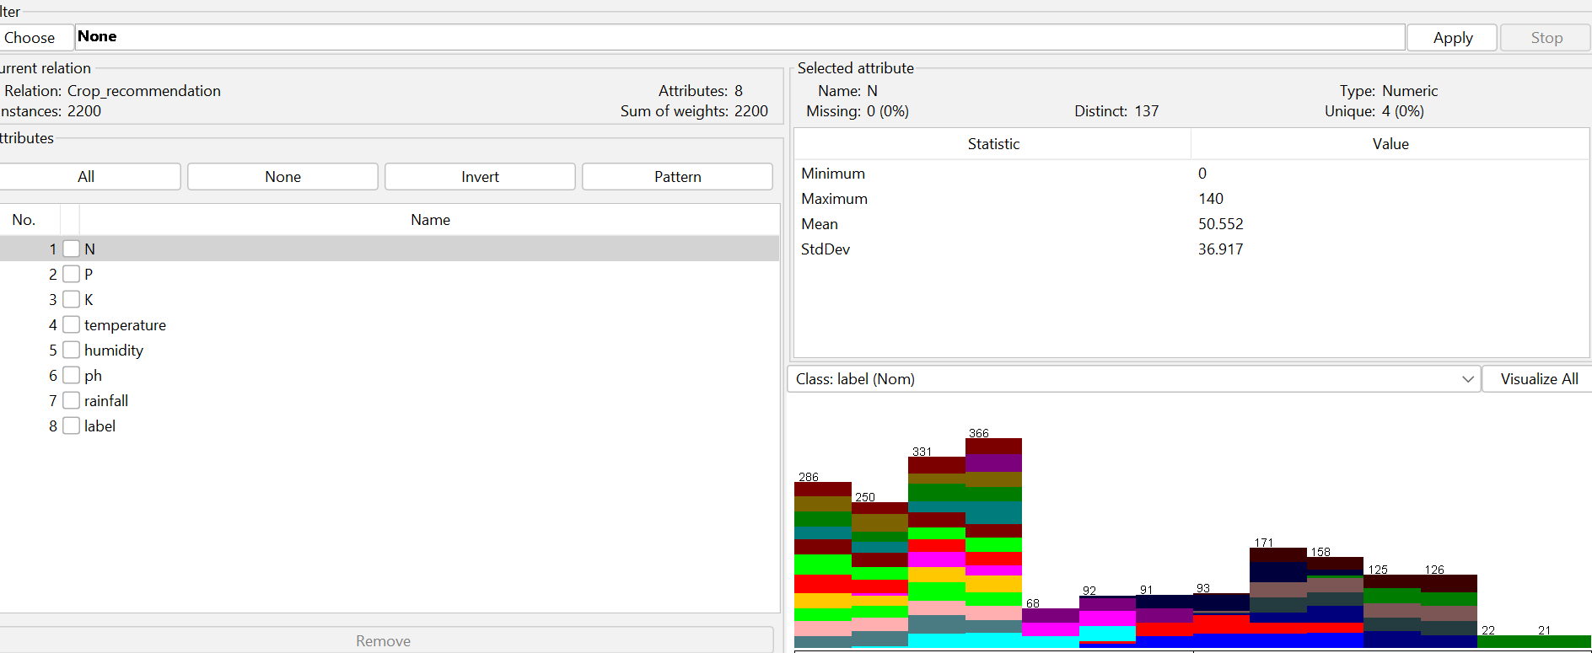

Figure A.2: J48 Decision Tree Classifier Configuration and 10-Fold Cross-Validation Results.
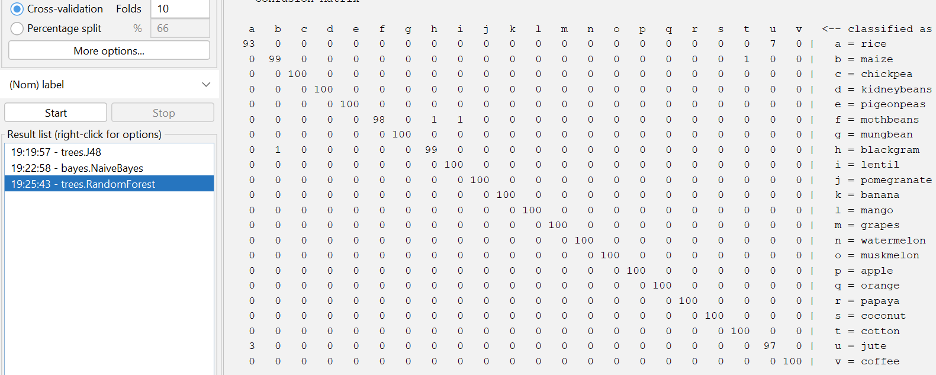
Figure A.3: j48 Classifier Configuration and 10-Fold Cross-Validation

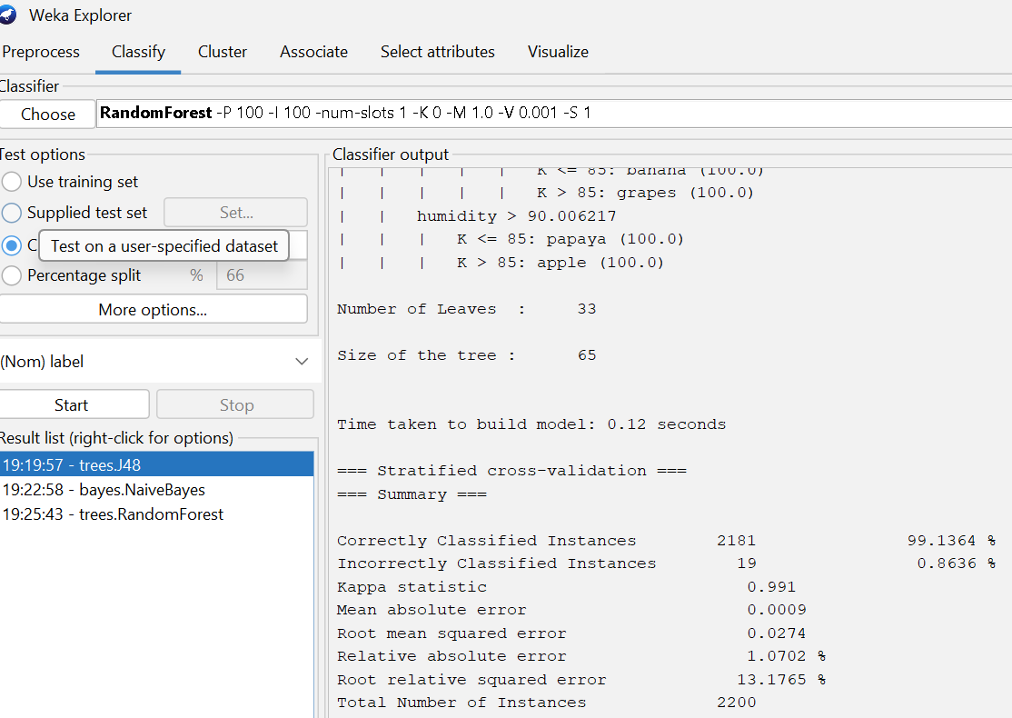

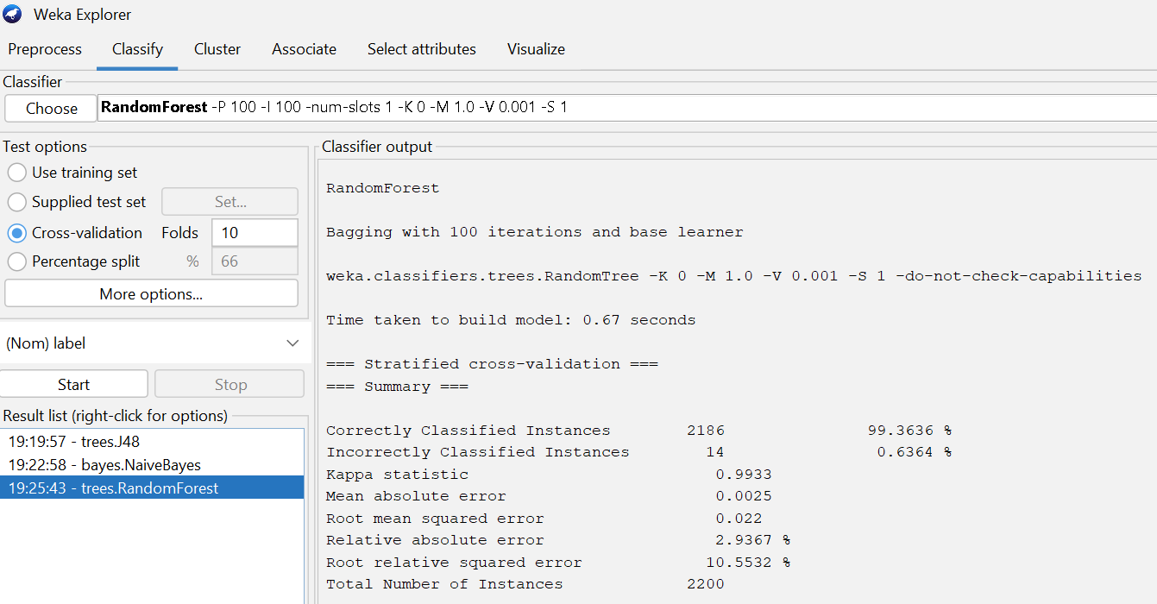
Figure A.3: Random Forest Classifier Configuration and 10-Fold Cross-Validation

Fig A.4: WEKA margin curve for the Naïve Bayes model (negative margins are misclassifications)

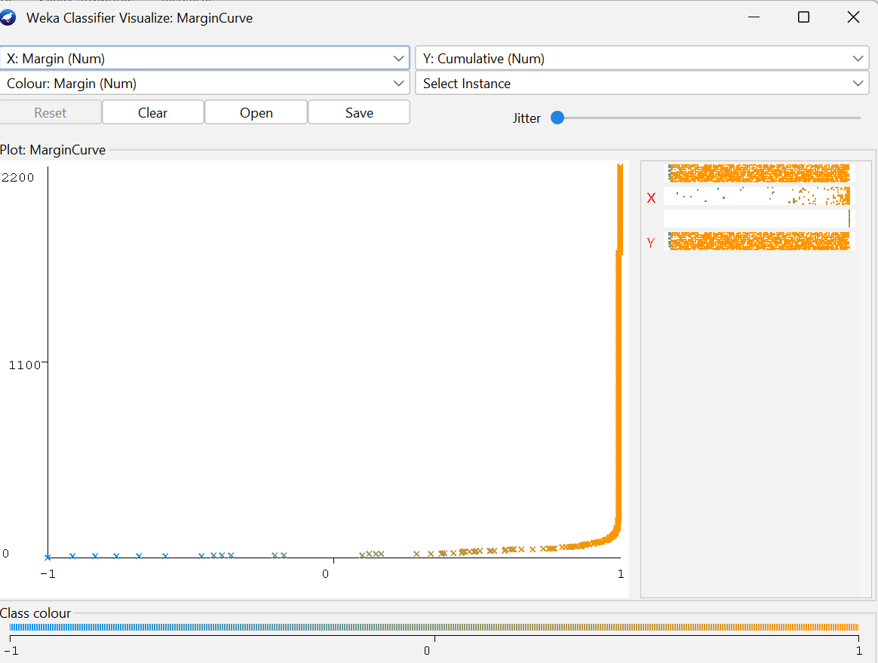

Figure A.5: Confusion Matrix for the J48 Decision Tree Classifier.
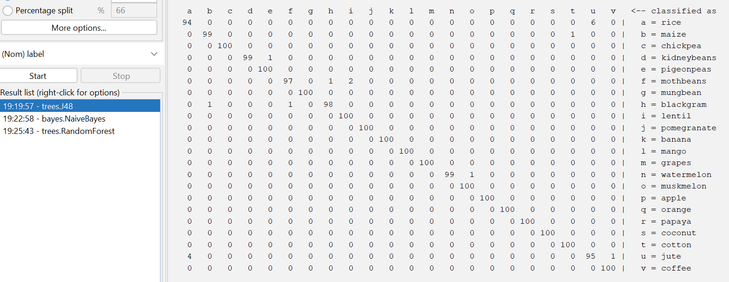

Figure A.6: Confusion Matrix for the Random Forest Classifier.

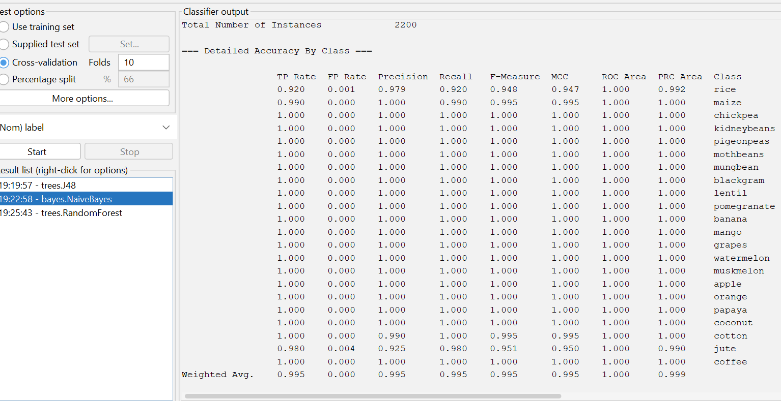
Fig A.7: Accuracyof the naïve bayes

