OSSP_WEEK2_PRACTICAL

Step 1 — Open Terminal
Press Ctrl + Alt + T

Step 2 — Install Required Tools
sudo apt update
sudo apt install build-essential strace -y
gcc --version
strace -V

Step 3 — Create Practical Folder
mkdir -p ~/ossp_practical2
cd ~/ossp_practical2
pwd

Step 4 — Create Source File
touch source.txt
nano source.txt
Inside nano, type:
This is OSSP Practical 2.
This file is used to demonstrate
open, read, write and close system calls.
Save with Ctrl + O → Enter → Ctrl + X.

Step 5 — Check Source File
cat source.txt
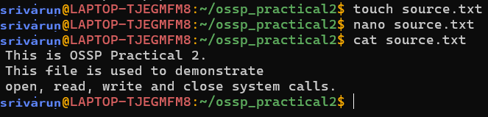

Step 6 — Create C Program
nano filecopy.c
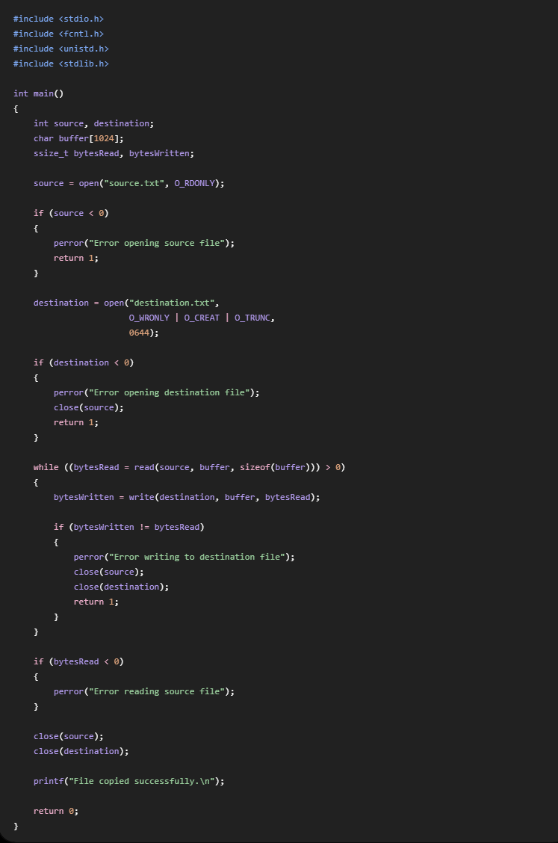
Paste the C program from Part A, then save with Ctrl + O → Enter → Ctrl + X.

Step 7 — Compile
gcc filecopy.c -o filecopy
ls
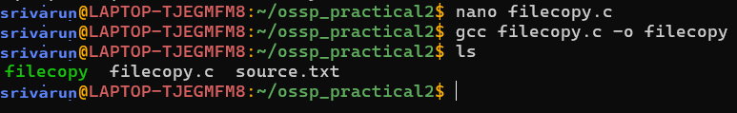

Step 8 — Run Program
./filecopy
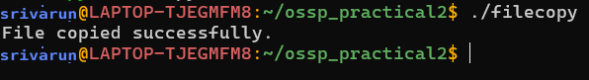

Step 9 — Check Destination
ls
cat destination.txt
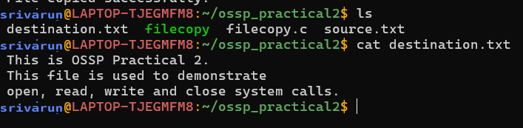

Step 10 — Compare Files
diff source.txt destination.txt
cmp source.txt destination.txt

Step 11 — Trace cat
strace cat source.txt
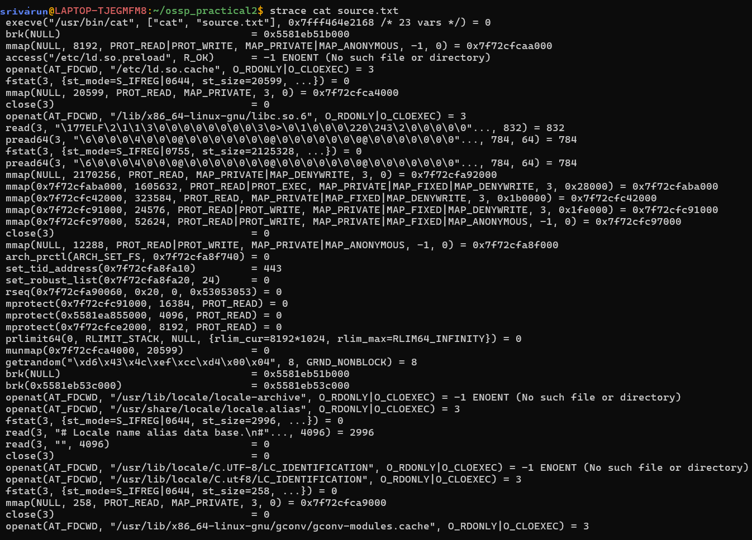

Step 12 — Trace Important File Calls
strace -e trace=openat,read,write,close cat source.txt

Step 13 — Save Trace
strace -o trace.txt cat source.txt
cat trace.txt

Step 14 — Filter Important Calls
grep -E "openat|read|write|close" trace.txt

Step 15 — Final Check
ls -l
